_{Name:} MRAD 281

CT Imaging of the Abdomen & Pelvis CT Imaging of the Spine

Part 1 – Anatomy

- Describe the major artery supplying blood to the abdominal organs and list its identifiable braches.

- Describe the major vein draining blood of the abdominal organs and list its identifiable branches.

- Label the branches of the abdominal aorta:
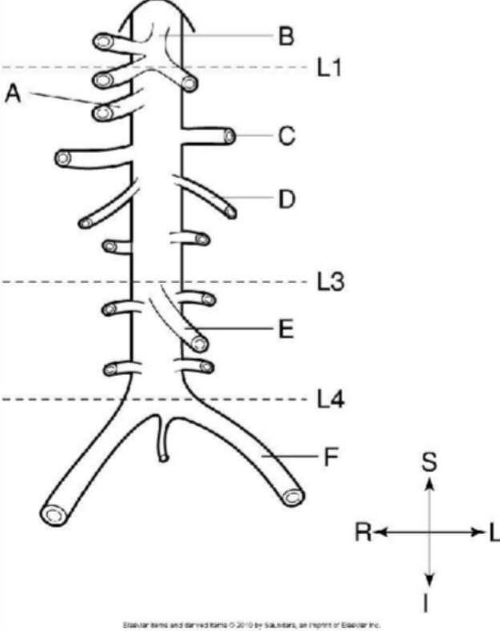

- At L4, the abdominal aorta bifurcates into which two vessels?

- At what vertebral level does the IVC pass from the abdomen into the mediastinum? What is this opening called?

- What two vessels join to form the IVC?

- At the level of the origin of the SMA, what is the SMA’s relationship to the splenic vein? To the left renal vein?

- What term is used to describe the location of organs in the abdominal cavity that have peritoneum only on the anterior surface?

- What anatomical structure marks the division between the right and left lobes of the liver?

- What separates the posterior caudate lobe from the more anterior quadrate lobe?

- What vessel supplies the liver with oxygenated blood?

- Describe the relationship of the gall bladder to the liver.

- Describe the regions of the stomach and their relationships (ie – which is most superior, anterior, etc.)

- List and describe the segments of the small intestine.

- List and describe the segments of the colon.

- Where is the spleen located?

- The splenic vein is usually easy to see on an axial CT image. Where does it sit?

- The pancreas extends between which two organs?

- Which portion of the pancreas is the most superior and posterior?

- Describe the relationship of the IVC to the abdominal aorta.

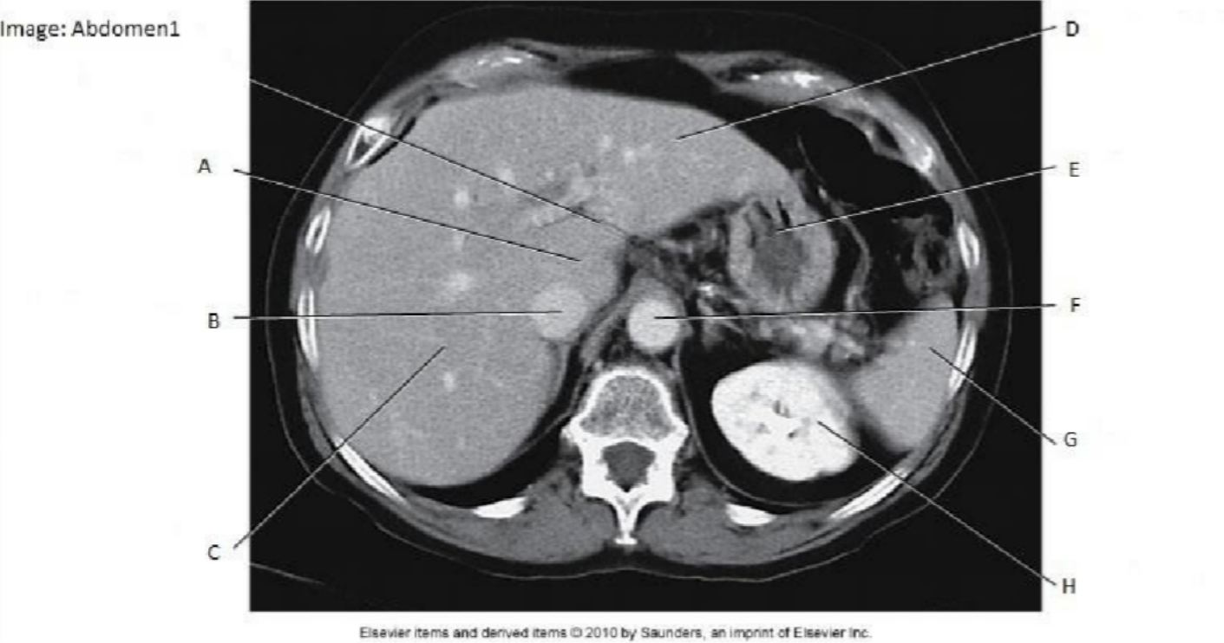
- Label

- Label

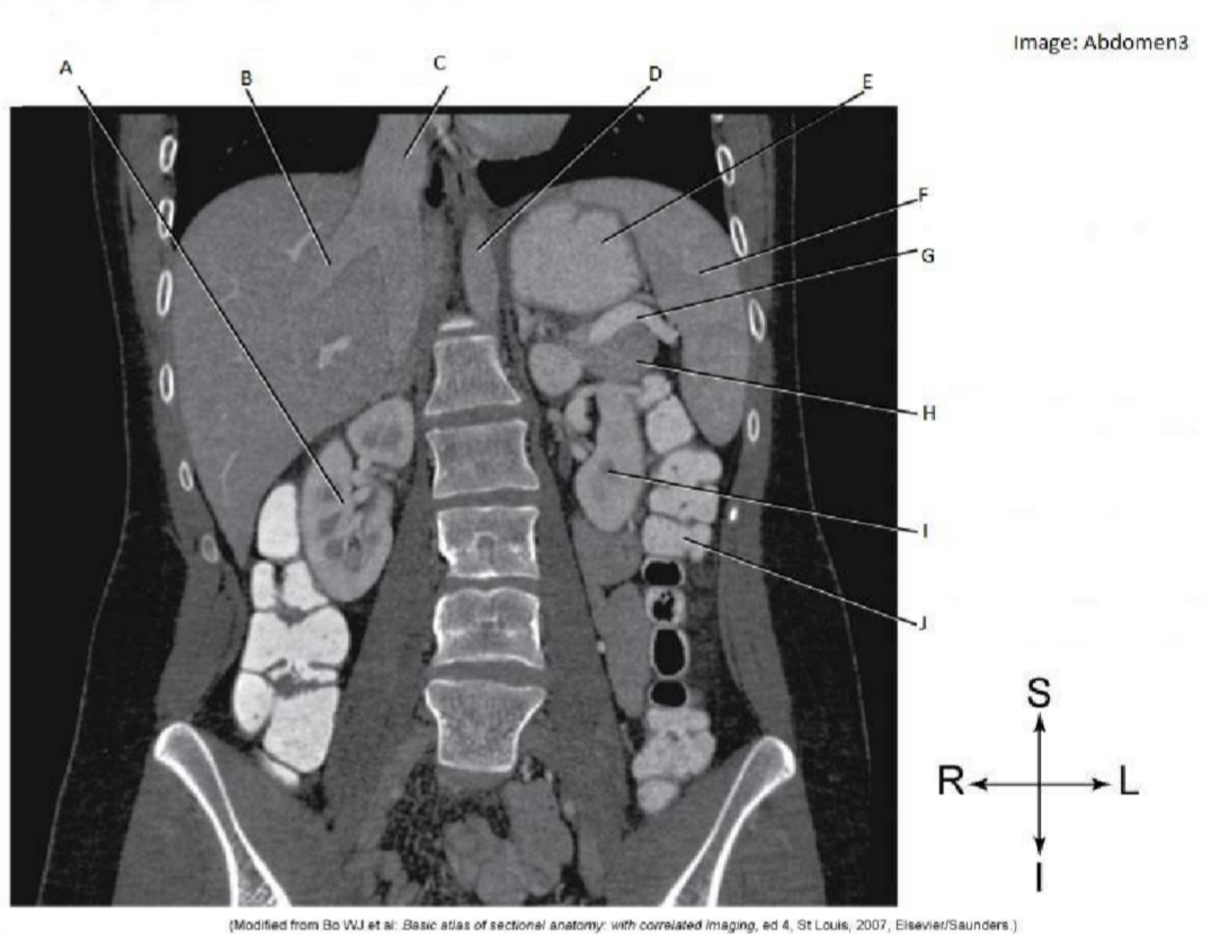

- Label:
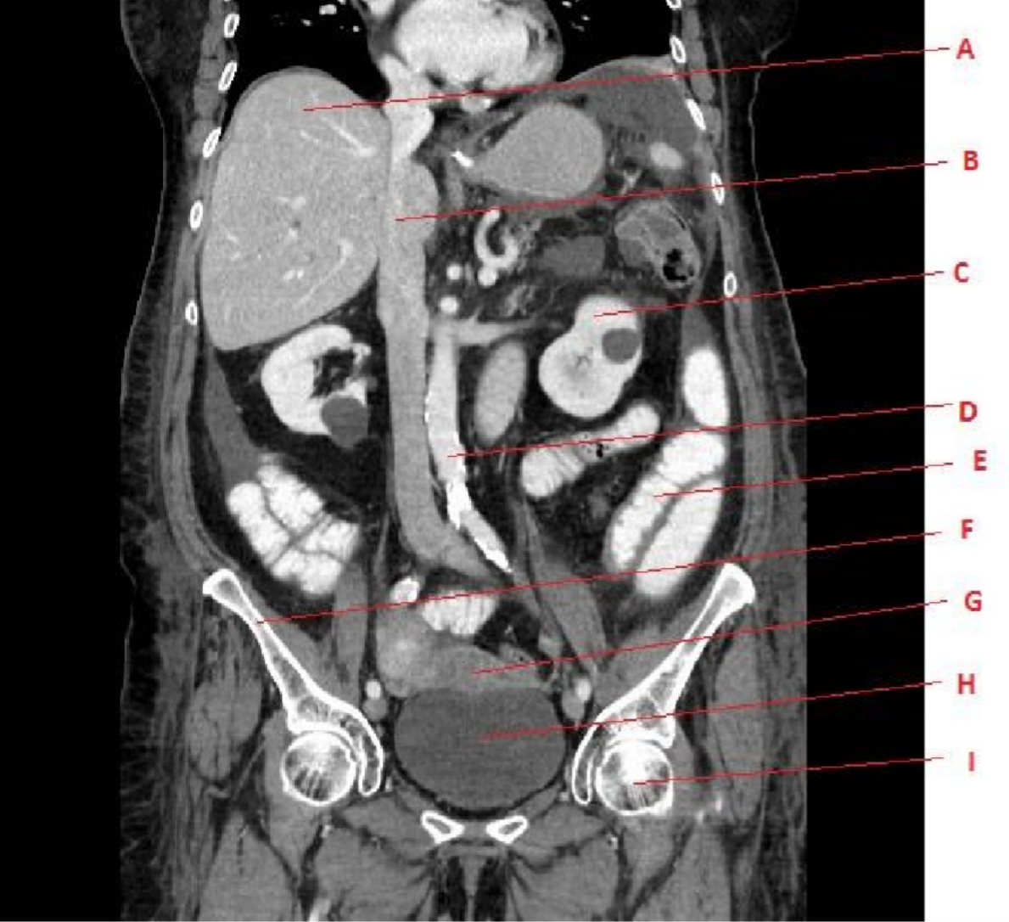

- Label
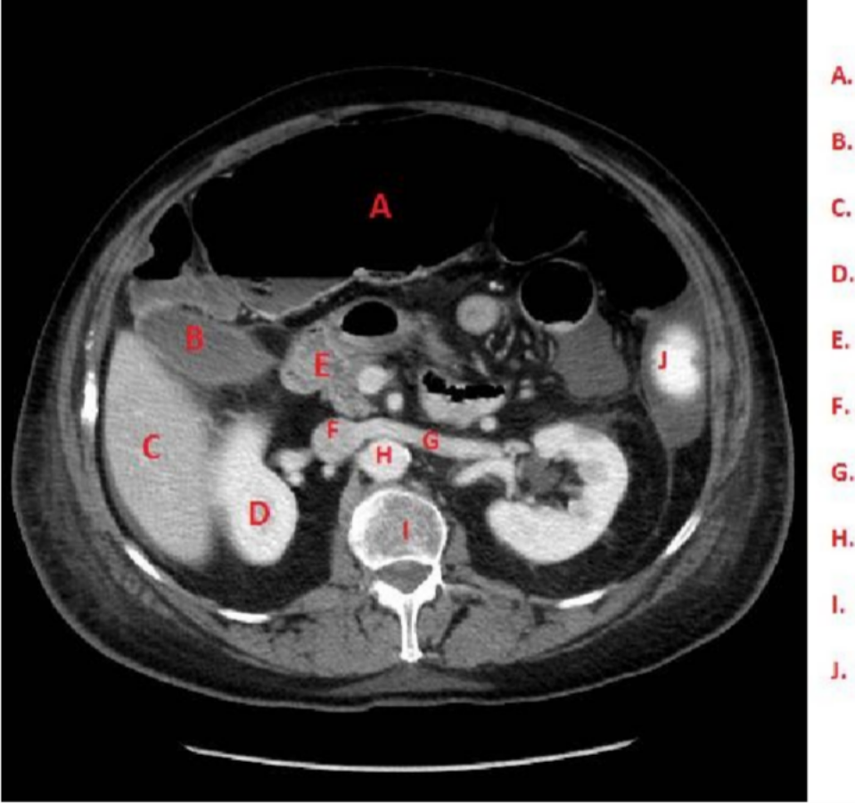

A.
B.
C.
D.
E.
F.
G.

- Label the image:
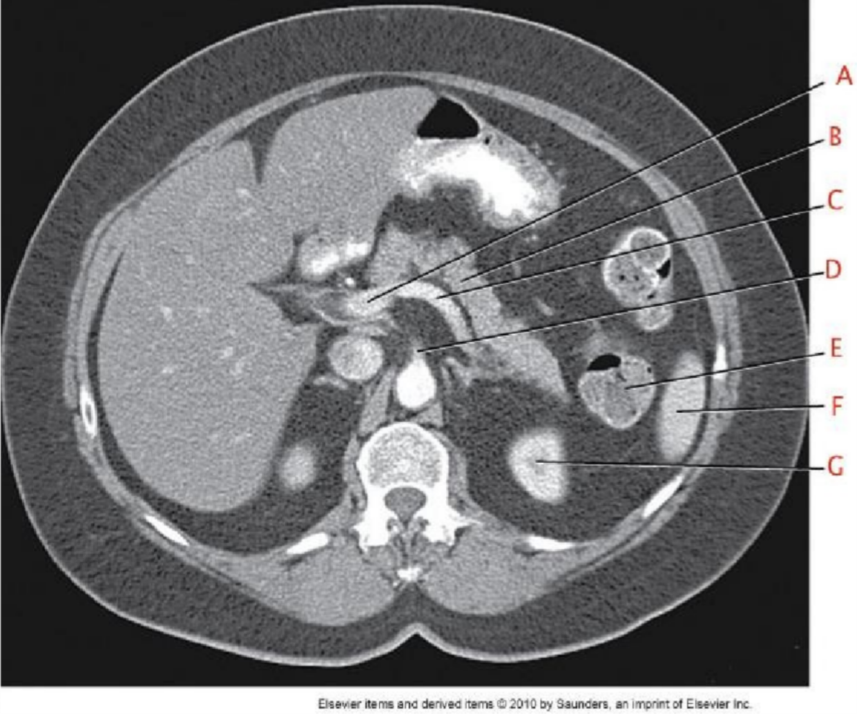

A.
B.
C.
D.
E.
F.
G.
H.

- Label the image:
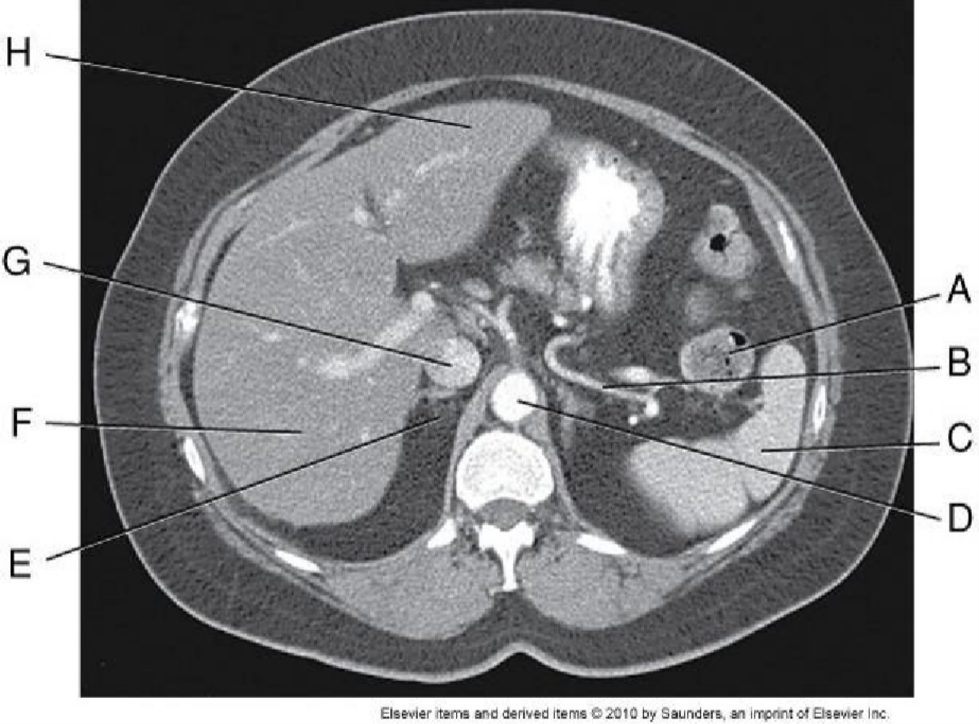

- What are the unique features that distinguish each type of vertebra?

- What special names are given to C1 and C2?

- What are the two parts of an intervertebral disc? Which is the inner portion and which is the outer portion?

- What is the purpose of curvatures in the vertebral column?

- At what level does the spinal cord terminate infereiorly? What structure(s) are present in the vertebral canal inferior to the spinal cord?

- What is in the subarachnoid space around the spinal cord?

- What type of tissue makes up the spinal cord?
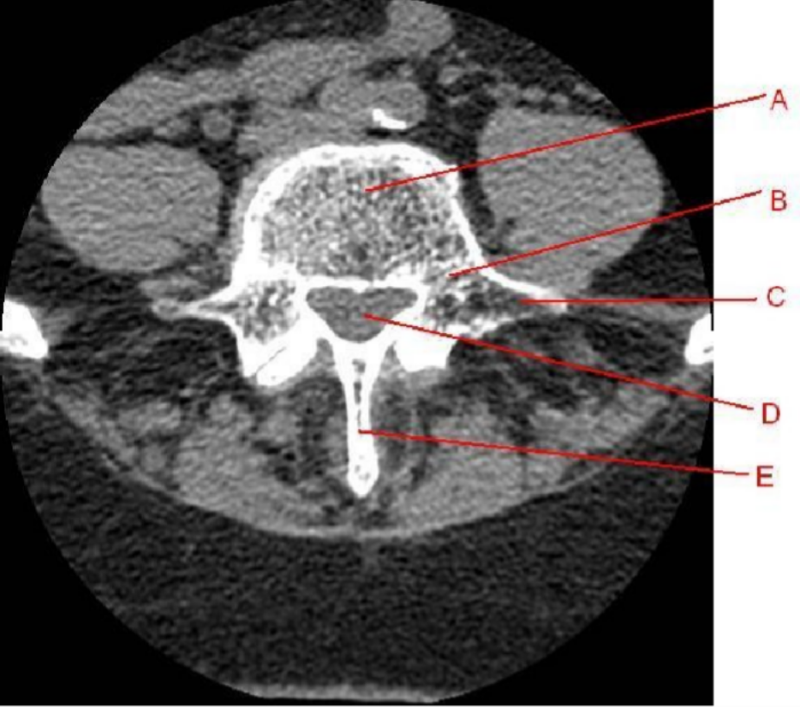
- A) Label the image:

B) In what plane is this image? What section of the spine is this? (C, T, L)?

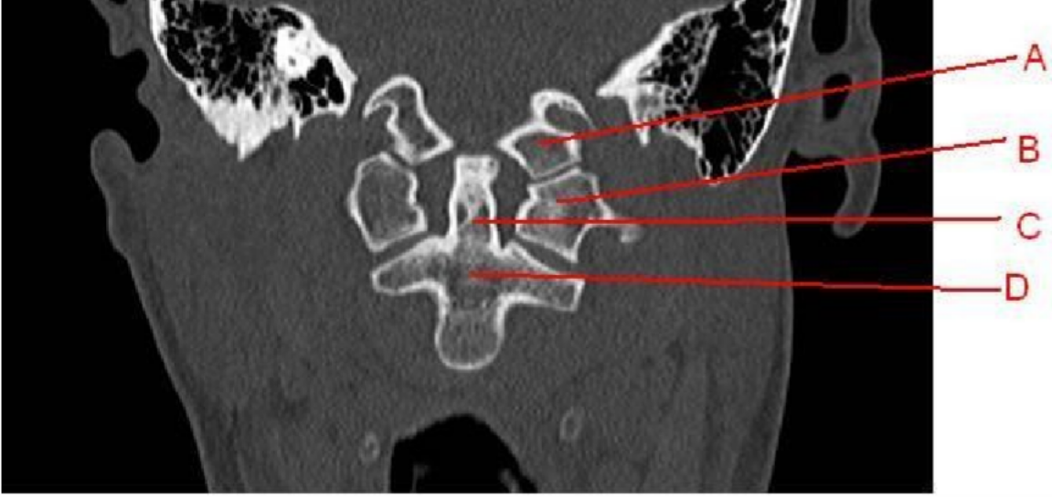
- Label the image:
A.
B.
C.
D.
- Label the image:

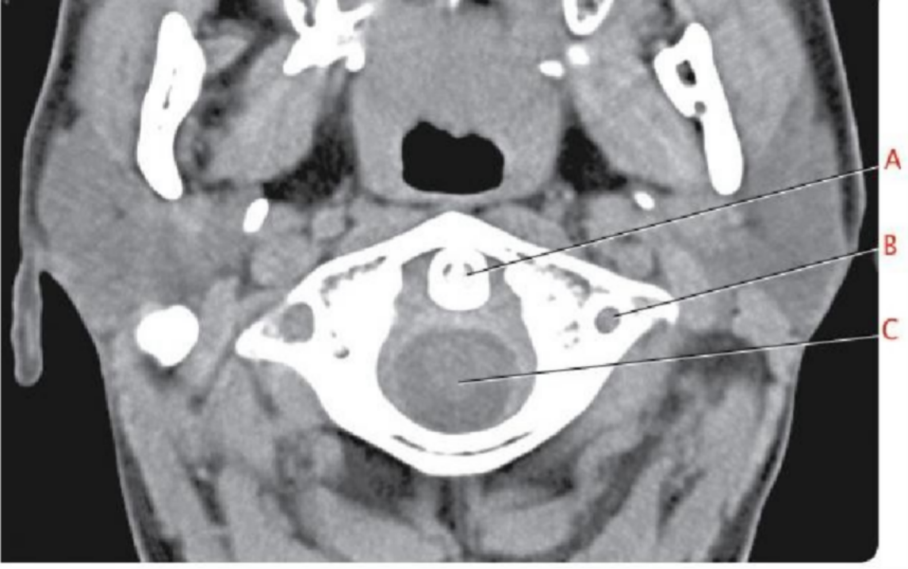
A.
B.
C.
- Label the image:
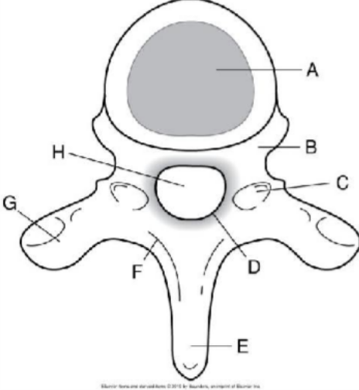

- Label the images:

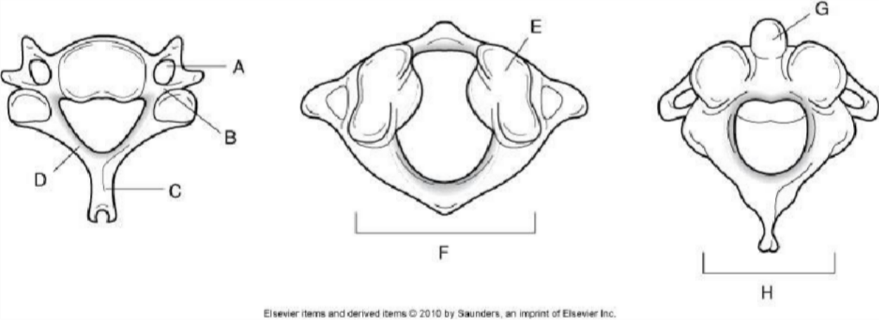

Part 2 – Procedures

- List at least 3 benefits of using oral contrast for a CT Abdomen & Pelvis.

- How much oral contrast should be given for a CT Abdomen & Pelvis?

- What low-attenuation contrast agents are commonly used for CT Abdomen & Pelvis? Describe their use.

- List at least 3 benefits of using IV contrast for a CT Abdomen & Pelvis.

- What is a routine, soft tissue window setting for a CT Abdomen & Pelvis?

- What is a liver window setting, and what will the setting demonstrate?

- What setting does the technologist control, that improves comparison to previous CT Abdomen & pelvis studies?

- What is the patient position for a CT Abdomen & Pelvis?

- List 4 common causes of involuntary motion artifact on CT Abdomen & Pelvis scans, and what can be done to minimize motion?

- What is the approximate CT number of a normal liver?

- Fatty infiltration of the liver attenuation of the liver.

- In what phase is fatty infiltration of the liver best demonstrated?

- Describe a hemangioma, and how it appears on CT.

- What is the contrast protocol for a RAP?

- What phase is a RAP scanned in, as described above?

- What is the IV contrast protocol for a multi-phase liver, and what phases are scanned? 125ml at 4ml/sec, with 50 ml saline flush.

- What is the IV contrast protocol for a multi-phase pancreas, and what phases are scanned?

- List 3 indications for a RAP.

- List 3 indications for a CAP.

- What is the main difference between a Routine CECT Abdomen & Pelvis, and a CECT Abdomen & Pelvis for appendicitis?

- List one indication (and an example of the clinical history) for an NECT Abdomen & Pelvis (or CT KUB).

- List 3 positive indications for an appendicitis on CT images.

- List the two most common indications for NECT spine examinations.

- Describe CT myelography

- List 2 indications for CT myelography.

- What anatomy should be included for a NECT cervical spine?

- What anatomy should be included for a NECT thoracic spine?

- What anatomy should be included for a NECT Lumbar spine?

- What SFOV should be used for CT spine?

- What is the advantage of performed helical scans of the spine?

- What are the bone window settings for CT spine?

- What mA setting is used for the cervical spine? Why?

- What is a contraindication for CT spine?

