INFC 215 – Infection Prevention and Control

Module Two: Interaction between Microbe and Host

Topic 2.5: Nosocomial Infections

Nosocomial Infection
Nosocomial infections are infections acquired during a stay in a hospital (HAI or hospital acquired infections) or other health care facility (HCAI Healtcare associated infections).
Accurate figures revealing the actual number of patients affected by nosocomial infections are hard to obtain. Most sources give the rate to be somewhere between 5 and 15% of hospitalized patients. The rates vary depending on the nature of the patient population. A pediatric hospital would have a different rate than a geriatric hospital.
According to the Canadian Patient Safety Institute, “In Canada, health care associated infections (HCAI) kill 8,000 – 12,000 people every year.” Therefore the CPSI has launched a hand hygiene program to reduce the number of deaths from Health care associated infections (nosocomial infections).

Factors contribute to nosocomial infections
Many factors contribute to nosocomial infections. These can be summarized under three categories.
- Hospital microorganisms: There tends to be a concentration of pathogenic bacteria in the hospital environment. Infected patients bring bacteria into the hospital with them. Warm, moist areas of hospitals perpetuate growth of bacteria. Often, only antibiotic resistant strains of bacteria survive in hospital environments, which makes the reservoir of bacteria potentially more dangerous.
- Immunodeficient (Immunocompromised) patient: Patients are in hospitals because they are sick and often do not have a fully-functional defence system. Treatments in hospitals often compromise the immune system and superficial defenses making the patient more susceptible to infection. A patient in an intensive care unit with a ventilator breathing for them is a prime candidate for a respiratory infection like ventilator assisted pneumonia (VAP), because the ventilator bypasses the normal defenses of the upper respiratory tract. Many of the drugs used to treat cancer weaken the defenses of the body to the extent that the patient may be infected with opportunistic pathogens.
The term immunodeficient replaces the term immunocompromised. Immunodeficiency occurs when a patient’s immune system is defective, and the B and T cells are unable or only partially able to respond to foreign substances such as bacteria, viruses and fungi. Immunodeficiency may either be congential (e.g., hypogammaglobulinemia) or acquired (e.g. HIV, renal failure). It may be temporary (chemotherapy for cancer, some drug therapies used for Rheumatoid arthritis) or life long (post organ transplant).
- Transmission: A number of factors related to life in a hospital contribute to transmission of pathogenic bacteria. Infected patients can easily disseminate pathogens to other patients because of the close proximity in hospital wards. Hospital staff visit multiple patients during a shift and pathogens are readily transferred by their activities. Many procedures in the hospital provide openings to normally protected areas. Needles, catheters, shunts and incisions all invite pathogenic bacteria into normally sterile areas.

Most common nosocomial infections
The most common nosocomial infections in order of occurrence are:
- Urinary tract infections: Usually related to bladder catheterization when fecal bacteria colonizing the urethra move up into the bladder. E.coli is frequently the causative agent.
- Surgical wound infections: Usually caused by Staphylococcus aureus introduced into the wound site during surgery or changing of dressings. The bacteria may come from hospital staff since many (up to 60%) are staph carriers, harboring these bacteria in their nasal passages with no sign or symptom of infection. (Note: Staphylococcus aureus is a different species than the staphylococci found as normal flora on the skin.) Some strains of Staphylococcus aureus have become resistant to many antibiotics and pose an expensive challenge for treatment.
- Pneumonia: Often in patients on a respiratory device. The mortality rate is much higher with this type of nosocomial infection.

Infections:
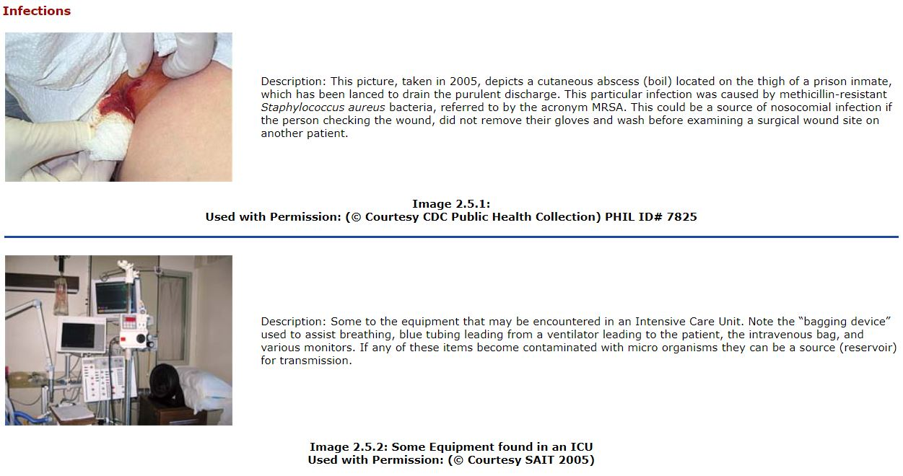
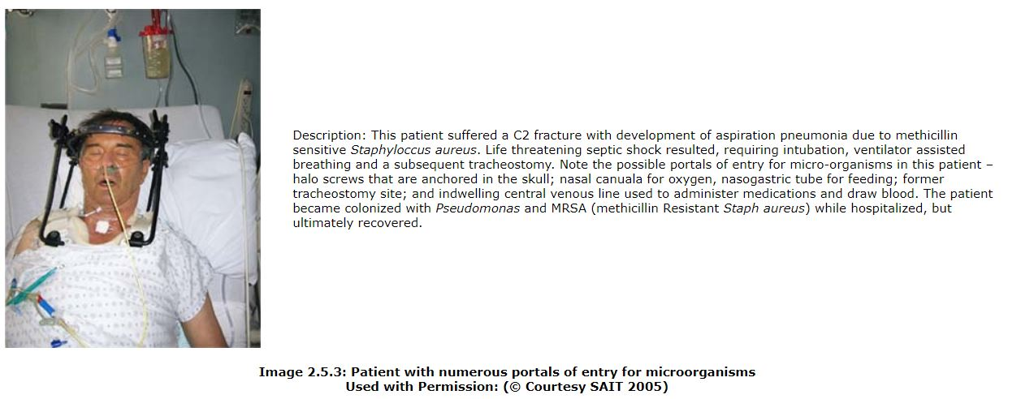
All health care workers should consider themselves to be potential staph (Staphylococcus aureus) carriers and use precautions to prevent transmission of the bacteria. Keep hands away from the nose and wash hands after coughing, sneezing or blowing the nose.

