ANPH 202 – Anatomy and Pathology 1
Worksheet – Review
Questions 1-20

- Which of the following is true regarding a hematocrit result of 55%?

  - The patient’s blood will be more viscous
  - The patient’s blood will be capable of carrying more oxygen
  - It is abnormally high and poses health risks
  - All of the above

- When a technologist shields the long bones of an infant during abdomen x-rays, they are trying to protect:

  - Epithelial tissue
  - Myeloid tissue
  - Lymphoid tissue
  - Muscle tissue

- All of the following are components of blood plasma except:

  - Fibrinogen
  - Na+
  - Erythrocytes
  - Water
- Which of the following components of blood plasma will help a patient ward off disease?

  - Electrolytes
  - Albumin
  - Fibrinogen
  - Globulins

- All of the following are made in myeloid tissue except:

  - Neutrophils
  - Eosinophils
  - Lymphocytes
  - Erythrocytes

- The three branches of the celiac trunk are:

  - Common hepatic artery, pancreatic artery, right gastric artery
  - Common hepatic artery, splenic artery, left gastric artery
  - Hepatic portal vein, pancreatic artery, right gastric artery
  - Superior mesenteric, inferior mesenteric, gastric artery

7 - 13. Using the chart below and image one below, number the following:

Right subclavian artery
Left subclavian artery
Right brachiocephalic artery
Abdominal aorta
Descending thoracic aorta
Aortic semilunar valve
Brachiocephalic artery
Left circumflex artery
Right common carotid artery
Left coronary artery

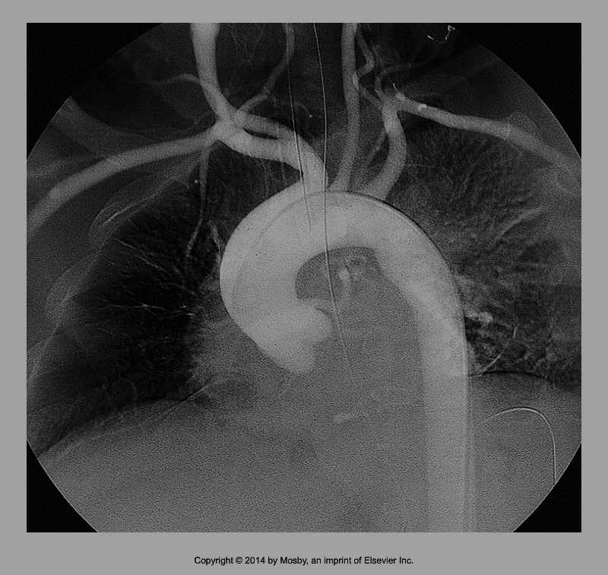

8

7

10
02
1
13
12
1
3
Image One

9

14 - 16. Using the chart below and image two below, number the following:

Right subclavian vein
Left subclavian vein
Right brachiocephalic vein
Left brachiocephalic vein
Brachiocephalic vein (only)
Right internal jugular
Left internal jugular
Right external jugular
Left external jugular
Superior vena cava
Image Two
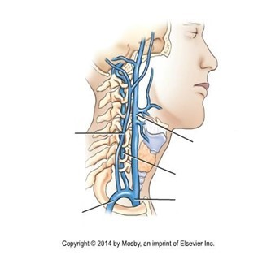

14

15
16

- Which of the following structures is most superior?

  - Celiac Trunk
  - Renal arteries
  - Superior mesenteric artery
  - Basilar artery

- “There is only one posterior communicating artery in the circle of willis”

  - True
  - False

- Which of the following vessels in most lateral when standing in anatomical position?

  - Brachial arteries
  - Common iliac artery
  - Renal arteries
  - External carotid arteries

- The popliteal artery is associated with the:

  - Ankle
  - Knee
  - Elbow
  - Shoulder

