Student marker information

Here are some suggestions:
This is a site from the USA: Penn-Jersey X-ray
Search on ETSY for local options
Prices vary! Shipping costs vary! Delivery timing varies!
Important to remember that we recommend ordering PLAIN and SMALL markers. It is recommended to order 2-4 sets of Left/Right with your student number, as well as arrow markers.

Here are some examples. Please verify that you are ordering markers with your student number found in ANDERSON.

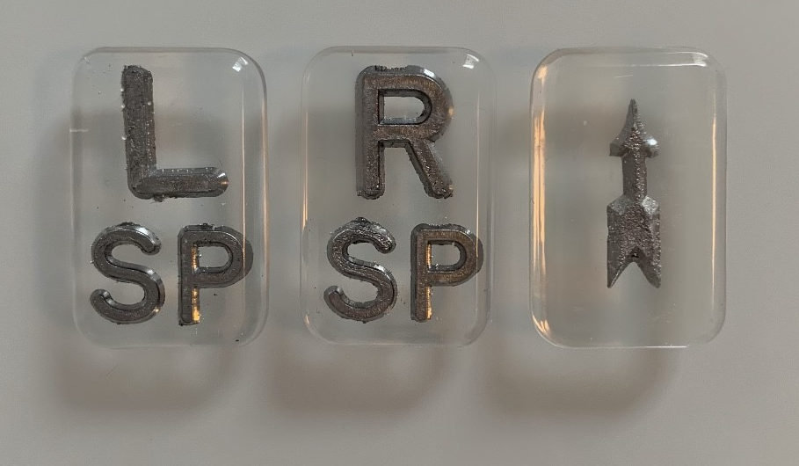

(These are 2.5cm x 1.6cm)

