Image Critique Questions

Module 10
- Use the images below to answer the next five questions:

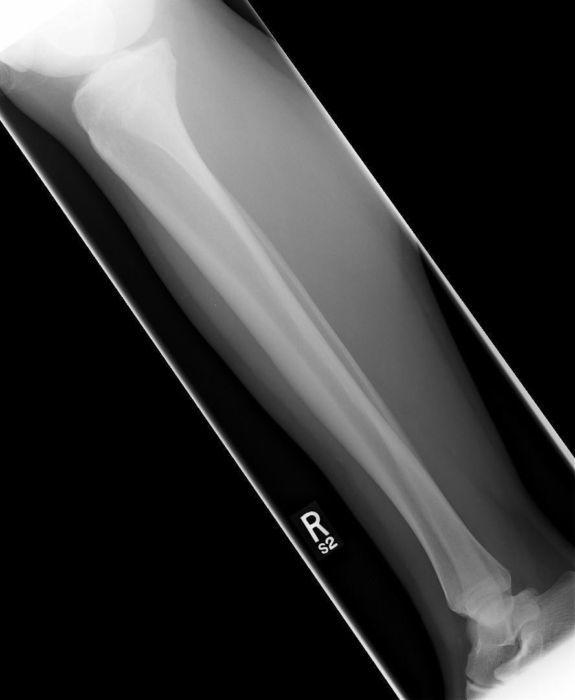
@ 70 kVp

- Which projection of the tibia & fibula (aka. lower leg) is displayed?
Lateral projection

- What positioning error(s) occurred?
  - Rotation

EDENBROOK Imaging library
- If the image was repeated, how would you correct the positioning error(s)?
  - Rotate the leg anteriorly (aka. externally; rolling the knee towards the IR)

- How did you identify the positioning error(s)?
  - Femoral condyles are not superimposed anteriorly-posteriorly
  - No interosseous space is evidenced between the fibula and tibia
  - The distal fibula is located too anteriorly on the distal tibia

- If the image had to be repeated, would you make any other adjustment(s)? Explain your rationale.
  - Center more posteriorly & decrease collimation (aka. expand light-field) anteriorly/posteriorly (side-side) to include all soft-tissue

- Use the 5 evaluation criteria categories when critiquing the following image to determine if it is diagnostic:

- Is all the required anatomy included in the radiograph? Yes No
*If no, explain what is required
Entire fibula (including lateral malleolus)

- Does the anatomical appearance in the radiograph correlate to what is expected from an AP projection?
Yes No
*If no, explain how the appearance of this radiograph is different compared to the ideal radiograph

- Identify if the appropriate amount of radiation was used to form the image.
Acceptable, Overexposed, Underexposed
  - Is motion present in the image?
Yes No
AP Tib/Fib @ 70 kVp

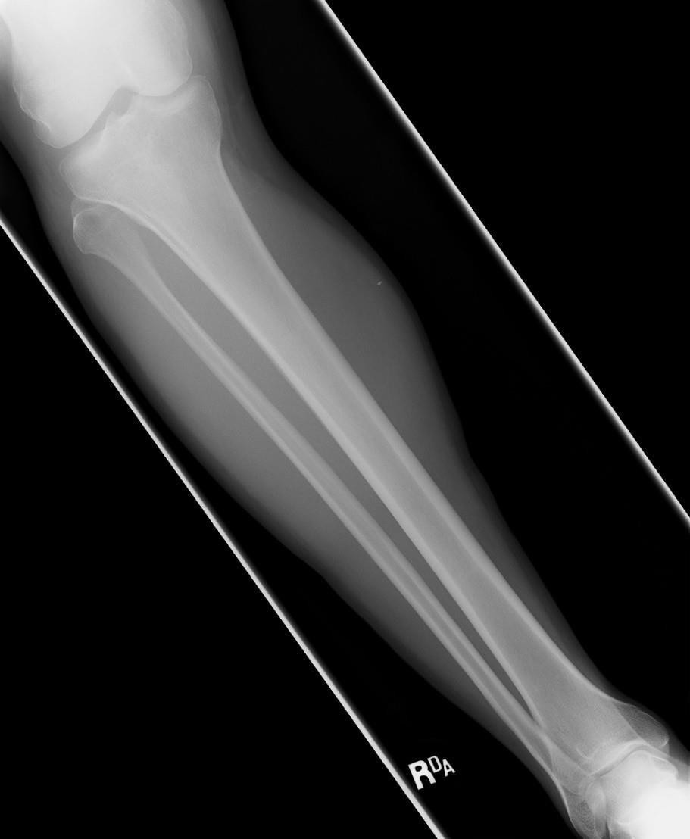
EDENBROOK Imaging library
Is this image diagnostic? Yes No

- Identify if the collimated light field was:
Acceptable, Too Small, Too Large
  - Was the CR close to the middle of the required anatomy?
Yes *however note the CR centering should be moved (very slightly) distally to ensure the lateral malleolus is included in the radiograph

- Does the marker placement follow Edenbrook’s Marker Rules? Yes No
  - Are there artifacts in the image? Yes No
*If yes, could they have been removed? Not likely, the very small white density appears to be inside the patient’s soft-tissue

- Use the 5 evaluation criteria categories when critiquing the following image to determine if it is diagnostic:

PA IC Fossa @ 70 kVp
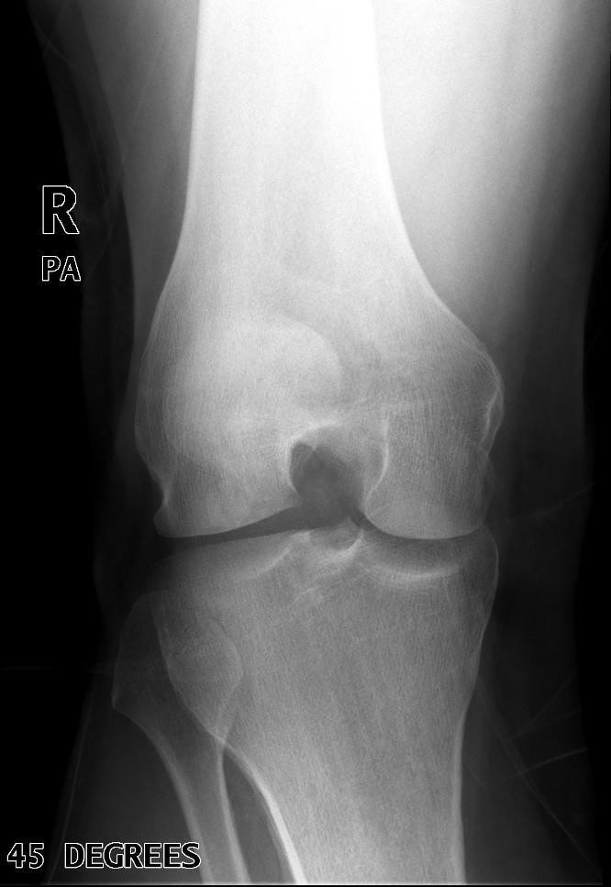
EDENBROOK Imaging library

- Is all the required anatomy included in the radiograph? Yes *excessive amounts No
*If no, explain what is required

- Does the anatomical appearance in the radiograph correlate to what is expected from a PA axial projection?
Yes No
*If no, explain how the appearance of this radiograph is different compared to the ideal radiograph
Slight lateral rotation evidenced by:
  - Asymmetric appearance of femoral condyles
  - Slight superimposition of patella over IC fossa
  - IC fossa not in profile

- Identify if the appropriate amount of radiation was used to form the image. Acceptable, Overexposed, Underexposed
  - Is motion present in the image? Yes No

Is this image diagnostic? Yes No

- Identify if the collimated light field was: Acceptable, Too Small, Too Large
  - Was the CR close to the middle of the required anatomy? Yes No *too superior/distal

- Does the marker placement follow Edenbrook’s Marker Rules? Yes No *lead anatomical marker is preferredover digital annotations
  - Are there artifacts in the image? Yes No
*If yes, could they have been removed? Patients should be given proper changing & gowning instructions to remove clothing that would appear over anatomy of interest

- Use the 5 evaluation criteria categories when critiquing the following image to determine if it is diagnostic:
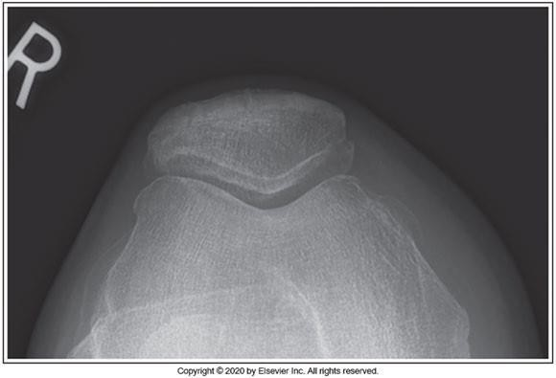
Seated Settegast @ 80 kVp
McQuillen Martensen 5th Ed. pg. 411 Fig. 6.43
Is this image diagnostic? Yes No
  - Is all the required anatomy included in the radiograph? Yes No
*If no, explain what is required
  - Does the anatomical appearance in the radiograph correlate to what expected from a tangential skyline patella projection?
Yes No
*If no, explain how the appearance of this radiograph is different compared to the ideal radiograph
    - The patellofemoral joint space is closed, indicating an incorrect CR angle was applied (i.e. CR angle was not parallel to the patellofemoral joint space)

  - Identify if the appropriate amount of radiation was used to form the image.
Acceptable, Overexposed, Underexposed
    - Is motion present in the image? Yes No

  - Identify if the collimated light field was: Acceptable, Too Small, Too Large
    - Was the CR close to the middle of the required anatomy? Yes No

  - Does the marker placement follow Edenbrook’s Marker Rules? Yes No
    - Are there artifacts in the image? Yes No
*If yes, could they have been removed?

