INFC 215 – Infection Prevention and Control

Module Two: Interaction between Microbe and Host

Topic 2.2: The Chain of Infection
There are three elements required for transmission of infection:
- A source of infectious microbes – the reservoir
- A means of transmission for the microbes
- A susceptible host
These three elements make up what is called the chain of infection. For an infection to occur, the chain must be complete. If the process is stopped at any point, infection can be prevented.

Figure 2.2.1
The susceptible host who becomes infected may then become the reservoir of microorganisms and the chain is repeated.
Sometimes the chain is illustrated as below. Notice the similarity to the biohazard symbol.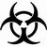

Figure 2.2.2: Chain of Infection
How do you break the chain of infection?
Breaking the chain of infection means stopping infections at the source, eliminating means of transmission, or reducing the susceptibility of potential hosts. Infection prevention and control programs are directed towards preventing transmission.
There are a number of methods of breaking the chain of infection. They will be discussed in detail in the following modules:
- Immunization and tuberculin testing
- standard precautions (routine practice) and isolation procedures
- PPE (personal protective equipment)
- Hand Hygiene
- Sterilization/disinfection/cleaning/waste disposal

Reservoirs of Infectious Microorganisms
There are three categories of reservoirs of infectious microbes:
- Human
- Animal
- Non-living

Human Reservoirs
The principle reservoir of human infectious disease is the human body itself. This includes people with disease and “carriers.”
The diagram below illustrates the most common reservoir (source) of human disease – other people.

Figure 2.2.3: Chain of Infection
Used with permission: (© Courtesy SAIT, 2000)
People with disease harbor thousands of microorganisms that are easily passed on to other people. Once a person has disease symptoms, care may be taken to prevent transmission of microorganisms, but there are often more infectious organisms present during the early stages of the disease when the person has no idea they are infectious.
Hepatitis A is a viral infection that initially involves the gastrointestinal tract before infecting the liver. As the virus multiplies in the gastrointestinal tract, millions of virus particles are excreted in feces, but the host has no disease symptoms. If the infected person does not wash his/her hands carefully after using the bathroom, the virus may be transmitted to other people. There are several records of a single food handler transmitting hepatitis A to over a hundred people before they knew they were infected themselves. Once the person has the symptoms of hepatitis, usually jaundice, they take more care with their personal hygiene, but the most infectious stage of the disease has passed.
The human reservoir also includes carriers. A carrier is defined as a person harbouring pathogenic organisms but with no signs of infection. The classical example is a typhoid carrier. This is a person who has usually had typhoid and recovered, but some of the typhoid bacteria have remained in the body, often in the gall bladder. These bacteria are excreted sporadically in the feces where they may directly infect another person or contaminate water supplies.

The Saga of Typhoid Mary
One of the most famous carriers of all times was Mary Mallon who became known as Typhoid Mary.
1901 | Mary Mallon worked as a cook for a New York family. Following the arrival of a visitor with typhoid fever, Mary, and later the laundress, also became ill.
1902 | Mary changed employers. Seven members of the household developed typhoid.
1903 | Mary moved to Ithaca, New York, where she is believed to be responsible for a typhoid outbreak, which killed 1,300 people.
1904 | Mary moved to Long Island, where within three weeks four fellow servants became ill.
1906 | Mary moved twice. Eight new cases and one death.
1907 | Using a false name, Mary started work as a cook in New York City. Two family members develop typhoid with one of them dying. The health department tracked her down. She refused to cooperate with officials who wanted to have her stool tested for the organism. Police forcibly took her to a hospital on an island in the East River for testing, which revealed that she harboured the organism in her gall bladder, and shed it in her stool. Mary did not believe in the germ theory of disease and so refused to have her gallbladder removed, as she was sure that she would die during surgery. She was sentenced to involuntary isolation in the hospital.
1907-10 | Her stool samples were tested every few days, while some cultures were negative, others contained huge numbers of typhoid bacilli. Mary became a media celebrity, as she was held against her will.
1910 | Using an assumed name, she gained employment at a hospital. Twenty-five cases of typhoid resulted in eight deaths of mostly doctors and nurses. Health authorities returned her to the island hospital, where she immediately volunteered to work in the kitchen, as cooking was the only job that she liked. Mary steadfastly refused to have gall bladder surgery. As antibiotics were still not available, she remained in quarantine for the rest of her life.
1938 | Mary Mallon died of a stroke.
Reference: Black, Jacquelyn G, Microbiology, 5th Edition, Principles and Explorations, John Wiley and Sons, 2002

Infection Sources of a Typhoid Outbreak:

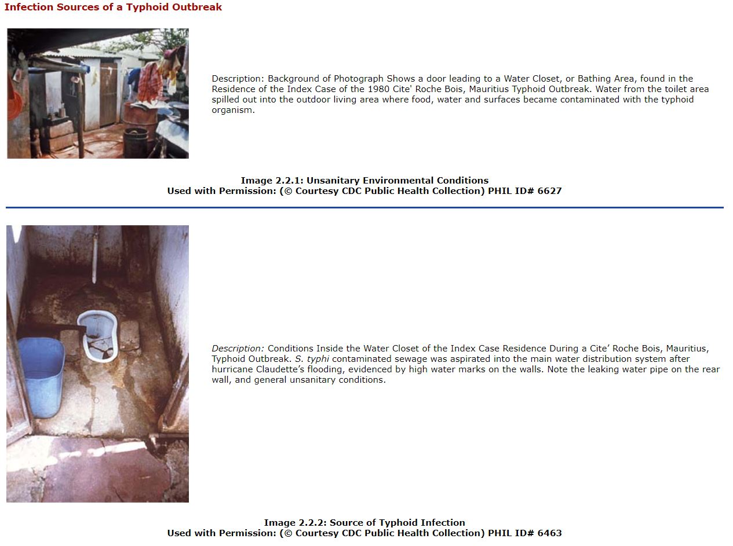

Animal Reservoirs

Figure 2.2.4: Rodents such as mice may carry infectious microorganisms
Used with permission: (© Courtesy SAIT, 2000)
Both wild and domestic animals may serve as the reservoir of infectious organisms for humans. Diseases that are primarily found in animals but may be transmitted to humans are called zoonoses.
Animals play an important role in Salmonella infections where the animal is usually poultry and man is infected by ingestion of improperly cooked poultry.
Other examples of zoonoses are the Hanta virus carried by deer mice and rabies carried by dogs, racoons and other wild animals.
Zoonoses Related Infection Sources:
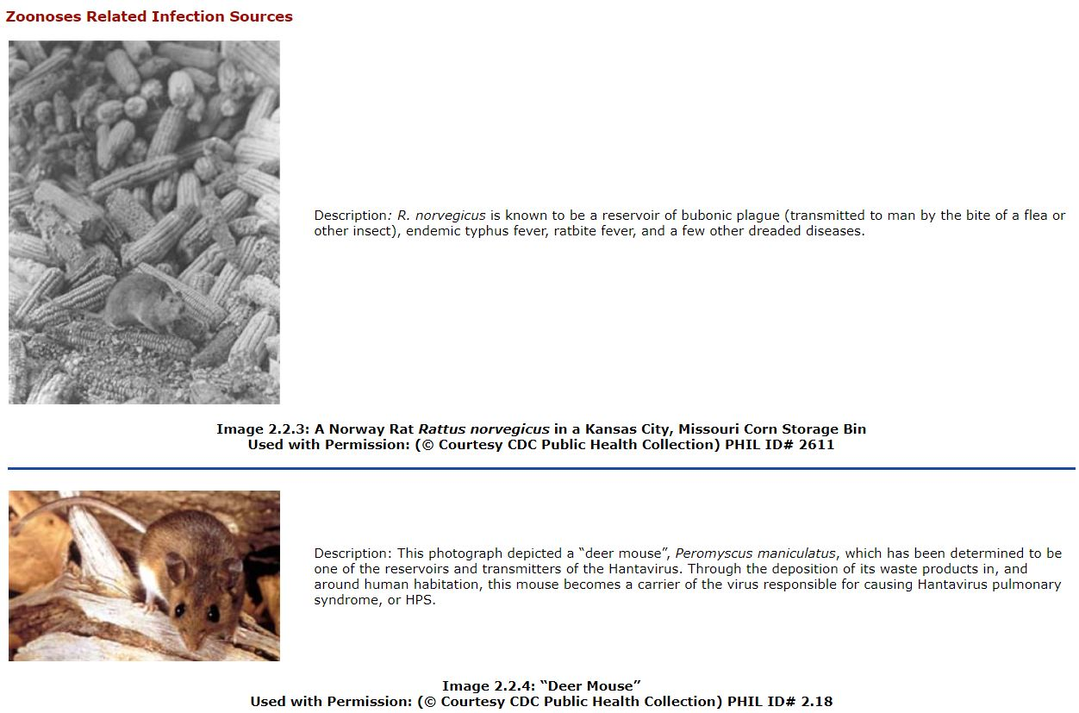
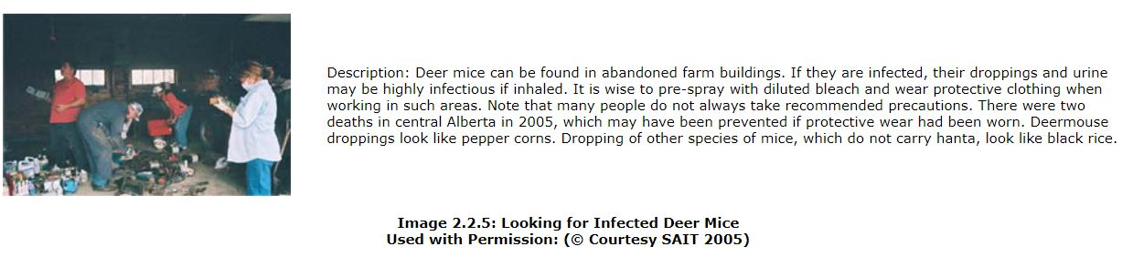
Many diseases are transmitted by carriers. Some examples include streptococcal sore throat, AIDS, hepatitis B and diphtheria. The carrier does not harbor as many infectious microorganisms as the infected person, but is often more dangerous because they might not know that they are carrying dangerous microorganisms.
The term “carrier” may be extended to include the incubation period of a disease where the person has the infectious organisms but shows no disease symptoms.
Once the person has recovered from a disease they may still be carrying infectious organisms. This person is called a convalescent carrier. If they are still carrying the organisms after six months, they are called a chronic carrier.

Non-Living Reservoirs
Soil and water contain a variety of microorganisms, but few of these are capable of causing disease. Two notable exceptions are botulism and tetanus. The spores responsible for both of these diseases are found in soil but simple contact with soil will not result in disease.
Botulism is a type of food poisoning and the spores must first grow in a food and produce toxin before disease results. Tetanus only results when spores are introduced into human tissue under conditions where there is little or no oxygen present. This oxygen-free environment is necessary for the spores to germinate in human tissue.
The non-living reservoirs of health care facilities are of concern to health care workers. Bacteria will grow in most moist environments in these institutions and may become important reservoirs of bacteria responsible for hospital acquired infections. Leaking drain pipes, wet equipment, therapy pools and sinks have all been identified as sources of infectious bacteria. Flowers are not allowed in some areas of the hospital because the water may be a source of infectious organisms. The bacteria called Pseudomonas aeruginosa, may be found normally in the environment in soil, water or on plants It does not usually cause a problem. However, if it makes its way into a health care facility, where it is warm and moist, patients with compromised immune systems may develop life threatening infections. Pseudomonas is resistant to a wide range of antibiotics, so is difficult to treat.
Skin rashes may also result from exposure to large numbers of organisms that may be found in untended recreational hot tubs. It is wise to shower with a soap that lathers well following a soak in a hot tub to remove any potentially contaminating organisms.

Pseudomonas related infections:

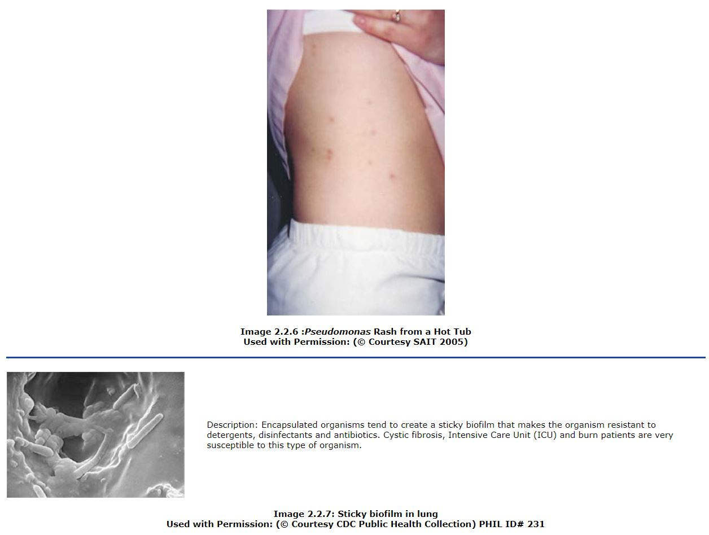

Transmission of Infectious Microbes
The causative agents of disease can be transmitted from the reservoir to a susceptible host by three principle routes: contact, vehicle and vector.

Contact Transmission
Contact transmission includes the spread of microorganisms by direct contact, indirect contact and droplet transmission.

Figure 2.2.5
Used with permission: (© Courtesy SAIT, 2000)
In direct contact transmission shown in the drawing above, there is direct physical contact between the reservoir and the host. There is no intermediate object involved and for this reason person-to-person transmission means the same thing. Touching, kissing and sexual intercourse are the usual forms of direct contact transmission. Many diseases such as colds, flu, streptococcal sore throat and gonorrhea are transmitted this way.

Figure 2.2.6
Used with permission: (© Courtesy SAIT, 2000)
Indirect contact transmission, shown in the drawing above, occurs when the infectious agent is transferred from the reservoir to a non-living object, or fomite, and then to the susceptible host. Bedding, towels, eating utensils, diapers, toys, syringes, endoscopes, uncovered knobs and handles in dental offices, thermometers and contaminated tissues (Kleenex) are fomites that may be involved in direct transmission of infectious agents in the health care setting. An example would be the transmission of colds – a person coughs on their hand, touches something, second person touches same item and spreads the virus to their own mucous membranes. Hepatitis B can be spread via dried blood to a cut on a second susceptible person.

Figure 2.2.7
Used with permission: (© Courtesy SAIT, 2000)
Droplet transmission as shown in the drawing above is transmission in which the infectious microbes are contained in mucus droplets discharged from the respiratory tract of the reservoir. These relatively large particles only travel one metre or less from the reservoir and the person being infected must be in close proximity. Colds, the flu, Staphylococcal pneumonia, and whooping cough are spread this way.
The definition indicating that droplets fall within one meter is currently under review (2009). The distance may increase to two meters for this definition, as the one meter rule was based on information from an informal study done in 1922.
In June 2009, Health Canada instructions for the H1N1 swine flu outbreak indicate that a surgical procedure mask used for droplet precautions be used if working within 2 meters of a patient. N 95 masks are indicated for coughing patients and aerosol producing procedures such as suctioning.
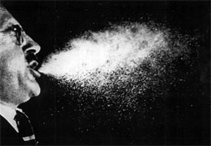 | Description: Note the large particles within one – two meters of the mouth.
Image 2.2.8: Used with permission: (© Courtesy SAIT, 20196800)

Vehicle Transmission

Figure 2.2.8
Used with permission: (© Courtesy SAIT, 2000)
Vehicle transmission, shown in the drawing above, refers to the transmission of infectious microbes by an agent such as food (e.g., unwashed, contaminated foods such as fruit and vegetables), water, air, blood or medication. The “vehicle” keeps the microbe alive until it is ingested or inoculated by another host. It is common for several people to be infected at the same time. It is uncommon in the clinical setting. It usually occurs in the community.
Hepatitis A and Salmonella are transmitted through contaminated foods.
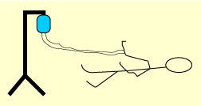
Figure 2.2.9
Used with permission: (© Courtesy SAIT, 2000)
Vehicle transmission occasionally occurs in health care facilities when an intravenous solution, blood or medication becomes contaminated. The transmission of AIDS to hemophiliacs by contaminated blood products is a tragic example of vehicle transmission.
Airborne transmission involves mucus droplets that travel further than one metre from the reservoir (2010 – definition may be altered). They are tiny particles that contain the microorganism and remaining suspended in the air for a long period time and float great distances on air currents are called droplet nuclei. Few diseases are actually transmitted by droplet nuclei, but tuberculosis is often spread by this method of transmission. Severe acute respiratory syndrome (SARS) is another example of airborne transmission via droplet nuclei.
Although droplet nuclei are too small to be seen, you can imagine them if you think of seeing dust particles floating in the air in a sunbeam.

Vector Transmission
Vectors are insects that carry infectious organisms from one host to another. Malaria spread by mosquitoes, Rocky Mountain spotted fever spread by ticks and West Nile virus spread by mosquitoes are examples.

Figure 2.2.10
Used with permission: (© Courtesy SAIT, 2000)
Vector transmission should not be a mode of transmission encountered in modern health care facilities although patients treated in hospitals may have been infected by vectors.
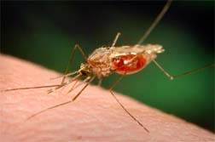 | Description: The Anopheles funestus mosquito, which along with Anopheles gambiae, is one of the two most important malaria vectors in Africa, where more than 80% of the world's malarial disease and deaths occurs. Humans infected with malaria parasites can develop a wide range of symptoms. These vary from asymptomatic infections, i.e., no apparent illness, to the classic symptoms of malaria including fever, chills, sweating, headaches, muscle pains, to severe complications such as cerebral malaria, anemia, and kidney failure, and even death. The severity of the symptoms depends on several factors, including the species of infecting parasite, and the infected human’s acquired immunity and genetic background.
Image 2.2.9: Anopheles Funestus Mosquito Partaking in a Blood Meal from its Human Host
Used with Permission: (© Courtesy CDC Public Health Collection) PHIL ID# 7192

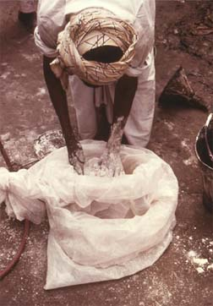 | Description: When applied in accordance with the rate of application and safety precautions specified on the label, malathion can be used to kill mosquitoes, and other pathogen vectors without posing unreasonable risks to human health or the environment. This is an example of an unsafe work practice.
Image 2.2.10: A Pakistani Malaria Control Worker mixing Malathion Spray Powder without covering his exposed skin in 1976
Used with Permission: (© Courtesy CDC Public Health Collection) PHIL ID# 5353

Susceptible Host
Host susceptibility determines whether an encounter with an infectious microbe will result in disease. Host susceptibility is influenced by a number of factors including age, health and immune status of the individual, as well as the dose of the infectious agent to which the individual is exposed.
- Newborns whose immune systems are not fully developed and the elderly whose immune systems are not functioning properly are more susceptible to infection.
- A person’s resistance to infection is impaired by factors such as poor nutrition, alcoholism, pre-existing infection and underlying disease.
- Therapeutic measures such as chemotherapy, radiation and antibiotics alter the immune status of the individual.
- Procedures such as surgery, anesthesia and insertion of catheters can also leave a person more susceptible to infection.
- The infectious dose, or number of organisms required to establish an infection, will vary with the microbe. The infectious dose for Salmonella bacteria is about 100,000 organisms; for Shigella (bacteria that cause dysentery), the infectious dose is much lower - somewhere between 10 and 100.
An individual who has received a vaccination against a disease-causing microbe, or someone who has recovered from a particular infection, will have produced antibodies against the pathogen and will be a less susceptible host on subsequent exposures to the micro-organism.

Portals of Entry for Infectious Microorganisms
Once an infectious agent reaches the new host, there are specific portals that allow entry. Not all pathogens enter the host via the same route. Microorganisms may gain access to the body through the skin, mucous membranes and the placenta, or by the parenteral route.

Skin
Very few organisms are able to gain entry to the body through the intact skin. However, microbes can penetrate:
- Via hair follicles or sweat glands (e.g., boils and styes)
- If the skin is excessively moist (e.g., infected diaper rash). Children are generally more prone to infections due to the delicate nature of their skin.
- If the skin is broken as a result of trauma injury, surgical incision or a simple abrasion (e.g., eczema - the disruption in the skin as a result of this condition predisposes to infection, particularly with Staphylococcus aureus)
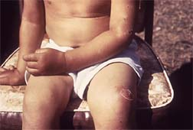 | Description: Impetigo is usually caused by Group A Streptococcus sp. or Staphylococcus aureus bacteria, and is highly contagious, able to be spread about ones own body merely through contact with the skin lesions, and their discharge.
Image 2.2.11: A Child With Maculopapular Lesions that Proved to be Impetigo, a Bacterial Skin Infection
Used with Permission: (© Courtesy CDC Public Health Collection) PHIL ID# 5155

Mucous Membranes
The mucous membranes that serve as portals of entry include those that line the respiratory, gastrointestinal and genital tracts. Each mucous membrane has its own set of microbes capable of entering by that route. For example:
- Influenza virus gains entry to the body via respiratory mucosa.
- Hepatitis A virus gains entry through the gastrointestinal tract.
- Organisms causing sexually transmitted infections (diseases) (STIs formerly called STDs) such as herpes, chlamydia, hepatitis B and AIDS gain entry through the genital mucosa.

Placenta
The placental membrane provides a filter for mother's blood entering fetal circulation and very few microorganisms are able to pass this barrier. There are a few notable exceptions including rubella virus (German measles) and the viruses causing hepatitis B and AIDS.

Parenteral Route (think POKE)
The term parenteral means introduction of something into the body by a route that bypasses the gastrointestinal tract. The parenteral portal of entry for infectious organisms includes intravenous or intramuscular injection of contaminated solutions. Punctures, bites, cuts, surgical wounds and trauma injuries all allow entry of microorganisms by the parenteral route.

