Activity: Test 14 Lead Apparel Testing Calculations/Evaluation

Purpose
This activity will provide you with practice in viewing lead apparel to determine if it passes evaluation and meets the standards for use. This test is typically done fluoroscopically.

Instructions
- Review the images below.
- The images would be evaluated to determine if the lead apparel is acceptable for use.

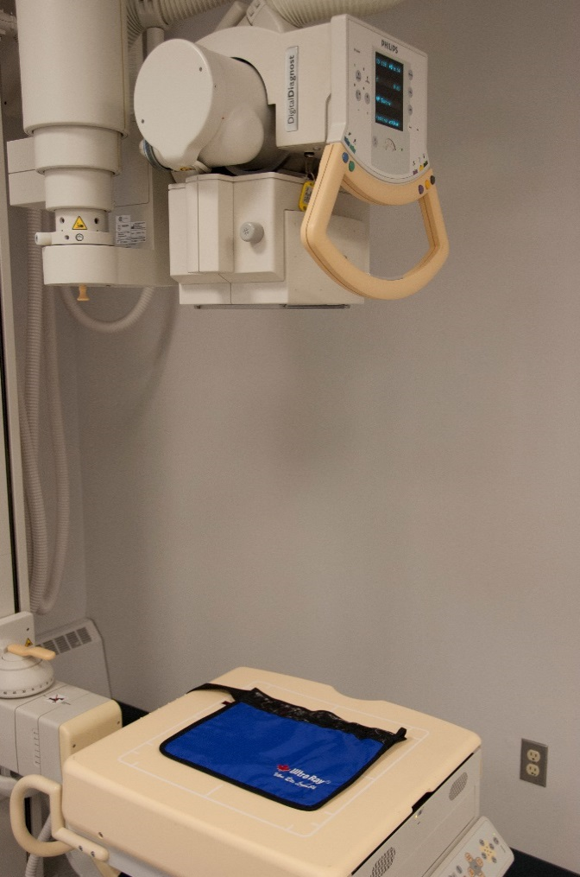

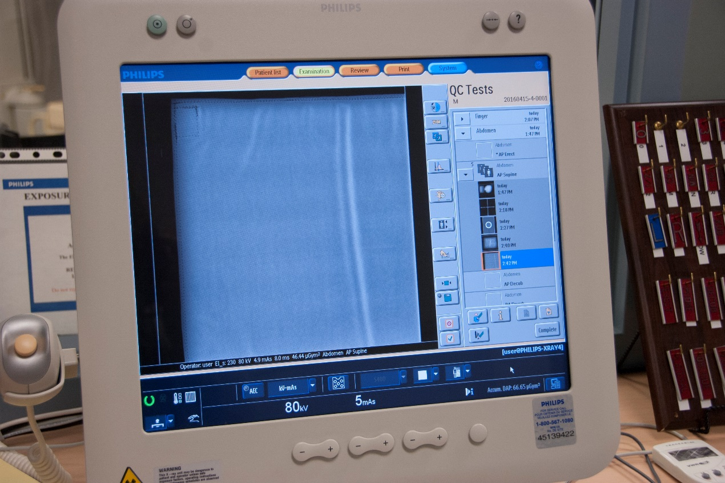

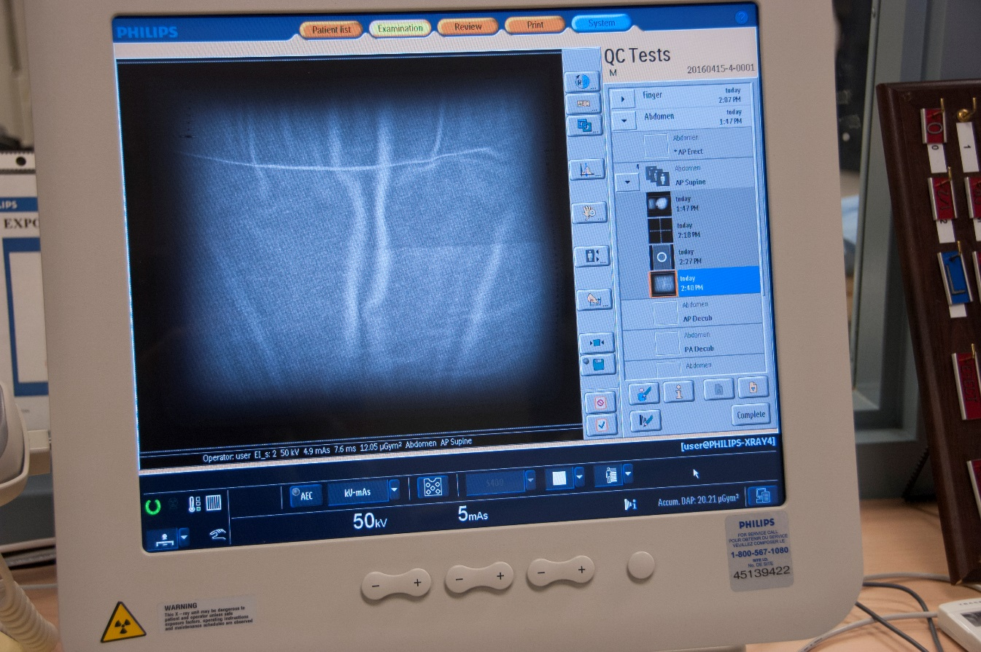

Sample Evaluation
- On each image, check for areas of increased radiographic density which may indicate holes, cracks or wear. A description of the damaged areas needs to be documented.

- When determining the pass/fail of each item, take into consideration the size and location of the defects. A defect on the very edge of a lead apron may not require immediate replacement, whereas a crack through the middle (in the abdominal or gonadal region) would require the apron to be removed from usage.

- Record all results on either a data table (as used by EDENBROOK) or any method utilized by the individual department.

Sample Chart
Lead | # | kVp | mAs | Lead/mm | P\F | Comments
Apron |  | 80 | 5
Apron |  | 80 | 5
Apron |  | 80 | 5
½ Apron |  | 80 | 5
Hang. Apron |  | 80 | 5
Glove |  | 80 | 5
Glove |  | 80 | 5
Lead sheet |  | 76 | 5
Lead sheet |  | 76 | 5
Lead sheet |  | 76 | 5
Lead sheet |  | 76 | 5

