MRAD 302: Specialized Imaging 2

Mammography

Mammography

Learning Outcome
Analyze a mammographic procedure.

Introduction
Breast cancer is one of the leading causes of cancer-related deaths in Canadian women. Evidence shows that although there is a higher rate of breast cancer detection, the number of deaths reported is in decline. The earlier breast cancer is detected, the greater the chance of survival.

Mammography has evolved into one of the most critical and demanding x-ray examinations performed. Mammography examinations are highly dependent on the knowledge and skills of a mammographer. A mammographer is a technologist who has undergone further training in mammography. Accurate and careful positioning of the breast is imperative in mammography and in diagnosing breast cancer. The maximum amount of breast tissue must be demonstrated on each projection.

Mammographic images must be characterized by optimum contrast and high resolution, and they must contain no artifacts that may potentially obscure any pathology.

Throughout this module, you will learn about breast anatomy, dedicated mammographic x-ray units, pre- and post-examination counsel and care, the importance of recording a thorough patient history, contraindications, screening versus diagnostic mammographic exams, basic positioning and other modalities used to detect breast cancer and other medical conditions. You will also view mammography images and evaluate for overall image quality.

Please note: As an entry level technologist, you will not have the skill set or theory to do mammography, but you should have an understanding of the modality in order to be able to assist in an examination. Specialized training and accreditation is required to become a practicing mammographer.

Understanding the Gross Anatomy, Relational Anatomy And Physiology of the Breast
Breast anatomy varies greatly from individual to individual and often within the same woman depending on her age and hormone levels. However, the average breast extends from the anterior portion of the second rib (clavicle) down to the 6th or 7th rib (mid sternum) and from the lateral border of the sternum into the axilla.

Each breast is made up of 15–20 lobes which are covered by adipose tissue.

Surface Anatomy
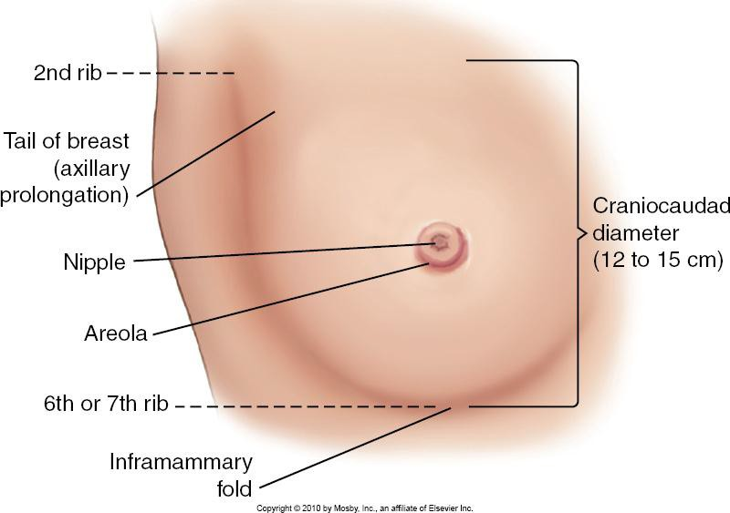
Figure 1: Surface Anatomy of Breast
Source: Textbook of Radiographic Positioning and Related Anatomy, Bontrager & Lampignano. © 2013, Mosby Elsevier. Used with permission.

Using the diagram above identify and describe the following:
- Inframammary fold (IMF)
- Axillary tail
- Mediolateral diameter
- Craniocaudal diameter
- Tail of the breast
- Nipple
- Areola

Question:
- What is the most common site for breast cancer?

Sagittal Section
This diagram demonstrates the relationship of the mammillary gland to the underlying structures of the chest wall.

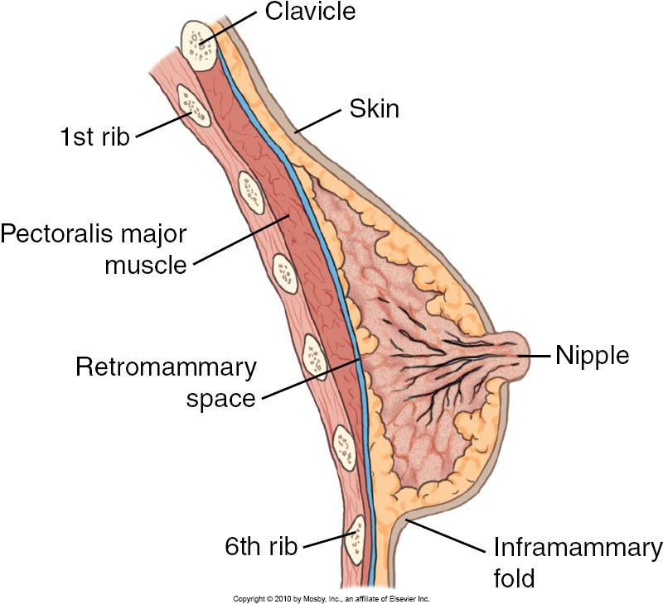
Figure 2: Sagittal Section of Breast
Source: Textbook of Radiographic Positioning and Related Anatomy, Bontrager & Lampignano. © 2013, Mosby Elsevier. Used with permission.

Using the diagram above identify and describe the following structures:
- Pectoralis muscle
- Retromammary space
- Glandular tissue
- Adipose tissue

Question:
- Why is it important to demonstrate on at least one image all of the retromammary space?

Methods of Localization

Quadrant Method

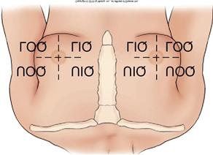
Figure 3: Quadrant Localization Method
Source: Textbook of Radiographic Positioning and Related Anatomy, Bontrager & Lampignano. © 2013, Mosby Elsevier. Used with permission.

- Easiest to use for generalized lesion location
- Nipple is the centre point of the four quadrants
- UOQ - Upper Outer Quadrant
- UIQ - Upper Inner Quadrant
- LOQ - Lower Outer Quadrant
- LIQ - Lower Inner Quadrant

Clock System
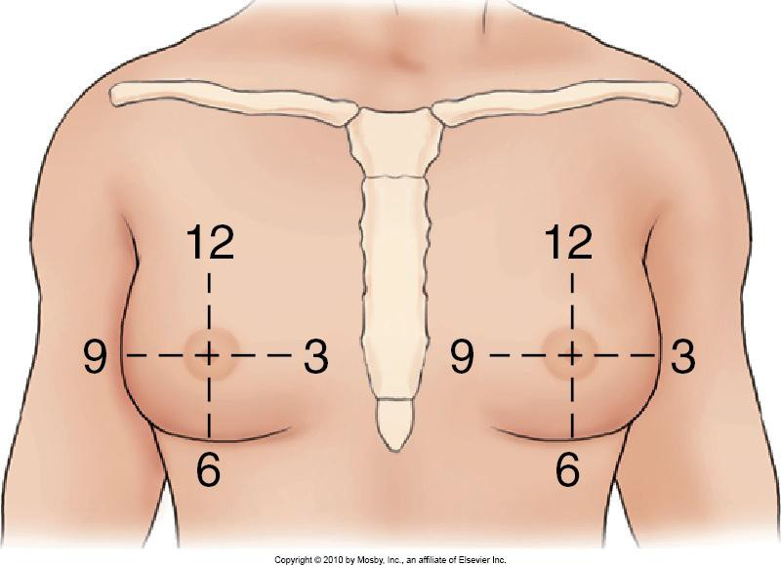
Figure 4: Clock System of Localization
Source: Textbook of Radiographic Positioning and Related Anatomy, Bontrager & Lampignano. © 2013, Mosby Elsevier. Used with permission.

- Compares surface of breast to the face of a clock
- More accurate description of location of a lesion
- What is described as 3 o’clock in the right breast has to be described as 9 o’clock in the left breast

One of these two systems will be used by the referring physician to describe a special area of interest to radiology personnel.

Questions:
- If you were to receive a requisition that stated there was a palpable mass in the left breast at 4 o’clock, that would correspond with o’clock in the right breast.
- In which quadrant of the left breast would the 7 o’clock position be located?

Frontal View Anatomy

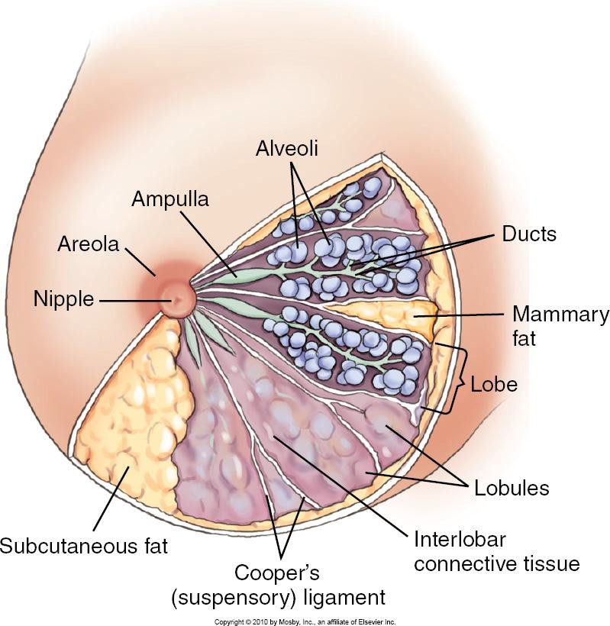
Figure 5: Frontal View of Breast Anatomy
Source: Textbook of Radiographic Positioning and Related Anatomy, Bontrager & Lampignano. © 2013, Mosby Elsevier. Used with permission.

Using the diagram above, identify and describe the following:
- Glandular tissue
- Glandular lobes
- Alveoli
- Ducts
- Cooper’s ligaments
- Trabeculae

Question:
- How do veins of the mammary glands differ from arteries of mammary glands?

Breast Tissue Types
One of the challenges associated with imaging the breast radiographically is that the various tissues have low inherent subject contrast or breast tissue “make up.”

The three main types of breast tissue are:
- Glandular - higher density (appears lighter)
- Fibrous or Connective - higher density (appears lighter)
- Adipose (Fatty) - lower density (appears darker as various shades of grey)

The fibrous and glandular tissues absorb radiation in a similar fashion, which make differentiating between them challenging.

The major difference between the three is that fatty or adipose tissue is less dense than the other two and accounts for the contrast differences that are apparent on the final image.

Note the difference in tissue density in the image provided below:
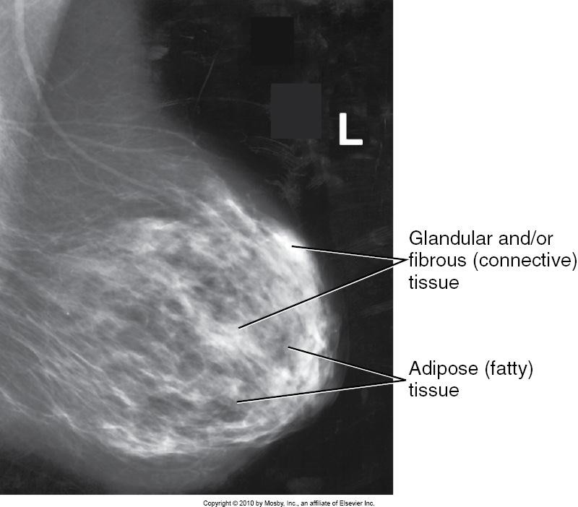
Figure 6: X-ray Image of Breast Tissues
Source: Textbook of Radiographic Positioning and Related Anatomy, Bontrager & Lampignano. © 2013, Mosby Elsevier. Used with permission.

Breast Classifications
In mammography, exposure factors depend on the following two factors:
- Compressed breast thickness
- Tissue density

Relative breast density is affected primarily by patient’s genetics, hormone status, age and number of pregnancies, and can be categorized into three broad categories depending on the relative amounts of fibro-glandular versus adipose (fatty) tissue.

There are three categories of breast density:
- Fibro-glandular breast
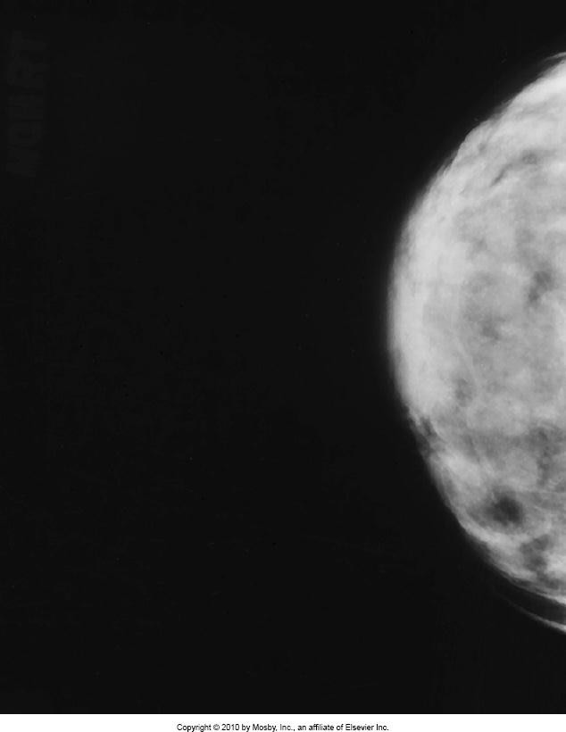
Figure 7: X-ray Image of Fibro-glandular Breast
Source: Textbook of Radiographic Positioning and Related Anatomy, Bontrager & Lampignano. © 2013, Mosby Elsevier. Used with permission.

  - Younger breasts are usually quite dense.
  - Common age group is post-puberty to about age 30.
  - Those over 30 who have never given birth will also be in this general grouping, as would lactating or pregnant women.
  - Genetics may also play a factor.
  - Compression can be very uncomfortable.
- Fibro-fatty breast
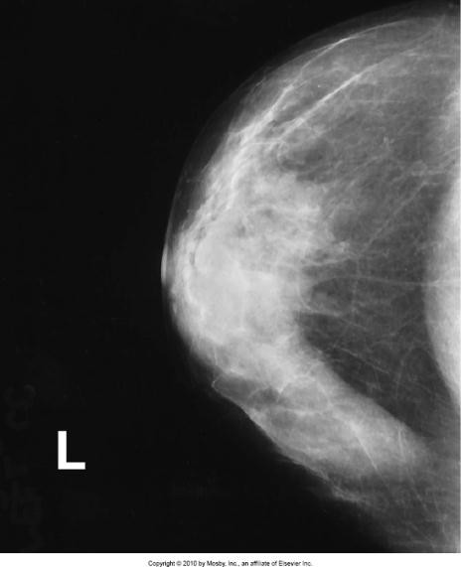
Figure 8: X-ray Image of Fibro-fatty Breast
Source: Textbook of Radiographic Positioning and Related Anatomy, Bontrager & Lampignano. © 2013, Mosby Elsevier. Used with permission.

  - Low amount of fatty tissue shifts to a more equal distribution of fat and fibro- glandular tissue.
  - Breast is not quite as dense as in the younger group.
  - Common in ages 30–50.
  - Breast is of average density and requires less exposure than fibro-glandular breast tissue.
  - Produces a better radiographic contrast because of the more equal distribution between the two tissue types.
  - Several pregnancies in early life can accelerate breast conversion to the fibro-fatty category.

- Fatty breast
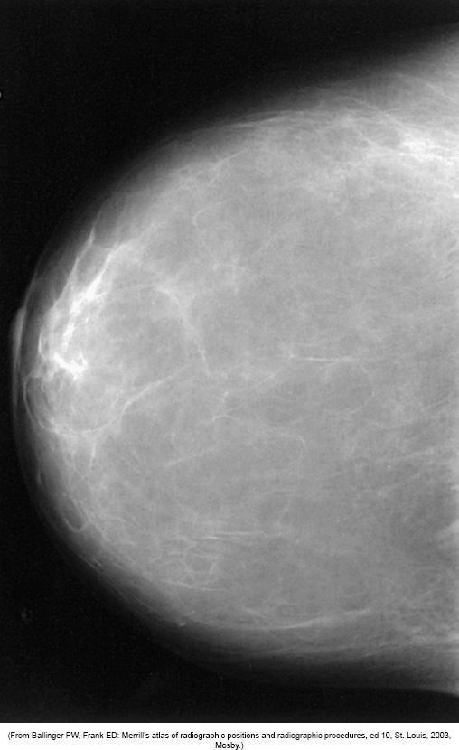
Figure 9: X-ray Image of a Fatty Breast
Source: Textbook of Radiographic Positioning and Related Anatomy, Bontrager & Lampignano. © 2013, Mosby Elsevier. Used with permission.
  - Common in women age 50 and older
  - Post-menopausal
  - Minimal density
  - Breasts of children and males

Questions:
- What would the breast tissue of a 35-year-old female without children be?
- What would the breast classification of a 45-year-old woman be with three or more pregnancies?
- Which of the breast tissues is considered least dense? How would this affect technique overall?
- Which breast type offers the highest contrast image?
- Which breast type would require the highest technique setting?

Using the clinical information provided to adapt the examination for an individual patient

Screening Mammograms versus Diagnostic Mammograms
Routine screening mammograms are the standard or basic views that are commonly performed in most mammography departments and include two positions of each breast: the craniocaudal (CC) and mediolateral oblique (MLO).

Diagnostic mammographic exams provide more detail of any abnormalities or changes found in the breast during a screening mammogram. Diagnostic exams are also used for women with a history or symptoms of breast cancer.

These specialized views might include the mediolateral (ML), exaggerated craniocaudal (XCCL), implant displaced (Eklund method) and magnification views.

Patient Contraindications for Screening Mammography
- Patient is younger than 40 years of age.
- Patient is breastfeeding/pregnant.
- Patient has an open wound and would rather have it heal prior to compression being applied to it.
- Patient is sick with a cold or flu (can easily rebook to a later date).
- Patient refuses exam.
- Patient books screening exam within one year of previous exam (the Alberta government only pays for one per year unless there is a new symptom that arises).

Patient Preparation and Explanation of Screening Exam Procedure
As with any x-ray examination you must prepare your room and your patient prior to starting the exam.

Patient Preparation – Gown/Clothing
Requisition forms will often contain information on how the patient is to prepare for the examination such as wearing a two-piece outfit to maintain patient modesty and dignity throughout the procedure. There are gowns that are specifically designed for mammographic procedures that allow for imaging of one breast at a time.

You would ask your patient to change appropriately and remove any jewellery, talcum powder, antiperspirant or lotions with glitter as they can cause artifact on the images.

Record Patient History
The requisition should indicate if the mammographic exam is a routine screening or is a diagnostic exam resulting from specific symptoms. The mammographer must document any relevant patient history as per departmental protocol

Generally, patient history will include the following:
- Number of pregnancies
- Date of Last Menstrual Period (DLMP)
- Family history of cancer, including breast cancer (relationship of relative)
- Medications currently taken (e.g., hormone therapy)
- Previous breast surgery
- Previous mammograms (when and where)
- Reason for current visit (i.e., routine screening mammogram or due to symptoms such as lumps, pain, discharge, etc.)
- The mammographer should note the location of scars, palpable masses, moles, warts, tattoos, etc.

Once you have completed the patient history you will explain the procedure to the patient. Women can be quite anxious about having a mammogram, not just because they can be uncomfortable, but also because of what the results may be. The threat of having cancer can be very stressful for some. It is extremely important to explain the procedure thoroughly to reduce the patient’s anxiety levels as much as possible.

Here is an example of how to explain the procedure:
“Today, I am going to start by taking two images of each breast—one image of each breast from the top and one image from the side. I will have you stand for the exam in front of my machine and we will start with your right side. There are two plates that will press together to flatten your breast. This compression causes a certain amount of discomfort, but only lasts a few seconds. It automatically releases after the exposure is complete. We need to flatten out your breast tissue to obtain the best possible images. If you feel a lot of discomfort then please let me know and I may be able to adjust it. Our radiologist will look at the images later today. They will be compared to any previous mammogram images and if any change is seen, or further imaging is needed, you will be called back for another appointment to investigate further. Your doctor will receive the full report within two business days.”

Breast Positioning
The base of the breast is the portion near the chest wall, whereas the nipple is termed the apex. In either the craniocaudal (CC) view or mediolateral oblique (MLO) view, the base of the breast is much thicker with more dense tissue than is found at the apex. To overcome this anatomical difference, a compression device is used in combination with a specially designed x-ray tube so a more intense central ray of the x-ray beam penetrates the thicker base of the breast.

X-ray Tube
- Unique design with a molybdenum target and small focal spots of 0.3 mm and 0.1 mm.
- Small focal spots must be of this size because the size of cancer calcifications in the breast typically measure less than 1.0 mm.

Prominent Heel Affect
- Results from short SID and the use of narrow reference target angle.
- Cathode side of x-ray beam has significantly greater intensity of x-rays compared to the anode side, resulting in more uniform density of image.
- The x-ray tube is aligned with the cathode over the base of the breast (at the chest wall) and the anode towards the apex (nipple area). This way, the heel effect can be used to the maximum benefit.

Automatic Exposure Control (AEC) Chamber Selection
- Adjustable up to 10 positions from chest wall to the nipple.
- To ensure adequate exposure of more dense or thick tissues, the chamber under the chest wall should be selected, or more dense tissue area should be selected (i.e., in fibro-fatty breast tissue where the nipple area is more dense).
- Patients who have had implants require a manual technique selection.

Compression
- Controlled by the technologist and typically applied at 25–45 pounds of force.
- Slow, steady application allows patient time to adjust to pressure.
- Important to keep visual contact with your patient to assess the level of their discomfort.
- Gentle verbal encouragement of the patient usually leads to the desired results.
- Smaller spot panel may be used to better visualize a possible lesion or area of interest.
- Sufficient compression must be used in order to decrease the thickness of the breast and make it more uniform and to bring the breast structures as close to the image receptor (IR) as possible.

Follow the link below to see a very good video explaining the benefits of applying compression to spread out breast tissue:

- http://youtu.be/q1PlZfmtdHw (BC Cancer Agency, 2011, 1:08)

The following diagrams also demonstrate how superimposed structures can be brought into more of a side-by-side alignment through compression:

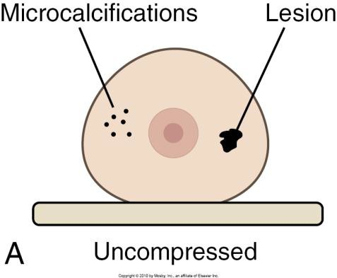
Figure 10: Uncompressed Breast
Source: Textbook of Radiographic Positioning and Related Anatomy, Bontrager & Lampignano. © 2013, Mosby Elsevier. Used with permission.

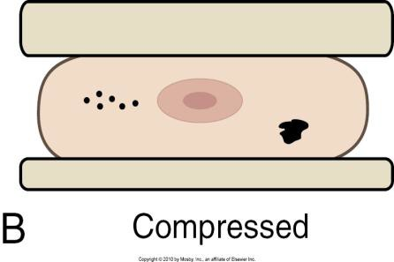
Figure 11: Compressed Breast
Source: Textbook of Radiographic Positioning and Related Anatomy, Bontrager & Lampignano. © 2013, Mosby Elsevier. Used with permission.

Magnification
- Special views are used to enlarge specific areas of interest such as small lesions or micro-calcifications.
- Requires an x-ray tube with a 0.1-mm focal spot to maintain image resolution.
- Magnification of 1.5–2 times can be obtained by using a magnification platform between the image receptor and the breast through increased OID.
- Magnification factor = SID
SOD
  - Used to rule out breast pathology

Patient Dose of Radiation
- Is significant in mammography due to low kVp (25–28 kV) and high mAs (75–85).
- Skin dose of 800–900 mrad and a mean glandular dose (MGD) of 130–150 mrad.
- Principal way to minimize dose is careful and accurate positioning.
- Repeat rate of less than 5% is recommended.
- Gonadal shielding is possible.

Questions:
- List all 6 reasons for using compression to achieve high quality mammographic images.
- With AEC selection, what is the exception to chamber placement?
- To best utilize the prominent heel effect, where should the cathode and the anode sit?
  - How does this create a breast image of more uniform density?
- What makes the design of a mammographic machine distinctive?
- Why would you ask about the number of pregnancies when taking a patient history?
- What are the two most common routine views done for a screening breast exam?
- What is considered the base of the breast? The apex?
- You are performing a magnification view using an SID of 60 cm and SOD of 30 cm. What would your magnification factor be?
- Describe what mean glandular dose (MGD) refers to.
- Please review your textbook and the power point provided to review basic positioning required for the following projections. Please pay attention to the abbreviations for each special view/projection as it is important to use these correctly:
  - Craniocaudal projection (CC)
  - Mediolateral oblique projection (MLO)
  - Mediolateral projection (ML)
  - Exaggerated Craniocaudal projection (EXCCL)
  - Implant Displaced Method (ID) aka – Eklund Method

Using Various Modalities to Diagnose Breast Disease

Digital Mammography
- Direct digital is most commonly seen in mammography practice.
- A flat panel detector captures the remnant x-rays and produces a digital image.
- The image is projected onto a monitor at the mammographer’s work station for direct viewing and post-processing as needed.
- See images below for examples:

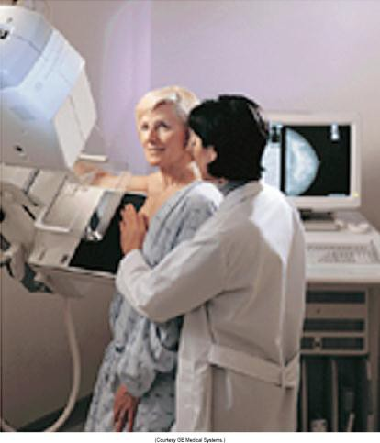 | 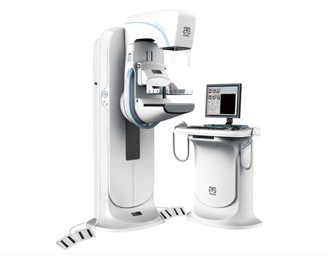
Figure 12: Digital Mammography Exam  Source: Textbook of Radiographic Positioning and Related Anatomy, Bontrager & Lampignano. © 2013, Mosby Elsevier. Used with permission. | Figure 13: Digital Mammography Unit  Source: Anke. Reproduced and used in accordance with Fair Dealing Policy (Schedule A, Copyright of External Materials Procedure AC.2.12.1); further distribution may infringe copyright. Retrieved from http://www.anke.com/ProductsView.asp?CasesID=14

Ultrasound
- Integral part of mammography department.
- Can distinguish between a cyst and a solid lesion.
- Used extensively to reveal fluid, abscess, hematoma and silicone gel.
- Option for young patients with dense breast tissue.
- Used in biopsy to localize lesions for core samples.
- Arrow in image below indicates a cyst:

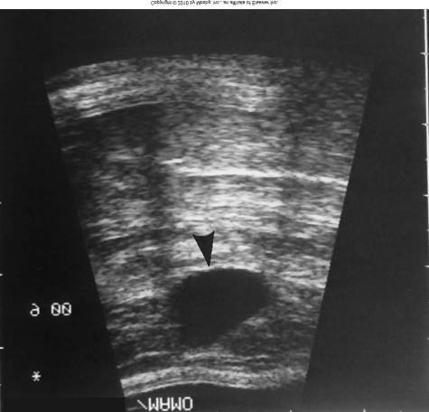
Figure 14: Ultrasound Image of Cyst
Source: Textbook of Radiographic Positioning and Related Anatomy, Bontrager & Lampignano. © 2013, Mosby Elsevier. Used with permission.

Nuclear Medicine

Mammoscintigraphy
- May be helpful in confirming a breast cancer diagnosis.
- A radionuclide is injected into patient’s arm opposite affected breast.

Sentinel Node Studies
- Becoming more useful in detection of breast cancer after localization procedure.
- Involves injection of sulphur colloid in subcutaneous tissue around the lesion.
- The flow is followed through the lymph node(s).
- Node(s) are then removed surgically and tested for pathology.

Positron Emission Tomography (PET)
- Used to detect early signs of cancerous growth within the breast.
- With the use of a tracer fluorodeoxyglucose, early cancerous cells can be detected by their increased metabolism.
- Used post-surgery to monitor whether recurrent disease is present or found elsewhere in the body.

MRI
- Used to detect palpable masses not seen in mammography or ultrasound.
- Used to assess lesions in an extremely dense, glandular breast.
- Can be used to screen young women at very high risk for breast cancer due to family history.
- Used to assess leakage from implants.
This MRI image indicates an intracapsular rupture:

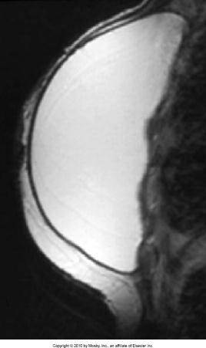
Figure 15: MRI Image of Intracapsular Rupture of Implant
Source: Textbook of Radiographic Positioning and Related Anatomy, Bontrager & Lampignano. © 2013, Mosby Elsevier. Used with permission.

This MRI image shows a normal implant:

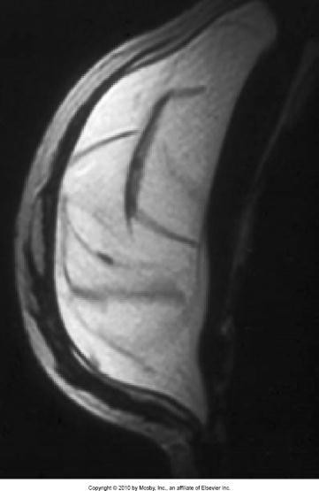
Figure 16: MRI Image of a Normal Implant
Source: Textbook of Radiographic Positioning and Related Anatomy, Bontrager & Lampignano. © 2013, Mosby Elsevier. Used with permission.

Computer Aided Detection (CAD) Technology
Provides radiologist with an estimate of probable malignancy.

Digital Breast Tomosynthesis (DBT)
- Presents the marriage of traditional methods with the latest technology of full-field digital mammography.
- Uses conventional mammography x-ray tube and digital detectors, but the detectors travel in an arced flight over the breast creating a series of image slices.
- Produces an image of breast that is almost 3-D.

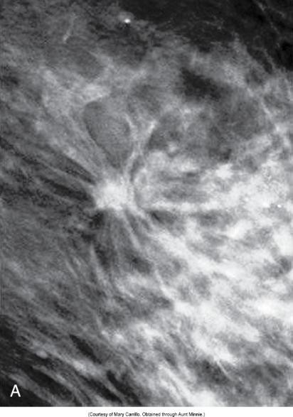 | 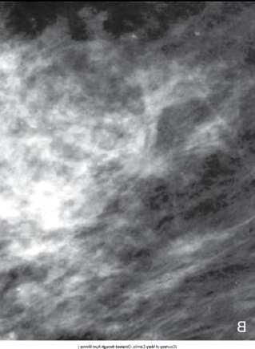
Figure 17: DBT Image of Breast  Source: Moore & Kopans. Reproduced and used in accordance with Fair Dealing Policy (Schedule A, Copyright of External Materials Procedure AC.2.12.1); further distribution may infringe copyright. Retrieved from http://www.auntminnie.com/index.aspx?sec=ser&sub=def&pag=dis&ItemID=76337 | Figure 18: Same Area of Breast Without Use of DBT  Source: Moore & Kopans. Reproduced and used in accordance with Fair Dealing Policy (Schedule A, Copyright of External Materials Procedure AC.2.12.1); further distribution may infringe copyright. Retrieved from http://www.auntminnie.com/index.aspx?sec=ser&sub=def&pag=dis&ItemID=76337

Complete the following chart comparing the strengths and weaknesses of the various modalities in diagnosing breast disease:

Modality | Advantages | Disadvantages
Computed Radiography Mammography
Direct Digital Radiography
Computer-Aided Detection Systems
Sonography (Ultrasound)

Modality | Advantages | Disadvantages
Nuclear Medicine
Positron Emission Tomography (PET)
MRI
Digital Breast Tomosynthesis (DBT)

Qualities Required for an Acceptable Mammographic Image
While each image acquired has specific evaluation criteria, there are some general imaging requirements for all images produced:
- kV factors: 23 kV–28 kV utilized
- SID: 60 cm utilized
- Marker Placement: always placed axillary side of IR
- Respiration: suspended
- Nipple: must be seen in profile on all images
- Shielding: waist apron
- Compression: 25–45 lbs of force

Posterior Nipple Line (PNL):
- Evaluates the depth of breast tissue.
- Draw an imaginary line from the nipple to the pectoral muscle or the edge of the image (whichever is shortest).
- Pectoral muscle will be visible on 20–30% of CC projections, but must be demonstrated on all MLO projections.
Note: The PNL on the CC projection should be within 1 cm of the PNL on the MLO projection.

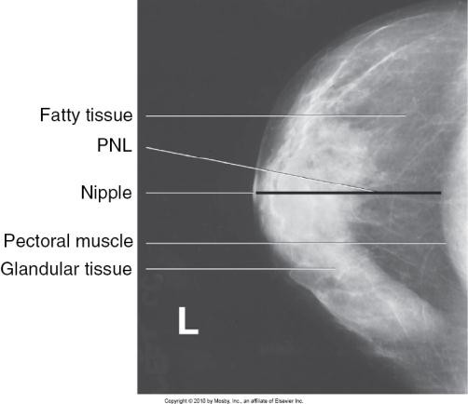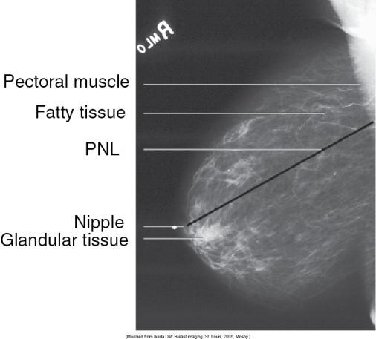
Figure 19: Examples of PNL
Source: Textbook of Radiographic Positioning and Related Anatomy, Bontrager & Lampignano. © 2013, Mosby Elsevier. Used with permission.

Questions:
- What are the two basic projections used most commonly in screening breast exams?
- When is a mediolateral projection requested by the radiologist?
- The XCCL projection best demonstrates which area of the breast?
- When imaging breasts with implants what is the specialized projection utilized?
- When imaging breast implants in place, why is it imperative to set manual techniques?
- How is positioning modified for breast implants that are encapsulated?
- The PNL line must be within ______ when measured on the CC and MLO projections.
- Describe the axillary tail view and what it demonstrates.

Pathological Considerations
Screening mammography is important in early detection of pathological changes in the breast. These changes can be benign (non-cancerous) or malignant (cancerous). Breast cancer is divided into two categories, non-invasive and invasive.

Non-invasive Cancer
- A distinct lesion of the breast that has the potential to become invasive.
- Lesions are restricted to the glandular lumen.
- They do not have access to lymphatic system or blood vessels.
- May be termed in situ.
- Non-invasive cancers account for 15–20% of all breast cancer diagnoses.

Ductal carcinoma in situ (DCIS)
- Isolated within the breast duct and does not spread to other areas of the breast.

Lobular carcinoma in situ (LCIS)
- Consists of abnormal cells that have been detected in one or more lobes of the breast.

Invasive Cancer

Infiltrating ductal carcinoma
- Most common form of breast cancer.
- Accounts for 80% of all breast cancer diagnoses.
- Believed to arise in the terminal duct lobular unit (TDLU).
- Usually requires biopsy of tissue for histologic evaluation (ultrasound guided).
- Carries worst overall prognosis.

Radiographic Appearance
- Mass with speculated border, architectural distortion or micro-calcifications.

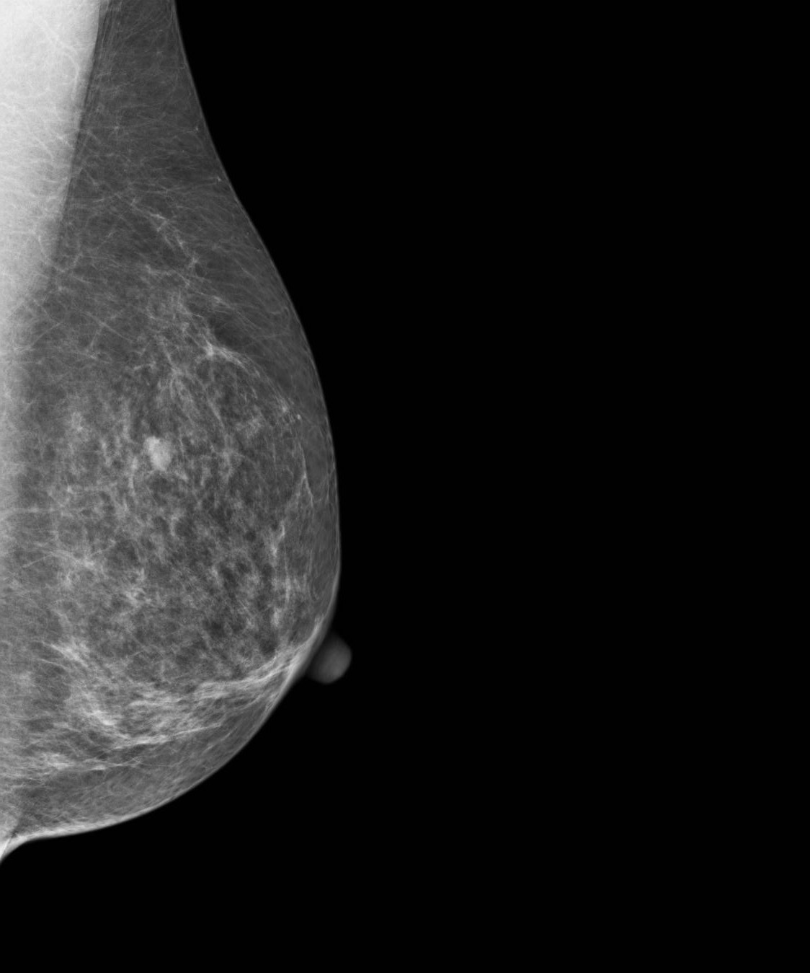
Figure 20: MLO Projection Right Breast Invasive Mass

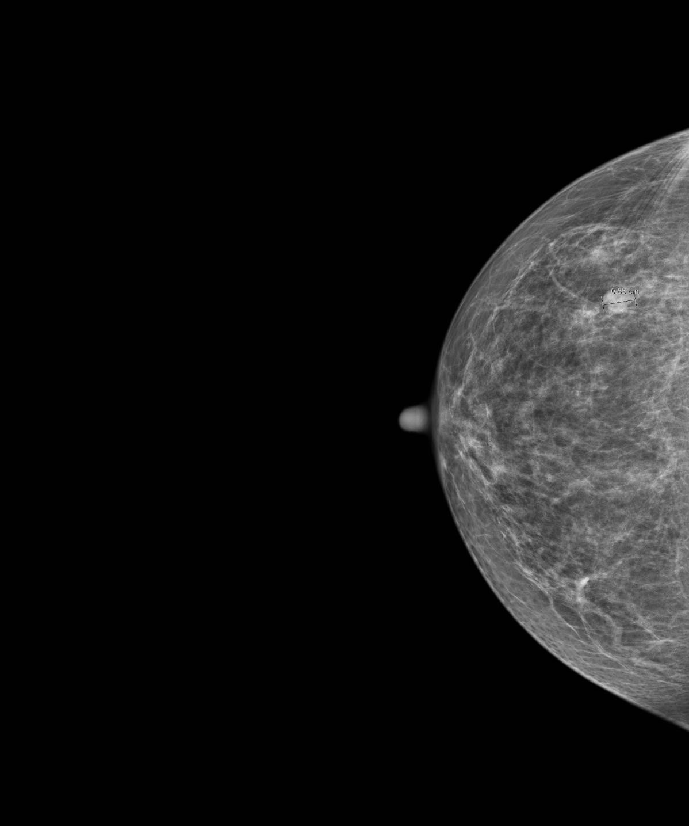
Figure 21: CC Projection Right Breast Invasive Mass

The invasive mass is demonstrated in the superior posterior aspect of the breast as indicated.

Cysts
- Fluid-filled sacs that are benign and appear as well-circumscribed masses.
- Sometimes high concentrations of calcium particles may be suspended within the cyst fluid.
- For positive diagnosis, ultrasound and needle biopsy are required.

Radiographic Appearance
- Well-defined margins.
- Only slightly higher density than surrounding tissues.

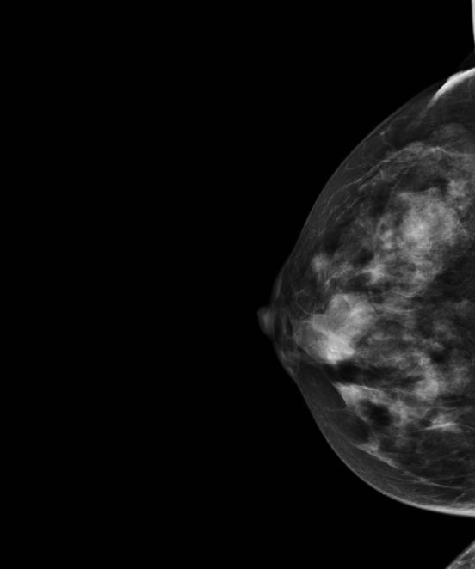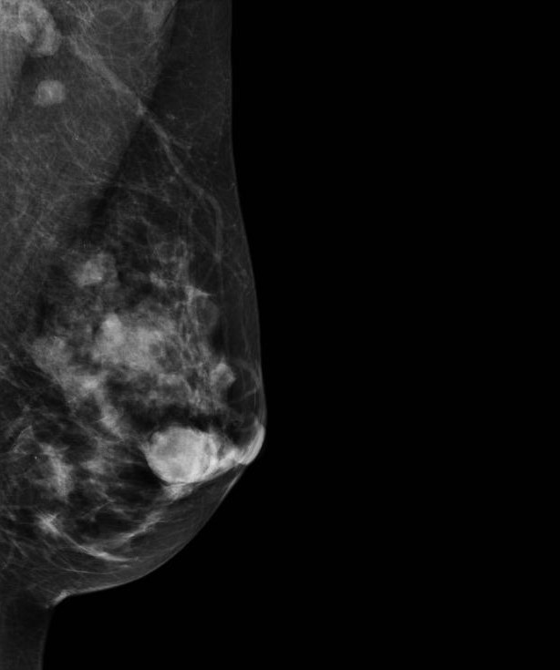
Figure 22: X-ray Images Showing Cysts

Fibroadenoma
- Most common benign solid lumps or tumors of fibrous and glandular tissue.
- Well-circumscribed lesions with clearly defined edges.
- Typically same density as surrounding tissues.
- Ultrasound can be used to differentiate solid versus fluid.

Radiographic Appearance
- Breast tumor has well defined, smooth margins.

Fibrocystic Changes
- Common, benign condition found bilaterally in post-menopausal women.
- Multiple cysts with increased fibrous tissue commonly distributed throughout the breasts.
- Sonography also used for diagnosis.

Radiographic Appearance
- Multiple fibrous cysts seen throughout the breast bilaterally as high density areas.

Gynecomastia
- Benign glandular enlargement of the breast occurs.
- May be unilateral or bilateral.
- Typically presents as a mass near the nipple.
- Sonography also used for diagnosis.

Radiographic Appearance
- Flame-shaped opacity extending and expanding posterior to the nipple.

Intraductal Papilloma
- Small growth occurs inside the duct of the breast near the nipple.
- Nipple discharge is a symptom.
- Radiographically appears normal.
- Use galactography to demonstrate a filling defect.
- Ultrasound may be best method to diagnose.

Paget’s Disease of the Nipple
- Appears as a crusty or scaly nipple sore or discharge from the nipple.
- Slightly more than half who have this cancer also have a lump.
- May be invasive or non-invasive.

Radiographic Appearance
- Masses may be present.

Questions:
- What is the most common form of breast cancer?
- Breast cancer is divided into two categories. What are these categories and what differentiates the two?
- Breast carcinoma appears radiographically as?

References
BC Cancer Agency. (2011, December 1). Why the Pressure? Screening Mammography Program. Video retrieved from https://www.youtube.com/watch?v=q1PlZfmtdHw&feature=youtu.be
Bontrager, K. L., & Lampignano, J. (2013). Textbook of radiographic positioning and related anatomy. (8th ed.). St. Louis, MO: Mosby Elsevier.
Bushong, S. C. (2013). Radiologic science for technologists. (10th ed.). St. Louis, MO: Mosby Elsevier.

