Activity Answers: Test 12 Collimator Light/X-ray Field Congruence and Perpendicularity Calculations

Evaluation A – Collimator Light/X-ray Field Congruence
- Calculate 2% of SID.

0.02 x ___110______cm = ____2.2____cm × 10 = _____22__mm

- On each side, measure and record the distance between the light field and X-ray image.

X

B
A Y

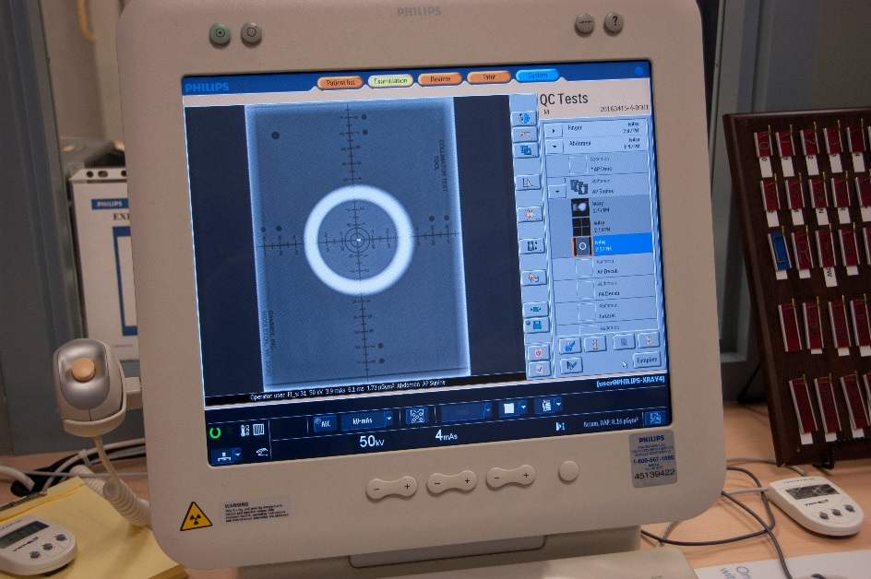

A = ___2___mm X = __1__mm

B = ___2___mm Y = ___3__mm

- Take the sum of the distances of opposite sides found in Step 2 and compare to the results of 2% SID found in Step 1.

A + B = ___4____ mm X + Y = ___4___mm

A + B + X + Y = _____8__mm

Conclusion: Pass _____X_________ Fail ________________

Acceptance Criteria:
According to SC 35, the measured misalignment of the visually defined field and the X-ray field along the length and width of the X-ray field shall not exceed 2% of the SID.

Evaluation B – Perpendicularity
Referring to the chart below, compare and record which alignment appears most similar to the results provided.

*closest to ~.5 degrees
~0.5 degrees | ~1.5 degrees |  |  | ~3 degrees
Results: |  | ~.5 deg

Acceptance Criteria:
According to SC 35, the X-ray beam axis should be within 3 degrees of the perpendicular to the image receptor plane. Using this test tool, the upper bead should be within the outer circle to pass.

Conclusion: Pass _____X_________ Fail ________________

Critical Thinking Questions

- What could cause the collimation to be off from what is set? (Papp pg. 105)
- Over time, the light mirror might shift or the mechanism that moves the shutters can malfunction, causing improper performance, which leads to greater patient dosing and repeat images.

- Describe an alternate test that can be used to test collimator/X-ray field congruence if a collimator test template is not available.
- Describe the penny test found on p. 107 in Papp

- What could cause the beam perpendicularity to be off from 90 degrees? (Papp, p. 108)
- X-ray tube can shift in its housing due to age and use
- Rubber o-rings that hold it in place in the housing deteriorate over time due to the heat within the housing
- Rough handling during exams can cause the tube to shift

