



MRT Program

Image Critique Handbook

The radiological examinations included in this handbook are listed alphabetically. This section is followed by specific topics to enhance technical performance.

Table of Contents

A 4
Abdomen 5
Acromioclavicular Joints 11
Ankle 12
Arthritis 16
C 17
Cervical Spine 18
Chest 29
Clavicle 35
Coccyx 37
E 39
Elbow 40
F 46
Facial Bones 47
Femur 54
Fingers 60
Foot 63
Forearm 67
H 70
Hand 71
Hip 75
Humerus 80
K 84
Knee 85
KUB 92
L 93
Lumbar Spine 94
M 100
Mandible 101
Panorex/Orthopan 103
N 107
Nasal Bones 108
Nasopharynx 111
O 114
Orbits 115
Os Calcis 117
P 120
Patella 121
Pelvis 124
R 128
Ribs 129
Upper Posterior/Axillary Ribs 131
S 136
Sacroiliac Joints 137
Sacrum 139
Scaphoid 142
Scapula 144
Scoliosis 147
Shoulder 151
Common Pathologies 156
Sinuses 158
Skeletal Survery 162
Skull 163
SC Joints 167
Sternum 169
T 171
Thoracic Spine 172
Thumb 176
Tibia/Fibula 179
Toes 183
V 186
Ventriculoperitoneal Shunt Series 187
W 188
Wrist 189
Mobile Procedures 194
Fluoro Procedures 203
Operating Room (OR) 216
Techniques 224
CR and DR 237
Mayfair Modifications 241
EFW Modifications 244
CDC Modifications 245
Common Acronyms 247
References 251

A

Abdomen

Acromioclavicular Joints

Ankle

Arthritis

Abdomen

Procedure Manual states when performing an abdominal three view series an AP upright abdomen, an AP supine abdomen, and a PA chest must be included if one has not been taken within 24 hours. If patient condition does not permit an AP upright abdominal view, then a left lateral decubitus abdomen should be performed.

AP Projection (Supine)
- Aligning the navel to the center of the table doesn’t always work because it is often shifted to one side and cannot be dependable. Ensure midsagittal plane of body is centered to the detector.
- Central ray is perpendicular to the IR at the level of the iliac crests and ensure pubic
symphysis is included at a minimum 100 cm (40 “) SID.
Note: if history/reason for exam is querying inguinal hernia, include ischial tuberosities on image.
- Suspend respiration on full expiration. This relieves pressure on the abdominal organs.

Evaluation Criteria
T11 to the symphysis included. Including T11 on the abdomen radiograph gets the tops of the kidneys, liver and spleen.
Cortical outlines of the posterior ribs, lumbar vertebrae, pelvis, and gases within the stomach and intestines are sharply defined.
Long axis of the spine is parallel to the long axis of the IR. Pelvis and ribs are equidistant from the edge of the IR. This ensures the lateral abdominal cavity won’t be clipped.
Spinous processes in center of the lumbar vertebrae.
The distance from the pedicles to the spinous processes is the same on both sides. Alae of the ilia are symmetrical.
Sacrum is centered within the pelvic inlet and aligned with the symphysis pubis. Ischial spines of the pelvis are symmetrical if visible.
To ensure that entire bowel is visualized look for fat stripe on both lateral borders of the abdomen. Enlargement of this fat stripe may also be indicative of peritoneal fluid (ascites).
Rotation decreases the visualization of the fat lines that surround the abdominal structures.
Adequate radiographic contrast and density to demonstrate lateral psoas muscles (originate at L1 and extend to the lesser trochanter) and kidneys as well as bony structures of the vertebrae and pelvis
If there is a lot of gas suspected in the abdomen, decrease the technique mAs 30-50% or kVp 5-8%. Radiation is not absorbed by gas (air has a lower atomic number) and this will result in an over exposed image.
Arrow marker indicating supine.

- Central ray perpendicular to approximately 2” (5cm) above the iliac crest. Must include
the both diaphragms to demonstrate free air if present. Minimum SID 100 cm (40”) used.
- Suspend respiration on full expiration. This relieves pressure on the abdominal organs.

Evaluation Criteria
Both diaphragms visible.
Spinous process in center of the lumbar vertebrae.
Distance from the pedicles to the spinous processes is the same on both sides. The side with the smaller distance is the side furthest from the film.
Alae of the ilia are symmetrical.
Sacrum is centered within the pelvic inlet and aligned with the symphysis pubis. Ischial spines of the pelvis are symmetrical if visible.
Rotation decreases the visualization of the fat lines that surround the abdominal structures.
Pelvis and ribs are equidistant from the edge of the IR. This ensures the lateral
abdominal cavity won’t be clipped.
Cortical outlines of the posterior ribs, lumbar vertebrae, pelvis, and gases within the stomach and intestines are sharply defined.
Adequate radiographic contrast and density to demonstrate lateral psoas muscles (originate at L1 and extend to the lesser trochanter) and kidneys as well as bony structures of the vertebrae and pelvis.
Excessive tissue drops. Increase technique from the supine position.
Ascites, obesity, bowel obstructions, or soft tissue masses may result in an underexposed image. This is because of an increase in the abdominal soft tissue density due to the absence of gas and fat that are normally present. Increase mAs 30-50% or kVp 5-8%.
If there is a lot of gas suspected in the abdomen, decrease the technique mAs 30-50% or kVp 5-8%. Radiation is not absorbed by gas (air has a lower atomic #) and this results in an over exposed image.
Arrow marker indicating upright/erect.

Left Lateral Decubitus Projection
- Ensure patient’s safety at all times. Hold on to the patient until the locks are engaged on the stretcher. Image should be taken AP with sponge between patient and IR.
- Use when patient is too ill to stand. The LLD is preferred. LLD positions the gastric bubble away from where the intraperitoneal air migrates under the elevated diaphragm. Sometimes the RLD is used when the patient cannot lie on their left side.
- Lie patient on their left side for a minimum of 5 minutes (10 – 20 minutes is preferred) before the exposure to allow the air to rise and the fluid to settle.
- Central ray horizontal and perpendicular to the detector 5 cm (2”) above the iliac crests
to ensure the diaphragms are included. Minimum SID of 100 cm (40 “) utilized.
- On an obese patient adipose tissue falls. Increase technique from the supine. Use a wedge filter to even out the densities between the thinner upper portion of the abdomen and the thicker lower portion.
- Suspend respiration on full expiration.

Valuable for air-fluid levels when the upright position cannot be used.
Diaphragms must be demonstrated to ensure visualization of intraperitoneal air. Pubic symphysis and rami are not required.
Diaphragms without motion. Expiration puts less pressure on the abdominal structures and makes the abdominal area less dense.
Both sides of the abdomen are included. If fluid is suspected, build the patient up on sponge or towels. If air is suspected, ensure all of the up side is included. Air moves to the right upper quadrant between the liver and the abdominal wall.
Upper and lower vertebrae show no rotation. Distance from the pedicles to the spinous processes equidistant. Sacrum is midline to the inlet of the pelvis.
- Properly mark the appropriate side and include an arrow.

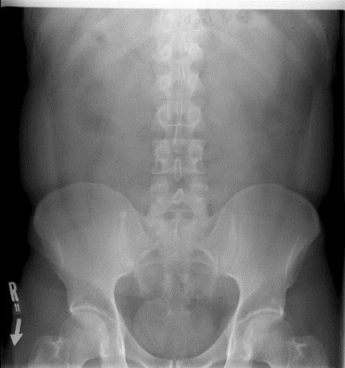
Spinous processes
in center of l-spine

Fat Stripe

Iliac alae
symmetrical

Down arrow to indicate supine
Sacrum aligned
with symphysis

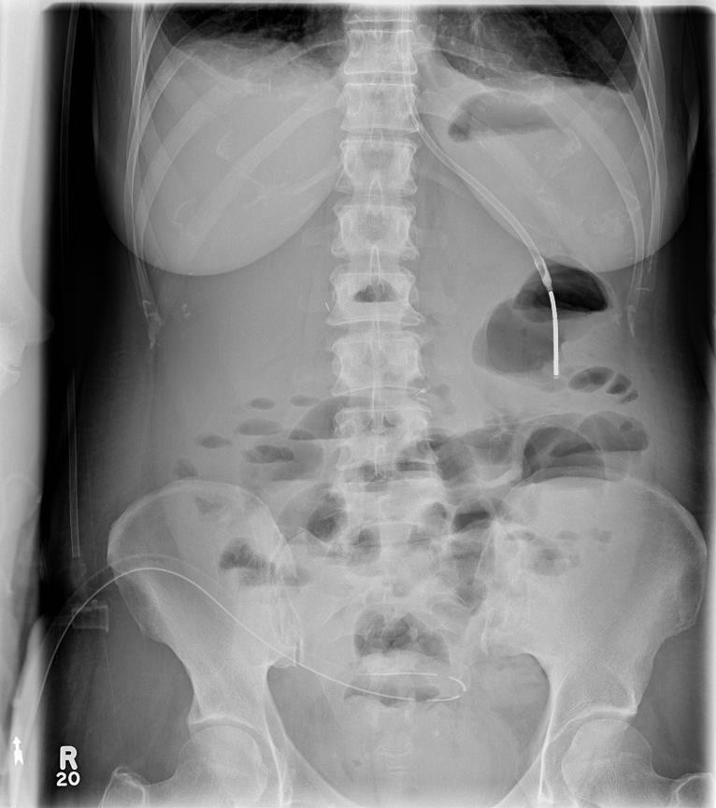
Diaphragms must
be include

Spinous processes
in center of l-spine

Ilia alae symmetrical

Up arrow to indicate erect

Sacrum aligned with symphysis

Include diaphragm down
Spinous processes in center of l-spine

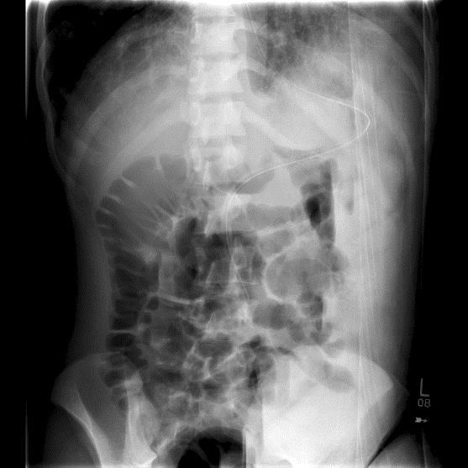
Arrow to
indicate side down

Acromioclavicular Joints

AP Projection (Weight-bearing)

Routine: Separate bilateral coned views of the AC joints without and with weights.
- Central ray perpendicular to the AC joint.
- Suspend respiration.
- Always check the without weight APs with the Radiologist or the Emergency Doctor for trauma patients before giving weights to ensure there are no fractures or dislocations prior to continuing.

Evaluation Criteria
Dislocation, separation and function of the AC joints. The weight bearing view evaluates the AC joint for injury to the AC ligament.
No rotation.
The normal joint space is 0.3 cm (0.125”). AC joint separation can be seen on the weight bearing view.
AC joints visualized with some soft tissue and without excessive density.
Include the coracoid process on each view. Markers to indicate weight-bearing.

How to Fix it
Lateral end of clavicle and acromion are rotated out of profile and AC joint is closed.
  - Patient is rotated toward affected side. The patient should be flat against the IR.

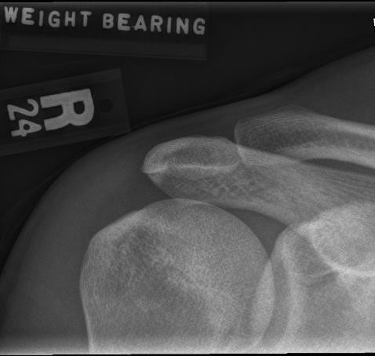
AP Projection (Weight-bearing)

No rotation

Ankle

AP Projection
- Central ray perpendicular to the ankle joint at the level of the palpable medial malleolus
at a minimum of 100 cm (40”) SID.

Evaluation Criteria
Distal 1/4th of the tibia/fibula and talus. Entire orthopedic device must be included if present.
Medial mortise open (medial talomalleolar articulation).
The tibiotalar joint is open and the tibia is demonstrated without foreshortening.
Distal tibia and talus partially superimposes the distal fibula, closing the lateral mortise (fibiotalar joint).
The distal tibiofibular articulation and the talofibular articulation will not be open on a true AP. If these joints are open on a true AP, it is a strong indication of ruptured ligaments or other types of separation injuries.
Talus with proper density and soft tissue.

Stress Views
- Obtained after an inversion or eversion injury to verify a ligament tear.
- Ligament tear is shown as a widening of the joint space on the side of the injury then without moving the leg, stress is applied to the foot to turn it toward the opposite side.

The Physician applies the stress to the joint.
- Sometimes in the case of pain, the Physician will inject a local anesthetic into the sinus tarsi.

AP Medial Oblique Projection (Mortise)
- Rotate entire leg medially 15-20 degrees until the intermalleolar line is parallel to the IR (malleoli are equal distances from the IR).
- Central ray perpendicular to the ankle joint mid-way between the malleoli at a minimum
of 100 cm (40 “) SID.

Evaluation Criteria
Distal fibula seen without talar superimposition.
Open mortise joint (medial mortise, tibiotalar joint and lateral mortise).
Lateral and medial malleoli in profile. Calcaneus distal to the lateral mortise and fibula this indicates dorsiflexion.

Note: Base of the 5th metatarsal seen on 45° oblique demonstrate possible Jones fracture.

How to Fix it
Sinus tarsi is seen and the medial mortise and is closed.
  - The leg is over rotated. Decrease the amount of internal rotation. Medial mortise is open and lateral mortise is closed.
  - The leg is under rotated. Increase the amount of internal rotation.
The calcaneus is superimposing the distal aspect of the lateral mortise and distal fibula.

  - The foot is not sufficiently dorsiflexed. If patient is able, dorsiflex the foot until it forms a 90 degree angle with the tibia.

Lateral Projection (Mediolateral)
- Central ray perpendicular to the ankle joint.

Evaluation Criteria
Collimated to include the distal ¼ of the tibia and fibula, the navicular, entire calcaneus, base of the 5th metatarsal and the entire soft tissue area of the heel.
Fibula over the posterior half of the tibia.
Tibiotalar joint well visualized, with the medial and lateral talar domes superimposed. Density of the ankle sufficient to see the outline of the distal portion of the fibula.

How to fix it
Fibula over the anterior half of the tibia (lateral talar dome anterior).
  - The forefoot was elevated. Depress the forefoot and elevate the heel. Fibula posterior to the tibia (medial dome anterior).
  - The forefoot was depressed. Elevate the forefoot and depress the heel. Navicular superimposes most of the cuboid (lateral talar dome is proximal).
  - Proximal tibia is elevated. Extend the knee positioning the leg parallel with the IR. More than 1 cm (0.5 “) of cuboid is visualized distal to the navicular (medial talar dome is proximal).
  - The distal tibia was elevated. Position the leg parallel with the IR.

AP Projection

Open tibiotalar joint space

Partial superimposition of fibula on tibia and
talus

Medial mortise joint open

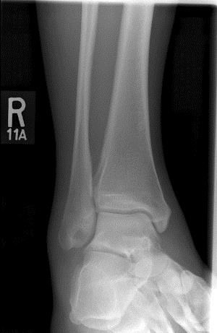
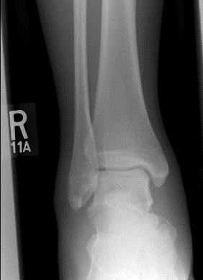
AP Medial Oblique Projection (Mortise)

Open talofibular
joint
Lateral malleoli in
profile
Medial malleoli in profile

Lateral Projection

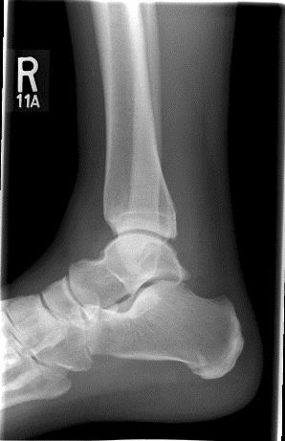
Fibula over posterior half of the tibia

Medial and lateral
talar domes superimposed
Tibiotalar joint well visualized

Arthritis

Please check the procedure manual at your clinical site when bilateral hands, wrists, or feet are requested for arthritis. Projections of the right and left body part may or may not be performed on the same image receptor. Confirm arthritis protocol with your clinical instructor.

C
    - Cervical Spine
    - Chest
    - Clavicle
    - Coccyx

Cervical Spine
Please note: For trauma patients (those in a cervical spine collar), you cannot remove or adjust the collar for any reason. If the collar needs to be adjusted, a Physician must do it.

Lateral Projection
- Head in a lateral position. Lateral aspect of shoulder resting against IR. Extend chin to bring the acanthiomeatal line (AML) parallel with the floor and ensure that the mandible and/or skull does not superimpose C1 and C2.
- Central ray horizontal and perpendicular to C4 at minimum 180 cm (72”) SID to reduce magnification and improve detail. Magnified shoulder farthest from the IR seen below the cervical vertebrae.
- Suspend breathing at the end of exhalation to help depress the shoulders.

Evaluation Criteria
All seven cervical vertebrae, from the sella turcica to include entire body of T1. C4 centered.
Intervertebral disc spaces open.
Cranial occipital cortices superimposed.
Posterior arch of C1 and the spinous process of C2 in profile with no skull superimposition.
Mandibular rami superimposed or nearly superimposed (magnification) and not overlying the cervical bodies.
Articular pillars superimposed to show no rotation.
C3-C7 zygapophyseal joints are open and superimposed to show no rotation.
Spinous processes in profile. Bone and soft tissue detail.
Include anterior soft tissue and the trachea in the lateral. There is a pre-vertebral fat stripe anterior to the cervical vertebrae. On properly positioned and exposed images any abnormal widening indicates a fracture, mass, or inflammation.

How to Fix it
Cervical spine seen with rotation.
  - Use magnification of the side farthest from the IR to determine which way the patient is rotated.
Vertebral foramina of C1 seen.
  - The head is tilted toward the IR. Adjust the interpupillary line to be perpendicular to the IR.
Posterior arch of C1 in profile but the cranial cortices and mandibular rami are not aligned.
  - The head is tilted away from the IR. Adjust the interpupillary line perpendicular to the IR.

Swimmers View (Cervicothoracic Region)
- Elevate the arm closest to the IR.
- Depress the shoulder farthest from the IR and rotate posteriorly. If patient cannot depress the shoulder enough use a 5º caudal angle.
- Central ray perpendicular to C7-T1 interspace at a minimum of 100 cm (40”) SID.
- For trauma angle the stretcher to separate the shoulders or angle the central ray 3-5º caudad to jugular notch.
- Suspend respiration.

Evaluation Criteria
C5-T3 or to include all levels not well visualized on the lateral c-spine image.
Superimposed articular pillars, posterior ribs, and zygapophyseal joints to show no rotation.
Humerus elevated above the patient’s head is aligned with the cervical vertebrae. X-ray penetration of the shoulder region.

Odontoid /Dens
- Occlusal meatal line (bottom of the teeth) perpendicular to the IR.
- Have patient open mouth. Align the upper incisors to the mastoid tip and/or base of skull.
- For trauma patient angle the central ray so that it is parallel with the infraorbitalmeatal line (IOML). This may give a 10º caudad angle on a patient in a cervical collar (The upper incisors will be projected 2.5 cm (1”) for every 5º of angulation at a minimum 100 cm (40”) SID).
- Central ray perpendicular to the midpoint of the open mouth.

Evaluation Criteria
Superimposed central incisors and skull. Occiputoatlantal joints.
Atlantoaxial (zygapophyseal) joint (C1-C2). Atlas is symmetrical in the axis.
Lateral masses, dens, and body. Lateral masses and dens spaces are even on both sides.
Transverse processes visible. C2 spinous process is midline.
Mandibular rami are equal distances from the lateral masses.

How to Fix it
Upper incisors are superimposing the dens.
  - The chin is too low or incorrect angle was used. Extend the chin or angle cephalad. The base of the skull is superimposing the dens.
  - The chin is too high or incorrect angle. Tuck the chin down or angle caudad. Joint spaces are not equal on both sides of the dens.
  - The patient’s head was rotated. Rotate the patient’s head away from the side with the narrowed joint space.

Fuchs Method for Odontoid

This image is recommended when the upper half of the dens in the open mouth is not demonstrated. It is not recommended if fracture or degenerative disease is suspected.
- Extend chin until the tip of the chin and the tip of the mastoid tip are vertical. In a trauma case, angle the tube to align the chin with the mastoid tip. DO NOT MOVE THE HEAD. The image will be distorted. Central ray distal to the tip of the chin on the midsagittal plane.
- Suspend respiration.

AP Axial Projection
- AML perpendicular to the IR.
- A line from the occlusal plane to the mastoid tip is perpendicular to the IR (aligns the mandible and occipital bone to show more mid-cervical area).
- Central ray 15-20º cephalad (accommodate for lordotic curvature) to C4, halfway
between the EAM and jugular notch at a minimum 100 cm (40”) SID.
- Suspend respiration.

Evaluation Criteria
C3-T2 included.
Open intervertebral disc spaces (central ray angulation ensures this).
Mandibular angles and mastoid tips are equal distances from cervical vertebrae. Symmetrical articular pillars and pedicles seen lateral to the cervical bodies.
Sternal ends of the clavicles are equal distances from the vertebral column. Bone and soft tissue.

AP Axial Oblique Projection
- Rotate body 45º (marker indicates the side down).
- AML parallel to the floor.
- Central ray 15º cephalad to C4 at minimum 100cm (40”) SID.
- Suspend respiration.

Evaluation Criteria
Includes all anatomy from sella turcica to T1-2 interspace.
Demonstrates vertebral foramina of the side furthest from the IR from C2-3 to C7-T1.
Open intervertebral disc spaces. Uniform size and shape of the foramina.
Pedicles of side furthest from IR are well visualized (opposite pedicles are aligned with the anterior vertebral bodies).
Chin not overlapping C1 and C2. Occipital bone not overlapping C1.

How to Fix it
Pedicles are seen too anterior or not seen at all.
  - The patient is under rotated. Rotate the patient more.
Pedicles are seen too posterior or in the middle of the vertebral bodies.
  - The patient is over rotated. Rotate the patient less.

Lateral Projection

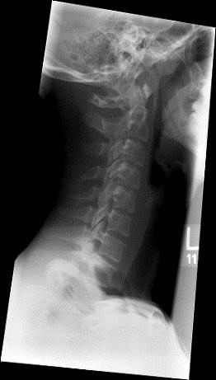
Mandibular rami superimposed

Zygapophyseal
joints superimposed (shows no rotation
or tilt)
No mandible on cervical bodies

Spinous processes in profile C7

C1 to at least 1/3 of T1

Swimmers View

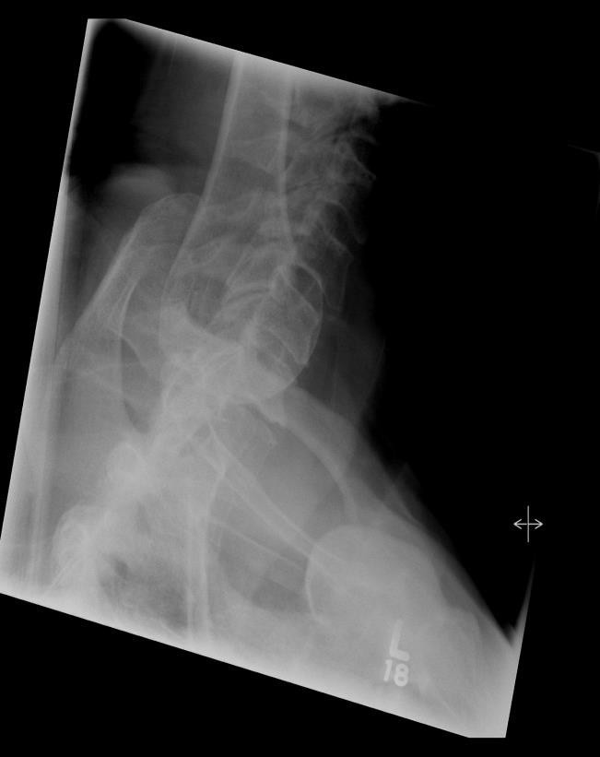
Separation of the
clavicles to visualize T1

X-ray penetration and separation of the shoulder region

Superimposed posterior ribs

Odontoid/Dens

Lateral mass of
atlas
C2 spinous process is midline
Superimposition of
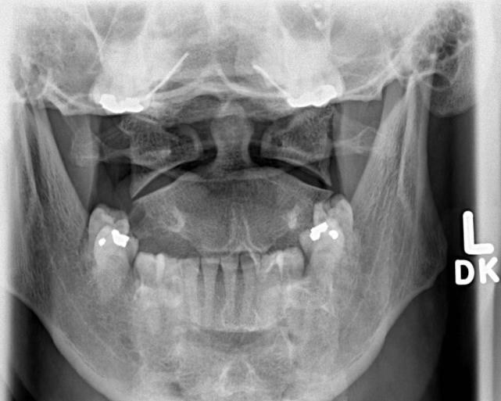
teeth and base of
skull Dens

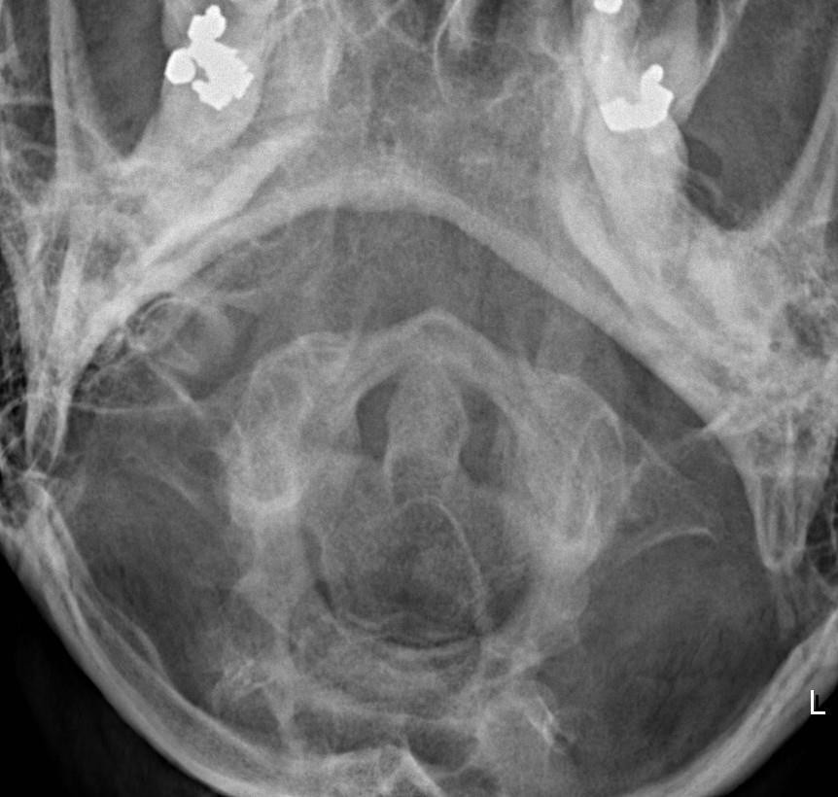
Dens seen below chin but above base of skull

Fuchs

AP Axial Projection

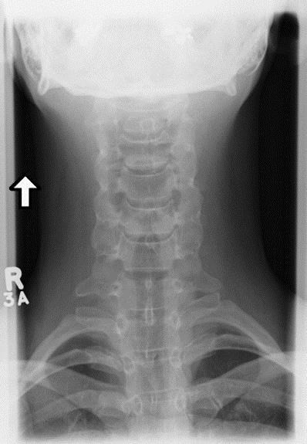
Mandibular angles equal distance from cervical vertebrae

C3 to T2

Open intervertebral disc spaces

Spinous processes midline

AP Axial Oblique Projection

Chin not overlapping C1 and
C2

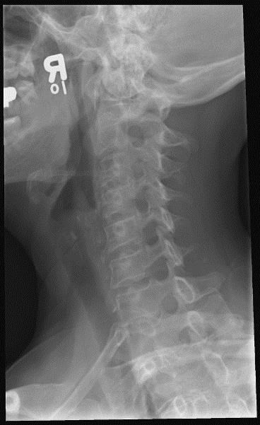
Open intervertebral disc spaces

Open vertebral
foramina of the side furthest from IR

Flexion/Extension Views
- Assesses mobility of the cervical vertebrae.
- Demonstrates natural spinal curvature, range of spinal motion (important for Rheumatoid Arthritis and intubation) and ligament stability (whiplash type injury).
- Trauma patients: Flexion extension views are often ordered following a c-spine series to allow the physician to clear the spine of injury. Physicians are responsible for removing the collar and must be present for all trauma flexion/extension exams.
- Due to the nature of this exam, selection of manual technical factors is recommended to ensure proper penetration.

Flexion Lateral Projection
- Patient will flex their head forward bringing chin as close as possible to chest.
- Central ray horizontal to C4 at a minimum 180 cm (72”) SID.
- Suspend respiration.

Evaluation Criteria
C4 centered to IR.
All anatomy from sella turcica to T1.
Spinous processes should be well separated. Soft tissue included.

Note: Clivis is a slanted structure extending posteriorly off the sella turcica. It is used to determine cervical injury (A line drawn along the clivis points to the tip of the dens in a normal patient).

Extension Lateral Projection
- Have the patient elevate their chin as much as possible.
- Central ray horizontal to C4 at a minimum 180 cm (72”) SID.
- Suspend respiration.

Evaluation Criteria
C4 centered to IR.
All anatomy from sella turcica to T1.
Spinous processes should be in close proximity. Soft tissue included.

Flexion Lateral Projection

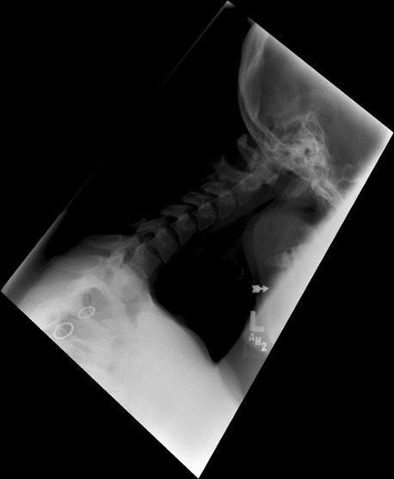
C1 to at least 1/3 of T1 included
Arrow to indicate flexion view

Extension Lateral Projection

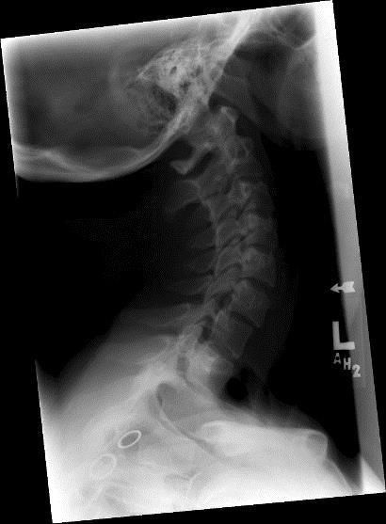
C1 to at least 1/3 of T1 included

Arrow to indicate extension view

Chest

PA Projection

- Should be performed in PA upright position whenever possible to demonstrate air fluid levels in the chest and upper abdomen. Erect positioning also allows for the diaphragm to go to its lowest level and engorgement of the pulmonary vessels is avoided.
- Central ray perpendicular to the midsagittal plane at the level of T7 (inferior angle of the scapula).
- SID is 180 cm (72”) to compensate for the OID and reduce magnification of the heart and lung details.
- Suspend respiration on second full inspiration.
- Use 100-130 kVp to penetrate the heart shadow to see the thoracic vertebrae, and demonstrate long scale contrast for lung detail.

Evaluation Criteria
Entire lung fields from apices to costophrenic angles included.
Proper mid-coronal positioning when 2.5 cm ( 1”) of the apices above the clavicles, manubrium at level T4, and no foreshortening of heart and lungs demonstrated
Clavicles seen horizontal.
No rotation: SC joints equidistant from the vertebral column.
Air filled trachea visible in midline.
Bronchial tree is shown from an oblique angle.
Faint shadow of the ribs and thoracic vertebrae seen through the heart shadow. Scapulae projected outside lung field.
Lung markings from the hilum to the lung periphery. 10 posterior ribs above the diaphragm (optimal).

How to Fix it
Increased amount of apices above clavicles, manubrium at T5 or lower, and heart and lungs are foreshortened.
  - Superior mid-coronal plane is tilted forward or too much caudad angle used. Tilt upper body backward or use less angle.
Less than 2.5 cm (1”) of apices are seen, manubrium at the level of T1-T3, and heart and lungs are foreshortened.
  - Superior mid-coronal plane is tilted backward or not enough angle used. Tilt upper body forward or angle caudad more.

PA Expiration Projection
- Demonstrates: pneumothorax and foreign body.
- 8 posterior ribs or fewer are seen
- Marker indicating expiration.
- May need to increase mAs. Lungs are denser with less air in them.
- Heart shadow appears broader and shorter.

Lateral Projection
- Central ray perpendicular to the detector, entering the mid-coronal plane at the level of
T7 at a minimum SID of 180 cm (72”).
- Suspend respiration on second full inspiration.

Evaluation Criteria

Apices to costophrenic angles
Arm and soft tissues not overlapping the superior lung field.
Long axis of the lung field demonstrated in vertical position with no forward or backward leaning (leaning causes distortion).
Hilum in center of the radiograph.
Ribs posterior to the vertebra are nearly superimposed. No more than 1.25 cm (0.5”)
between them.
Open thoracic intervertebral spaces and foramina (except in patients with scoliosis), no tilt.
Penetration of the lung fields and the heart. Sharp outlines of the diaphragms and heart.
Right lung and diaphragm are higher than the left (caused by the liver).
T11 is superimposed by the lung fields. When the hemi-diaphragms are inferior to T11 and dividing the body of T12, this indicates full aeration. To locate T11: Find T12 with the 12th rib attachment or follow the curvature of the spine. The T spine is kyphotic and the L spine is lordotic. Just above where you see the slight change in curvature is T12.
Sternum in profile, no rotation.

How to Fix it
Right hemi-diaphragm is inferior to the left.
  - The hips are tilted towards the IR ensure the patient is not leaning against the IR.

Lateral Decubitus Projection (right/left)
- Fluid in the pleural cavity: affected side down. Free air in the pleural cavity: affected side up.
- Patient should lie in this position for at least 5 minutes to allow the fluid to settle and the air to rise.
- If the patient is lying on the affected side, raise the body on a sponge or folded blanket 5-7 cm (2-3)”.
- AP projection only with the patient positioned away from the back edge of the stretcher and a sponge placed between the upright detector and the patient’s back. Have patient’s knees flexed for stability.
- Ensure brakes on stretcher are engaged.
- Central ray horizontal and perpendicular to the center of the cassette 7.5cm (3”) below the jugular notch).
- Suspend respiration on full inspiration. Exposure is made after the second full inspiration to ensure maximum expansion of the lungs.

Evaluation Criteria

Collimate to include the entire lung fields. Apices to costophrenic angles
No rotation: Clavicles equidistant from the spine. Lateral aspect of the clavicles projected upwards.
Patient arms not seen in the field of interest. Raising the arms above the head move the scapula outside the lung field.
9-10 posterior ribs.
Properly mark the appropriate side and include an arrow.

Note: Pneumothorax: absence of lung markings. ( affected side up if possible)
Pleural Effusion: due to a presence of fluid a darker radiograph is acceptable.(affected side down if possible)
Lateral Decubitus chest can better detect smaller amounts of fluid in the pleural space than either the erect PA/lateral images.

AP Supine Chest

Evaluation Criteria
Entire lung fields from apices to costophrenic angles.
Proper mid-coronal positioning if you see: 2.5cm (1”) of the apices above the clavicles, manubrium at level of T4, and no foreshortening of heart and lungs
Clavicles seen horizontal.
No rotation: SC joints equidistant from the vertebral column.
Air filled trachea visible in midline.
Bronchial tree is shown from an oblique angle.
Faint shadow of the ribs and thoracic vertebrae seen through the heart shadow. Scapulae projected outside lung field.
Lung markings from the hilum to the lung periphery. 8-9 posterior ribs above the diaphragm.

Coning to AC joints

2.5 cm (1” )of apices above
clavicle
Scapulae off of
lung field

PA Projection

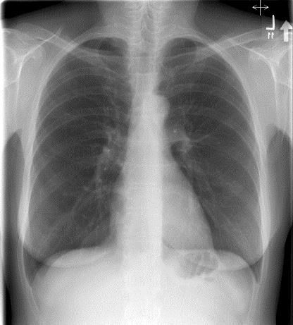
Arrow indicating upright
SC joints equidistant from vertebral column (no rotation)

Ribs and vertebrae seen through heart shadow (adequate penetration)

10 posterior ribs above diaphragm

1

Arrow indicating
upright

Lateral Projection
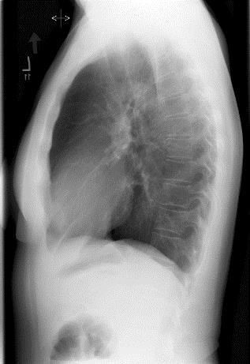
Arms off of lung
field
Lung field in vertical position (no forward or backward leaning)

Lateral sternum (no
rotation)
Ribs superimposed (no rotation)

Open intervertebral
foramina

Open intervertebral
spaces

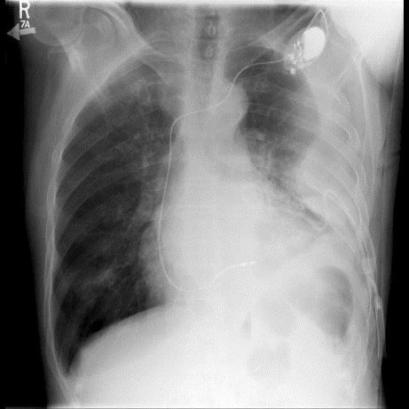
Arrow indicating side up

Left Lateral Decubitus Projection

Arms elevated
SC joints equidistant from vertebral column

Ribs and vertebrae seen through heart shadow (adequate penetration)

9-10
posterior
ribs

Clavicle

AP Projection
- Palpate the medial and lateral ends to find centering point.
- Central ray perpendicular to mid-clavicle.
- Suspend respiration on Expiration for a more uniform density across the length of the clavicle.

Evaluation Criteria
Lateral half of the clavicle above the scapula, with the medial half superimposing the thorax.
Entire clavicle centered on the image. Uniform density.
Note: 80% of fractures – middle 1/3 and 15% of fractures – lateral 1/3.

How to Fix it
The medial end of the clavicle is drawn away from the vertebral column and the clavicle is longitudinally foreshortened.
  - The patient is rotated towards the affected shoulder. Adjust patient position to a true AP.

AP Axial Projection
- Central ray 15-30º cephalad and perpendicular to mid-clavicle. Thinner patients require more angulation to project the clavicle off the ribs and scapula.
- Suspend respiration at the end of full Inspiration to further elevate the clavicle.
- A manual technique is preferred for this projection due to the difficulty with precise centering.

Evaluation Criteria
Medial end superimposes 1st and 2nd ribs. Lateral and middle thirds of the clavicle are superior to the acromion. The clavicle bows slightly upwards and is horizontal.
Entire clavicle along with the AC and SC joints.
The axial demonstrates a non-displaced fracture that can’t be demonstrated in the AP projection due to overlap of the scapula and ribs.
Upright arrow to indicate axial projection.

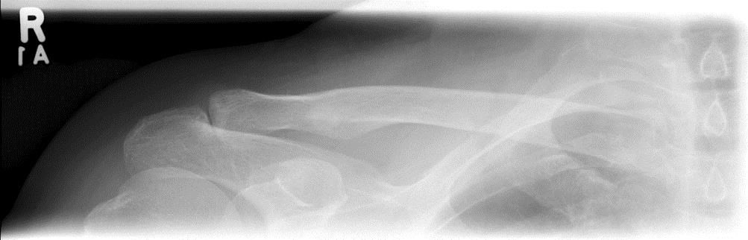
AP Projection

Lateral half
above
scapula Medial half
superimposing
thorax

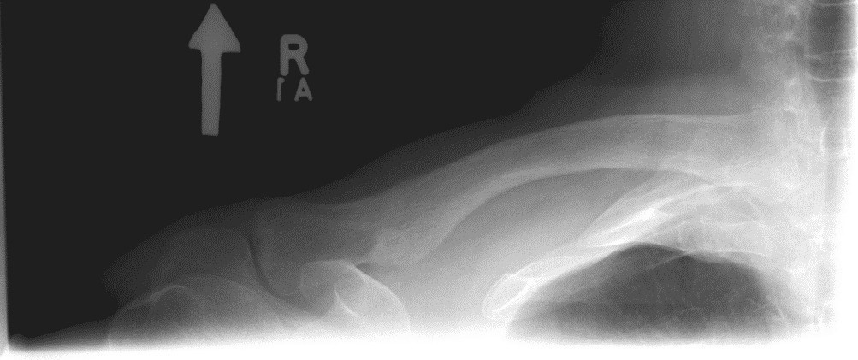
AP Axial Projection

Medial end superimposing 1st and 2nd rib

Lateral and middle thirds
above scapula

Clavicle in horizontal placement

Coccyx

Protocol states that Coccyx and Sacrum should be imaged separately on both the AP and Lateral projections.

AP Axial Projection
- Same patient position as the sacrum.
- Central ray is angled 10º caudad entering 5cm (2”) above the symphysis pubis.
- Suspend respiration.

Evaluation Criteria
Coccygeal segments free of superimposition. Short scale contrast.
No rotation. Entire coccyx.
Tight coning to reduce scatter and improve detail (will reduce the amount of irradiated tissue for the female patient).

Lateral Projection
- Central ray perpendicular and directed to the level of the ASIS, to a point 8 cm (3.5”) posterior and 5cm (2”) inferiorly.
- Place lead blocker on the table behind the patient to absorb scatter radiation and improve the quality of the radiograph.
- Suspend respiration.

Evaluation Criteria
Coccyx in profile
Tight collimation to include entire coccyx
The exposure for lateral coccyx should be 50% less than lateral sacrum.

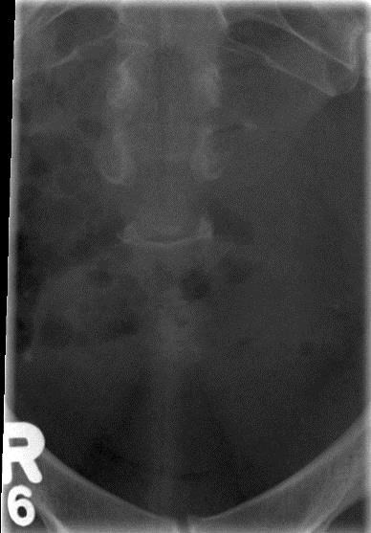
AP Axial Projection

Entire coccyx
Coccygeal segments free of superimposition

Lateral Projection

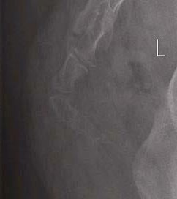
Entire coccyx in profile

E

- Elbow

Elbow

AP Projection
- CR perpendicular to the elbow joint 2cm (0.75”) or distal to the medial condyle at an SID
of no less than 100cm (40”).

Evaluation Criteria
Radial head, neck, tuberosity slightly superimpose 0.6cm (0.25”) the lateral aspect of proximal ulna (no rotation).
Open elbow joint.
The coronoid is demonstrated on end, not in profile.
Radial tuberosity is in profile medially. Radius and ulna are parallel to each other.
Medial and lateral humeral epicondyles are in profile (no rotation). Soft tissue and bony trabeculation.

Note: Compensation for a flexed elbow: Place area of interest closest to the IR. If elbow cannot be extended more than 30º then take two separate partial AP projections.

How to Fix it
Capitulum is projected into the elbow joint space.
  - The CR is proximal to the elbow joint. Re-center the CR distally. Radial head is projected into the elbow joint space.
  - The CR is distal to the elbow joint. Re-center the CR proximally. Olecranon is moved away from the fossa.
  - The humerus is elevated and should be positioned in same plane as the forearm. Radial head is seen on end and capitulum-radial joint space is closed.
  - The distal forearm is elevated and should be positioned in the same plane as humerus.

AP Oblique Projection (Medial/Internal Rotation)
- Adjust the elbow to place its anterior surface at a 45º angle.
- CR perpendicular to the elbow joint 2cm (0.75”) distal to the medial condyle at an SID of
no less than 100cm (40”).

Evaluation Criteria
Coronoid process in profile and free of superimposition from the radial head.
Trochlear notch and medial aspect of the trochlea in profile. Trochlear-coronoid articulation open.
Radial head and neck superimposed on the ulna. Elongated medial humeral epicondyle.
Olecranon in the olecranon fossa. Soft tissue and bony trabeculation.

The radial head is anterior to the coronoid.
  - The elbow is obliqued more than 45^{o.} Rotate the elbow less a few degrees.
The radial head is posterior to the coronoid and does not entirely superimpose the ulna.
  - The elbow is obliqued less than 45^{o.} Rotate the elbow forward a few degrees. Olecranon is moved away from the fossa.
  - The elbow is flexed. Extend the elbow fully.

AP Oblique Projection (Lateral/External Rotation)
- Place the posterior of the elbow at a 45º angle.
- CR perpendicular to the elbow joint 2cm (0.75”) distal to the medial condyle at an SID of
no less than 100cm (40”).

Evaluation Criteria
Capitulum and radial tuberosity are in profile.
Radial head, neck, and tuberosity free of superimposition from the ulna. Radio-ulnar articulation is seen.
Open capitulum-radial articulation. Soft tissue and bony trabeculation.

How to Fix it
Radial head and tuberosity still superimpose the ulna.
  - The elbow is obliqued less than 45º Rotate the patient more.
Coronoid process superimposes a portion of the radial head and the radial head is no longer in profile.
  - The elbow is obliqued more than 45º Rotate the patient less.

Lateral Projection
- With muscular forearms elevate the wrist to place the forearm parallel with the cassette.
- CR perpendicular to the elbow joint at an SID of no less than 100cm (40”).

Evaluation Criteria
Open elbow joint.
Elbow flexed 90º. If elbow is not flexed 90º, it changes the appearance of the fat pads. Superimposed humeral epicondyles.
Radial tuberosity faces anteriorly.
Radial head partially superimposing the coronoid process. Olecranon process seen in profile.
Bony trabeculation and any elevated fat pads in the soft tissue at the anterior and posterior distal humerus and the anterior proximal forearm.

Note: In the case of injury to soft tissue around the elbow the joint should be flexed only 30 –
35º. This partial bend does not compress or stretch the soft structures as the 90º flexion does.

The radial head is distal to the coronoid process.
  - The distal forearm is positioned too close to the IR. Elevate the distal forearm until the humeral epicondyles are superimposed.
The radial head is positioned posteriorly on the coronoid process.
  - The proximal humerus is elevated. Place the humerus and forearm in the same plane.

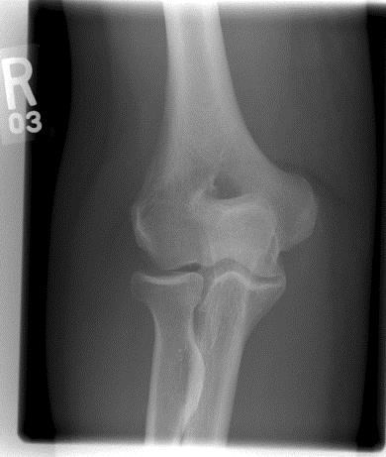
AP Projection

Open elbow
joint
Medial and lateral humeral epicondyles in profile (shows no rotation)

Radial head, neck, and tuberosity superimpose
ulna

AP Oblique Projection (Medial/Internal Rotation)

Radial head and neck superimposes
ulna
Olecranon in the olecranon fossa
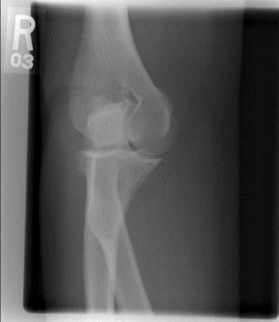
Trochlea in profile

Coronoid process in profile

AP Oblique Projection (Lateral/External Rotation)

Capitulum in profile

Radial head, neck, and tuberosity free of superimposition

Radial tuberosity in
profile

Open elbow joint

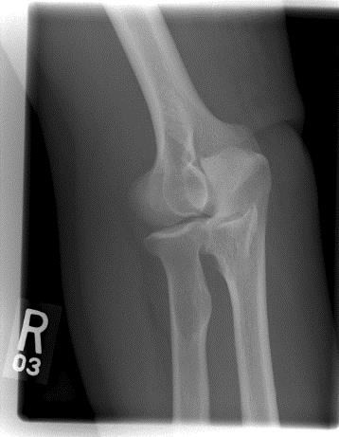
Radio-ulnar articulation

Lateral Projection

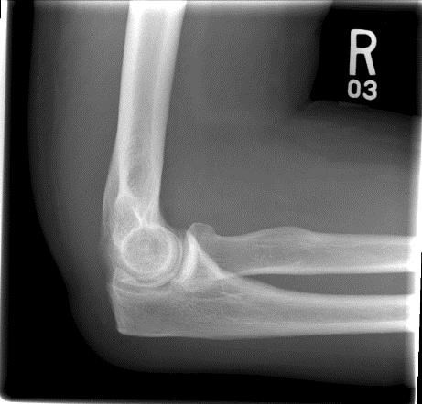
Elbow flexed 90o

Superimposed
humeral epicondyles

Open elbow
joint
Radial tuberosity faces anteriorly
Radial head partially superimposing coronoid process

Fat Pads:

Anterior fat pad: teardrop shaped, anterior to distal humerus
Posterior fat pad: deep within the olecranon fossa, not visible in a normal exam, may become visible if elbow is flexed greater than 90º
Supinator fat stripe: anterior to proximal radius, visualization may be indicative of radial head fracture.

F
    - Facial Bones
    - Femur
    - Fingers
    - Foot
    - Forearm

Facial Bones

PA Axial Projection (Caldwell 20º)
- OML is perpendicular to the IR.
- Central ray 20º caudad to exit the nasion at an SID of no less than 100cm (40”).
- When the orbital floors are the area of interest, use a 30º caudad angle to project the petrous ridges below the orbital margins.
- Suspend respiration.

Evaluation Criteria
Coning: include entire frontal bone, frontal sinuses, orbits, maxillae, anterior nasal spine, zygomatic bones and nasal septum.
Equal distance from the lateral border of skull to lateral border of orbit on both sides. Distance from the crista gali to the lateral cranial cortices is equal on both sides.
Crista gali and nasal septum aligned with long axis of the film. Slight head tilting does not change any anatomical relationships. Severe head tilting prevents tighter collimation.
Supraorbital rims are in the same horizontal plane.
Superior orbital fissures are within the orbits. Ethmoid sinuses centered.
Petrous ridges horizontally through infraorbital margins. Petrous pyramids superimpose the infraorbital rims.
Penetration of frontal bone without excessive density at lateral borders of skull.

How to Fix it
Larger distance from orbit to lateral border of skull on right side.
  - The head is rotated towards the left side.
Larger distance from orbit to lateral border of skull on left side.
  - The head is rotated towards the right side. Petrous ridges are in upper ½ of orbits.
  - Less than 20º caudad angle from the OML. More angulation required Petrous ridges are below the infraorbital margins.
  - More than 20º caudad angle from the OML. Less angulation required.

Parietoacanthial Projection (Waters)
- Central ray perpendicular to the acanthion at an SID of no less than 100cm (40”).
- Suspend respiration.

Evaluation Criteria
Coning: include the orbits, the maxillae, nasal septum, anterior nasal spine, zygomatic bones and the zygomatic arches.
Petrous ridges projected immediately inferior to the maxillary sinuses and extend laterally from posterior maxillary alveolar process.
The lateral margin of the orbit to the lateral margin of the skull should be equidistant on both sides.

How to Fix it
Maxillary sinuses superimpose the posterior molars and alveolar process.
  - The chin is too high. Lower the chin.
Petrous ridges are superior to posterior maxillary alveolar process and superimposing the maxillary sinuses.
  - The chin is too low. Raise the chin. This image MUST be repeated. If the patient is unable to raise the chin further and is in the PA position, angle CR caudad.

AP Axial Projection (Townes)
- OML is perpendicular to the IR.
- If OML cannot be aligned, then align IOML perpendicular to the IR and increase the central ray angle to 37º caudad.
- Central ray 30º caudad entering the glabella approximately 2.5 cm (1”) above the nasion
at no less than 100 cm (40”) SID.
- Suspend respiration.
- Rectangular (slit) collimation to include arches only.

TIP- Coning should include TMJ’s to gonion with CR passing through mid-zygomatic arch.

Evaluation Criteria
No overlap of zygomatic arches by mandible.
No rotation evident because arches are symmetric.
Zygomatic arches projected lateral to mandibular rami.

How to Fix it
Dorsum sellae and posterior clinoids is projected superior to the foramen magnum.
  - The chin is not tucked enough or less than 30º caudad angle was used. Lower the chin a bit or angle more.
Dorsum sellae is foreshortened and superimposes the posterior arch of the atlas.
  - The chin is tucked too much or more than 30º caudad angle was used. Raise the chin a bit or angle less.

Lateral Projection
- Side of interest closest to the IR.
- Adjust flexion so IOML is perpendicular to the front edge of the IR.
- Central ray perpendicular and entering the lateral surface of the zygomatic bone halfway between the outer canthus and the external auditory meatus (EAM) at no less than 100 cm (40”) SID
- Suspend respiration.

Evaluation Criteria
All facial bones in their entirety, with the zygomatic bone in the center to include mandible as per site protocol.
Almost perfectly superimposed mandibular rami. Superimposed orbital roofs.
No rotation of sella turcica.
Greater wings of the sphenoid are superimposed.

Submentovertical Projection (Basal)
- Central ray perpendicular to the IOML and entering the midsagittal plane of the throat at a level approximately 2.5cm (1”) posterior to the outer canthus no less than 100 cm SID.
- Suspend respiration.

Evaluation Criteria
Superimposition of the mental protuberance over the anterior frontal bone. Zygomatic arches free from overlying structures.
Zygomatic arches symmetric and without foreshortening. No rotation of head.

Note: Tangential view for Zygoma:

- Rotate midsagittal plane 15º TOWARD the affected side and tilt the top of the head 15º AWAY from the affected side.
- Central ray perpendicular to IOML and centered to the zygoma 3.75 cm (1.5”) posterior to the outer canthus.
- Useful in patients with depressed fractures or flat cheekbones.

Trauma Routine

- Do not adjust the head if cervical injury is suspected. Take the radiograph as is.
- The following techniques can be used for a supine patient on c-spine precautions.

AP Axial Projection (Caldwell 20º)
- If the chin is not tucked enough angle the central ray parallel with the OML then adjust the central ray 20º cephalad from this point.
- Greater magnification of the orbits.

How to Fix it
Petrous ridges are in upper half of orbits.
  - You have used less than 20º cephalad angle from the OML. Angle more. Petrous ridges are below the infraorbital margins.
  - You have used more than 20º cephalad angle from the OML. Angle less.

Acanthioparietal Projection (Waters)
- Angle the central ray cephalad to be parallel with the MML. If this is difficult to align or if the patient’s mouth is open, the central ray directed through the acanthion may be angled 37º cephalad from the OML.

How to Fix it
Maxillary sinuses superimpose the posterior molars and alveolar process.
  - You have used more than 37º cephalad angle from the OML. Angle less.
Petrous ridges are superior to posterior maxillary alveolar process and superimposing the maxillary sinuses.
  - You have used less than 37º cephalad angle from the OML. Angle more.

AP Axial Projection (Townes 30º)
- Angle the tube to be parallel with the OML then angle 30º caudad from this angle. Use the transverse collimator light to help you line up the tube parallel to the OML. Correction should not be more than 45º or distortion occurs.
- Central ray entering the glabella.

Lateral Projection (X-table)
- Place crosswise IR vertically against patient’s shoulder or place stretcher next to IR.
- Central ray perpendicular and entering the lateral surface of the zygomatic bone halfway between the outer canthus and the external auditory meatus (EAM).

Tangential Zygoma
- Angle the tube cephalad until the central ray is perpendicular to the IOML.
- Rotate the tube 15º from midsagittal toward the affected side.
- Angle of tube works like a tangential view.
- Two images are needed to get tangential of zygomatic arches in c-spine collar.

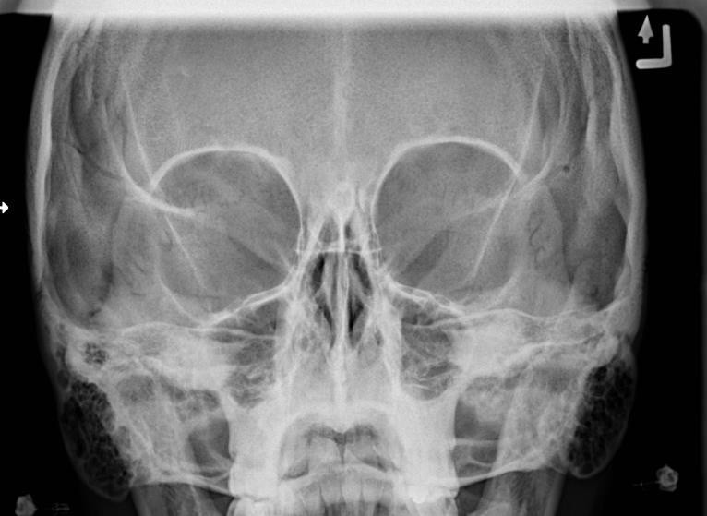
PA Axial Projection (Caldwell 20º)

Entire frontal bone
Equal distance from the lateral border of skull to lateral border of orbit

Nasal septum
Petrous ridges at the infraorbital margin of the orbit

Parietoacanthial Projection (Waters)

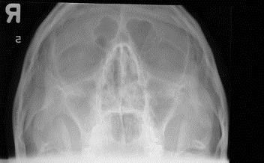
No rotation

Include zygomatic arches
Include maxilla

Petrous ridges immediately inferior to maxillary sinuses

AP Axial Projection (Townes)

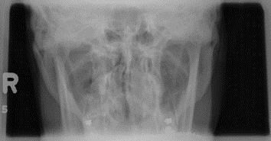
Zygomatic arch
projected lateral to mandibular rami

Arches
symmetrical
(shows no rotation)

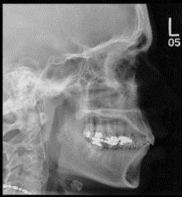
Lateral Projection

Sella turcica in profile (shows no rotation or tilt)

Superimposed orbital roofs (shows no tilt)

Superimposed mandibular rami (shows no rotation)

Include mandible

Submentovertical Projection (Basal)

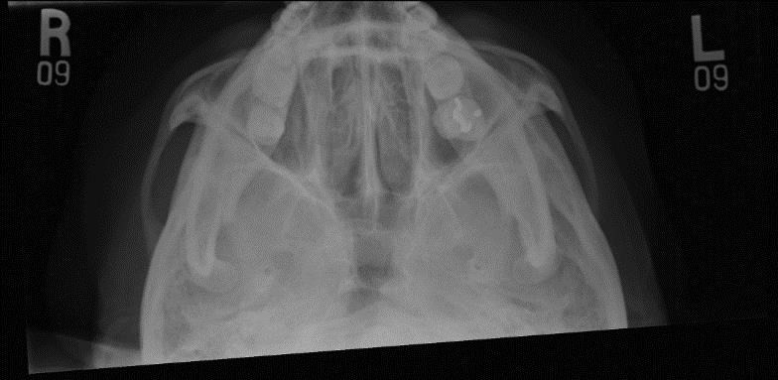
Zygomatic arches free from overlying structures

Femur

AP Projection
- Procedure manual states the majority of the femur with the joint nearest the injury (the second projection with minimal overlap to include the joint furthest from the injury).
- When possible, fractures and/or orthopedic devices should be demonstrated in their entirety on one of the images.
- Proximal Femur: Top of collimation field at the level of ASIS.
- Distal Femur: Central ray perpendicular to the mid-thigh
- SID no less than 100cm (40”).

Evaluation Criteria
Majority of the femur and the joint closest to the area of interest.
Femoral neck not foreshortened achieved by internally rotating the leg 15-20º.
Lesser trochanter not seen beyond the medial border of the femur or only a very small portion seen on the proximal femur.
Entire orthopedic device included if one is present.
Femorotibial joint space opened but narrowed. Anterior and posterior margins of the proximal tibia are superimposed.
Use gonadal shielding but be mindful that a patient with a femoral fracture could also have a pelvic fracture.
Trabecular detail on the femoral shaft.

Lateral Projection

Mediolateral: This positioning is not recommended for patients with suspected fracture or destructive disease. Cross table lateral projections are then recommended.
- Proximal Femur: Top of collimation field at the level of ASIS.
- Distal Femur: Central Ray perpendicular to the mid-thigh and the IR at an SID no less
than 100cm (40”).

Evaluation Criteria
Majority of the femur and the joint nearest to the area of interest. Any orthopedic device demonstrated in its entirety.
Femoral condyles are aligned on the distal femur.
Patella in profile.
Open patellofemoral joint space.
Inferior surface of the femoral condyles are not superimposed because of the divergent ray.
No overlap of the opposite leg on the affected femur (proximal femur).
Lesser trochanter in profile medially and the femoral neck superimposes the greater trochanter.
Trabecular detail.

Axiolateral Projection (Proximal and Distal Femur)

Proximal Femur Axiolateral Projection
- Patient supine and preferably arrives in the department on a stretcher with a hard slider board.
- Flex the patient’s unaffected leg until the femur is as close to a vertical position as possible then abduct the leg as far as the patient will allow. Support this leg with a leg holder.
- Angle the stretcher 40-70º to bring the femoral neck parallel with the IR.
- Use of a filter will even out the density between the thicker hip joint and the proximal shaft of the femur.
- Central ray is perpendicular to the long axis of the femoral neck at a distance no less
than 100 cm (40”).

Note: If a wall detector is not available, place an IR (with grid) against the patient’s affected side at the level of the iliac crest. Angle the lower border of the IR until it is parallel to the long axis of the femoral neck and forms a 45º angle with the femur. Ensure that the lead strips of the grid are in a horizontal position. The grid needs to be vertical and the tube needs to be centered to the grid or grid cut off could result.

Evaluation Criteria
Femoral neck demonstrated without overlap of the greater trochanter.
Small amount of the lesser trochanter on the posterior surface of the femur. Greater trochanter is superimposed by the femoral shaft.
Soft tissue shadows not overlapping the affected hip and femur. Hip joint demonstrated with acetabulum.
Any orthopedic device is included in its entirety. Ischial tuberosity posterior to the femoral head.

Distal Femur Cross-table (Mediolateral)
- Place the lateral aspect of the affected femur against the IR
- Decrease the amount of flexion in the unaffected leg and move the leg support distal to avoid obscuring area of interest.
- Ensure a minimum of 5 cm (2”) of overlap with the proximal image and include the proximal tibia and fibula.

AP Projection

Greater trochanter
in profile

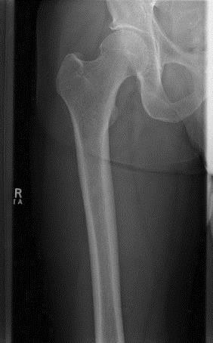
Femoral neck not
foreshortened
Lesser trochanter not seen (or only slightly beyond the medial border of femur)

AP Projection

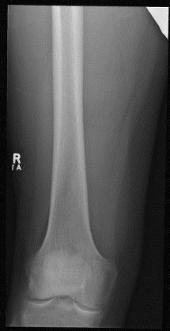
Femorotibial joint
space open

Lateral Projection

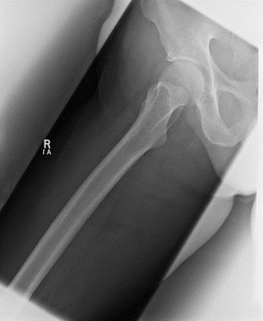
Greater trochanter superimposing femoral neck
Lesser trochanter in profile medially

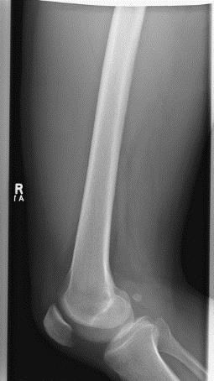
Lateral Projection

Open patellofemoral joint
space
Aligned femoral condyles

Axiolateral Projection

Femoral neck without overlap
from greater
trochanter

Small amount of
lesser trochanter
on the posterior surface of
femur

Hip joint with the acetabulum

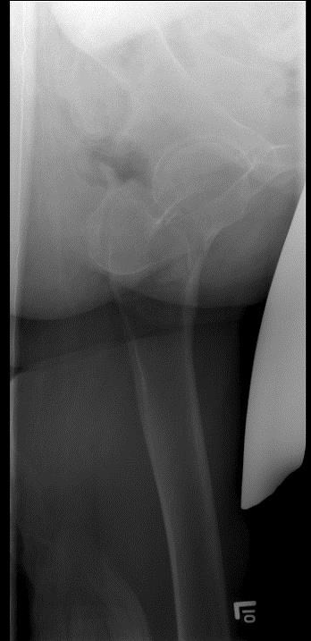
Small amount of greater trochanter on the anterior and posterior surfaces proximal femur (properly inverted)

Fingers
Protocol states to annotate digit of interest.

PA Projection
- Hand flat and fingers slightly separated.
- Central ray is perpendicular to the proximal interphalangeal joint of the affected digit at
no less than 100 cm (40”) SID
- Marker may be anterior or posterior.

Evaluation Criteria
Equal concavity of the metacarpal and phalangeal shafts on both sides (no rotation).
Equal amounts of soft tissue on both sides of the phalanges with no overlapping (no rotation).
Fingernails, if visualized, in the center of the distal phalanx (no rotation). Open metacarpal phalangeal and interphalangeal joints (hand is flat).
Soft tissue and bony trabeculation.

PA Oblique Projection
- Central ray is perpendicular to the proximal interphalangeal joint of the affected digit at
no less than 100 cm (40”) SID.
- Marker may be anterior or posterior.

Evaluation Criteria
Entire digit rotated at a 45º angle, including the distal portion of the adjoining metacarpal.
No superimposition of the adjacent digits over the proximal phalanx or metacarpal phalangeal joint.
Open interphalangeal and Metacarpal phalangeal joint spaces.

Lateral Projection
- Central ray is perpendicular to the proximal interphalangeal joint of the affected digit at
no less than 100 cm (40”) SID. .
- Marker may be anterior or posterior.

Evaluation Criteria
Entire digit in a true lateral position.
Fingernail in profile, if visualized and normal. Concave, anterior surface of the phalanx.
No obstruction of the proximal phalanx or metacarpal phalangeal joint spaces by adjacent digits.
Open interphalangeal and metacarpal phalangeal joint spaces.

PA Projection

PA Oblique Projection

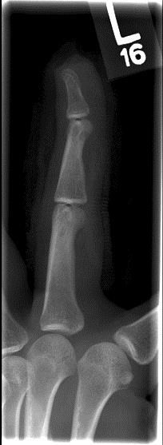
Open interphalangeal joints (shows hand is flat)

Entire digit rotated at a 45o
angle Open MCP joints (shows hand is flat)

Equal concavity both sides of metacarpals (shows no rotation)

No superimposition of the adjacent
digits

Open MCP joint

Lateral Projection

Open interphalangeal
joints

Entire digit in a true lateral position

Open MCP joint

Concave anterior surface of phalanx

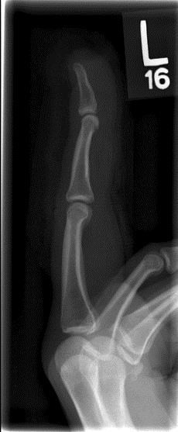
No obstruction of the proximal phalanx or MCP joint by adjacent digits

Foot

AP Axial or Dorsoplantar Projection

- Central ray 10º towards the heel at the base of the third metatarsal at no less than 100
cm (40”) SID.
Note: No angulation used if querying foreign body.

Evaluation Criteria
Visualization of the phalanges, metatarsals, and tarsals distal to the talus. No rotation of the foot.
Equal amount of space between the adjacent midshafts of the second through fourth metatarsals.
Slight overlap of the 2nd through 5th metatarsal bases.
Joint space between the medial (1st) and intermediate (2nd) cuneiforms is open. Tarsometatarsal and navicular-cuneiform joint spaces are open.
2cm (0.75 “) of the calcaneus is seen without talar superimposition.

AP Oblique Projection
- Rotate the patient medially until the plantar surface of the foot forms a 30º angle to the IR. If the foot is rotated more than 30º the lateral cuneiform is thrown over the other cuneiforms.
- If patient has a low arch rotate the patient’s foot 30º. If the patient has a high arch, then you may have to rotate the patients’ foot 45º. If the obliquity is not right the cuneiform cuboid space is closed.
- Central ray perpendicular to the base of the third metatarsal at an SID no less than
100cm (40”).

Evaluation Criteria
Equal amount of space between the shafts of the 2nd through 5th metatarsals.
1st and 2nd intermetatarsal joints are closed.
3rd-5th metatarsal bases free of superimposition.
Tuberosity of the base of the 5th metatarsal should be seen in profile. Lateral tarsometatarsal and intertarsal joints seen open
Cuboid shown in profile (joints spaces around cuboid open). Sinus Tarsi is demonstrated.
Sufficient density to demonstrate the phalanges, metatarsals, and tarsals.

Mediolateral Projection
- Dorsiflex the foot 90º.
- Rotate the patient and affected leg until the lateral foot surface is parallel against the IR.
- Central ray perpendicular to the base of the third metatarsal

Evaluation Criteria
Distal fibula superimposed over the posterior half of the distal tibia.
Tibiotalar joint open.
Heads of the metatarsals nearly superimposed.
Approximately 1.25 cm (0.50”) of the cuboid seen inferiorly to the navicular on the average patient.
Sufficient density to demonstrate the superimposed tarsals and metatarsals.

How to Fix it
Navicular superimposes most of the cuboid (lateral talar dome is proximal).
  - Proximal tibia is elevated. Extend the knee positioning the leg parallel with the IR. More than 1.25 cm (0.5”) of cuboid is visualized distal to the navicular (medial talar dome is proximal).
  - The distal tibia was elevated. Position the leg parallel with the IR.

Weight Bearing Lateral Projection
- Longitudinal arch is best demonstrated on weight bearing views.
- Talar domes superimposed when patient’s foot is in true lateral position.
- On the average patient the amount of the cuboid distal to the navicular is 1.25cm (0.50”). Weakening of the tendons and ligaments that support the bones of the foot cause the arch to fall. This is seen as less cuboid is demonstrated below the navicular.

AP Axial Projection

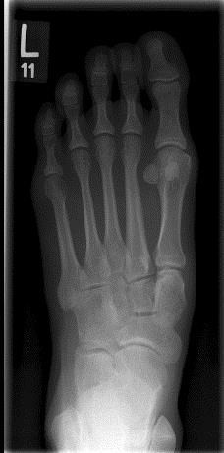
Equal amount of space between the adjacent mid- shafts of the 2nd-4th metatarsals

Tarsometatarsal joint spaces
open

Open joint space between medial and intermediate cuneiform

AP Oblique Projection

5th metatarsal tuberosity
Cuboid in profile

3rd-5th metatarsal bases free of superimposition

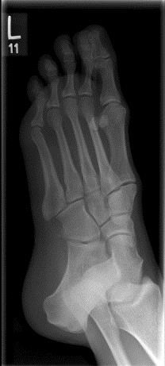
Sinus Tarsi

Lateral Projection

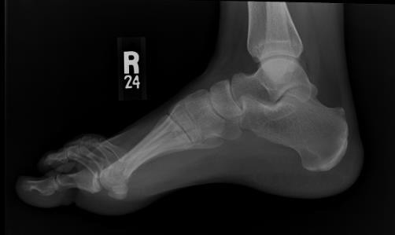
Heads of the metatarsals nearly superimposed

Forearm

AP Projection
- In cases of a fracture, you may not be able to position both the wrist and elbow joints in an AP position. In this case position the joint closest to the fracture in a true AP. It may be necessary to do a PA instead of an AP.
- CR perpendicular to the mid forearm at no less than 100 cm (40”) SID.

Evaluation Criteria
Medial and lateral humeral epicondyles are demonstrated in profile. Olecranon is within the fossa and the coronoid is seen on end.
Radial head articulating surface is visualized. Elbow joint partially closed (divergent rays).
Slight superimposition of approximately0.6 cm (0.25”) of the radial head, neck, and tuberosity over the lateral aspect of the proximal ulna. Capitulum-radial joint either partially or completely closed.
Include proximal row of carpal bones.
Similar radiographic densities of the proximal and distal forearm.

How to Fix it
The radius is overlapping the ulna at its proximal 3rd.
  - The hand is pronated. Place the wrist in a true AP position.
The olecranon is moved away from the fossa and the coronoid is shifted proximally.
  - The humerus is elevated and the elbow is flexed. Position the humerus in same plane as the elbow and wrist.

Lateral Projection
- Shoulder joint, humerus and elbow lie in the same plane, elbow flexed 90 degrees.
- Adjust the limb in a true lateral position, thumb side up.
- Central ray perpendicular to mid-forearm at a no less than 100 cm (40”) SID.

Evaluation Criteria
Elbow flexed at 90º. Poor elbow positioning will displace the fat pads. These fat pads may indicate an elbow injury.
Superimposed humeral epicondyles.
Radial head superimposes the coronoid process.
Radial tuberosity facing anteriorly.
Proximal row of carpal bones to distal humerus well demonstrated.
Wrist in a true lateral. Distal scaphoid and pisiform superimposed and anterior to the capitate and lunate. Ulnar styloid in profile. Superimposition of the distal radius and ulna.
Soft tissue and bony trabeculation.

How to Fix it
Elbow joint space is closed, the radial head is distal to the coronoid, and the capitulum is more anterior.
  - The proximal end of the forearm is thicker and therefore elevated. Raise the distal end of the forearm.
Elbow joint space is closed, the radial head is placed proximal to the coronoid, and the capitulum is posterior to the medial trochlea.
  - The distal end of the forearm is thicker and therefore elevated. Raise the proximal end of the forearm.

AP Projection

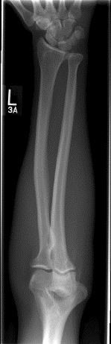
AP wrist with no rotation

Radial head, neck, and tuberosity slightly superimposing
ulna

Medial and lateral humeral epicondyles in profile

Lateral Projection

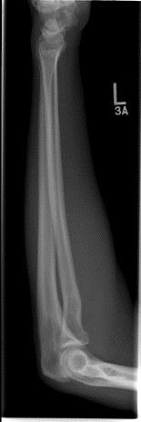
Wrist in true lateral

Elbow flexed 90o

Superimposed
humeral epicondyles

Radial head superimposes the coronoid process

H

Hand
    - Hip

Humerus

Hand

PA Projection
- Hand flat and fingers slightly separated.
- Central ray is perpendicular to the 3rd metacarpophalangeal joint at no less than 100cm
(40”) SID.

Evaluation Criteria
All anatomy distal to the radius and ulna.
Equal concavity of the metacarpal and phalangeal shafts on both sides (no rotation).
Equal amounts of soft tissue on both sides of the phalanges with no overlapping (no rotation).
Open metacarpophalangeal and interphalangeal joint spaces (hand is flat). Fingernails, if visualized, in the center of the distal phalanx (no rotation).
Soft tissue and bony trabeculation.

How to Fix it
Hand is in a slightly medial oblique position and the thumb is in a lateral position.
  - The hand is relaxed. Fully extend the fingers.

PA Oblique Projection
- Keep the fingers extended but separated. This will open up the interphalangeal joints.
- Central ray perpendicular to the 3rd metacarpophalangeal joint.

Evaluation Criteria
All anatomy distal to the radius and ulna.
Digits separated slightly with no overlap of soft tissue.
Open interphalangeal and metacarpophalangeal joint spaces.
Slight overlap of the 3rd through 5th metacarpal bases and heads. Minimal overlap of the 3rd- 4th and 4th -5th metacarpal shafts.
Separation of the 2nd and 3rd metacarpals. Soft tissue and bony trabeculation.

Lateral Projection
- Fan the fingers to see each digit individually.
- If patient cannot fan the fingers, then a slightly flexed position of the fingers will demonstrate anterior or posterior displacement in fractures of the metacarpals. An extended finger lateral will demonstrate foreign bodies.
- Central ray perpendicular to the 2nd metacarpophalangeal joint at no less than 100 cm
(40“) SID.

Evaluation Criteria
Superimposed distal radius and ulna. Individual phalanges on a fan lateral.
Superimposed metacarpals. Thumb free of superimposition.
Each bone outlined through the superimposed shadows of the other metacarpals.

PA Projection

Open MCP
joints (shows hand is flat)
Open
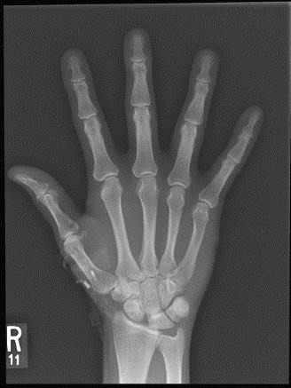
interphalangeal
joints (shows hand is flat)

Equal concavity on both sides of metacarpals (shows no rotation)

PA Oblique Projection

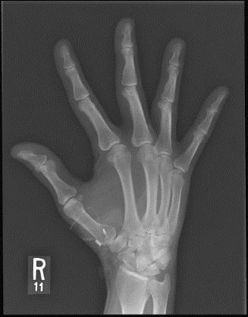
Open interphalangeal joints (shows fingers are straight)

Separation of the 2nd and 3rd metacarpals
Digits separated (no soft tissue overlap)

Minimal overlap of 3rd-4th and 4th- 5th metacarpal shafts

Lateral Projection

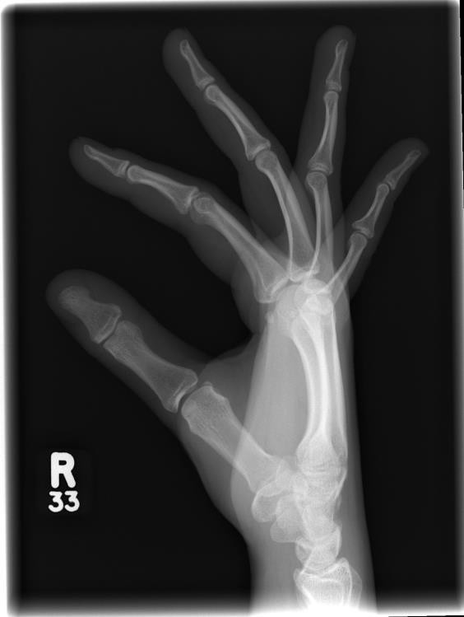
Individual phalanges in fan lateral

Thumb free of superimposition
Superimposed metacarpals

Common Pathologies:
Boxer’s Fracture: transverse fracture seen at the neck of the 5th metacarpal with palmar angulation of the distal fragment.
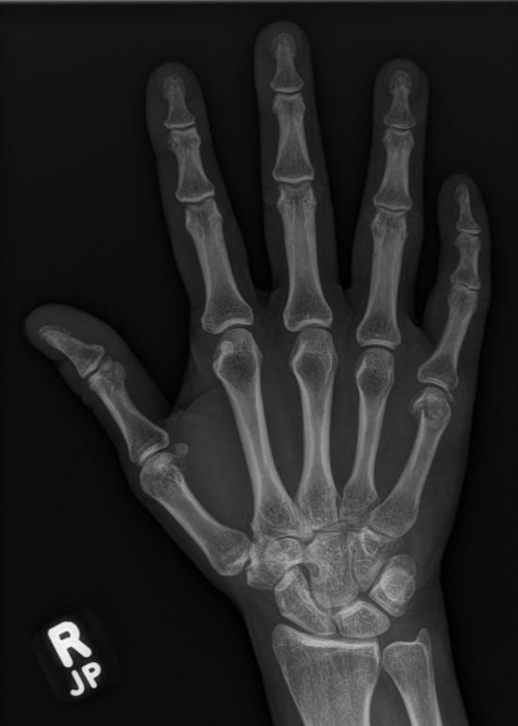

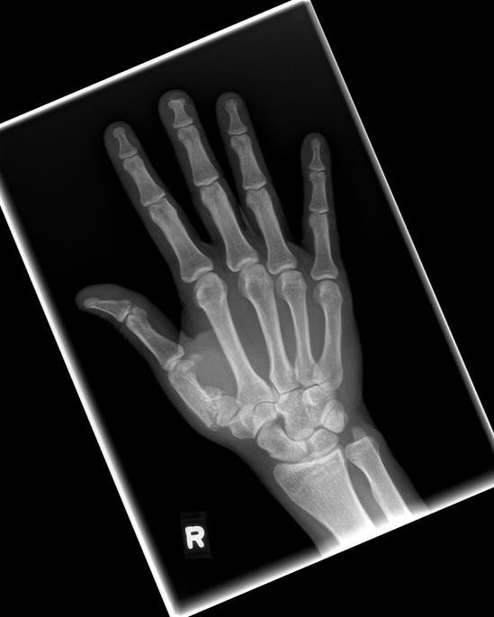
Bennett’s Fracture: fracture of the base of the 1st metacarpal.

Hip

AP Projection
- Central ray perpendicular to the femoral neck at no less than 100 cm (40”) SID
- Internally rotate affected leg 15-10 degrees unless trauma indicated
- Suspend respiration.

Evaluation Criteria
Regions of the ilium and pubic bones adjoining the pubic symphysis are included.
Should visualize half of the sacrum and symphysis pubis.
Ischial spine is aligned with pelvic brim, sacrum and coccyx aligned with symphysis pubis and obturator foramen is open.
Include from ASIS to the proximal 1/3rd of the femur.
Femoral head, penetrated and seen through the acetabulum.
Entire long axis of the femoral neck demonstrated not foreshortened. Greater trochanter in profile.
Lesser trochanter is usually not projected beyond the medial border of the femur, or only a very small amount of the trochanter is seen.
Any orthopedic appliance demonstrated in its entirety.

Note: If querying trauma, include orthopedic sphere at level of hip joint.

Lateral Projection - Lauenstein
- Rotate the patient toward affected side enough to allow them to flex their leg 60-70º and abduct it 45º.
- Central ray perpendicular through the hip joint 3.75cm (1.5”) medial to the ASIS at the level of the symphysis pubis).
- Suspend respiration.

Evaluation Criteria
Hip joint centered.
Obturator foramen closed due to patient rotation. Femoral neck superimposes the greater trochanter. Lesser trochanter demonstrated medially.
Any orthopedic appliance included in its entirety.

How to Fix it
The greater trochanter is positioned medially.
  - The knee was flexed more than required. Decrease the knee flexion until the femur is aligned at a 60 to 70º angle to the tabletop.

Note: Cross-Table hip is done in cases of possible hip fracture or recent surgery.

Axiolateral Projection (Cross Table Lateral)
- Patient supine and preferably arrives in the department on a stretcher on a hard slider board.
- Flex the patient’s unaffected leg until the femur is as close to a vertical position as possible then abduct the leg as far as the patient will allow. Support this leg with a leg holder.
- Angle the stretcher 40-70º to bring the femoral neck parallel with the IR.
- Use of a filter will even out the density between the thicker hip joint and the proximal shaft of the femur.
- Central ray is perpendicular to the long axis of the femoral neck at no less than 100 cm
(40”) SID..

Note: If wall detector is not available, place the IR with grid against the patient’s affected side at the level of the iliac crest. Angle the lower border of the IR until it is parallel to the long axis of the femoral neck and forms a 45º angle with the femur. Ensure that the lead strips of the grid are in a horizontal position. The grid needs to be vertical and the tube needs to be centered to the grid to avoid grid cut off.

Evaluation Criteria
Hip joint with acetabulum id included.
Ischial tuberosity posterior to the femoral head. Femoral neck seen without foreshortening.
Greater trochanter is superimposed by the femoral shaft.
The lesser trochanter in profile on the posterior surface of the femur.
Soft tissue shadows not overlapping the affected hip. Any orthopedic device is included in its entirety.

Clements- Nakayama Method
- This method used when patient is supine and unable to elevate legs, or when querying bilateral hip fractures.
- Do not internally rotate the limb. Leave as is.
- Bring patient’s affected side as close to the IR as possible.
- Adjust the IR to bring the lower margin below the patient.
- Angle the stretcher to bring the femoral neck parallel to the IR (40-70º).
- Direct central ray 15-30º posteriorly (down) and tilt IR to match this angulation at a SID
no less than 100 cm (40 “).
- Center to the femoral neck.
- Suspend respiration.

Note: Technique used for Clements-Nakayama will be less than is used for cross-table hip.

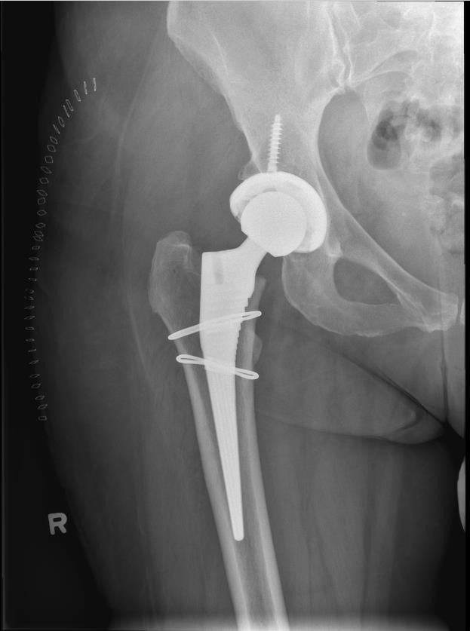
AP Projection

Femorl head penetrated through
acetabulum

Femoral neck not foreshortened

Greater trochanter in profile

Lesser
trochanter not seen (or only
slightly beyond medial border of
femur)

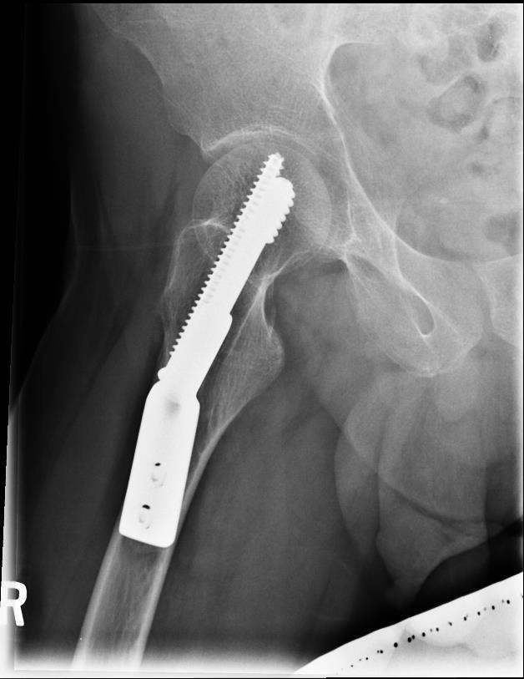
Lateral (Lauenstein) Projection

Lesser trochanter demonstrated
medially
Femoral neck superimposing greater trochanter

Axiolateral Projection

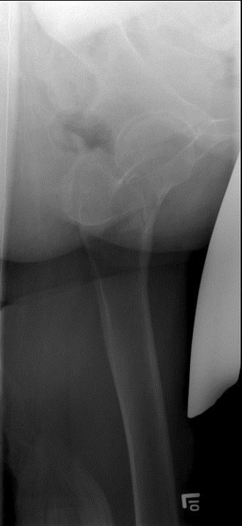
Femoral neck without overlap
from greater
trochanter

Hip joint with the acetabulum
Small amount of greater

Small amount of
lesser trochanter
on the posterior surface of
femur

trochanter
on the anterior and posterior surfaces proximal femur (properly inverted)

Humerus

AP Projection
- Abduct the arm slightly and supinate the hand ensuring the epicondyles are parallel to the IR.
- All projections should be performed upright if possible (either standing or seated) for patient comfort.
- In cases of possible fracture or recent fracture recheck with patient still in a brace: DO NOT EXTERNALLY ROTATE THE HAND. This increases the chance of radial nerve damage. Instead rotate the patient’s body 35-40º toward the affected humerus to place the greater tubercle in profile. Depending on the amount of rotation at the humeral fracture site the humeral epicondyles may or may not be parallel to the IR. If the fracture is closer to the elbow rotate the patient’s body to place the epicondyles parallel to the IR. In this case the greater tubercle may or may not be in profile.
- Suspend respiration.
- Central ray perpendicular to the mid-portion of the humerus at a minimum SID of 100 cm
(40”).

Evaluation Criteria
Elbow and shoulder joints included.
Humeral head and greater tubercle are demonstrated in profile.
Outline of the lesser tubercle between the greater tubercle and the medial aspect of the humeral head is visualized.
Maximal visibility of epicondyles without rotation.
Visualize 2.5cm (1”) below the elbow joint with the radial head and tuberosity superimposing the lateral aspect of the ulna by 0.6cm (.25”).Beam divergence possibly closing the elbow joint.

Note:
- If the upper arm measures more than 12.5 cm (5”) or you are using above 70kVp, use a grid to absorb scatter and improve detail.
- There is usually not a great variation in density from the proximal to distal humerus. However, if there is a large difference in density, use a compensating filter or the Anode- Heel Effect (Density greater under the cathode (shoulder) and less under the anode (elbow).

How to Fix it
The humeral epicondyles are not demonstrated in profile, the radial head and tuberosity do not superimpose the ulna, and the cortical margin of the lesser tubercle is not shown halfway between the greater tubercle and humeral head.
  - The arm was externally rotated more than the required amount. Internally rotate the arm until the humeral epicondyles are positioned parallel with the IR.
A fracture is present at the distal humerus. On the AP projection, the elbow is in a true AP position but the glenohumeral joint space is well demonstrated, indicating that this image was taken with the patient rotated toward the humerus.

  - The joint closer to the fracture is properly positioned, therefore no repositioning is required.

Lateral Projection (Mediolateral)
- Patient is PA where possible to reduce OID and increase detail. Elbow flexed 90º.
- Rotate the humerus internally (palm up) while body remains in a true PA position. If the body rotates there is an increase of shoulder tissue over the humerus.
- Central ray perpendicular to the mid-portion of the humerus no less than 100 cm (40”)
SID.

Evaluation Criteria
Shoulder and elbow joints included.
Greater tubercle superimposed over the humeral head.
Lesser tubercle in profile medially. Superimposed humeral epicondyles.
Beam divergence may partially close the elbow joint.
Most of the radial head is demonstrated anterior to the coronoid process and the radial tuberosity is seen in profile.

How to Fix it
The density is lighter at the proximal humerus than at the distal humerus.
  - The patient’s body is not in a true PA position; the torso is rotated toward the humerus. Properly position the patient.
  - Alternatively, the patient is properly positioned and the technique selected was not sufficient to adequately penetrate the proximal humerus. Set a higher technique and consider using a compensating filter for the repeat.

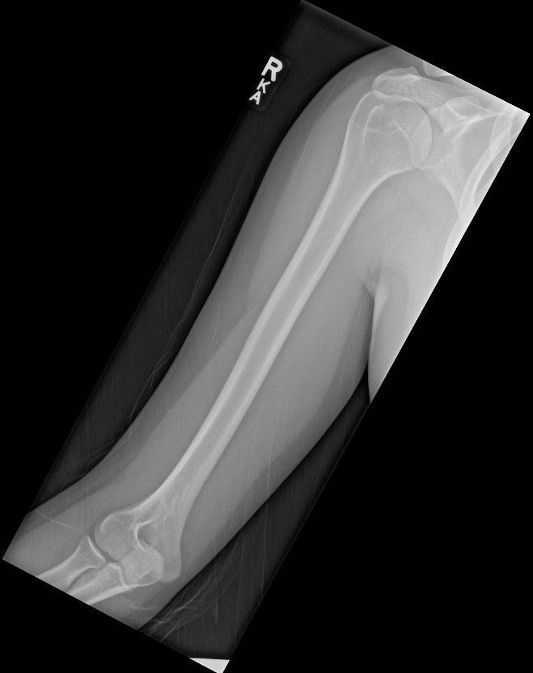
AP Projection

Greater
tubercle in Humeral head in
profile

Radial head, neck, and tuberosity slightly superimposing ulna

Lateral Projection

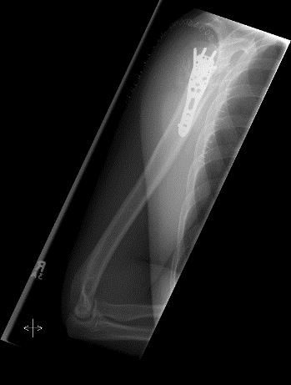
Lesser tubercle in profile

Superimposed
humeral epicondyles

K
    - Knee
    - KUB

Knee

AP Projection

Note: PA verses AP positioning: when examining the patient PA no central ray angulation is required.
Knee images can be taken with or without a grid. Central ray is directed 1.25cm (0.5”) below the
patellar apex no less than 100cm (40”) SID.
- If patient is supine an angle may be required, amount needed varies on patient body habitus.
< 19 cm (small pelvis) 3 - 5 degrees caudad 19 - 24 cm 0 degrees
> 24 cm (large pelvis) 3 - 5 degrees cephalad
If querying osteoarthritis, weight bearing will best demonstrate this pathology. Follow site protocol.

Evaluation Criteria
Knee fully extended if the patient’s condition permits.
Include 1/4 of the distal femur and proximal tibia. Femorotibial joint seen open.
Medial and lateral femoral epicondyles in profile and symmetrical.
Intercondylar eminence centered in the intercondylar fossa. Interspaces of equal width demonstrated on both sides
Fibular head slightly superimposed by the tibia and 1.25 cm (0.5”) distal to the tibia plateau.
Patella completely superimposed by the femur. Bony detail surrounding the patella seen.
Soft tissue around the knee joint included.

Note: Non Extendible Knee: Align central ray perpendicular with the anterior tibia adjusting it parallel with the tibial plateau.

How to Fix it
Medial femoral condyle appears larger and the fibular head, neck, and shaft are superimposed by the tibia.
  - The leg is externally rotated. Rotate the leg internally until the femoral epicondyles are equal distances from the IR.
Lateral femoral condyle appears larger and the tibia demonstrates very little superimposition of the fibular head.
  - The leg is internally rotated. Externally rotate the leg until the femoral epicondyles are equal distances from the IR.

Medial Oblique Projection
- Internally rotate the entire leg 45º.
- Central ray 1.25 cm (0.5”) inferior to the patellar apex no less than 100 cm (40”) SID.

Evaluation Criteria
Open knee joint seen.
Lateral femoral condyle seen in profile without medial condyle superimposition. Open proximal tibiofibular joint is demonstrated.
Head and neck of fibula will be visualized without superimposition.
Posterior portion of the tibia visualized.
Medial and lateral knee joint spaces appear unequal
Approximately half of the patella is seen free of superimposition by femur.
Bony detail of the distal femur and proximal tibia are demonstrated Soft tissue around the knee joint is visualized.
Note that patellar position may vary slightly in patients with previous injury.

Lateral Oblique Projection
  - Externally rotate the entire leg 45º.
  - Central ray 1/2” inferior to the patellar apex or 0.75” distal to the palpable medial condyle.

Evaluation Criteria
Open knee joint.
Medial femoral condyle in profile without superimposition of the lateral condyle.
Fibular head, neck, and shaft superimposed over the lateral half of the tibia. Fibular head is aligned with the anterior edge of the tibia.
Medial aspect of tibia visualized. Tibial plateaus.
Approximately half of the patella free of superimposition by femur. Note that patellar position may vary slightly in patients with previous injury.
Bony detail on the distal femur and proximal tibia. Soft tissue around the knee joint.

How to Fix it
The fibula is demonstrated without complete tibial superimposition.
    - The patient’s knee was rotated less than 45^{o.} Increase the amount of lateral rotation.

Note: The angulation provided for AP knee imaging may be used on both oblique projections.

Lateral (Mediolateral) Projection
  - Flex affected knee 20-30º.
  - Central ray is directed to the knee joint 2.5 cm (1”) distal to the medial epicondyle at an angle of 5º cephalad to the long axis of the femur. No less than 100 cm (40”) SID used.

Evaluation Criteria
Knee should be flexed 20-30º on knees where a fracture is not suspected.
Femoral condyles are superimposed with proper density. This demonstrates a true lateral.
Open joint space between the femoral condyles and the tibia demonstrated. Patella seen in lateral profile.
Open patellofemoral joint space. All soft tissue around the knee.

How to Fix it
Medial condyle is too far posterior and tibia superimposes too much of the fibular head.
    - Patient is not rotated enough. Rotate the patient forward.
Medial condyle is too far anterior and fibular head is free of the tibia.
    - Patient is rotated too much. Rotate the patient back.

Axiolateral (Lateromedial) Projection (X-table)
  - Demonstrates joint effusion, lipohaemarthrosis and intra-articular fracture.
  - Patient supine.
  - Place support under the knee to avoid cutting off posterior soft tissue structures and center leg and knee to the IR.
  - Place IR beside the knee centered to the level of the knee joint, 2.5 cm (1”) distal to medial epicondyle.
  - Direct horizontal CR 5-7º caudad to open the femorotibial joint space at noless than 100
cm (40”) SID

Evaluation Criteria
The distal femur, proximal tibia/ fibula and patella are seen in profile. Open femorotibial joint space is demonstrated.
Femoral condyles are superimposed with proper density. This demonstrates a true lateral.
The patellofemoral joint may not be open if the patient is unable to flex the knee.

Note: Lipohaemarthrosis is the mixture of fat and blood in a joint cavity. Following trauma, fat and blood enter the knee joint from the marrow space. Fat is less dense than blood and floats on the surface of the blood collection. The radiographic detection of lipohemarthrosis depends on the x-ray beam being parallel to the fat-blood interface.

PA Axial Projection, Tunnel View, or Holmblad Method
Used for the detection of loose bodies (bone mice), split and displaced cartilage in osteochondritis dissecans, and flattening or under development of the lateral femoral condyle in congenital slipped patella.
  - Central ray perpendicular to the lower leg at no less than 100 cm (40”) SID.

Evaluation Criteria
Distal femur and proximal tibia are included. There should be a slight tibiofibular overlap. Femoral epicondyles demonstrated in profile.
Posteroinferior surface of the femoral condyles are seen. Intercondylar eminence seen in open intercondylar fossa. Anterior and posterior margins of the tibia are superimposed.
Apex of the patella not superimposing the fossa. This happens because of the 60-70 degree angle the femur forms with the tabletop.
Soft tissue in the fossa and interspaces.
Bony detail on the intercondylar eminence, distal femur, and proximal tibia.

How to fix it
The patella is positioned within the intercondylar fossa.
    - The knee was over flexed. Extend the knee.
The patella is positioned too far proximal to the fossa.
    - The knee was under flexed. Flex the knee more.

Standing P.A. projection with knees flexed 30°
- Patient stands facing IR with the anterior surface of the femora against the IR. The great toe is in line with the front of the IR.
- Central ray angled 10° caudad, to exit at a point 1.25 cm (.5”) below
the apex of the patella at no less than 100 cm (40”) SID.

Evaluation Criteria
Collimate to include from just proximal of the patella to just distal to the tibial tuberosity.
Visualize entire knee joint.
Anterior and posterior margins of the medial and lateral tibial plateaus are superimposed.

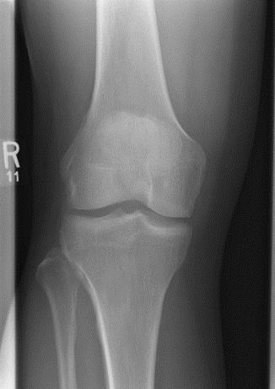
PA Projection

Interspaces of
equal width Open
femorotibial joint

Fibular head
slightly superimposed
by tibia

Medial Oblique Projection

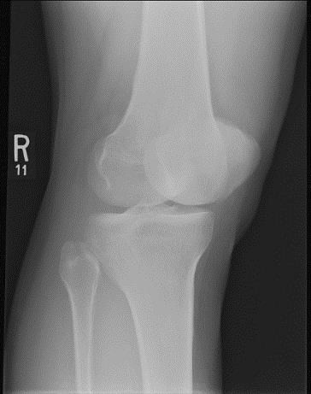
Margin of the patella projected
slightly beyond
medial condyle

Lateral femoral
condyle in

profile Open
femorotibial joint

Open proximal tibiofibular joint

Lateral Oblique Projection

Margin of patella projected slightly beyond lateral condyle

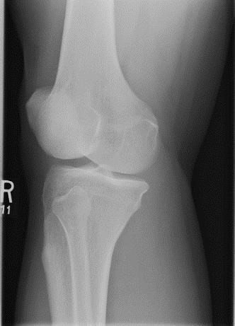
Medial femoral
condyle in
profile

Fibula superimposed
over lateral half
of tibia
Open
femorotibial joint

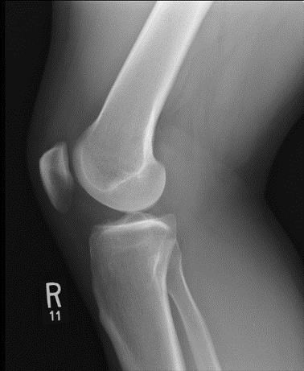
Lateral Projection

Knee flexed 20-
30 degrees

Patella in lateral
profile
Open patellofemoral
joint
Superimposed femoral condyles

Open femorotibial joint

Tunnel View

Apex of the patella not superimposing
fossa

Femoral epicondyles in profile

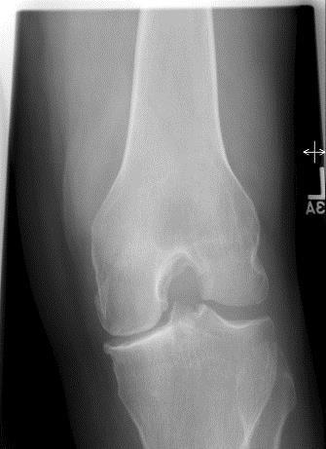
Open intercondylar fossa

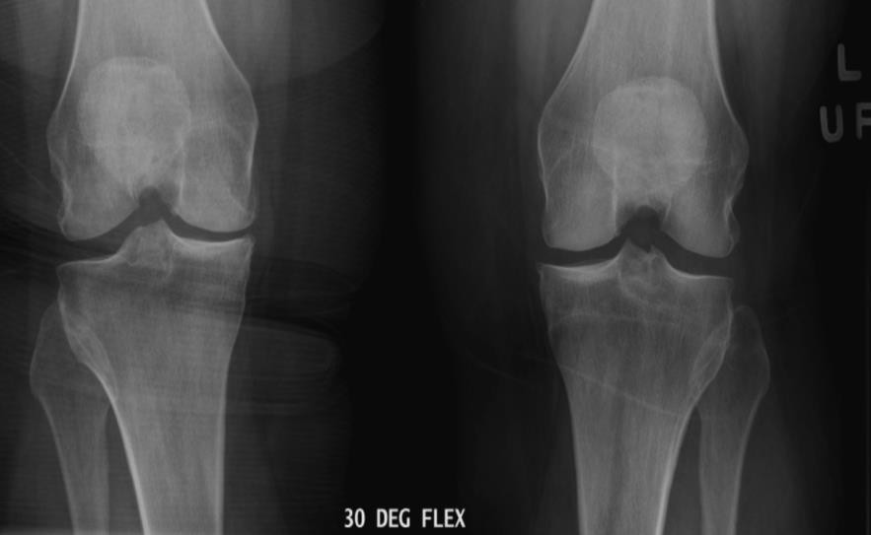
Standing P.A. projection with knees flexed 30°

Anterior and posterior margins of the medial and lateral tibial plateaus are superimposed

KUB

Procedure manual states “When an abdomen is requested for renal or ureteric calculus, a KUB examination is performed rather than an abdominal series.”

AP Projection
  - Positioning similar to a supine AP abdomen but with kVp reduced to 70-75 to lengthen greyscale and demonstrate calcifications if present.
  - CR perpendicular approximately. 2.5-5cm (1-2”) above the iliac crest in order to include
kidneys no less than 100 cm (40”) SID
  - Include entire kidneys to the superior border of the symphysis pubis and entire abdominal contents laterally.
  - AP of kidneys should be performed if clipped on first image.
  - AP axial projection of bladder area should be performed if clipped on first.
  - Expose at the end of exhalation.

Evaluation Criteria

Anatomy from T11 to pubic symphysis including kidneys, ureters and bladder Visualize psoas muscle outline
No rotation of patient seen in the iliac wings, obturator foramen (if visible), ischial spines appear symmetric, and outer lower rib margins are equidistant from spine
Soft tissue grey toned demonstrating lateral abdominal wall fat layer included lateral borders of image
Appropriate marker included

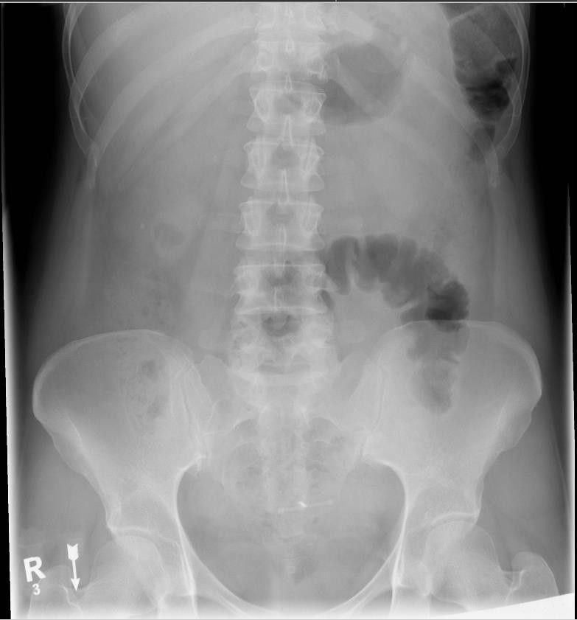

L

- Lumbar Spine

Lumbar Spine

AP Projection
  - Central ray perpendicular to L3.Minimum SID 100 cm (40”)
  - Bend patients knees to reduce lordotic curve.
  - Suspend at the end of expiration.

Evaluation Criteria
Collimated to include T12 to the sacrum included. Intervertebral disc spaces open.
Spinous processes seen in the midline of the vertebral bodies. Distance from the pedicles to the spinous processes is equal. SI joints equal distances from the vertebral column.
Good exposure to demonstrate the vertebral column and the psoas muscles. No artifacts from waistband elastics.

AP Oblique Projection
  - Patient turns 45º from the supine AP projection towards the right side for the first oblique image and then to the left for the second oblique image.
  - Mark the side down.
  - Central ray is perpendicular to L3 and 5 cm (approx. 2 fingers) medial to the ASIS on
elevated side. Minimum SID 100cm (40”)
  - Suspend at the end of expiration.

Evaluation Criteria
Collimate to include T12-L5, 1st& 2nd sacral segments, and SI joints.
Zygapophyseal joints closest to the IR or side down are seen. Open joints indicate a well-positioned oblique.
Scottie dogs are well defined and stacked one on top of the other.
Superior and inferior articular processes are in profile (ear and front foot of the Scottie dog).
Pedicles (eye of the Scottie dog) in the center of the vertebral bodies.

How to Fix it
Zygapophyseal joints closed, pedicle (eye) and transverse process (nose) are too posterior on the vertebral body and are distorted, and less of the lamina is seen.
    - The patient is over rotated you need to roll them back.
Zygapophyseal joint closed, pedicle (eye) is closer to the lateral surface of the vertebrae than midline, superior (ear) and inferior (leg) articular processes are not in profile, and more lamina is seen.
    - The patient is under rotated you need to roll them up.

Lateral Projection
  - Central ray perpendicular L3. minimum SID of 100 cm (40”)
  - Place a strip of lead on the table behind the patient to absorb scatter and improve image quality.
  - Ensure shoulders and hips are stacked in a true lateral position. Spine should be running parallel with the IR.
  - Suspend respiration at the end of expiration.

Evaluation Criteria
T12-S1 demonstrated.
Open intervertebral disc spaces.
Intervertebral foramina are seen (L1-L4).
Spinous processes are in profile.
Superimposed posterior margins of each vertebral body.
Spine in a neutral position with no anterior or posterior flexion. Nearly superimposed crests.

Lumbosacral Junction Lateral Projection (Spot)
  - Center 2” (5cm) posterior to ASIS and 1.5” (4cm) inferior to iliac crest.
  - CR angulation will vary with patient but generally between 5-7 degrees. Angle to bring CR parallel with PSIS.
  - Tightly collimate to include all of L5 (including spinous process) and upper sacrum.
  - Suspend respiration.

Evaluation Criteria
L5 to 2nd segment of the sacrum.
L5-S1 disc space is open. Intervertebral foramina seen.
Right and left pedicle is superimposed and is in profile.
Greater sciatic notches and pelvic wings are nearly superimposed Sacrum not foreshortened.

Flexion and Extension Projections
  - Done to demonstrate mobility of the vertebrae.
  - Maximum Flexion: Flex shoulders, upper thorax, and knees anteriorly while in a lateral position (Fetal position). Shows reduced lordotic curvature.
  - Maximum Extension: Arch the back. Extend the shoulders, upper thorax, and legs as far posteriorly as possible from a lateral position. Shows increases curvature.
  - Should meet most of the requirements of the lateral lumbar position.
  - Presetting manual techniques are preferred for these exams as precise centering is not always achievable.

AP Projection

Intervertebral disk
spaces open

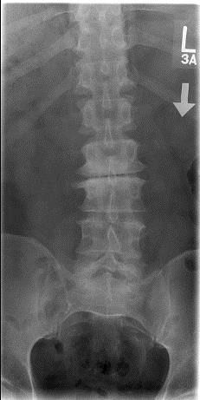
T12 to sacrum included

Spinous processes seen in midline (shows no rotation)

SI joints equal distances from the vertebral column

Lateral Projection

L1-L4 intervertebral foramina seen

Superimposed posterior margins of each vertebral body (shows no
rotation)

Spinous processes
in profile
T12-S1
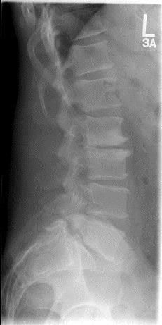
demonstrated

Open intervertebral disc spaces

Lumbosacral Junction Lateral Projection

Spinous process in
profile
Intervertebral foramina seen

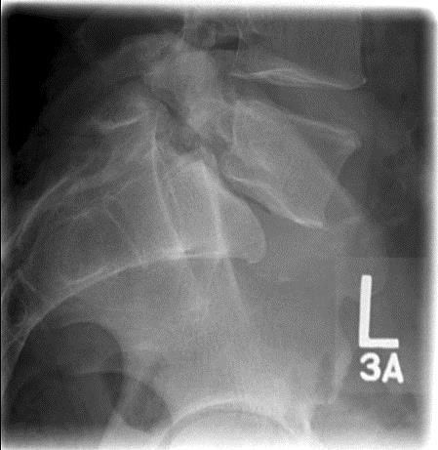
L5-S1 disk space is open

AP Oblique Projection

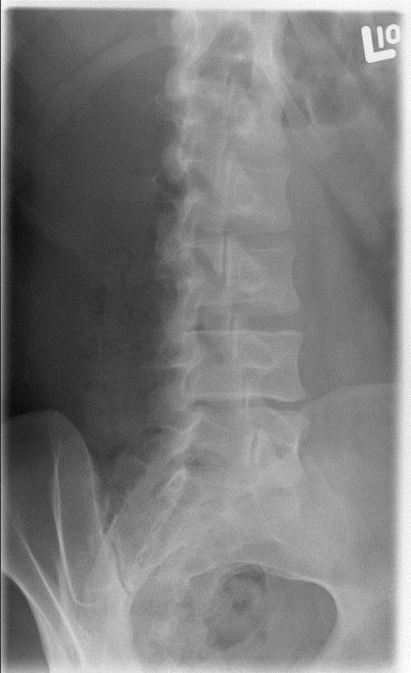
Open zygapophyseal joints (side down)

Superior articular process in profile
Pedicles (eye of Scottie dog) well defined

Inferior articular process in profile

Anatomy of the Lumbar Spine
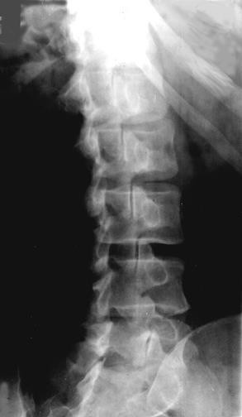
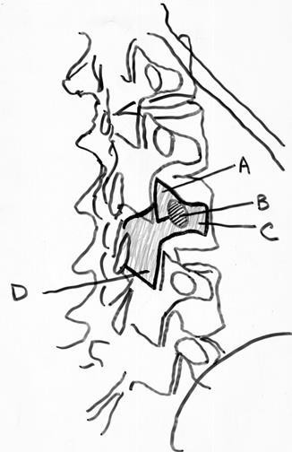
Oblique radiograph of the lumbar spine A = Superior articular process of L3 (Scottie dog's ear)
B = Pedicle of L3 (Scottie dog's eye)
C = Transverse process of L3 (Scottie dog's nose)
D = Inferior articular process of L3 (Scottie dog's front leg)

M
- Mandible

Mandible

AP Axial Projection (Townes 35º)
  - OML is perpendicular to IR. Minimum SID of 100 cm (40”)
  - Central ray 35-40º caudad, centered midway between the TMJs, and entering at a point
approximately 3” (7.5 cm) above the nasion.
  - If the area of interest is the tempomandibular fossae, use a 35-40º caudad angle to free the tempomandibular fossae of mastoid tip superimposition. Center at the glabella.
  - Slit collimation.
  - Suspend respiration.

Evaluation Criteria
Temporomandibular joints included.
Mandibular condyles and rami are demonstrated. Minimal superimposition of petrosa on the condyle. No rotation of head.

PA Projection
  - OML is perpendicular to the IR. Minimum SID of 100 cm (40”)
  - Mandibular Rami: Central ray perpendicular to exit the acanthion.
  - Mandibular Body: For a true PA projection of the mandibular body, raise the chin so the acanthiomeatal line is perpendicular to the IR.
  - Suspend respiration.

Evaluation Criteria
Entire mandible.
Demonstrates medial or lateral displacement of fragments in fractures of the rami. Mandibular body and rami symmetric on each side.

Axiolateral Oblique Projection
  - Patient in true lateral with shoulder against IR (shoulders in same horizontal plane).
  - Adjust head so the midsagittal plane forms a 25º angle with the IR (tilt head to touch wall bucky). A cephalad angle of 25º with the head in a true lateral position or a combination of head tilt and cephalad angle that equals 25º can be used.
  - Extend the patient’s chin.
  - Central ray perpendicular to a point 5cm below the uppermost angle of the mandible to enter midway between the angles of the mandible. Central ray to exit mandibular region of interest. Minimum SID of 100 cm (40”)
  - Ramus: head in a true lateral Body: 30º rotation toward the IR Mentum: 45º rotation toward the IR
General Survey: 10-15º rotation toward the IR

Evaluation Criteria
Collimate to the side of the mandible closest to the IR. Do not include upside TMJ.
Demonstrates the mandibular fossa, head, neck, ramus, coronoid process and body of the mandible closest to the film.
No overlap of the ramus by the opposite side of the mandible or the cervical spine. No elongation or foreshortening of ramus or body.

AP Axial Projection (Townes 35º)

No rotation of
head
Minimal superimposition of petrosa on the condyle

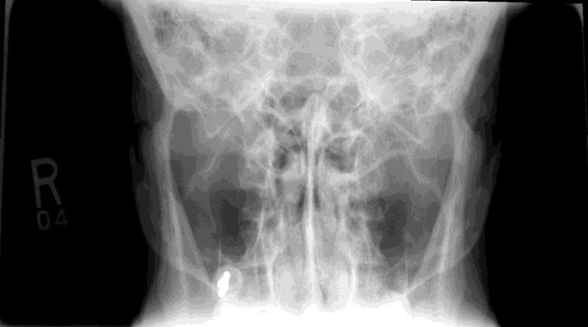
Mandibular condyles and rami are demonstrated

PA Projection

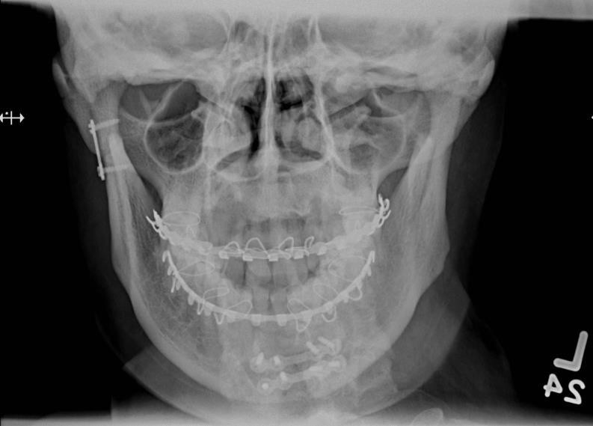
Mandibular body and rami symmetric on each side

Entire mandible

Axiolateral Oblique Projection

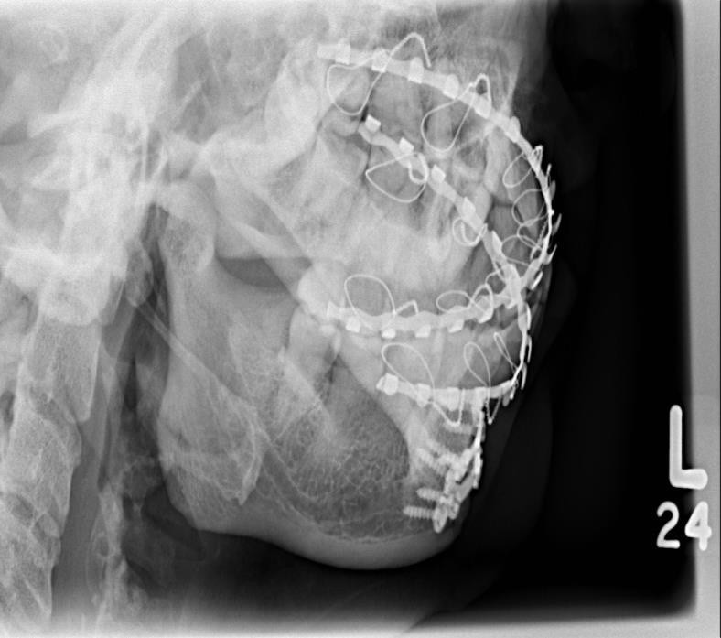
Demonstrates the temporal mandibular of the side closest to the IR.

No overlap of the ramus by the opposite side of the mandible

Demonstrates the coronoid process

Demonstrates the ramus of the side closest to the IR

Panorex/Orthopan

Exposure Technique

Patients with osteoporotic bone are difficult to image the amount of kilovoltage peak (kVp) needed to penetrate the condylar area will often cause the jawbones to appear too dark on the image. Patients with large amounts of fatty tissue at the back of the neck also will prove difficult as the superimposition of this tissue over other anatomy makes the image difficult to read.

Positioning

The bite stick should rest evenly between the front teeth, not on a single incisor, which would result in a slightly turned head position. The bite block holds the teeth apart so that the crowns are not superimposed on the image.

The position of the chin is adjusted until the IOML is parallel to the floor. This places the chin at a 4-7º downward tilt, which is necessary to counter the opposing 4-7º upward angle of the x-ray beam.

The technologist must ensure that the patient is standing upright with no slump to the cervical spine and is close enough to the machine that the cervical spine is perpendicular to the floor with the hips forward. Make sure the head and neck are not stretched forward. Large patients may be asked to step closer to the machine than is typical while holding onto the handlebars for support. This helps ensure that the spine is not included in the image and attempts to keep adipose tissue at the base of the neck out of the exposure area as well.

The head should be face forward, not rotated to 1 side or tilted. The shoulders should be relaxed to allow adequate room for the tube head and IR to rotate. Inability to lower the shoulders is a common problem in panoramic imaging. It may be necessary to purposefully position the patient with the chin higher than ideal to allow the tube head to rotate. Most machines provide a handlebar apparatus to help the patient maintain balance. Bypassing the use of the handlebars may help lower the shoulders for tube rotation; allowing the arms to hang lowers the shoulders.

Immediately before beginning the exposure, the patient should be instructed to swallow and press their entire tongue against the hard palate. The presence of air between the tongue and the hard palate will result in a radiolucent band over the apices of the maxillary teeth.

Tell the patient what to expect and explain the importance of not moving during the exposure.

A correct panoramic image will show the condyles perpendicular to the bottom edge of the IR, equidistant from the coronoid processes. The hard palate will be parallel to the bottom edge of the IR and the anterior dentition will show no signs of abnormal distortion. Structures on the left and right sides of the IR will appear symmetrical.

How to Fix it
Condyles splayed outwards, hard palate bowed up, and loss of focus of maxillary anterior teeth.
    - IOML above parallel to the floor. Lower the chin.
Condyles curved inward, v-shaped hard palate, loss of focus of mandibular anterior teeth.
    - IOML below parallel to the floor. Raise the chin. Left and right anatomy asymmetrical.
    - Head twisted to 1 side. Ensure the midsagittal plane perpendicular to the IR. Anterior teeth very thin and blurry, cervical spine superimposes mandibular rami.
    - Anterior teeth in front of grooves on bite stick. Move the head back. Anterior teeth magnified.
    - Anterior teeth behind grooves on bite stick. Move the head forward. Radiolucent band beneath hard palate obscures apices of maxillary anterior teeth.
    - Tongue not compressed against hard palate. Instruct the patient to push their tongue against the roof of their mouth.

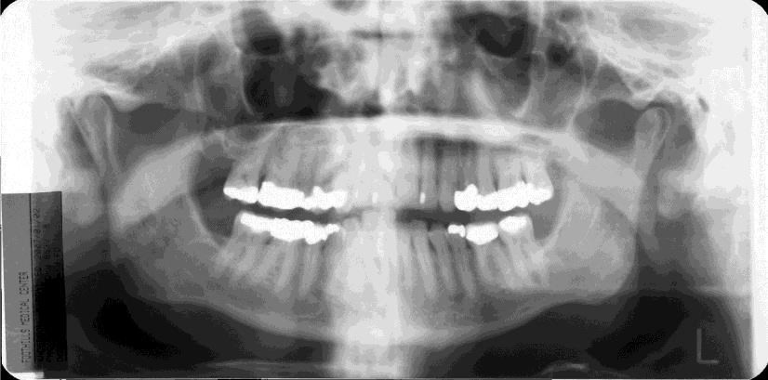
Orthopantomogram

Rami in vertical position
No frown or smile to the line of teeth
Include TMJs to mental protuberance

N
      - Nasal Bones
      - Nasopharynx

Nasal Bones

Parietoacanthial Projection (Waters)
  - Extend neck to rest chin on the IR (OML forms a 37º angle with the IR). The mentomeatal (MML) line is perpendicular to the IR. This places the petrous ridges below the maxillary sinuses.
  - Central ray perpendicular to the acanthion. Minimum SID of 100 cm (40”)
  - Suspend respiration.

Evaluation Criteria
Collimation to include anterior nasal spine, frontonasal suture and entire maxillary sinus.
Petrous ridges projected immediately inferior to the maxillary sinuses and extend laterally from posterior maxillary alveolar process.
No rotation of nasal bone and soft tissue.

How to Fix it
Maxillary sinuses superimpose the posterior molars and alveolar process.
    - The chin is too high. Lower the chin.
Petrous ridges are superior to posterior maxillary alveolar process and superimposing the maxillary sinuses.
    - The chin is too low. Raise the chin.

Lateral Projection

  - Non-grid cassette/detector tabletop (manually set a finger technique).
  - Central ray perpendicular to the bridge of the nose at a point ½” (1.3cm) distal to the nasion. Minimum SID of 100 cm (40”)
  - Use close collimation.
  - Suspend respiration.

Evaluation Criteria
Collimated to include nasal bones and soft tissue of nose.
Anterior nasal spine and frontonasal suture. No rotation of nasal bone and soft tissue.

Parietoacanthial Projection (Waters)

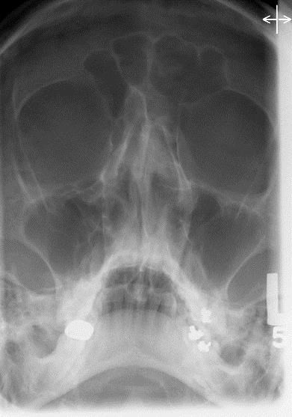
No rotation of nasal
bone and soft
tissue

Nasal septum

Petrous ridges projected immediately inferior to the maxillary sinuses

Lateral Projection

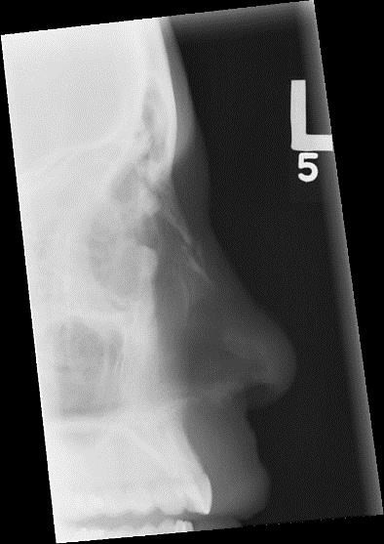
Frontonasal suture

Collimated to include nasal bones and soft tissue of nose

Anterior nasal spine

Nasopharynx

Lateral Projection
Demonstrates hypertrophy of the adenoids and tonsils, vocal cords, function of the glottis.

  - 180 cm (72”) SID for lateral projection only.
  - Extend patient’s head slightly to bring AML parallel to the floor.
  - Top of IR at the level of the nasion.
  - Central ray perpendicular to the laryngeal prominence (for larynx, laryngeal pharynx, and upper end of the esophagus).
  - Exposure on Modified Valsalva maneuver (blow cheeks outward against closed nostrils/mouth).
  - Preset manual technique, kVp should be modified (ex: 10 kVp less than a lateral c- spine).

Evaluation Criteria
Include from the bridge of nose to sternal notch, anteriorly from EAM to include entire nose.
Soft tissue density of the pharyngolaryngeal structures. Air filled trachea.
Shoulders not superimposing the trachea. Mandibular shadows closely superimposed.

AP Projection
  - Extend patient’s head slightly to bring AML perpendicular to the IR.
  - Central ray perpendicular to the laryngeal prominence. Minimum SID of 100 cm (40”)
  - Exposure on Modified Valsalva maneuver (blow cheeks outward against closed nostrils/mouth).
  - Use shortest exposure time as possible and take the exposure just before the chest comes to rest at the end of inspiration.

Evaluation Criteria
Lower level of nasal bones to sternal angle, lateral borders of soft tissue neck. Air filled trachea.
Laryngeal area free of mandibular superimposition.
No rotation of the neck.
Radiographic density to visualize the pharyngolaryngeal structures.

Lateral Projection

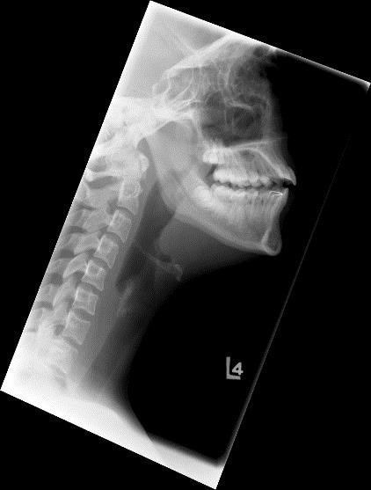
Include from the bridge of the nose to the sternal notch

Mandibular shadows closely superimposed

Air filled trachea

AP Projection

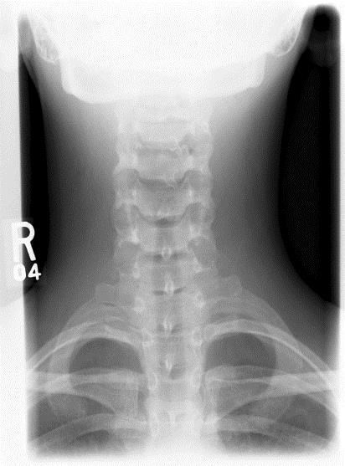
Lower level of nasal bones to sternal angle

Laryngeal area free of mandibular superimposition

Air filled trachea

O
- Orbits
- Os Calcis

Orbits

PA Axial Projection (Caldwell)
  - OML is perpendicular to the IR.
  - Central ray directed through the center of the orbits at a caudal angulation of 30º. This angulation is used to project the petrous portions of the temporal bones below the inferior margin of the orbits. Minimum SID of 100 cm (40”)
  - Suspend respiration.

Evaluation Criteria
Petrous pyramids lying below orbital shadows. No rotation of cranium.
Close beam restriction centered to orbital region.

Parietoacanthial Projection (Waters)
  - Central ray perpendicular to the acanthion. Minimum SID of 100 cm (40”)
  - Suspend respiration.

Evaluation Criteria
Coning: include the orbits, the maxillae, and the zygomatic arches.
Petrous ridges projected immediately inferior to the maxillary sinuses and extend laterally from posterior maxillary alveolar process.

Lateral Projection
  - Central ray perpendicular through the outer canthus. Minimum SID of 100 cm (40”)
  - Suspend respiration.

Evaluation Criteria
Close beam restriction centered to orbital region.
Superimposed orbital roofs. No rotation of sella turcica.
Density and contrast permitting optimal visibility of orbit and eye for localization of foreign bodies.

PA Axial Projection

Close beam restriction

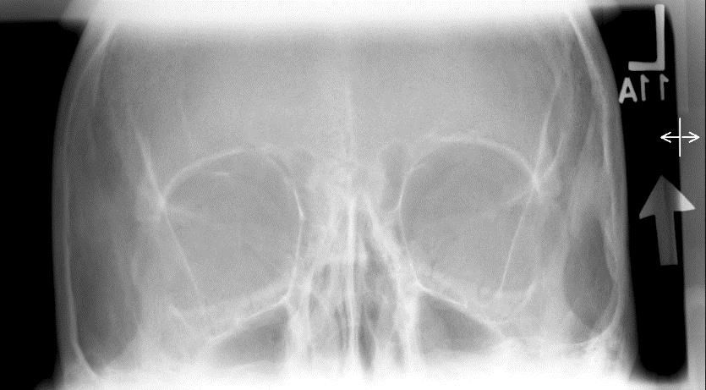
No rotation of cranium

Petrous pyramids lying below
orbital shadows

Parietoacanthial Projection (Waters)

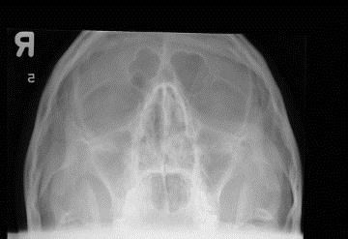
No rotation of cranium

Lateral Projection
Petrous ridges projected immediately inferior to the maxillary

Superimposed orbital roofs (show no tilt)

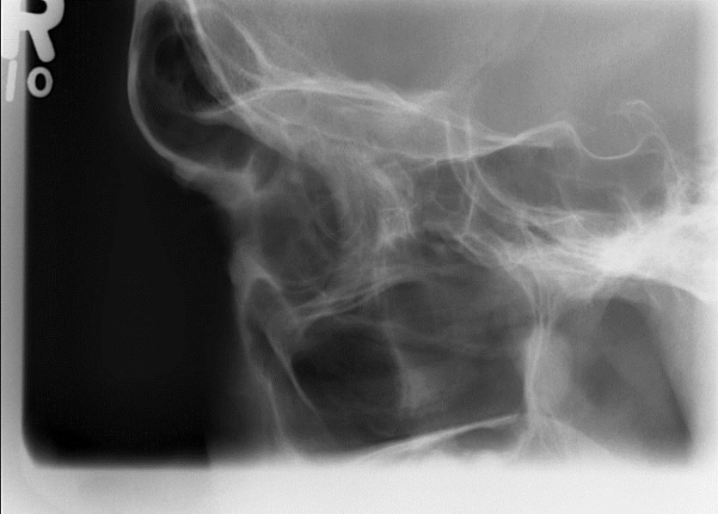
No rotation of sella turcica

Close beam

Os Calcis

Axial or Plantodorsal Projection
  - Elevating the leg on sandbags or increasing the central angle may help with the patient who cannot dorsiflex the foot to place it perpendicular to the cassette.
  - CD directed to the base of the third metatarsal at an angle of 40º cephalad. Minimum
SID of 100 cm (40”)

Evaluation Criteria
Talocalcaneal joint space (Subtalar joint). Calcaneal tuberosity without distortion.
No rotation of the calcaneus. Neither the 1st, 4th, or 5th metatarsals seen on the medial or lateral aspect of the foot. Place the ankle in a true AP.
Anterior portion of the calcaneus without excessive density over the posterior portion.
Proximal calcaneal tuberosity centered in the collimated field. This is the midline of the foot at the level of the 5th metatarsal base.

Note: The subtalar joint space should be no more than 2mm. In the case of a calcaneal fracture the surgeon will use this space to determine if surgery is indicated.

How to Fix it
The talocalcaneal joint space is obscured, and the calcaneal tuberosity is elongated.
    - The foot was dorsiflexed beyond the vertical position. Decrease the flexion of the foot or decrease your angle.
The talocalcaneal joint space is obscured, and the calcaneal tuberosity is foreshortened.
    - The foot was not dorsiflexed enough. Dorsiflex the foot to a vertical position or increase the angle of the central ray.

Mediolateral Projection
  - Central ray perpendicular to a point 1” (2.5 cm) distal to the medial malleolus. Minimum
SID of 100 cm (40”)
  - Collimate 5 cm (2”) anterior to the medial malleolus. This includes all the articulating surfaces of the calcaneus.

Evaluation Criteria
Talar domes superimposed.
Distal fibula is superimposed by the posterior half of the distal tibia. Tibiotalar joint is open.
Tibiotalar joint, talus, calcaneus, and calcaneal articulating tarsal bones are seen.
Density of the sustentaculum tali, lateral tuberosity, and soft tissue. Sinus tarsi demonstrated
Long axis of foot is positioned at 90º with the lower leg.

How to Fix it
Navicular superimposes most of the cuboid (lateral talar dome is proximal).
    - Proximal tibia is elevated. Extend the knee positioning the leg parallel with the IR. More than1 cm (0.5”) of cuboid is visualized distal to the navicular (medial talar dome is proximal).
    - The distal tibia was elevated. Position the leg parallel with the IR.

Neither the 1st, 4th, or 5th metatarsals seen on medial or lateral aspect (shows no rotation)

Axial or Plantodorsal Projection

Talocalcaneal (subtalar) joint seen

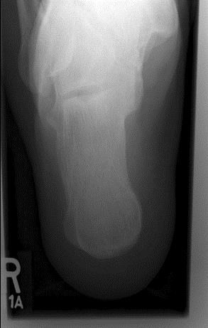
Sustentaculum tali seen

Calcaneal tuberosity

Lateral Projection

Open tibiotalar joint

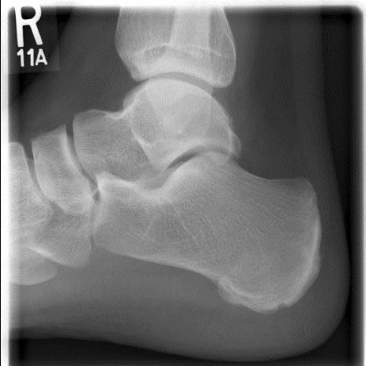
Talar domes superimposed

Sinus Tarsi Sustentaculum tali

P
      - Patella
      - Pelvis

Patella

Skyline and Merchant Views
This view demonstrates fractures, articulating surfaces, and subluxation. A subluxed patella is demonstrated lateral to the intercondylar sulcus. Do not do this view until a transverse fracture of the patella has been ruled out with the lateral image.

AP Skyline View (Settegast Method)
  - When angling the central ray toward the patient’s upper body shield the thyroid and thorax in addition to gonadal shielding.
  - Flex knee slowly as much as possible, until the patella is perpendicular to the IR.
  - Central ray is parallel to the joint space between the patella and the femoral condyles. Knee flexion will determine the degree of tube angulation required (typically 15-20 º cephalad). Minimum SID of 100 cm (40”)

PA Skyline View (Hughston) Method)
  - With the patient lying prone, flex the affected knee so that the lower leg forms a 50-60º angle with the IR.
  - Center to the patella femoral joint with a central ray angle of 45º cephalad, rest the
patient’s foot on the collimator.
  - Minimum SID of 100 cm (40”)
  - This method lessens the thyroid dose.

Merchant View
  - Uses an angle board or axial viewer that is set at 45º.
  - Femurs should be parallel to the tabletop.
  - Internally rotate the knees so the femoral epicondyles are parallel with the tabletop.
  - Have patient relax their quadriceps and hamstrings. If tense, a patellar subluxation that is present may not be visualized as when the leg is relaxed.
  - Evaluate the patella shadows on the cassette. Should have oval shadows with indentations on each side of the patella.
  - Central ray angulation + axial viewers angle = 105º. The normal central ray angle is 60º. 60+45=105.
  - SID is 180 cm (72”). This decreases magnification.

Evaluation Criteria
Patella in profile.
Open patellofemoral articulation.
The lateral femoral condyle demonstrates more height than the medial condyle because it is more anterior.
Surfaces of the femoral condyles, patellae, intercondylar sulci.
Ensure patient is in a true AP/PA position and not externally rotated prior to imaging. Don’t mistake poor positioning with subluxation. Both show the patella lateral to the intercondylar sulcus.

How to Fix it
The patella is resting against the intercondylar sulci.
    - The knee is too bent reduce the bend in the knee.
The tibial tuberosity is demonstrated within the patellofemoral joint space.
    - The knee is not bent enough. Increase the bend in the knee.

Skyline (Merchant) View

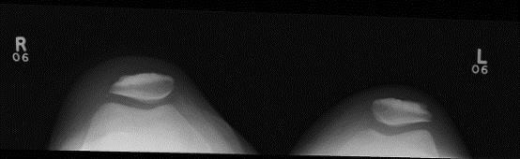
Open patellofemoral
articulation
Patella in profile

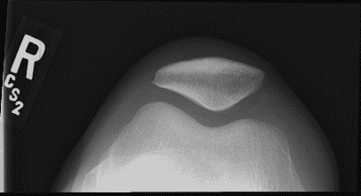
Patella Skyline Unilateral

Pelvis

AP Projection
  - Separate the heels 8-10 inches apart and medially or internally rotate the entire lower limb 15–20º.
  - Ensure collimation no greater than 35cm x 43cm.).
  - For fractures and dislocations do not internally rotate affected leg.
Central ray midway between the ASIS and the pubic symphysis (approximately 5 cm (2”) superior to the pubic symphysis). Minimum SID of 100 cm (40”).
Suspend respiration.

Evaluation Criteria
Entire pelvis with the proximal femora Symmetrical iliac alae.
Vertebral column centered. Both ilia and greater trochanters equidistant from the edge of the radiograph.
Sacrum and coccyx aligned with the symphysis pubis. Ischial spine is aligned with the pelvic brim.
Obturator foramina open and symmetrical. Femoral head and acetabulum are centered.
No foreshortening of the femoral necks. Greater trochanters in profile.
See minimal, if any, of the lesser trochanter. Include all of an orthopedic device if present.

Pelvic Inlet Projection
This view is done when there is a question of pubic or ischial rami fractures.
  - Central ray 35º caudad to a point midway between ASIS (at the level of the ASIS).
  - Minimum SID of 100 cm (40”).
  - Suspend respiration.

Evaluation Criteria
Medially superimposed superior and inferior rami of the pubic bones. Nearly superimposed lateral two thirds of the pubic and ischial bones. Pubic and ischial bones centered to the radiograph.
Symmetric pubis and ischia. Hip joints included.

Pelvic Outlet Projection
This view is done when there is a question of pubic or ischial rami fractures.
  - Central ray 35º cephalad to a point 2.5cm (1 “) distal to the inferior border of the symphysis pubis.
  - Minimum SID of 100 cm (40”).
  - Suspend respiration.

Evaluation Criteria
Pubic and ischial bones magnified with pubic bones superimposed over the sacrum and coccyx.
Symmetric obturator foramina.
Pubic and ischial rami near the center of the radiograph. Hip joints included.

Bilateral Judet Views
  - Place top of IR 2.5 to 3.8cm above the iliac crest.
  - Minimum SID of 100 cm (40”).
  - Rotate patient 45º onto right/left side.
  - Pelvis centered to midline of the IR for both oblique views.
  - Center midline with the central ray perpendicular to a point 5cm (2”) inferior to the ASIS.
  - Suspend respiration.

Evaluation Criteria
Posterior rim of the acetabulum on elevated side. Anterior rim of the acetabulum on the side down.

AP Projection

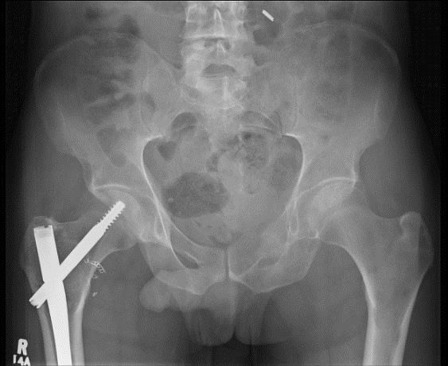
Symmetric ilia alae

Sacrum and coccyx
aligned with the symphysis
pubis

Lesser trochanter not seen (or only slightly beyond the
medial border of the femur

Greater trochanter in profile

Inlet Projection

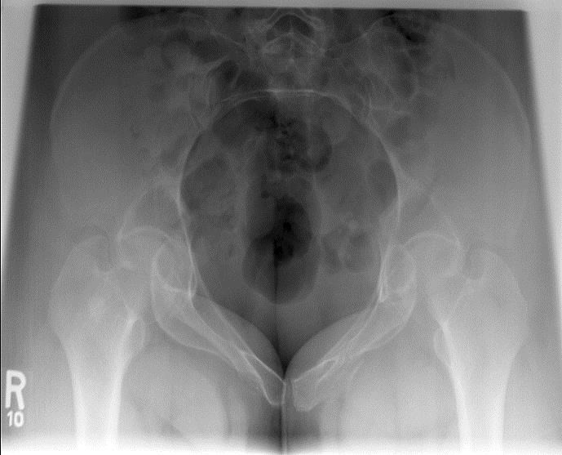
Symmetric ilia alae

Nearly superimposed lateral 2/3 of the pubic and ischial bones
Medially
superimposed
superior and inferior rami

Outlet Projection

Symmetric obturator foramina
Pubic bones superimposed over the sacrum and coccyx

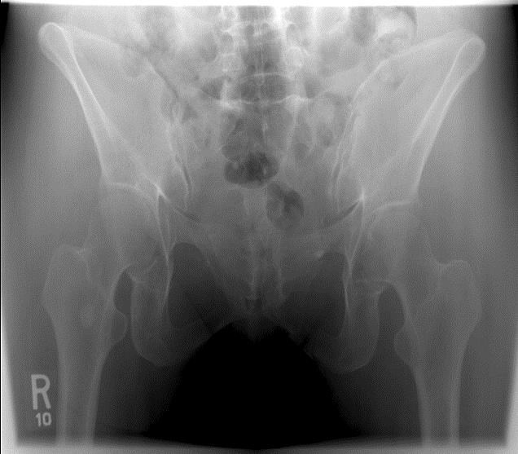
Pubic and ischial bones magnified

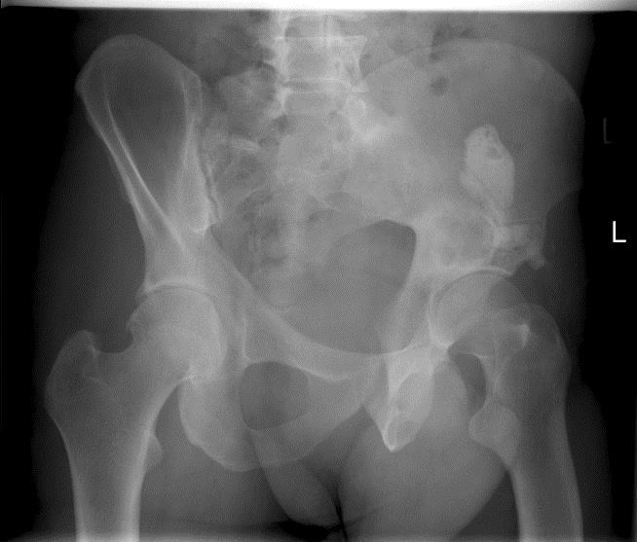
Judet View

Posterior lip
of the acetabulum on the side
up
Anterior lip of the acetabulum on the side down

R
- Ribs

Ribs
  - PA chest should be done on all trauma patients where ribs views are requested (separate accession number needed) to rule out any associated injury to the lungs as a result of rib fractures. For upper rib fractures upper thorax, axilla, neck soft tissue as well as vascular markings are studied for signs (hematoma and air) to indicate lung pathology (pneumothorax, interstitial emphysema), ruptured trachea, bronchus or aorta. For lower rib fractures, upper abdominal tissue is studied for kidney, spleen, or diaphragm injury.
  - Take patient history.
- Where is pain? Left or right, upper or lower thoracic area, anterior or posterior?
- Difficulty breathing?
  - Use 65-70 kVp for high contrast in the upper rib area.
- For posterior ribs that overshadow the heart shadow use a higher kVp for penetration.
- For upper ribs double your mAs from a shoulder technique. For lower ribs use an abdomen technique (75-80 kVp range). This will penetrate the denser abdominal structures and still demonstrate high contrast for the ribs.
  - Tight collimation and a high ratio grid reduces scatter and improves contrast.

Upper Anterior Ribs

PA Projection
  - Central ray perpendicular to T7 (Using a 10-15º caudad angle will project the diaphragm lower to better demonstrate the 7th, 8th, and 9th ribs).
  - Minimum SID of 100 cm (40”).
  - Suspend respiration on full inspiration.

Evaluation Criteria
First through tenth ribs in their entirety, with the posterior portions lying above the diaphragm.
Ribs visible through the lungs with sufficient contrast.
Costovertebral joints included. Half of vertebral column included.

PA Oblique Projection
  - Rotate patient 45º away from the IR, the affected side up.
  - Central ray perpendicular to T7 of affected side, midway between the vertebral column and lateral border of chest wall.
  - Minimum SID of 100 cm (40”).
  - Suspend respiration on full inspiration for ribs above diaphragm.

Evaluation Criteria
First through tenth ribs visible above the diaphragm. Ribs visible through the lungs.
Axillary portion of the ribs free of superimposition. Costovertebral joints included.
Inferior sternal body is demonstrated halfway between the lateral body surface and the vertebral column.

How to Fix it
Sternal body is next to the vertebral column.
    - The patient is under rotated. Rotate the patient away from IR. Sternal body is next to the lateral edge.
    - The patient is over rotated. Rotate the patient towards the IR.

Upper Posterior/Axillary Ribs

AP Projection
  - Central ray perpendicular to T7.This is halfway between the Xiphoid process and the jugular notch.
  - Minimum SID of 100 cm (40”).
  - Suspend respiration on full inspiration.

Evaluation Criteria
First through tenth posterior ribs.
Ribs visible though the lungs. Costovertebral joints included.
Half of vertebral column included.

AP Oblique Projection
  - Rotate patient 45º towards the IR, the affected side down.
  - Central ray perpendicular to T7 of affected side, midway between the vertebral column and lateral border of chest wall.
  - Minimum SID of 100 cm (40”).
  - Suspend respiration on full inspiration for ribs above diaphragm.

Evaluation Criteria
See PA Oblique Projection.

Lower Posterior/Axillary Ribs

AP Projection
  - Central ray perpendicular to the level of T10 (Xiphoid at level of T10).
  - Minimum SID of 100 cm (40”).
  - Suspend respiration on full expiration.

Evaluation Criteria
Eighth through twelfth posterior ribs in their entirety.
Ribs visible through the abdomen. Costovertebral joints included.
Half of vertebral column included.

AP Oblique Projection
  - Bottom of IR at the level of iliac crest.
  - Rotate patient 45º towards the IR, the affected side down.
  - Central ray perpendicular to T10, midway between vertebral column and lateral border of chest wall of affected side.
  - Minimum SID of 100 cm (40”).
  - Suspend respiration on full expiration.

Evaluation Criteria
Eighth through twelfth visible below the diaphragm. Axillary portion of the ribs free of superimposition.
Ribs visible through the abdomen. Costovertebral joints included.

PA Projection (Upper)

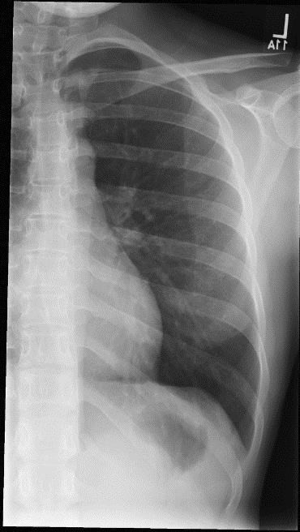
1st through 10th ribs visible above diaphragm

Ribs visible through the lungs

Vertebral column
included

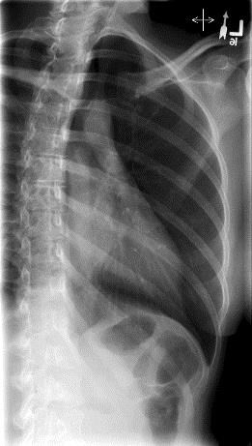
PA Oblique Projection (Upper)

1st through 10th ribs visible above diaphragm

Vertebral column
included

Ribs visible through
the lungs

Inferior sternal body is halfway between the lateral body surface and the vertebral column (correct rotation)

AP Projection (Lower)

Vertebral column
included

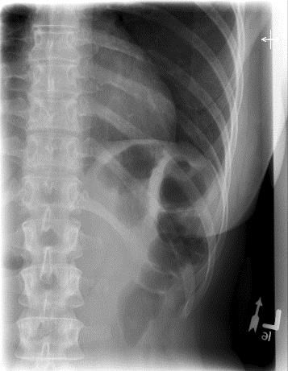
8th through 12th ribs in their entirety

Ribs visible through the abdomen

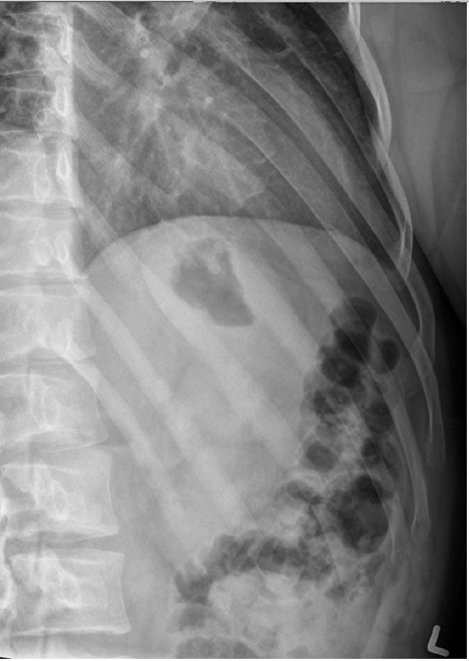
AP Oblique Projection (Lower)

Vertebral column
included

Ribs visible through the abdomen

8th through 12th ribs in their entirety

Scottie dogs in lumbar spine (correct rotation)

S
- Sacroiliac Joints
- Sacrum
- Scaphoid
- Scapula
- Shoulder
- Sinuses
- Skeletal survey
- Skull
- Sternoclavicular joints
- Sternum

AP Axial Projection
Sacroiliac Joints

  - Central ray 30º (male) or 35º (female) cephalad entering 1 1/2” superior to the symphysis pubis (halfway between the ASIS and symphysis pubis).
  - Minimum SID of 100 cm (40”).
  - Suspend respiration.

Evaluation Criteria
Open intervertebral space between L5-S1.
Lumbosacral junction and sacrum. Both SI joints included.
Sacrum is equal distance from the lateral wall of the pelvic brim. Sacral crest aligned with the symphysis pubis.

AP Oblique Projection
  - Rotate patient 25-30º.
  - Elevated side demonstrated.
  - Ensure correct marker is used.
  - Central ray perpendicular to 2.5 cm (1”) medial to elevated ASIS. Minimum SID of 100
cm (40”).
  - Suspend respiration.

Evaluation Criteria
Sacral ala and ilium are in profile.
Minimum overlapping of the ilium and sacrum. Open SI joint space demonstrated.
SI joint is centered in collimated field.

How to Fix it
Ilium and sacral ala are not in profile and ilium superimposes the lateral sacral ala and inferior sacrum.
    - The patient is over rotated. Roll patient back.
Ilium and sacral ala are not in profile, inferior and superior sacral ala seen without ilium superimposition, and lateral sacral ala superimposes the iliac tuberosity.
    - The patient is under rotated. Roll the patient up more.

AP Axial Projection

Both SI joints
Lumbosacral junction and
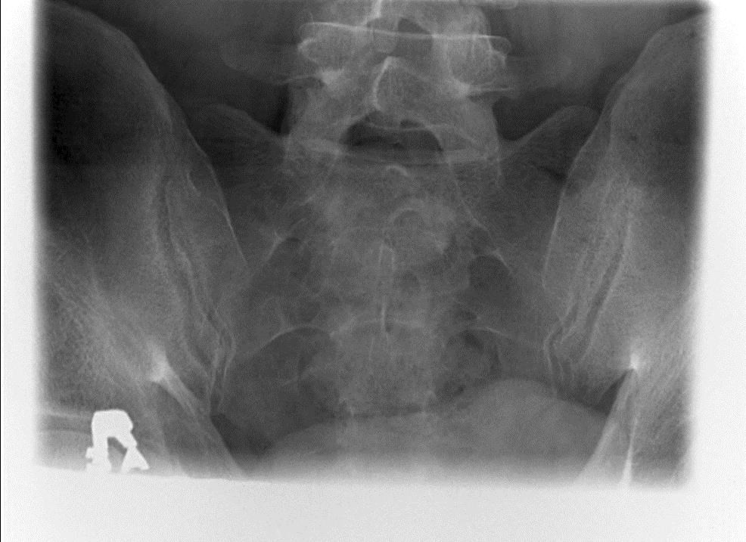
sacrum

AP Oblique Projection

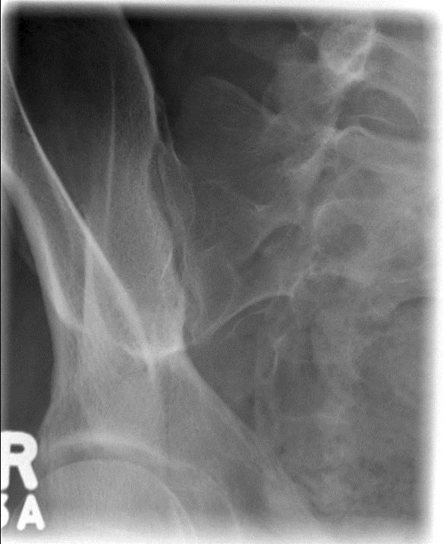
Minimal overlapping of the ilium and
sacrum Open SI joint

Sacral ala and ilium in profile

Elevated side is marked

Sacrum
Protocol states that Coccyx and Sacrum should be imaged separately on both the AP and lateral projections.

AP Axial Projection
  - Central ray 15º cephalad entering 2” above the symphysis pubis (about halfway between the ASIS and the symphysis pubis).
  - Minimum SID of 100 cm (40”).
  - Suspend respiration.

Evaluation Criteria
L5, 1st -5th sacral segments, SI joints, and coccyx are demonstrated.
Equal spacing of the sacral foramina. No foreshortening of the sacrum.
Ischial spines are aligned with the pelvic brim.
No overlap of the symphysis pubis onto the sacrum.
Sacrum and the coccyx are aligned with the symphysis pubis.

Lateral Projection (Sacrum)
  - Central ray perpendicular and directed to the level of the ASIS and to a point 7 cm
(3 ½ ”) posterior.
  - Minimum SID of 100 cm (40”).
  - Place lead blocker on the table behind the patient to absorb scatter radiation and improve the quality of the radiograph.
  - Suspend respiration.

Evaluation Criteria
L5-S1 joint space to S5 is seen.
Sacral crest demonstrated in profile. Sacral promontory.
Greater sciatic notches, ischia, and pelvic wings are nearly superimposed.
S1-S5 with no sacral foreshortening. Short scale contrast.

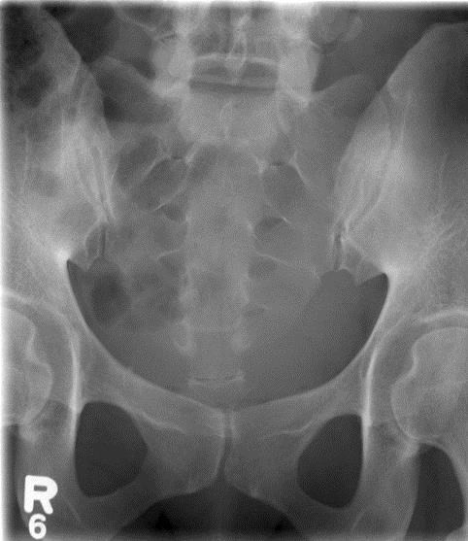
AP Axial Projection (Sacrum)

No overlap of the symphysis pubis onto to
sacrum
Sacrum and coccyx aligned with symphysis pubis

Lateral Projection (Sacrum and Coccyx)

L5-S1 joint space to S5 included
Sacral crest
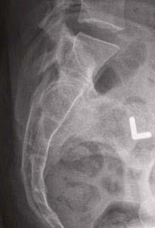
in profile

Scaphoid
Protocol states that views should include PA projection and PA projection with 20 º
angulation. On initial exam, full wrist routine should be performed.

PA, PA 20º Angulation Projection
  - Most commonly fractured carpal bone. When hand is dorsiflexed in a fall there is a lot of stress placed on the scaphoid waist.
  - Palpate halfway between the base of the first metacarpal and the radial styloid process in ulnar flexion. Center to include all carpal bones.
  - Without moving the forearm, turn the hand outward until the wrist is in ulnar deviation to prevent foreshortening or excessive elongation of the scaphoid. Ulnar deviation is demonstrated by the alignment of the first metacarpal and the radius.
  - Minimum SID of 100 cm (40”).

Evaluation Criteria
All carpal bones included
If the hand is not extended so that the palm is placed flat (hand is flexed), then the 2nd metacarpal base superimposes the trapezoid and trapezium and closes the scaphotrapezium and scaphotrapezoid joint spaces.
No rotation of the wrist. Ulnar deviation.
Soft tissue and bony trabeculation.

Note: Scaphoid Fat Pad: Change in convexity may indicate a subtle radial sided fracture.

How to Fix it
The scaphoid is foreshortened.
    - The hand is not in ulnar deviation. Turn the hand outward until the wrist is in extreme ulnar deviation.
The 2nd metacarpal base superimposes the trapezoid and trapezium and the scaphotrapezium and scaphotrapezoid joint spaces are closed.
    - The hand is not extended. Extend the hand so that the palm is placed flat.

PA Axial Projections

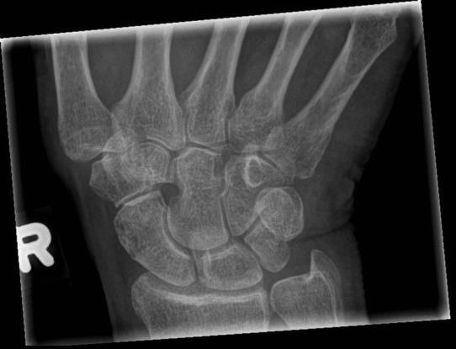
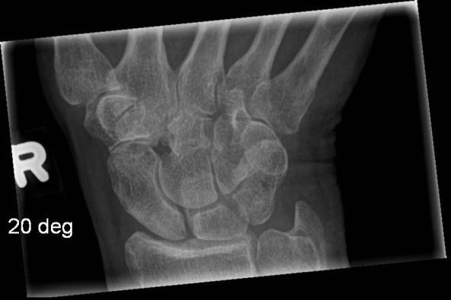

AP Projection

Scapula

  - Abduct the arm to a right angle (90º) with the body to draw the scapula laterally away from the thoracic cavity. Supinate the hand and flex the elbow to externally rotate the arm. This retracts the shoulder, moving the scapula laterally and posteriorly. If the patient can abduct the arm, do NOT oblique towards the affected side (this offsets the effect of abduction).
  - If the patient cannot abduct the arm, oblique towards the affected side until the body of the scapula is parallel with the IR.
  - Central ray is 5-7 cm (2-3”) below the coracoid and 0.5” medially if no abduction is used.
  - Minimum SID of 100 cm (40”).
  - Suspend on expiration to demonstrate an even density across the entire scapula (non- aerated lung over the medial portion) or expose during shallow breathing to obliterate the lung detail.

Evaluation Criteria
The superior scapular angle is approximately 0.6cm (0.25”) inferior to the clavicle.
Lateral portion of the scapula free of superimposition from the ribs. Scapula demonstrated horizontal and not obliqued.
Scapular detail through the superimposed lung and ribs.
Anterior and posterior margins of the glenoid are nearly superimposed. Acromion process, coracoid, superior and inferior angles.

How to Fix it
The inferolateral border of the scapula is superimposed by the thoracic cavity, and the superior angle is superimposed by the clavicle.
    - The humeral shaft is not abducted 90º with the body. Abduct the humerus to draw the inferolateral border away from the thorax and move the superior angle away from the clavicle.

Lateral Projection
  - Rotate the patient toward the affected side 45-60º until the medial and lateral borders superimpose. Degree of obliquity depends upon the amount of humeral elevation.
  - Arm positioned 2 ways:
- Elbow flexed and the hand placed on the posterior thorax to prevent humeral overlap on the scapula. Demonstrates the acromion and coracoid.
- Extend the arm upright and rest the forearm on the head OR place arm across the chest and grasp the unaffected shoulder. Ensure the arm is elevated to 90º with the
body to position the scapula perpendicular to the IR. Demonstrates the scapular body.
  - Central ray is 2.5 cm (1”) anterior to the vertebral border and halfway between the inferior angle and the acromion angle.
  - Suspend respiration.

Evaluation Criteria
Lateral and vertebral borders superimposed
Scapular body seen without thoracic cavity superimposition.
Humerus is drawn away from the superior scapular body and the superior angle superimposes the clavicle.
Entire scapula seen.
The higher the humerus is elevated, the more the inferior angle of the scapula glides anteriorly. Therefore, less patient rotation is required.
Lateral thickness of the scapula with proper density.

How to Fix it
The lateral and medial borders of the scapula are demonstrated without superimposition. The thick lateral border is demonstrated laterally and the vertebral border is visible next to the ribs.
    - The patient was not rotated enough for this image. Increase the patient obliquity.

AP Projection

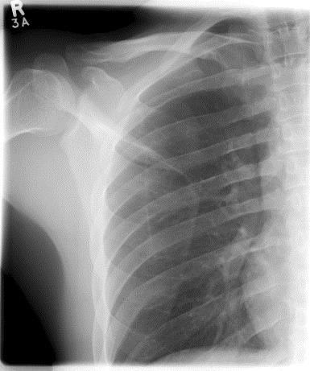
Anterior and

posterior margins of the glenoid nearly superimposed

Lateral portion of scapula free
of superimposition

Scapular detail through the superimposed lungs and ribs

Lateral Projection

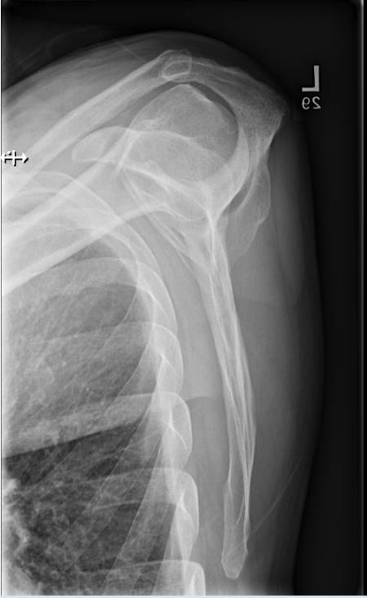
Humerus drawn away from the superior scapular body

Scapula in lateral profile

Scoliosis
Note: The scoliosis protocol will vary and is dependent on the clinical site. The protocol below is a sample for reference.

  - Only AP/PA image done if patient from Doctor’s office (unless patient has been referred to orthopedics and orthopedics has requested a lateral image to be done also).
  - AP and lateral images performed if requisition history states Kyphosis or Lordosis (swayback).
  - Patient must be changed and all artifacts removed from area of interest.
  - Imaging routinely performed with patient done standing. If patient is wheelchair bound, images are to be done sitting.
  - Patient MUST remove shoes.
  - If patient has AFO’s (ankle-foot orthotics) on and is unable to stand without them, the
image should be annotated “with AFO’s on”. Also document in Millennium.
  - If the requisition indicates lifts are required under patient foot, the images must be annotated with cms and which foot the lift was placed under (Ex: 3cm block under RT foot). Also document in Millennium.
  - Images are to be done at an SID of 180cm (72”).
  - SHIELDING is required as patients are young and this is typically a full body dose. Appropriately sized triangular shields are to be used. Shielding should be affixed using tape (directly to the skin or taut gown).
- For females, long side of shield to be placed/taped at level of ASIS
- For males, long side of shield at the bottom and apex of shield lined up to the greater trochanters
  - If shield placed correctly, you should be able to see the entire hip joint while covering the sacrum/ovaries for females and testes on males.
  - Give appropriate breathing instructions as per equipment (please note that Digital units typically take longer to expose entire spine and patient should be informed they may be required to suspend breathing for up to 15 seconds if applicable)
  - If using some digital equipment, you may have to manually adjust image. If image is manipulated in any way this MUST be noted on image (EX: “manually adjusted image”). Also note in Millennium.

AP/PA Projection

  - Images can be done PA or AP (depends on site preference). Please note PA imaging results in lower dose to breast, thyroid and gonadal tissue but increases magnification of spine and can possibly increase patient movement.
  - Patient must be as erect as possible. Knees are straight (patella’s forward) and arms hanging by sides
  - Collimate from C7 to hip joints (depends on site preference). Keep coning wide enough to include both shoulder joints and hip joints.

Lateral Projection
  - For lateral image patient to place left side against detector. Knees are straight.
  - Arms are raised no higher than shoulders (No higher than 90 degrees). If arms are raised higher than 90º, this will result in patient arching back unnecessarily and changing the nature of the spine curvature.
  - Collimate to include from C7 to coccyx/hip joints (site dependent). If the patient is large and your equipment permits it, try to collimate off breast tissue. Entire rib cage so this must be included
  - For patients with scoliosis, it may be difficult to achieve superimposition of the posterior ribs.
  - Depending on site, a preset manual technique may be preferred on lateral image

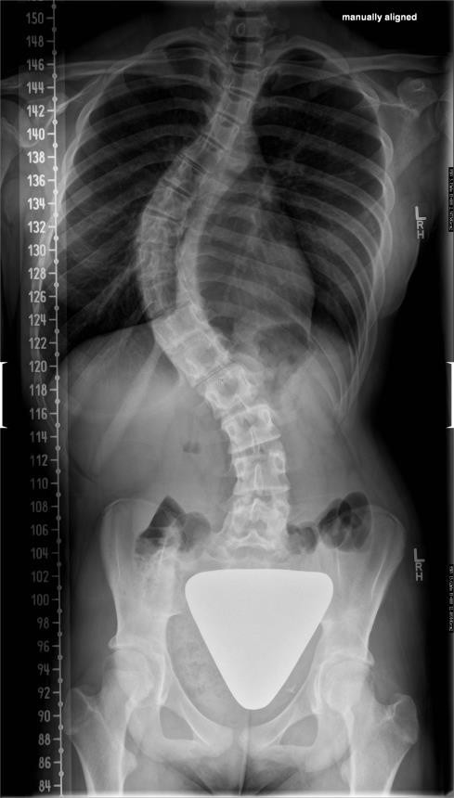
AP/PA Projection

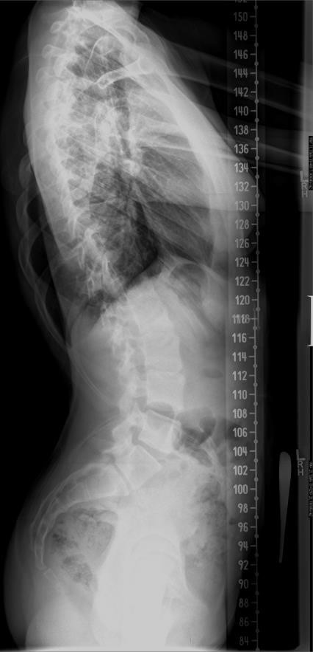
Lateral Projection

Shoulder

AP Projection (External Rotation)
  - Central ray perpendicular to 2.5 cm (1”) inferior to the coracoid process.
  - Minimum SID of 100 cm (40”).
  - Suspend respiration.

Evaluation Criteria
Entire clavicle, scapula, and proximal 1/3 of the humerus are demonstrated. Superior scapular angle is superimposed by the mid-clavicle.
Humeral head in profile medially and greater tubercle in profile laterally (Greater tubercle is the insertion point for the supraspinatus, infraspinatus, and teres minor muscles).
Outline of lesser tubercle between the humeral head and the greater tubercle.
Scapulohumeral joint visualized with slight overlap of humeral head on glenoid cavity.
The area of the subacromial bursae is also seen.
Entire scapula is seen in 35-45º obliquity.
Superolateral portion of the scapula is seen without superimposition of the thoracic cavity.
Humerus is parallel with the body (no abduction).
Bony and soft tissue structure of the shoulder and proximal humerus.

How to Fix it
The scapular angle is superior to the clavicle, and the acromion and humeral head are no longer superimposed.
    - The patient is kyphotic. Angle cephalad to be perpendicular to scapula

AP Oblique Projection (Glenoid Cavity/Neutral Rotation)
  - Preset manual technique based on AP mAs readout
  - Most accurate method of determining obliquity is to palpate the coracoid and acromion angle then rotate the patient until the coracoid superimposes the acromion angle, making them perpendicular to the IR.
  - Central ray perpendicular to the glenoid cavity at a point 5 cm ( 2”) medial and 5 cm (2”)
inferior to the superolateral border.
  - Minimum SID of 100 cm (40”).
  - Suspend respiration.

Evaluation Criteria
Glenoid fossa in profile and open scapulohumeral joint.
Coracoid is 2 cm (0.75”) inferior to the midpoint of the lateral half of the clavicle and medial to the humeral head.
Lateral coracoid demonstrates 0.25 “superimposition over the humeral head. Use this to determine if correct obliquity is used.
Clavicle is transversely foreshortened. This also determines correct obliquity except in the kyphotic or supine patient.
Soft tissue at the scapulohumeral joint along with trabecular detail on the glenoid fossa and humeral head.

Posterior part of the supraspinatus insertion (may show small calcified deposits not seen otherwise).
Inferosuperior Axial Projection (Used for all dislocated or post-reduction axial views)
  - Physician must position an arm in the case of fracture or dislocation.
  - If possible, keep humerus in external rotation to demonstrate a compression fracture of the posterolateral aspect of the humeral head. (See Hill-Sachs Defect below). Rotation of the limb is not recommended in trauma cases.
  - Central ray directed horizontally through the armpit to the region of the acromioclavicular joint. Degree of medial angulation is often 15-30º depending upon the amount of arm abduction. Minimum SID of 100 cm (40”).

Evaluation Criteria
Coracoid process projected above the clavicle. AC joints through the humeral head.
Lesser tubercle in profile anteriorly and posteriolateral aspect of the humeral head in profile posteriorly. (Lesser tubercle is the insertion point for the subscapular tendon.)
Point of insertion of the teres minor tendon on the greater tubercle.
Proximal humerus seen without distortion. Shown as a portion of the humeral head is proximal to the greater tubercle.
Inferior and superior margins of the glenoid fossa are nearly superimposed with only a small amount of humeral head superimposition (Open scapulohumeral joint).
Soft tissue and bony trabecular detail.

How to Fix it
The coracoid process is not included on the image.
    - The patient’s head was not turned or neck flexed toward the unaffected shoulder enough to allow positioning of the IR medially. Note that it is not always possible to make this adjustment (i.e. c-spine precautions).

Superoinferior Axial Projection
  - Hand pronated.
  - Correct any anterior or posterior leaning of the body to get the humeral head lateral.
  - Central ray 5-15º through the shoulder joint toward the elbow. Degree of CR angulation will depend on the ability of the patient to abduct the affected arm.
  - Minimum SID of 100 cm (40”).
  - Suspend respiration.

Evaluation Criteria
Shows the joint relationship of the humerus and glenoid fossa. Gleno-humeral joint space is open except for patients with limited flexibility.
Lesser tubercle in profile.
AC joint through humeral head.
Points of insertion of the subscapularis muscle and teres minor muscle.
Coracoid process projected above the clavicle. Soft tissue and bony trabeculation.

How to fix it
The humeral head is overlapping the glenoid fossa.
    - Central ray angulation was not sufficient to open the joint space. Note that with increased humeral abduction, the shoulder joint moves laterally and increased tube angulation is required to open the joint space.

PA Oblique Projection (Transcapular Y)
  - The mid-coronal plane forms an angle approximately 45 – 60º to the IR. Obliquity varies according to shoulder roundness, arm position and pressure placed on the shoulder when the patient touches the detector.
  - Preset a manual technique based on AP (increase 8-10 kVp and increase mAs by 1.5 x AP mAs readout)
  - Central ray is perpendicular to the scapulohumeral joint.
  - Minimum SID of 100 cm (40”).
  - Suspend respiration.

Evaluation Criteria
No superimposition of the scapular body over the thorax. Scapula in lateral profile.
Acromion projected laterally and free of superimposition.
Coracoid possibly superimposed or projected below the clavicle.
Good for anterior and posterior dislocations. Humerus is superimposed in the glenoid fossa if not dislocated.

How to Fix it
Lateral border (thick and rough) is next to the ribs and vertebral border is seen laterally.
    - Over obliqued .Rotate the patient less.
Vertebral border (smooth thin line) is next to the ribs and lateral border is seen laterally.
    - Not enough obliquity. Rotate the patient more. Scapula is longitudinally foreshortened.
    - Patient is kyphotic, compensate with caudad angle for anterior oblique view and cephalad for posterior oblique view.

AP Projection (External Rotation)

Greater tubercle in
profile

Humeral head in profile

Entire clavicle

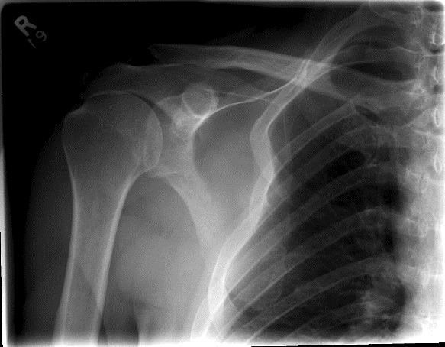
Slight overlap of humeral head on glenoid cavity

Entire scapula

AP Oblique Projection (Neutral Rotation)

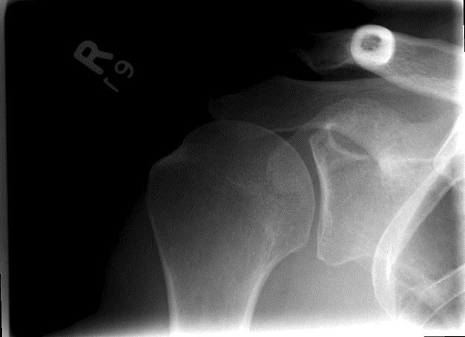
Close beam restriction

Glenoid fossa in profile

Superoinferior Axial Projection

Open scapulohumeral
joint

AC joint through humeral head

Coracoid process
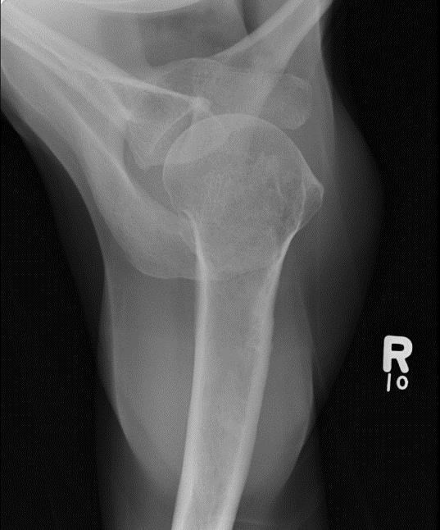
projected above
the clavicle

Lesser tubercle in profile

PA Oblique Projection (Transcapular View)

Acromion free of superimposition

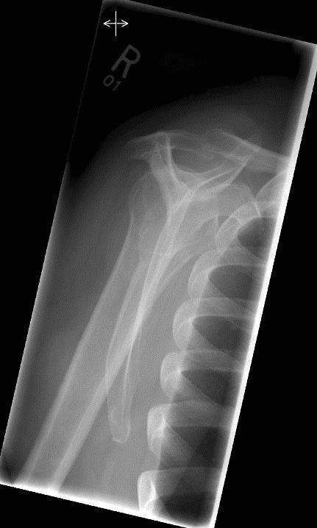
Coracoid possibly superimposed

Scapula in lateral profile

Scapular body
free of superimposition

Common Pathologies
Dislocation: (Best visualized on the Scapular Y view)
- Non dislocated shoulder: Humeral head is centered and slightly superimposed over the glenoid fossa.
- Anterior dislocation: Most common- 95%- Humeral head is below the coracoid.
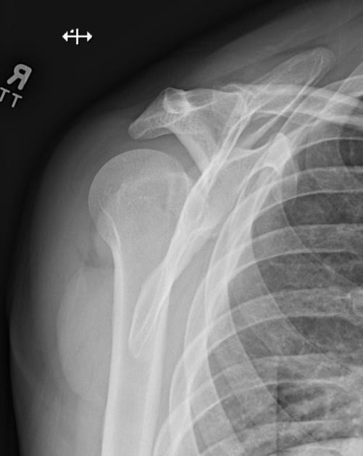
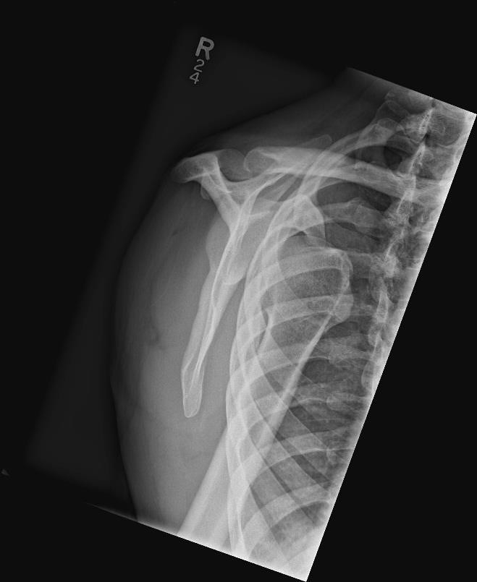
- Posterior dislocation: Less common- 2-4%- Humeral head is below the acromion or scapular spine.

Humeral
head posterior to the scapula indicating a posterior dislocation

Humeral head anterior to scapula

Humeral head
“locked” around
glenoid

Hill-Sachs deformity: Best visualized on the axial view.

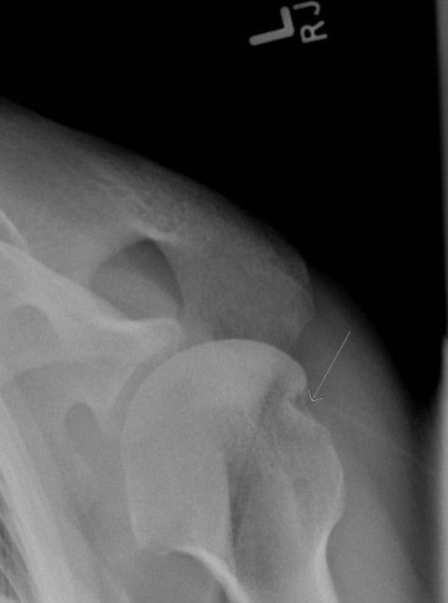
Hill-Sachs
deformity

Sinuses

PA Axial Projection (Caldwell 15º)
  - Extend the patient’s chin to form a 15° angle between the orbitomeatal line (OML) and the IR.
  - Horizontal beam perpendicular to exit the nasion.
  - Pre-coning: cone tight (14cm x 14cm) to include frontal and ethmoid sinuses.
  - Minimum SID of 100 cm (40”).
  - Suspend respiration.

Evaluation Criteria
Frontal sinuses lying above the frontonasal suture and the anterior ethmoidal air cells lying above the petrous ridges.
Ethmoid sinuses centered.
Supraorbital rims are in the same horizontal plane. Superior orbital fissures are within the orbits.
Equal distance from the lateral border of skull to lateral border of orbit on both sides. Crista gali and nasal septum aligned with long axis of the IR.
Petrous ridges horizontally through lower 1/3 of the orbits. Petrous pyramids superimpose the infraorbital rims.
Clearly visible air-fluid levels, if present.

How to fix it
Larger distance from orbit to lateral border of skull on right side.
    - The head is rotated towards the left side.
Larger distance from orbit to lateral border of skull on left side.
    - The head is rotated towards the right side.

Parietoacanthial Projection (Open mouth Waters)
  - Neck extended to place chin resting on the IR (OML forms a 37º angle with the IR). The mentomeatal (MML) line is perpendicular to the IR.
  - Have patient open their mouth.
  - Central ray horizontal and exiting the acanthion.
  - Pre-coning: cone tight (14cm x 14cm)
  - Minimum SID of 100 cm (40”).
  - Suspend respiration

Evaluation Criteria
  - Take images upright with a horizontal ray to show air-fluid levels.
  - Demonstrates the maxillary sinuses, frontal and ethmoid sinuses are distorted.
  - Equal distance from the lateral border of skull to lateral border of orbit on both sides.
  - Petrous ridges projected immediately inferior to the maxillary sinuses and extend laterally from posterior maxillary alveolar process.
  - Orbits and maxillary sinuses symmetric on each side.
  - Demonstrates the foramen rotundum. Seen inferior to medial aspect of the orbital floor and superior to the roof of the maxillary sinuses.

  - Demonstrates the sphenoid sinus through the open mouth. Open mouth and the lateral are the only two views beside the basal to demonstrate the sphenoid sinus.

How to fix it
Maxillary sinuses superimpose the posterior molars and alveolar process.
    - The chin is too high. Lower the chin.
Petrous ridges are superior to posterior maxillary alveolar process and superimposing the maxillary sinuses.
    - The chin is too low. Raise the chin.

Lateral Projection
  - Central ray directed horizontal entering the patient’s head 1-2.5 cm (0.5”-1”) posterior to the outer canthus.
  - Pre-cone tightly to 14 cm by 14.cm
  - Midsagittal plane is parallel to IR and interpupillary line is perpendicular to IR.
  - Minimum SID of 100 cm (40”).
  - Suspend respiration.

Evaluation Criteria
Demonstrates all four sinus groups, but the sphenoid sinus is of primary importance. Superimposed orbital roofs.
No rotation of the sella turcica.
Clearly visible sinuses with air-fluid levels, if present. Superimposed mandibular rami.
If patient is unable to be done erect, a cross-table lateral is performed to demonstrate fluid levels.

PA Axial Projection (Caldwell 15º)

No rotation of
cranium
Petrous ridges through lower 1/3 of the orbits
Frontal sinuses lying above the frontonasal suture
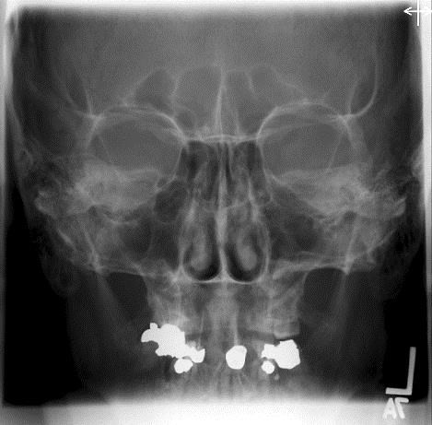
Anterior ethmoidal air cells lying above petrous ridges

Parietoacanthial Projection (Open mouth Waters)

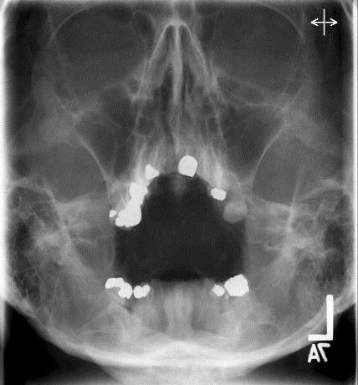
No rotation of cranium

Symmetric maxillary sinuses

Sphenoid sinuses seen through open
mouth
Petrous ridges projected immediately inferior to the maxillary sinuses

Lateral Projection

All four sinus
groups
Superimposed orbital roofs
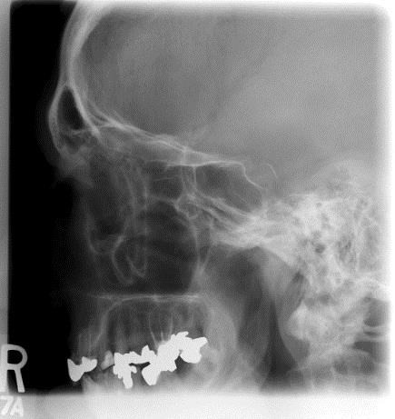
No rotation of sella turcica

Superimposed mandibular rami

Skeletal Survey

  - Skeletal survey protocols varies from site to site. Ensure following correct site protocol
  - The main clinical indication for a skeletal survey is multiple myeloma. Other indications include plasma syndrome, non-accidental trauma and differentiating between myeloma and metastatic disease.

Skull

PA Axial Projection (Caldwell 15º)
  - OML is perpendicular to the IR.
  - Central ray 15º caudad to exit the nasion.
  - Alternate method: 20-25º caudad angle to demonstrate the superior orbital fissures. 25- 30º caudad angle to demonstrate the foramen rotundum. Petrous ridges will be projected below the inferior orbital rim region.
  - Minimum SID of 100 cm (40”).
  - Suspend respiration.

Evaluation Criteria
Supraorbital rims are in the same horizontal plane. Superior orbital fissures are within the orbits.
Equal distance from the lateral border of skull to lateral border of orbit on both sides. Distance from the crista galli to the lateral cranial cortices is equal on both sides.
Crista galli and nasal septum aligned with long axis of the IR. Slight head tilting does not change any anatomical relationships. Head tilting prevents tighter coning.
Petrous ridges horizontally through lower 1/3 of the orbits. Petrous pyramids superimpose the infraorbital rims.
Ethmoid sinuses centered.

How to fix it
Larger distance from orbit to lateral border of skull on right side.
    - The head is rotated towards the left side.
Larger distance from orbit to lateral border of skull on left side.
    - The head is rotated towards the right side. Petrous ridges are in the upper ½ of the orbits.
    - The chin is tucked too much or less than 15º caudad angle was used. Raise the chin a bit or angle more.
Petrous ridges are inferior to the infraorbital rims.
    - The chin is not tucked enough or more than 15º caudad was used. Lower the chin a bit or angle less.

AP Axial Projection (Townes 30º)
  - Tuck the chin down so that the OML is perpendicular to the IR.
  - If OML cannot be aligned then align IOML perpendicular to the IR and increase the central ray angle to 37º.
  - Central ray 30º caudad entering 5 cm (2.5”) above the glabella and exits at the level of the EAM (IOML perpendicular: 37º caudad angle 5 cm 2.5” above the glabella).
  - Minimum SID of 100 cm (40”).
  - Suspend respiration.

Evaluation Criteria
Equal distance from the lateral border of skull to lateral margin of foramen magnum on both sides, indicating no rotation.
Petrous ridges are symmetrical.
Sagittal suture is aligned with the long axis of the IR. Inferior occipital bone centered.
Dorsum sellae and posterior clinoid process projected within the foramen magnum.

How to Fix it
Dorsum sellae and posterior clinoids is projected superior to the foramen magnum.
    - The chin is not tucked enough or less than 30º caudad angle was used. Lower the chin a bit or angle more.
Dorsum sellae is foreshortened and superimposes the posterior arch of the atlas.
    - The chin is tucked too much or more than 30º caudad angle was used. Raise the chin a bit or angle less.

Lateral Projection
  - IOML is perpendicular to the transverse axis of IR.
  - Interpupillary line is perpendicular to the IR.
  - Central ray perpendicular to 5 cm (2”) superior to the EAM.
  - To check for head rotation, ensure the external occipital protuberance posteriorly and the glabella and nasion anteriorly are equidistant from the IR in a true lateral position.
  - Minimum SID of 100 cm (40”).
  - Suspend respiration.

Evaluation Criteria
No rotation of the sella turcica.
Superimposed orbital roofs and greater wings of the sphenoid. Cranium is lateral.
Cranial cortices are superimposed and included in the field.
Superimposed EAMS and mastoid region. Sella turcica in profile.
Penetration of the parietal bone.
No overlap of cervical spine by the mandible.
Posteroinferior occipital bone and posterior arch of the atlas free of superimposition.

How to Fix it
Sella turcica, mandibular rami, greater wings of the sphenoid, EACS, and anterior cranial cortices are not superimposed.
    - The patient is rotated (midsagittal plane). Ensure the midsagittal plane parallel to the IR.
Orbital roofs, one side of the greater wings of the sphenoid, EACS, and inferior cranial cortices superior are not superimposed.
    - The patient is tilted (interpupillary line). Ensure the interpupillary line perpendicular to the IR.

166 Image Critique Handbook – Version 1, 2024

Trauma Routine
Do not adjust the head if cervical injury is suspected.

AP Axial Projection (Caldwell 15º)
  - Angle 15º cephalad entering the nasion.
  - If the chin is not tucked enough angle the central ray parallel with the OML, then adjust the central ray 15º cephalad from this point.
  - Minimum SID of 100 cm (40”).
  - Greater magnification of the orbits.

How to fix it
Petrous ridges are in upper ½ of orbits.
    - You have used less than 15º cephalad angle from the OML. Angle more. Petrous ridges are below the infraorbital margins.
    - You have used more than 15º cephalad angle from the OML. Angle less.

AP Axial Projection (Townes 30º)
  - If patient is in a cervical collar angle the tube to be parallel with the OML then angle 30º caudad from this angle. Use the transverse collimator light to help you line up the tube parallel to the OML. Correction should not be more than 45º or distortion occurs.
  - Minimum SID of 100 cm (40”).

Lateral Projection (X-table)
  - Place crosswise IR vertically against patient’s shoulder or place stretcher next to IR.
  - Central ray 2” superior to the EAM.
  - Minimum SID of 100 cm (40”).

PA Axial Projection (Caldwell 15º)

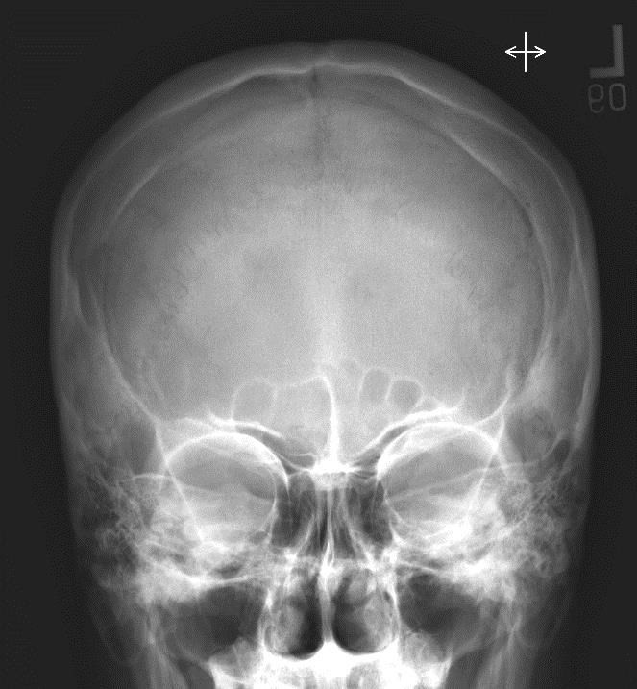
Entire skull included
Equal distance from the lateral border of skull to lateral border of orbit (shows no rotation)

Petrous ridges through lower 1/3 of orbits

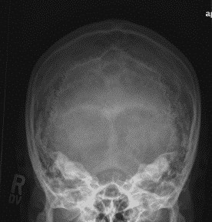
AP Axial Projection (Townes 30º)

Petrous ridges symmetrical
Dorsum sellae is centered in the foramen magnum

Equal distance from the lateral border of skull to lateral margin of foramen magnum (shows no rotation)

Lateral Projection

Superimposed
EAMs
Superimposed orbital roofs
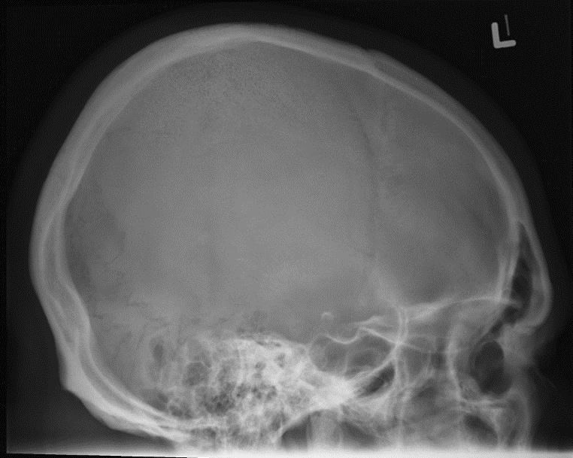
Sella turcica in profile

Sternoclavicular Joints

PA Projection
  - Central ray perpendicular IR, entering at T3 to exit the sternal notch.
  - Minimum SID of 100 cm (40”).
  - Suspend respiration on full expiration to obtain more uniform density.

Evaluation Criteria
Both sternoclavicular joints and the medial ends of the clavicles (with no rotation).
Sternoclavicular joints visualized through the superimposing vertebral and rib shadows.

PA Oblique Projection (RAO/LAO)
  - Rotate patient 10-15º to bring the SC joint of the side down parallel with the IR. This will also project the vertebrae well behind the joint.
  - Central ray perpendicular to the sternoclavicular joint closest to the IR. The central ray enters at the level of T2-T3. Minimum SID of 100 cm (40”).
  - Suspend respiration on full expiration to obtain a more uniform density.

Evaluation Criteria
Sternoclavicular joint of interest in the center of the radiograph, with the manubrium and the medial end of the clavicle included.
Open sternoclavicular joint space (side down).
Sternoclavicular joint of interest immediately adjacent to the vertebral column.
Reasonably good visibility of the sternoclavicular joint through the superimposing rib and lung fields.

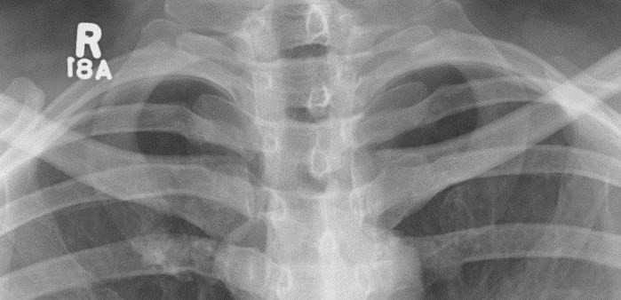
PA Projection

Sternoclavicular joints through
the superimposing
vertebral and rib
shadows

No rotation present

Both Sternoclavicular joints included

PA Oblique Projection

Reasonably good visibility of the
sternoclavicular joint through the
superimposing rib and lung fields
Open sternoclavicular
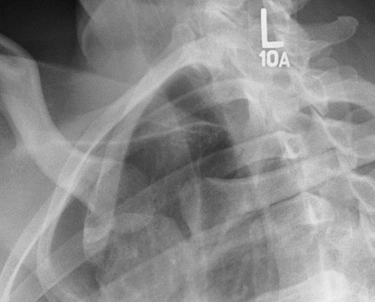
joint space (side
down)
Sternoclavicular
joint of interest directly in front of the vertebral column

Sternum

Procedure manual states lateral sternum and PA chest (if one not done in last 24 hours) performed when sternum x-ray requested (Chest x-ray requires separate accession number).

Lateral Projection
  - Due to location of photocell, it is advisable to preset a manual technique.
  - Patient should be seated or standing for comfort.
  - If possible, patient should be directed to clasp their hands behind their back and rotate the shoulders posterior, to project the sternum forward.
  - Central ray perpendicular lateral border of the mid-sternum. Minimum SID of 100 cm
(40”).
  - Collimate to the sternum.
  - Suspend respiration on full inspiration.

Evaluation Criteria
Lateral image of the sternum in its entirety.
Entire sternum free of superimposition by the soft tissues of the shoulders, arms, and ribs.
Inferior portion of the sternum unobscured by the breasts of a female patient (a second radiograph with increased penetration may be necessary).
Contrast, density, and penetration are adequate to visualize the bony trabecular patterns and cortical outlines of the jugular notch, manubrium, sternal body, and Xiphoid process.

How to Fix it
Heart shadow seen extending anterior to the sternum.
    - The patient was positioned with the left thorax rotated anterior. Rotate the right side forward.
Heart shadow does not extend beyond the sternum and the left lung is situated posterior.
    - The patient was positioned with the right thorax rotated anterior. Rotate the left side forward.

Lateral Projection

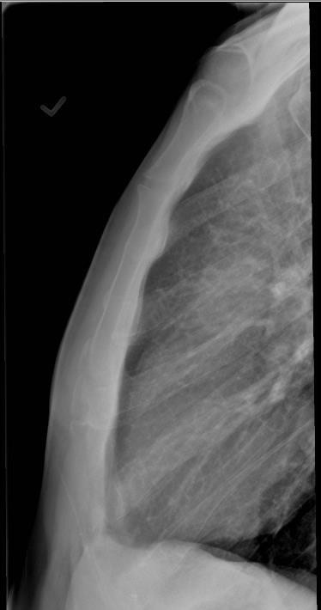
Sternum free of superimposition by the soft tissues of the shoulders, arms, and ribs

Sternum in lateral profile

T
      - Thoracic Spine
      - Thumb
      - Tibia/Fibula
      - Toes

Thoracic Spine

AP Projection
  - Central ray perpendicular to T7. If the patient is kyphotic angle the central ray to align it with the vertebral bodies.
  - Minimum SID of 100 cm (40”).
  - Utilize the anode heel effect or filter to even out densities.
  - Suspend on full inspiration.

Evaluation Criteria
Must include T1-T12.
Cones open to include 2.5” of posterior ribs and mediastinum on either side of vertebrae. Sternal ends of the clavicles are equal distances from the vertebral column.
Spinous processes are aligned midline in the vertebral bodies. Pedicles are equal distances from the spinous processes.
Intervertebral disc spaces are open.
Vertebral column centered to long axis of the IR. Ensures no lateral flexion.

Lateral Projection
  - Central ray perpendicular to T7 (inferior scapular border).
  - Minimum SID of 100 cm (40”).
  - Respiration: suspend on full inspiration.

Evaluation Criteria
T1-T12 included (look for vertebrae with the last rib or follow the curve of the lower thoracic spine and the upper lumbar, above the point where the kyphotic curve subtly changes into the lordotic is T12).
Nearly superimposed posterior ribs. Magnification of the side up may make it hard to completely superimpose the ribs.
Open intervertebral disc spaces (closed disc spaces and distorted lower vertebral bodies indicate that the spine was not parallel with the imaging receptor).
Due the thickness of the shoulders it is hard to get T1-T3 on a lateral radiograph. A swimmers view is required.

Swimmers View (Cervicothoracic Region)
  - Elevate the arm closest to the IR.
  - Depress the shoulder farthest from the IR and rotate posteriorly. If patient cannot depress the shoulder enough, then use a 5º caudal angle.
  - Central ray perpendicular to C7-T1 interspace. Minimum SID of 100 cm (40”).
  - For trauma you angle the stretcher to separate the shoulders or you can angle the central ray 3-5º caudad to jugular notch.
  - Suspend respiration.

Evaluation Criteria
C5-T3 or to include all levels not well visualized on the lateral t-spine image.
Superimposed articular pillars, posterior ribs, and zygapophyseal joints to show no rotation.
Humerus elevated above the patient’s head is aligned with the cervical vertebrae. X-ray penetration of the shoulder region.
Anterior soft tissue does not need to be included.

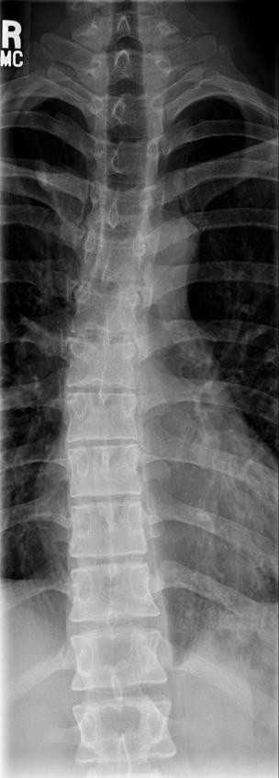
AP Projection

T1-T12 must be included

Open intervertebral
disc spaces

Spinous processes midline

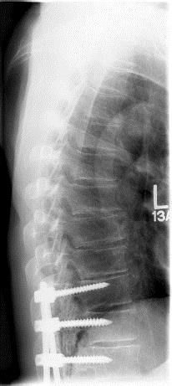
T1-T12 included

Nearly superimposed posterior ribs

Open intervertebral
disc spaces

Separation of the clavicles to visualize T1

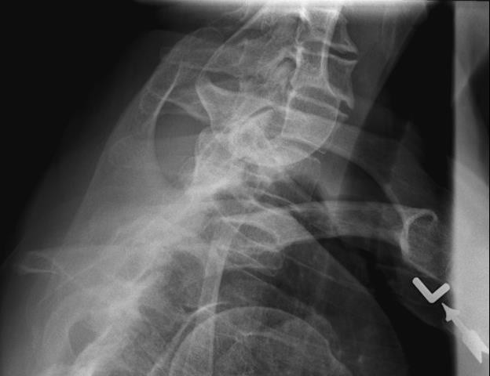
- ray penetration and separation of the shoulder region

Superim posed
posterior
ribs

Thumb
The trapezium should be demonstrated on all views.

AP Projection
- Central ray perpendicular to the 1st MCP joint. Minimum SID of 100 cm (40”).
- AP projection is preferred over PA for reduced OID and increased detail.

Evaluation Criteria
Area from the distal tip of the thumb to the trapezium.
Thumbnail, if visualized, in the center of the distal phalanx. Equal concavity of the phalangeal and metacarpal shafts. Equal amount of soft tissue on both sides of the phalanges.
Open interphalangeal and metacarpal phalangeal joint spaces without overlap of bones. Overlap of soft tissue profile of the palm over the midshaft of the 1st metacarpal.

PA Oblique Projection
- Central ray perpendicular to the 1st MCP joint.
- Minimum SID of 100 cm (40”).

Evaluation Criteria
Area from the distal tip of the thumb to the trapezium.
Proper rotation of phalanges, soft tissue, and 1st metacarpal. Open interphalangeal and metacarpal phalangeal joint spaces.

Lateral Projection
- Central ray perpendicular to the 1st MCP joint.
- Minimum SID of 100 cm (40”).

Evaluation Criteria
Area from the distal tip of the thumb to the trapezium.
Thumbnail, if visualized and normal, in profile. First digit in a true lateral projection.
Concave anterior surface of the proximal phalanx. Open interphalangeal and MCP joint spaces.

 |  |  | Equal concavity
Open |  |  | of the
interphalangeal |  |  | phalangeal and
joint |  |  | metacarpal shafts
Open MCP joint
 |  |  | Area from the distal tip of the thumb to the trapezium

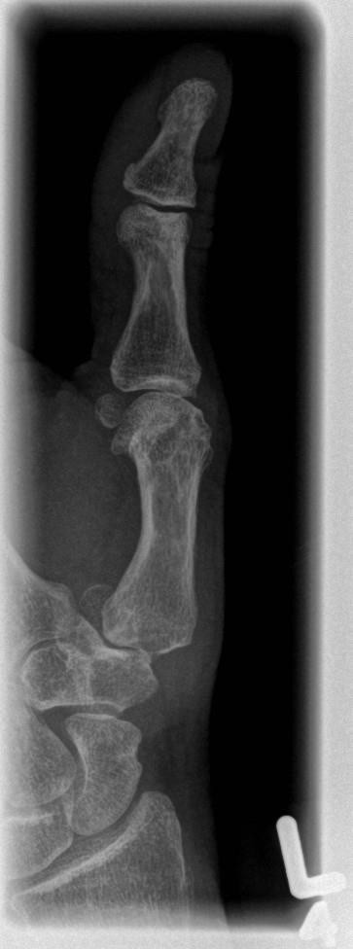
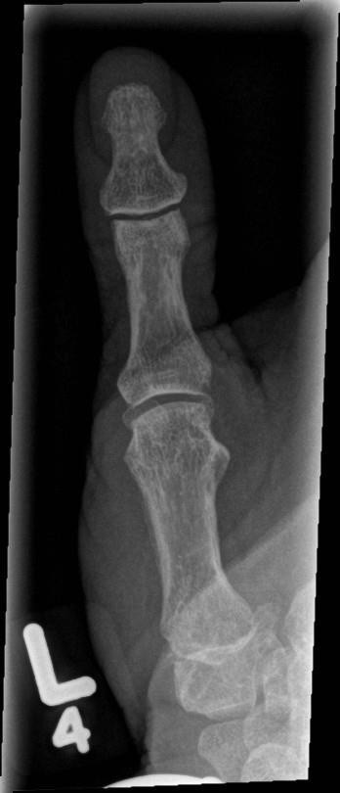
PA Oblique Projection

Open
interphalangeal
joint Proper rotation
of phalanges, soft tissue, and 1st metacarpal
Open MCP joint

Area from the distal tip of the thumb to the trapezium

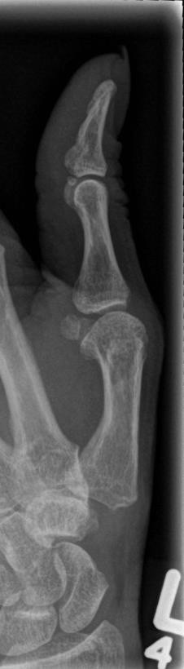
Concave, anterior surface
of the proximal
phalanx
Open interphalangeal joint

Open MCP joint

Area from the distal tip of the thumb to the trapezium

Tibia/Fibula
Note: Two images may be required to visualize the entire tibia and fibula for each position.

AP Projection
- Central ray perpendicular to the center of the leg.
- Minimum SID of 100 cm (40”).
- Note site specific protocols as some sites require entire talus included on the image.

Evaluation Criteria
Medial and lateral femoral condyles in profile.
Intercondylar eminence is centered in the intercondylar fossa. Head of the fibula partly superimposed by the tibia.
Fibular mid-shaft free of superimposition of the tibia. Medial mortise is open.
Distal tibia and talus partially superimpose the fibula closing the lateral mortise (talofibular joint).
Divergent rays close the knee and ankle joints

Note: Fracture positioning: position the joint closest to the fracture in a true AP.

How to Fix it
Fibula shifts towards and beneath the tibia obscuring the medial mortise.
  - The leg is laterally rotated. Rotate the leg internally.
The head of the fibula draws away from the tibia and the base of the fibula draws away from the talus.
  - The leg is medially rotated. Rotate the leg externally.

Lateral or Mediolateral Projection
- Central ray perpendicular to the mid-point of the leg.
- Minimum SID of 100 cm (40”).
- Note site specific protocols as some sites require entire talus included on the image.

Evaluation Criteria
Include 1-11/2” beyond the joints on the film. Tibia partially superimposes the fibular head. Fibular mid-shaft free from tibial superimposition.
Distal fibula superimposed by the posterior ½ of the tibia.
Talar domes superimposed. Soft tissue and trabecular detail.
Divergent rays close the knee and ankle joints.

Note: Fracture positioning: Cross table laterals are more comfortable for the patient. Position the joint closest to the fracture in a lateral position.

How to Fix it
Fibula over the anterior half of the tibia (lateral talar dome anterior).
  - The forefoot was elevated. Depress the forefoot and elevate the heel. Fibula posterior to the tibia (medial dome anterior).
  - The forefoot was depressed. Elevate the forefoot and depress the heel.

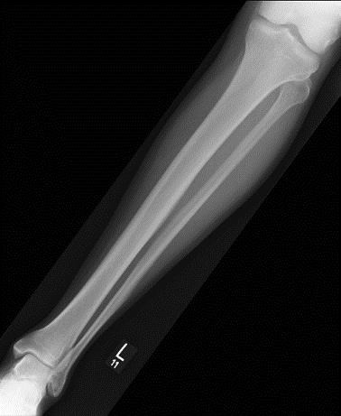
Medial and lateral femoral condyles in profile

Fibular mid-shaft free of superimposition

Medial mortise
open Distal tibia and
talus partially superimposing the fibula

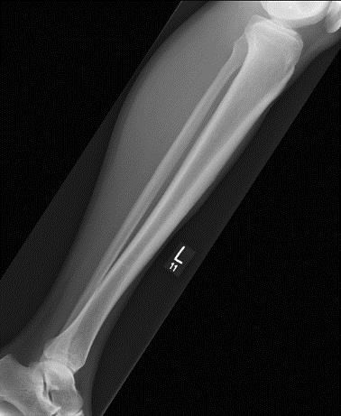
Tibia partially superimposes the
fibular head

Fibular mid-shaft free of superimposition

Distal fibula superimposed by the posterior ½ of
the tibia

Talar domes superimposed

Toes
Procedure manual states AP forefoot with an Oblique and Lateral of the affected toe should be performed.

AP Projection (Forefoot)
- Central ray perpendicular to 3rd metatarsophalangeal joint.
- Minimum SID of 100 cm (40”).

Evaluation Criteria
Entire phalanges and distal ends of metatarsals. No rotation of phalanges.
Soft tissue and bony trabeculation.

AP Oblique Projection (Toe)
- Central ray perpendicular to the metatarsophalangeal joint of the affected toe.
- Minimum SID of 100 cm (40”).

Evaluation Criteria
Open interphalangeal and metatarsophalangeal joint spaces. Toes separated from each other.
Distal end of the metatarsal.
Soft tissue and bony trabeculation.

Lateral Projection (Toe)
- Central ray perpendicular to the metatarsophalangeal joint of the great toe or the proximal interphalangeal joint of the lesser toes.
- Minimum SID of 100 cm (40”).

Evaluation Criteria
Phalanges in profile (toenail should appear lateral).
Phalanx, without superimposition of adjacent toes. When superimposition cannot be avoided, the proximal phalanx must be demonstrated.
Open interphalangeal joint spaces. The metatarsophalangeal joints will be overlapped but may be seen in some patients.
Distal third of the metatarsal.
Soft tissue and bony trabeculation.

AP Projection (Forefoot)

Toes separated from each
other

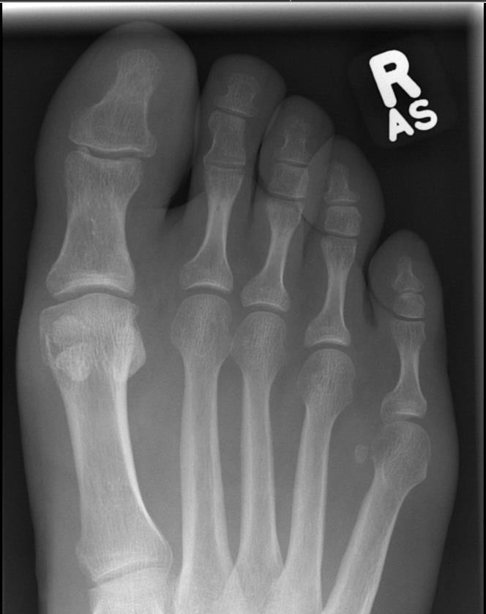
No rotation of phalanges

Entire phalanges and distal ends of metatarsals

AP Oblique Projection (Toe)

Toes separated from each other

Oblique toe

Distal end of metatarsal

Open interphalangeal joint spaces

Open metatarsophalangeal joint

Lateral Projection (Toe)

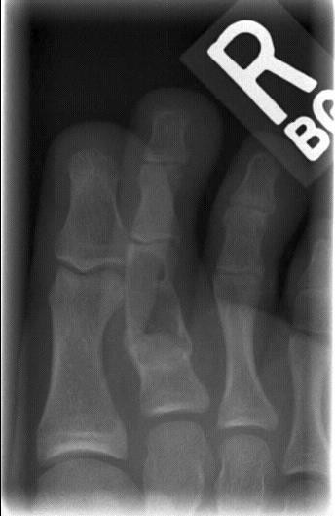

Toes separated from each other

Distal end of metatarsal

Phalanges in profile
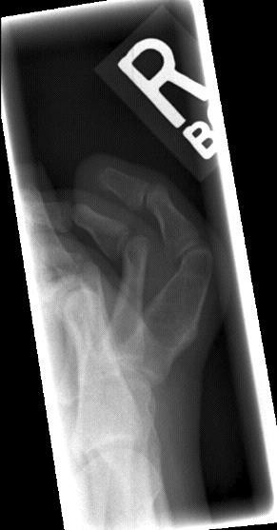
Open interphalangeal joint spaces

Open metatarsophalangeal joint

V
- Ventriculoperitoneal Shunt Series

Ventriculoperitoneal Shunt Series

Procedure manual states series to be done supine if requested by Nuclear Medicine. This is because they require the patient to be supine for 20 minutes-1/2 hour prior to the VP Shunt exam. Overlap between skull, chest, and abdomen images should be seen to rule out kinks or breaks in the line. Line must be visualized on all images.

W
- Wrist

PA Projection
Wrist

- Slightly flex the fingers to bring carpals in contact with IR.
- CR perpendicular to midcarpal region, just distal to the radial and ulnar styloid processes.
- Minimum SID of 100 cm (40”).

Evaluation Criteria
Distal radius and ulna, carpal bones, and proximal half of metacarpals. No excessive flexion to overlap and obscure metacarpals with digits. Radial and ulnar styloids are at extreme lateral and medial edges.
Anterior and posterior carpal articulating margins of the radius are nearly superimposed. No rotation in carpals, metacarpals, or radius.
Soft tissue and bony trabeculation.

Note: There is a scaphoid fat pad just lateral to the scaphoid in a non-injured wrist. It is normally convex. A change in convexity may indicate a joint effusion or radial side fracture of the scaphoid, radial styloid process, or proximal first metacarpal.

How to Fix it
Signet ring appearance of the scaphoid.
  - The hand is extended. Slightly curl the fingers to flex the metacarpals 10-15º.

AP Projection
Better demonstrates the carpal interspaces. Interspaces are more parallel in an AP projection.

PA Oblique Projection
- Oblique the wrist 30-45º. Judge the obliquity of the wrist by looking at the plane passing through the styloid processes, not the hand.
- CR perpendicular to midcarpal region, just distal to the radial and ulnar styloid processes.
- Minimum SID of 100 cm (40”).

Evaluation Criteria
Distal radius and ulna, carpal bones, and proximal half of metacarpals. Slight interosseus space between the 3-4th and 4-5th metacarpal shafts. Trapezium and distal scaphoid are well demonstrated.
Open trapeziotrapezoid and scaphotrapezial joint space. Minimal overlap of the trapezoid on the capitate.
Slight overlap of the distal radius and ulna. Soft tissue and bony trabeculation.

How to Fix it
There is excessive superimposition of the trapezoid on the capitate.

  - The wrist is over-obliqued. Reduce the amount of external rotation.

Lateral Projection
- Adjust the forearm and hand so that the wrist is in a true lateral position (5º posterior rotation from a true lateral hand position).
- CR perpendicular to the midcarpal region.
- Minimum SID of 100 cm (40”).

Evaluation Criteria
Distal radius and ulna, carpals, and proximal half of the metacarpals.
Superimposed metacarpals. Distal scaphoid and pisiform superimposed. Lunate has a cup or half-moon shape.
Trapezium is free of superimposition of the first metacarpal (thumb is parallel to the IR). Superimposed distal radius and ulna.
Radiographic density similar to PA and oblique radiographs, which requires increased exposure factors to compensate for greater part thickness.

Note: There is a pronator fat pad seen on the anterior or volar surface of the lateral wrist. Normally it is convex. If it is bowing or obliterated this could indicate a subtle radial fracture.

Radial styloid at extreme lateral
edge
No rotation in carpals, metacarpals, or radius

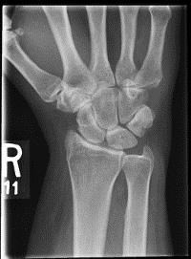
Ulnar styloid at extreme medial edge

PA Oblique Projection

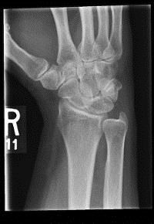
Slight interosseus space between the 3rd-4th and 4th-5th metacarpal shafts

Trapezium and trapezoid free of superimposition and joint space
open

Proximal half of metacarpals to distal radius and ulna included

Proximal half of metacarpals to distal radius and ulna included

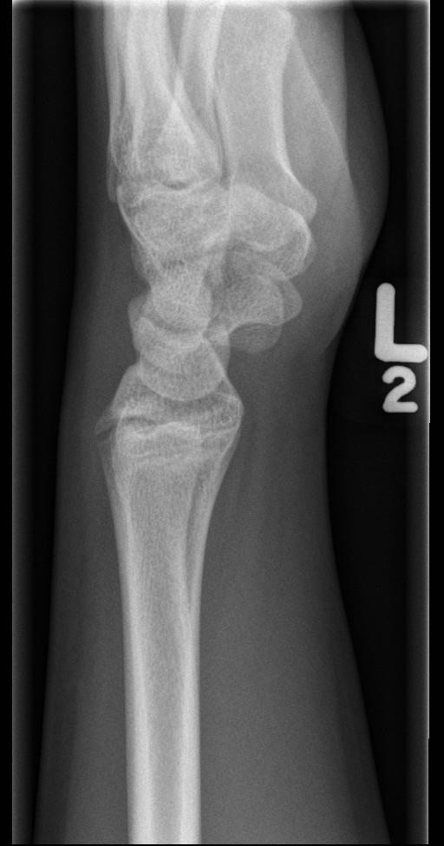
Superimposed distal radius and ulna

Colle’s Fracture: Most common fracture of the wrist (FOOSH). Transverse fracture of the distal radius with posterior displacement of the distal fragment.
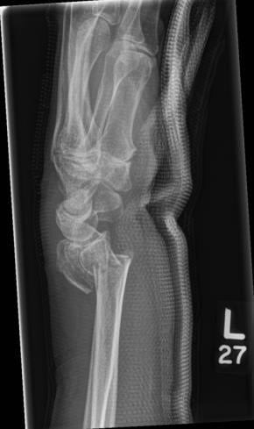

Smith’s Fracture: Transverse fracture of the distal radius with anterior displacement of the distal fragment.
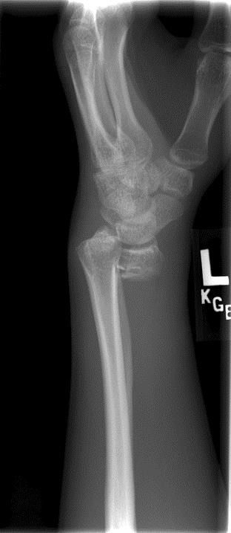

Mobile Procedures

ALL MOBILE PROCEDURES

- Read your requisition. Know why the exam is being performed:
- Introduce yourself to the patient and tell them why you are there.
- Ensure you have the correct patient. Check wristband, ask patient their name, ask
patient their date of birth, or check with the patient’s nurse (double id required).
- Ensure the patient’s nurse is present in room. The patient is their responsibility: therefore, any patient movement should have their approval first. They should be assisting with the patient movement.
- Assess the patient to see what kind of assistance may be required.
- Ensure sure you have all necessary equipment for the entire exam.
- Re-arrange the room to make space for your machine and yourself before entering.
- Announce your intention to expose by stating clearly “XRAY BED (number)”. Ensure everyone is clear. If you are next to another bed with a patient place your shielded body between them and the tube. Otherwise keep a distance of at least 3 meters (6 feet) between you and the tube. Always wear a lead apron when exposing.
- After exam is complete make sure the patient is comfortable and the side rails are up. Return the room as you found it.
- Clean mobile/IR to prevent cross contamination and check charge on mobile before turning machine off.
- Post processing: Note on the image and/or in Millennium: time, technique, distance, and position (ex: AP upright) as per site protocol.

Chest Mobile
- Read your requisition. Know why you are performing the exam:
  - Tube placement (ex: nasogastric (NG), endotracheal (ET), etc.)
  - Line Placement (ex: central line)
  - Lungs (ex: pleural effusion, pneumothorax, pneumonia, etc.)
- Preset a chest technique.
- Assess the patient to see if they can sit in an upright position. For pneumonia, pleural effusion, and free air try to get the patient in an upright position. This is important as it shows fluid levels and free air. If placing the patient in an upright position is contraindicated, then perform the case supine.
- Swing the mobile arm into the appropriate position with a slight caudad angle on the tube (approximately perpendicular to the sternum).
- Use appropriate markers/arrows on IR as per site protocol
- Place the IR in a protective covering (i.e., pillowcase or garbage bag). This is especially important if the IR could be exposed to fluids. Placing the IR in a garbage bag or clear plastic bag allows the technologist to move the patient on the IR more easily (Note: An egg crate sponge should be used on very thin patients for comfort). Place the covered IR behind the patient but not directly against the patients’ skin. Have a sheet or soaker in between the patient and the IR.
- Most times the IR can be placed crosswise (check body habitus).
- Collimate to AC joints bilaterally
- For a supine chest positioning, the abdomen is compressed and this doesn’t allow for the lungs to fully inflate.
- Depress the shoulders and place them in the same horizontal plane. Ensure the legs, pelvis, and shoulders are in alignment so there is no rotation of the clavicles.
- Angle the mobile tube so that the central ray is perpendicular to midsagittal plane 4” inferior to the jugular notch (T7 centered). Stand behind the tube and check to see that there is no side to side angulation.
- Measure the distance. 180 cm (72”) is optimal.
- If not possible, 140 cm (56”) will reduce the OID and give desired detail. The heart will be magnified (ensure the SID is placed on image).
- Remember to maximize the SID as much as possible for supine chests.
- Lower the kVp for non-grid chests. 90 kVp is acceptable for CR exams. This demonstrates the lung fields but will not penetrate heart shadow area.
- Heart penetration requires higher kVp the overall contrast is lower due to the scatter. Indicated for:
- Swan-Ganz catheter
- Central venous pressure line
- Shield patient and arrange all movable wires off of chest area.
- Announce “x-ray and bed number” and wait for the area to clear
- Take exposure on inspiration. It may be necessary to take exposure on 2nd inspiration if patient is able to follow directions.
- After the exposure remove the IR from behind the patient first. Then swing the tube and lock it back into position.

Evaluation Criteria
No rotation: Clavicles equidistant from the vertebral column.
Manubrium superimposes T4. This is determined by the central ray alignment.
1” of the apices above the clavicles (or three ribs) Posterior ribs show a gentle downward contour
Scapulae are in the lung field but arms are abducted.
Lines, tubes, etc. are shown (but all movable wires should be removed from chest). 9-10 posterior ribs.
Heart magnified. Document the distance measured in Millennium and on the image.
Apices to costophrenic angles included Air filled trachea
Clavicles are in a horizontal plane
Lung markings visible from the hilum to the periphery of the lung
Faint shadow of the ribs and superior thoracic vertebrae through the heart shadow

Note: Supine Patient: Patient’s shoulders and upper thorax naturally extend posteriorly. You can compensate by a 5 degree caudad central ray angle. Heart and great vessels are magnified and engorged. The lung fields appear shorter because of abdominal compression moves the diaphragm to a higher level. In the supine position, patient’s shoulders will naturally become elevated therefore avoid using shoulders as a guide for collimation.

Arrow to indicate upright
or supine

AP Projection (Upright Mobile Chest)

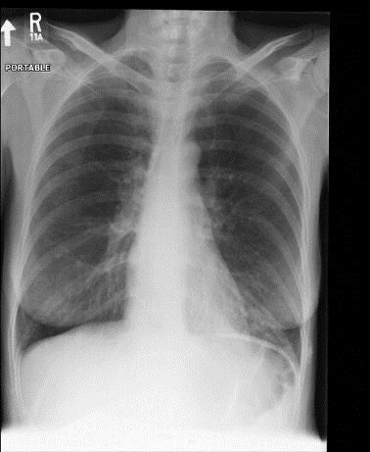
1” of apices above clavicles (proper

angulation)

Clavicles equidistant from vertebral column (shows no rotation)

Faint shadow of
ribs and vertebrae through heart
shadow (adequate penetration)

9-10 posterior ribs seen above diaphragm

Abdomen Mobile
- Read your requisition. The routine mobile abdomen procedure is a one view supine image.
- Decubitus abdomens are only performed if the reason stated is perforation or free air.

For Supine Abdomen Views:
- Preset an abdomen technique
- Must use a grid
- Place your marker and arrow on the outside of the grid
- Put your IR in a protective covering (i.e., pillowcase or garbage bag)
- Ensure that there are enough personnel to safely roll the patient and inquire which would be the best side to roll the patient towards.
- Palpate the patient to locate the crests prior to rolling the patient so you can use this as a centering point for your IR.
- Roll the patient and place the IR portrait (lengthwise) centered at the level of crests. Some larger patients will require two separate exposures placed landscape (crosswise)
- Ensure the legs, pelvis and shoulders are in alignment and no rotation is present
- Drive mobile along the side of the bed and swing the arm out

- Shield the patient appropriately and move extraneous wires from abdomen if
- Announce “x-ray and bed number” and wait for the area to clear
- Take the exposure on expiration
- Move the portable out of the way
- Call for assistance in rolling the patient and removing the IR

Evaluation Criteria
Spinous processes in center of the lumbar vertebrae.
Sacrum is centered within the pelvic inlet and aligned with the symphysis pubis. Ischial spines of the pelvis and Alae of the ilia are symmetrical.
Rotation decreases the visualization of the fat lines that surround the abdominal structures.
Long axis of the spine is parallel to the long axis of the IR. Pelvis and ribs are equidistant from the edge of the IR. This ensures the lateral abdominal cavity won’t be clipped.
T11 to the symphysis included. Including T11 on the abdomen radiograph gets the tops of the kidneys, liver and spleen.
Cortical outlines of the posterior ribs, lumbar vertebrae, pelvis, and gases within the stomach and intestines are sharply defined.
Contrast and density to show the collections of fat to demonstrate lateral psoas muscles (originate at L1 and extend to the lesser trochanter) and kidneys as well as bony structures of the vertebrae and pelvis
If there is a lot of gas suspected in the abdomen, decrease the technique mAs 30-50% or kVp 5-8%. Radiation is not absorbed by gas (air has a lower atomic number) and this will result in an over exposed image.
Arrow marker indicating supine.

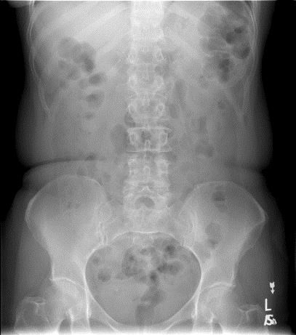
AP Projection Supine

Decubitus Abdomen Views
- Make sure you are prepared with at least 2 cassettes, a grid, a hard slider board (or blankets), tape and enough people to roll the patient safely as well as extra lead aprons. Note: this procedure may require a nurse or someone else from the unit to hold the IR. Ensure that you provide lead for them to wear.
- Portable decubitus abdomens can be done AP or PA depending on patient condition or room set up
- Patient should be elevated on a hard surface and rolled on to their left side (LLD) for a minimum of 5 minutes to allow fluid and air to settle. Ensure that the patient’s arms are raised
- Minimum SID of 100 cm (40”).
- Mark the side down and use a down arrow.
- Place the IR at a level to ensure that the diaphragms on included on the image.
- Remember to include lead markers and appropriate arrows
- Preset a technique and line up the tube, remove all removable lines from the field of view
- Announce “x-ray and bed number” and wait for the area to be clear
- Expose on expiration

- Return the patient and area to original state

Evaluation Criteria
Valuable for air-fluid levels when the upright position cannot be achieved.
Include diaphragms without motion. Diaphragms above the level of T11 indicates expiration. Expiration puts less pressure on the abdominal structures and makes the abdominal area less dense.
Both sides of the abdomen are included. If fluid is suspected build the patient up on sponge or towels. If air is suspected ensure you have all of side up. Air moves to the right upper quadrant between the liver and the abdominal wall.
Upper and lower vertebrae show no rotation. Distance from the pedicles to the spinous processes equidistant. Sacrum is midline to the inlet of the pelvis.

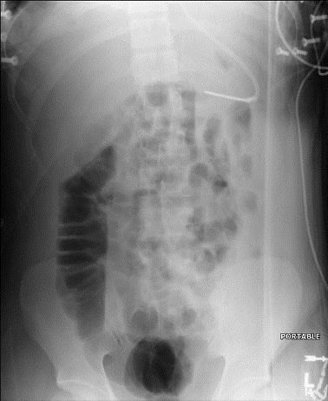
Left Lateral Decubitus Projection

Skeletal Mobile
- Read your requisition. Know why you are performing the exam:
- Fracture query
- Foreign body, etc.
- Come prepared with tape, sponges and proper sized cassettes
- Trauma routines are acceptable. Full routines are preferable but not always necessary. Views can be modified due to patient condition.
- Consult with nursing staff in regard to patient’s capabilities.
.

Fluoroscopic Procedures

Contrast Enema

Three types:

- Single
- Double
- Defecogram- anus and rectum.

- Water soluble contrast enema is done on pre-op, post-op, suspected perforation or any time where a leak into the peritoneal cavity is suspected.

Procedural Steps

- PREP: Colon needs to be well cleaned out especially for a double contrast exam. Contraindications for the prep are: Gross bleeding, severe diarrhea, obstruction, inflammation lesions (appendicitis).
- Take a detailed history and explain the procedure to the patient.
- Scout film if required by the Radiologist. or if the patient has had a recent CT or contrast exam.
- Show the history and scout to the Radiologist.
- Organize cassettes for overheads. Set the control panel for fluoro.
- Mix the Barium bag and clamp off.
- Attach the proper enema tip and run the barium through the tubing. Clamp off. Check to see if the balloon properly inflates and deflates.
- Position patient in the left lateral recumbent position or Sims position.
- Apply the lubricating jelly to the end of the tip. Insert the enema tip and inflate the balloon (Radiologist may prefer to insert the tip and inflate it themselves).
- Lead up.
- Notify the Radiologist that you are ready.
- Administer contrast under the direction of the Radiologist and aid the patient with turning.
- When the Radiologist is finished taking his spot images change the control panel for the overheads. Choose the proper technique and cassette. Take the requested images.
- When the exam is completed, escort the patient to the washroom. Inform them to drink lots of water over the next couple of days to avoid constipation.

Double Contrast Enema

- Uses thick barium which adheres better to the mucosa.
- The air moves the barium forward and dilates the bowel to visualize it.
- The air cannot be allowed to get in front of the barium.
- Double contrast enema show neoplasms that are not seen on a single contrast exam.

Radiographic Positioning for Double Contrast Enema

AP Projection

Patient supine. Midsagittal plane centered to the IR. Central ray perpendicular to the midline centered at the level of the iliac crests.

Demonstrates:
- Air in the Transverse and sigmoid colon.
- Contrast usually in the ascending and descending colon (parts are more posterior) as well as the rectum.
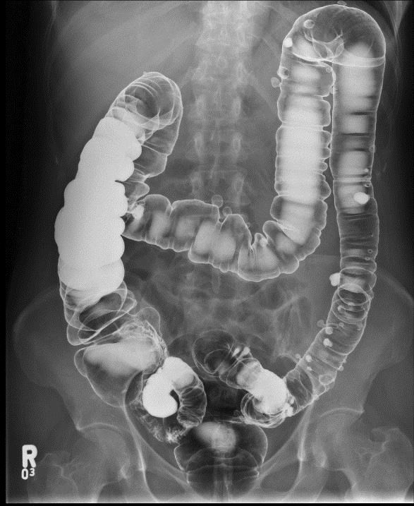

Please refer to the notes and textbook(s) for Radiographic Positioning for Single and Double Contrast Exams.
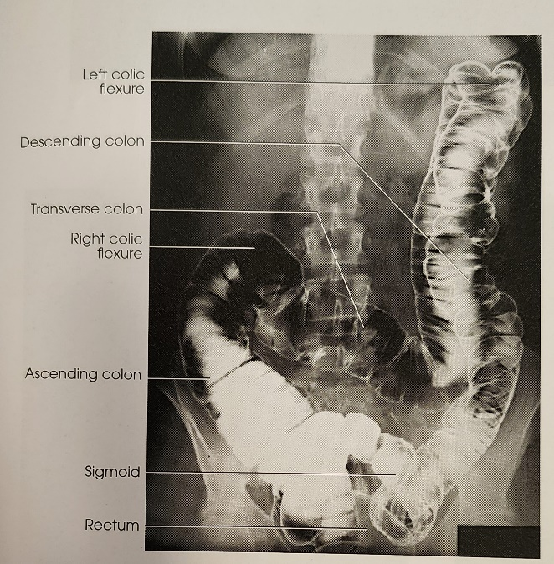

PA Projection

Patient prone. Midsagittal plane centered to IR. Central Ray perpendicular to midline at the level of the crest.

Demonstrates:
- Shows more even density than the AP.
- Contrast in the transverse and parts of the sigmoid colon.
- Air in the ascending and descending colon.
- Air in the rectum.

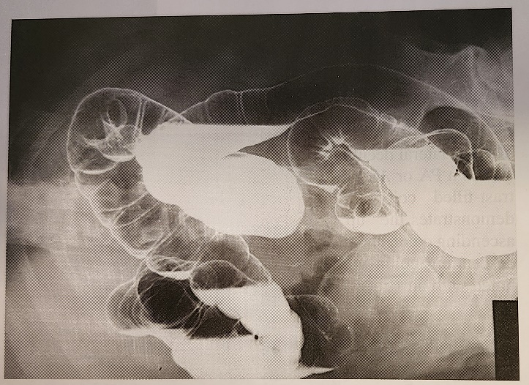

Right Lateral Decubitus

Patient lying on their right side. Central ray horizontal to midsagittal plane at the level of the iliac crests. Center the cassette to the iliac crests. Make sure the grid is straight with no tilt to avoid grid cut off. Mark side down with the appropriate right marker and down arrow. Use a filter if possible.

Demonstrates:
- Medial side of the ascending colon and the lateral side of the descending colon.

Please refer to the notes and textbook(s) for Radiographic Positioning for Single and Double Contrast Exams.
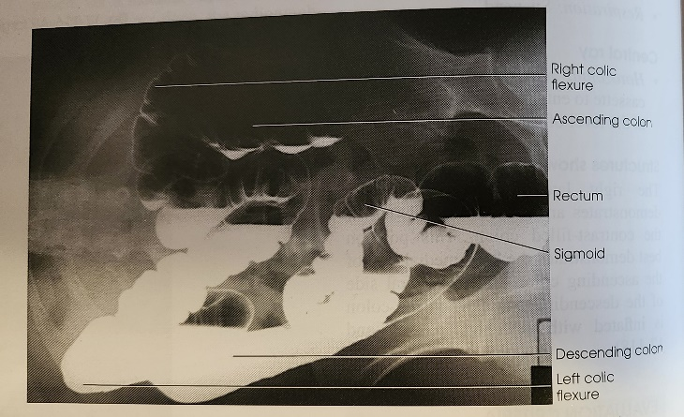

Left Lateral Decubitus

Patient lying on their left side. Central ray horizontal to midsagittal plane at the level of the iliac crests. Center the cassette to the iliac crests. Make sure the grid is straight (no tilt to avoid grid cut off). Mark side down with the appropriate left marker and down arrow. Use a filter if possible.

Demonstrates:
- Lateral side of the ascending colon and the medial side of the descending colon.

Evaluation Criteria

- Entire colon including the flexures and the rectum (2 IRs may be needed for hypersthenic patients).
- Vertebral column centered so the ascending and descending portions of the colon are included.
- No rotation. Shown by spinous processes equidistant to pedicels

Lt Colic Flexure

Rt Colic Flexure

Descending Colon

Ascending Colon Transverse Colon

Cecum

Sigmoid

Rectum

Please refer to the notes and textbook(s) for Radiographic Positioning for Single and Double Contrast Exams.
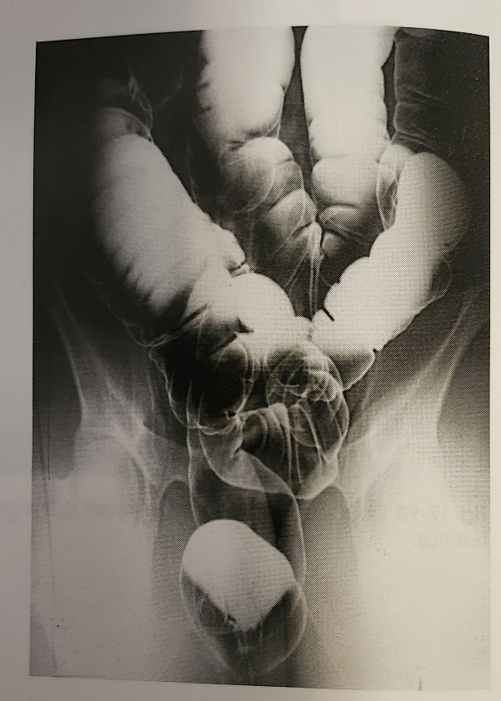

Sigmoid

Can be done PA or AP. Central Ray 30-40 degrees caudad for PA exiting at the level of the ASIS. 30-40 degrees cephalad for AP exiting 2” below the level of the ASIS. Center of the cassette should be approximately 2” above the level of the iliac crests.

Demonstrates:
- Air in the sigmoid in the AP projection.
- Contrast in the rectum.

Note:
There are variations of this image depending on which site you are at.

Evaluation Criteria

- Rectosigmoid area centered to radiograph
- Rectosigmoid area with less superimposition than in the PA/AP projection because of the angulation of the central ray
- Please refer to the notes and textbook(s) for Radiographic Positioning for Single and Double Contrast Exams.
- Transverse colon and both flexures not necessarily included

Cross Table Rectum

Patient prone. 10X12 IR centered at the level of the ASIS. Central ray horizontal for double contrast exams. Ensure that the top of the IR is at the level of the crests and the curve of the buttocks is at the bottom of the IR. Marker is placed anterior. Use filter if possible for double contrast exams.

Tip is deflated and either left in or removed depending upon the Radiologist.

Demonstrates:
- Rectum filled with air.

Note:
Because of the thickness of the hips, and because you are using a grid use a filter, collimate, and use lead at the back of the cassette to absorb scatter and improve image quality.

Evaluation Criteria

- Rectosigmoid area in the center of the radiograph
- No rotation of the patient
- Superimposed hips and femurs
- Superior portion of colon not necessarily included when the rectosigmoid region is the area of interest

Radiographic Positioning for Single Contrast Enema
For AP, PA, sigmoid and cross table rectum positioning, please refer to the notes and textbook(s) for Radiographic Positioning for Double Contrast Exams.

Left Posterior Oblique Projection

Patient supine with 35-45 degree obliquity. Midsagittal plane to center of IR. Central ray perpendicular to 1-2” lateral to midsagittal plane toward the side up at the level of the iliac crests.

Demonstrates:
- Right colic flexure. Opens the flexure of the side up.
- Ascending colon and cecum.
- Sigmoid portions.
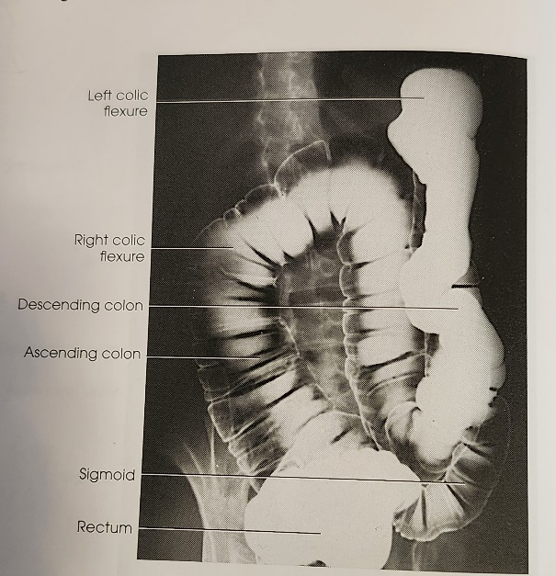
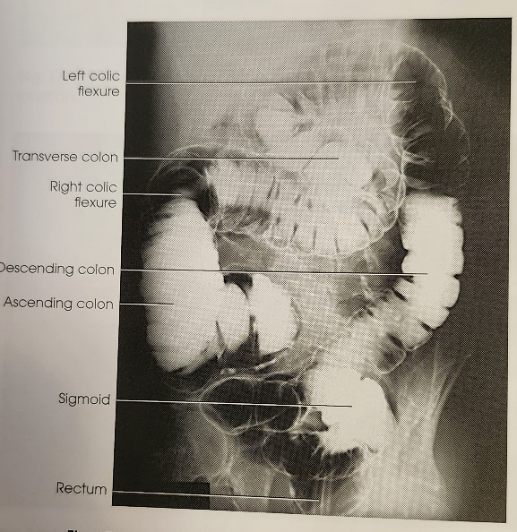

Evaluation Criteria

Right Posterior Oblique Projection

Patient supine with 35-45 degree obliquity. Midsagittal plane to center of IR. Central ray perpendicular to 1-2” lateral to midsagittal plane toward the side up at the level of the iliac crests.

Demonstrates:
- Left colic flexure. Opens the flexure of the side up.
- Descending colon
- Entire colour
- Colic flexures less superimposed or open when compared with the PA/AP projections

Small Bowel Follow Through

- Shows form and function
- Timed exam to evaluate bowel function.

Procedural Steps
- PREPARATION: NPO for at least 8 hours. No smoking or chewing gum, as this increases gastric juices and air.
- Take a detailed history.
- A preliminary scout image may be performed (this is site specific). Check with radiologist.
- Patient is instructed to drink barium mixture. Document the time when patient is finished drinking.
- 15-30 minute PA abdomen is taken. Prone causes the loops of bowel to separate. If UGI exam is not done center higher to include the stomach on the first image.
- Use high KVP (100+) to penetrate the barium on the images for the first hour. Then
lower the KVP (90’s) as the barium spreads throughout the bowel.
- Images are taken at timed intervals as per radiologist. Ensure images are annotated correctly with time and the entire small bowel is visualized on each image.
- Exam is completed when the barium reaches the terminal ileum. At this point the radiologist uses fluoroscopy to take spot images using a compression paddle or cone. This pushes the loops of bowel out of the way so that better imaging of the TI is possible.
- For post procedure care have the patient drink lots of water to help reduce water from being absorbed from the barium causing impaction or constipation.

Stomach and Duodenum

Single and Double Contrast Exams

Single Contrast:
  - Determines size, shape, position and function of the stomach and esophagus.
  - Contour of the stomach during peristalsis.
  - Filling and emptying of the duodenal bulb.

Double Contrast:
  - Shows lesions and the mucosal lining.
  - Patient must be able to move easily.

Pre Procedure Instructions

- NPO after midnight. Allow 8-9 hours before the exam to allow the stomach to be empty.
- No smoking or chewing gum after midnight. Smoking and gum chewing increases gastric fluid and dilutes the barium sulfate.

PA Projection

Center at the level of L1-L2

Demonstrates:
- Stomach.
- Pyloric canal.
- Duodenal Bulb.
- Air is in the Fundus.
- Barium is in the Pyloric portion.

Radiographic Positioning of the Stomach

AP Projection

Center halfway between the left lateral border of the abdominal wall and midline at the level of L1-L2

Demonstrates:
- Retrogastric portion of the duodenum and jejunum
- Gastric body
- Pylorus
- Duodenal bulb.
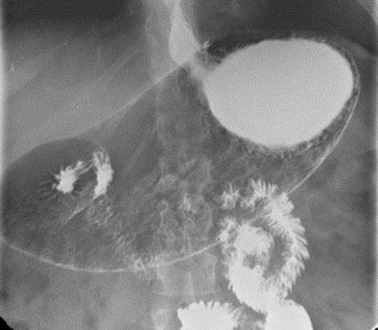

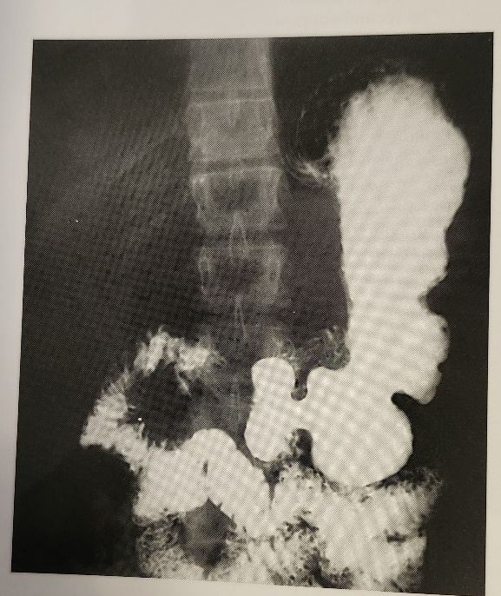
Please refer to the notes and textbook(s) for Radiographic Positioning for Single and Double Contrast Exams.

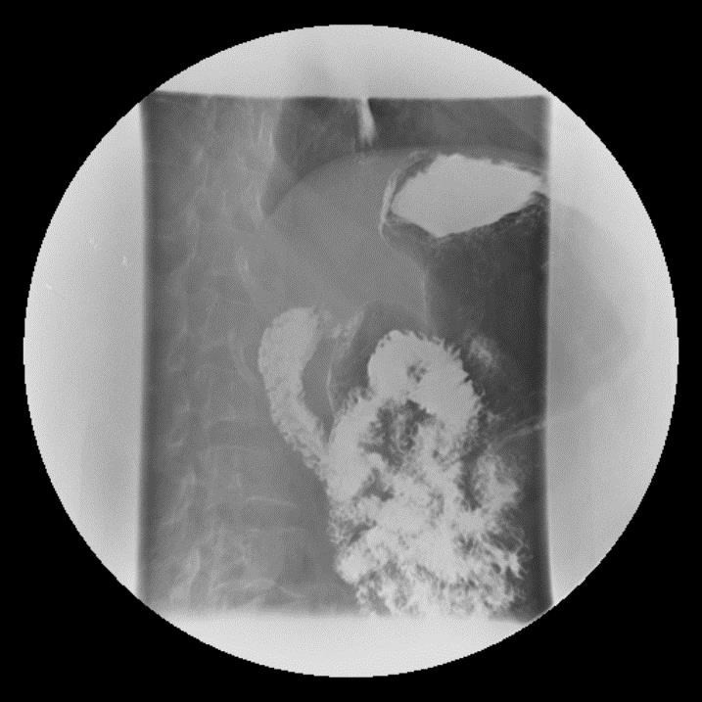

Right Anterior Oblique Projection

40-70 degree oblique centered halfway between the vertebral column and the lateral border of the abdominal wall of the SIDE UP to the level of L1-L1.

Demonstrates:
- Pyloric canal
- Duodenal bulb and loop

Note:
Peristalsis very active in the RAO.

Left Posterior Oblique Projection

45 degree oblique centered halfway between the vertebral column and the lateral abdominal border of the SIDE DOWN at the level of
L1-L2.

Demonstrates:
- Fundus barium filled.
- Pylorus and stomach mostly air filled.
- LPO is a variation of a supine.

Note:
Sometimes obliquity can vary from 30-60 degrees depending upon body habitus. LPO is a variation of a supine.

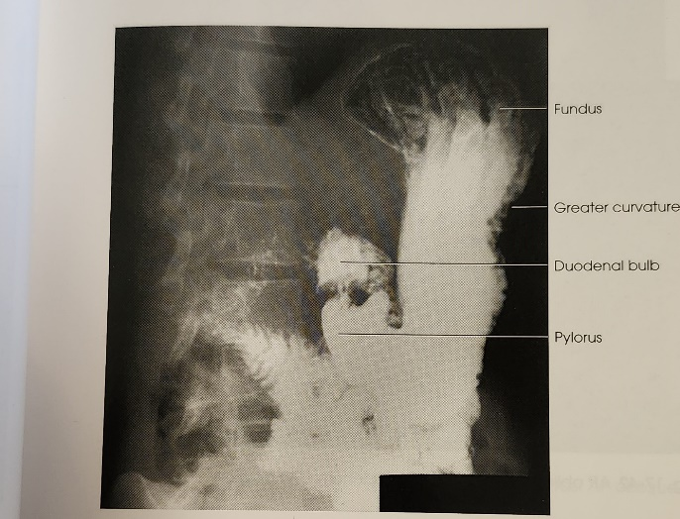
Please refer to the notes and textbook(s) for Radiographic Positioning for Single and Double Contrast Exams.

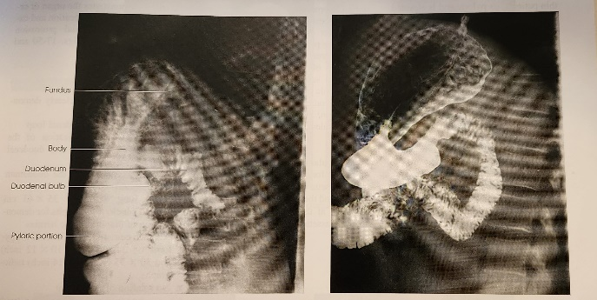

Right Lateral Projection

Center halfway between the midcoronal plane and the anterior abdominal wall at the level of L1-L2.

Demonstrates:
- Right retrogastric space and duodenojejunal junction,
- Duodenal loop.
- Pyloric canal.
- Anterior and posterior aspects of the stomach in hypersthenic patients.

Please refer to the notes and textbook(s) for Radiographic Positioning for Single and Double Contrast Exams.

G.I. Transit Study (Abdomen)

AP Projection
- This examination consists of the patient having been given by the G.I. Specialist, a
number of radiopaque “pellets” by mouth.
- Each day at the same time, the patient will have an AP abdomen film done.
- This continues usually for 5-8 consecutive days.
- Each day the film must be labeled Day 1, Day 2, etc, with time and position (supine).

Operating Room (OR) Procedures

OR procedures will vary by site and surgeon, but there are a few things that apply across the board:

- Wear hospital issued OR greens during your shift and refrain from wearing long-sleeved garments underneath.
- OR greens should be worn in the hospital only – do not wear them to and from the hospital site.
- It is essential that the shoes you wear in the OR be worn in the hospital only. It is not acceptable to track dirt into the OR theatre.
- Before entering an OR theatre, ensure that your lead apron is on, hair is completely covered, mask is properly fitted and gloves are either on or easily accessible (this is particularly important in orthopedic cases).
- Perform a quick visual check of the equipment to ensure that it is clean and ready for use.
- As you drive the equipment in and move around the OR theatre, be aware of sterile fields.
- Exams in the OR are performed either with a c-arm or designated OR mobile machine (i.e., flat plates, x-table views). Connect and power up equipment immediately to avoid delays in the case. Ensure the mobile is sufficiently charged.
- Obtain a patient label from the circulating nurse and sign the Perioperative Report. Note the time on the label so an accurate start time can be recorded.
- It is still important to ID patients in the OR! Confirm patient name and/or procedure description in multiple places (OR manager, chart, whiteboard, nurse, etc.) to ensure you have the correct information.
- Enter appropriate patient identification information into the equipment you are using.
- Assist the scrub nurse in draping the c-arm or detector and cover the fluoro foot pedal if required to prepare for the start of the case.
- All surgeons operate differently, but in general, only fluoro/expose when asked to do so by the surgeon. The main exception to this rule is pacemakers.
- Always save your image and swap it to the opposite screen for reference before moving the c-arm to achieve the alternate projection (i.e., AP to lateral).
- At the end of the case, retrieve your equipment as required and exit the theatre.
- Even if they are not visibly soiled, all machines should be wiped with the appropriate cleaner after being in an OR theatre.
- Doctors generally do not pre-order x-rays for their OR cases. It is the responsibility of the technologist to order the appropriate exam in the RIS at the completion of the case. This is the ONLY time technologists should be ordering examinations for a patient. Order the exam as per site protocol.
- Annotate and send your images (generally only final images are sent to IMPAX for c-arm cases but if in doubt, clarify with the surgeon) to the appropriate accession number as per site protocol.
- Complete the exam in the RIS.

Common Procedures

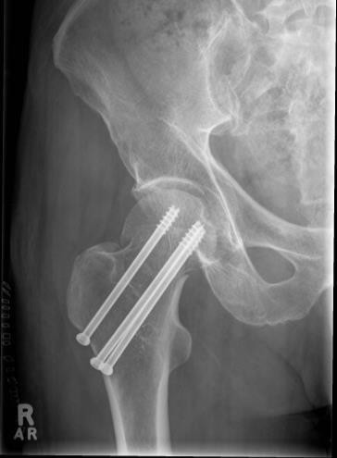
Cannulated Screws

- Subcapital femoral neck fracture

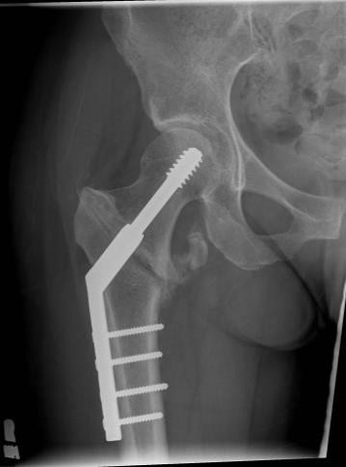
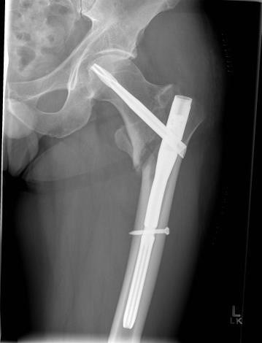
Dynamic Hip Screw (DHS)

- Transfixes an intertrochanteric fracture
- Interchangeable with the short gamma nail; it is an older technique and based on a surgeon’s preference
- Requires an intact lateral cortex for fixation
- Used for fractures that are located outside the capsule* in subtrochanteric and intertrochanteric fractures as the blood vessels are left unharmed

Short Gamma or Trochanteric Fixation Nail

- Transfixes an intertrochanteric fracture
- Interchangeable with the DHS, based on a surgeon’s
preference
- Used for fractures that are located outside the capsule* in subtrochanteric and intertrochanteric fractures as the blood vessels are left unharmed
- Used also in fractures located further down the neck of the femur

*capsule- the area where the blood vessels are located

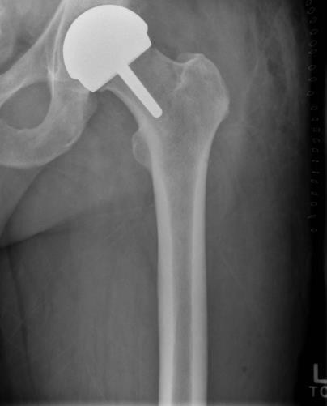
Birmingham

  - For use on younger, active patients.
  - Femoral neck is maintained for potential future replacement
  - Patient likely to need a total hip replacement in the future

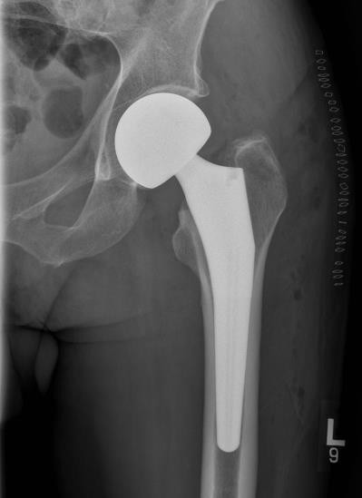
Hemi Arthroplasty

  - Replacement of the femoral head/neck OR
acetabulum, but not both.
  - The cap and stem of the orthopedic device are a single unit
  - Used in younger patients
  - Used in patients that have a fracture around the stem
  - These fractures can occur either during surgery or from a trauma

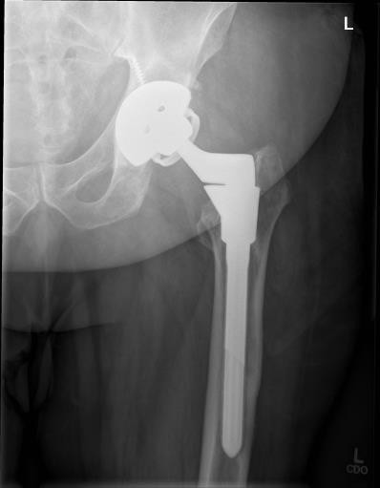
Total Hip Replacement/Arthroplasty (THR/THA)

  - Total hip replacement components include a stem that inserts into the femur, a ball that replaces the head of the femur and a shell that lines the hip socket (acetabulum).
  - Generally, not applicable in trauma situations. Most patients have chronic pain and/or mobility issues.

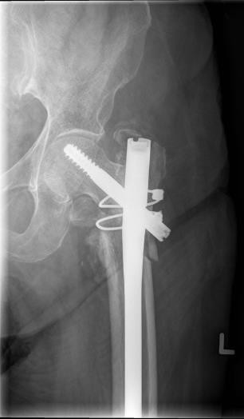
Gamma Nail

- Patient presents with a subtrochanteric or diaphyseal fracture of the femur
- Also used on intertrochanteric fractures with loss of bony cortex integrity
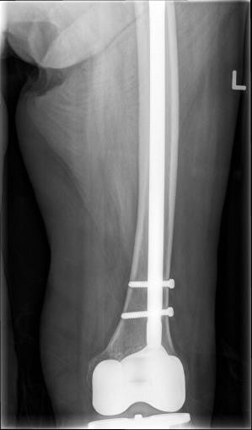
- Components include a screw in the femoral neck, long intermedullary (IM) nail in the femur and locking screws at the knee
- Surgeon may choose to perform an antegrade (proximal to distal) or retrograde (distal to proximal) insertion
- May use circlage wire as well (wire that wraps and tightens the bone)

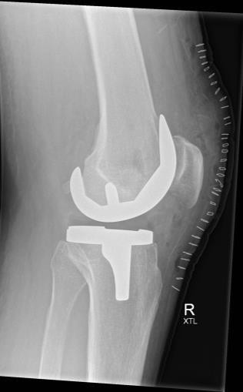
Total Knee Replacement/Arthroplasty (TKR/TKA)

- Indications include pain and joint deformity, primarily from arthritis
- X-ray is not required during the OR procedure but patients require imaging pre- op and 2 day post- op

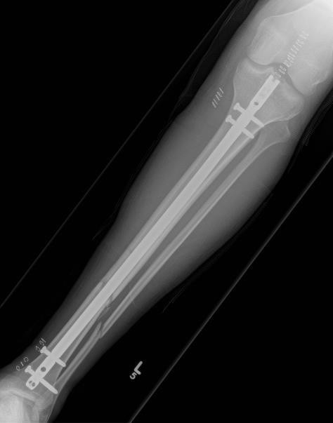
Tibial IM Nail

  - Tibial diaphyseal fracture
  - Fibula is a non-weightbearing bone and is quite often not plated unless the integrity of the ankle joint is compromised
  - May use circlage wire as well (wire that wraps and tightens the bone)

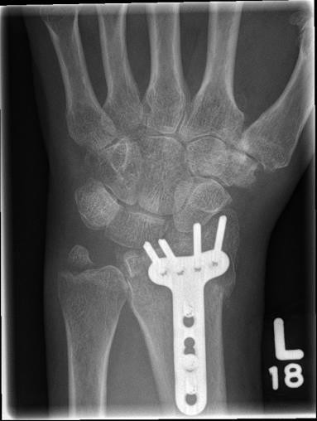
Plate and Screw Fixation

  - Used for absolute fixation on anatomy where callus formation would limit mobility, such as ankles, wrists and spines

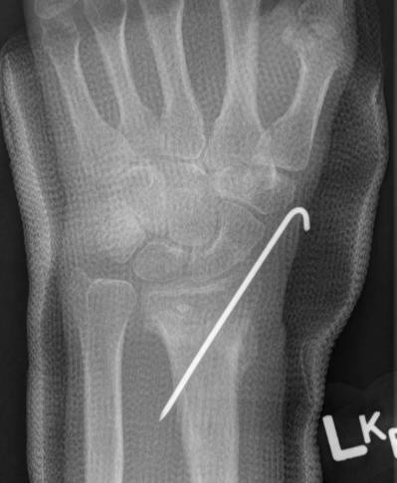
K-wires

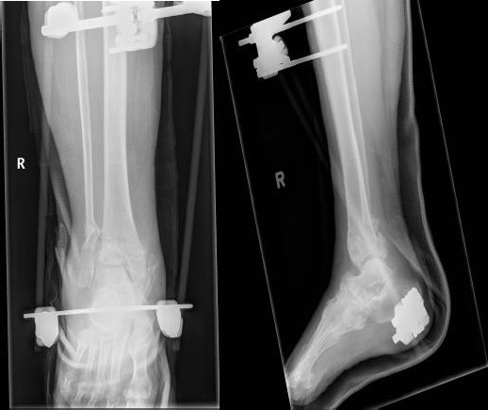

Cardiac:
- Used for many types of finicky fractures. Phalanges, metacarpals/tarsals, heels, wrists, etc.
- Fixates the bone until healing takes place then the wire is removes.

External Fixation (ExFix)

  - Commonly used when swelling in the limb is an issue but fixation is still necessary
  - Surgeon will perform a second procedure (ORIF) 7-10 later once swelling has subsided

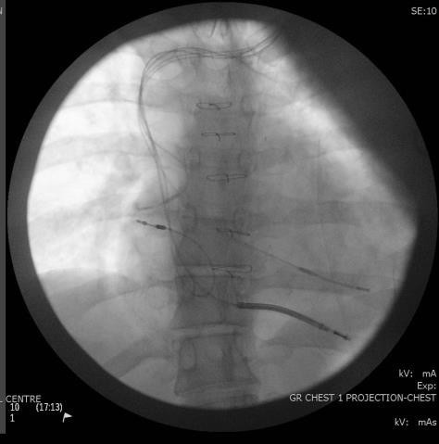
Pacemaker

- Patient with inadequate cardiac pacing
- Consists of 1 (single chamber), 2 (dual chamber) or 3 (CRT) leads with a generator up at the left or right shoulder
- Vascular runs (cine runs) are common in these cases
- Always use a cardiac appropriate C-arm

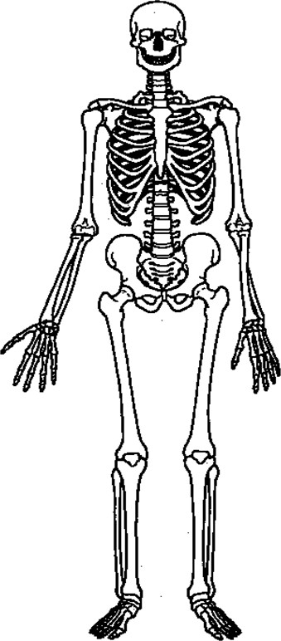
Abdomen: (AP upright 150cm) 85kvp @ AEC (AP supine 110cm) 85kvp @ AEC (should be less than upright)
Barium filled abdomen: 110kvp @ AEC
Chest: (PA/Lat) grid: 121kvp @ AEC (AP) non grid: 90kvp @ 2mAs

Some Helpful Hints for Setting Techniques

Some Fundamentals:

mAs:  Chosen for the # of photons needed to produce an image without quantum noise | kVp:  Chosen for desired subject contrast
 | For both CR & DR systems, it is recommended that kVp be increased by 15% at a time to optimize detector efficiency, contrast and to reduce radiation exposure
mAs = patient dose
mAs = patient dose | Most DR & CR systems place the optimal kVp range for greatest detector  efficiency at 60 to 110 kVp
Thicker patients will attenuate more of the primary x-ray photons than thin patients. If the kVp selected will allow penetration through the part, then increasing the mAs will generate enough x-rays to provide more photons on larger patients

15% rule: By increasing KVp by 15%, you can reduce mAs (and therefore patient dose) by HALF and still achieve the EI value.
Best Practice:
Exposures should not be repeated in digital radiography because of overexposure, brightness or contrast concerns (as these can be managed with windowing). With DR, excessive overexposure is seen as loss of bony detail, washed out grays, oversaturation/data drop (not “black” like on film)

DR systems cannot compensate for excessive noise caused by quantum noise – a repeat may be warranted

Watch dose creep. As technologists try to avoid quantum noise, they use more exposure than necessary at a cost of increased dose to the patient - this is called dose creep & is an issue more common with digital imaging vs. conventional radiography

NEVER SHUTTER IMAGES. Collimation & beam limitation is going to provide you with best image quality.

EI charts:

Computed Radiography Exposure Indicator Parameters (CR)
System | Exposure Indicator | Acceptable Parameters | Ideal Exposure | Insufficient Exposure | Excessive Exposure | Change Factor  (by doubling or  halving mAs)
Kodak | Exposure  Index (EI) | 1700-2300 | 2000 | Below 1700 | Above 2300 | 300
Fuji | Sensitivity #  (S) | 100-400 | 200 | Above 400 | Below 100 | 100
Agfa | Log Median Value (LgM) | 2.2-2.8 | 2.5 | Below 2.5 | Above 2.8 | 0.3
**Table 2-1, Radiographic Image Analysis 3rd Ed. Mcquillen & Martensen

Digital Units & Their Exposure Indicator Parameters (DR)
System | EI | EI Range | Direct/Inversely Proportional
Siemens | EXI | 200-400 | Direct
Philips | EI | 200-800,  Ideal=400 | Inverse
Siemens YSIO | EXI | 300-600 | Direct
Siemens | EI | 1500-2500 | Inverse
Shimadzu (tethered detector) | REX* | 300-600 chest | Direct
Shimadzu (tethered detector) | REX* | 200-600 bone  work | Direct
Shimadzu (cordless detector) | EI | 150-300 chest | Direct
Shimadzu (cordless detector) | EI | 100-200 bone  work | Direct
* Reached Exposure Value

Pediatric Imaging Units & Parameters (ACH*)
System | Exposure  Indicator | Acceptable  Parameters | Ideal Exposure | Excessive  Exposure
Kodak CR | Exposure  Index (EI) | 1700-1800 | N/A | Above  1800
Philips DR | Exposure Index (EI) | 250-1200 | Babies = 400 | Below 250 (Inverse)
Philips DR | Exposure Index (EI) | 250-1200 | Large Child, Extremities = 400 | Below 250 (Inverse)
Philips DR | Exposure Index (EI) | 250-1200 | Large Child, Other Imaging = 800-  1000 | Below 250 (Inverse)
Philips DR | Exposure Index (EI) | 250-1200 | Torso/Skull = 800-1000 | Below 250 (Inverse)
Shimadzu
Mobile
ACH* = Alberta Children’s Hospital

CONVERTING BETWEEN CR and DR SYSTEMS

Type of Image Receptor Speed
CR Image Receptor 200
Philips DR Detectors (wall/table) 400 (can be modified) Siemens DR Detectors (wall/table) 400 (can be modified) Siemens Flat Panel Detector (Siemens YSIO) 400 (can be modified)
Shimadzu Mobile, Corded Detector 600
Shimadzu Mobile, Cordless Detector 800-1000 (changes with APR)

If the speed of the DR system is higher (i.e.: Shimadzu mobiles), you can decrease your technique (mAs).

When moving between CR & DR systems, the easiest way to convert is:
- kVp can be maintained for both systems
- CR to DR: half your mAs
- DR to CR: double your mAs

COMMON “TRICKS” TO HELP WITH TECHNIQUES:

- SHOULDER:

AP View: Use AEC for the AP shoulder. Check EI.
Glenoid View: Remember your mAs readout from your AP and adjust technique accordingly based on EI readout from AP. Do not use AEC for Glenoid.
Eg. AP Shoulder = 75kvp @ 10mAs Glenoid = 75kvp @ 13mAs.
Transcapular View: Use 8-10 kVp higher for the Y view than from the AP/glenoid view. Increase your mAs readout from the AP view by 1.5x.
Eg. AP Shoulder = 75 kvp @ 10mAs Transcapular = 85kvp @ 15mAs.
Axial View (non-grid): Use 66kvp @ 6 mAs (avg)

Techniques will need adjusting to compensate for OID, patient thickness, etc
.

Hip & Upper Femur:

AP View: use AEC for the AP Hip or Upper Femur.
Lateral View: Increase the mAs slightly for the Lateral view. Try not to use AEC for the Lateral unless centering through hip joint.
E.g. AP Hip = 75kvp @ 16mAs Lat Hip = 75kvp @ 20mAs
In cases of known prosthesis in the hip/femur: Try setting a technique or decreasing the AEC’s
density setting to avoid causing overexposure.

Ribs:

Use a lower kVp (70 kVp) to achieve BLACK and WHITE (high) contrast for upper ribs & a bit higher kVp (75-80kVp) to penetrate diaphragms and achieve optimal contrast for lower ribs.

AP or PA Ribs: Use AEC
Oblique Ribs: Increase mAs approximately 1.5x from AP view.

Facial Bones:

Increase and decrease the mAs by 10.
E.g. Lateral = 85kvp@ 8mAs Caldwell = 85kvp @ 12mAs Waters = 85kvp @ 22mAs Townes= 85kvp @ 32mAs
For arches, or SMV view NEVER USE AEC: most sites do bilateral SMV view and use 70kVp @ 12.5mAs non-grid (CR system). With grid: 70kVp @ 16mAs. EI numbers may not correctly portray what is a good image due to being unable to collimate to the anatomy of interest (the arches).

Converting from Grid to Non Grid:

If you are using a grid, how do you change your technique to image the same body part without a grid? Easy – decrease your kVp by 10 and half your mAs.
E.g. Knee (Grid) = 70kvp @ 4mAs Knee (Non-Grid) = 60kvp @ 2.5mAs Hip (Grid) = 75kvp @ 16mAs Hip (Non-Grid) = 65kvp @ 8mAs

Use the Grid Conversion Factors.

Technical Adjustments for Trauma Patients
Patient Condition | kVp  Adjustment | mAs  adjustment
Small – Medium Plaster Cast | +5-7 kVp | +50%-60%
Large Plaster Cast | +8-10 kVp | +100%
Fiberglass Cast | No Adjustment | No Adjustment
Fluid in Abdomen/Swollen Joint | +5 kVp | +25%-30%
Pleural Effusion (in lungs) |  | +50%-75%
Pneumothorax | -8% kVp
Soft Tissue Injury (Foreign body imaging/upper airway  imaging) | -15%-20% kVp
Table 1-5, Radiographic Image Analysis, McQuillen Martensen, 3rd Ed.

Additional Notes:

Image Quality Analysis:

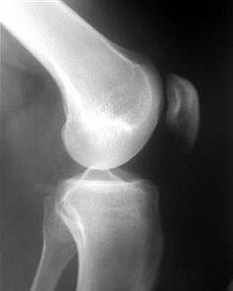 | The KV is too low:  - the femoral condyle is under-penetrated  - bony trabeculation cannot be seen  - contrast is too high to demonstrate all the soft tissues.
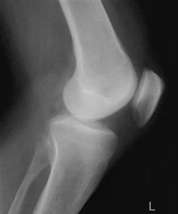 | Proper KV:  - Subject is penetrated properly  - Soft tissues are visible  - Bony trabeculation seen

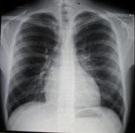 | Proper Exposure of a Chest:  - Mediastinum is penetrated  - the image is exposed well, demonstrating the bones and soft tissues, including lung markings
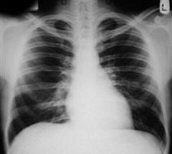 | Under Penetrated Chest:  - Cannot see vertebral column beneath the heart shadow
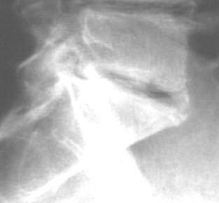 | Under Penetrated L5-S1Spot film:  - Unable to see bony trabeculation

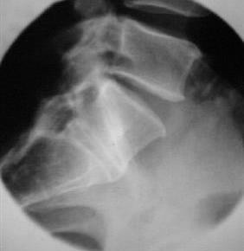 | Properly Penetrated:  - Can visualize through the L5-S1 Joint space, including seeing bony trabeculation of the spine
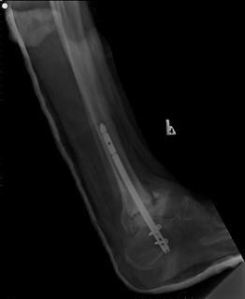 | Too Much mAs:  - Image is “dark” looking  - No repeat warranted, as brightness can be modified with digital windowing

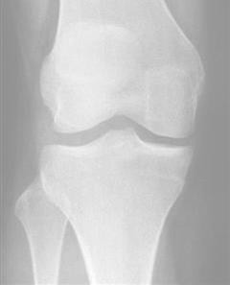 | Too Little mAs:  - Image is “bright” looking, indicating under- exposure  - If quantum noise is present, repeat may be warranted

CR and DR
Best Practice for Digital Imaging

Digital Imaging

There are two types of digital imaging:

Computerized Radiography
  - Direct or Indirect Digital Radiography:

Computed Radiography (CR):

  - Uses a conventional radiography machine & conventional positioning & technical factors (is practical and easy for techs to use)
  - Uses an image receptor (commonly called an IR)
  - The IR stores trapped electrons in a photostimulable phosphor. The amount of energy trapped in each area of the plate reflects the subject contrast.
  - Once exposed, the IR is inserted into a reader device, which scans the imaging plate with a laser & the radiographic image is then converted to digital format and can be viewed and manipulated on a computer monitor. Images can be transferred to a CD.
  - Typically has lower spatial than DR
  - Inferior in terms of image quality and diagnostic value when compared to modern digital detectors
  - The detector/screen speed of most CR systems is ~ 200

Direct/Indirect Digital Radiography:

  - A cassette less image detector system that is hard wired to the image processing system
  - During an exposure, thin-film transistors receive the remnant radiation and convert it to electrical signals of varying intensity. These signals are sent to the computer for processing and manipulation. Only the detector elements that have been included in the collimation field & have received radiation will send their signals
  - There is no need for the exposure field recognition process that occurs in CR systems, therefore, DR is the solution for histogram errors that commonly occur with CR

Best Practice with DR and CR

As professionally regarded by ethics, values and beliefs

Optimal Images:

- Correct Technique
- Centering
- Control Scatter
- 4 Sided Collimation
- Appropriate IR Size (CR)
- Markers (C.A.R.* standard) – L or R on the appropriate side

DR:

Automatic Rescaling is NO substitute of use of appropriate technical factors, but can be used to avoid repeats
  - Exposures of 120% over and 60% under can be rescaled without much loss to image quality

Avoid Quantum Mottle/Quantum Noise (AKA: Photonflux)
  - Use enough kVp suitable for the exam, patient size & system being used. Do not go below 55kVp with most systems

CR:

Collimation should be parallel to edges (otherwise a poor EXI or S# may occur)
    - Do not go below 55kVp with most systems

Watch your Exposure Indicator Parameters!!

For all digital x-ray systems, regardless of the detector type, the primary cause of exposure variation is the improved consistency of the digital image's appearance when under- or overexposed. This attribute unfortunately provides a lack of image appearance feedback to the technologist. –www.AuntMinnie.com

When Imaging, Follow These Tips For Best Practice:

Digital Systems are very sensitive to scatter so use Lead Strips whenever possible to absorb scatter (ie: lateral L-spine, X-table views)

- Do not pre-window images before sending to PACS – this can inhibit radiologists’

ability to window images

- AVOID DOSE CREEP: A phenomenon unique to digital imaging, where technologists inadvertently overexpose to avoid quantum noise

In practice, overexposing is better than quantum noise
  - Digital systems accommodate for overexposure better than underexposure

Some systems do not display images properly (sometimes we see only 50% of the image quality that radiologists would see), causing unnecessary repeats

- SAFETY CODE 35:

Keep doses as low as we can (ALARA)
  - Shielding

Coning:
    - To the size of the IR or smaller

4 sided collimation evident (beam restriction!)

- AVOID SHUTTERING!
- Show the “white border” before sending to PACS

Common Acronyms in Medical Imaging

x/7 Days (ie. 2/7 is 2 days)
x/52 Weeks (ie. 3/52 is 3 weeks)
x/12 months (ie. 4/12 is 4 months)
# Fracture
? Query
ACL Anterior cruciate ligament
ARDS Acute respiratory distress syndrome
AXR Abdominal x-ray
BaEn Barium enema
BOOP Bronchiolitis obliterans organizing pneumonia
BP Blood pressure
C/O Complains of
Ca Cancer
CABG Coronary artery bypass graft
cc Unit of liquid measure (1cc=1mL)
CCU Cardiac care unit
C-Diff Clostridium difficile
CF Cystic fibrosis
CHD/CDH Congenital hip dysplasia
CHF Congestive heart failure
COPD Chronic obstructive pulmonary disease
CP Chest pain
Cerebral Palsy
CVA Cardiovascular accident
CXR Chest x-ray
CRT Cardiac resynchronization therapy
DCBE Double contrast barium enema DHD/DDH Developmental hip dysplasia DNR Do not resuscitate
DVT Deep vein thrombosis
ECG Echocardiogram
EEG Electroencephalography
ER Emergency room
ERCP Endoscopic retrograde cholangiopancreatography ET Endotracheal
ETOH Ethanol, used to indicate patient intoxication
F/U Follow up
FB Foreign body
FOOSH Fall on outstretched hand

FT Fluoro time
Fx Fracture
GERD Gastroesophageal reflux disease/disorder
GI Gastrointestinal
GLF Ground level fall
GSW Gunshot wound
GU Genitourinary
Gyn Gynecology/gynecologist
HIV Human immunodeficiency virus
Hx History
Hystero Hysterosalpingogram
IAC Internal auditory canal
IABP Intra-aortic balloon pump
IBS Irritable bowel syndrome
ICD Implantable/internal cardiac defibrillator
ICN Intensive care nursery (also NICU)
ICU Intensive care unit
IJ Internal jugular
INR International normalized ratio (blood clotting ability)
IV Intravenous
IVU (IVP) Intravenous urogram/pyelogram
KUB Kidneys, ureters, bladder
LBO Large bowel obstruction
LBP Lower back pain
LLD Left lateral decubitus
LLQ Left lower quadrant
LMP Last menstrual period
LOC Level of consciousness
LP Lumbar puncture
LUQ Left upper quadrant
LV Left ventricle
MD Muscular dystrophy
Ml Myocardial infarction
MRI Magnetic resonance imaging
MRSA Methicillin resistant staphylococcus aureus MVA/MVC Motor vehicle accident/crash
NG Nasogastric
NEC Necrotizing enterocolitis
NICU Neonatal intensive care unit
NKA No known allergies
NPO Nothing by mouth
NU Nursing unit

NYD Not yet diagnosed
OA Osteoarthritis
OD Overdose
OG Orogastric
OP Outpatient
OR Operating room
ORIF Open reduction internal fixation
PACU Post anesthesia care unit
PARR Post anesthesia recovery room
PCXR Portable chest x-ray
PE Pulmonary embolism
PICC Peripherally inserted central catheter
POD # Post op day # (i.e. POD 2 is post op day 2)
Pt Patient
PUD Peptic ulcer disease
R/O Rule out
RA Rheumatoid arthritis
RLQ Right lower quadrant
RR Recovery room
RSV Respiratory syncytial virus
RUQ Right upper quadrant
S&D Stomach and duodenum
SBFT Small bowel follow-through
SBO Small bowel obstruction
SCFE Slipped capital femoral epiphysis
SOB Shortness of breath
Stat Immediately
STEMI ST elevation myocardial infarction
Sx Surgery
TAVI Transcatheter aortic valve implantation
TB Tuberculosis
THA/THR Total hip arthroplasty/replacement TI Terminal ileum
TIA Transient ischemic attach
TKR Total knee replacement
TURP Transurethral resection of the prostate
Tx Treatment/Therapy
UGI Upper GI (also Stomach & Duodenum)
US Ultrasound
UTI Urinary tract infection
VEPTR Vertical expanding prosthetic titanium rib
VCUG Voiding cystourethrogram

VRE Vancomysin resistant enterococcus
VUR Vesicoureteral reflux
W/O Without
WOB Work of breathing (indrawing)

References

Ballinger, P. (1999). Merrill’s atlas of radiographic positions and radiological procedures
(9th ed.). St. Louis, Mo: Mosby Inc.

Bushong S. C. (2004). Radiologic science for technologists: Physics, biology, and protection (8th ed. ). St. Louis, Mo: Elsevier Mosby.

Johnson J. N., & McNally M, Essay C. (2003). Essentials of dental radiography (7th ed.). Upper Saddle River. NJ: Prentice Hall.

Langland O. E, Langlais, R. P., & Preece J. W. (2002). Principles of dental imaging (2nd ed.). Baltimore, Md: Lippincott Williams & Wilkins.

McQuillen-Martensen, K. (1996)/ Radiographic critique. St.Louis, Mo: W.B. Saunders Company.

White S. C., & Pharoah M. J. (200). Oral radiology principles and interpretation (4th ed.). Philadelphia, Pa.

