ANPH 202 – Respiratory Pathology Exam Review – ANSWER KEY

B | Emphysema 1
N | Carcinoma of lungs (primary) 2
R | Carcinoma of lungs (metastases) 3
C | Atelectasis 4
P | Pleural effusion 5
D | Pneumonia 6
H | Respiratory distress syndrome (infant) 7
L | Acute respiratory distress syndrome (adult) 8
O | Cystic fibrosis 9
G | Bronchiectasis 10
I | Chronic bronchitis 11
J | Pulmonary edema 12
F | Tuberculosis 13
Q | Subcutaneous emphysema 14
M | Pulmonary emboli 15
E | Lung abscess 16
K | Pulmonary infarct 17
B | Empyema 18
Using the chart above match the letter to the pathology
- Infected purulent, loculated pleural effusion
- Enlargement of airspaces caused by destruction of alveolar walls
- Loss of lung volume secondary to collapse
- Infection within the lung due to material filling the alveoli
- Circumscribed collection of pus within the lungs
- Disease common in developing countries, caused by bacteria
- Irreversible abnormal dilation of the bronchial tree
- Presents on imaging as diffuse ground glass lungs with lowvolumes and a bell-shaped thorax
- Presence of a productive cough for 3 months in 2 successive years
- A broad term for an abnormal accumulation of fluid in the extravascular components of the lung
- A complication of a pulmonary embolism
- Lung injury occurring as a result of severe pulmonary injury causing alveolar damage throughout the lung
- Occlusion of the pulmonary arteries or its branches
- Linked to inhaled carcinogens
- Affects exocrine function of lungs liver, pancreas, small bowel and sweat glands
- Collection of serous fluid in the pleural space
- Can be caused by penetrating trauma
- Appears as rounded nodules of various size scatteredthroughout the lungs
Using the chart above match the number of the pathology to the image
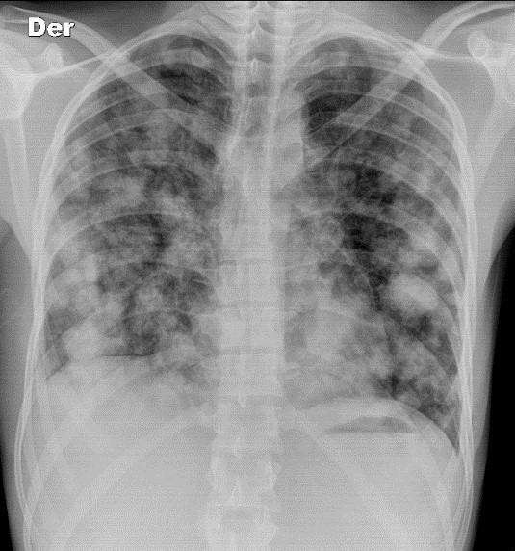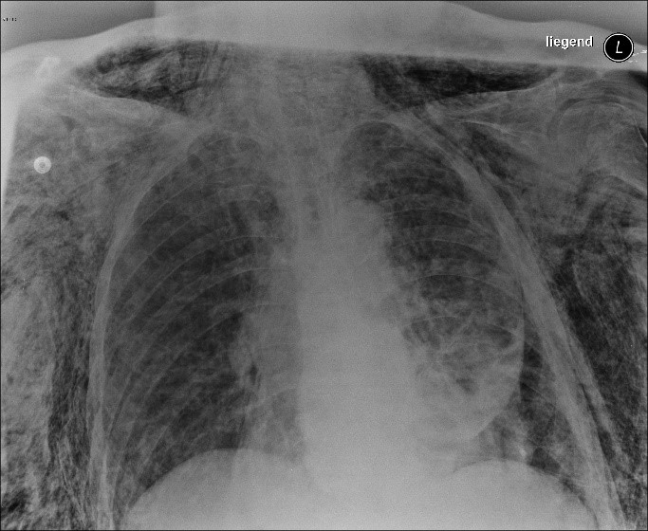
Case courtesy of Dr David Cuete, Radiopaedia.org, rID: 24822 Case courtesy of Dr Sajoscha Sorrentino, Radiopaedia.org, rID: 16291

Pathology: 3 Pathology: 14
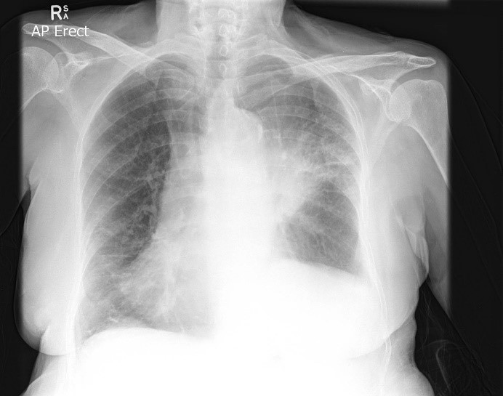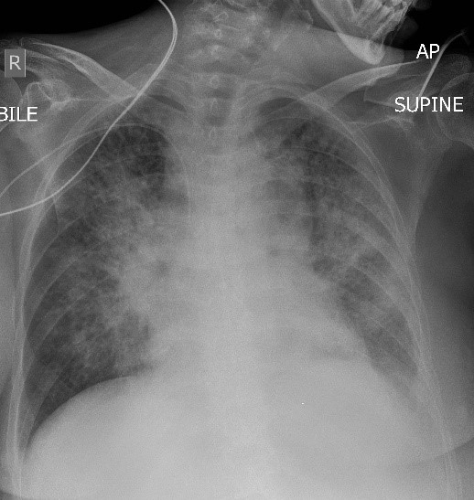
Case courtesy of Assoc Prof Frank Gaillard, Radiopaedia.org, rID: 15099 Case courtesy of Dr Ian Bickle, Radiopaedia.org, rID: 26492

Pathology: 2 Pathology: 12

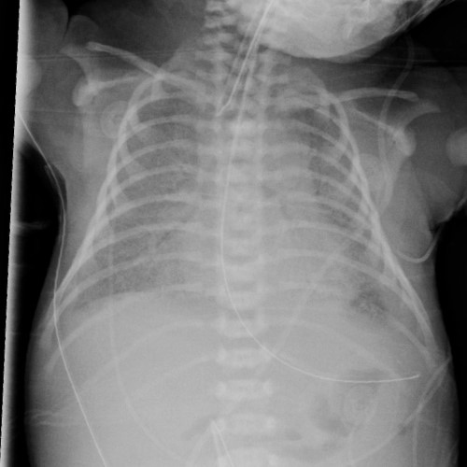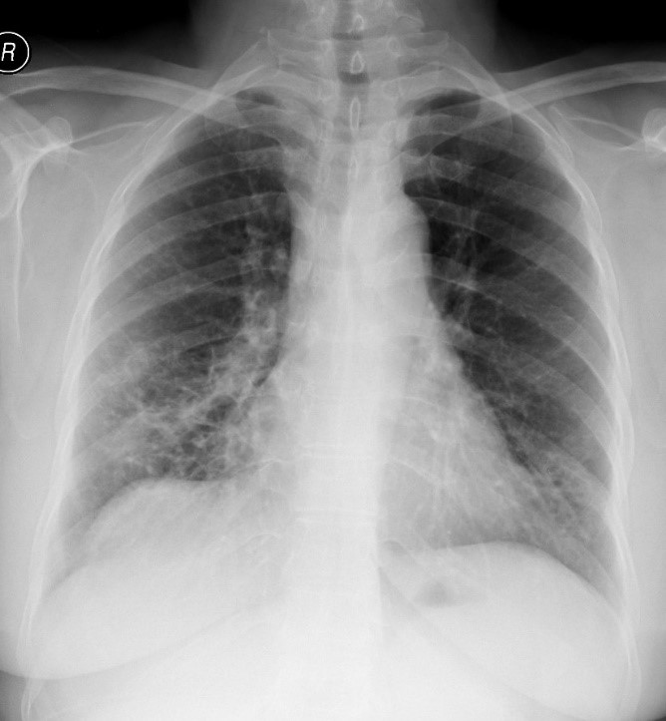
Case courtesy of Dr Fahd Alshehri, Radiopaedia.org, rID: 51689 Pathology: 7 Pathology: 10
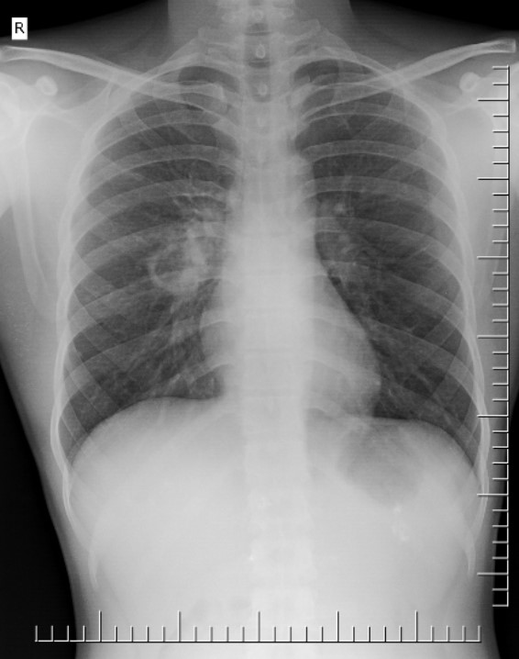  Case courtesy of Dr Aditya Shetty, Radiopaedia.org, rID: 27747 | 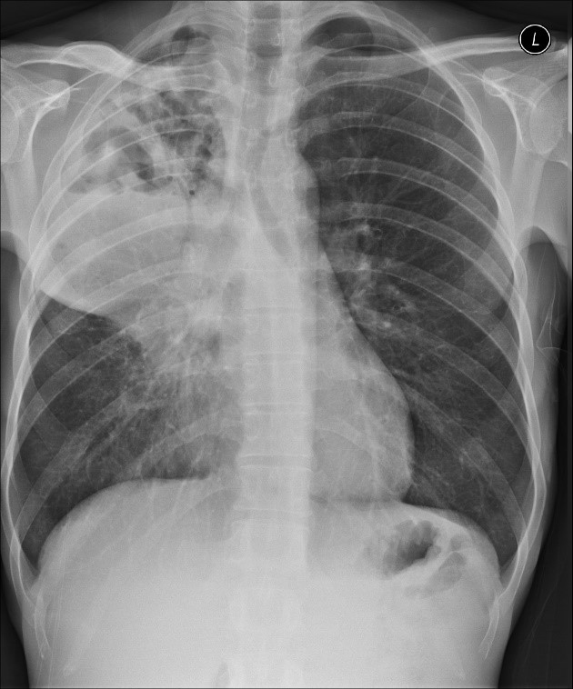  Case courtesy of Dr Derek Smith, Radiopaedia.org, rID: 34806
Pathology: 13 Pathology: 16

