Activity - CT Equipment Review

Purpose:
Objective 2.2: Characterize the various acquisition components that comprise a CT scanner.

Instructions:
- Answer the following short answer questions.
- Compare your answers with the answer key.

Questions
- List at least 4 components of a CT imaging system.

- What are the 2 purposes of filtering the x-ray beam in a CT scanner?

- Describe a special type of filter used in CT, and how it works.

- Explain 2 functions of the collimators in a CT scanner.

- Identify the collimation schemes.

- Which type of collimation Acts on the beam before it passes through the patient?

- What is the purpose of having a collimator positioned before the detector array?

- What is the purpose of a detector in a CT system?

- In CT, what is the difference between analog and digital information?

- What controls the slice thickness in a SDCT scanner? Is this different for a MDCT unit? Explain your answer.

- How does slice thickness affect spatial resolution?

- Label the following:

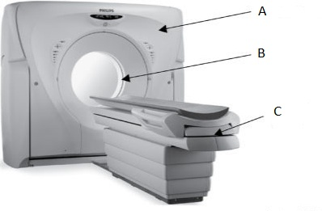

- Draw the location of the isocenter on the image provided in question 12.

- List 4 components housed within “A” from question 12?

- What does DAS stand for, and what is its function?

- Which component enabled Helical scanning?

- What helps reduce heat production within the tube in a CT imaging system?

- Define scannable range, and explain why it is important for technologists to identify.

- Which component enables a technologist to adjust the DFOV?

- What enables accurate patient positioning?

