

MEDICAL RADIOGRAPHY

TECHNOLOGY
PROGRAM HANDBOOK

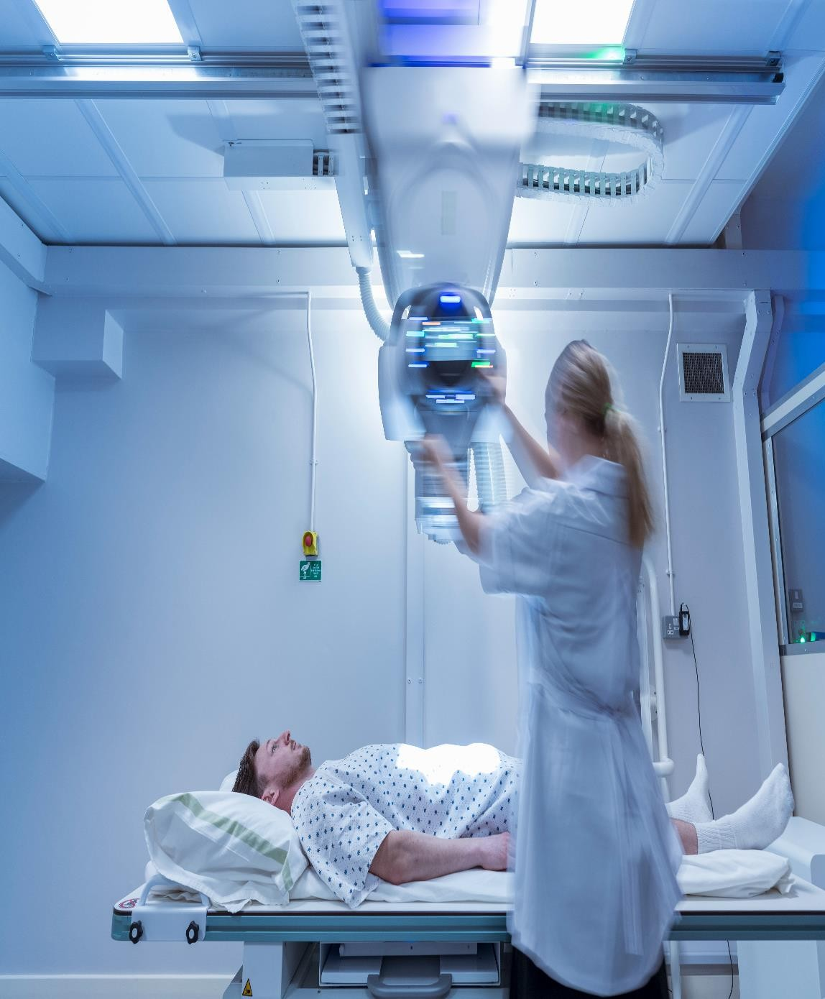

Eden Brook College

Contents
Welcome 5
Introduction 5
Mission Statement 5
Vision Statement 5
MRT Program Goal and Outcomes 5
Values 6
MRT Program Certification 6
Admissions 7
Admission Requirements 7
Limited Enrolments 8
Statement of Non-Discrimination 8
MRT Program Structure 8
N95 Fit Testing 8
Immunization Status 9
Criminal Record Check 9
Graduation Requirements 9
PROGRAM OVERVIEW 9
Semester 1 11
Semester 2 12
Semester 3 14
Semester 4 16
Evaluation 17
Policy Statement 17
Scope 17
Definitions 17
Evaluation Policy 18
Grading Methodology 19
Remedial Help 20
Homework 21
Appeals 21
Progression Criteria 21

Attendance Policy 21
Tardiness 22
Travel and Commute 22
Weather 22
Make-up Policy 22
Attendance Expectations 23
MRT Program Process for Excused Absences Approval/Review 24
MRT Program Attendance Policy 24
CODE OF CONDUCT 25
Code of Professional Conduct 25
MRT Student Code of Conduct 25
Student Responsibilities 25
Student Behaviour 26
Accountability 26
Patient Confidentiality 26
Attire/Dress Code 26
Consent 26
Acceptable Behaviour 26
Cell Phones/Smartphones, Electronic Equipment and Visitors 27
Use of Technology in the Classroom and Lab 27
Photographing or Recording Class Activities 27
Student Sexual Abuse Policy 28
What Constitutes Sexual Abuse? 28
Our Zero Tolerance Policy 28
Guiding Principles for Student 28
Support Resources: 29
Conclusion 29
Academic Integrity 29
During Examinations 30
Professional Boundaries 30
PRIVACY AND SUPPORT 31
Protection of Privacy 31
Counseling 31
Safety and Security 32
General Expectations 32
Guiding Principles for Infection Control 32
General College Responsibility with Respect to Infection Control 32
Infection Prevention & Control Protocols 33
Personal Protective Equipment (PPE) 35
ALARA Policy for Medical Radiography Technology Program 37
Accident Or Incident 38
COVID-19 38
Emergency Evacuation 39
Security 39
Accommodations/Rights of Individuals with Disabilities 39
Complaints, Commendation, Continuous Improvement 40
Problem Solving 40
Student Feedback 40
COURSE EVALUATION 40
APPENDIX 42
Appendix A: Acknowledgement of Sexual Abuse Policy 42
Appendix B: Release of Personal Information 43
Appendix C: Accident Incident Investigation Form 44
Appendix D: Witness Statement Form 48
Appendix E: Confidentiality Statement 49
Appendix F: Student Pledges 50
Appendix G: Immunization Form 51
Appendix H: Brightspace 54

Welcome
Welcome and congratulations on your acceptance to the Medical Radiography Technology (MRT) Program at Eden Brook College.
The MRT Program Handbook has been compiled by the faculty at Eden Brook College to provide information pertinent to MRT students. This handbook is used as a supplement to the Eden Brook College Student Handbook. The information, policies and procedures set forth in this handbook are designed to support the success of the students in the MRT program.

Introduction
The Medical Radiography Technology program is 78 weeks, full-time program where students are trained as radiologic technologists, responsible for the safe and competent operation of a wide range of X-ray generating machines, the production of digital images, and use of accessory medical equipment.
Students will complete courses in anatomy and pathology, apparatus, and image management, computed tomography, radiation protection, general and specialized radiographic techniques, professional practice, and patient care.
They will also focus on specialized imaging, clinical integration, quality assurance and control, and professional practice. Additionally, students will complete three clinical placements where they rotate through general and specialized Medical Imaging departments, applying what they have learned in these clinical settings.

Mission Statement
The mission of the MRT program is to develop competent, entry-level medical radiologic technologists who promote excellence and integrity in patient care by demonstrating professional proficiency and currency in skills through a commitment of life-long learning.

Vision Statement

Our vision is to cultivate a community of students who embody the highest standards of excellence, integrity, and compassion in the field. Through a foundation of rigorous education and unwavering commitment to evidence-based practice, our students aspire to redefine the landscape of medical radiation technology.

MRT Program Goal and Outcomes
The goal of the MRT program is to provide students with foundational knowledge in the duties and scope of practice as a medical radiologic technologist practicing in the province of British Columbia.

Graduates of the Eden Brook College MRT Program will be career ready to perform medical imaging diagnostic examinations of patients using a variety of x-ray equipment and innovative technology. Specifically, graduates will be able to:

- Produce and assess a variety of high-quality diagnostic images employing current technologies for image acquisition and processing.
- Interpret requests and adapt procedures relative to patient and diagnostic image requirements in routine and complex clinical cases.
- Comply with relevant legislation, regulations, and ethical standards for the best practice in diagnostic imaging.
- Employ accepted radiation, health and safety practices with self, patients, their families, and healthcare team members in a variety of clinical settings.
- Provide quality care to diverse patients in assessment, diagnostic and interventional imaging, while incorporating patient advocacy and education to patients, their family, healthcare team members and the public.
- Monitor patients` status at all times and respond to emergency situations where indicated.
- Operate, set up, troubleshoot, and evaluate a variety of complex equipment safely.
- Analyze a broad range of diagnostic imaging procedures to assist physicians in the diagnosis and management of multiple system disorders.
- Interact with patients, their families, the healthcare team members, and the public using effective communication and interpersonal skills.
- Exhibit behaviour consistent with the professional role of a radiologic technologist, including teamwork, provision of health education and establishment of strategies for lifelong learning.
- Identify and apply discipline-specific practices that contribute to the local and global community through social responsibility, economic commitment, and environmental stewardship.

Values
The college embraces the following values:

- INTEGRITY - We act honestly and ethically with one another, our students, and the larger community.
- EXCELLENCE - We consciously set high standards and take steps to achieve and exceed them.
- RESPECT - We create a kind, honest, and respectful environment that encourages people to act responsibly and give their best.
- PROFESSIONALISM - We are committed to developing, following, and modeling the best practices of our chosen professions with each other and our students.
- COMMUNITY - We foster open and constructive communication and interactions with one another to support creative collaboration and opportunities for growth.
- DIVERSITY - We acknowledge that education is grounded and enriched by the wide variety of life experiences and learning styles of our students and instructors.
- GROWTH - We continuously seek to improve ourselves to become better people, instructors, learners, and professionals in our chosen fields.

MRT Program Certification
When you graduate from the Eden Brook College Medical Radiography Technology program, you will be career ready for entry level medical imaging positions in hospitals, clinics, medical imaging companies,

sales and marketing.

Admissions
The College is committed to quality admissions. This means that admission is limited to students who have demonstrated the aptitude and dedication to succeed.

Admission Requirements
All students must meet one of the following minimum requirements for enrollment:
  - High school diploma/GED, or
  - 19 years of age or older at time of program start
All students must also have completed senior level (Gr. 11 or 12) or post-secondary coursework in the following subjects.
  - English
  - Mathematics
  - Physics
  - Anatomy & Physiology or Biology or equivalent

Applicants with post-secondary education must provide official transcripts for all secondary and post- secondary institutions attended. Foreign trained individuals must have their credentials assessed for equivalency by WES, ICES or a comparable organization.

Students with English as an additional language (ESL/EAL) must demonstrate English language proficiency through one of the following measures:
- Minimum 70% in English 12 or 70% in Communications 12.
- Minimum 70% in post-secondary level English or Communications coursework.
- Successful completion of a standardized language proficiency test at or above ONE of the following standards:
  - Canadian Language Benchmark (CLB) 7
  - IELTS 6.0 with no band lower than 5.5
  - TOEFL iBT score of 78
  - Cambridge English: Advanced (CAE) score of 169
  - Pearson Test of English (PTE-A) score of 51.6
  - Versant English Placement Test (VEPT) score of 68

Profession Specific Aptitude Test
Applicants will be assessed on their capacity to understand and follow directions. The assessment may include questions related to reading comprehension, math, science, career awareness, and reasoning-type questions, or scenarios related to interpersonal interactions.

CASPer Test
All applicants must complete the CASPer test. CASPer is an online test which assesses for non-cognitive skills and interpersonal characteristics that are important for successful students and graduates of this healthcare program. In implementing CASPer, we are trying to further enhance fairness and objectivity in our admission selection process.

Students must submit clear criminal record check through the Criminal Records Review Program

N95 respiratory mask fitting

Students must submit an up-to-date Eden Brook College Immunization Report. Students must provide CPR Level C with an issue date within three months of the program start.

Students must provide proof of 8 hours of volunteer time in a medical radiology clinical setting prior to entering the MRT program.

Limited Enrolments
Please note that possession of the prerequisite course requirements does not guarantee admission. If the number of qualified applicants exceeds the number of places available in the program, Eden Brook College reserves the right to select from among those applicants. All qualified students will be given equal consideration.

Eden Brook College offers reserved seats for individuals selected from our affiliated hospitals, Indigenous, rural and British Columbia students. Only applicants who self-identify as First Nation, Métis, or Inuit or those with a home address (living) in rural and British Columbia regions will be eligible for these seats. The same selection process will apply to the above noted applicants. If the seats are not filled by a specified date, they will be offered to waitlisted applicants.

Statement of Non-Discrimination
The Medical Radiography Technology (MRT) program does not engage in any form of enrollment discrimination including, but not limited to, race, gender, religion, nationality, age, disability, and sexual orientation.

MRT Program Structure
The MRT program is a demanding program that combines theory and lab work with real-life hands-on training in clinical settings.

The program is structured around two main components as follows:
- Classroom and Laboratory Sessions
- Clinical Placements

Please Note:
Eden Brook College reserves the right to make changes to the program without notice. For a detailed outline of the current program, see the MRT Program Map.

N95 Fit Testing
In compliance with Occupational Health and Safety Regulations, G8.40 Respiratory protection.

You will be fit-tested for respiratory masks prior to your clinical placement. Fit-testing will be available to students. Failure to adequately fit an N-95 mask may result in a restricted clinical placement and/or

limited employment. Facial abnormality/hair may result in unsuccessful fit testing. You are responsible for carrying your fit test card at all times during your clinical placement.

Immunization Status
For your personal safety, as well as a contribution to ongoing health and wellness, medical immunizations are necessary for your clinical placement experience. The receiving clinical site has the right to refuse acceptance of students who cannot prove they have all required immunizations.
Within 30 days of starting the program, an Immunization Report is required indicating the student is fit to undertake the program/practical and has up-to-date immunization. Immunizations include tetanus and diphtheria, polio, measles, mumps and rubella, varicella (chickenpox), Hepatitis B (including a Hep B titer within the last 24 months), TB skin test (Mantoux), influenzae and Covid-19. All immunization records must be completed and authenticated by a Physician, with a signature and clinic seal.

You are responsible in showing your immunization report when requested by the clinical site.

Criminal Record Check
Information about police information check requirements is found in the student letter and Orientation PowerPoint presentation.

Clinical placement students working in the healthcare field (acute and long-term care) must obtain a criminal record check. This is required prior to attending the program. Failure to obtain a criminal record check will result in refused entry to the clinical sites and, consequently, the inability to complete your program.

In the event your status changes or you receive a criminal conviction during the length of your program, you are obligated to disclose that information to the Campus Director.

Graduation Requirements
Students must attain a grade of 70% or better in each course to progress through the program. To qualify for graduation, students must pass all courses with a minimum grade of 70% or better and complete all course requirements including clinical placement within the prescribed timelines. Students must achieve 100% of the competences to be successful in the Clinical Placement courses.

PROGRAM OVERVIEW
The 78-weeks full-time Medical Radiography Technology program provides you with the crucial knowledge and technical skills to correctly position the patient and use x-ray equipment to produce and record images for visualizing the extent of disease or injury.

Medical Radiography Technology Core Course Sequence

SEMESTER 1
COURSE# | COURSE TITLE | COURSE HOURS
ANPH 202 | Anatomy and Pathology 1 | 50
APPH 226 | Apparatus and Image Management | 100
MEDT 211 | Medical Terminology | 25
MRAD 204 | Radiographic Technique 1 | 125
MRAD 223 | Patient Care 1 | 50
RADP 215 | Radiation Protection | 75
PRCT 250 | Introduction to Clinical Placement | 37.5

SEMESTER 2
COURSE# | COURSE TITLE | COURSE HOURS
ANPH 252 | Anatomy and Pathology 2 | 50
MRAD 251 | Computed Tomography Theory 1 | 75
MRAD 254 | Fluoroscopic Imaging | 50
MRAD 202 | Patient Care 2 | 50
MRAD 256 | Radiographic Technique 2 | 125
MRAD 240 | Specialized Imaging 1 | 50
MRAD 358 | Clinical Integration 1 | 50
PRCT 353 | Clinical Placement 1 | 337.5

SEMESTER 3
COURSE# | COURSE TITLE | COURSE HOURS
MRAD 281 | Computed Tomography Theory 2 | 50
INFC 215 | Infection Prevention and Control | 25
MRAD 209 | Professional Practice 1 | 25
MRAD 285 | Radiographic Applied Skills | 50
MRAD 302 | Specialized Imaging 2 | 100
QUAL 370 | Quality Assurance and Control | 50
PRCT 356 | Clinical Placement 2 | 337.5

SEMESTER 4
COURSE# | COURSE TITLE | COURSE HOURS
MRAD 360 | Clinical Integration 2 | 50

MRAD 374 | Professional Practice 2 | 25
PRCT 358 | Clinical Placement 3 | 337.5

Semester 1
Anatomy and Pathology 1
Anatomy and Pathology 1 focuses on select clinical and anatomic presentations of human health and disease states from the standpoint of the radiologic technologist. Conventional anatomic presentations and images from a variety of medical diagnostic modalities related to the central nervous, endocrine, immune, and cardiovascular systems and hemopoietic sub-system, will be used to demonstrate how structural and functional changes affect radiographic appearances, procedures and protocols.
Apparatus and Image Management
Apparatus and Imaging Management presents the principles of X-ray image formation and manipulation. An explanation of how radiographic equipment works and the ways in which the results can be manipulated in order to obtain the best diagnostic image are discussed. Application of theory and hands- on work with X-rays will help encourage the critical thinking skills required to control image quality as well as safely operate the imaging equipment. The practical component for hands-on learning is conducted at the clinical environment.
Medical Terminology
This self-directed introductory course enables the learner to use and understand the medical terminology common to most allied health personnel. By learning prefixes, suffixes, and word roots, the learner will be able to build, use, and spell medical words that relate to body systems and body organization. Common abbreviations and symbols are also included.
Radiographic Technique 1
Radiographic Technique 1 presents an introduction to the positioning of patients for radiographic imaging. Through a blend of theory and hands-on experience, importance will be placed upon correct standards of positioning, the positioning nomenclature and how to develop a workflow. The hands-on component includes performing and critiquing radiographic exposures, identifying radiographic anatomy, and developing the cognitive and affective skills to correct mistakes and problem solve. The practical component for hands-on learning is conducted at the clinical environment.
Pre-requisites: ANPH 202 - Anatomy and Pathology 1, MRAD 223 - Patient Care 1

Patient Care 1
Patient Care 1 introduces the principles, concepts and applications of proper body mechanics and patient transfers. Documentation, policies, procedures and their importance will be emphasized. The purposes and uses of other types of medical accessory equipment will also be covered. The practical component for hands-on learning is conducted at the clinical environment.
Pre-requisites: ANPH 202 - Anatomy and Pathology 1

Radiation Protection
Radiation Protection introduces radiographic policies, regulations and procedures that are based on the as-low-as-reasonably-achievable (ALARA) principle for the protection of self, the patient and the other individuals who may find themselves exposed to medical radiation. Topics will also include the effects of ionizing radiation on body tissues and the detection and measurement of radiation.

Introduction to Clinical Placement
Introduction to Clinical Placement provides learners with an orientation and overview of clinical practice environment. Radiation protection and the ALARA principle are reviewed. Students will learn clinical assessment tools, criteria and documentation for logbook entries and apply training in CompTracker in preparation for Clinical Placement. Students are also introduced to professionalism standards.
Pre-requisites: MEDT 211 - Medical Terminology, RADP 215 - Radiation Protection, ANPH 202 - Anatomy and Pathology 1, APPH 226 - Apparatus and Image Management, MRAD 223 - Patient Care 1, MRAD 204- Radiographic Technique 1

Semester 2
Anatomy and Pathology 2
Anatomy and Pathology 2 is a continuation of the course material studied in Anatomy and Pathology 1. Conventional anatomic presentations and images from a variety of medical diagnostic modalities related to the respiratory, gastrointestinal, hepatobiliary, skeletal, and genitourinary systems will be used to demonstrate how structural and functional changes affect radiographic appearances, procedures and protocols.
Pre-requisites: ANPH 202 - Anatomy and Pathology 1, APPH 226 – Apparatus and Image Management, MEDT 211 - Medical Terminology, MRAD 204 - Radiologic Technique 1, MRAD 223 - Patient Care 1, RADP 215 - Radiation Protection, PRCT 250 - Introduction to Clinical Placement

Computed Tomography Theory 1
Computed Tomography Theory 1 provides learners with an overview of computed tomography (CT), basic principles of CT, equipment, image acquisition, reconstruction and quality control. Emphasis will be placed on safety, patient care, assessment and contrast administration.
Pre-requisites: ANPH 202 - Anatomy and Pathology 1, APPH 226 – Apparatus and Image Management, MEDT 211 - Medical Terminology, MRAD 204 - Radiologic Technique 1, MRAD 223 - Patient Care 1, RADP 215 - Radiation Protection, PRCT 250 - Introduction to Clinical Placement

Fluoroscopic Imaging
Fluoroscopic Imaging introduces how fluoroscopic equipment works and its’ numerous features. Different procedures used to determine the function capabilities and anatomical structures for the digestive, biliary and genitourinary systems will be introduced. Patient care, radiation dose and patient positioning related to these procedures will also be covered. The practical component for hands-on learning is conducted at the clinical environment.
Pre-requisites: ANPH 202 - Anatomy and Pathology 1, APPH 226 – Apparatus and Image Management, MEDT 211 - Medical Terminology, MRAD 204 - Radiologic Technique 1, MRAD 223 - Patient Care 1, RADP 215 - Radiation Protection, PRCT 250 - Introduction to Clinical Placement

Patient Care 2
Patient Care 2 prepares learners for working with isolation patients in a safe and respectful manner. Focus will be placed upon how radiographers address medical emergencies. Pharmaceuticals will be explored related to the systems of the body and the medications’ purposes. The principles of vital signs will also be taught, and the patient care labs will allow learners with the opportunity to apply their knowledge in a lab environment. The practical component for hands-on learning is conducted at the clinical environment.
Pre-requisites: ANPH 202 - Anatomy and Pathology 1, APPH 226 – Apparatus and Image Management, MEDT 211 - Medical Terminology, MRAD 204 - Radiologic Technique 1, MRAD 223 - Patient Care 1, RADP 215 - Radiation Protection, PRCT 250 - Introduction to Clinical Placement

Radiographic Technique 2
Radiographic Technique 2 expands on Radiographic Technique 1 and covers radiographic procedures for more complex anatomical structures, including the vertebrae, thorax, cranium and facial bones. Standard radiographic positioning, exposures and procedures will be discussed, in addition to nomenclature and how to develop a workflow. A hands-on component will allow learners to practice critiquing radiographic images, correcting mistakes and using problem solving skills in the clinical environment. The practical component for hands-on learning is conducted at the clinical environment.
Pre-requisites: ANPH 202 - Anatomy and Pathology 1, APPH 226 – Apparatus and Image Management, MEDT 211 - Medical Terminology, MRAD 204 - Radiologic Technique 1, MRAD 223 - Patient Care 1, RADP 215 - Radiation Protection, PRCT 250 - Introduction to Clinical Placement

Specialized Imaging 1
In Specialized Imaging 1 the essentials of applying medical and surgical asepsis in healthcare settings are covered. Learners will participate in preparing for, and assisting with, sterile procedures and will practice contact and behaviour required in these unique environments. Diagnostic equipment, its’ capabilities, and adaptions to procedures for special demographic groups will also be covered. The practical component for hands-on learning is conducted at the clinical environment.
Pre-requisites: ANPH 202 - Anatomy and Pathology 1, APPH 226 – Apparatus and Image Management, MEDT 211 - Medical Terminology, MRAD 204 - Radiologic Technique 1, MRAD 223 - Patient Care 1, RADP 215 - Radiation Protection, PRCT 250 - Introduction to Clinical Placement

Clinical Integration 1
Clinical Integration 1 reviews medical radiographic technology concepts covered to-date and provides learners with opportunities to integrate their experiences in the clinical environment with theoretical concepts. Preparation for the national CAMRT exam will also be covered. By combining hands-on training in the clinical setting with online learning, students can benefit from a more flexible learning experience.
Pre-requisites: ANPH 202 - Anatomy and Pathology 1, APPH 226 – Apparatus and Image Management, MEDT 211 - Medical Terminology, MRAD 204 - Radiologic Technique 1, MRAD 223 - Patient Care 1, RADP 215 - Radiation Protection, PRCT 250 - Introduction to Clinical Placement, MRAD 202- Patient Care 2

Clinical Placement 1
Clinical Placement I involves performing procedures under the supervision of certified technologists in a clinical environment. Aspects of clinical work covered include practice in patient care and handling, radiographic positioning, equipment use, radiation protection and image evaluation.
Pre-requisites: ANPH 252 - Anatomy and Pathology 2 MRAD 202 - Patient Care 2, MRAD 240 - Specialized Imaging 1, MRAD 251 - Computed Tomography Theory 1, MRAD 254 - Fluoroscopic Imaging, MRAD 256 - Radiographic Technique 2

Semester 3
Computed Tomography Theory 2
Computed Tomography Theory 2 covers routine computed tomography (CT) procedures and protocols along with the cross-sectional anatomy of the abdomen, chest, head, neck, pelvis, spine and extremities. In addition, focus will be placed on identifying anatomical structures on various cross-sectional imaging planes.
Pre-requisites: ANPH 252 - Anatomy and Pathology 2, MRAD 202 - Patient Care 2, MRAD 240 - Specialized Imaging 1, MRAD 251 - Computed Tomography Theory 1, MRAD 254 - Fluoroscopic Imaging, MRAD 256 - Radiographic Technique 2, MRAD 358 - Clinical Integration 1, PRCT 353 - Clinical Placement

Infection Prevention and Control
The chain of infection and methods of prevention and control of microorganisms, including blood borne viruses such as hepatitis and human immunodeficiency virus (HIV) will be reviewed. Immunization, routine practice, additional isolation precautions, sterilization and disinfection, safety and Workplace Hazardous Materials Information System (WHMIS) are also covered.
Pre-requisites: ANPH 252 - Anatomy and Pathology 2, MRAD 202 - Patient Care 2, MRAD 240 - Specialized Imaging 1, MRAD 251 - Computed Tomography Theory 1, MRAD 254 - Fluoroscopic Imaging, MRAD 256 - Radiographic Technique 2, MRAD 358 - Clinical Integration 1, PRCT 353 - Clinical Placement I

Professional Practice 1
Professional Practice 1 is a general introduction to the field of Medical Radiation Technology. Learners will cover a variety of topic areas including the technologist in the workplace, legal issues and relevant professional organizations. There will also be discussions on risk management, professional conduct, with an emphasis on the importance of customer service, conflict management, and problem-solving.
Pre-requisites: ANPH 252 - Anatomy and Pathology 2, MRAD 202 - Patient Care 2, MRAD 240 - Specialized Imaging 1, MRAD 251 - Computed Tomography Theory 1, MRAD 254 - Fluoroscopic Imaging, MRAD 256 - Radiographic Technique 2, MRAD 358 - Clinical Integration 1, PRCT 353 - Clinical Placement I

Radiographic Applied Skills
This course introduces adaptive radiology, the process of modifying procedures, and patient care skills to meet specific situations. Assessing and managing patients using effective communication and problem- solving strategies will be performed in a lab setting. Focus will also be placed upon critical thinking, teamwork, conflict management, and decision-making skills in the workplace. The practical component for hands-on learning is conducted at the clinical environment.
Pre-requisites: ANPH 252 - Anatomy and Pathology 2, MRAD 202 - Patient Care 2, MRAD 240 - Specialized Imaging 1, MRAD 251 - Computed Tomography Theory 1, MRAD 254 - Fluoroscopic Imaging, MRAD 256 - Radiographic Technique 2, MRAD 358 - Clinical Integration 1, PRCT 353 - Clinical Placement I

Quality Assurance and Control
Quality Assurance and Control provides an introduction to quality control tests for radiographic equipment and the development and maintenance of a quality assurance program. The values of resource management and quality assurance in the diagnostic imaging department will also be discussed. By combining hands-on training in the clinical setting with online learning, students can benefit from a more flexible learning experience.
Pre-requisites: ANPH 252 - Anatomy and Pathology 2, MRAD 202 - Patient Care 2, MRAD 240 - Specialized Imaging 1, MRAD 251 - Computed Tomography Theory 1, MRAD 254 - Fluoroscopic Imaging, MRAD 256 - Radiographic Technique 2, MRAD 358 - Clinical Integration 1, PRCT 353 - Clinical Placement I
Specialized Imaging 2
Specialized Imaging 2 presents specialized examinations, equipment and related procedures used for imaging various body systems. Focus will be placed on bone density, mammography, angiography, radiation protection and patient care. Adjunct diagnostic imaging modalities will also be covered.
Pre-requisites: ANPH 252 - Anatomy and Pathology 2, MRAD 202 - Patient Care 2, MRAD 240 - Specialized Imaging 1, MRAD 251 - Computed Tomography Theory 1, MRAD 254 - Fluoroscopic Imaging, MRAD 256 - Radiographic Technique 2, MRAD 358 - Clinical Integration 1, PRCT 353 - Clinical Placement I

Clinical Placement 2
Clinical Placement 2 builds on the previous clinical placement and provides learners with continued opportunity to perform patient care and handling, radiographic positioning, equipment use, radiation protection, quality control and image evaluation. Emphasis is placed on mastering image evaluation, typical positioning, and more advanced procedures.
Pre-requisites: MRAD 285 - Radiographic Applied Skills INFC 215 - Infection Prevention and Control MRAD 302 - Specialized Imaging 2 MRAD 209 - Professional Practice 1 MRAD 281 - Computed Tomography Theory 2 PRCT 353 - Clinical Placement I

Semester 4
Clinical Integration 2
Clinical Integration 2 builds upon Clinical Integration 1 with more technologically-advanced concepts related to medical radiologic technology imaging being presented. Opportunities are provided for the learner to integrate theoretical concepts in a clinical environment. Preparation for the national Canadian Association of Medical Radiation Technologists (CAMRT) exam will also be covered. By combining hands- on training in the clinical setting with online learning, students can benefit from a more flexible learning experience.
Pre-requisites: MRAD 285 - Radiographic Applied Skills, INFC 215 – Infection Prevention and Control, QUAL 370 - Quality Assurance and Control, MRAD 302 - Specialized Imaging 2, MRAD 209 - Professional Practice 1, MRAD 281 - Computed Tomography Theory 2, PRCT 356 - Clinical Placement II

Professional Practice 2
Professional Practice 2 covers professionalism and best practices in the clinical environment. Elements of the research process will also be introduced, with an emphasis on forming a research question, designing research strategies and analyzing research data. By combining hands-on training in the clinical setting with online learning, students can benefit from a more flexible learning experience.
Pre-requisites: MRAD 285 - Radiographic Applied Skills, INFC 215 – Infection Prevention and Control, QUAL 370 - Quality Assurance and Control, MRAD 302 - Specialized Imaging 2, MRAD 209 - Professional Practice 1, MRAD 281 - Computed Tomography Theory 2, PRCT 356 - Clinical Placement II

Clinical Placement 3
Clinical Placement 3 builds on the previous clinical placements and involves clinical education under the supervision of certified technologists. Focus will be on continued practice in patient care and handling, radiographic positioning, equipment use, radiation protection, quality control and image evaluation.
Mastering advanced procedures will be emphasized.
Pre-requisites: MRAD 285 - Radiographic Applied Skills, INFC 215 – Infection Prevention and Control, QUAL 370 - Quality Assurance and Control, MRAD 302 - Specialized Imaging 2, MRAD 209 - Professional Practice 1, MRAD 281 - Computed Tomography Theory 2, PRCT 356 - Clinical Placement II

Evaluation

Policy Statement
The College recognizes that consistent, fair, and timely evaluation of student learning is an integral aspect of education, is crucial to the academic process, and contributes to students having a positive attitude towards learning. Evaluation measures student learning of the course and program learning outcomes after appropriate learning opportunities have been provided. The evaluation of student learning considers the needs of the student, the faculty member, and relevant stakeholders, such as the administration office, the BC Ministry of Post-Secondary Education and Future Skills and external regulating bodies as appropriate.

Scope
This policy applies to all course delivery, independent of the delivery strategy, i.e., hybrid, online or full- time. It provides a coordinated and consistent institutional approach to the evaluation of student learning.

Definitions
Program Learning Outcomes
Terminal statements that indicate what a student is reliably expected to demonstrate at the end of a program.

Program Handbook
A document produced by the program team and published that sets out expectations, rules, and regulations for the program.

Faculty
Individuals responsible for the teaching and learning process. They provide learning opportunities related to the course and program learning outcomes and are responsible for the evaluation of student learning of the outcomes. Faculty has the opportunity to contribute to both course and program plans.

Course Outline/Syllabi
An official, approved document outlining the course and unit learning outcomes, required resources and the evaluation components for the course.

Course Learning Outcomes
Terminal statements that indicate what a student is reliably expected to demonstrate at the end of a course and upon which they are formally evaluated through grade allocation.

Instructional/Lesson Plan
A structured plan that ensures that dates for learning opportunities and evaluations are clearly communicated to students and other stakeholders as well as providing course-related information and practices.

Feedback/Formative
Constructive formative information provided to students to support continued learning and improve performance. Constructive summative information explaining achievement of the course learning outcome(s).

Evaluation
Formative and summative activities that assess student achievement of course learning outcomes after learning opportunities are provided. These activities provide evidence of the degree to which the student has met the learning outcomes. These include, but are not limited to, demonstrations, exams, projects, tests, and quizzes.

Supplemental Evaluation
An evaluation provided to a student who meets the supplemental eligibility criteria to clear an academic deficiency.

Evaluation Policy
The evaluation of student learning aligns with the course learning outcomes and the learning opportunities supplied. In keeping with outcomes-based evaluation, no bell- curving or norm- referencing occurs. The evaluation of student learning uses valid and reliable measures.
- The weight assigned to each evaluation component must reflect the relative importance of the course learning outcome(s) to which the component aligns as well as the effort required for that component.
- Evaluation components must be spaced at timely intervals during the course to provide students with prompt and constructive feedback about their progress and opportunities for additional learning prior to a subsequent evaluation.
- The specific components for the evaluation of student learning outcomes are published in the course outline/syllabus and followed in the instructional plan. The evaluation methods

contribute to ensuring appropriate standards are set for demonstration of the course and program learning outcomes.
- A schedule of dates listing each evaluation component will be part of the course outline/syllabus available to the students (instructors reserve the right to change dates based on outside circumstances given they provide students with ample time to prepare).
- Faculty will evaluate student work fairly and consistently using written rubric and/or marking schemes. These schemes use criteria aligned to the course learning outcomes and clearly specify the required standard for success.
- Confidentiality will be maintained in the return and discussion of all evaluations.
- Students will have access to their marked evaluations on request. Explanation of the grade or marks assigned will be available upon request.
- Completed evaluation items will be retained until after the date for student appeals. Some programs with external accreditation may require a longer retention period.
- In the event of an interrupted evaluation, the faculty member will determine how the interrupted evaluation will be addressed and advise the students and the Program Chair and/or designee.
- Students will be informed of the processes for academic appeals and supplemental assessments.

Grading Methodology
In the syllabus of every course is a grading rubric describing how students earn/accumulate points towards their grades. Every syllabus describes the grading percentage assigned to quizzes, tests, class projects/presentations, and professional performance. The student’s final course grade will be assigned based on the percentage of points accumulated vs. total points available.

The following grading scale applies to MRT students:

A | 90 – 100% | Superior grasp of material, excellent performance
B | 80 – 89% | Good level of proficiency, good performance
C | 70 – 79% | Satisfactory level of proficiency and achievement
F | Below 70% | Unsatisfactory or failing
P/f |  | Pass/Fail
W |  | Withdrawal

Course subject marks may be determined by any of the following: examinations, assignments, laboratory work, reports, projects, classroom participation, and standards of practice.

A passing mark of 70% or better is required for all courses in the MRT program in order to be used as a prerequisite. Students must successfully complete all semester requirements to progress to the next semester.

To pass their courses, students must score a minimum of 70% on the final exam and overall course grade. Those who receive a failing grade below 70% can take a supplemental exam using one of their (3) re-writes, but they must undergo remedial assistance beforehand. Progression in the program requires a passing grade in the course.

For the clinical placement courses, Students must achieve 100% of the competences to be successful in the course. Students are also expected to make-up any clinical placement days/hours that were missed and must complete a total of 337.5 hours at the end of clinical placement 1, 2 and 3. Students will not progress in the program without achieving a passing grade in the clinical placement courses.

Remedial Help
College can be overwhelming; we are here to help.

The ultimate goal of Eden Brook College of Health, Business and Technology is to support students so they can achieve success academically, in their career aspiration and in their personal lives. There may be times when students need extra help or may require remedial sessions, this may be due to being unsuccessful on a practical exam, or theory test/exam. Instructors may require students to attend supplementary classes, study skill workshops before a repeated exam, test, quiz or competency can be taken. This is meant to help students to be successful and should not be looked at as a punishment.

Eden Brook College can also assist with arranging:
- Peer tutoring
- Mental health and wellness tips and strategies
- Study skills workshops
- Outside resources such as doctors, dentists, spiritual support, housing, etc.

It is the student’s responsibility to notify the college (as early as possible) to identify individual disability- related educational requirements. The college will then assist students to map out a successful path.

All information shared with the College will not be released without the student’s written consent. All personal information is held in utmost confidence within the College. Personal information including medical documentation and psycho-educational assessments are collected to better understand student needs, determine reasonable disability accommodations and to meet our requirements under the British Columbia Human Rights Code. Personal information is maintained and disposed of in a secure manner, in compliance with relevant privacy legislation. Information provided to the College is stored separate from a student’s academic record to protect a students’ right to privacy. All college employees with access to student files maintain strict levels of privacy and confidentiality.

Homework
It is understandable that students will have other responsibilities, obligations, and commitments while in school. It is important, however, that students do not lose sight of their academic goals. In addition to attending school as scheduled, students are required to complete additional hours of personal study time. As in any learning environment, effective performance requires planning and consistent execution.
Students are expected to make effective use of their time by preparing for their “workday” in advance. Homework may consist of reviewing course material completed that day, making notes, completing assignments, and preparing for the next day by reading ahead.

Excellent study habits lead to excellent work habits. We encourage students to continually improve their study habits while at the College.

Appeals
To provide students with a timely, respectful, and thorough review of an academic decision they perceive to be unfair, all students have a right to an appeal regardless of their academic record. Please refer to your Eden Brook College Student Handbook on the process to complete an appeal or speak to your Program Chair.

Progression Criteria
- All theory courses must be completed in sequential order prior to moving on to the next course, and all theory courses must be completed prior to moving on to the laboratory learning.
- Prior to attending the clinical placements, students must meet the clinical placement requirements established for the program and have successfully passed all theory and laboratory- based learning.

NOTE: Any student found in noncompliance with these requirements and criteria is ineligible to continue in the program and will be notified by the instructor.

Attendance Policy
The faculty and staff at Eden Brook College want you to succeed. Since studies indicate a positive relationship between good attendance and better grades, you are strongly encouraged to attend all classes and arrive on time.
Student attendance will be recorded and maintained in each student’s record. Attendance is recorded
daily and monitored regularly.
It is understood that unforeseen and unavoidable absences can, and will, occur. If a student is absent for an entire session of class, clinical or lab, an Absence Form must be submitted to the instructor and program chair no later than one week after the absence occurs. Any absence does not reduce the satisfactory progress requirements for any didactic, lab, or clinical course.
Course grading may be reduced by absences. Punctuality is equally as important as attendance and may affect course grades. Excessive tardiness will warrant discussion between the course instructor and the

student and may result in an adverse effect on students’ grades or other aspects of satisfactory
academic progress.

Tardiness
Punctuality is equally as important as attendance and may affect course grades. A late arrival of >6 minutes will be recorded as an episode of tardiness. Excessive tardiness will warrant discussion between the instructor and the student and may result in an adverse effect on students’ grades or other aspects of satisfactory academic progress.

Travel and Commute
It is the responsibility of each student to maintain personal transportation to and from all class and clinical assignments/placements. Students are required to arrive punctually to all clinical assignments/placements.

Weather
There may be days in which severe weather makes conditions dangerous for travel. If weather conditions are severe enough that the benefit of student attendance to class/clinical does not outweigh the risk, classes and/or clinical experiences may be cancelled by Eden Brook College.

Each student is encouraged to use his/her own judgment regarding personal travel during inclement weather to ensure safe travel. If program activities have not been cancelled but a student is unable to travel safely to campus or clinical site due to inclement weather, assigned hours and attendance hours will be adjusted appropriately and may require make-up. Regardless, an Absence Form must be submitted.

Make-up Policy
Program Responsibilities
The Program is responsible for ensuring opportunities for student learning are made available according to the stated curriculum hours. The Program is responsible for the delivery of all content necessary to prepare graduates to become credentialed entry-level medical radiologic technologists at the completion of the curriculum. However, unavoidable, and unforeseen circumstances may occur to disrupt the scheduled program hours (inclement weather, respectively). The course instructor will determine if additional class sessions need to be scheduled in order to maintain the appropriate delivery of all curriculum content. Students are advised that any rescheduled sessions may occur outside of the routine schedule.
Student Responsibilities
Students are required to attend program activities and complete assignments. The Attendance Policy outlines the procedure for calculating attendance and the minimum required amount of attendance. If a student falls below the minimum required attendance hours for didactic, lab, or clinical courses, additional assignments will be required related to the course content or additional clinical hours will be scheduled. All make-up hours will be scheduled at the convenience of the instructor, the clinical site, and around other students’ clinical needs. If a student requires additional clinical attendance, a mutually agreed upon schedule will be created between the student, the Program Chair, and the

clinical site. Students are not permitted to make-up any clinical attendance without the prior approval of the Program Chair.

Attendance Expectations
Students in the MRT program are expected to achieve 100% attendance for scheduled classes and to participate in any learning activities on a regular basis. There is a positive correlation between attendance, participation, and grades. Failure to keep up with course work or repetitive and cumulative absences will result in a formal review of the student’s progress.

A successful, well-rounded, and career ready MRT graduate must demonstrate the necessary knowledge, skills and abilities while attending both Eden Brook College and workplace learning experiences.

The Medical Radiography Technology program expects students to:

- Attend all gradable components up to, and including, the last day of the final exam week.
- Arrive on time and be prepared for all gradable components.
- Act as a responsible leader by modelling professional attendance behavior and being accountable for personal actions. This is demonstrated by communicating and documenting personal disruptions to instructors and or preceptors, if applicable.
- Communicate and document any current and/or upcoming personal disruptions as early as possible to their instructor, preceptors, and/or Director of Education/Campus Director.
- Contact instructor(s) on the first day of return to the program after an absence to plan for missed time, if allowed.
- Schedule personal appointments outside of program schedules when possible.
- May be required to complete a Physician Statement form when requesting a deferred gradable course component and submit the form to the Director of Education/Campus Director.
- Discuss and ensure any changes to a course or workplace schedule are approved by the College instructor and/or Director of Education/Campus Director.
- Schedule a meeting with the Director of Education/Campus Director to discuss any extended illness or medical leaves, accessibility requirements, or accumulated absences or chronic lateness.

Eden Brook College understands there are recognized excused absences. These must be communicated to, and approved by, the Director of Education/Campus Director.

If you are absent for a test or exam without sufficient reason, you will receive a grade of zero. If you had special circumstances, a letter outlining the reasons must be submitted to your instructor within two business days of the examination date. If your appeal is approved, only one date will be arranged for a make-up test/exam. Failure to write a make-up test/exam as scheduled will result in a grade of zero, which is not open to appeal.
Absences will be tracked and accumulated throughout the duration of a course. In order for the student to be successful in the clinical placement, students should continue to demonstrate attendance expectations at the clinical placement. The student can prevent a possible rescheduling or termination of a clinical

placement by demonstrating attendance expectations and avoiding disruptive behaviour which could potentially result in risks to safety and patient care or others.

In the event that a clinical placement has been delayed or terminated due to disruptive behaviour, the College will try, within reason, to reschedule the clinical placement, but clinical placements are limited and not guaranteed.

If an extension is required and a clinical placement has been approved, a temporary “Incomplete” or “I” grade may be given for the course. An extension to a clinical placement course must be completed within a set amount of time.

It is important to understand that students who must return to complete the clinical placement experience may be required to wait for some time until there is a next available clinical experience.

MRT Program Process for Excused Absences Approval/Review
Each potential excused absence will be assessed by the instructor and/or Campus Director.

In order for absence due to illness to be excused, the Director of Education/Campus Director may request a physician statement to be completed. Once a physician completes this form, it will be placed in a sealed envelope for you to take to the Director of Education/Campus Director within two business days of the medical situation for which you believe special consideration is required. If this is not possible the form can be scanned and emailed to the Director of Education/Campus Director

Students must understand that their decision not to attend a gradable component may have a consequence on completing the course.

MRT Program Attendance Policy
Further to Edenbrook’s Attendance Policy the following applies specifically to the MRT program.

The MRT Attendance Policy has provisions:
- Exams missed for excused absences may be written at another time, which is within 2 days after the exam was originally scheduled (or can be scheduled ahead of the set time if permitted).
- Missed labs will not be made up, even for excusable absences. You may be requested to submit a portion of the lab work such as a lab prep, alternative assignments, or case studies, and be asked to complete some tasks as time permits during subsequent labs.
- If you miss a lab, even if the absence is excused, you will not be allowed to change lab groups in order to make up the lab.
- If the missed lab is an unexcused absence, you will receive a zero for that lab.
- Attendance of synchronous on-line lectures, during regularly scheduled class times, is expected in order to interact with other students and the instructor. There may be gradable components involved in this attendance.

- If you are unable to attend class or lab, you need to contact the instructors ahead of time for the classes you will miss.
- You must contact your instructor within 24 hours of any missed lab or gradable component, following an excused absence, in order to make arrangement to complete any course work that you have missed.
- Some lab evaluations that are missed may be rescheduled outside of class time if the absence is excused.

CODE OF CONDUCT

Code of Professional Conduct
As healthcare professionals, your actions are guided by the codes of conduct set out by the provincial and employer-based standards. The profession recognizes its obligation to identify and promote professional standards of conduct and performance. The execution of such standards is the personal responsibility of each member. Eden Brook College’s MRT program is built on these standards and ethics.

MRT Student Code of Conduct
Students are responsible for adhering to all rules, regulations, and policies at the College. The College expects mature and professional behaviour on the part of its students both in school and while attending College-related activities off campus. Students should demonstrate the same behaviour at school as they would in the workplace.
Policies and expectations unique to our program are outlined in the Student Handbook. Please ensure that you read the Eden Brook College Student Handbook on academic policies and procedures.

Student Responsibilities
The following list outlines your responsibilities as a student:
- Get and keep informed about course and program requirements and the availability of staff.
- Get informed about procedures respecting class rescheduling or replacement.
- Maintain satisfactory achievement in your course/program.
- Maintain communication with instructional staff.
- Conduct yourself in a manner that reflects a positive image of Eden Brook College when representing Eden Brook College in official and co-curricular activities.
- Observe all health and safety procedures outlined for classrooms.
- Follow all procedures that are in place during the pandemic. Program specific procedures will be provided as well.
- The use of audio devices for lecture recording is at the discretion of the instructor and should be agreed upon with him/her prior to class start.
- Video recording devices are not permitted in the classroom unless they are part of an activity organized and supervised by the instructor.
- All other forms of electronic, should be maintained in the off position unless they are part of an approved student accommodation.

Student Behaviour
It is your responsibility to ensure that you are familiar with Eden Brook College’s academic policies/regulations including, but not limited to, grades and progression, attendance, grade appeals, drop/add/withdrawals, deficiency clearance, student conduct, and marking system. You are also responsible for the maintenance of your academic records and assurance that all graduation requirements of the program have been satisfied.

Accountability
You are directly responsible to the Eden Brook College faculty, clinical coordinators, and preceptors.

Patient Confidentiality
You must keep confidential any information regarding patients and must complete the Confidentiality Agreement form as per your clinical host’s standards.

Attire/Dress Code
You are required to demonstrate a neat and professional appearance at all times. You are required to wear an approved uniform, scrub top and bottom, and slip-resistant, closed-toe, closed-heel water impervious shoes during lab sessions at Eden Brook College. A long-sleeved shirt may be worn under the scrub top if it is cold. Long hair should be tied back and loose clothing and dangly jewelry should not be worn. Labs are scent free environments, therefore proper hygiene practices are required and no strong scents such as deodorants, perfumes or colognes are to be worn. Required attire during clinical placement will be discussed at each clinical site and the shoes described above are a requirement at all BC sites. All healthcare students are required to wear name badges when on-site either at school or at a clinical placement.

Consent
The program, to ensure mutual consent and understanding between students and Eden Brook College regarding sensitive matters, may use formal consent procedures with the approval of academic management. To ensure informed use of student information, you may be required to provide your consent or show your commitment for the following:
- Use of photographs by Eden Brook College.
- Permission to publicly post grades and names on honour rolls.
- Maintaining confidentiality of information while at Eden Brook College or at clinical practice.
- Consent for patient care activities and tasks in the labs.
- Consent for use and disclosure of police information check to clinical sites.

Acceptable Behaviour
You are expected to perform in an ethical, responsible, professional, and clinically competent manner. You are expected to utilize all opportunities to improve your knowledge and skills and attitude; and while in the clinical phase, to contribute to the department and clinical site in such a way as to provide the highest quality of patient care.

Cell Phones/Smartphones, Electronic Equipment and Visitors
Any student carrying a cell phone/smartphone must turn it off or on vibrate when entering classroom, lab, or study area. As a consideration for your fellow students, no cell phone calls are permitted in the learning areas unless in an emergency situation.

The College requests that students do not have family or friends call the school with the expectation that the student will be called to the telephone. The Office Administrator will not take messages for students except in the case of extreme emergency.

The use of audio devices for lecture recording is at the discretion of the instructor and should be agreed upon with him/her prior to start of class. Video recording devices are not permitted in the classroom, lab or study area unless they are part of an activity organized and supervised by the instructor. All other forms of electronic equipment should be maintained in the off position unless they are part of an approved student accommodation.

Use of Technology in the Classroom and Lab
Technology is commonplace in the classroom from laptop computers, tablets to smartphones and other devices. However, it is important that students follow instructions from their instructors as to acceptable use of technology in the classroom. Ultimately, your use of technology and computing is governed by the Student Conduct Policy.
Your instructor will outline appropriate classroom rules for using technology in class. Some instructors may have an outright ban on these devices while others may allow them to be used for in-class research activities, accessing class resources via Brightspace, etc. Common-sense should dictate how you approach using technology in class. Make sure that your use of technology does not negatively affect your classmates and use your devices to enhance your learning experience, not replace it with something else!

Photographing or Recording Class Activities
Before you take photos of your instructor, or your classmates please ask them for permission. Always ask before you take a photo; some people would prefer not to be photographed and it’s important that you respect that. Never take photos of individuals under the age of 19, or the age of consent. Recording devices are not allowed during any practical settings that require undressing.
Do not record (audio or video) your classes without the express written permission of your instructor and your classmates who may appear (or be heard) in your recording. Do not distribute any recordings outside of your class or post to 3rd person websites such as YouTube, Facebook even if your instructor allows you to record them for your personal use.
Please note that the reposting of photographs of classmates and your instructor to third-party sites, i.e., social media, requires informed consent and is governed by provincial privacy legislation.

Photographing or Recording Human Subjects (For Course Assignments)
More generally, when completing class assignments, the use of photography and video recording devices to record observations involving human subjects is subject to using an ethical approach. Your instructor should walk you through the process of an ethics review, should it be determined that one is needed.

Student Sexual Abuse Policy
As a student enrolled in the Medical Radiography Technology Program, it's vital to understand and adhere to the policy regarding sexual abuse. This policy addresses the appropriate conduct expected from the MRT student during their educational tenure.

What Constitutes Sexual Abuse?
Providing a safe environment for patients and intervening in circumstances of abuse is stated in the Member Code of Ethics and Professional Conduct, of the Canadian Association of Medical Radiation Technologists (CAMRT).
Sexual abuse includes any behavior or action of a sexual nature without a person’s consent, and that goes beyond professional boundaries. This involves, but is not limited to:

- Physical sexual relations with patients.
- Touching a patient in a sexual manner, such as unnecessary contact with intimate body parts during procedures.
- Displaying behavior that suggests a sexual interest in a patient, even through non-physical gestures.
- Making remarks or comments of a sexual nature towards a patient.

Our Zero Tolerance Policy
The Medical Radiography Technology Program has a strict zero-tolerance policy for any form of sexual abuse or misconduct towards students and patients. We emphasize:

- Sexual abuse in any form is never acceptable and will not be tolerated.
- All reported allegations of sexual abuse will be thoroughly investigated by the program.
- Recognizing the impact of sexual abuse on students, patients, and their families, acknowledging diverse perspectives on what constitutes abuse, and respecting patient comfort levels.
- Students should promptly adjust their behavior or language if a student or patient expresses discomfort.

Guiding Principles for Student
During interactions with students and patients, the student is expected to:

- Obtain consent before any procedure involving physical contact.
- Respect personal space and a patient's right to withdraw consent at any time. Greet patients and their companions warmly and professionally, introducing themselves and clearly explaining procedures. Maintain a respectful, caring attitude, considering individual needs, cultural backgrounds, and autonomy. Avoid assumptions or judgments, ensuring non-verbal cues and language remain neutral and respectful. Communicate clearly and maintain confidentiality regarding patient information.

Reporting Incidents: Any student who experiences or witnesses’ behaviour that may constitute sexual abuse as outlined in this policy is encouraged and expected to report the incident promptly. Reports shall be directed to instructors, the program chair, or the campus director. Confidentiality will be maintained, and measures will be in place to safeguard individuals from any form of retaliation when reporting these incidents.

Investigation Process: Upon receiving a report, Eden Brook College will initiate a thorough and impartial investigation into the alleged incident. This investigation will adhere to established protocols and timelines, involving appropriate authorities, and ensuring the involvement of all relevant parties.

Confidentiality and Support: Confidentiality will be maintained throughout the investigation process to the extent possible, respecting the privacy of all involved parties. Students involved in the investigation will be provided with necessary support resources and assistance.

Resolution and Follow-up: Following the investigation, appropriate actions will be taken based on the findings. This may include disciplinary measures if the reported behaviour is found to violate the Sexual Abuse Policy. Eden Brook College will communicate the resolution to the involved parties and take steps to prevent recurrence.

Non-Retaliation: Eden Brook College ensures that there will be no negative repercussions for individuals reporting incidents of sexual abuse. Protection against retaliation is a fundamental aspect of the reporting and investigation procedures.

Support Resources:

https://www.camrt.ca/mrt-profession/professional-resources/code-of-ethics/

https://www.traumainformedcare.chcs.org/what-is-trauma-informed-care/

https://www.wsps.ca/search- results#q=Workplace%20Violence%20%26%20Harassment%20Awareness&t=Shop&sort=relevancy

Conclusion
This policy serves as a guideline to ensure a safe and respectful learning environment for both students and patients. Any violation of these standards will be treated seriously, leading to necessary disciplinary measures, potentially including dismissal from the program.

Academic Integrity
Academic integrity is the pursuit of scholarly activity free from fraud and deception and is an educational objective of Eden Brook College. Actions involving dishonesty within the program violate the professional Code of Ethics and are disruptive to the academic/clinical environment. Academic dishonesty includes, but is not limited to, cheating, plagiarizing, fabricating information or citations, facilitating acts of dishonesty by others, having unauthorized possession of examinations, submitting work of another person or work previously used without informing the instructor, or tampering with the academic work of other students. Individuals found guilty of academic dishonesty may receive a failing grade for the

assignment and/or course as per instructor decision and/or dismissal from the program. It is the student's responsibility to have a clear understanding of the various aspects of academic dishonesty.
Plagiarism and other forms of scholastic dishonesty are serious academic violations that will not be tolerated. Scholastic dishonesty encompasses, but is not limited to, cheating, plagiarism, collusion, and any act designed to give an unfair academic advantage to the student.
“Cheating” includes, but is not limited to:
- Copying from another student’s work.
- Using materials not authorized by a testing proctor.
- Possessing materials that are not authorized by a testing proctor, such as lessons, books, or notes.
- Knowingly using or soliciting, in whole or part, the contents of a non-administered test.
- Collaborating with or seeking aid from another student without authorization during the test.
- Substituting for another person, or permitting another person to substitute for oneself, in taking a course test or completing any course-related assignment.
- Using, buying, stealing, or transporting some or all the contents of a non-administered test, on-line test, test rubric, homework answer, or computer program.

“Plagiarism” includes, but is not limited to, the appropriation, buying, receiving as a gift, downloading from a website, or obtaining by any means, someone else’s work and then submitting that work for credit as if it were one’s own.
“Collusion” includes, but is not limited to, unauthorized collaboration with another person in the preparation of an academic assignment offered for credit.
The penalties for scholastic dishonesty in graded assignments include the possibility of failure in the course. Scholastic dishonesty in examinations will result in a grade of “F” on the examination and an “F” in the course. Students found guilty of scholastic dishonesty are subject to disciplinary action including dismissal from the program and possible dismissal from the College. A student dismissed for dishonesty is not eligible for readmission.

A student will be given “due process” following the Administration of Student Discipline procedure in the Eden Brook College of Health, Business and Technology Student Handbook. The instructor involved or Program Chair/Instructor will initiate the process, both verbally and in writing, with the student.

During Examinations
Student desks are to remain clear of items not specifically required for testing during an examination such as purses, wallets, books, etc. Personal electronic devices (i.e., cell phones, tablets, watches,
electronic dictionaries, etc.) are to be turned “OFF”.

Professional Boundaries
Professional boundaries define effective and appropriate interaction between students, educators, supervisors, and the public they serve. Boundaries exist to protect students, patients/clients, educators, clinics, institutions, and healthcare professions in general. Any behavior or interaction, which damages the learning environment, healthcare environment, or those involved, is a violation. Violations include sexual and non-sexual misconduct.

Students are responsible for conducting themselves in a professional manner and are to refrain from any activity that tends to compromise the academic integrity of the institution or subvert the educational process.

Specifically, when dealing with:
- Patients/clients entrusted to their care.
- College faculty/staff; and/or
- Lab instructors/staff, students shall not:
  - Fraternize and/or engage in social-level activities/behaviors outside of the learning environment.
  - Interfere with another person’s work performance.
  - Create an intimidating, hostile, or offensive learning environment.
Such relationships and/or interaction will be looked upon as potentially detrimental to the working and learning environment, considered inappropriate and unacceptable, and grounds for disciplinary action, which may include program dismissal.

PRIVACY AND SUPPORT

Protection of Privacy
British Columbia’s Freedom of Information and Protection of Privacy Act requires that the College protect student privacy. This means we cannot give any information about you to anyone outside the College, not even a parent or guardian, spouse, family, or friend. We cannot release, for example, information on your:
- Address and phone number
- Student status
- Timetable
- Grades and academic record
- Attendance

If you need proof of academic achievement for an employer, contact a member of our staff who will be happy to assist you in arranging for an official academic transcript. We will not release information to you over the phone.
If you have questions regarding privacy issues, please speak with your Campus Director who will be able to guide you in the right direction.

Counseling
Student success is at the core of the College’s beliefs. Students have available academic support, advising services and referral support services through the Student Success Department. If students require assistance, they are encouraged to contact the Student Success Advisor at their campus.

In the campuses, we have a list of Community Services available to students who are in crisis or are having personal problems which as a result may affect their academic and career goals. The Student Success Advisory is available to speak to students who need assistance. They are also able to provide

referrals for any students requesting additional support outside of the MRT program during the didactic portion as well as during the clinical placements. The College personnel will hold a brief confidential meeting to ensure the appropriate services and/or resources are provided to the student. Students also have direct access to their instructor to assist them with various situations and or tutorial requirements.

At Edenbrook, we care about you and your wellbeing. We have partnered with keep.meSAFE to provide our students with a free Mental Wellness Student Support Program (SSP). We recommend that you download the mySSP app as soon as possible so that you can benefit from the service. For more information, please visit: https://www.keepmesafe.org/.

Safety and Security

General Expectations
Faculty are familiar with the program’s health and safety guidelines. Throughout your program of study,
you will receive instruction and direction on health and safety issues.

You are expected to do the following:
- Use safe work practices.
- Report unsafe acts and conditions to an instructor.
- Comply with all applicable rules and regulations as set forth in the Student Handbook and at Student Orientation.
- For policies relating to the correct handling of workplace hazardous materials, please refer to WHMIS guidelines.
- Report any injury or incident to the instructor.
- Make safety suggestions.

Guiding Principles for Infection Control
As an academic healthcare learning institution, the college is responsible for providing a safe and healthy environment for its students, faculty, staff, and volunteers. As healthcare providers, personal support workers have a duty of care and ethical responsibility to take all reasonable steps to safeguard themselves, fellow students, faculty and staff, and the public from infection.

Infection control policies and procedures are put into place to minimize the risk of transmitting and acquiring infectious diseases. These diseases are usually caused by bacteria, fungi or viruses and can be spread by human-to-human contact, human contact with an infected surface, airborne transmission through infectious agents suspended in the air, or transmitted through food or water.

General College Responsibility with Respect to Infection Control
The general college responsibility is:

- To be knowledgeable regarding current infection control guidelines for the lab and clinical facilities.
- To be knowledgeable on how to apply infection control guidelines in the lab and clinical

facilities.
- To adhere to our current infection control guidelines.
- To educate and display infection control practices for everyone.
- To ensure ongoing quality of infection control practices.
- To monitor changes to our infection control practices and updating our practices as needed.

Infection Prevention & Control Protocols
The single most important practice for controlling infection in a facility-based or community-based environment is handwashing. All healthcare workers are required to practice good hand-washing techniques.
Routine Practices and Additional Precautions are now in effect at all clinical sites. Routine Practices assume that all blood and body fluids from all patients are potentially infectious and should be handled as such. Healthcare workers should routinely use appropriate barrier precautions when contact with blood or body fluid of any patient is anticipated. Gloves, gowns, masks, shields, and protective eyewear are provided for use when required.

The protocol for handling contaminated waste, laundry and equipment will be explained at each clinical site.

Everybody is Responsible for Infection Prevention

Infection prevention begins with self-awareness and personal responsibility. This means that every individual should protect their personal safety by protecting themselves by:

- Ensuring that they have appropriate immunization.
- Ensuring that they prevent the spread of disease.
- Being mindful of the patients we need to take special precautions for.
- Being mindful of the jobs and tasks that place us at increased risk of exposure to infection.
- Being mindful of infection prevention by looking at the equipment we use and even our facilities and resources such as telephones and computers and their potential for spreading infection.
- Being aware and practice cleaning, disinfecting sterilizing, and disposing of equipment and resources.
- Ensuring that we follow proper disinfection and sterilizing procedures.

Hand Hygiene - Care Begins with Clean Hands

Hand washing is your best defense against infection. Good hand hygiene means washing your hands with soap and water or using a waterless, alcohol-based hand gel or foam product to clean your hands. Clean your hands with alcohol-based hand rub unless your hands are visibly soiled, then soap and water are preferred. It is recommended that you perform hand hygiene at the following times:

- Before initial contact with a patient.
- Before putting on gloves when performing an invasive/aseptic procedure.
- Before preparing, handling, or serving food or medications.
- After care involving contact with blood, body fluids, secretions, and excretions of a client even if gloves are worn.

- Immediately after removing gloves and before moving to another activity.
- Between clean and dirty procedures on the same patient.
- After handling items that might be contaminated.
- Immediately if your skin is contaminated, or any injury occurs.
- After blowing your nose.
- After personal body functions.
- On leaving room, even if the patient has not been touched.
- Whenever in doubt.

Hand Hygiene Best Practices

All healthcare providers including employees and students shall perform hand hygiene before and after touching any patient and/or touching any object that comes in contact with the patient. The expectation is that all staff and students shall comply 100% of the time in non-emergency situations, specifically:

Before
- Touching a patient
- Touching any object or furniture in the patient’s environment
- Putting on gloves
- Performing any aseptic procedure
- Handling food

After
- Touching a patient
- Touching any object or furniture in the patient’s environment
- Removing gloves
- Performing any aseptic procedure
- Exposure to blood/body fluids

NOTE 1: In emergency situations, patients will be assisted and stabilized, and hand hygiene will be performed as soon as possible after the emergency is resolved.

NOTE 2: Staff/Students that are unable to perform hand hygiene due to injury or skin conditions (e.g., eczema, psoriasis) must report to their manager/program coordinator immediately.

Methods of Performing Hand Hygiene
There are two methods of killing/removing microorganisms on hands:

- Hand washing with soap and water must be performed when hands are visibly soiled.
- Hand sanitizing with an alcohol-based hand rub (ABHR) is the preferred method when hands are not visibly soiled for cleaning.

Handwashing Procedure

- Stand back so that you do not touch the sink.
- Place hands under faucet so that the water starts to run (sensor at base of faucet).
- Apply antimicrobial soap by placing hands under soap dispenser (sensor at base of dispenser).
- Work up soap into a lather, scrubbing all surfaces including between the fingers and around the

knuckles. Rub your hands together vigorously. This procedure should take one minute.
- Rinse hands in a downward motion from the wrists to fingertips, removing soap and dislodged dirt and microorganisms.
- Dry hands with a clean piece of paper towel, pat, starting from the wrists down.
- Discard used paper towel in regular garbage.

Alcohol Hand Cleaners Hand Sanitizers

Hand sanitizer stations have been made available throughout the campus. Hand sanitizer approved by Health Canada is available for use if soap and water are not available (alcohol-based sanitizer at 70%-90% alcohol). How to use hand sanitizer (Rub hands for at least 20 seconds):

- Apply 1 to 2 pumps of product to palms of dry hands.
- Rub hands together, palm to palm.
- Rub in between and around fingers.
- With palm of other hand rub fingertips of each hand in opposite palm.
- Rub each thumb clasped in opposite hand.
- Rub hands until product is dry. Do not use paper towels.
- Once dry, your hands are clean.

Exposure to Blood and Body Fluids

Immediate Responsibilities:
- Allow exposure site to bleed freely.
- Cleanse exposure site with soap and water.
- Flush mucous membrane exposure sites with water or saline x 15 minutes.
- Following cleaning, cover lightly or use Op-Site.

Reporting and Testing Responsibilities:
- Notify your instructor who will assist you with the process and investigation form.
- Seek medical attention from a physician as soon as possible after you have informed your instructor and performed the above first aid. A blood or body fluid exposure requires professional medical attention within two hours.
You are accountable for your own safety performance. This will be part of your Workplace Expectations evaluation component.

Personal Protective Equipment (PPE)
PPE provides a barrier against infection; it includes protective clothing and other items worn by an individual to protect mucous membranes, airways, skin and clothing. Healthcare professionals should assess whether they are at risk of exposure to non-intact skin, blood, body fluids, excretions or secretions and choose their items of personal protective equipment according to this risk. Here are some recommendations regarding the use of PPE:

Gloves and Masks
- PPE is used at all times where contact with blood and body fluids of patients may occur. This includes performing patient procedures and clean up procedures.

- PPE does not completely eliminate the risk of acquiring an infection.
- Always follow manufacturing instructions on how to wear the PPE.
- Never share PPE.
- Gloves and masks are single use items.
- Change personal protective equipment completely and thoroughly wash hands each time you have to attend to another patient or another duty.

When to wear Gloves
- The use of gloves does not replace handwashing.
- Gloves are not required for routine care activities in which contact is limited to intact skin.
- Wear gloves during any procedures and patient-care activities that are likely to generate splashes or sprays of blood, body fluids, secretions, and excretions.
- When you are cleaning contaminated items, linen or handling waste that may generate splashes or sprays of blood body fluids, secretions, and excretions.
- When you are performing invasive procedures, to protect yourself and the patient.
- To protect immunocompromised patients.
- If there is a health alert in effect that requires you to gloves (MRSA or C-difficile).

Proper Removal of Examination Gloves
- The wrist of one glove is grasped with the opposite gloved hand.
- The glove is pulled inside out over and off the hand.
- With the first glove held in the gloved hand, the fingers of the non- gloved hand are slipped under the wrist of the remaining glove without touching the exterior surfaces.
- The glove is then pulled inside out over the hand so that the first glove ends up inside the second glove, with no exterior glove surfaces exposed.
- Gloves are now discarded into the large biohazard containers.

When to use a mask
- When you are in close contact e.g., within one meter of a person who is suspected of having a communicable disease that is droplet spread for example, patient who is coughing or sneezing or if you suspect you may be ill.
- To protect immunocompromised patients.
- When there is a health alert in effect that requires you to wear surgical masks.
- An N95 respirator is used when there is a threat of air born transmission of disease. An outbreak in a hospital may require the use of an N95 mask.

Procedure for Putting on a Mask
  - Locate the top of the mask, it will have a metal strip along the top edge.
  - Place loops over ears.
  - Pull bottom of mask over chin.
  - Pinch metal strip over the bridge of the nose to make a snug fit around nose and cheeks.

How to remove a Dirty Mask Properly
- Remove your mask carefully to prevent contaminating yourself.

- Remove soiled gloves and wash your hands prior to removing the mask.
- Hold your mask with your hand.
- Undo the ties and then pull the mast directly way from your face.
- Do not drag the mask up or down over your face.
- Discard your mask and gloves.

ALARA Policy for Medical Radiography Technology Program
Policy Statement: Eden Brook College is dedicated to upholding the highest standards of radiation safety in our Medical Radiography Technology program. We follow the As Low As Reasonably Achievable (ALARA) principle to minimize radiation exposure for students while ensuring comprehensive and effective learning experiences.

Guiding Principles:

Minimization of Exposure: All of our medical radiography students are expected to adopt measures that minimize radiation exposure, aligning with the ALARA principle.

ALARA Best Practices: Students must incorporate ALARA best practices endorsed by the Canadian Association of Medical Radiation Technologists (CAMRT). This involves the use of appropriate shielding, optimizing exposure factors, and following established protocols to achieve diagnostic image quality with the least possible radiation dose.

CAMRT Code of Ethics and Description of Practice: Students are expected to adhere to the CAMRT Code of Ethics and Description of Practice, which includes a commitment to providing the highest standard of patient care and ensuring a safe environment.

Supervised Clinical Practice: During clinical rotations, students will be under the direct supervision of certified and experienced medical imaging technologists and instructors. Students are expected to follow ALARA practices under guidance to ensure safe and effective patient care.

Personal Protective Equipment (PPE): Proper utilization of PPE where appropriate, and wearing radiation monitoring devices, is required for students during medical imaging procedures, in accordance with CAMRT guidelines and clinical site policy and procedures.

Continuous Learning and Improvement: Eden Brook College is committed to continuous improvement in the radiation safety education of our students. Regular feedback from students, faculty, clinical instructors, and medical imaging staff from our hospital partner sites will be used to enhance the curriculum and clinical training.

References:

- Canadian Association of Medical Radiation Technologists (CAMRT). (2019). "Code of Ethics," and
“Description of Practice”.

- Health Canada. (2015). "Safety Code 35: Safety Procedures for the Installation, Use and Control of X-ray Equipment in Large Medical Radiological Facilities."

- IAEA, International Atomic Energy Agency (2023). “Radiation Protection in Radiology”, and “Radiation Protection of Patients”.

- ICRP, International Commission on Radiological Protection. (2007). “Radiological Protection in Medicine”.

- WorkSafeBC, Occupational Health and Safety Regulation. (2005). “Part 7: Noise, Vibration, Radiation and Temperature”.

Accident Or Incident
Despite the best efforts of all members of the College community, accidents do happen. As a student at the College, you are required to report accidents to your instructor/supervisor. Eden Brook College requires all accidents or incidents that which involve personal injury to a student and accidents which result in damage/loss of college property must be reported using an Accident/Incident Report form. Personal injury includes all injuries (regardless of seriousness), occupational illnesses, hazardous exposures to blood and body fluids and hazardous exposures to chemical, biological or physical agents.The student is responsible to ensure that their instructor/supervisor is immediately notified of accidents or hazardous conditions and that an Accident/Incident Report is initiated. Where an accident results in lost time or medical aid and/or prevents the student from doing their regular studies the student must seek health services from a physician.
Instructors Supervisors are to ensure that:
  - First aid/medical treatment is provided as required.
  - The Accident/Incident Report form is completed with the student.
  - The Accident /Incident Report is signed by the instructor/supervisor and that it is taken to the health service physician
If the accident occurs outside of regular business hours or when a supervisor is not readily available or if urgent circumstances require treatment to precede reporting, the Accident/Incident Report must be forwarded to the supervisor for completion and subsequently sent to Health Services by the end of the next working day.

COVID-19
Eden Brook College remains committed to the health, safety and wellness of all staff, students, and visitors. We continue to deliver high-quality education to our students in the safest way possible as we all navigate the pandemic. Our current schedule, delivery model and on-Campus policies are aligned with Provincial Health & Safety Guidelines, as well as recommendations and mandates from the BC Ministry of Post- Secondary Education and Future Skills.

Human coronaviruses cause infections of the nose, throat, and lungs. The coronavirus is most commonly spread from an infected person through:

- Respiratory droplets generated when you cough or sneeze.

- Close, prolonged personal contact, such as touching or shaking hands.
- Touching something with the virus on it, then touching your mouth, nose, or eyes before washing your hands.

Current evidence suggests person-to-person spread of COVID-19 is efficient when there is close contact. Physical distancing a critical prevention measure. Respiratory droplets of relevant size can travel a few feet before falling to the ground or evaporating so the 2 metre (6 feet) physical distancing rule is based on this. Proper handwashing, cough hygiene and cleaning with an appropriate disinfectant are also key to limiting virus transmission.

Emergency Evacuation
Emergency evacuation procedures will be reviewed during program orientation. If you need assistance, please identify yourself during orientation. This could include unseen disabilities such as muscle or joint problems, asthma, epilepsy, or any other condition that might hamper or prevent exiting via the staircase.
Emergency evacuation procedures and a map are posted outside of each classroom and lab at Eden Brook College. If you detect a fire, pull the closest fire alarm, and leave the building as directed. You are expected to follow the instructor’s directions and leave the building when directed to do so, regardless of the activity that they are engaged in at the time.
If an exam is interrupted by an evacuation drill, you are expected to adhere to Eden Brook College’s policies governing academic honesty. Students caught cheating and/or helping others cheat must be prepared to accept the consequences of their actions.

Security
Do not leave belongings unattended by ensuring they are locked up properly. Avoid bringing special/expensive items to campus that can potentially be lost. Report any suspicious incidents to the Campus Director and an instructor.

Accommodations/Rights of Individuals with Disabilities
Eden Brook College has an institutional commitment to provide equal educational opportunities for qualified students with disabilities in accordance with provincial and federal laws and regulations, including the Human Rights legislation enacted federally and in each province.

To provide equality of access for students with disabilities, Eden Brook College will provide accommodations and auxiliary aids and services to the extent necessary to comply with provincial and federal laws. For each student, these accommodations and services will specifically address the functional limitations of the disability that adversely affects equal educational opportunity.

College applicants or students with a disability who wish to ask the campus for accommodations should submit medical documentation to show the present level of the disability and describe any accommodations requested. If the applicant has any other information, they wish to present to show a need for accommodations (past accommodations in another school, for example), the student should submit that information for review.

Upon admission to the college, a student who discloses a properly certified disability will receive reasonable accommodation but must be able to perform the essential function of the curriculum and meet the prescribed standards for the selected program in which the student is enrolled.

Possible accommodations include individual and group counselling, peer counselling, linkages with community services, faculty advisory committees whose members are aware of disabled students and their needs, career counselling, assistance with job searches and interview skills, and extended test taking time, if and when appropriate. Students seeking accommodation should initiate their request with the Campus Director. Upon acceptance into the program, students should notify the Program Chair of any needed accommodation before beginning courses.

Complaints, Commendation, Continuous Improvement Problem Solving
You may encounter personal, financial, academic or health problems. Under such circumstances, you
should approach any faculty member who will then attempt to support and guide you to the most appropriate resource(s). If the problem is a concern or complaint, it is important for you to solve the problem—successively—through three levels:

Levels | Eden Brook College | Clinical Site
First Level | Instructor | Preceptor and Student Services Department
Second Level | Director of Education | Director of Education
Third Level | Campus Director | Campus Director
Begin the process at the first level that is closest to the problem. Early intervention with respect to when a concern arises may make it easier to resolve the issue. Should the problem in question remain unresolved, you will be guided to the next appropriate resource level.

Student Feedback
All faculty and staff in the MRT program and in our clinical sites are committed to continuous quality improvement. At various stages throughout the program, you will be requested to complete an evaluation on all facets of the program including the Eden Brook College MRT courses, instructors, and preceptors.
Upon graduation, you will be requested to complete an evaluation form on the program as a graduate to evaluate the overall effectiveness of the program. Participation in these surveys is helpful to program improvement.

COURSE EVALUATION
Course evaluations are an integral part of program curriculum review and development. As one part in the College’s endeavor to continually assess and improve our programs, students are asked to evaluate each course they take by completing a respective course evaluation form at the end of each course. A sample course evaluation is in the appendix section of this handbook.
The procedure for students’ evaluation of a course is as follows:

- During the final class students will be provided a link to a Course Evaluation. This is to be completed before the final exam is written.
- Upon being provided a link to the course evaluation, please complete the survey. The survey provides you with an opportunity to provide feedback on the course, facilities and instructors.
If any student is not in class to complete the evaluation, then the evaluation should be completed upon return to the college.

APPENDIX

Appendix A: Acknowledgement of Sexual Abuse Policy

I, , enrolled in the Medical Radiography Program at Eden Brook College, have read and understood the following sections of the Sexual Abuse Policy outlined in the program handbook:

- What Constitutes Sexual Abuse
- Zero Tolerance Policy
- Guiding Principles for Students
- Reporting and Investigation Procedures
- Consequences of Policy Violation
- Support Resources

I acknowledge that I am aware of the expectations, guidelines, and zero-tolerance approach towards any form of sexual abuse or misconduct towards students and patients as detailed in the policy.

Student Signature: Date:

Witness: Designation:

Appendix B: Release of Personal Information

As a student in the MRT program at Eden Brook College of Health, Business and Technology, I consent to the release of the following information for the purposes of receiving information, materials, and/or telephone calls from various recruiters and/or agencies that are interested in employing new program graduates.

Additionally, I agree to sharing any completed evaluations while the program is undergoing an accreditation process. All personal information will be removed and not shared with the accreditation reviewers.

I understand that I may remove my personal information from any published list by contacting the College.

Printed Name:

Address:

Phone Number: Anticipated Graduation Date:

Student Signature Date

Signature of Program Personnel Date

Appendix C: Accident Incident Investigation Form
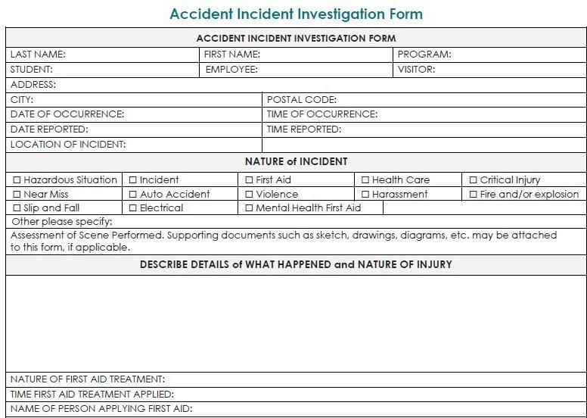

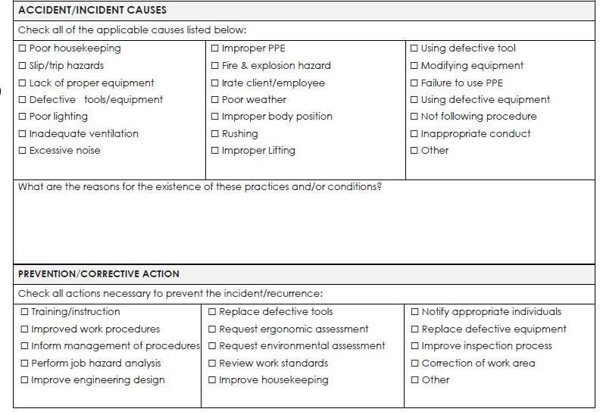

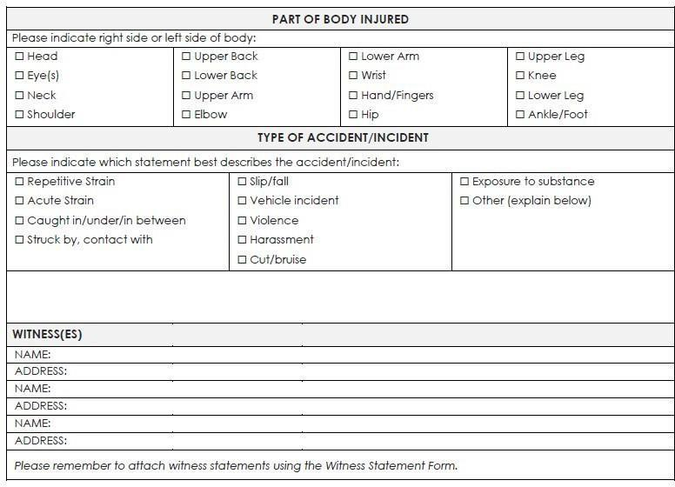

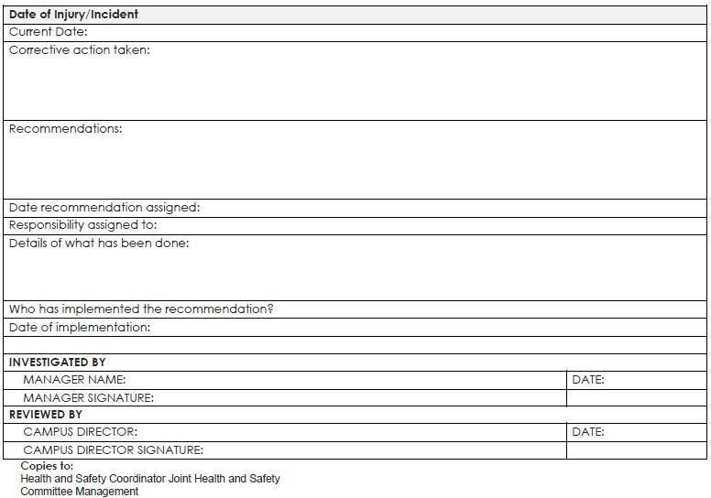

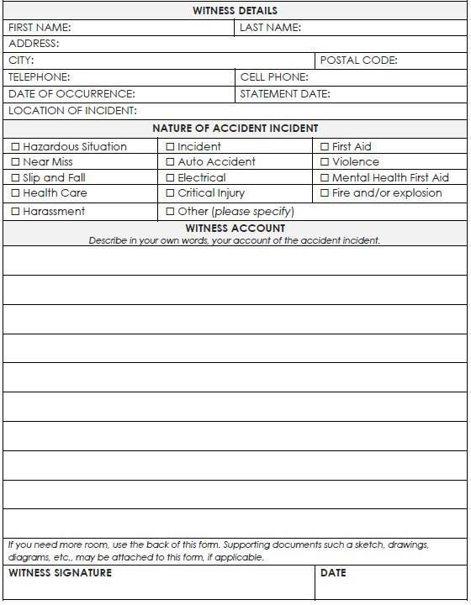
Appendix D: Witness Statement Form

Appendix E: Confidentiality Statement

In accordance with regulations regarding confidentiality of information or knowledge concerning the patient, students in Eden Brook College of Health, Business and Technology shall adhere to the following policy:

- All aspects of the patient’s medically related information and/or data shall not be discussed with
any person or persons under any circumstances, except in a structured, teaching-learning situation.
- Under no circumstances is the student to photocopy and/or tape record any part of the patientF’s medical record/chart or requisition.
- Failure to honour this basic ethical right of the patient may result in the immediate dismissal of the student from the program.

I understand that all information about the patient’s condition is confidential. I hereby acknowledge that I will not discuss such confidential information in ANY public area inside or outside of the educational arena.

Name of Student (PRINTED) Date

Name of Student (SIGNATURE)

Signature of Program Personnel Date

Appendix F: Student Pledges

Pledge to Confidentiality
As an employee, member of the medical staff, volunteer, other worker, placement student, or co-op student associated with the host site, I understand that I will have access to information and materials relating to patients, employees, and other individuals, which is of a private and confidential nature.
- At all times, I shall respect the privacy and dignity of patients, employees and all associated individuals.
- I shall treat all administrative, financial, patient, employee and other records as confidential material, and I will protect them to ensure full confidentiality. I shall not read records or discuss, divulge, or disclose such information unless there is a legitimate purpose as it relates to my employment.
- I shall ensure that confidential information is not inappropriately accessed, used or released either directly by me, or by virtue of my signature or security access to premises or systems.
- I shall only access, process and transmit confidential information using the host site hardware, software, and other authorized equipment, as required by the duties of my position

Pledge to the Code of Conduct
As an employee, member of the medical staff, volunteer, other worker, placement student, or coop student associated with the host site, I share in the vision of the host site and will strive to create a culture of respect and co-operation. As such, I pledge to:
- Treat others with respect, dignity, caring, and compassion.
- Demonstrate courtesy, honesty, and integrity.
- Respect the rights of others regardless of their race, ancestry, place of origin, citizenship, religion, gender, sexual orientation, age, or disability.
- Provide an environment that ensures and protects the right to personal dignity and privacy for every individual.
- Ensure the physical safety of each individual.
- Refrain from the use of offensive and abusive language.
- Maintain confidentiality and honour the privacy of health information in all respects including not seeking information of others.
- Act in a professional manner that promotes teamwork, communication and accountability.
- Display accountability for my actions and decisions.
- Comply with all applicable federal, provincial, and municipal laws.

I understand and agree to abide by the principles outlined in this document. I also understand that should any of these principles be breached, I will be subject to disciplinary action up to and including termination, loss of privileges, or similar action appropriate to my position with the host site.

Student Name: Witness Name:

Date: Date:

Signature: Signature:

Appendix G: Immunization Form

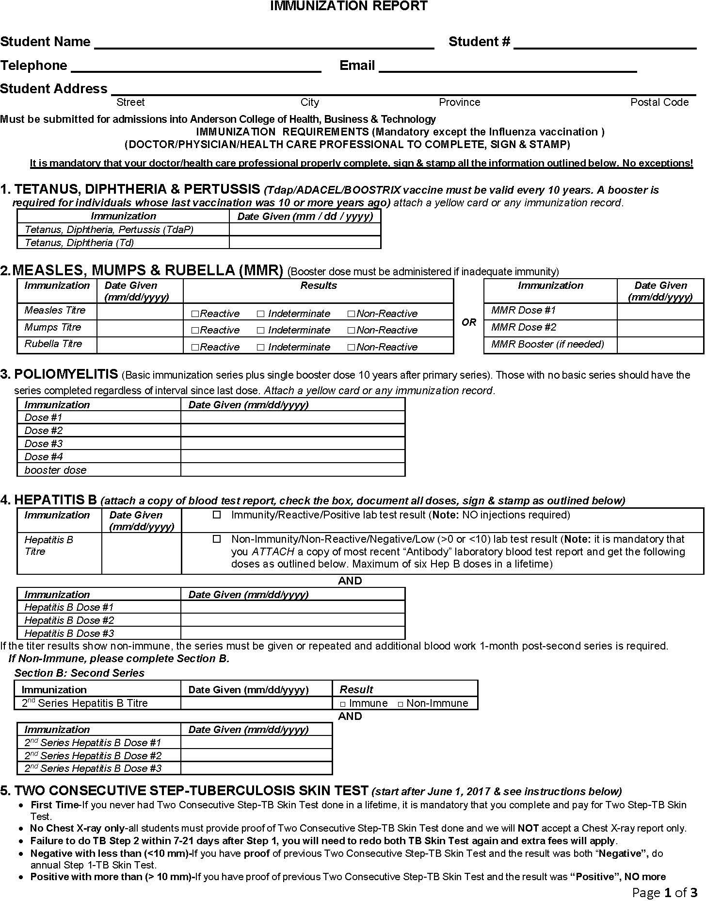

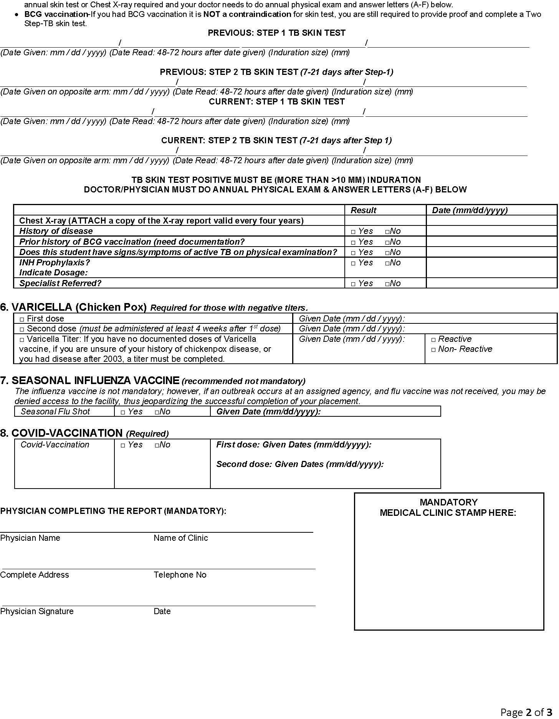

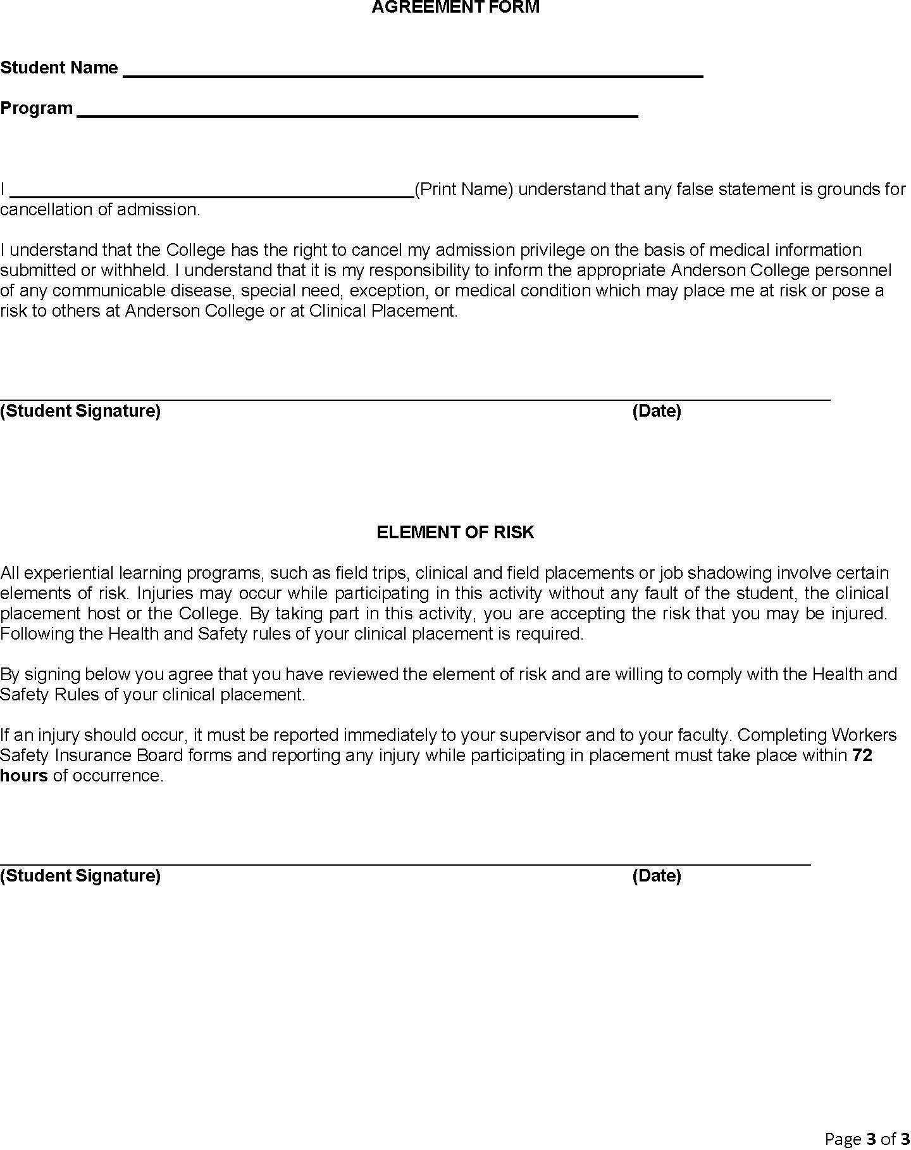

Appendix H: Brightspace

How do I log into my Brightspace courses?
Recommended web browsers are Safari, Edge, Firefox, and Chrome. Log into your online courses, as follows:
  - Open your browser and type in the web address and log in with your assigned number and password (student email and password).

I need help , where do I find it? Why is my computer responding slowly?
Online help screens are available from all pages of the course. Click on the Help button at the top of the window at any time for assistance. You can also contact support for technical issues by phone or email:
help:
The Eden Brook College IT Support helpline is the best place for students to contact in regard to related issues.

What do I need to tell them when I email in?
You will need to provide:
- Full name, student number, and name of program.
- Details of what the issue is.
- Time it happened (as accurate as possible).
- Web address(es) you were trying to access.
- Where are you trying to access from (i.e., on campus, at work, at home, etc.)
- The time that you are having problems accessing Brightspace

