ANPH 202 – Anatomy and Pathology 1
Worksheet - Cardiovascular Anatomy

1. The human heart is about the size of one’s fist and sits directly behind the sternum with one third projecting to the _________ and two thirds projecting to the ___________.

2. The ___________ of the heart lies on the diaphragm.

3. The most anterior surface of the heart is formed mainly by the _________ ventricle.

4. The diaphragmatic surface of the heart is formed mainly by the _________ ventricle.

5. The heart is located in the mediastinum. It is covered by its own double layered serous membrane known as the _____________. The parietal layer of the pericardium is a loose fitting sac, while the visceral layer is in direct contact with the surface of the heart and as such it is sometimes called the _______________. Between the parietal and visceral layers of the pericardium, is a narrow space that contains _______________

6. Explain the function of pericardial fluid:

7. The middle muscular wall of the heart is known as the _______________, while the smooth innermost layer of tissue that lines the cavities of the heart is called the ________________.

8 Number off the tissue layers of the heart and pericardium in order, from the most superficial to the deepest.

Myocardium
Parietal pericardium
Pericardial cavity
Visceral pericardium or epicardium
Endocardium

9. Internally, the heart is divided into right and left halves by the ______________________ and the ____________________.

10. The heart is a double-sided pump that has two upper chambers called the right and left ___________________, and two lower chambers called right and left __________________. “Auricles”, are outpouchings that expand the volume of the _________________. The right side of the heart maintains ________________ circulation while the left side of the heart maintains ______________ circulation.

11. The most muscular of the four heart chambers is the ______________, because it is primarily responsible for pumping blood to the far reaches of the body i.e. systemic circulation.

12. The heart muscles receives its oxygen supply through the ______________ arteries.

13. Coronary circulation originates with the ______________ coronary arteries which branch off the aorta near the aortic valve.

14. The left coronary artery branches into the ______________ artery and the __________________ artery which is sometimes called the left anterior descending artery or LAD)

15. After blood has circulated through the myocardium it is collected by a series of cardiac veins that dump into the _____________, and finally into the ______________ of the heart.

16. There are four valves in the heart. Two atrioventricular valves which include the _________________ and the ______________, and two semilunar valves which include the _______________ and the ___________________.

17. Heart valves have “leaflets or “cusps” that are designed to ensure that blood can only move in one direction through the heart. If valve function is compromised, the blood may flow in a backwards or _______________ fashion.

18. “Heart strings”, known medically as _________________ control the movements of the atrioventricular valve leaflets.

19. Heart chambers “contract” during ____________ and “relax” during _____________.

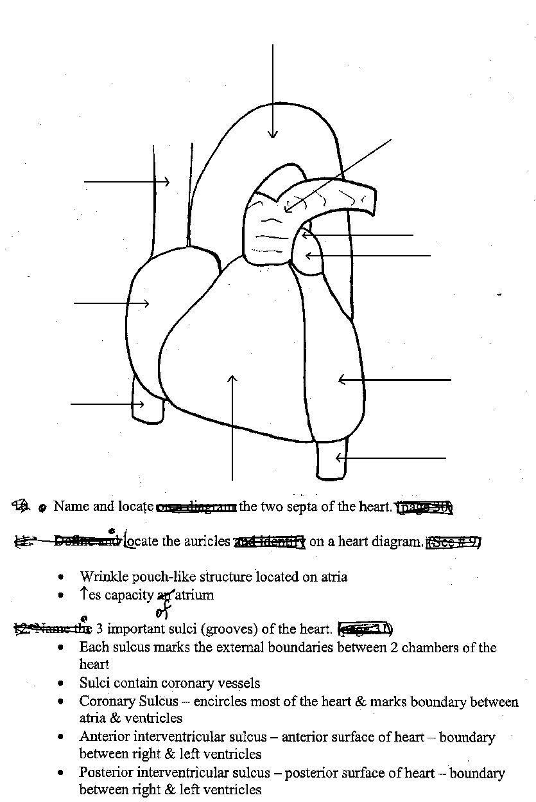
20. Label the following on the diagram to the right:

1. Aortic arch

2. Inferior Vena Cava

3. Superior Vena Cava
4. Pulmonary arteries

5. Right atrium

6. Left atrium

7. Right ventricle

8. Left ventricle
9. Descending thoracic aorta

21. Label the structures on the diagram below:

Vessel?
Vessel?

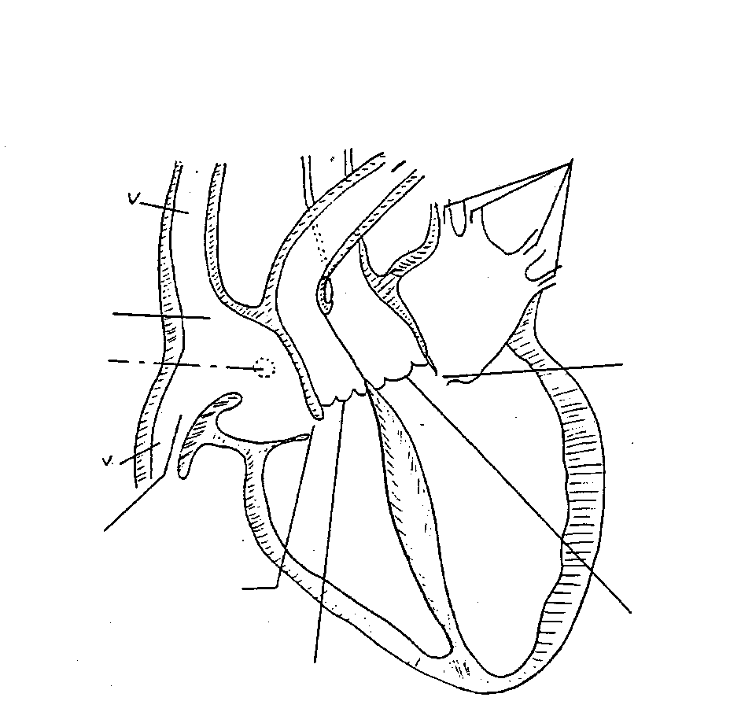
Vessel?
Chamber?
Chamber?
Vessels?

Chamber?
Structure?
Valve?

Vessel?
Chamber?

Valve?
Valve?

Valve?
Chamber?

Artery?

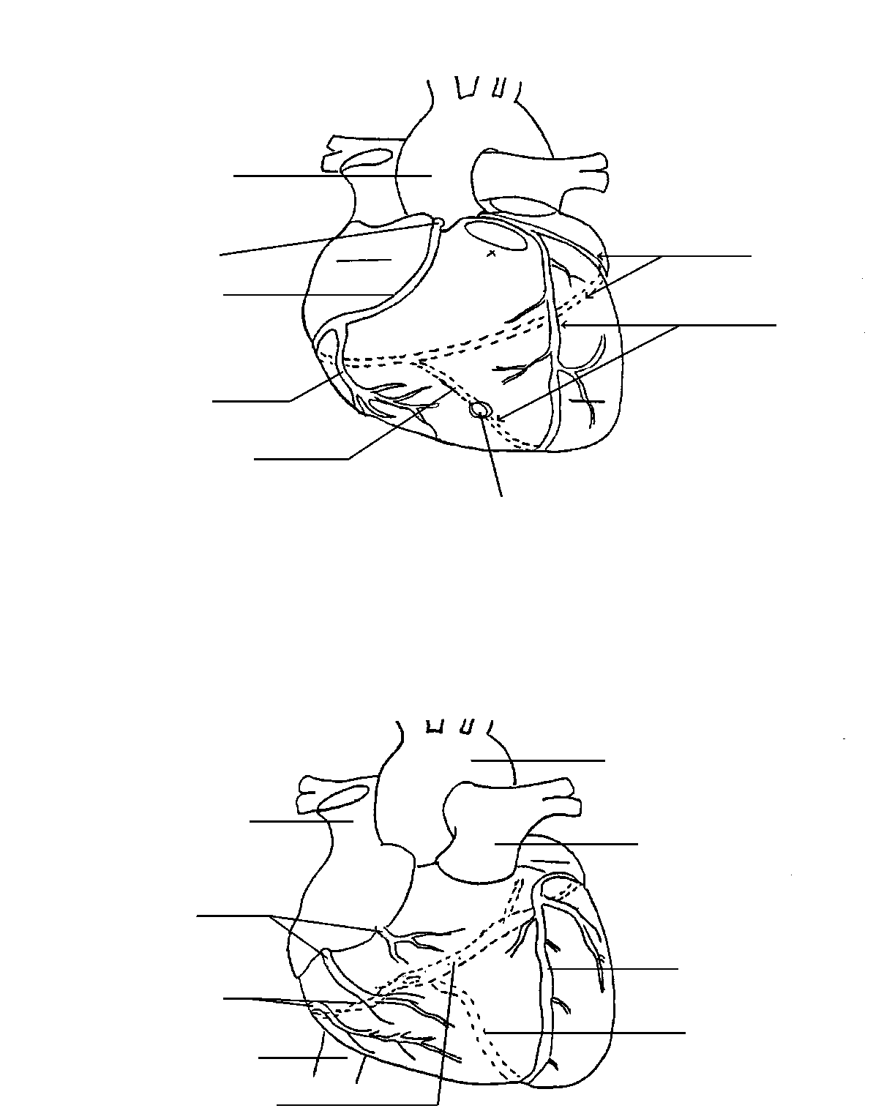
22. Label the following arteries on the diagram to the right:
Artery?

- Right Coronary
Artery?
- Left Coronary
- Right Marginal
- Posterior Interventricular
Artery?
- Left anterior descending
Artery?
- Circumflex artery
- Anterior interventricular
Artery?

23. Describe the path an erythrocyte would take through the heart, from the time it enters the IVC to the time it leaves the aorta

24. Based on what you know about the anatomy and physiology of the heart, which heart valve takes the most wear and tear

25. Based on the what you know about the anatomy and physiology of the heart, explain why high blood pressure is often referred to as the “silent killer”

