ANPH 252 – Worksheet - Respiratory System
Image One
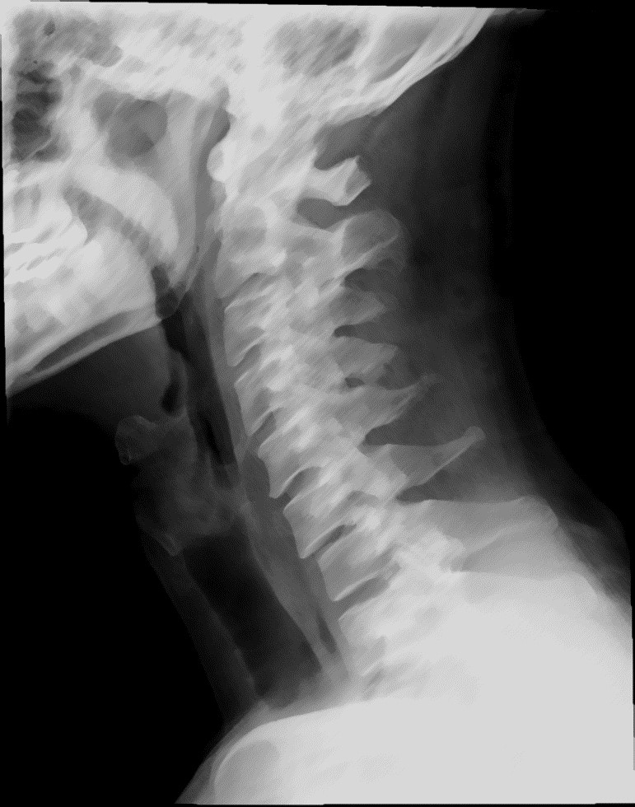

1.
Label the following on “image one” above.
A
B
C
G
E
F
D

H
A.
B.
C.
D.
E.
F.
G.
H.

- “The structures in image one above are all part of the upper respiratory tract” T F
- List four functions of the respiratory system.
- The external openings of the nose are known as the _________________.
- The nasal cavity is divided midline by the ___________________.
- What structures are responsible for humidifying, warming, and cleaning air in the nasal cavity?
- The thyroid cartilage is _________ to the pharynx and is commonly known as the ________________.
- The ________________________ is the prominent point on the thyroid cartilage, and it is an exterior landmark for __________ of the cervical spine.
- Place the following anatomy in order, starting with “1” to designate the first structure where air enters, and finishing with “7” to designate the last structure.
Bronchioles (< 1 mm)
Lobar (secondary) bronchi
Alveolar ducts
Tertiary bronchi
Terminal bronchioles (< 0.5 mm)
Alveolar sacs
Right and left primary bronchi

- All of the following structures maintain patency through the support of cartilaginous tissues except:
  - trachea
  - external nares
  - primary bronchi
  - alveoli
- A pneumothorax is a condition characterized by air in the pleural cavity. It may occur spontaneously, or as a result of trauma or pathology. In the case of a trauma such as a crush injury, what two membranes of the body may be compromised in the case of a pneumothorax?
a.
b.
- The primary bronchi, pulmonary vessels, nerves, and lymphatics enter the lung at the _____________.
- A substance that reduces surface tension is known as a/an ___________________.
- What structures of the respiratory system secrete the “anti-surface tension” substances described above, and what respiratory structures are kept inflated as a result?
From the following list circle the statements that are true.
- The diaphragm is the main muscle responsible for human respiration
- The diaphragm relaxes the as lungs inflate
- The diaphragm contracts as the lungs inflate
- The diaphragm forms the base of the lungs
- If a child swallows a small toy, which lung is it most likely to end up in, and why?
- “Under duress, the body employs alternate muscles in the neck and chest to help maintain adequate tissue oxygenation” T F
- On inspiration, the volume of the thoracic cavity (increases/decreases) and airpressure within the lungs (increases/decreases)
- The connective tissue area contained within the blue circle in image two below,would best be described as the __________________.
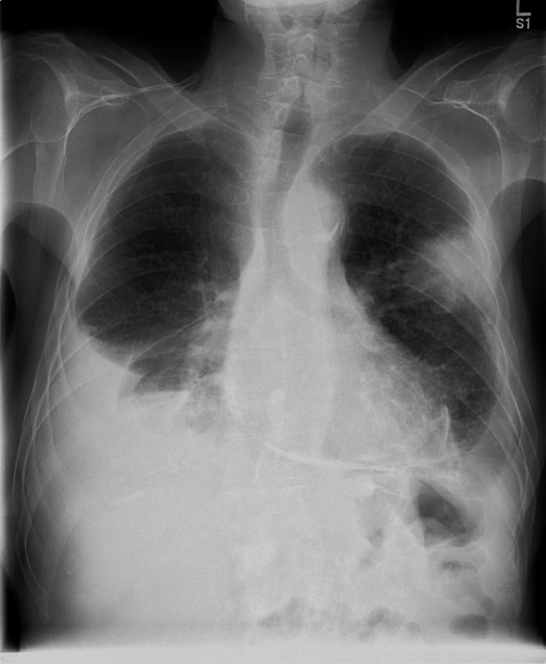
Image

Two
A

B

F

E

D

C

G
- Select from the list of anatomical terms below to label image two above.
Stomach air ______ Trachea _____ Esophagus _____
Apex _____ Pleura _____ Carina _____
Base _____ Left Bronchi _____ Lobar fissure _____
- The lungs receive their oxygen supply from the pulmonary arteries. T F

