Fluoroscopy Equipment

Learning Outcome: Evoluote the fluoroscopic performance of on x-roy roomoccording to Safety Code 3J requirements.

Ob|ectives J.1 — J.Ó

Visual Inspection, Environmental Inspection and Performance TestingPopp 6" Edition pg
151-153
- Similar process as the evaluation of radiographic systems
  - Visual inspection
    - At leost every Ó months
  - Environmental inspection
    - At leost every Ó months
  - Performance testing
    - At least every 6 months

Depending on SC35, some onnually
- Areas to include on Visual Inspection are:

Fluoroscopic tower and table locks
    - Check all locks to verify function, are they working properly?
- Power ossist

Tower should move smoothly over the tabletop
  - If it is |erky, can affect imaging during exams
- Protective curtain
  - Ensure it is in place, and moves freely
  - Meets minimum requirement for lead equivalence
- Bucky slot cover
  - When Bucky is moved to the end of the table, the cover should move intoploce
  - Meets minimum requirement for lead equivalence
- Exposure switch
  - Must be dead man type
  - Check that it is not sticking/molfunctioning
- Fluoroscopic timer
  - J minute reset required
  - Check timer accuracy
- Lights/meter function

All lights and meters should function as specified
- Compression Devices
  - Devices should be clean and move easily

- Pork Position Interrupt

If the tower is in the parked position, should not be able to emit radiation

- Table angulation
  - Table should move freely between upright and table positions, and beable to stop at ongulations in between
- Environmental Inspection
  - In addition to other components that are inspected on the radiographic unit, it isparticularly important to check:
    - High tension cables - condition
    - Image intensifier — mechanical condition of the tower
    - Table — mechanical condition
- Performance Testing
  - Just as important as with radiographic units
  - Critical to avoid variation in system performance

Potential of high patient doses in fluoroscopy
  - Essentially the some/similar procedures that are performed on general radiographic equipment, but the acceptance limits may be different
  - Setup for the procedures may be slightly different
    - Consider the configuration of the unit
      - Over table tube vs under table tube

Fluoroscopic kVp Accuracy (Test 15)
Generator Tests — Reproducibility, HVL, mA lineorily, Timer Accuracy Popp 6*‘
Edition: pg 104-110, 113-116, 153-154 SC 35 : pg 25-26

These ore the same tests as done on the radiographic unit. Please review the procedures, ondrefer to the Safety
Code 35 for the acceptance criteria for radioscopic equipment.

- Refer to the QUAL 3Z0 Procedures manual for the equipment, procedure to performthese tests and formulas for the calculations.

Automatic Brightness Control & Automatic Gain Control Popp 6"' Edition: pg 155

- What is the difference between automatic brightness control and automatic gain control?
  - Automatic brightness control (ABC) is what allows the fluoroscopic unit to automatically maintain the brightness level of the image

    - Regardless of patient thickness and position
    - Works by varying kVp and mA
  - Automatic gain control maintains image display brightness
    - Does not change the technical factors, the system odiuststhe gain of thevideo system instead
    - Changes display parameters, not actual exposure

- Automatic Brightness Control Test procedure
  - Set up the dosimeter with two Plexiglass blocks over it
  - Expose until the ABC stabilizes
    - Measure and record the brightness of the monitor with a light meter
    - Measure and record the exposure rate, kV and mA from the dosimeter
  - Remove one block and expose again, until the ABC stabilizes
    - Measure and record the brightness of the monitor with a light meter
    - Measure and record the exposure rote, kV and mA from the dosimeter
  - Outcome:

The dose rate (exposure rate, kV and mA) for one block should be
approximately half the value of what it was for the two blocks
    - The brightness of the monitor should be a similar value

Maximum Fluoroscopic Exposure Rote (Test 16j Popp 6 *‘ Edition pg 155-156, SC 35 pp 26, 54
- This tests for the higher possible rote of exposure thot can be delivered by thefluoroscopic system
- This must be regulated because patient doses can be extremely high with fluoroscopiccases
- The setup depends on the type of equipment
  - Under table unit — rate is measured at the table top
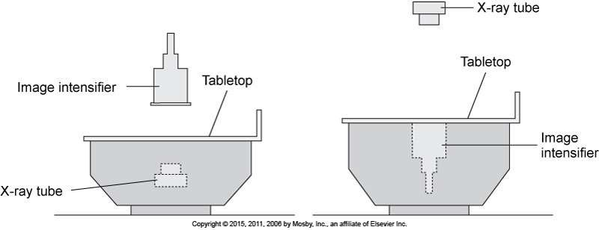
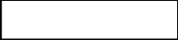
  - Over table unit — rate is measured where the beam enters the patient
Papp 6th – Fig. 7.12

- Purpose of this test: to confirm that the maximum exposure rate that can be delivered does not surpass the regulation as determined by the SC3J for any combination of mAond kVp.
- Testing is done on acceptance, and annually.
- Refer to the QUAL 370 Procedures manual for a more detailed sample procedure ondadditional information.

Fluoroscopic Resolution (Test 1 Z, 18 and 19) Popp 6*‘ Ed. Pg 15Z-158
- High contrast resolution
  - Ability to resolve small, thin, block and white areas
  - Measure of spatial resolution
  - Commonly wire-mesh test tools are used, line pair tools may also be used.
- Low contrast resolution
  - Ability to resolve relatively large objects that differ slightly in rodiolucency fromthe
surrounding area
  - Special test tool for low contrast resolution is used (aluminum plates with holes ofvorying sizes in an aluminum disk)
- Evaluation criteria for high and low contrast resolution is dependent on the manufacturer.
- * Note thot these tests are subjective because they ore based on user observations.Results may
vary, but should be similar if performed by more than one individual.

High Contrast Resolution (Test 1 Z and 19)
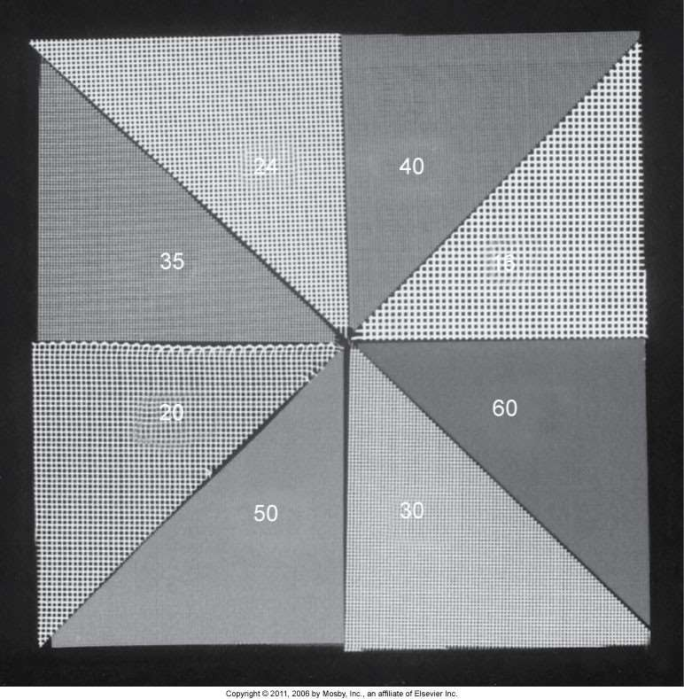
  - When observing small, thin, block and white areas
— how well con they be differentiated? How small can the structures be, that we canstill observe that the structures are separate, not one?
  - Expose the test tool and observe the image on the monitor — the edges and center of theimage will need to be assessed
  - An image of the test tool should be taken using regular mode, and every magnificationmode
- Purpose: to determine if the resolution is within acceptable limits as visualized on the monitor
- Refer to the QUAL 370 Procedures manual for amore detailed sample procedure and additional information.

Low Contrast Resolution (Test 18)

When observing relatively large o*iectsthat hove small differences in
radiolucency from the surrounding areas — can the differences be seen?

Expose the test tool and observe the image on the monitor
  - An image of the test tool should be taken using regular mode, and every magnification mode.
  - The more holes that can be visualized, the better the system is.

Purpose: to determine if the low contrast resolution is within acceptable limits.
- Refer to the QUAL 3Z0 Procedures manual for a more detailed sample procedure ondadditional information.

Fluoroscopic Image Noise/Log (Test 20) Popp 6*‘ Ed Pg 15 8-159

- It is important to evaluate the lag of video systems used in fluoroscopy
  - What will be the use of fluoroscopy, if the system cannot capture what is happening in real time?
- This can be done in a variety of methods
- Again, this is a subjective test based on the impression of the observer
- Observer must be experienced and love tested both good and poor systems
  - They need to have a basis of comparison
  - No hard data is documented, this test is for a subiective impression
  - The observer needs to decide if the lag is acceptable for the types of examsbeing performed (e.g. interventional exams, GI exams)
- When performing the test, it is important to note the type of camera tube in the unit andod|ust expectations accordingly
  - Vidicon — more image lag
  - Plumbicon — should have less image lag than Vidicon
- There will always be some inherent log in a system, but it is up to the observer to decidewhether it is acceptable or not for that particular system
  - During the test, they move the rodiopoque object (washer) or image intensifier.They must assess how fast they ore moving and how much image lag is beingdemonstrated to deem what is acceptable.
- Refer to the QUAL 370 Procedures manual for a more detailed sample procedure andadditional information.

Image Noise

Caused by:
  - Quantum mottle
  - Electronic noise
- So how can it be differentiated?
- Electronic noise
  - Observe the monitor without an image on it, just the monitor alone. If there isnoise (static) present, that is an electronic noise issue.
  - Service will need to be contacted, likely an issue with the gain of the videoamplifier
- Quantum mottle
  - Caused by: not enough photons reaching IR
  - Test this by exposing a phantom with the lower mA setting possible
  - Gradually increase the mA, if the amount of noise visualized decreases as themA is increased, that means that quantum mottle was causing the noise.

