INFC 215 – Infection Prevention and Control

Module Two: Interaction between Microbe and Host

Topic 2.1: Host – Microbial Relationships
The body exists in conjunction with millions of microorganisms. This is usually a peaceful arrangement in which we humans derive benefit from our microscopic friends. On occasion, they become our foes and inflict damage on their hosts.
There is a delicate balance between health and illness.
Of the thousands of microorganisms that make contact with the human body, very few are pathogenic or capable of causing disease. Many microbes become part of the normal flora of the host. Normal flora organisms cover body surfaces that are exposed to the external environment. This includes skin, mucous membranes of mouth, and the more external parts of the upper respiratory system, gastrointestinal and genito-urinary system. The organisms are protective because they “take up all the space”, so that pathogens are less able to adhere to the surface.
Internal areas of body are sterile. This includes tissues, blood, cerebrospinal fluid, peritoneal, pericardial and other fluids.
Many normal flora (Bacteria and Fungi) microorganisms can be grown in the laboratory. Microorganisms are said to be “ubiquitous”, which means that they are found everywhere … in our environment and on our bodies. Note that the most organisms are found in warm, moist environments (humans and animals), while the least is in treated water and on dry surfaces.

Follow the links, to see Laboratory Cultures of Normal Flora, They are:
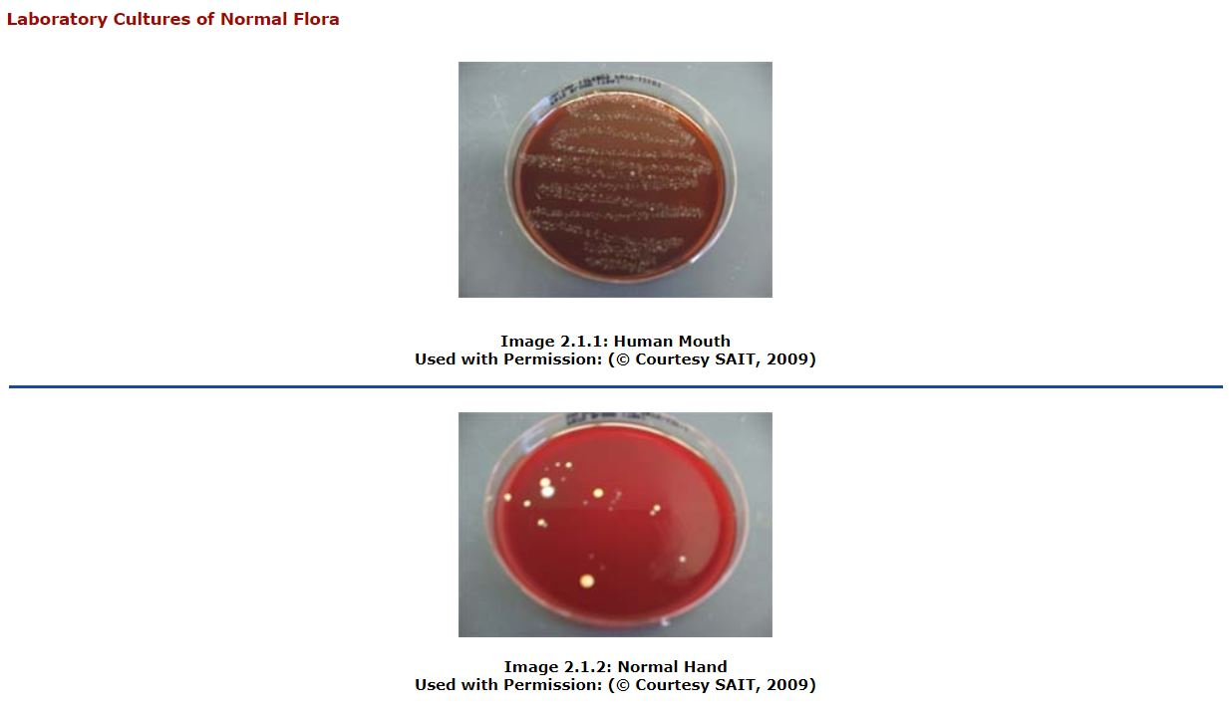

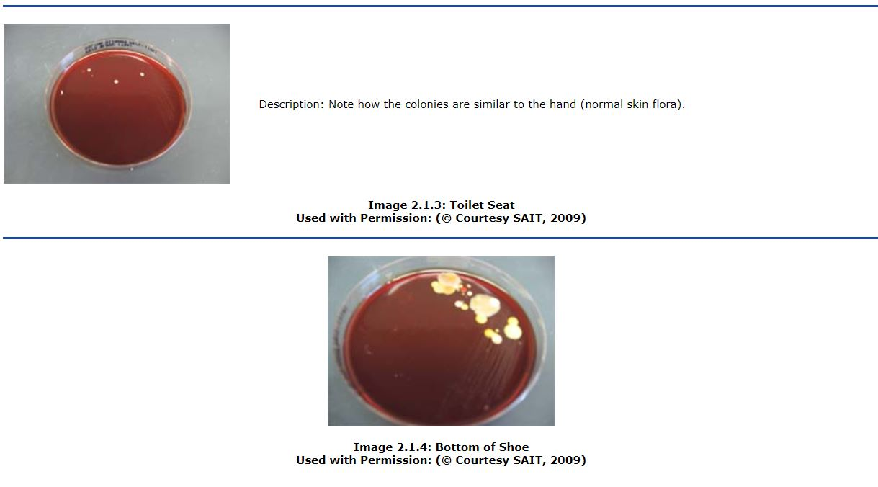

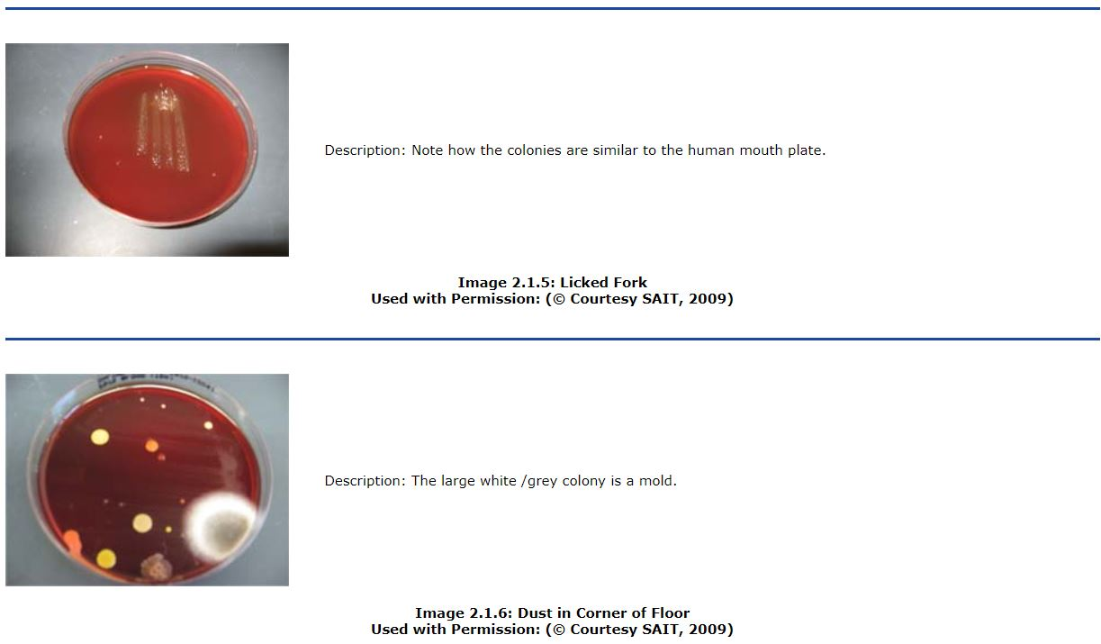

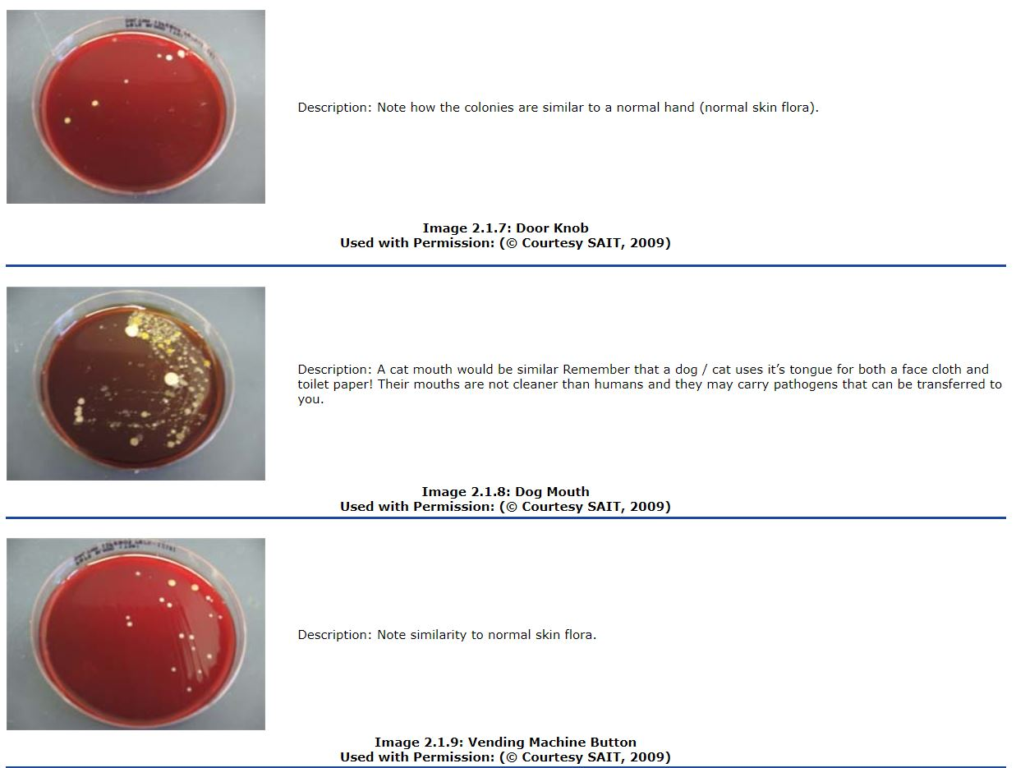



Normal Flora of the Human Body
- Normal Flora
Under normal circumstances, humans enter this world “germ free.” The placental barrier between mother and fetus prevents microbial penetration. In the few cases where bacteria or viruses invade the fetus in the uterus, the fetus may not develop normally or may die in-utero.
Following birth, microbial populations rapidly establish themselves on the skin and mucous membranes lining the gastrointestinal, respiratory and genital tracts. The microorganisms that establish more or less permanent residence and do not produce disease under normal circumstances are known as normal flora.
- Normal Flora in different body sites
The composition of normal flora is fairly constant for a given site. For example, most people basically have the same normal flora in the mouth. However, the normal flora composition varies depending on the site: normal flora of the mouth is very different from normal flora of the intestine or the skin.
The large intestine is the area of the body that has the greatest normal flora population. There are millions of bacteria in 1 gram of feces and in fact, bacteria make up the bulk of fecal material. A rod-shaped bacterium called Escherichia coli (E.coli) is found in the feces of most people. The normal intestinal flora plays an important role in food digestion and evacuation of feces. E. coli also produce Vitamin K in the colon. The vitamin K is absorbed and travels to the liver where it is incorporated into clotting factors. A lack of E.coli in the colon can ultimately lead to a bleeding disorder. There are many types of E.coli. Some are vital to good health, while others such as E.coli 0157 H7 can cause severe diseases such as “hamburger disease”.
The mucous membranes of the upper respiratory tract establish their own specific normal flora. Many of these bacteria are called Streptoccus viridans. These bacteria occupy attachment sites on host cells and prevent pathogenic bacteria from invading respiratory tissue.
The outer surfaces of the body encounter many bacteria but only a few are able to grow on the cool, dry and salty environment of the skin. Staphylococcus epidermidis (Coagulase negative Staphylococcus) make up the majority of the normal flora of the skin although a few other bacteria flourish along hair follicles and sweat glands.
- Factors that affect Normal Flora
Two factors that may alter the composition of normal flora are:
- Excess moisture on the skin contributes to an increase in the staphylococci on skin surfaces. Skin under a wide ring or watch strap will have more normal flora than exposed skin. Health care workers wear latex or vinyl gloves when performing certain procedures and the moisture resulting from this may increase the amount of normal flora on their hands.
- Antibiotic use will often alter normal flora as the sensitive bacteria are killed, which allows other more resistant strains to dominate. Patients are more prone to the antibiotic resistant bacteria that may be found in the hospital environment.

Host/Microbial Relationships other than Normal Flora
- Contamination, Colonization and Infection/Disease
Contamination describes the situation where microorganisms are introduced to a body site where they are not expected, but there is no growth of the microbes. There is no increase in numbers of microbes and no damage to the host. For example, if saliva from the mouth gets on the skin, the skin is contaminated with normal mouth bacteria. The mouth bacteria on the skin as contaminants are easily removed by normal hand hygiene procedures.
The diagram below illustrates the layered skin cells, with the circle representing a contaminating organism.
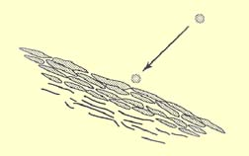
Figure 2.1.1
Used with Permission: (© Courtesy SAIT, 2009)
Colonization implies contamination with an organism that is not normal to a site and actual growth of the microbe but still no damage to the host, at least initially. Colonization can occur on a normally sterile area or a site with normal flora. In some cases, colonization may lead to disease but in other cases it never does cause damage to the host. Many patients in intensive care units requiring ventilated-assisted breathing become colonized in the upper airways by fecal bacteria. These bacteria may be present for a period of time and then disappear uneventfully or, in some cases, may set the stage for pneumonia. Staphylococcus aureus as well as Methicillin Resistant Staphylococcus aureus may colonize in the nares (nose). The person is then said to be a "carrier" and can pass the organisms on to the susceptible hosts.
The diagram below illustrates the layered skin cells, with the circle representing a number of organisms that have colonized.
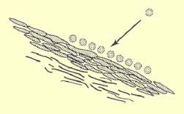
Figure 2.1.2
Used with Permission: (© Courtesy SAIT, 2009)
Infection and Disease are often used interchangeably and mean that the host has been colonized with microorganisms and host damage has resulted.
The true definitions of the terms do differ: Infection implies the host has been invaded with an organism but there are no signs of host injury.
Disease implies the host has been infected and host injury is evident.
For example, the terms are often used correctly to describe patients with AIDS. A person may be infected with the HIV virus but show no host injury for some period of time. Once the symptoms of AIDS become evident, the host is described as having the disease.
Another example would be if Staphyloccocus aureus, which is not normally found on the skin, established itself in a hair follicle, it would be called an infection. If a swollen, painful, red pus filled eruption occurred, it would be called the disease “carbuncle”.
The diagram below illustrates the layered skin cells, with the circles representing organisms that have infected the skin. If there are obvious signs, then it can be said that disease has resulted.

Figure 2.1.3
Used with Permission: (© Courtesy SAIT, 2009)
The following examples demonstrate the proper use of terms that describe interactions between host and micro-organism.
- The lining of the urinary bladder is normally sterile. Bacteria will occasionally grow on the bladder mucosa without causing any disease or harm to the host. The term for this relationship is colonization.
- The bacteria causing tuberculosis multiply inside white blood cells of the body for several weeks without causing any injury to the host. During this time the person is described as being infected with tubercle bacilli. Several weeks later, if symptoms of tuberculosis become evident and the person is said to now have the disease.
- Throat cultures of most individuals with no evidence of sore throats will show Streptococcus viridans. These streptococci are normal flora. However, in people with damaged heart valves, the organism can cause the disease, subacute bacterial endocarditis. Death can result if the organisms enter the blood stream during dental work and grow on the damaged valve. Medical histories are a vital part of a dental visit. Patients are assessed and prophylactic (preventative) antibiotics may be given pre and post dental procedures.
- Staphylococcus aureus growing in a surgical incision causing swelling and inflammation would be described as infection and then disease.
- Fecal bacteria on the hands of a person visiting the bathroom and failing to wash their hands after this visit would be called contamination as long as the bacteria were not growing and injuring the host.
- Pathogens, Non Pathogens and Low-Grade Pathogens
A pathogen is defined as a disease-causing organism. Generally speaking, exposure to a pathogen results in infection and ultimately disease. The etiology or cause of the disease is an organism. Virulence is the degree of pathogenicity. There are numerous virulence factors and the more of these factors a micro-organism has, the more able it is to cause disease. Virulence factors include:
- Enzymes that dissolve hyaluronic acid (tissue cement), collagen and fibrin clots, allowing bacteria to spread faster in the tissue
- Substances that destroy red blood cells, releasing iron necessary for bacterial growth
- Substances that destroy white blood cells, weakening body defenses
- Capsules, or slimy coatings, which prevent phagocytic white blood cells from engulfing and destroying the microorgansim. Bacterial pneumonia is caused by the capsulated organism, Streptococcus pneumonia. The young and the elderly are particularly susceptible to this, as their white blood cells may not be as able to phagocytise and destroy the bacteria.
Click the link to see pictures illustrate the Effect of Virulence Factors:
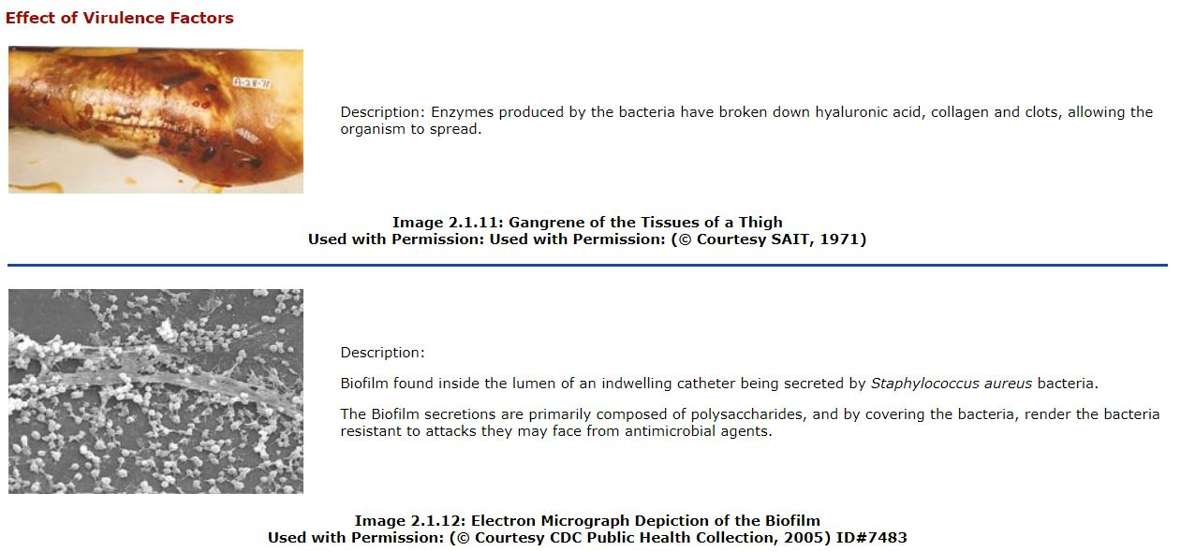
A non-pathogen is an organism that is not able to cause disease. A few bacteria fit this description but the list gets shorter as people with impaired immune systems are being infected with microorganisms previously considered to be non-pathogenic.
Some microorganisms are low-grade pathogens or opportunistic pathogens. These organisms are non-pathogenic under most circumstances (often normal flora) but may cause disease when the host's defences are lowered by other predisposing conditions or they are moved to another part of the body.
Some of the normal flora staphylococci of the skin are low-grade pathogens and may infect normally sterile tissue if an opening is provided. This may occur in patients with a needle left in a vein for intermittent administration of intravenous fluids.
E.coli, normally found in the colon, can cause urinary tract infections (UTI’s) if they are able to make their way to the bladder. The resulting infection/disease is commonly called cystitis. In females, this can occur following sexual activity or wearing tight fitting underwear that causes irritation in the area. Sometimes, there is no obvious reason for the development of cystitis. A substance found in cranberry and blueberry juice can often prevent cystitis by blocking the E.coli from adhering to the bladder wall.
Catheterized patients are prone to urinary tract infections because organisms, such as E.coli, can migrate up some types of catheter tubing. Research is currently under way to develop tubing that is less likely to allow organisms to make their way to the bladder.
- Bacterial Toxins
Virulence factors cause damage to the host in the immediate area of the infection. Other substances called toxins cause damage to sites far-removed from the initial site of infection. The effect of a toxin on a host differs with the type of toxin. There are two types of toxins:
Click on the link to see the Effect of Bacterial Toxins:
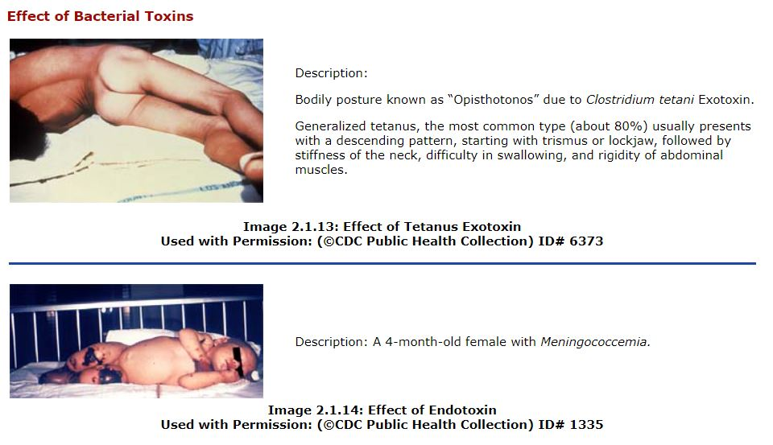

Exotoxins
- Produced mainly by Gram positive bacteria
- Released from intact bacterial cells
- Carried away from the infection site by blood
- Attack a specific target tissue
For example, the tetanus toxin affects the central nervous system and interferes with transmission of impulses from the brain to groups of muscles. One of the first symptoms of tetanus is often a clenched jaw that cannot be released, hence the name “lock jaw.”
Figure 2.1.4 illustrates that exotoxins are secreted from intact gram positive bacterial cells into the blood stream. Image illustrates the effect of the toxin on the body.

Figure 2.1.4

Endotoxins

- Produced by Gram negative bacteria; located in the cell wall.
- Released only when the bacterial cells are disrupted.
- Have a more generalized effect on the host, rather than attacking a specific tissue.
- May be responsible for fever or general malaise and aches accompanying bacterial infections.
- Can also have life-threatening effects such as drop in blood pressure and circulatory collapse. The reason for this is not really understood.
- The use of antibiotics can sometimes cause serious complications, as the bacterial cell is destroyed, resulting in the sudden release of endotoxins and subsequent shock.
For example, pyrogens are endotoxins that cause fever; the endotoxin associated with “hamburger disease” bacteria can cause potentially life-threatening kidney damage; Neisseria meningitidis can cause shock, circulatory collapse, tissue and kidney damage.
Figure 2.1.5 illustrates the breakdown of the cell wall of gram negative bacteria, resulting in the release of endotoxins which are carried by the blood to various locations in the body.

Figure 2.1.5

