Computed Tomography Theory 2 Final Exam Comprehensive Review

- What lobe of the liver sits between the gall bladder and the round ligament? Quadrate
- Which is the most anterior lobe of the liver? Left
- The portal vein runs ______ to the hepatic artery. Posterior
- What vessel(s) first branches off the abdominal aorta, and supplies blood to the diaphragm? Inferior phrenic arteries
- The head of the pancreas sits within the ______. Duodenum
- The spleen is located ______ to the stomach. Posterior
- The gall bladder sits on the anteroinferior portion of the _____ lobe of the liver. Right
- The common hepatic artery sits _____ to the portal vein. Anterior

- Axial image of abdomen to demonstrate the pancreas. Student has to identify the pancreas (check exam image)
- Axial image of abdomen for the splenic vein (contrast filled) axial projection (check exam image)
- Axial image of abdomen for the spleen (check exam image)
- Axial image of abdomen the left Kidney (check exam image)
- Axial image of abdomen for the IVC (check exam image)

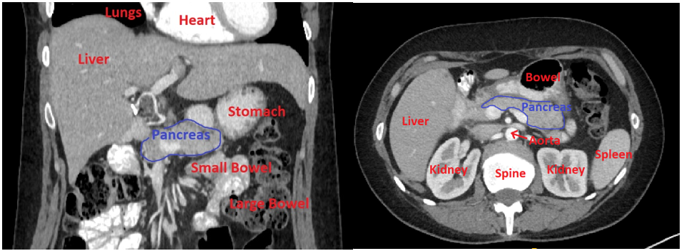
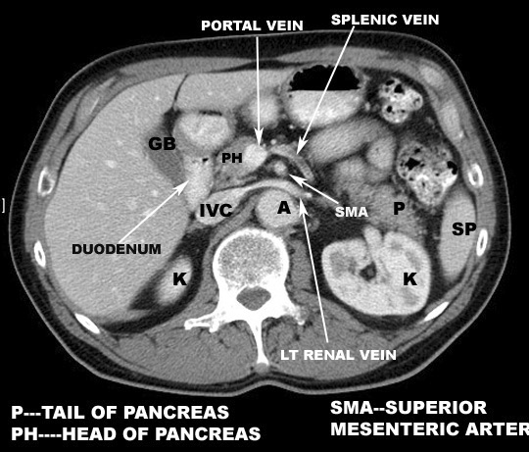

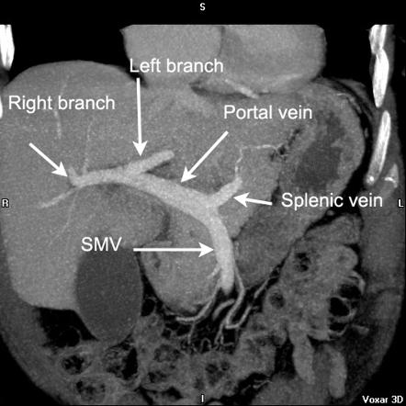
- What position best describes the adrenal glands, in relation to the kidneys? Superior
- The abdominal aorta bifurcates into the right and left common iliac arteries at what approximate vertebral level? L4
- The internal iliac artery is smaller, and more medial than the external iliac artery. True
- The superior mesenteric artery branches off the aorta at what approximate vertebral level? L1
- IVC seen through liver – student to identify, please check image, axial scan
- Right lobe of liver – student to identify, please check image, axial scan
- Stomach – student to identify, please check image, axial scan
- Which of the following is considered a low-attenuation oral contrast agent for use in CT? Water
- Generally speaking, what is the minimum volume of oral contrast that should be used for a CT scan of the abdomen and pelvis? 600 ml
- Which of the following is not an advantage of using low-attenuation oral contrast for a CT scan of the abdomen and pelvis? Reduced volume is required
- What setting can the technologist control, which allows easy visual comparison to a lesion identified on a previous abdominal CT scan? DFOV
- Which of the following is an indication for a routine CECT Abdomen and Pelvis? Colon cancer
- Which of the following is an indication for NECT Abdomen and Pelvis? Renal colic
- What is the standard soft-tissue window setting that will best demonstrate the liver? WW 150 WL 70
- Which of the following is an indication for a CECT multi-phase liver? Answers: Hemangioma, fatty liver and liver metastases
- What anatomy should be included on a CECT multi-phase liver? Just above diaphragms – iliac crests
- Which of the following is a common finding of acute appendicitis on CT images? Soft-tissue inflammation in fat adjacent to the appendix
- What is hydronephrosis? Dilation, distension and enlargement of the renal collection system of the kidney.

- Identify the portal vein, in axial scan (check exam image)
- Identify the Inferior Vena Cava IVC, axial scan (check exam image)
- Identify the Celiac artery (celiac trunk), axial scan (check exam image)
- Identify the Stomach, axial scan (check exam image)
- Identify the Left kidney, axial scan (check exam image)
- Identify the Spleen, axial scan (check exam image)
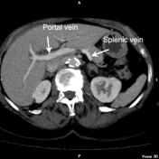

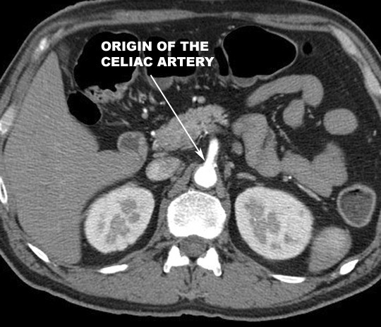
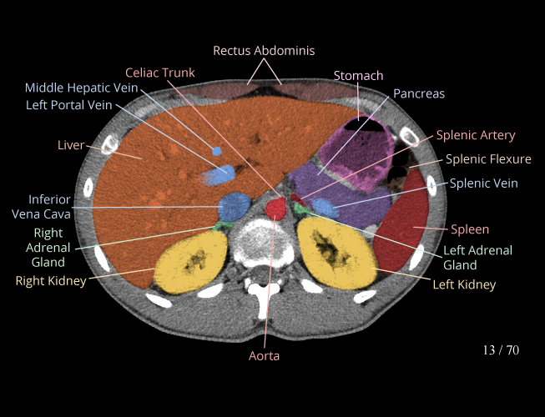

- Identify axial of costovertebral joint, axial scan (check exam image)
- Identify Thoracic spine in axial, look for rib attachment (check exam image)

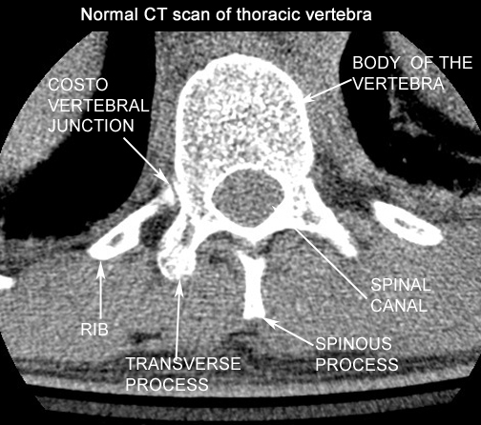
- At what vertebral level does the spinal cord terminate? L1

- Coronal scan - identify the occipital condyle (check exam image)
- Coronal scan - identify the lateral mass of C1 (check exam image)
- Coronal scan - identify the odontoid (dens) process of C2 (check exam image)
- Coronal scan - identify the body of C2 (check exam image)

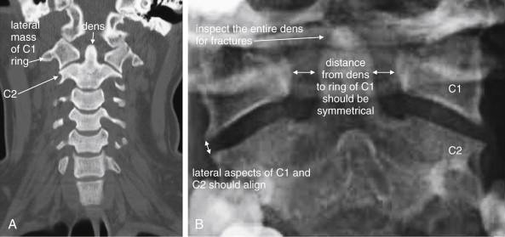
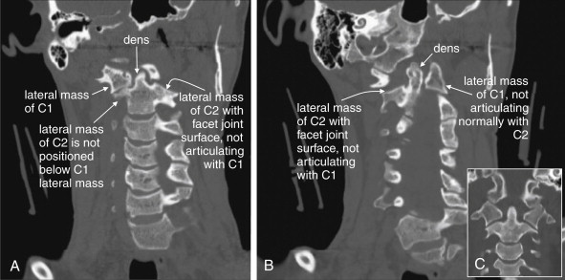

- CT imaging of musculoskeletal anatomy is useful to provide specific diagnostic information about: Bones
- What is the most common scout position(s) for a CT scan of an extremity? AP and Lateral
- Which of the following is an indication for an IV contrast-enhanced MSK scan? Tumors
- What anatomy should be included for a NECT wrist? Proximal to the radioulnar joint - proximal metacarpals
- Special care must be taken when annotating examinations of the upper extremity. True
- What is the contrast protocol for a routine, CECT Head? 100 ml at 1.0 ml/sec, 5 min scan delay
- What is the best window setting to view soft tissue structures of the brain? WW 160 WL 40
- Which salivary glands are very easy to spot on CT, due to the fact they contain fatty and lymph tissue? Parotid
- The common carotid arteries lie _______ to the internal jugular veins at the level of C6. Medial
- Which chest pathology would indicate a NECT Chest? Emphysema
- What is the technologist's role when a thoracic CTA for pulmonary embolism is ordered on a pregnant patient? Identify the risk and bring it to the attention of the radiologist

