Activity: Test 12 Collimator Light/X-ray Field Congruence and Perpendicularity Procedure

Purpose
This activity will help you identify the procedure steps for this test.

Instructions
- Review the images below of the equipment and materials used at Edenbrook for this test.
- Review the procedure steps from the Edenbrook MRT lab.
- Compare the textbook readings and your practicum site QA manual for similarities and differences.

Equipment
- Collimator alignment template
- Beam alignment test tool
- Calculator
- Level

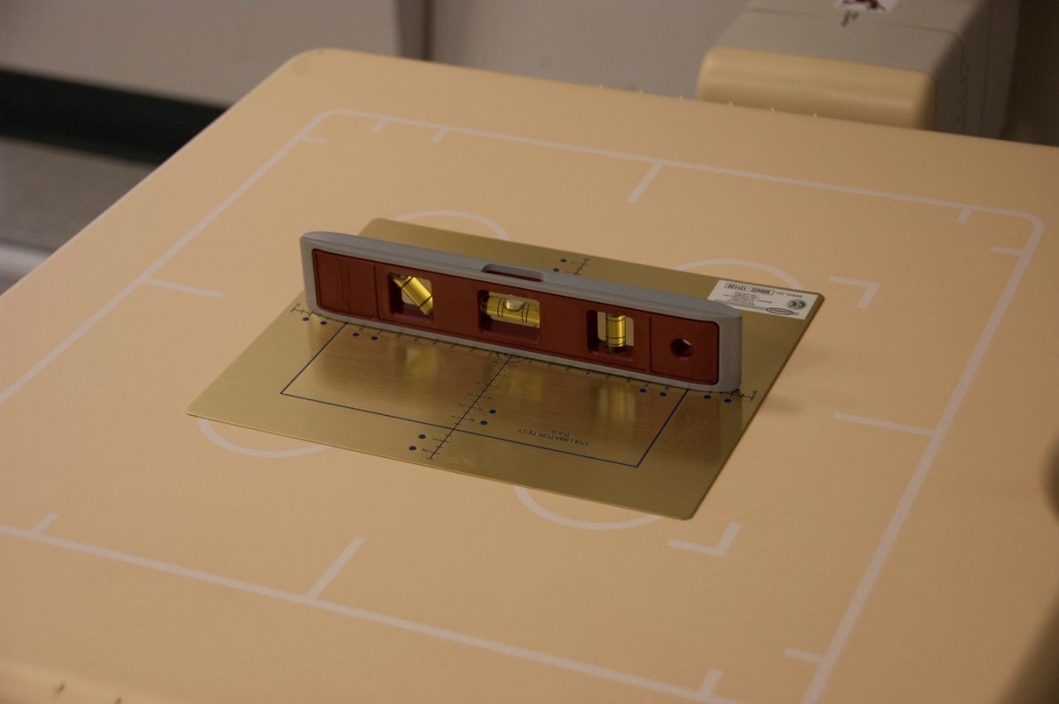

Edenbrook MRT Procedure Steps
- Using a 110 cm SID, centre the tube to the table detector.

- Place the collimator alignment template on top of the detector. The dot in the corner of the template should correspond to a patient’s right shoulder. The dot is used to determine the direction of collimator error.

- Use the carpenter level to ensure there is no angle on the tube and the template; this is critical to the accuracy of the results. Both the tube and template need to be checked with the level.

- Place the beam alignment tool in the centre of the collimator alignment template. Ensure the metal bead in the bottom of the cylinder is directly over the crosshairs of the template.

- Collimate carefully to the blue marker lines nearest to the centre of the template.

- Expose using 50 kVp and 4 mAs.

- Using the processing tools on the console, open the mask to visualize the edges of the collimation. On the image, measure the distance between the actual collimation and the blue marker lines on all four sides. Record the results.

- Observe the bead locations of the beam alignment test tool on your image. Determine the result based on the chart on the calculations page.

Questions
- What differences do you see from the textbook compared to the SAIT MRT procedure steps or equipment?

- Access your department’s quality control manual and compare the equipment and procedure to the SAIT MRT steps and equipment.

