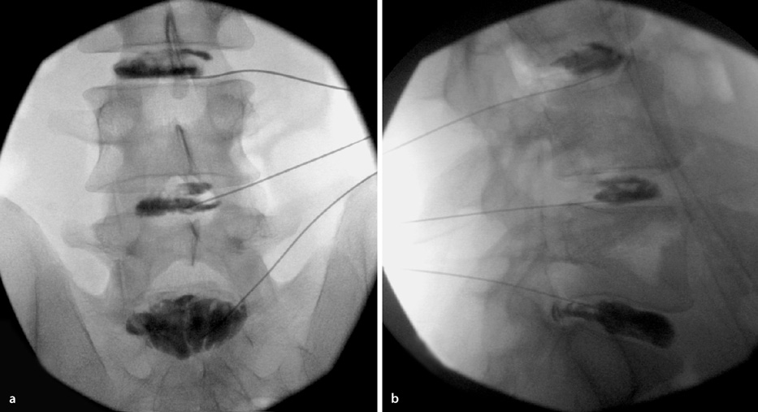
https://link.springer.com/referenceworkentry/10.1007%2F978-3-540-29805-2_2238

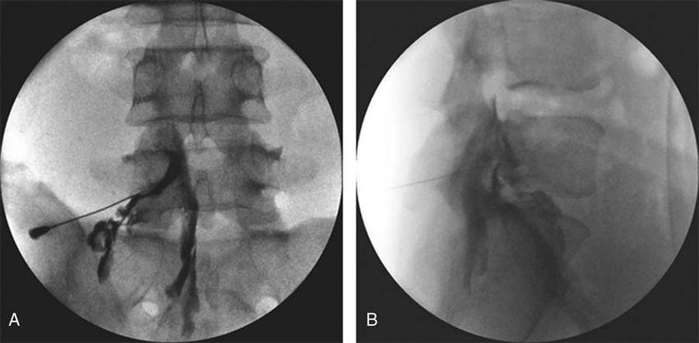
https://www.researchgate.net/
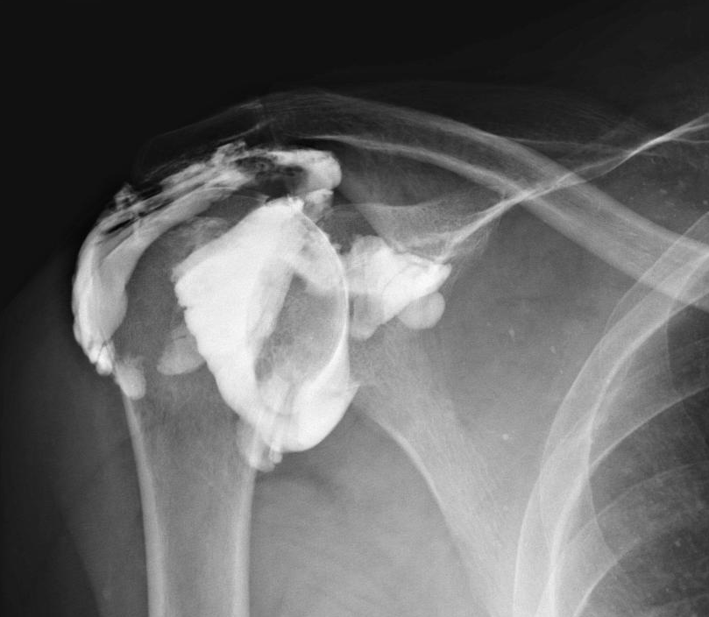
https://radiopaedia.org/cases

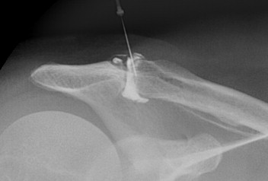
https://www.sciencedirect.com/science/article/abs/pii/S1058274614000433
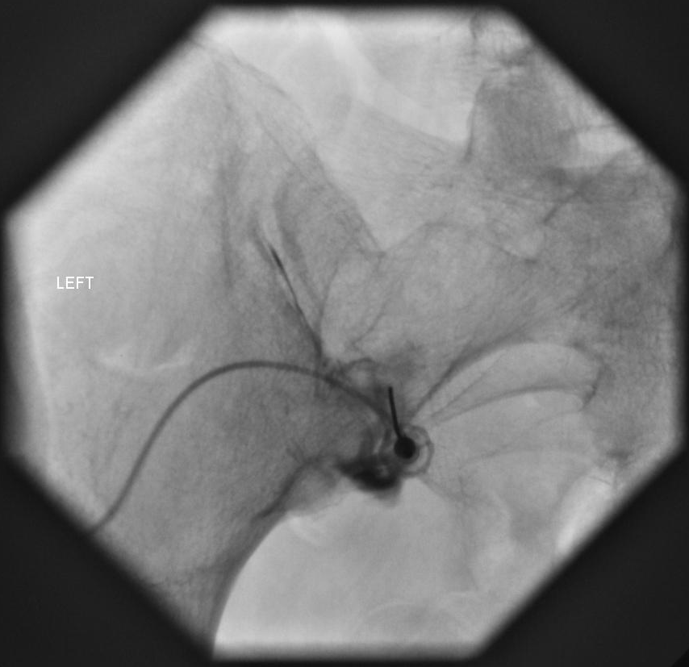
https://boneandspine.com/

