MRAD 240 – Specialized Imaging 1
Activity – Identify Control Buttons

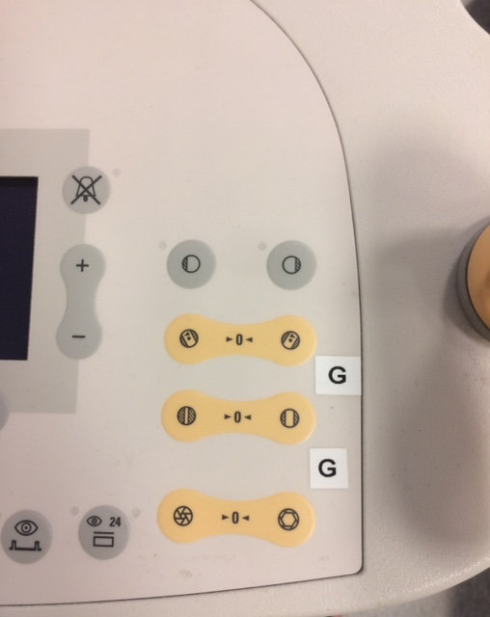
- What is the purpose of the button with symbol with an “X” through it?
- Do any of these buttons allow iris collimation?

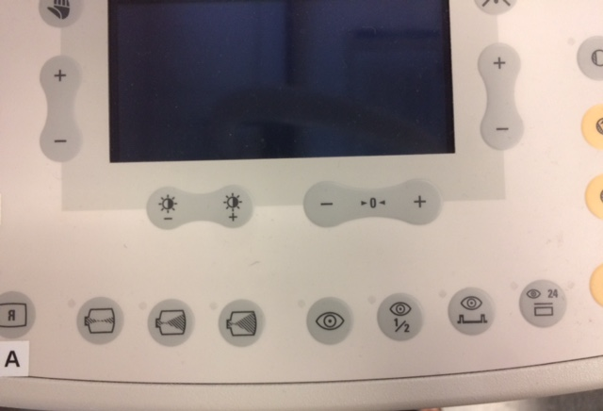

- Describe what the buttons with the “sun” icons would be used for.
- How many buttons look like an Image Intensifier and what do these buttons do?
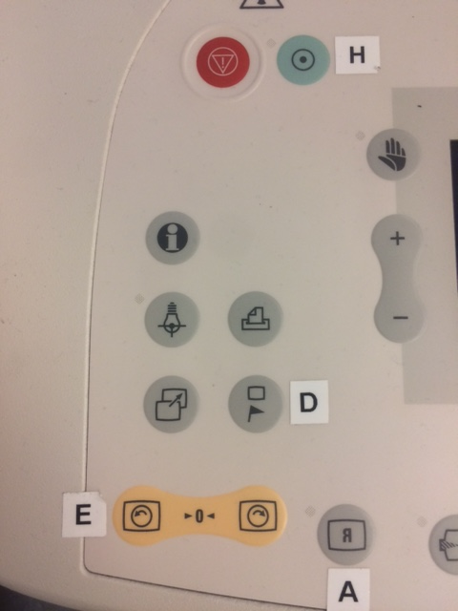
- What is the purpose of the button with the “letter H”?
- Which button reverses the image side to side?
- Which button moves the image from one monitor to another?
- What is the purpose of the button with the ‘letter D”?

