CR and DR Equipment

Learning Outcome:

Evaluate the performance of a computed radiographic (CR) system according to Safety Code 35 requirements.
Objectives 6.1-6.5

Evaluate the performance of a direct radiography (DR) system according to Safety Code 35 requirements.
Objectives 7.1-7.5

Readings:
Papp 6th Edition pg 172-178,182-192 Safety Code 35: pg 31-34, 42-47, 56
For a review on digital equipment, read Papp 6th Edition pg 163-174, 182-185
***Quality Control procedures may be site specific for the various types of digital systems and sites. For the purposes of this course, the focus will be on the textbook procedures and SC 35. ***

Quality Control of Digital Radiographic Imaging Systems
- Fewer variations in system performance with digital imaging than with film/screen systems
- However, there are other potential issues with the imaging chain to considered
  - Example: On hard copy images, if there is an error on the demographic label, it is simply corrected by replacing the label. In digital imaging, multiple copies of the image have been created, archived and transmitted – to make a correction requires more work, we must ensure that all copies of the image are corrected.
- There are three levels of system performance for QC and system maintenance
  - Routine
  - Full inspection
  - System adjustment
- There is no standard QC process that is used for all systems as manufacturers and sites will have various protocols. For the most part, QC technologists must follow manufacturer guidelines for specific procedures, but there are a few basic procedures common to all systems.

CR, DR and Imaging Plate (IP) care
  - CR cassettes and imaging plates are reusable and are used repeatedly, this is why it is important to inspect their condition regularly
  - Under normal use, dust, dirt, scratches and cracks may reduce image quality.
  - Dust and debris are undesirable as they can cause image artifacts
  - IPs can be cleaned with a dry cloth or a manufacturer approved cleaning solution (cannot be water based)
    - Cleaner cannot be poured directly onto IP as it may stain
  - IPs need to be inspected for:
    - hairline cracks, dirt, debris, and defects
  - IPs are sensitive to light. To reduce image noise, they should be erased if they have not been used recently
  - Possible causes of damage to IPs are:
    - Exposure to chemical agents (i.e. non-approved cleaners)
    - Handling with dirty or wet hands (i.e. lotion)
  - The exterior of the CR cassettes must be kept clean and can be cleaned regularly to ensure it is free of dirt, debris, body fluids and contrast media
  - CR cassettes can be cleaned with soap and water, or a non-aggressive cleaner
    - The inside must not come into contact with soap/water, as a soap residue may be left on the protective coating
  - Bar code labels must be inspected to ensure they are clean and not worn out
  - Additionally, hinges and latches on CR cassettes should be checked to ensure they are in good working condition
  - Image receptors used with DR must be kept clean and free of dirt, debris, body fluids and contrast media
  - Wireless DR cassettes need to be checked to ensure the internal battery is always charged before use
    - Batteries should also be checked to ensure they are holding charge sufficiently
  - Clean and inspect DR cassettes
  - For DR image receptors that are contained in a table/wall unit, inspect the top surface area for any scratches or debris that may cause artifact
    - Visually inspect condition of the cables and wires
    - Thorough cleaning of a DR image receptor should be performed by a qualified service technician.
  - The SC 35 recommends using a logbook to document the physical conditions of all IPs and CR cassettes
  - Frequency of cleaning is dependent on patient volume, plate handling and how often artifacts are noticed
  - In generally, the recommendation is a weekly visual inspection for dust and dirt, monthly cleaning for IPs

Display Monitor care
  - Testing depends on the type of monitor: CRT, LCD
  - Radiologists primarily read and diagnose using soft copy images on monitors rather than hard copy film images
  - Monitors can be used up to 24 hours a day, 7 days a week
  - Cleaning
    - CRT monitors attract dirt and dust because of electrostatic attraction
    - Many monitors also use touch-screen technology, which can cause dirt to build up
    - LCD screens are less likely to attract dirt and debris, but should still be inspected
    - LCD screens must be cleaned very carefully to prevent damage to the plastic face and LCD crystals beneath
    - For all monitors, manufacturer guidelines must be followed closely
  - Potential issues that may occur with CRT monitors are:
    - Monitors can lose focus over time, lose image brightness and contrast
    - When comparing variability of digital image display quality, CRT is the weakest link – less variation in quality with LCD displays
  - Potential issues that may occur with LCD displays are:
    - Limited viewing angles – for best accuracy, must view the monitor from straight on, not off to the side
    - Requires replacement of the light source (approximately every 30000 hours)

Testing systems with Phantom Image Testing
  - Phantom images can be used to assess several qualities of CR and DR systems
    - It is recommended for this testing to be performed on acceptance, as those results may be used as a baseline
    - Follow up testing may be performed monthly or as required
  - The acceptance criteria may vary as per manufacturer of the system or test tool, but common tests that can be performed are:
    - Relative sensitivity test
      - This is used to test whether the CR or DR sensitivity is consistent with the baseline
      - Sensitivity is directly linked to patient dose
      - This same test can also provide information on the x-ray generator, specifically reproducibility of exposure and output
      - When the same exposure is taken, the CR or DR system should display a consistent exposure indicator
        - Acceptance limits will be defined by the manufacturer
    - Shading or uniformity test
      - Evaluation to ensure that the brightness is uniform across the entire IR

      - Also confirms the CR readers light guide position, if the laser is not performing uniformly, low contrast light and dark bands may appear
    - Contrast evaluation
      - Evaluate the contrast resolution capabilities of the image processor, workstation monitors and hard copy printers
    - Spatial accuracy
      - Evaluate the spatial resolution capabilities (sharpness of the image) of the DR array, CR reader optics, x-ray tube and hard copy printer
      - Phantom should have a wire mesh pattern
      - Can also demonstrate if the CR/DR system is presenting images with the correct geometric relationships
    - Laser jitter test
      - Evaluates the horizontal and vertical movement of the laser optic and transport systems of the CR reader and printer
    - Image noise test
      - Evaluates the image for noise or artifacts and monitor degradation
    - Accuracy of measurement tools
      - Evaluates the accuracy of workstation measurement tools and printer software
    - System linearity test
      - Measures linearity of CR/DR system
      - This is important for patient dose
      - If exposures are increased in 10% increments of mR, the exposure indicator should track accordingly
    - Spatial resolution test
      - Test tool should have a spatial frequency pattern in lp/mm
      - There should be no variance over time

- If test tool/phantom is unavailable, these are other methods to test CR/DR systems
  - Uniformity
    - Use a long SID (72” or 180 cm) and an exposure of 80 kVp and enough mAs to produce about 10mR of exposure on the IR
    - Process the CR cassette and examine the image for uniformity
      - Can print it and take optical density readings across the image
      - Can also use ROI to check brightness at various points throughout image
    - DR systems, the acceptance testing needs to include the number and location of bad pixels, data that should be tracked is the development of new bad pixels over time

  - Spatial accuracy
    - can use the wire mesh test tool (also used for film/screen contact)
    - place the test tool on a CR or DR image receptor and take an exposure (use 180 cm SID, 60 kVp, and enough mAs for about 5 mR of exposure on IR)
    - after processing, it should appear uniform, with no geometric distortions
      - if distortions appear, inspect the CR plate or DR array for any defects
      - if distortions appear across multiple plates, the cause is likely the laser in the CR reader, not the CR plate
  - Erasure test (CR)
    - This evaluates the ability of the sodium discharge lamp in a CR system to completely erase previous exposure data from the IP
      - If the previous exposure is not completely erased, this can result in ghosting artifacts on subsequent exposures
      - This is especially evident on images with extreme overexposure
    - Using an extremity phantom, take an extremely overexposed image
    - After processing, verify that the image is completely erased from the plate
      - Can do this by processing the cassette immediately after, to see if there is any residual exposure remaining on the plate
  - Laser function
    - Use a metal ruler, place it perpendicular to the laser scan lines
    - Take an exposure using 180 cm SID, 80 kVp and mAs for about 5 mR of exposure on IR
    - After processing the image, the edges of the ruler should appear as straight lines
      - If not, this could indicate an issue with the laser in the reader, service should be called
  - Wireless transmission integrity (wireless DR systems)
    - Take an exposure of a phantom on a wireless DR and view it on the monitor to ensure the wireless signal was received without issue
    - Important to ensure there is no signal interference or corruption between different systems when they are on the same wireless network
    - Signal must also be encrypted appropriately to maintain privacy of patient information standards
    - There should also be a procedure for loss prevention and image recovery for images that are interrupted or corrupted during transmission
  - In addition to these tests, the exposure indicator system must also be tested, typically by the physicist
    - Calibration – to determine if the manufacturer’s indicator value is consistent with the radiation exposure to the IR
    - Accuracy – can be assessed by using a dosimeter to record exposure to IRs

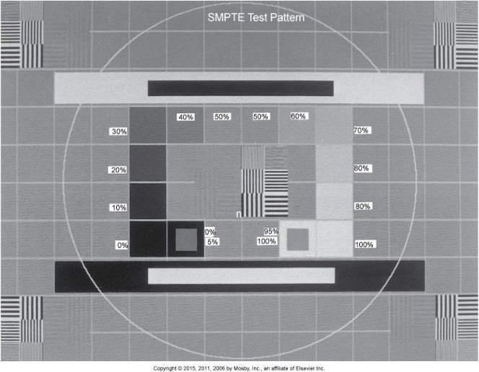
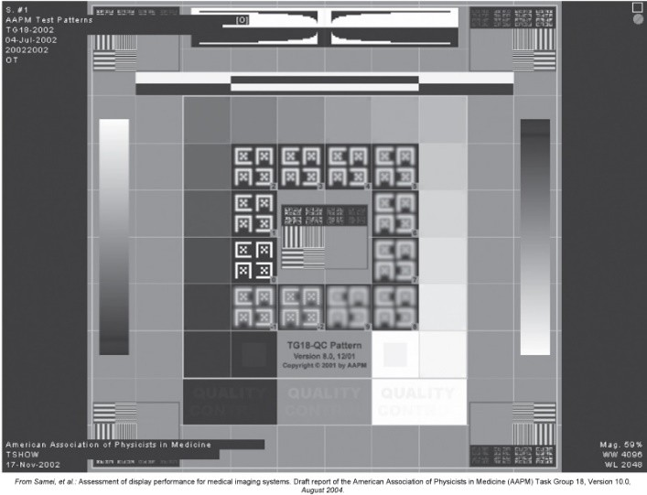
Papp Fig 8-29
Papp Fig 8-28

QC of Electronic Display Devices
  - This is a critical component for testing as the display devices are responsible for image display in all modalities of digital imaging
  - To date, there has not been complete agreement or endorsement of one specific set of recommendations for QC guidelines
    - Medical physicists and radiologists should be consulted to set the performance standards at each site until universal standards are set
  - General recommendations are that display devices should be operated between 0-40°C with a relative humidity range 10-70%.
  - LCD monitors are more sensitive to temperature fluctuations
  - General daily testing parameters should include:
    - Turning on the monitor, and following the start-up procedure
      - CRT monitors need a minimum of 30 min to warm up
      - Set the display window level/width to the specifications of the test pattern manufacturer
    - Clean the front screen with manufacturer approved methods
    - Take an image of a test pattern (SMPTE or AAPM TG18-QC) according to specifications

      - Geometric distortion
        - All lines and borders in the test pattern are visible, straight and centered
      - General image quality and appearance
        - Evaluate image for any areas of non-uniformity or artifacts
      - Luminance
        - Verification that all 16 luminance patches are visualized

        - of significant importance that the 5% patch can be distinguished from the 0/5% patch, and that the 95% patch can be distinguished from the 95/100% patch
      - Resolution
        - Verification that all numbers and letters can be visualized
      - Ambient light
        - Illuminance measurement in the area where primary reading occurs, ensure it does not exceed parameters

  - Monthly/annual testing is a bit more involved, and will generally test for the following.

Maximum Luminance (Luminance response)
      - The purpose of this test is to assess the relationship between displayed luminance (from results during testing) and the input values of a standardized display system (brightness from test pattern).
      - Luminance measurements will be taken with a photometer at different areas of the test pattern as displayed on the monitor
      - AAPM TG-18 LN pattern and photometer method
        - Luminance measurements as taken at the center of the monitor and must meet a specified criteria.
        - Papp states:
          - Variance from previous tests should be <10%
          - If multiple monitors are used, the variance between them should be less than 10%
        - Monitor brightness controls can be readjusted if the luminance is out of limits





TG18-LN01

TG18-LN08

TG18-LN18
Papp Fig 8-30 to 8-32

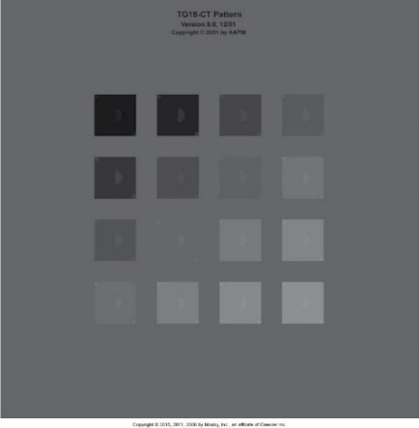
      - If a photometer is unavailable, testing can be performed with the AAPM TG18-CT test pattern
AAPM TG18-CT Papp Fig 8-33
        - On this pattern, evaluate the visibility of the central half- moon targets and the four low-contrast objects at the corners of each of 16 different luminance regions
        - Evaluation of the patterns should be done from a distance of about 30 cm
        - Low contrast targets in all 16 regions should be visualized
          - If an area fails, usually it is in the darker regions


        - AAPM TG18-MP test pattern can be used to evaluate bit depth resolution – the quantity of grayscales that can be displayed at the same time
AAPM TG18-MP Papp Fig 8-34
- There should be no contrast reversal (bright spots in dark areas, and vice versa)
- The luminance levels should not be further than the distance between the 8-bit markers

Contrast Ratio
      - Luminance readings are also used to assess the contrast ratio of the monitor
      - A measurement is taken of the minimum black level (TG18-LN01) and the maximum white level (TG18-LN18) displayed on the monitor.
      - Contrast ratio: ratio of the max white level to the min. black level
        - According to Papp, it should be > than 250 for primary monitors, and >100 for secondary monitors
      - The values will be similar to the straight line portion in film/screen imaging, where most of the diagnostically useful densities are found between 0.1-2.5 OD

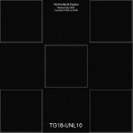
Luminance Uniformity
AAPM TG18-UNL10 Fig 8-35
      - This refers to whether brightness is uniform across the entire screen – this is done by comparing luminance values of the center and edges of the screen
      - In CRT displays, it is common for luminance to decrease from the center to the edges, due to the shape of the screen
      - Non uniformity is less pronounced in LCD displays, but still needs to be evaluated
        - Luminance readings should be within 20% of each other
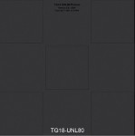
        - If not, the monitor controls can be adjusted, or the physicist/engineer must be called
      - Without a photometer, this test can be done by visually evaluating the TG18-UNL10 and TG18-UNL80 test patterns
        - On viewing, there should not be any areas of gross non- uniformity or variances larger than 1 cm.

Workstation Monitor Uniformity
      - Value is determined with TG18-LN 18 test pattern, each workstation monitor will have the brightness measured in the center of the monitor with a photometer
AAPM TG18-UNL80 Fig 8-36
- There should not be more than 10% variance between monitors

Luminance Dependencies
      - This refers to the luminance response previously mentioned, but luminance dependency is more specifically evaluating how luminance can vary when the viewing angle of the observer and the center of the display is changed
      - Angular dependence is how bright the image appears from various viewing angles. Ideally there should be no variation in luminance when the viewing angle is changed
        - With LCD monitors, there is often severe variation due to viewing angle changes
      - To evaluate angular dependence:
        - Use the TG18-CT test pattern (half-moon patterns)
        - Begin by viewing the test pattern straight on, and determine how visible the half-moon targets are
        - Then move to the right and left of center to determine when the patterns disappear.
          - With CRT and plasma displays, the patterns are not likely to disappear, but will with LCD displays
          - Any viewing angle limits should be clearly labeled on the front of the monitor

Spatial or Geometric distortion
      - To assess if there is any distortion displayed on the screen
      - Evaluated with the SMPTE or AAPM TG18-QC pattern
        - The squares should appear perfect over the entire screen and should not show any pincushion or barrel distortion
        - Can also use a ruler to measure the height/width of each square
          - Should be done in the center and all quadrants

Spatial Resolution
      - Viewing high contrast images and evaluating if it is well defined
      - If utilizing a test tool, examine the pattern at the center and at the four corners of the image using a magnifying glass
        - Note any differences in the visibility of the test pattern
      - CRT displays may have less resolution at the edges

Low Contrast Resolution
      - Using the SMPTE or AAPM TG18-QC pattern
        - Evaluate visibility of the 5% contrast patches in the 100% and 0% squares
        - Perceived contrast between the 5% square and the 0% surrounding should be equal to the 95% square and a white square

Grayscale Uniformity
      - Using the SMPTE or AAPM TG18-QC pattern
        - Evaluate the image to see if the gray background of the pattern is uniformly gray over the entire display

Display Artifacts
      - There should not be any streaks, lines or dark/light patches
      - Make note of any small black dots – these indicate nonfunctioning pixels

Display Reflection
      - To verify that the light emitted from the display surface is generated by the display, and not from any reflected light.
        - Typically antireflective coatings on the surface of the display, and reducing ambient light while viewing should reduce reflections
      - More common with CRT, rarely with LCD monitors

      - Reflection occurs in two forms:
        - Specular
          - Mirror image of the light source creating it
        - Diffuse
          - Uniform luminance of the display with no pattern of the source creating it
      - This can be evaluated by turning the monitor off, and observing the display to see if there are any reflected light sources or objects visualized (i.e. reflection of bright clothing or white lab coats) – this is specular reflection
        - If reflection is noted, turn down the ambient lighting, and re-evaluate
      - Testing for diffuse reflection requires the TG18-AD test pattern
        - Observe it in both total darkness and normal lighting levels
        - The low contrast pattern should appear the same in both lighting conditions
          - If the pattern is not visible in normal lighting, the ambient light must be reduced as it is causing a reduction in contrast on the image.

Display Noise (annual)
      - Evaluated with the TG18-AFC test pattern
      - Four quadrants, each quadrant had 48 squares, each square has random low contrast dots within it. The size of the dots is constant, but the values are different for each quadrant.
        - On a primary monitor, the viewer should be able to determine the location of all the dots in at least 3 of the quadrants
        - For a secondary monitor, at least 2 quadrants

Display Chromaticity (annual)
      - The color tint of LCD monitors can be affected by the backlight and viewing angle
      - Workstations with multiple monitors should be matched for tint at the factory and sold in sets
      - To test this, display the TG18-UN80 test pattern on the grayscale monitors, note any differences in the relative color uniformity across the display area and between the monitors of the workstation
      - Viewing must be done straight on, no angled viewing as this will affect the accuracy of the evaluation

