Activity: Test 13 Half Value Layer Procedure

Purpose
This activity will help you identify the procedure steps for this test.

Instructions
- Review the images below of the equipment and materials used at Edenbrook for this test.
- Review the procedure steps from the Edenbrook MRT lab.
- Compare this procedure, the textbook reading and your practicum site QA manual for similarities and differences between a C-arm and dedicated fluoroscopy unit.

Equipment
- Set of aluminum filters ranging from 0.1 mm to 2.0 mm in thickness
- Dosimeter
- Lead sheets
- Tape
- Ruler

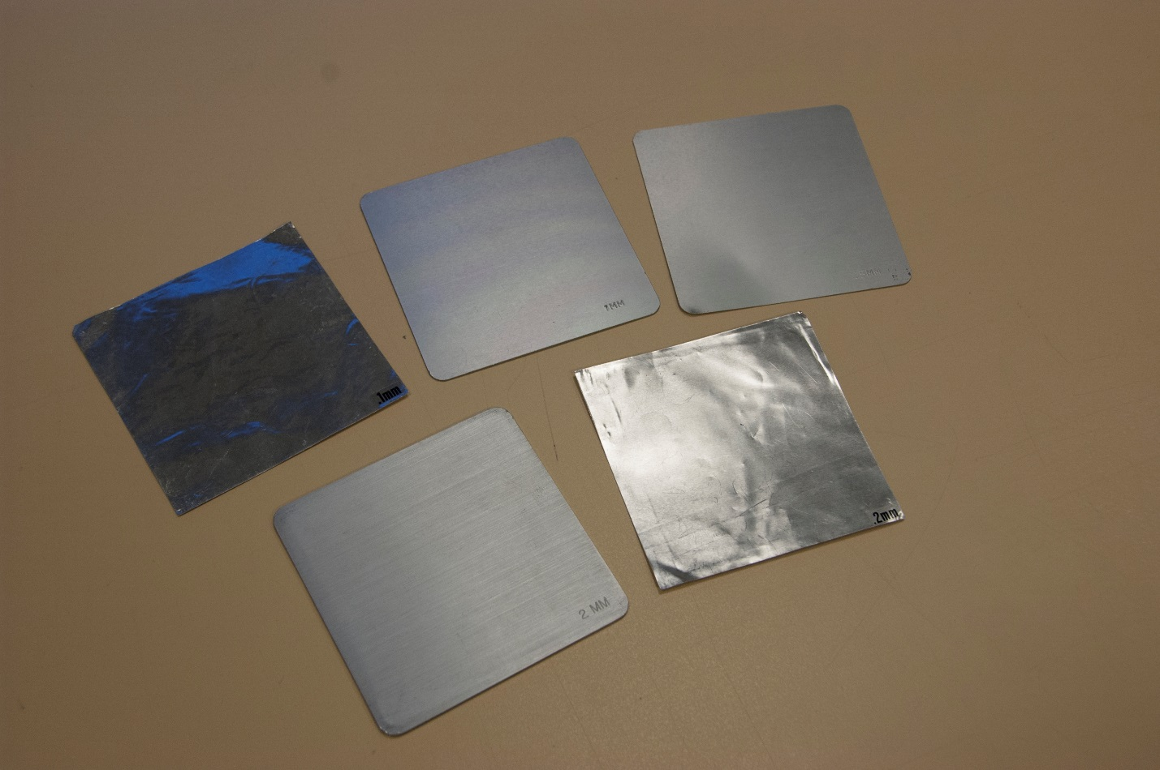

Edenbrook MRT Procedure Steps
- Place the dosimeter on the X-ray table with the lead sheet beneath it to reduce the effects of backscatter.

- Using a 110 SID, centre to the dosimeter and collimate appropriately to include the entire chamber.

- Set the kVp to 80 and mAs to 50. The first exposure is with no added aluminum. Record the results in a chart (see example below).

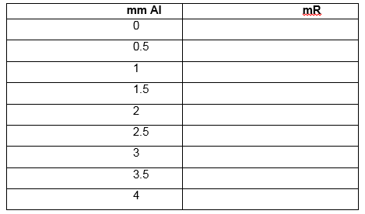

- Select the appropriate thickness of aluminum specified in the data table and tape it to the collimator. Complete the remaining exposures and record the results.

- Plot the results onto the graph (example below), and draw a “best fit” line for the data points.



