MRAD 358 – Clinical Integration 1
Pathology Review – Questions 1-19

- Name the pathology in the image. Is this pathology malignant or benign?
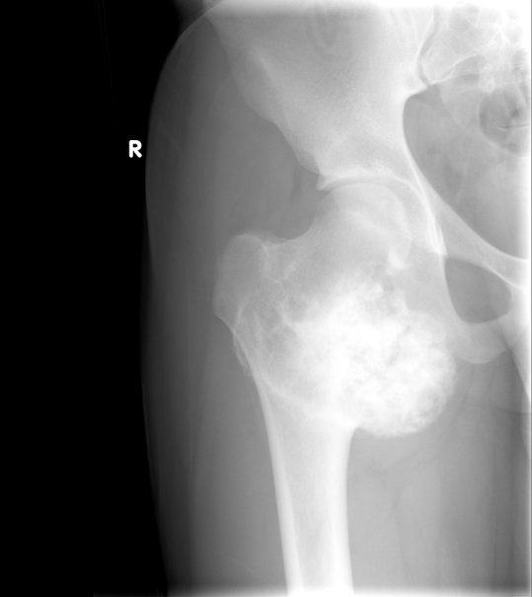

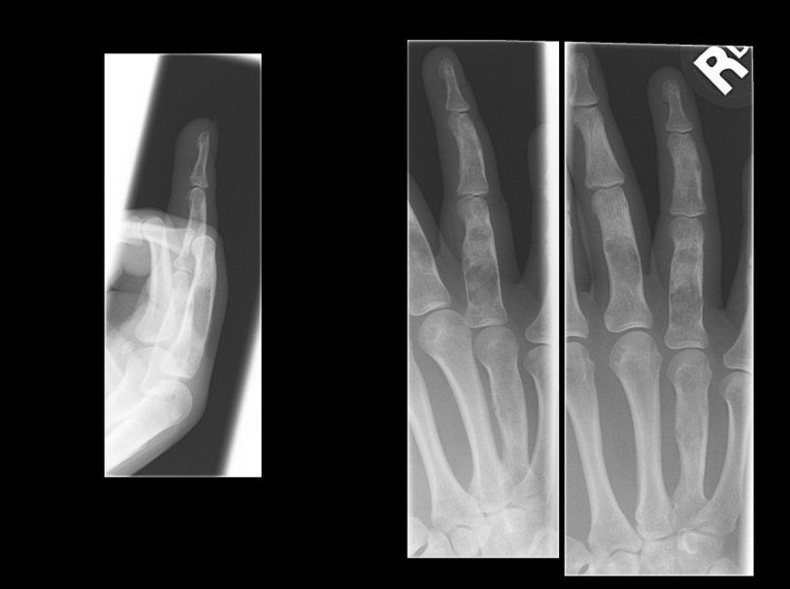
- Name the pathology in the images. Is this pathology malignant or benign?

- Define atelectasis and describe its etiology.

- Why do inhaled foreign bodies tend to occur more frequently in the right lower lung?

- List some congenital respiratory pathologies.

- What are some disease processes that contribute to COPD?

- What pathology is shown in the image?
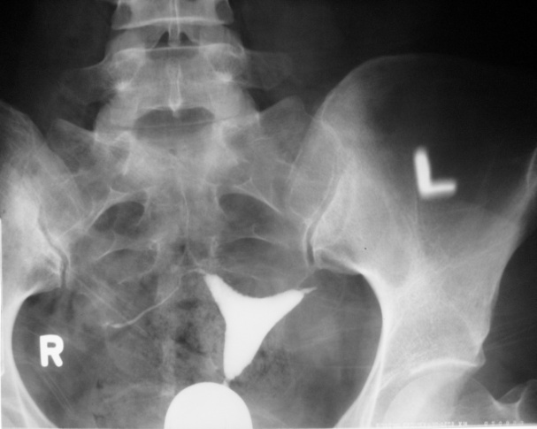

- Describe the radiographic projection used to demonstrate an imperforate anus.

- How would you adjust your radiographic technique for the following pathologies?
  - Ascites –
  - Bowel obstruction –
  - Cirrhosis –

- Describe the radiographic signs of Crohn’s disease?

- Name the pathology in the image.
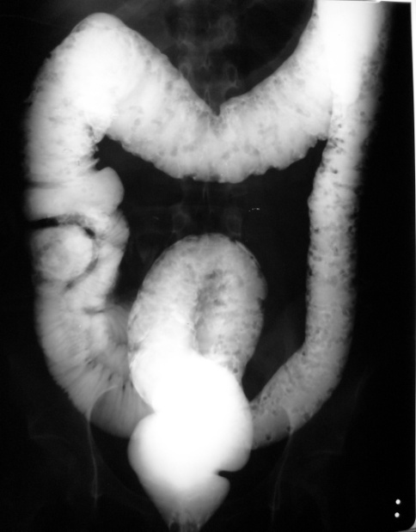

- What four anatomical abnormalities characterize the Tetralogy of Fallot?
1.
2.
3.
4.
- Why is a chest x-ray taken on a patient who has had an MI?

- Describe the difference between thrombus and embolus.

- What are some predisposing factors for a CVA?

- What is a “goiter”?

- What are the signs and symptoms of Cushing’s syndrome?

- What would the following hematomas look like on a CT image?

Intracerebral hematoma –

Subdural hematoma –

Epidural hematoma –

Subarachnoid hemorrhage –

- For the images below, state whether the hematoma is intracerebral, subdural or epidural. (Note: images are from the Evolve website and can also be found at the following link: https://evolve.elsevier.com/staticPages/s_index.html )
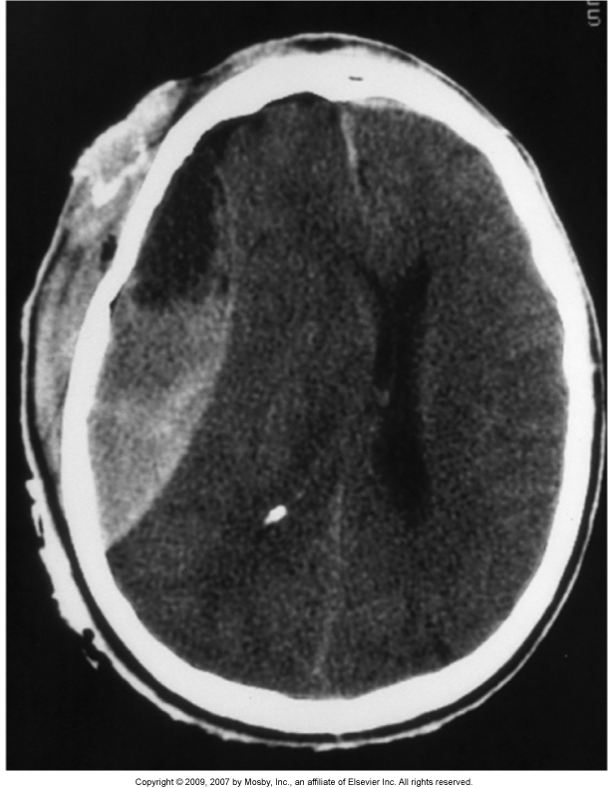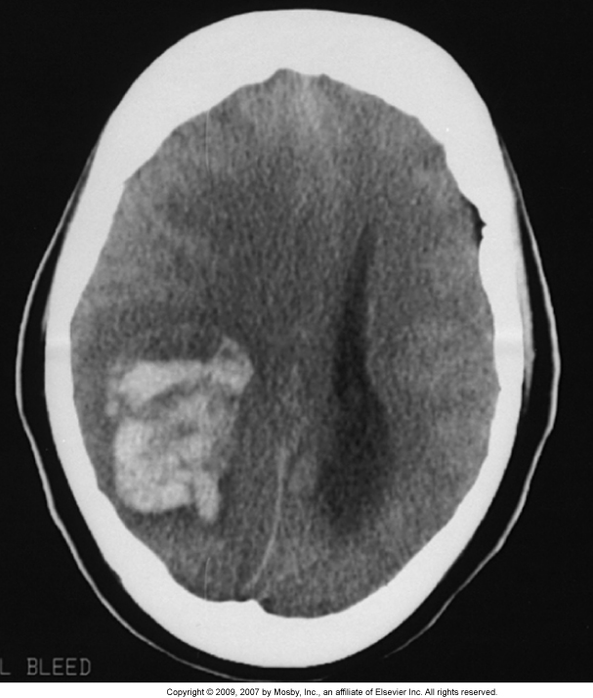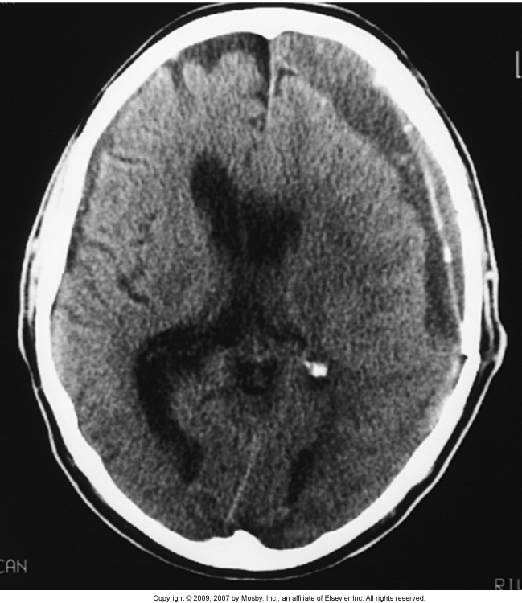
Image 1 Image 2 Image 3
Answer : ________________ ___________________ _________________

