Image Critique Questions

Module 10
- Use the image below to answer the next five questions:

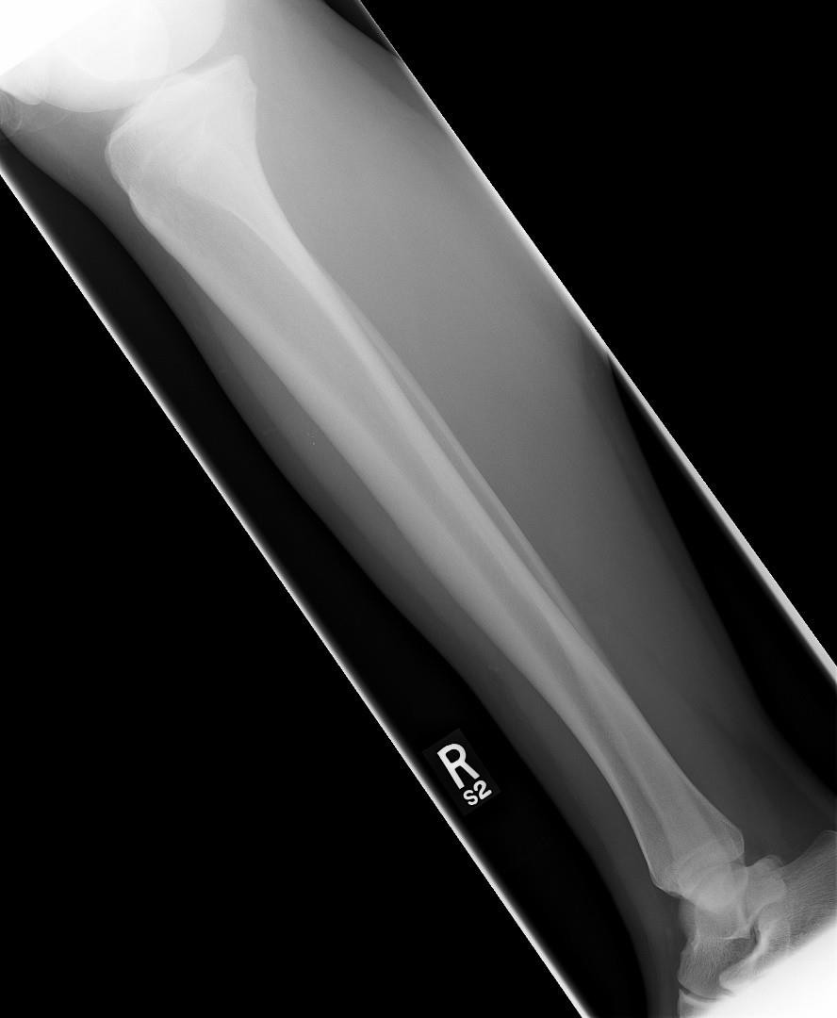
@ 70 kVp
- Which routine projection of the tibia & fibula (aka. lower leg) is displayed?

- What positioning error(s) occurred?

- If the image was repeated, how would you correct the positioning error(s)?

- How did you identify the positioning error(s)?

- If the image had to be repeated, would you make any other adjustment(s)? Explain your rationale.

- Use the 5 evaluation criteria categories when critiquing the following image to determine if it is diagnostic:

- Is all the required anatomy included in the radiograph? Yes No
*If no, explain what is required

- Does the anatomical appearance in the radiograph correlate to what is expected from an AP projection?
Yes  No
*If no, explain how the appearance of
this radiograph is different compared to the ideal radiograph
AP Tib/Fib @ 70 kVp

- Identify if the appropriate amount of radiation was used to form the image.
Acceptable, Overexposed, Underexposed
  - Is motion present in the image?
Yes No
- Identify if the collimated light field was:
Acceptable, Too Small, Too Large
  - Was the CR close to the middle of the required anatomy?
Yes No

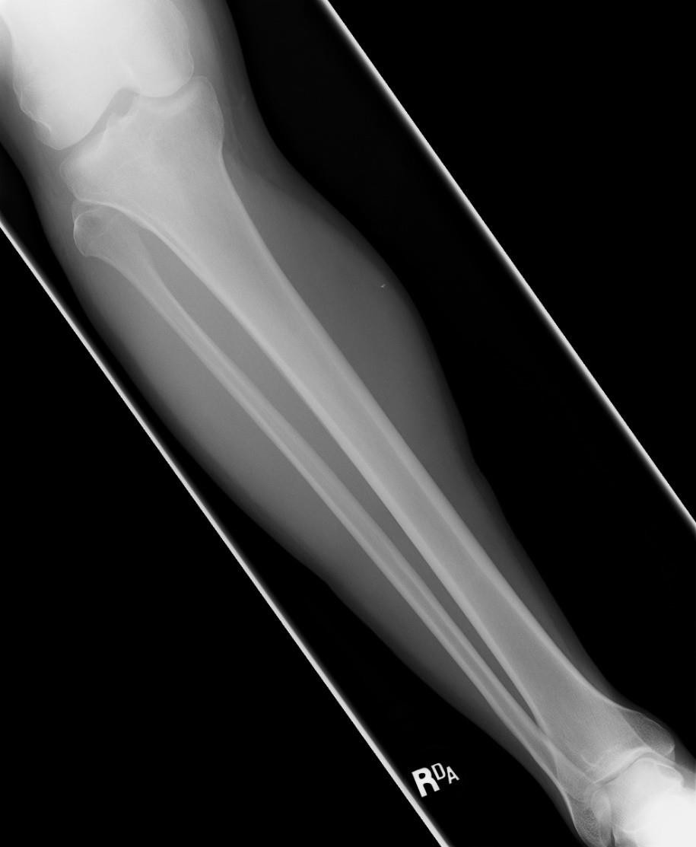
EDENBROOK Imaging library

Is this image diagnostic? Yes No

- Does the marker placement follow Edenbrook's Marker Rules?
Yes No
  - Are there artifacts in the image?
Yes No
*If yes, could they have been removed?

- Use the 5 evaluation criteria categories when critiquing the following image to determine if it is diagnostic:

PA IC Fossa @ 70 kVp

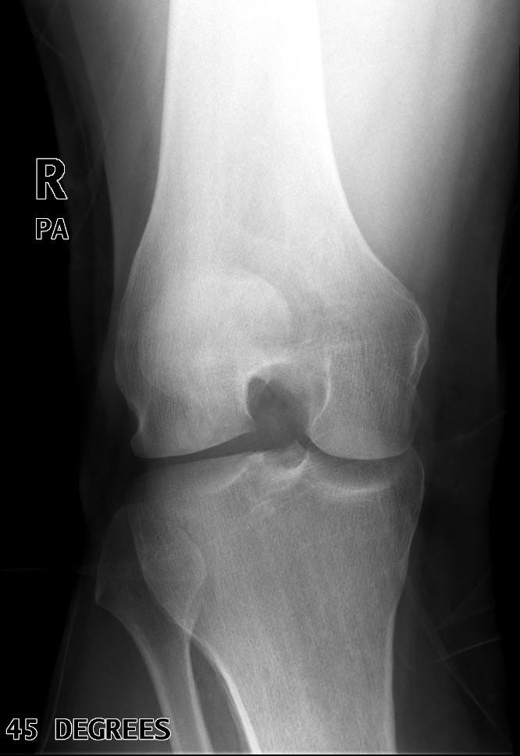
EDENBROOK Imaging library

    - Is all the required anatomy included in the radiograph? Yes No
*If no, explain what is required

    - Does the anatomical appearance in the radiograph correlate to what is expected from a PA axial projection?
Yes No
*If no, explain how the appearance of this radiograph is different compared to the ideal radiograph

    - Identify if the appropriate amount of radiation was used to form the image.
Acceptable, Overexposed, Underexposed
      - Is motion present in the image? Yes No

Is this image diagnostic? Yes No

    - Identify if the collimated light field was: Acceptable, Too Small, Too Large
      - Was the CR close to the middle of the required anatomy? Yes No

    - Does the marker placement follow Edenbrook's Marker Rules? YesNo
      - Are there artifacts in the image? YesNo
*If yes, could they have been removed?

- Use the 5 evaluation criteria categories when critiquing the following image to determine if it is diagnostic:
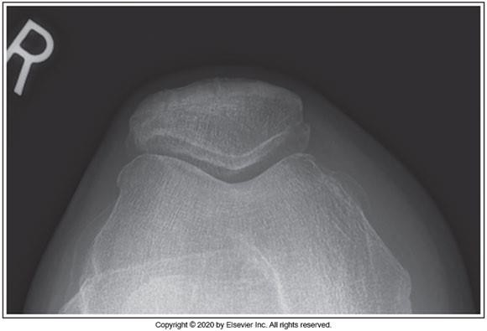
Seated Settegast @ 80 kVp
McQuillen Martensen 5th Ed. pg. 411 Fig. 6.43
Is this image diagnostic? Yes No
  - Is all the required anatomy included in the radiograph? Yes No
*If no, explain what is required

  - Does the anatomical appearance in the radiograph correlate to what is expected from a tangential skyline patella projection?
Yes No
*If no, explain how the appearance of this radiograph is different compared to the ideal
radiograph

  - Identify if the appropriate amount of radiation was used to form the image. Acceptable, Overexposed,Underexposed
    - Is motion present in the image? YesNo

  - Identify if the collimated light field was: Acceptable, Too Small, Too Large
    - Was the CR close to the middle of the required anatomy? Yes No

  - Does the marker placement follow Edenbrook's Marker Rules? YesNo
    - Are there artifacts in the image? Yes No
*If yes, could they have been removed?

