Image Critique Questions

Module 11

- Use the 5 evaluation criteria categories when critiquing the following image to determine if it
is diagnostic:

AP Ankle @ 80 kVp
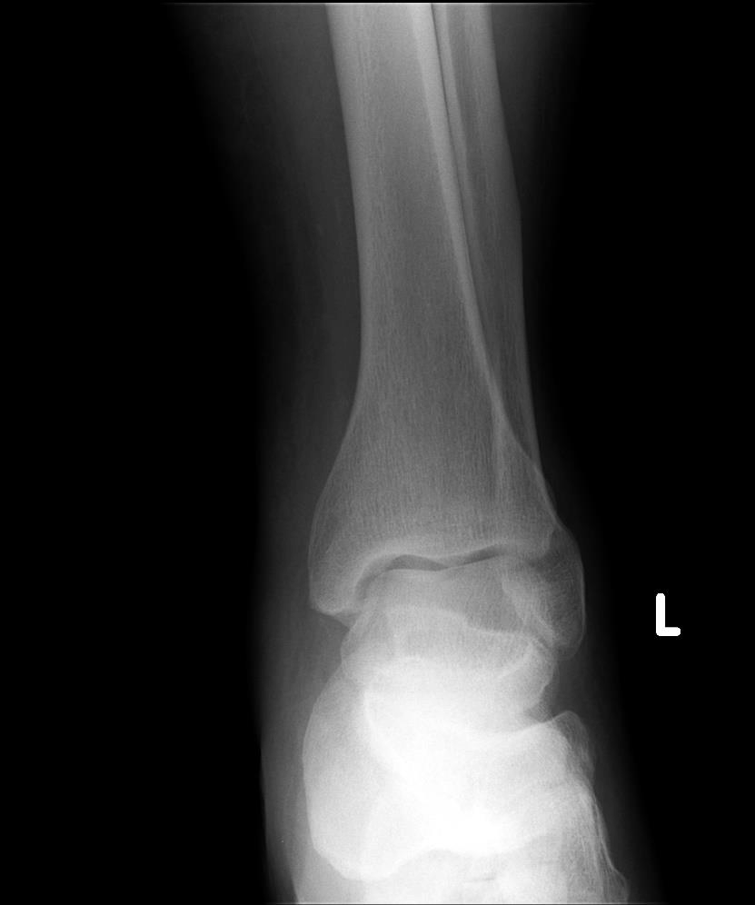
EDENBROOK Imaging library

- Is all the required anatomy included in the radiograph? Yes No
*If no, explain what is required

- Does the anatomical appearance in the radiograph correlate to what is expected from a Routine AP projection?
Yes No
*If no, explain how the appearance of this radiograph is different compared to the ideal radiograph

- Identify if the appropriate amount of radiation was used to form the image. Acceptable, Overexposed, Underexposed
  - Is motion present in the image? Yes No

Is this image diagnostic? Yes No

- Identify if the collimated light field was: Acceptable, Too Small, Too Large
  - Was the CR close to the middle of the required anatomy? Yes No

- Does the marker placement follow Edenbrook's Marker Rules? Yes No
  - Are there artifacts in the image? Yes No
*If yes, could they have been removed?

- Use the image below to answer the next five questions:

- Which routine projection of the ankle is displayed?

- What positioning error(s) occurred?

- If the image was repeated, how would you correct the positioning error(s)?

- How did you identify the positioning error(s)?
75 kVp
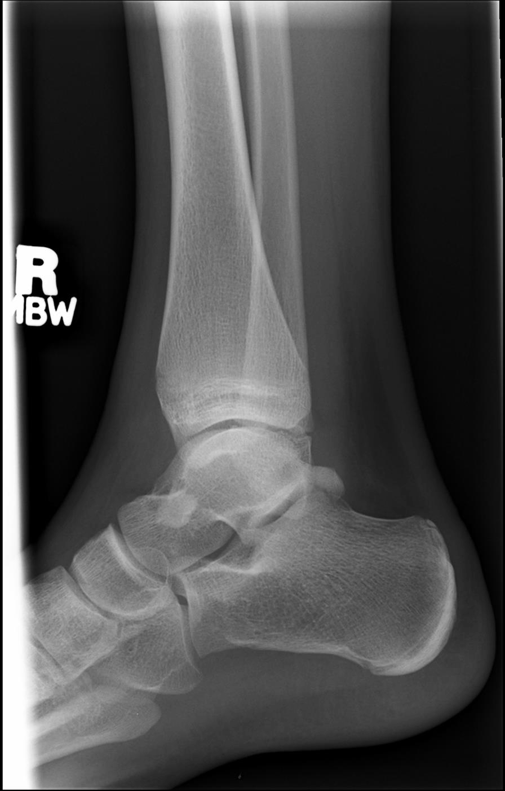
EDENBROOK Imaging library

- If the image had to be repeated, would you make any other adjustment(s)? Explain your rationale.

- Use the 5 evaluation criteria categories when critiquing the following image to determine if it is diagnostic:
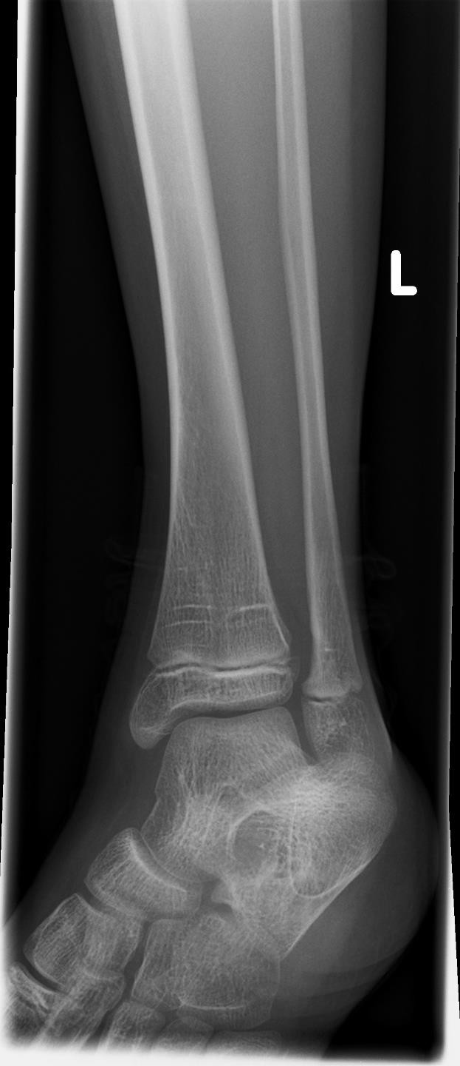
AP Mortise @ 70 kVp
  - Is all the required anatomy included in the radiograph? Yes No
*If no, explain what is required

  - Does the anatomical appearance in the radiograph correlate to what is expected from an AP Mortise projection?
Yes No
*If no, explain how the appearance of this radiograph is different compared to the ideal radiograph

  - Identify if the appropriate amount of radiation was used to form the image.
Acceptable, Overexposed, Underexposed
    - Is motion present in the image? Yes No

  - Identify if the collimated light field was: Acceptable, Too Small, Too Large
    - Was the CR close to the middle of the required anatomy? Yes No

EDENBROOK Imaging library

Is this image diagnostic? Yes No

  - Does the marker placement follow Edenbrook's Marker Rules? Yes No
    - Are there artifacts in the image? Yes No
*If yes, could they have been removed?

- Use the 5 evaluation criteria categories when critiquing the following image to determine if it is diagnostic:
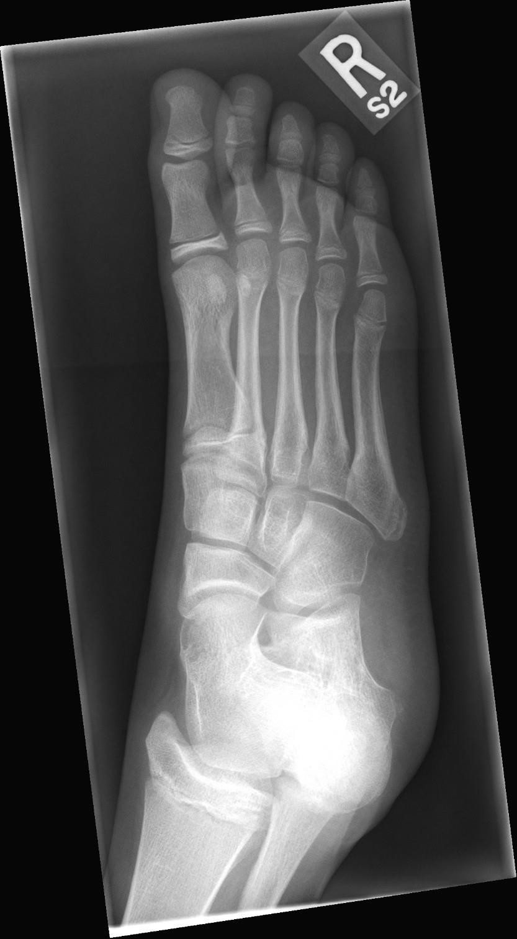
AP Oblique Foot @ 60 kVp
- Is all the required anatomy included in the radiograph? Yes No
*If no, explain what is required

- Does the anatomical appearance in the radiograph correlate to what is expected from a Routine AP oblique projection?
Yes No
*If no, explain how the appearance of this radiograph is different compared to the ideal radiograph

- Identify if the appropriate amount of radiation was used to form the image. Acceptable, Overexposed, Underexposed
  - Is motion present in the image? Yes No

- Identify if the collimated light field was: Acceptable, Too Small, Too Large
  - Was the CR close to the middle of the required anatomy? Yes No

EDENBROOK Imaging library

Is this image diagnostic? Yes No
- Does the marker placement follow Edenbrook’s Marker Rules? Yes No
  - Are there artifacts in the image? Yes No
*If yes, could they have been removed?

- Use the 5 evaluation criteria categories when critiquing the following image to determine if it is diagnostic:

- Is all the required anatomy included in the radiograph? Yes No
*If no, explain what is required
AP Foot @ 70 kVp

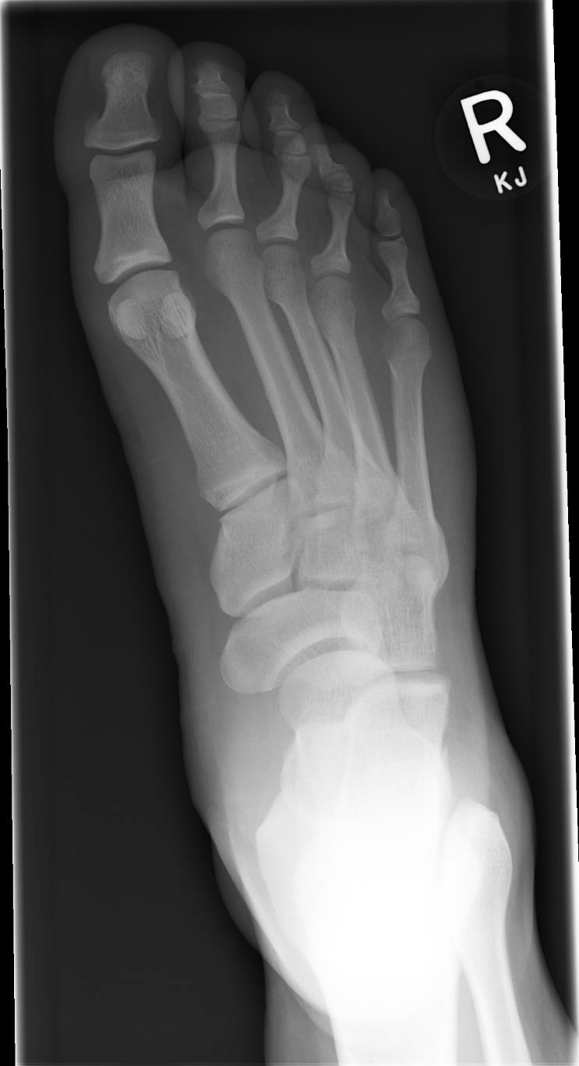
- Does the anatomical appearance in the radiograph correlate to what is expected from a Routine AP (axial) projection?
Yes No
*If no, explain how the appearance of this radiograph is different compared to the ideal radiograph

- Identify if the appropriate amount of radiation was used to form the image.
Acceptable, Overexposed, Underexposed
  - Is motion present in the image?
Yes No
- Identify if the collimated light field was: Acceptable, Too Small, Too Large
  - Was the CR close to the middle of the required anatomy?
Yes No

- Does the marker placement follow Edenbrook's Marker Rules?
Yes No
  - Are there artifacts in the image?
Yes No
*If yes, could they have been removed?

EDENBROOK Imaging library

Is this image diagnostic? Yes No

- Use the image below to answer the next five questions:
75 kVp
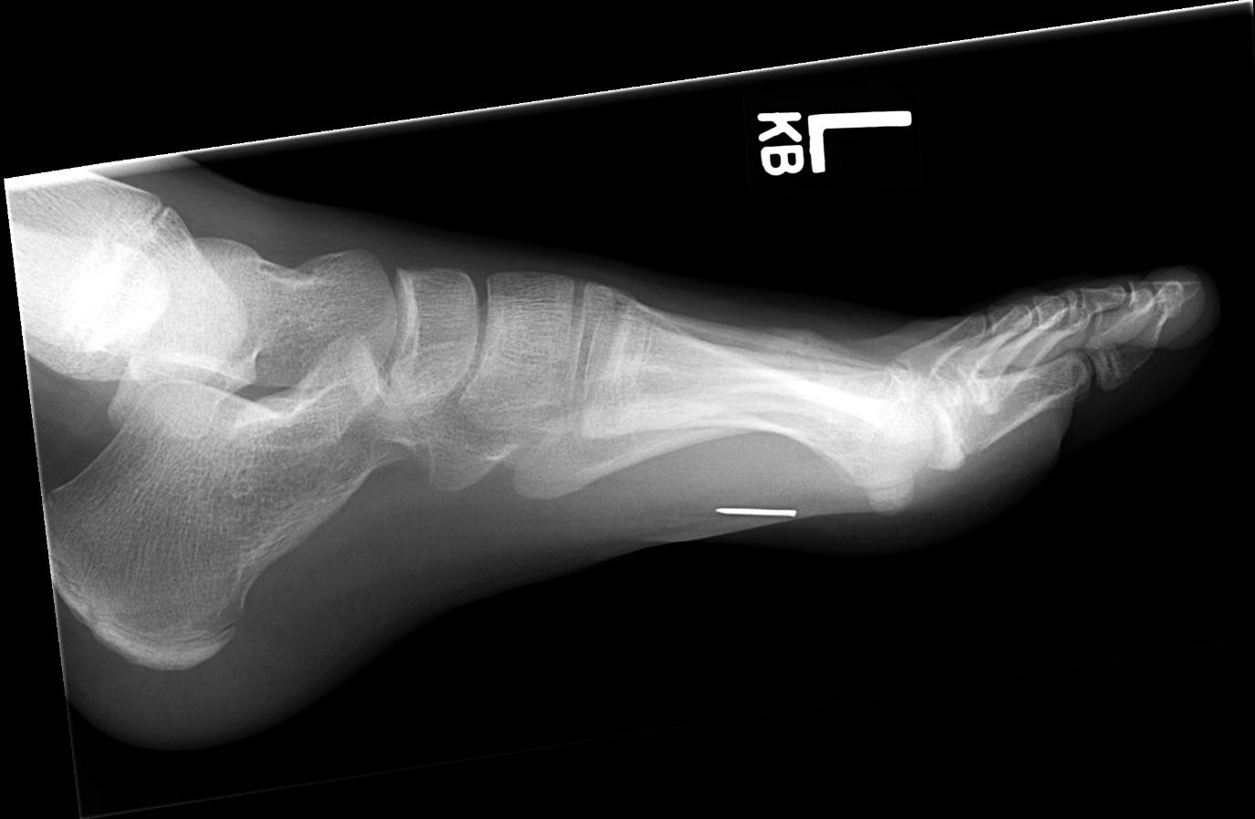
EDENBROOK Imaging library

    - Which routine projection of the foot is displayed?
    - What positioning error(s) occurred?

    - If the image was repeated, how would you correct the positioning error(s)?

    - How did you identify the positioning error(s)?

    - If the image had to be repeated, would you make any other adjustment(s)? Explain your rationale.

- Use the 5 evaluation criteria categories when critiquing the following image to determine if it is diagnostic:

Lateral calcaneus @ 75 kVp
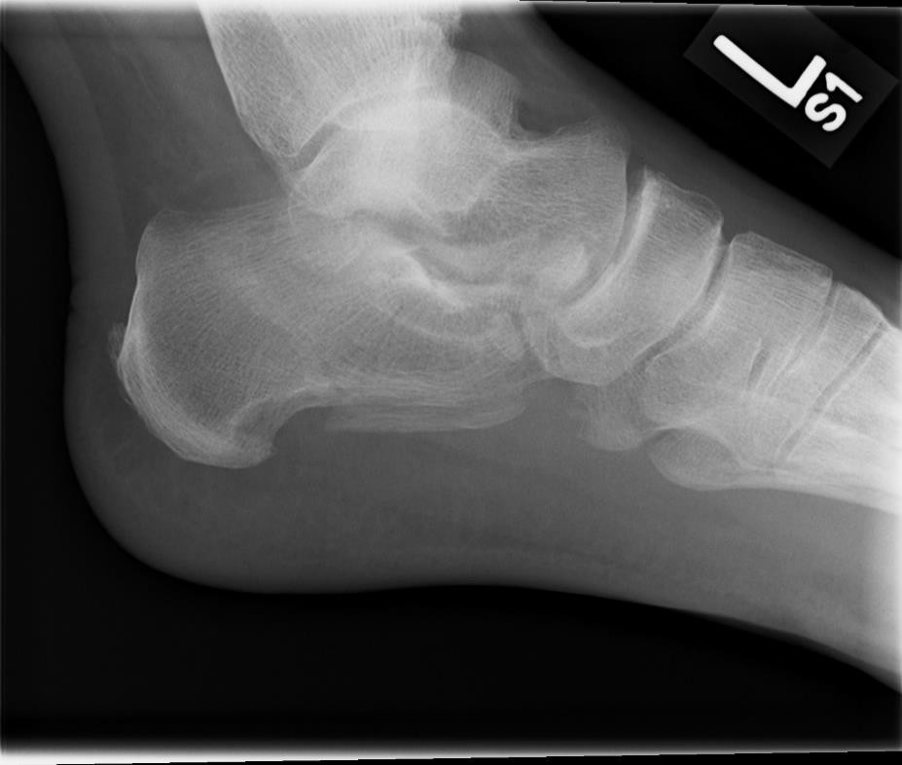
EDENBROOK Imaging library

Is this image diagnostic? Yes No

- Is all the required anatomy included in the radiograph? Yes No
*If no, explain what is required

- Does the anatomical appearance in the radiograph correlate to what is expected from a routine lateral projection?
Yes No
*If no, explain how the appearance of this radiograph is different compared to the ideal radiograph

- Identify if the appropriate amount of radiation was used to form the image. Acceptable, Overexposed, Underexposed
  - Is motion present in the image? Yes No

- Identify if the collimated light field was: Acceptable, Too Small, Too Large
  - Was the CR close to the middle of the required anatomy? Yes No

- Does the marker placement follow Edenbrook's Marker Rules? Yes No
  - Are there artifacts in the image? Yes No
*If yes, could they have been removed?

- Use the images below to answer the next five questions:

75 kVp
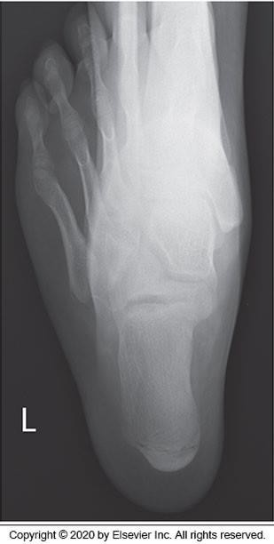
McQuillen Martensen 5th Ed. Fig.6-78

- Which routine projection of the calcaneus is displayed?
- What positioning error(s) occurred?

- If the image was repeated, how would you correct the positioning error(s)?

- How did you identify the positioning error(s)?

- If the image had to be repeated, would you make any other adjustment(s)? Explain your rationale.

