ANPH 252 – Anatomy and Pathology 2

Tortora Chapter 24
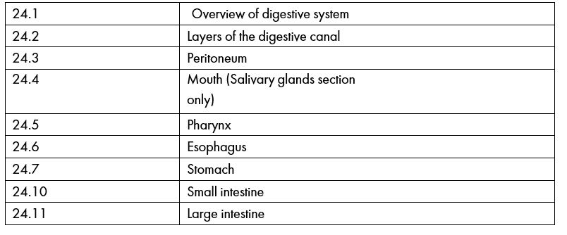
Bontrager
Pages 108-109 | Abdominal Cavity
 | Peritoneum
 | Mesentery
 | Omentum
 | Mesocolon
 | Greater sac and Lesser sac
 | Retroperitoneal Organs
 | Infraperitoneal Organs
 | Intraperitoneal Organs
Male and Female Peritoneal
Enclosures

