Pain Management Procedures of the Spine

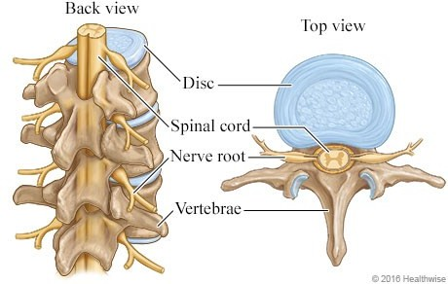
https://www.healthlinkbc.ca/health-topics/zm2325

- Nerve roots extend from the spinal cord out through foramina in the vertebrae which innervate your arms, back, and legs.
- The epidural space is a small space that surrounds the nerve root and spinal cord.
The use of pain management procedures in diagnostic imaging has been able to provide relief to a majority of the population of back pain/nerve pain patients.

Below are five common spine procedures in pain management:

Facet Joint Injection
  - An injection into the facet joint on one or both sides of a vertebra.
  - Reduces inflammation caused by friction in the joint as a result of osteoarthritis.
  - Needle position confirmed using radiographic contrast and imaging in the PA or oblique plane.
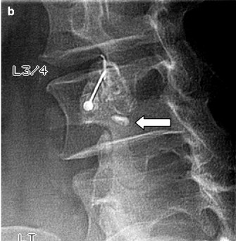
https://radiologykey.com/percutaneous-imaging-guided-facet-and-other-joint-injections/

Epidural Steroid Injection (ESI)
  - An injection into the epidural space surrounding a nerve root.
  - Reduces inflammation of the nerve root caused by pressure from a herniated disc.
  - Can help with pain radiating down the leg. Depending on where that pain is, can help determine which nerve is being compromised.
  - Requires a prior MRI or CT scan to determine affected roots.

ESI Approaches:
Transforaminal:
  - Simply means "through the hole."
  - The epidural space is accessed via the intervertebral foramina.
  - The most common and safest approach.
  - The needle positioning will be evaluated in multiple orthogonal planes. Interlaminar:
  - Used when transforaminal approach is not possible. Slightly higher risk of complications.
  - This approach involves guiding a needle through the space between the posterior aspects of the vertebrae to access the epidural space.
  - The positioning is evaluated in the same planes as the transforaminal approach.

Caudal:
  - Used when the other two approaches are not achievable or do not achieve desired results.
  - The needle is inserted through the sacral hiatus into the terminal end of the dural sac.
  - This approach delivers medication into the cauda equina which makes up the sacral and coccygeal nerves as well as the lower lumbar region.
  - Two views are needed during this procedure: PA and Lateral view.

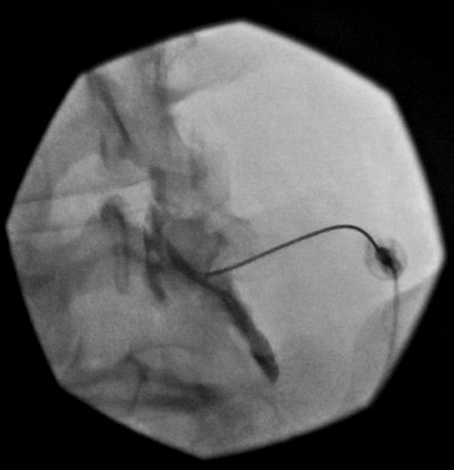
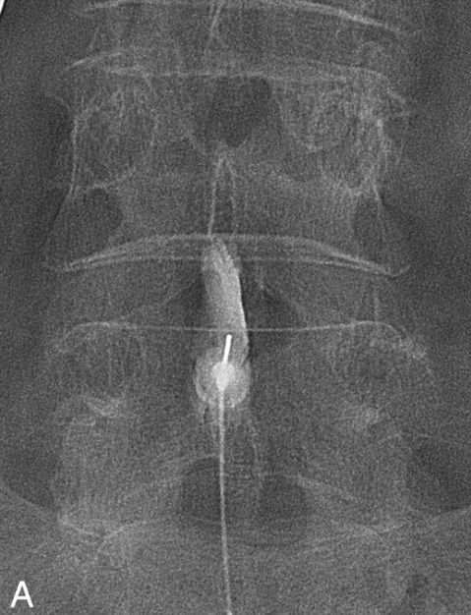
Transforaminal ESI image courtesy of Canada Diagnostic Centres Interlaminar ESI http://www.ajnr.org/content/31/10/1817

Selective Nerve Root Block (SNRB)
  - Similar to an ESI
  - The target is the same area as a transforaminal ESI.
  - It is a much more localized injection and a higher concentration of anti-inflammatory.
  - Positioning is the same as transforaminal approach.

Medial Branch Block (MBB)
  - An MBB is a diagnostic injection used as a precursor to a radiofrequency neurotomy
  - Involves freezing two small nerves supplying feeling to corresponding lumbar facet joint.
  - The L4/5 facet joint sensation is supplied by a small nerve that supplies both the inferior articular surface of L4 and the superior articular surface of L5.
  - Usually done twice to guarantee the efficacy of the first injection and reduce incidence of the placebo effect.
  - This type of injection only lasts a few hours (4 to 6 hours), but it is common to get a record of pain scores from the patient at intervals of time after the injection for a period of 24 hours.
  - Conformation of needle placement is often done with a slightly oblique view and a true PA.
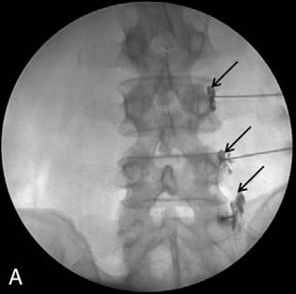
Han, Seung Hoon et al. “Ultrasound versus fluoroscopy-guided medial branch block for the treatment of lower lumbar facet joint
pain.” Medicine (2017).

Radiofrequency Neurotomy (RFN)
  - Burning away or “cooking” the nerve supplying pain to the facet joints
  - These nerves do not supply any other functional structures, so can be ablated without
affecting a patient’s mobility.
  - Nerves will grow back in time, usually in 6-18 months, when the RFN can be redone.
  - Electrodes attached to a generator are placed against the nerves and heated up.
  - No contrast is used, so positioning is checked in multiple angles, usually a true PA, oblique, and lateral.
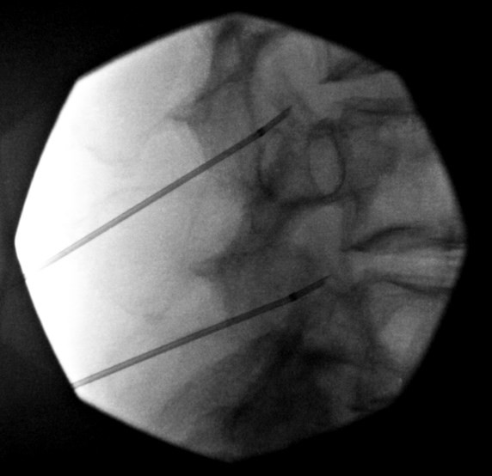
RFN image courtesy of Canada Diagnostic Centres

Lumbar Provocative Discography
  - Diagnostic exam done to aid surgical planning.
  - Injection of fluid into the nucleus of the intervertebral disc.
  - Attempts to provoke pain by targeting a disc suspected of pathology as well as a
“control” disc.
  - Performed with extensive surgical asepsis measures to minimize the chance of infection.
  - Imaging done in a PA and lateral plane to evaluate integrity of discs.

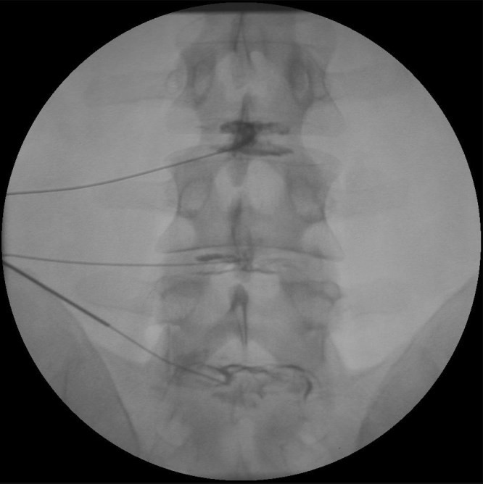
Lumbar Provocative Discography image courtesy of Canada Diagnostic Centres

Specialized Medications for Spine Procedures
  - Preservative free - helps reduce the risk of bleeding, infection and spinal leaking.
  - Solubility is important so the medications do not precipitate and cause embolization of an artery.
  - Dexamethasone and Betamethasone are the commonly used Steroid in spines as they are freely dissolvable in water.

Examples:
  - Lidocaine 1% or 2% - used to locally freeze the skin and muscle tissue.
  - Omnipaque 240 - contrast agent used to show placement of needle in the epidural space.
  - Dexamethasone or Betamethasone - corticosteroid- 10mg/ml usually in a 1cc single dose vial.
  - Bupivacaine 0.25 % - preservative free type of Marcaine for injection with the Dexamethasone.
  - Preservative Free Saline - used to help push or spread the medication for more widespread effect.

