Activity - CT Linearity
Table 1: Characteristics of CT Phantom (Seeram page 201)
Material | Density | Linear Attenuation Coefficient (cm⁻¹) | Approximate CT Number
Polyethylene | 0.94 | 0.185 | -85
Polystyrene | 1.05 | 0.196 | -10
Nylon | 1.15 | 0.222 | 100
Lexan | 1.20 | 0.223 | 115
Acrylic (Perspex) | 1.19 | 0.229 | 130
Water | 1.00 | 0.206 | 0
Teflon | 2.2 | 0.479 | 990
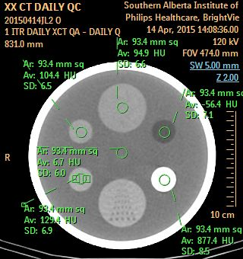

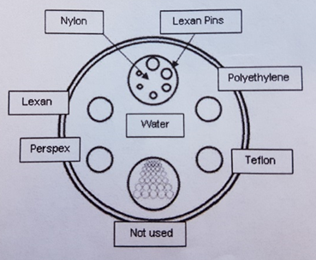

Hounsfield Unit Linearity
Insert | Polyethylene | Teflon | Acrylic | Lexan | Nylon | Water
Acceptable Limits | -70 ± 40 | +950 ± 75 | +140 ± 40 | +116 ± 40 | +100 ± 40 | 0 ± 40
QC Results | -56.4 | 877.4 | 129.4 | 104.4 | 94.9 | 6.7
Pass/Fail | P | P | P | P | P | P
Activity: CT Accuracy, Uniformity and Noise
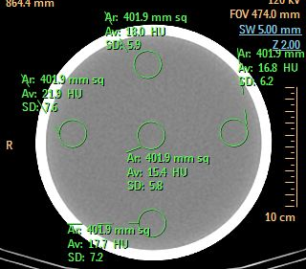
ROI 2
ROI 4
ROI 1
ROI 5
ROI 3
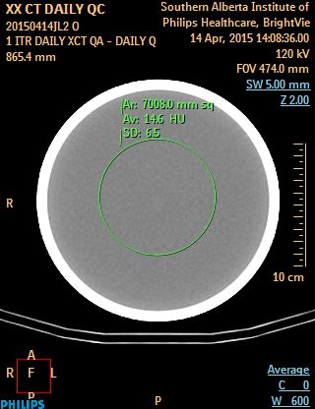
Image 3 (Source: SAIT)

CT QC Chart
Acceptable Limits | ROI size: 400 ± 50 mm²  *All values should be between -40 and +40 HU  *Max ROI-Min ROI <40 |  |  |  |  | ROI  *7000 ± 2000 mm²  AV: 0±40HU  SD: <10 HU
QC Results | ROI 1 | ROI 2 | ROI 3 | ROI 4 | ROI 5 | 14.6 | 6.5
QC Results | 18 | 16.8 | 17.7 | 21.9 | 15.4 | 14.6 | 6.5
Pass/Fail | P | P | P | P | P | P | P
- CT Number Accuracy = All values should be between -40 & +40
- CT Uniformity limit = Max ROI – Min ROI ˂40
- CT Noise acceptable limit = SD within a large ROI must be ˂10 HU

Activity: QC in CT

Purpose
Objective 4.4: Identify different types of QC tests.
Recognize the parameters each QC test can evaluate.

Instructions:
- Review the following CT QC images.
- Identify which QC test(s) was being evaluated.
Image 1: (Source https://www.ceessentials.net)
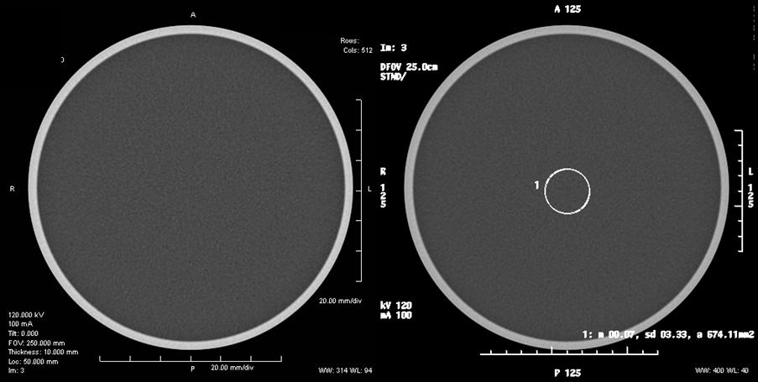

Image 1: QC parameter evaluated:
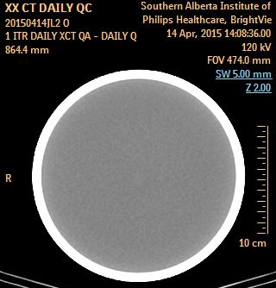
Image 2: (Source SAIT)
Image 2: QC parameters that could be evaluated:

Image 3: (Source SAIT) Image 4: (Source https://www.ceessentials.net)
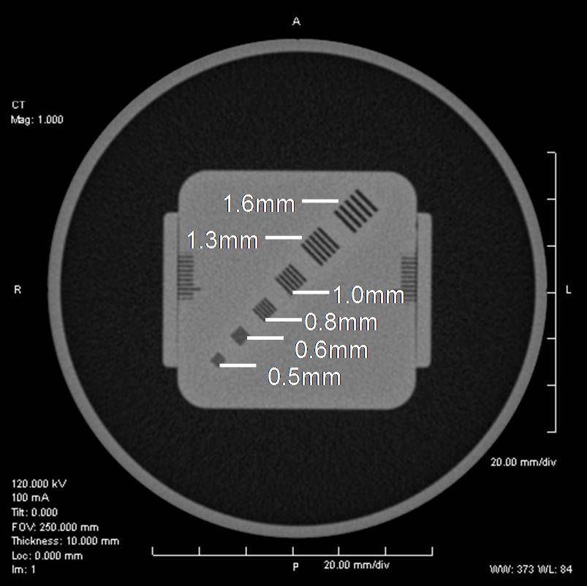
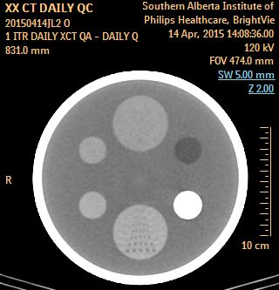
Image 3: QC Parameter(s) evaluated: Image 4: QC Parameter evaluated:

Image 3: (Source SAIT) Image 4: (Source SAIT)

Image 5 (Source: http://ijcto.org/index.php/IJCTO/rt/printerFriendly/0203.9/ijcto.0203.9html)
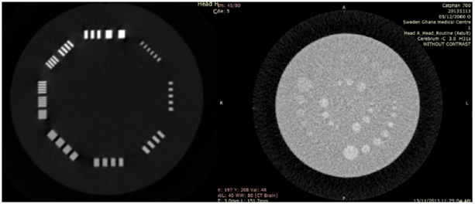
Image 5: QC parameters evaluated:
Left Right:
Image 6 (Source: https://www.ceessentials.net)
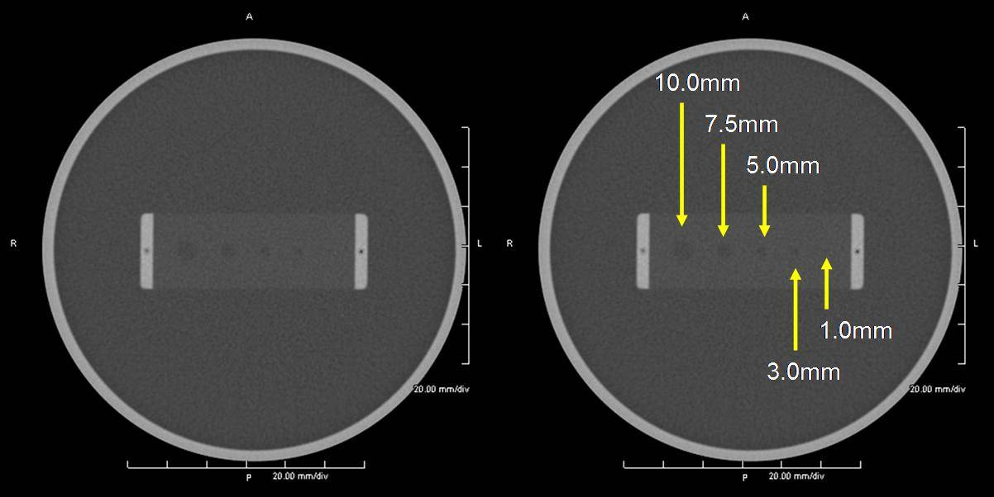

Image 6: QC parameter evaluated:

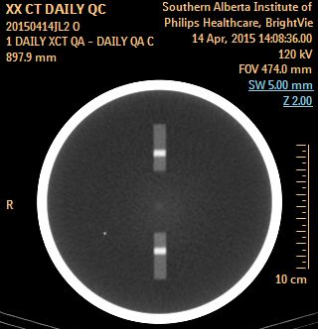
Image 7: (Source: SAIT) Image 8: (Source: SAIT)

Image 7: QC parameter evaluated: Image 8: QC parameter evaluated:

Image 9: (Source: https://www.ceessentials.net)
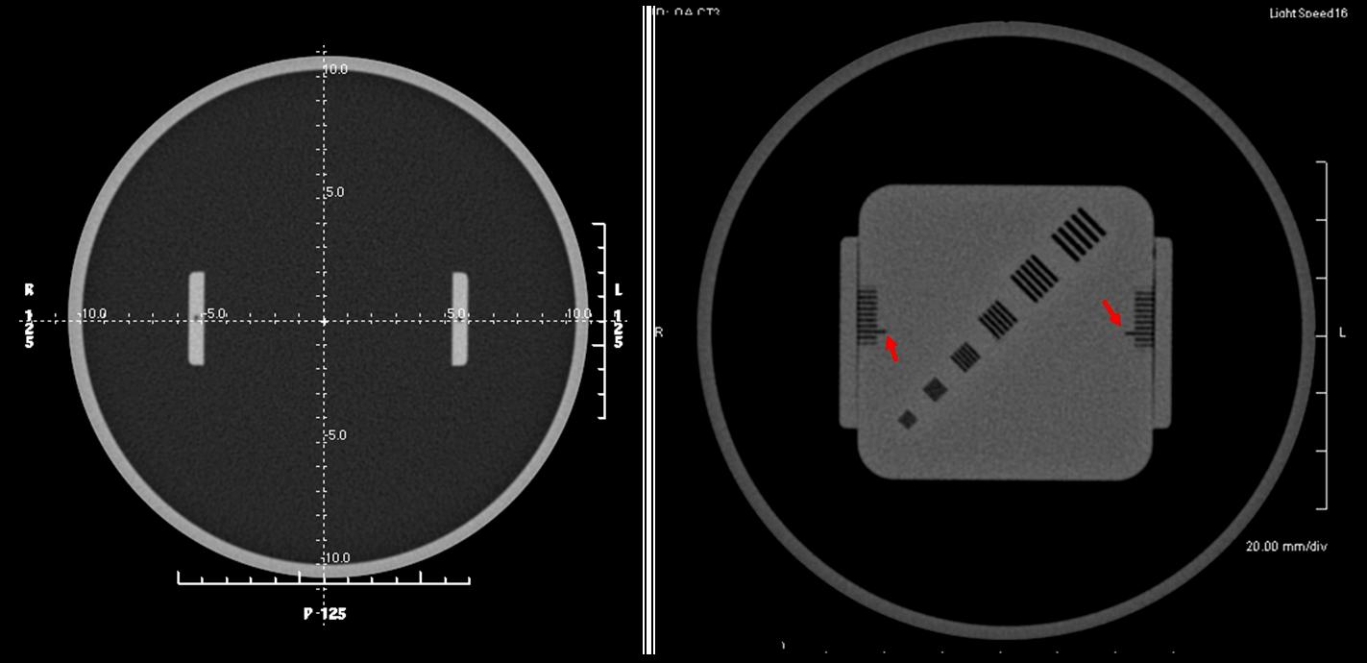
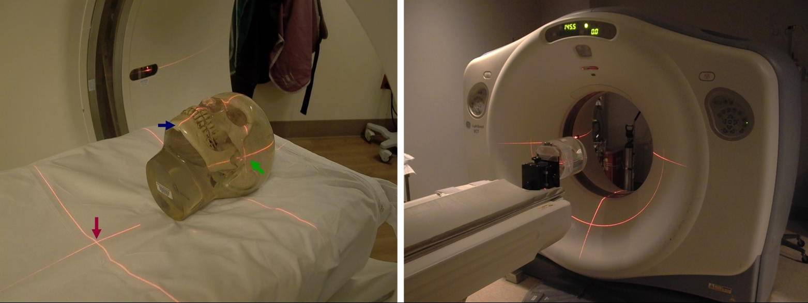

Image 9: QC parameter evaluated:

