ANPH 202 – Worksheet – Artery Labeling – ANSWER KEY
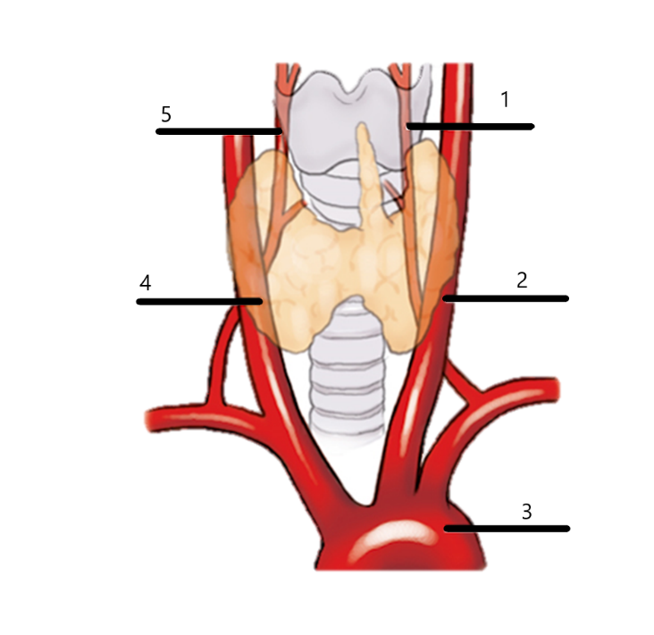

1: Left vertebral artery
2: Left common carotid artery
3: Aortic arch
4: Right common carotid artery
5: Right vertebral artery

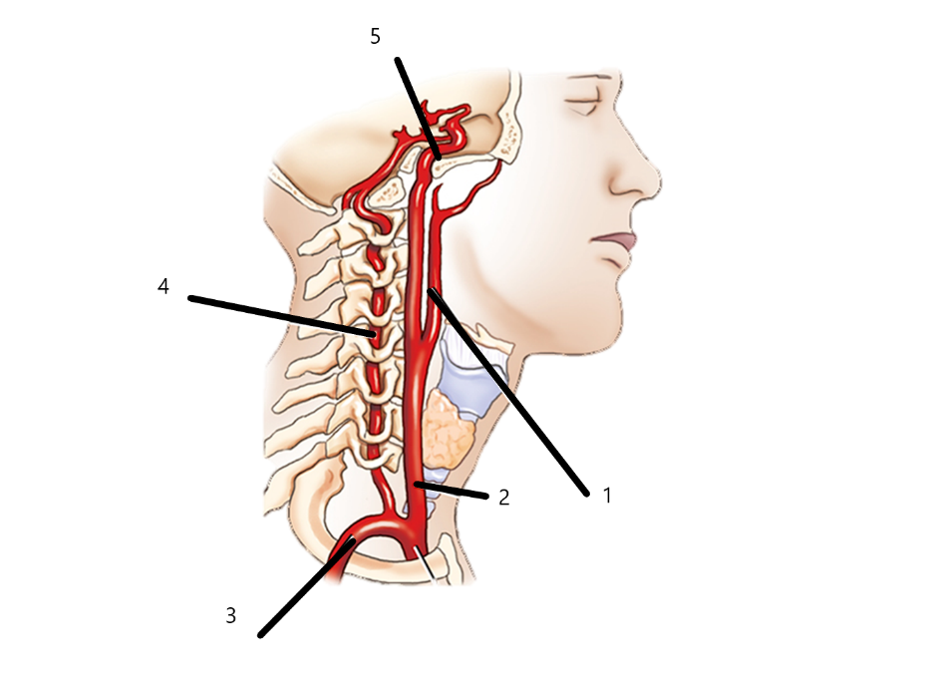

1: Right external carotid artery
2: Right common carotid artery
3: Right subclavian artery
4: Right vertebral artery
5: Right internal carotid artery

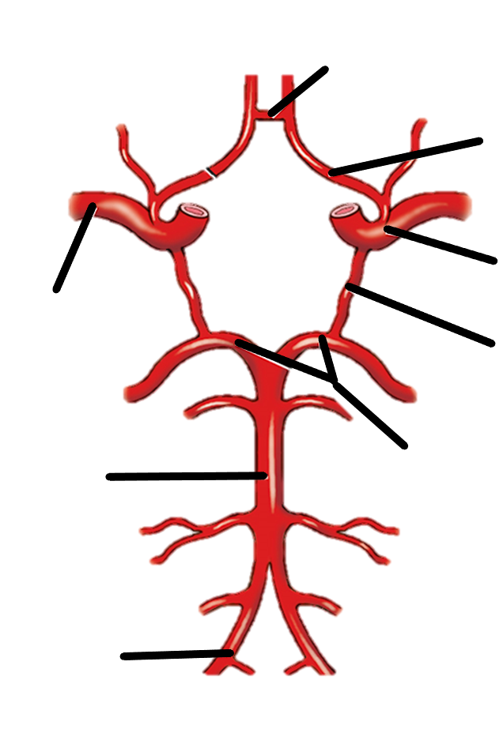
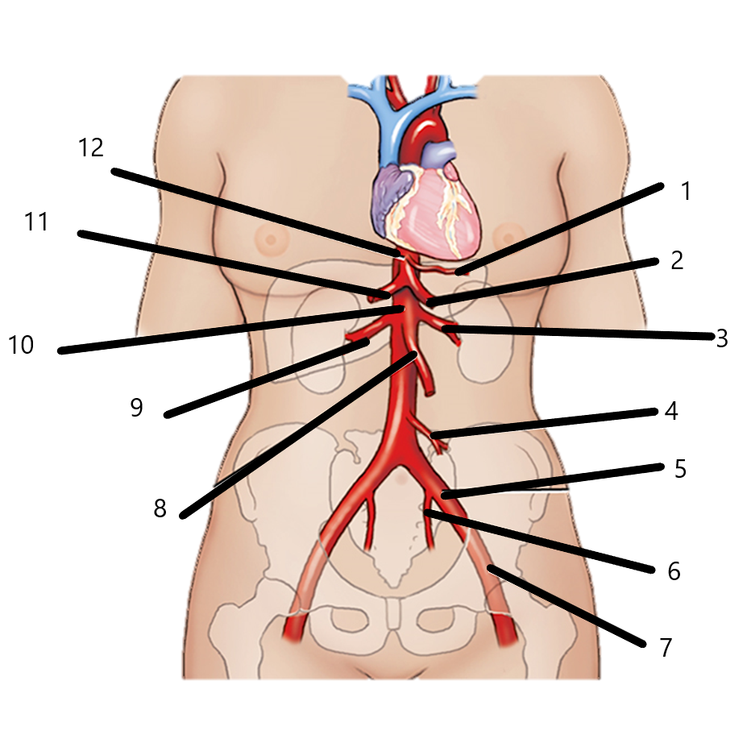
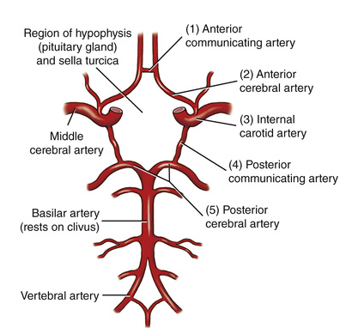
1. Left Gastric
2. Splenic
3. Left Renal
4. Inferior mesenteric
5. Left common iliac
6. Left internal iliac
7. Left external iliac
8. superior mesenteric
9. right renal
10. Abdominal Aorta
11. hepatic
12. celiac (trunk) axis

