Anatomy and Pathology 2 Final Exam Comprehensive Review
- What type of fracture breaks on the convex side and bends on the concave side? Greenstick
- What is the function of the small openings in the cribriform plate? For branches of the olfactory nerves
- Which fracture demonstrates a fracture of the distal third of the radius with dislocation of the distal radioulnar joint, with an intact ulna? Galeazzi
- Which of the following is a fracture due to fatigue or stress? Marcher’s
- Which fracture is also called traumatic spondylolisthesis of the axis? Hangman’s
- Which type of fracture involves the epiphyseal plate? Salter Harris
- What is the most common metacarpal fracture? Boxer’s
- Image of gout toe
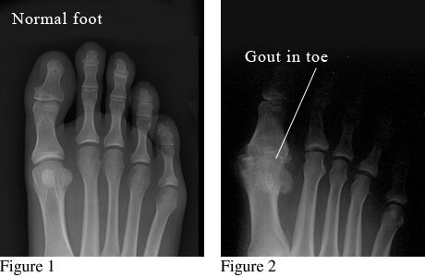
- Ankylosing spondylitis is a form of which pathology? Rheumatoid arthritis
- Which pathology arises from the bone marrow of long bones? Ewing’s sarcoma
- Image of lateral skull with multiple myeloma
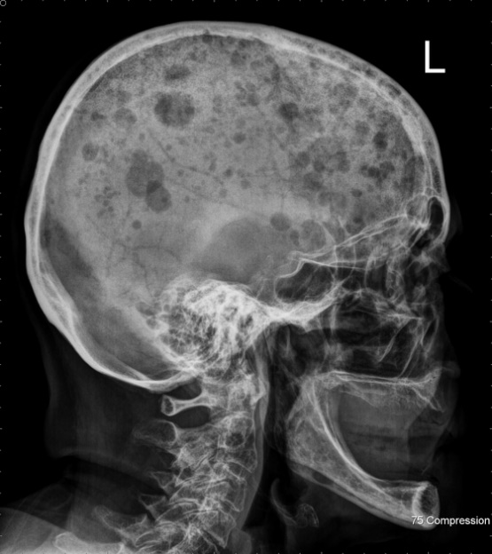
- Which of the following is TRUE regarding osteoarthritis? Bony spurs form along the articular edges of the bone
- Which disease is also known as "marble bone disease"? Osteopetrosis
- Developmental dysplasia of the hip is due to which of the following? Incomplete formation of the acetabulum
- Which pathology involves the patellar ligament insertion on the tibial tuberosity? Osgood-Schlatter disease
- Which of the following malignancies causes lung metastases to develop early in the disease? Osteosarcoma
- Which of the following is true regarding a Le Fort fracture? Involves separation of the midface from the skull base
- Image of Galeazzi fracture on radius and ulna
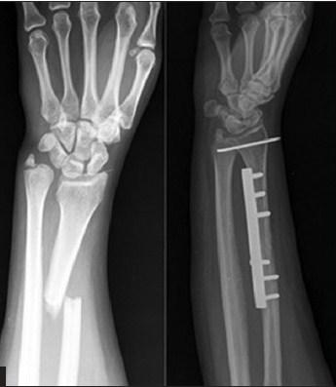

- Image of an intertrochanteric fracture AP hip
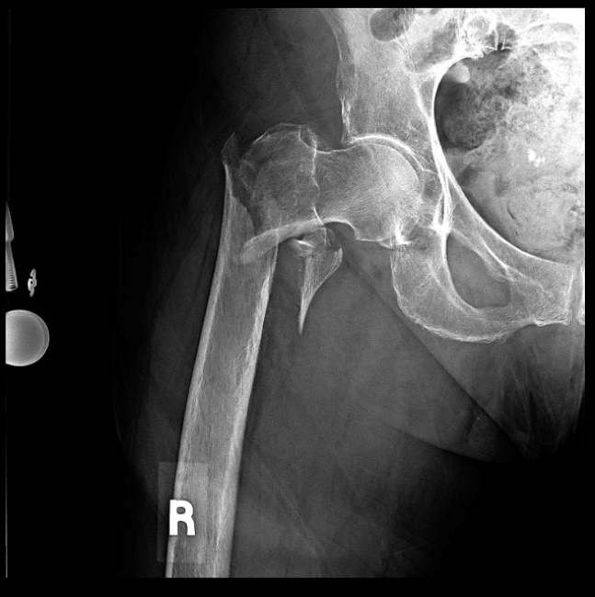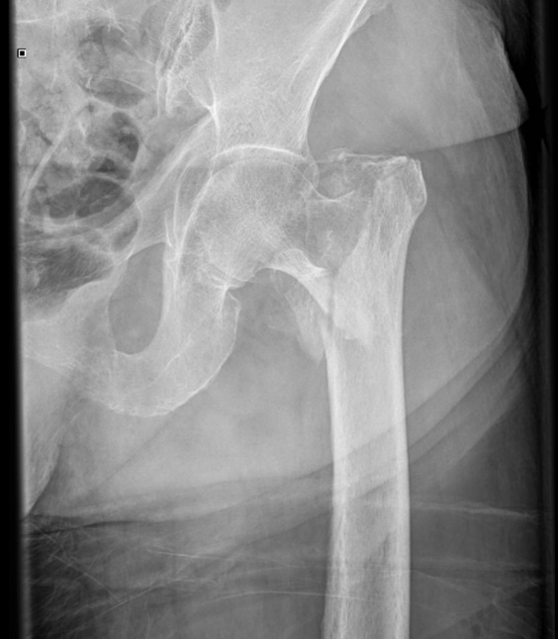
- Image of Monteggia fracture radius and ulna
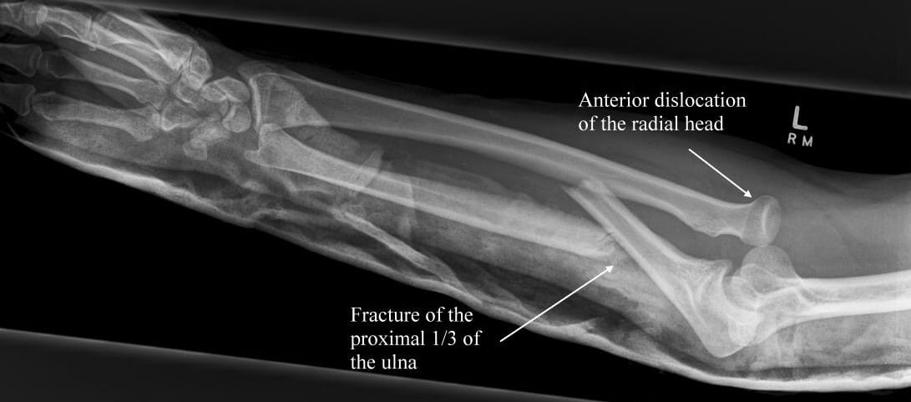
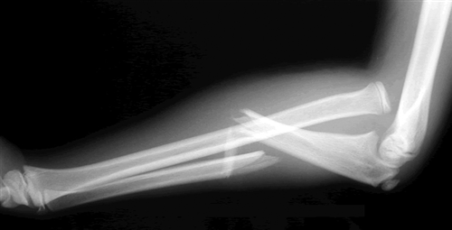

- What type of fracture occurs in an area of bone weakened by a disease process? Pathological
- Image on non-comminuted fracture of the clavicle
- Which type of fracture most commonly occurs in the vertebrae? Compression
- Which of the following is true regarding fracture injuries? Some fractures heal more slowly due to decreased blood supply to the area
- Which of the following would be a "stable" fracture? Stress
- Imaging signs of osteoarthritis include all of the following except: Answer is Fusion (loss of joint space, subchondral cysts and osteophytes)
- The ball catcher's position is used to demonstrate which pathology? Rheumatoid arthritis
- Which disease causes bone softening due to insufficient mineralization in an adult skeleton? Osteomalacia
- Which pathology results from white blood cells surrounding bacterium in the lung, and the body encapsulating these collections in fibrous tissue? Tuberculosis

- Visual of cells with lung pathology, Emphysema
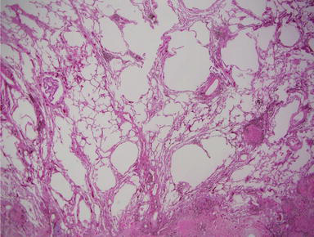
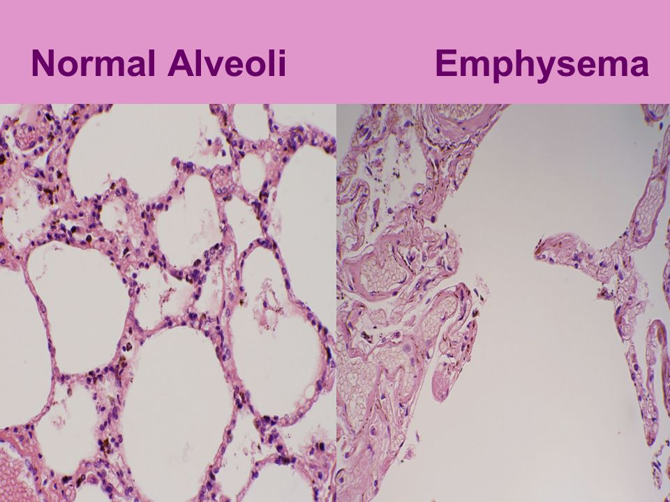

- What is the most common cause of COPD? Smoking

- Image PA chest of subcutaneous emphysema

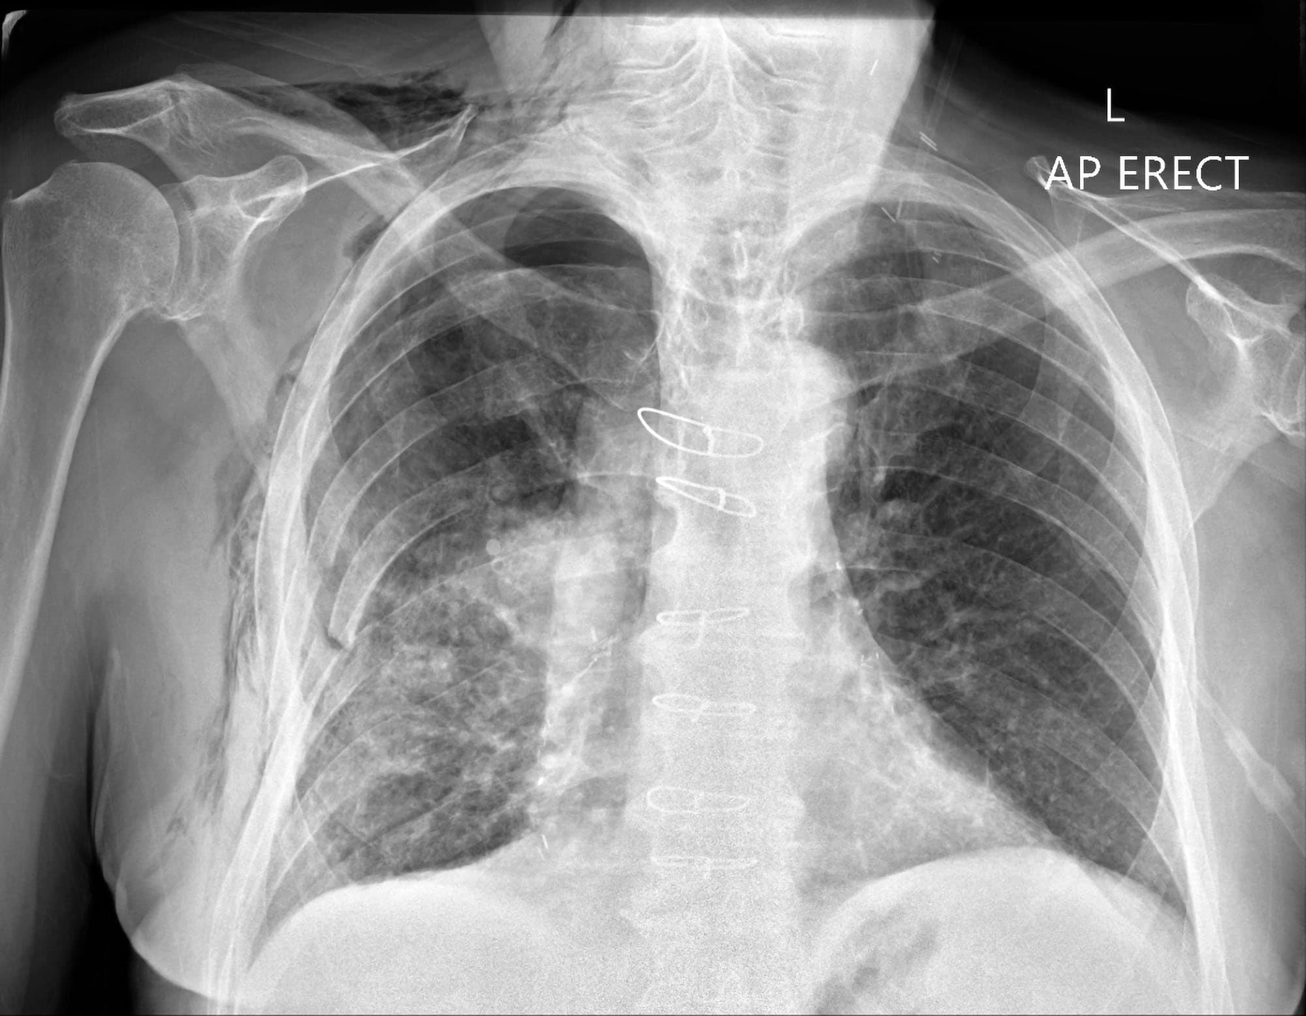

- What type of injury is responsible for 25% of all trauma deaths? Chest injury
- Which image will best demonstrate a trimalleolar fracture? Lateral ankle
- What is the most common elbow fracture in children? Supracondylar
- Which fracture involves the 1st metacarpal and trapezium? Bennett’s
- What is a potential complication of a lung abscess? Cavitation
- What causes an air bronchogram? Radiopaque lung parenchyma
- Where does ankylosing spondylitis typically originate in the body? SI joints

- Image of Colles fracture wrist
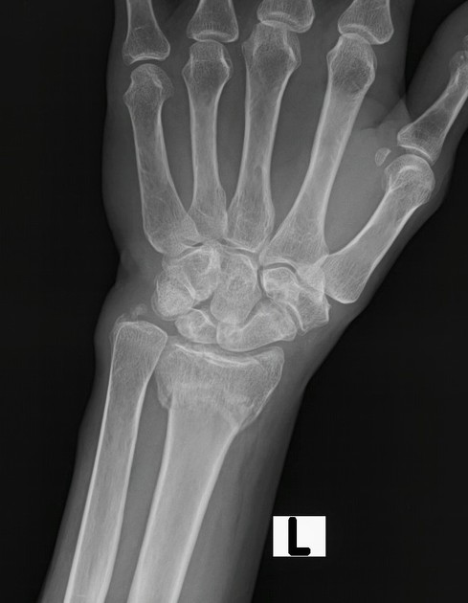
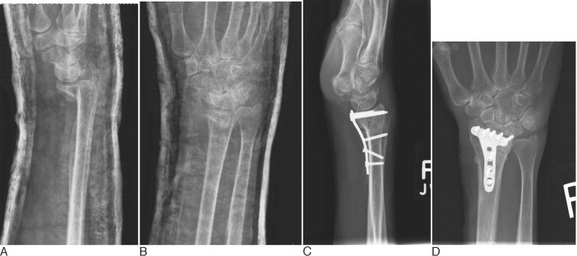

- Image of lateral C spine for handman’s fracture
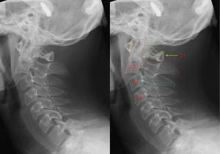
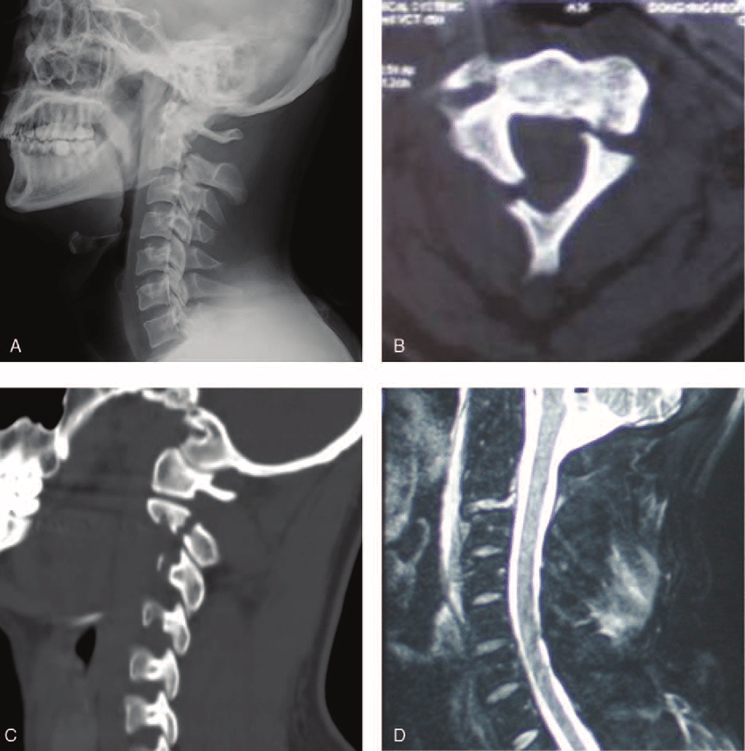
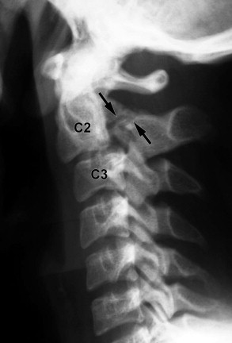

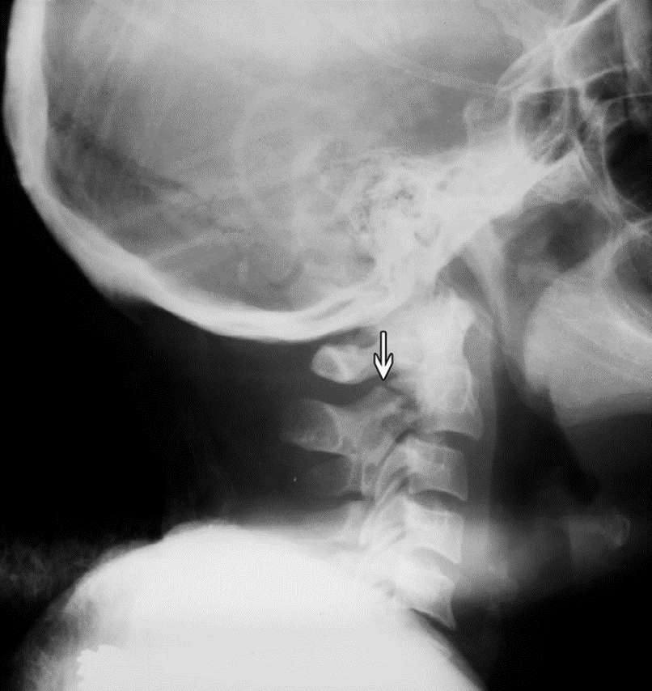

- Which of the following is true regarding a hangman's fracture? Can seriously damage the spinal cord
- A Monteggia fracture is more common in adults than children. False
- Stress fractures are diagnosed conclusively with radiographs. False
- Osteoclasts are responsible for bone destruction. True
- Image of exostosis in femur
- Any fracture that goes through the epiphyseal plate is given a Salter Harris classification. True
- What is the primary goal when treating Legg-Calve-Perthes disease? To keep the femoral head rounded
- A contrecoup fracture occurs on the opposite side of the point of impact. True
- The most common form of degenerative arthritis that has osteophyte development is: Osteoarthritis
- What pathology is caused by increased uric acid in the blood? Gout
- The beginning phase of Paget's disease involves which of the following? Destruction
- Which of the following best describes an avulsion fracture? Small bony fragment pulled from a prominence
- Which of the following best describes subluxation? Partial loss of joint continuity
- Which of the following best describes multiple myeloma? Answer is Disseminated malignancy of plasma cells
- Which of the following best describes ischemic necrosis? Answer is Loss of blood supply
- Which of the following is a radiographic sign of overinflation of the lungs in patients with emphysema? Flattened diaphragms
- Which of the following best describes COPD? Obstructive airway condition causing ineffective gas exchange
- Which of the following is due to allergens causing widespread narrowing of the airways? Asthma
- Which of the following pathologies results from alveolar damage throughout the lungs? Acute respiratory distress syndrome

