Activity: Test 18 Fluoroscopic Field Size and Beam Alignment Procedure

Purpose
This activity will help you identify the procedure steps for this test.

Instructions
- Review the images below of the equipment and materials used at Edenbrook for this test.
- Review the procedure steps from the Edenbrook MRT lab.
- Compare this procedure, the textbook reading and your practicum site QA manual for similarities and differences between a C-arm and dedicated fluoro unit.

Equipment
- Level
- Beam alignment test tool
- Collimator alignment template

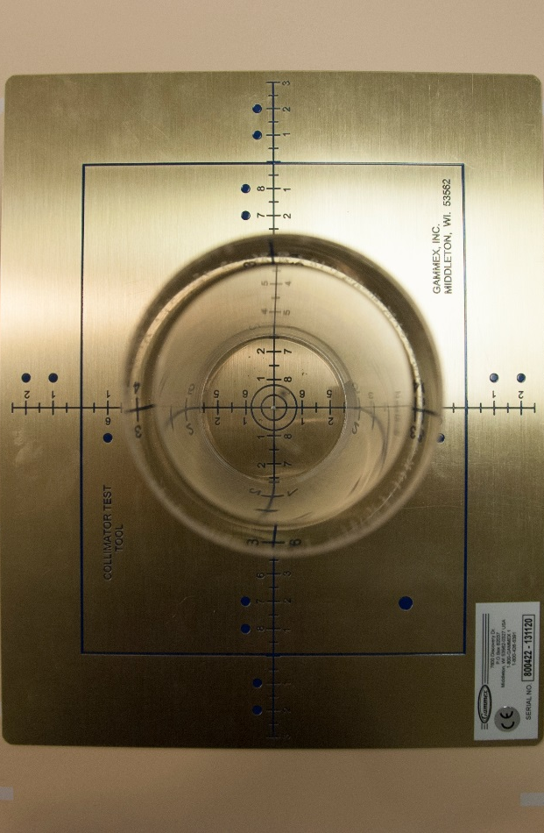

Edenbrook MRT Procedure Steps (Note: using C-arm at Edenbrook is limited by equipment)
- Position the C-arm with the image intensifier on the bottom.

- Place the collimator alignment template on top of the image intensifier. The dot in the corner of the template should correspond to a patient’s right shoulder. The dot is used to determine the direction of collimator error.

- Use the carpenter level to check that there is no angle on either the tube or the template; this is critical to the accuracy of the results.

- Place the beam alignment test tool in the centre of the collimator alignment template. Ensure the metal bead in the bottom of the cylinder is directly over the crosshairs on the template.

- Collimate carefully to the blue marker lines nearest to the centre of the template.

- Expose and save the image on the monitor.

