Worksheet - Hand & Wrist Labelling – ANSWER KEY

Module 1

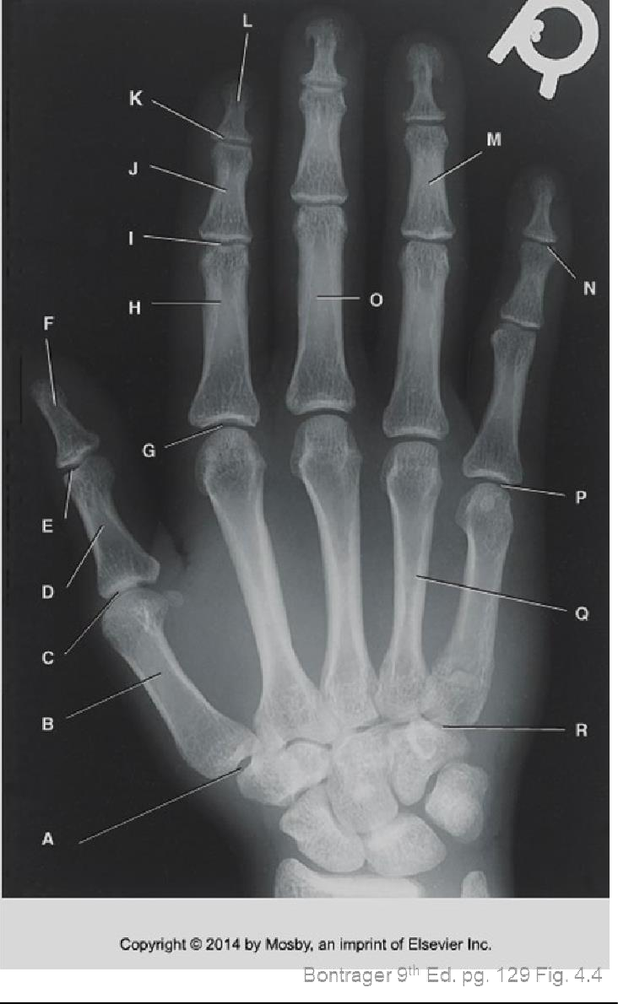
L. Head: 2nd Distal Phalanx

K. 2nd DIP
M. Body: 4th Middle Phalanx
J. Body: 2nd Middle Phalanx

I. 2nd PIP

H. Body: 2nd Proximal Phalanx N. ₅th _{DIP}

- Head: 1st Distal Phalanx O. Body: 3rd Proximal Phalanx

- 2nd MCP

E. 1st IP P. 5th MCP

^{st} Proximal Phalanx
D. Body: 1
Q. Body: 4th Metacarpal
C. 1st MCP

B. Body: 1st Metacarpal R. 5th CMC

A. 1st CMC

th
Hamate
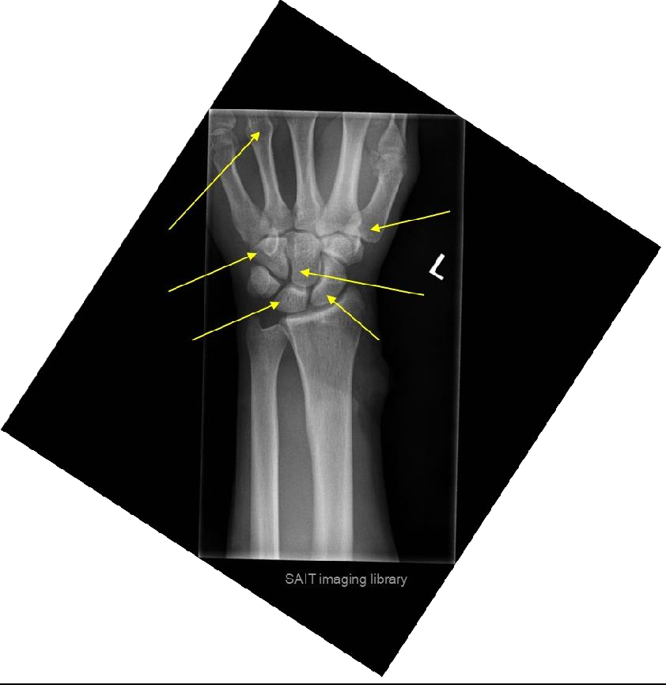
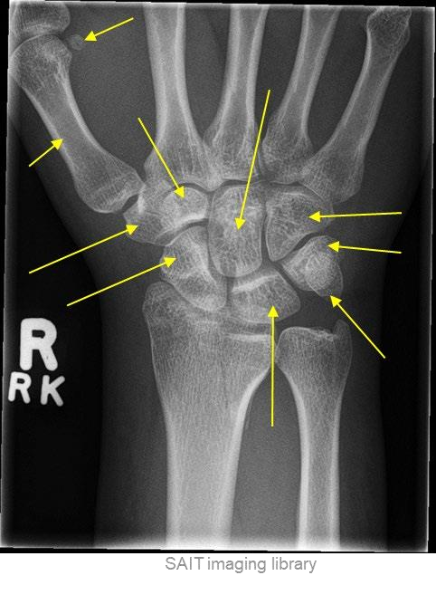
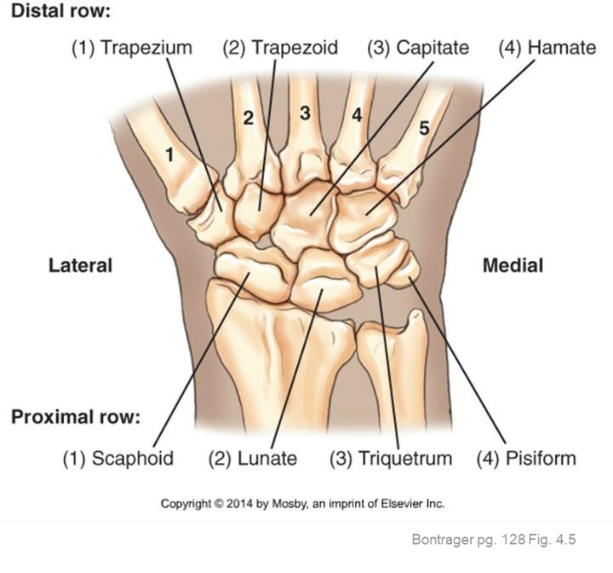
Lunate
MRAD

204:

P
OWER
P
OINT

A
NSWER

K
EY

Head:

4
Metacarpal

Base:

1
st

Metacarpal

Capitate

Scaphoid

2

MRT

Program

–

MRAD

204:

Radiographic

Technique

I

Sesamoid

Body: 1
st

Metacarpal

