
CT Rotation Package for Students

Contents
Purpose: 2
Section 1: Refresh and Prepare 3
Section 2: Clinical expectations 4
2a – Clinical Site Poster 4
2b – Rotational Objectives 5
2c – Required CT Procedures 6
2d – Common Protocols and Abbreviations 7
2e– Sample Requisition and Consent Forms 11
2f – CT Contrast Use 13
Section 3: Cross-Sectional Review 14
Section 4: Test your Knowledge 29
  - – Questions 29
  - Case Studies 32

Purpose:

The function of this package is to assist in the transition for your CT rotation. Being as prepared as possible for this modality will help make it the best learning opportunity for you.
Prior to your rotation, begin by reviewing the materials listed under Section 1. This will ensure you have a refreshed your grasp on the fundamentals. Continuing into the Clinical Expectations section will help give you a guide on how to conduct your first few days in the rotation, and will give you specific knowledge to help ease the transition into the CT department.
There are examples of common CT abbreviations, samples of protocols, paperwork and contrast media. Please be aware that the Samples provided in this package are for informative purposes only and do not necessarily reflect specific site protocols. **Students are expected to follow site protocols.
Finally, the last two sections will allow you to practice recognizing cross-sectional anatomy and test the knowledge you have gained throughout your CT clinical rotation.

Section 1: Refresh and Prepare
Review the following topics from CT Theory courses MRAD 251 & MRAD 281

    - Data Acquisition
      - Axial / Conventional / Sequential Scanning
      - Spiral / Helical / Volume Scanning
      - Pitch
      - Radiation Attenuation
      - CT numbers
      - Scan Field of View (SFOV)

    - Image Display
      - Window Width
      - Window Level
      - Spatial Resolution
      - Contrast Resolution
      - Algorithm / Kernel
      - Image Artifacts (motion, metal, beam-hardening, partial volume)
      - Image Noise

    - Image Post-Processing
      - Multi-Planar Reconstruction (MPR)
      - Reformat
      - Effect of Window Width on Contrast
      - Effect of Window Level on Brightness / Density

    - Radiation Dose
      - Absorbed Dose
      - Effective Dose
      - Factors Affecting Dose in CT
      - Radiation Protection / ALARA in CT

Section 2: Clinical Expectations

2a – Clinical Site Poster
This poster is at all Clinical Rotation sites for Technologist and Student Reference

Computed Tomography Rotation
Focus: The student is developing basic skills of a CT technologist
Expectations of the Student | Tips for Preceptors
- Identify anatomy of the head, chest, spine and abdomen.  - Understand pathologies related to the head, chest, spine and abdomen commonly imaged using CT.  - Assess the patient for hypersensitivity or contraindications to contrast media (with direct supervision).  - Select, prepare, and assist in the administration of contrast media using automatic pressure injector (with direct supervision).  - Understand how to monitor and respond to adverse reactions to contrast media.  - Plan / Set up scan parameters for imaging procedure.  - Position patient using anatomical landmarks.  - Evaluate quality of images for diagnostic value  - Participate in processing and reformatting images, as appropriate to your department protocol.  - Counsel patient with respect to post- procedural care. | Week 1 - Have students develop the following skills:  - Review patients’ requisitions and discuss scan  protocols with relation to clinical history.  - Learn function of buttons on the gantry.  - Position patients using anatomical landmarks.  - Introduce scan parameters for routine head, chest, spine and abdomen/pelvis procedures.  - Review contrast media used in your department, load automatic injector, set up injection parameters.  - Review emergency procedures.  - Review basic cross-sectional anatomy of head, chest, spine, abdomen/pelvis.  Weeks 2 & 3  - Perform routine scans independently (with supervision).  - Identify common pathologies seen on CT head, chest, spine and abdomen/pelvis  - Participate in all aspects of workflow of CT department.
If you have any questions contact the Clinical Instructors: | Free Online Preceptor Training  If you are interested, please contact one of  the Clinical Instructors.

2b – Rotational Objectives
√ | Objectives- Day 1
 | Housekeeping items- where to put coat, shoes, lunch, bag, etc.
 | Pick up site personal radiation dosimeter/radiation badge (if applicable)
 | Location of blanket warmer, linen/equipment supply cart, soiled utility
 | Location of emergency supplies- airway bags, drug box, O2 monitor, O2/suction setup, how to call a code, etc.
 | Review of basic principles- coronal/axial/sagittal planes and basic CT knowledge
 | Objectives- First week
 | Introduction to Gantry & room setup- button function, adjusting table height, basic positioning of patient, centering points, radiation safety protocols (closed doors, ALARA), double ID patients
 | Review contrast screening/consent form and requisitions. Assess for contraindications
 | Patient prep- change rooms, oral contrast administration
 | Introduction to radiation safety (shielding) and immobilization techniques (ex. Head holder) as applicable at site
Introduction to power injector- how to refill safely, how to restock contrast warmer, handling of sterile parts when
loading new contrast lines.
 | How to stop injection in case of emergency (in room and at control panel)
 | Understand and interpret lab results (Creatinine/eGFR)
Safely inject patients during IV contrast exams, monitor for complications such as extravasation and counsel patient
with pre/post injection care
 | Introduction to scanning protocols- radiologist protocolling vs auto protocolling, as applicable
 | Introduction to scanner software- worklist/patient selection, selection of protocol, scout images, scan parameter setup, ROI, contrast enhancement, reformats (both DMPR and manual). How to stop the scan in case of emergency
 | Communication with other staff (radiologists, nurses, etc.) as required
By the end of first week student should aim to be setting up room, positioning patient and scanning simple
plain/enhanced cases with assistance/supervision
 | Objectives- Second week
 | Improve speed and efficiency, start to perform more complicated cases including smart prep/bolus tracking
 | Safely use injector during contrast exams, perform more complicated types of exams, if applicable
 | Differentiate anatomy on scans
 | Understand venous vs arterial phase and why we require them
By the end of the second week the student should aim to be scanning all types of scans independently and using
the power injector under supervision.
 | Objectives- Third week
Continue to improve workflow, perform more difficult cases (such as stroke/cardiac/trauma cases if applicable to
site)
 | Participate in all tasks in department in a similar way to techs
 | By the end of the third week the student should complete all logbook lines

***Note: The above objective checklist is only a guideline. Students can perform cases as soon as they feel comfortable/competent. However, all tasks should be completed in this general order***

2c – Required CT Procedures
 | # Required | Comptracker ID | Evaluation
CT Head NE | 2 | IC-CTHeadNE
CT Abdomen Pelvis E | 2 | IC-CTAb/PelE
CT Head E | 1 | IC-CTHeadE
CT Neck/Spine | 1 | IC-CTVertebral/Neck
CT Chest NE | 1 | IC-CTChestNE
CT Chest E | 2 | IC-CTChestE
CT Abdomen Pelvis NE | 1 | IC-CTAb/PelNE

Students must complete these 10 procedures, and require verification in CompTracker from their supervising preceptor that the exam was performed independently.
It’s important to note that MRT students are currently not required to perform venipuncture on patients. Students have completed accredited venipuncture training but all sites cannot guarantee that students will have the staffing to support students performing venipuncture during their clinical rotation.

2d – Common Protocols and Abbreviations
The Protocol is a code that the Radiologist uses to indicate the specific exam they would like the technologist to perform. This Protocol is based on the Clinical Indications of the exam and there are many different ways of writing protocols depending on your radiologist. Here are some common abbreviations you may see in your CT rotation.

Non Enhanced | Routine Enhanced | Other Enhanced
Plain | Wet | -/+ (combined dry/wet)
Dry | +C | Triphase, Biphase
-C | 10 (Primary) | CTA (CT Angiogram)
Non-Contrast | Contrast / Enhanced | +Delay

Abdomen Pelvis (Routine) – Siemens Scanner “Sample Protocol”

INDICATIONS | Lymphoma, Tumor staging, Abdominal pain, Adenopathy,  Suspected mass, Splenic Infarct, Appendicitis
POSITIONING | Patient Supine Feet First, Arms above head.
LANDMARK | Mid Chest (nipple line)
TOPOGRAM | PA and Lateral
SCAN COVERAGE | Above Diaphragms to Below Symphysis Pubis
FOV | Skin to Skin, to contain abdominal cavity
TECHNICAL FACTORS | 120kV, CareDose On
DETECTOR CONFIGURATION | 0.5 sec rotation; 0.6mm
RECON | Axial Abd/Pel | Coronal Abd/Pel | Sagittal Abd/Pel | Axial Lung
SLICE THICKNESS/INTERVAL (mm) | 5x5 | 3x2 | 3x2 | 5x5
KERNEL/WINDOW | B31f 350/50 | B31f 350/50 | B31f 350/50 | B60f 1500/-700
ORAL CONTRAST | Telebrix - 2hrs prior to scan
IV CONTRAST | 2ml/kg at a rate of 3ml/sec
DELAY | ROI over descending aorta, Trigger at 100 HU
COMMENTS

Non-Contrast Head (Conventional)-Toshiba Scanner “Sample Protocol”

INDICATIONS | Headache, TIA, Stroke, R/O Mass, Dementia, Abnormal  Behaviour, Trauma, R/O Bleed, Seizure
POSITIONING | Supine, Head First
LANDMARK | Centered to EAM. Scan plane to OML
SCOUT | AP and Lateral
SCAN COVERAGE | Foramen Magnum to Skull Vertex
FOV | SFOV - Head; DFOV - 24cm
TECHNICAL FACTORS | 1.0 sec Rotation; 120kV, 250mA
DETECTOR CONFIGURATION | 5mm/ 4i
SERIES | HEAD ROUTINE | HEAD BONE
RECON/DMPR | R1 | R2
SLICE THICKNESS/INTERVAL | 5x5 | 5x5
ALGORITHM/WINDOW | STND 80/40 | BONE 2700/350
ORAL CONTRAST | N/A
IV CONTRAST | N/A
DELAY | N/A
COMMENTS | Check with Radiologist if abnormality detected.

Contrast Chest - GE Scanner “Sample Protocol”

INDICATIONS | Trauma, empyema, parenchymal abnormalities, mediastinal  or hilar abnormalities
POSITIONING | Supine, Feet First
LANDMARK | Sternal Notch
SCOUT | AP and Lateral
SCAN COVERAGE | Apices to Adrenals
FOV | SFOV –Large Body DFOV- Skin to Skin
TECHNICAL FACTORS | 120kV w/ Smart mA
DETECTOR CONFIGURATION | 40mm/0.625
SERIES | R1 | R2 | R3 | R4 | DMPR | DMPR
RECON/DMPR | Chest for reformat | Lung for reformat | Axial Chest | Axial Lung | Coronal Lung | Sagittal Lung
SLICE THICKNESS/INTERVAL | 0.625 | 0.625 | 5x5 | 5x5 | 1x1 | 3x2
ALGORITHM/WINDOW | STND 400/40 | LUNG 1500/-700 | STND 400/40 | LUNG 1500/-700 | LUNG 1500/-700 | LUNG 1500/-700
ORAL CONTRAST | None
IV CONTRAST | 2ml/kg at a rate of 3.5ml/sec
DELAY | ROI on Descending Aorta, Trigger @ 100 HU
COMMENTS

2e– Sample Requisition and Consent Forms

Sample CT Requisition
ID number: Name: DOB:
Gender:
9999 999 999
Patient, Fake 01/01/1900 M

Urgent € Elective € Follow Up  Area to be Examined:  Abdominal CT  Clinical History  Changes in Bowel Habits LLQ pain  Family hx colon ca  Relevant Procedures:  Cholecystectomy  Requesting Physician(print): Dr. I.M. Clever _  Signature: Dr.Clever _ Phone: (555) 111-1234 _  Fax: (555) 111-5678 _  Copies to: _ Copy Fax: _  Radiologist Protocol:  Priority: 1 2 3 4  10A/P Dr. Rad  Without Contrast € With IV Contrast €  Oral Contrast: Water/Telebrix/Other: _ | Allergies: Yes € No  List: : penicillin, cats  Asthma: € Yes No  Medicated with: € Puffer € Pills | _
List: : _
Previous Contrast Injection: Yes € No
Reaction to IV contrast: € Yes No
 | If yes, Describe reaction:
 | _
 | Treatment Required:
_
Kidney Disease: € Yes No Creatinine Level: 116 GFR: 59 _
Date Collected: March 2/12 _
Heart Disease: € Yes No
Pheochromocytoma: € Yes No
Diabetes: Yes € No
Treated by Metformin/Glucophage? Yes € No Multiple Myeloma: € Yes No
Sickle Cell Disease: € Yes No
Bleeding Problem: € Yes No
INR: Date Collected:
Is patient: Pregnant? € Yes No
Breastfeeding? € Yes No
 | Date of LMP: _
 | Patient Weight: _
Relevant Exams: Location Date
□ Xray/Mammo _
 | Ultrasound Clinic Nov ‘10 _
CT Hospital Apr ‘09 _
- MRI _
- Nuc Med/BMD _
- Interventional _

ID Number:
Name:
DOB:
Gender:

Sample Consent form for Contrast Injection

Your doctor has requested an imaging examination that requires an injection of Contrast Media or “dye”. Contrast media shows
up on your images and allows the Radiologist to better visualize blood vessels, organs and disease processes.
The contrast injection will be given into a vein or artery. Some people experience mild side effects that are normal and usually disappear after a few minutes. These side effects may include warmth, pressure, burning sensation, nausea/vomiting and taste alteration. In rare occasions people may experience an allergic reaction to the IV contrast. These symptoms range from mild (itching, sneezing, hives) to more severe (difficulty breathing, swelling, anaphylaxis) requiring medical treatment. If you have any questions or concerns regarding this examination or risks please speak with your technologist and supervising
radiologist/physician.
Please answer the following questions:
- Have you had an injection of contrast before? € Yes € No If yes, for what test? _
- Have you had a reaction to contrast/dye before? € Yes € No If yes, explain _
- Do you have any allergies? € Yes € No If yes, list: _
- Do you have Asthma? € Yes € No If yes, do you use: € Pills € Puffer
- List previous surgeries in detail (include what was removed, pathology results, etc) Dates
_ _
_ _
_ _
_ _
- Have you ever had chemotherapy or radiation treatment? € Yes € No
What area? _ _
- Do you smoke tobacco? € Yes € No For how long? How many per day? _
- Do you have:
Kidney Disease or Failure € Yes € No Multiple Myeloma € Yes € No Bleeding Problem/taking Blood Thinner € Yes € No Sickle Cell Disease € Yes € No Diabetes € Yes € No Pheochromocytoma € Yes € No If yes, do you take Glucophage/Metformin € Yes € No Heart Disease € Yes € No
- Do you have any other illnesses or medical problems? _
_
- Are you currently breastfeeding? € Yes € No € N/A
- What is the date of your last menstrual cycle? Any chance of pregnancy? € Yes € No
I, (name of patient/legal representative) understand the nature and anticipated effects of injecting contrast dye for the purpose of this exam. The specific risks have been explained to me by
and I am satisfied with, and understand the information provided to me.
Signature of Patient/Legal Representative Date: _ I certify that I have explained the procedure to who, in my opinion, understands the nature, risks and consequences.
Signature of Physician/Health Care Provider Printed Name _ Signature of Witness/Translator Printed Name _
Contrast Injected By: Amount: Contrast Type: Lot # _

2f – CT Contrast Use
Contrast is used in CT scans to help delineate luminal structures and highlight organs. The most common types of contrast used in hospital sites are as follows:
IV contrast

- Optiray 320; Omnipaque 300 and 350; Isovue 370 - Iodinated Non-Ionic Monomers
- Visipaque 320 - Iodinated Non-Ionic Dimer
- The type, volume and flow rate is dependent on department, type of scan, creatinine level, and size of patient. All IV contrast media provides positive contrast.
Oral Contrast

- Telebrix - Mixed as per department protocol (example: 22ml Telebrix with 1500ml Water). Commonly used for Abdomen/Pelvis Scans. Patient to drink over a predetermined course of time to provide positive contrast to the hollow digestive organs.
- Water – Volume and course of time dependant on department and protocol (example: Triphase Pancreas or CT Enterography). Patient is instructed to drink over a predetermined course of time. Water provides a negative/neutral contrast to the hollow digestive organs.
- Esophageal Barium Paste. This is used immediately prior to the scan to provide positive contrast to the esophagus as indicated by department/radiologist protocol.
Rectal Contrast

- Telebrix - Mixed similar to oral contrast. Administered rectally immediately prior to scan to provide positive contrast to distal colon.
- Carbon Dioxide/Air – Used to inflate the entire large bowel for CT Colonography and provide negative contrast.

Section 3: Cross-Sectional Review

Review the following anatomical structures, physiology and relational anatomy.

**Answer Key Available – Please Contact Clinical Instructors**

Brain
- Meninges
- Ventricular System
  - Ventricles
  - Cisterns
- Cerebrum
  - Grey & White matter
  - Cerebral lobes
- Diencephalon
  - Thalamus
  - Hypothalamus
  - Epithalamus
- Brainstem
  - Midbrain
  - Pons
  - Medulla Oblongata
- Cerebellum
- Cerebral Vascular System
  - Arteries
  - Dural sinuses
  - Superficial & Deep veins
Pelvis
- Bony Pelvis
- Viscera
  - Urinary bladder
  - Rectum
  - Female reproductive system
  - Male reproductive system
  - Vascular System
Thorax
  - Bony Thorax
  - Lungs
  - Pleural Cavity
  - Bronchi
  - Mediastinum
    - Thymus gland
    - Trachea & Esophagus
  - Heart
    - Pericardium
    - Chambers
    - Valves
  - Great Vessels
    - Circulation
    - Aortic arch and its branches
    - Superior Vena Cava and its branches
  - Coronary Circulation
  - Azygos venous system
Abdomen
  - Abdominal Cavity
    - Peritoneum
    - Retroperitoneum
  - Liver
    - Surface anatomy
    - Segmental anatomy
    - Portal Hepatic System
    - Vascular System
  - Gallbladder & biliary tree
  - Pancreas
  - Spleen
  - Adrenal glands
  - Urinary system
  - Stomach and Intestines
  - Abdominal Aorta & its branches
  - Inferior Vena Cava and its branches

Axial CT Head with Contrast
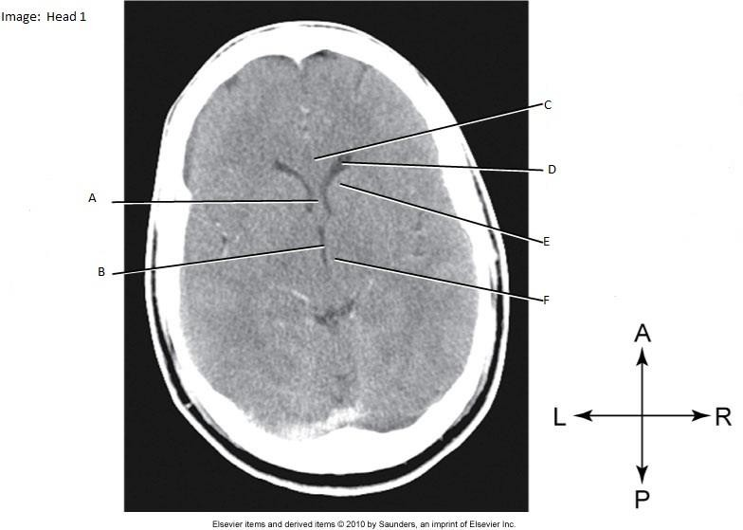

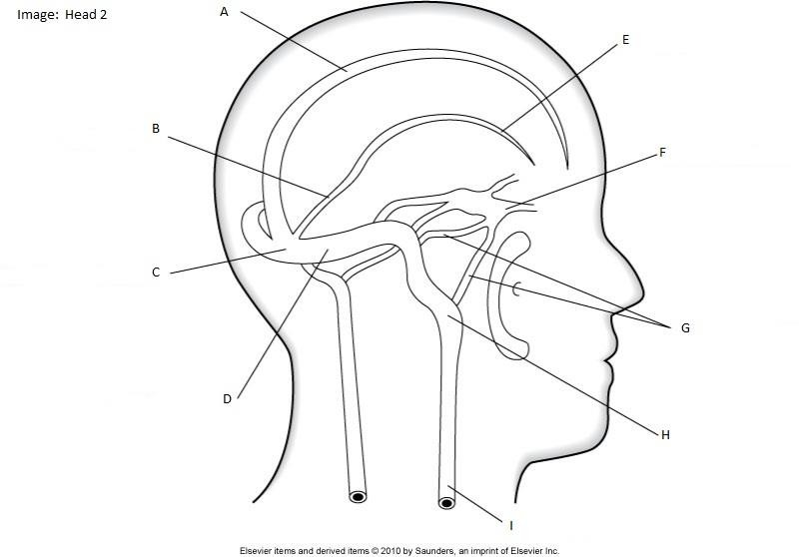
Venous Drainage Sinuses

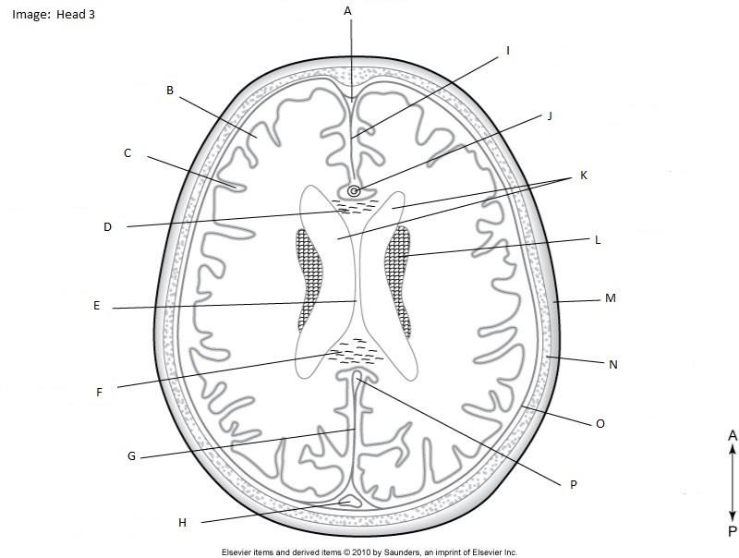
Axial Head Anatomy

- I.

- J.

- K.

- L.

- M.

- N.

- O.

- P.

Axial Head/Sinuses Non Contrast
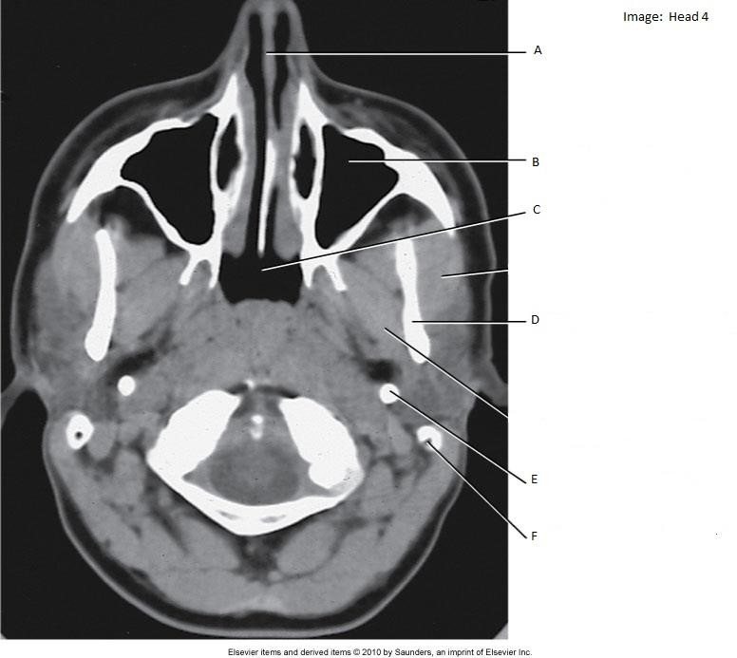

Sagittal Head MRI - for Anatomy
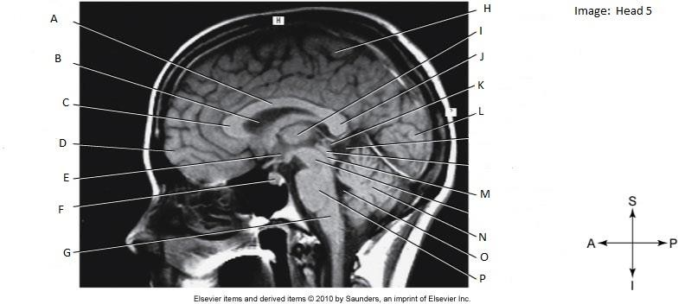

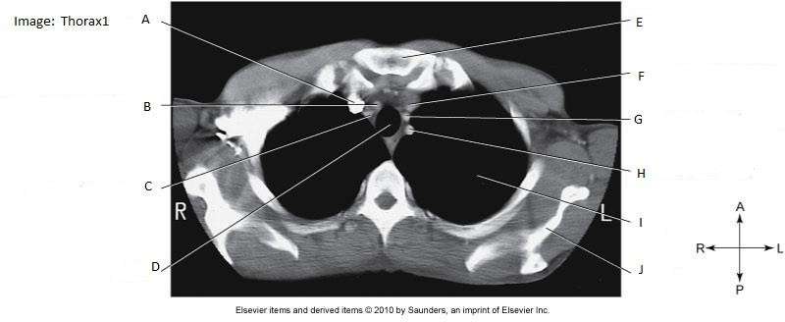
Axial Chest with Contrast

Axial Chest with Contrast
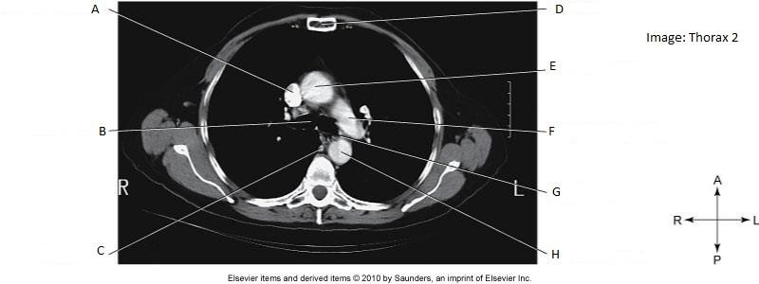

Axial Chest with Contrast
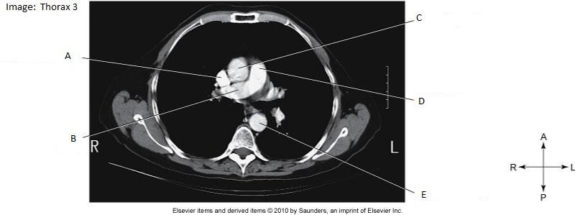

Axial Abdomen with Contrast

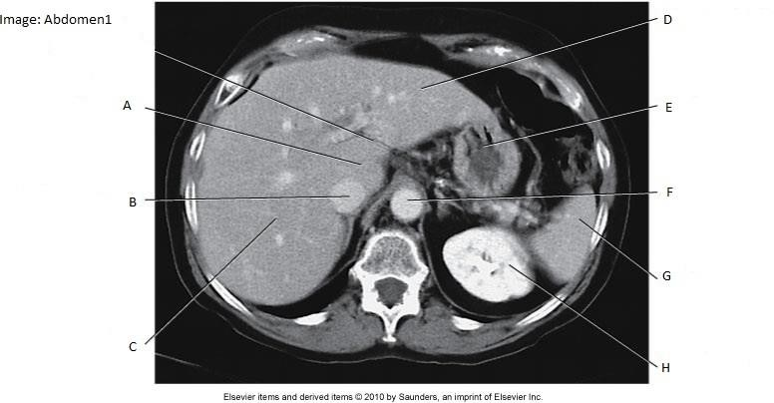

Axial Abdomen with Contrast
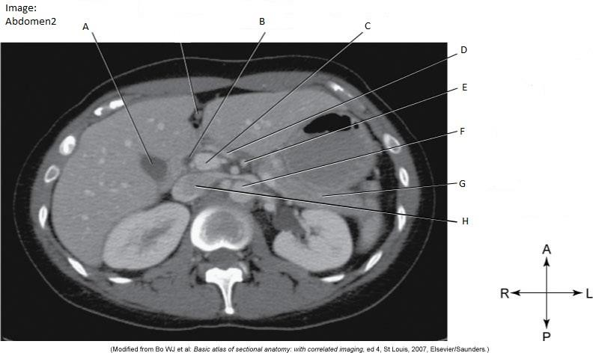

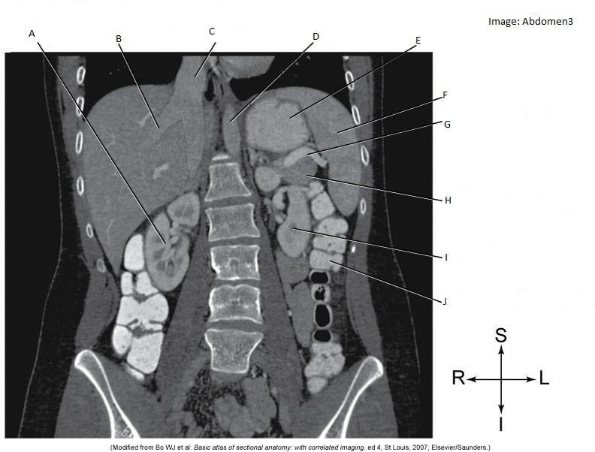
Coronal Abdomen with Contrast (IV and Oral)

- _

Axial Abdomen with Contrast

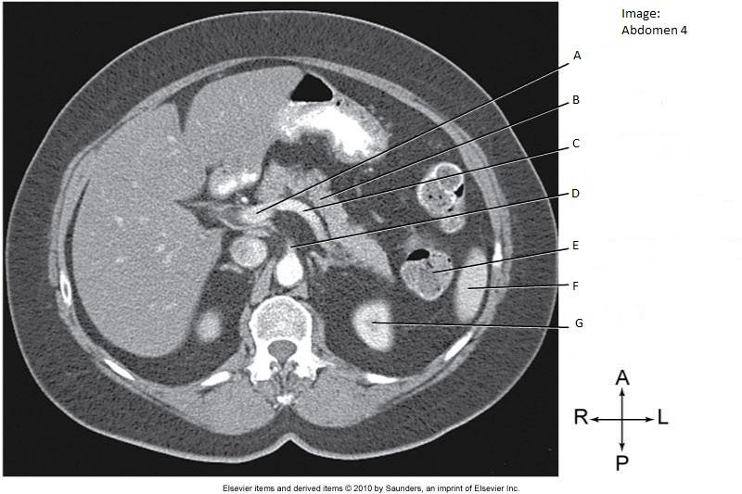

Axial Pelvis with Contrast
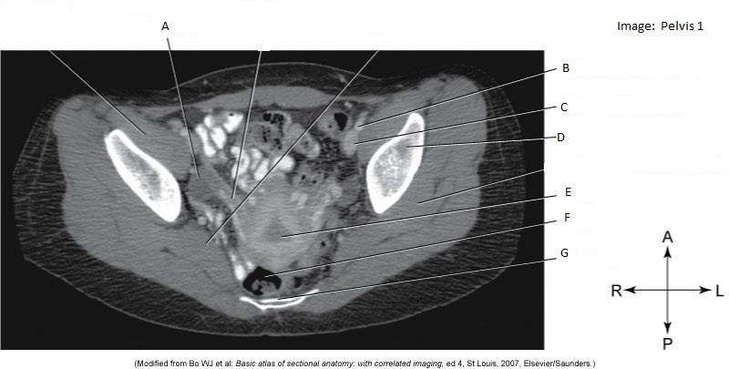

- _

Axial Pelvis with Contrast (Arterial Phase)
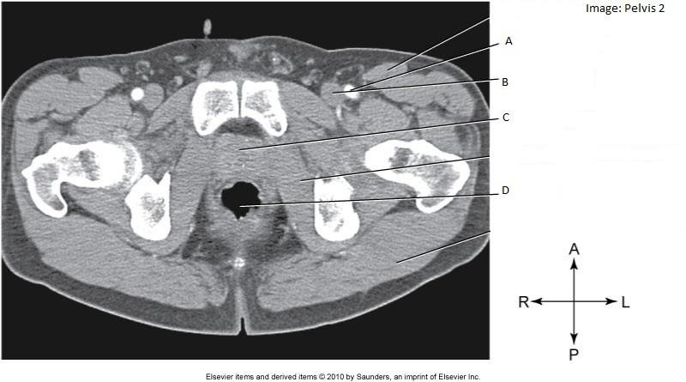

Section 4: Test your Knowledge

– Questions
**Answer Key Available – Please contact your Clinical Instructors**

    - What are the types of Contrast used specific to your clinical site: IV-
Oral- Rectal-
    - When creating a coronal reformat, the direction of images will run:

    - What are the average CT #’s for: Bone Fat Blood Air _

    - At your site, what is a typical WW/WL for:
Head/Brain: _ Bone: Lung: _ Mediastinum: _ Abdomen: Angio: _

    - The range of CT numbers displayed on an image is the Window . This controls: .

    - The centre of the range of numbers (grey scale) is the Window . This controls: .

    - What is the difference between a reconstruction and reformat?

    - Briefly describe Axial/Sequential Acquisition and Helical Acquisition:

    - Give examples of where Axial scanning is utilized.

    - Give examples of how an ROI is utilized?
    - Why would you avoid or limit IV contrast in a person with elevated creatinine?

    - When would be the only time a patient with a significantly elevated creatinine level could receive IV contrast?

    - Which of the following conditions is an indication for a CT scan of the head without intravenous (IV) contrast?
      - stroke
      - aneurysm
      - metastatic disease
      - arteriovenous malformation

    - Which of the following structures produces cerebrospinal fluid as the result of filtration and secretion?
      - choroid plexus
      - lateral ventricles
      - fourth ventricle
      - pineal gland

    - The celiac artery corresponds to the level of:
      - T7.
      - T11.
      - L1.
      - L3.

    - The level of the Carina is typically at:
      - C3
      - T2
      - T5
      - T12

    - The bifurcation of the abdominal aorta occurs at the level of:
      - L1.
      - L3.
      - L4.
      - L5.

    - Which three veins empty into the portal vein?
      - splenic, gastric, hepatic

      - splenic, gastric, superior mesenteric
      - splenic, inferior mesenteric, superior mesenteric
      - gastric, inferior mesenteric, superior mesenteric

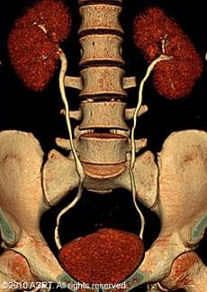
    - This image represents an example of:

      - straightened multiplanar reformat
      - volume-rendered 3-D.
      - neuro digital subtraction angiography.
      - curved planar reformat.

    - Edge gradient (Beam Hardening) artifacts appear as a:
      - streak.
      - ring.
      - band of noise across the image.
      - white circles.

    - Which of the following techniques reduces edge gradient/Beam Hardening artifacts?
      - scanning with thinner slices
      - decreasing data sampling rates
      - scanning with thicker slices
      - using detectors with large apertures

Case Studies

**Answer Key Available – Please Contact your Clinical Instructors**

Case Study 1

A 22 year old female arrives from Emergency for a routine Abdomen/Pelvis CT scan. The

patient’s history is RLQ pain for the past 48 hours, the physician is querying appendicitis.

The patient’s chart indicates her blood creatinine level is normal; she is non-diabetic and a non-smoker; her pregnancy test is negative; she weighs 60 kg.

a) What is a normal blood creatinine range for a female? Male? _

Does this patient have any contraindications for IV contrast?

What is the oral contrast protocol (if any) for this type of scan?

Describe the patient position on the table.

What projections are the scout images for a routine Abdomen/Pelvis?

What anatomy needs to be included on a routine Abdomen/Pelvis scan?

Describe the IV contrast protocol.

What type of contrast should be used, ionic or non-ionic?

What is the contrast volume?

What is the contrast injection rate?

What is the scan delay, post contrast injection?

What are the appropriate kV and mA settings for this type of scan?

What are the breathing instructions for this type of scan?

What reconstruction planes are used?

What is an appropriate WW and WL for an Abdomen/Pelvis scan?

Describe the radiographic appearance of appendicitis on a CT scan.

Case Study 2

A 71 year old male arrives from Emergency for a Head CT scan. The patient’s history is LOC (loss of consciousness), disorientation, headache and slurred speech; the physician wants to rule out a bleed or mass in the brain.

What type of head scan will the Radiologist choose, enhanced or non-enhanced? Explain why.

Describe the patient position on the table.

a) Describe the difference between conventional and helical CT scans.

List one advantage of a helical scan over a conventional scan.

List one advantage of a conventional scan over a helical scan.

What anatomy needs to be included on a CT head?

What is an appropriate scan field of view? Display field of view?

What are the appropriate kV and mA settings for this type of scan?

What algorithm(s) are used for acquisition and reconstruction?

What is the reconstruction thickness and increment for this type of scan?

What is an appropriate WW and WL for a CT head scan?

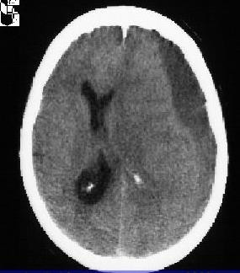
The following image is from this patient’s CT scan.

What plane is this image in?

What pathology is seen?

