RADP 2J 5 — Radiation Protection Final Exam Review — ANSWER KEY

Briefly describe the interaction

Photoelectric Absorption (PE)
  - Total absorption of the incident photon gives up all its energy to e|ect the electron in

the shell

Coherent

Occurs between very low energy photons & motfer
  - Photon changes direction buf not energy

Compton
  - Interaction between incident photon & loosely bound outer shell electron
  - Incident photon has enough energy to e|ect fhe electron from its shell, resulting in ionization of the atom
  - Incident photon is “scattered” in a different direction
  - Incident photon surrenders a portion of its kinetic energy to dislodge the electron
  - Photon could interact with other atoms by PE, Compton or may emerge from the patient & degrade the image

Pair Production

Between a very high energy incident photon of at least 1.02 MeV & the nucleus
  - Photon gives up all of its energy & two particles ore formed

Photodisintegration
  - Occurs in high-energy radiation therapy freofmenf unifs
  - High energy photon collides with the nucleus of on atom, which absorbs all of the photons' energy
  - Energy excess in the nucleus creates on instability thot in most cases is alleviated by the emission of a neutron by the nucleus

Under what conditions will we see the interaction?

Photoelectric Absorption (PE)
  - Only occurs if the energy is equal to or slightly greater than the binding energy of the

  - X-roy phofon interacts with on inner shell electron (k-shell)
  - Occurs mosf often of low kV, effecf increases wifh increasing ofomic number
  - Occurs in the bone & contrast media (when used)

Coherent

Occurs with photons fhot ore 30 KeV or less & happens less than 5% of the time

Compton
  - Probability of occurrence of Compton scattering relative to the PE interaction increases as the energy of the x-roy photon increases
  - Effecf dominates at J0 KeV & higher also increases depending on irradiated material
  - Afoms fhof hove a loosely bound outer electron hove on increased in probability of scatter

Pair Production
  - Occurs when photon has at least 1.02 MeV because the energy equivalent of the moss of one electron at rest is 0.J1 MeV
  - Photon gives up all its energy & 2 particles ore formed, a positron & a negotron
  - Positron & the negotron (electron) annihilate each other

Photodisintegration

Occurs above 1 0 MeV in high-energy radiation therapy treatments, high above any energy range in diagnostic radiology

- What are the products of this interaction?

Photoelectric Absorption (PE)
  - Incident photon e|ects on electron called a photoelectron
  - Photoelectron is a negative ion is absorbed quickly & doesn't travel for
  - Photoelectron kinetic energy is equal fo he difference between he incident phofon & he binding energy of he inner shell electron
  - Positive atom is created because the photoelectron has left the atom; resulting in one less electron
  - Characteristic radiation is given off when on electron from the L shell drops fo fill the void leff by he photoelectron
  - Electrons drop from one shell to another in a cascade effecf creating characteristic radiation equal fo the difference between the binding energies of the 2 shells

Coherent

  - The incident photon emits the some amount of energy absorbed but in a different direction, called a scattered photon Scohering has occurred but it is unmodified because the energy of the photon does not change

Compton
  - Incident phofon will deposit some of ifs energy into fhe ofom causing on electron fo

be e|ecfed
  - Loss of on electron, atom becomes a positive ion
  - E|ected electron is called Compton or Recoil electron
  - After the incident phofon has deposited some of ifs energy, if will become a scattered phofon
  - Energy & direction of scatter depends on the energy of the photon
  - High energy photons usually will travel in a straight line

Pair Production
  - Photon gives up all ifs energy producing two particles
  - Negotron is a regular electron
  - Positron is a positively charged electron
  - Both love the some moss & magnitude of charge

Photodisintegration

Energy causes on emission of a neutron by fhe nucleus
  - Other emissions profon , proton-neutron or alpha particles ore possible process makes a nucleus radioactive

- List some factors that need to be token into consideration when designing on X-roy room or department.

- Location within the building
- Protective barrier requirements
- Use of adioining rooms

- What lypes of radiation do we need to protect against

- Primary radiation
- Scatter radiation”
- Leakage radiation”

* Bofh scatter & leakage radiations ore collectively known as secondary radiation

- What factors need consideration when determining the shielding necessary for diagnostic X-ray installations.

- Primary or Secondary Barriers

Any wall fo which a primary beam may be directed Materials- Lead bonded to drywoll or wood poneling Concrete, concrete block or brick
4” of masonry is equivalent to 1/16“ of lead
Secondary:
Less thick than primary barriers, provide shielding from leakage and scatter Materials- Lead often not required
For control boofh, is always considered secondary barriers as the primary beam is never directed of the control booth.

- Distance from the radiation source
Distance between the nearest poinf of area fo be shielded & main position of fhe tube
To adjacent room occupied not |ust to inside wall of x-roy room Often best to put tube in the middle of the room

- Occupancy factor of the area (T) Use of fhe area to be profecfed
High use area more shielding needed fhon if low use area Time of occupancy (T) fhe determining factor

Complete the Occupancy Factors as per SC 3J

Adminisfrofive offices and receptionist areas, laboratories, pharmacies and ofher areas fully occupied by on individual, offended wailing rooms, children's indoor ploy areas, od|ocenf X-roy control room, living quarter
T = 1

T = 1/20 | Public toilets, unattended vending areas, storage rooms, outdoor areas with seating, unohended waiting rooms, patient holding areas
T = 1/40 | Outdoor areas with only transient pedestrian or vehicular traffic, unattended parking lots, vehicular drop off areas (unattended), attics, stairways, unattended elevators, |onitor’s closets

T = 1/2 T = 1/J T = 1/8
Rooms used for patient examinations and treatments Corridors, pofienf rooms, sfoff lounges, staff resf rooms Corridor doors

- Controlled or Uncontrolled area Controlled
Any area occupied by workers who love been trained in radiation safety procedures & who wear radiation monitoring devices

Uncontrolled
Area in which member of the general public may be found Individuals who ore not trained to work with radiation

- Workload (W)

Level of radiation activity in a room per week
Greater workload (activity) means more shielding needed W is expressed in mA minutes per week

- Maximum & average tube potential & output

KVp is used to measure penetrobilily of the beam
Con go as high as 1JO kVp, but mostly around 7J kVp Constant operation assumed at higher kVp to be safe

- Use factor (U)

Amount of time the useful beam is directed towards the barrier under consideration
Complete the Use Factors as per SC 3J

Primary Barrier
U = 1 | Floors of radiation rooms, walls containing a vertical image receptor; any other walls, doors, or ceiling areas routinely exposed to the direct radiation beam
_{U= 1/4} Doors and wall areas of radiation rooms not routinely exposed to fhe direcf radiation beam
_{U = 1/16} Ceiling areas of radiation rooms not routinely exposed to the direct radiation beam
Secondary Barrier
U = 1 | The use focfor for secondary protective barriers is always foken to be 1

- What is the minimum barrier requirement for the control booth?
  - The control boofh, and fhe viewing window, must hove shielding properties such fhot no operator is occupotionolly exposed to more tion 0.4 mSv/week
  - The walls of the control boofh ore calculated as secondary barriers

- Scatter at one meter from the patient is defined as 0.1% intensity of the useful beam.

- If on exam results in 250 mR at the patient, what will the scatter be at 1 meter away?

2J0 mR X 0.001 = 0.2J mR at 1 meter

- If on exam results in 350 mR at the patient, what will the scatter be at 2.5 meter away?

3J0mR X 0.001 = 0.35 mR at 1 mefer

Use ISL

𝐈𝟏
𝐈𝟐
= (^{𝐝𝟐})
𝐝𝟏
𝟐
I .0.3JmR
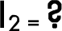

di-1
d2-2.J

I2 - (1 w)² X 0.3J mR
(2.J m)²

!2 -0.056 mR
- What will the total primary beam be if the output is 1.J0 mR/mAs, the weekly beam-on time is 7' minutes and the average mA is 1 SO?

JmR/mAs x 1J0mA x (7' x 60s) = 94J00 mR

  - What will the scatter be at a control booth 2 meters away for the above question?

Scatter at 1 meter = 94.J mR

0 2m 94.J /4 = 23.62J mR

  - What would the leakage be at the control booth 2 meters away?

Leakage at the tube: 100 mR/hr (7/60) = 11.67mR

Leakage @ 2m: 11.67mR / 4 = 2.92mR

  - What is the total amount of secondary radiation at the control booth?

2.92mR + 23.62J mR = 26.J4J m

- Describe the radio sensitivity of spermatogonia and ovo during their different stages.

Spermatogonia
•
•
•
•
•
Ova
•
•
•
•
•
•
Mature ore specialized and so less rodiosensitive (no longer dividing) Immature ore still dividing rapidly and so ore extremely rodiosensitive 2 Gy may cause temp sterility for as long as a year
J or 6 Gy may cause permanent sterility
0.1 Gy may cause genetic mutations

Rodiosensifivily varies during the lifetime of a female
Immature ono ore very rodiosensitive — in young females (fetus to young child) At puberty less rodiosensitive (Age 20 — 30 least rodiosensitive)
At 3 0, sensitivity increases until menopause
Single dose of 2 Gy to ovaries con cause temp sterility

Single dose of J Gy con cause permanent sterility

- List the recommended limits for pregnant radiation workers.

  - 4 msv once pregnancy has been declared
  - Fetal monitor processed every 2 weeks

- Who is required to calculate fetal exposure?

  - Radiation Safely Officer/Medical physicist responsible to calculate the fetal exposure

1 S. List some modifications and considerations that should be made in regards to exams involving a pregnant patient.

- When if is in he best inferesf of he pf, x-roys must be foken
- Use gonodol shielding whenever possible
- Prone vs supine to save the fetus dose
- Close collimotion
- Double shielding
- Limit views as per rodiologist

- Describe the possible effects of irradiation in utero at different stages of pregnancy.

  - Time and dose related
  - Prenatal death, neonatal death, congenital abnormalities, malignancy induction, general impairment of growfh, genetic effects and menfol retardation
  - Wifhin 2 weeks of fertilization, prenatal deofh (spontaneous abortion) — all or nothing response.
  - 2 — 10 weeks — congenital abnormalities

2 — 1J weeks mental retardation
  - 0 — 9 months — malignant disease, impaired growth and development, genetic
mutation

Increase in these effects is extremely due to radiation. Effects occur more often naturally

1 Z. Why is it useful to be aware of the patient's previous exams?

It may make further examination or a full exam unnecessary, also, if there is any pathology or conditions present, technical factors/positioning con be adjusted accordingly.

What is the purpose of Diagnostic Reference Levels (DRL)?

They ore guidelines for pofienf dose during diagnostic procedures. If has been found thot dose varies considerably between institutions. The DRL's provide a guide to be used for comparison of average doses and optimize doses during procedures

What constitutes unnecessary patient dose?

Any dose thot is not required for the patient's well being or proper management and core.

When is it acceptable to perform a repeat exposure?

When the original radiograph does not include fhe required diagnostic information

- How can good communication help decrease patient dose?

Decrease repeats
  - Reduces voluntary mofion
  - Patient cooperation

Reduces anxiety

- AP or PA: Which scoliosis position will decrease breast dose & why?

PA
  - Places fhe breasts farther from he lube
  - X-roys absorbed by lhe beck not lhe breasts

What is the main reason why the proper use of immobilizotion devices may decrease patient dose?

  - Decreases repeats due to motion

- Define the following terms:

LET

The measure of the rote of which energy is transferred from ionizing radiation fo
moffer
  - Average energy deposited per unit length of track is known as LET (linear energy transfer)

High LET

  - Causes dense ionization along ifs lengfh of frock
  - Higher likelihood of interacting with biologic tissue
  - More destructive buf connof travel/penetrate as for
  - Particles wifh substantial moss & charge
  - E.g. alpha particles

Low LET

  - Electromagnetic radiation fhot is sparsely ionizing
  - Has random inferocfions along the lengfh of ifs frock
  - Usually causes indirect damage (free radicals)
  - E.g. x-roys, gamma roys
Target Theory

A key/master molecule fhot is necessary for the survival of fhe cell, if if is damaged/inocfivofed by radiation fhe cell will die . DNA is considered critical torgef

Low of Bergonie & Tribondeou

  - Most rodiosensitive cells ore the ones thot love the least maturity & least

specialization & the highest reproductive activity

Indirect action

Effect of radiation thot results from the production of free radicals produced by the interaction of radiation with water
  - Free radicals ore the cause of the damage

Direct action

  - When ionizing particles interact directly wifh biologic mocromolecules & damages

fhem (DNA)

Relative Biologic Effectiveness (RBE)

Describes the relative capabilities of radiation with different LETs to produce a particular biologic reaction

Acute Radiation Syndrome (ARS)

AKA Radiation Sickness
  - Collection of symptoms associated with high-level radiation exposure

Equivalent dose

  - Radiation quantity used to compare exposures from different types of ionizing radiation
  - Numerically specifies he differences in biologic harm produced by different fypes of radiation

Direct Transmission

X-roy photons fhot pass through a patient without interaction
  - Cause no increase in dose

Protraction

  - Continuous dose delivered at a lower dose rote

Fractionation

Dose delivered of some dose role, buf separated info equal fractions delivered wifh a lime period in between
  - E.g. one dose of J0 rod every 24 hours for 8 treatments as opposed to one dose of

400 rod at once.

Lethal Dose

LD 50/30- Kill J0% within 30 days

What is the difference between the absolute risk model, excess (biologic) risk model & the
relative risk model?

Absolute risk

Predicts a number of excess cancers thot will occur as a resulf of exposure
  - Units of cases/population/dose
  - AI least 2 different dose levels ore known
  - Assumes non threshold linear dose relationship

Plotted & defined by the slope

Relative risk

Model used to estimate late radiation effects wifhouf knowing precise dose exposure
  - Define by fhe percentage increase from normal (non exposed) population

Excess risk

  - Number of cases of a particular effect over & above the expected number

- Explain: Ionization

Ionization refers to when radiation causes an electron to be e|ected from on atom

Explain: Excitation

Excitation refers to when radiation causes an electron to reach a higher energy state, but to remain with the same atom.

- Draw a nonlinear threshold & nonthreshold radiation response
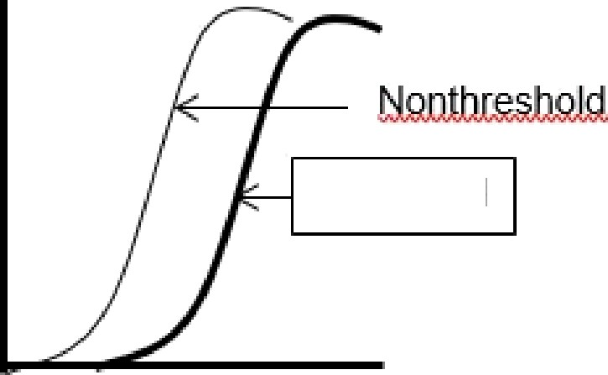

Threshold

Draw a linear threshold & linear nonthreshold radiation response
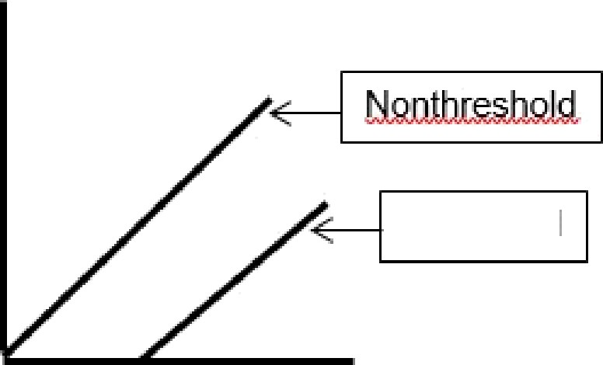

Threshold

- Define Tissue reactions/Deterministic Effects

Biological response whose severity varies wifh radiation dose

- Define Stochastic/Probabilistic Effects

Probability or frequency of the biologic response to radiation as a function of the radiation dose. Disease incidence increases with dose and there is NO threshold.

- Define the following terms:
- equivalent dose: (EqD): Dose quantity that takes into account the type of radiation used. Provides on indication of the potential for biological effects. Used for risk comparisons between different fypes of radiation. Sv

Radiation weighting factor (W(R))

EqD = D x W(R)

- effective dose: (EfD): Provicles a measure of overall risk to humans from ionizing racliationTakes into account the part of the body that is irracliated. Sv or msv

Tissue weighting factor (W(T))

EfD = D x W(R) x W(T)

- absorbed dose (D) Radiation energy absorbed per unit moss. J/kg or Gy

