ANPH 202 – Anatomy and Pathology 1
Worksheet – Circulation

- Please label the vessels in image 1. Be sure to label the anatomical side:

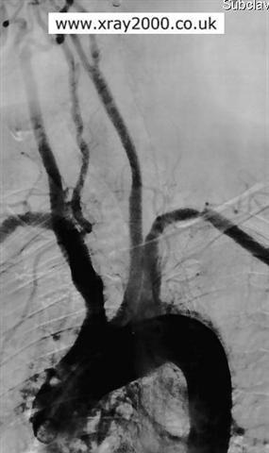
Image 1

1.

2.

3.

4.

5.

6.

7.

8.

2) List the following sections of the aorta in order, from the most proximal to the most
distal:

descending thoracic aorta
aortic arch
abdominal aorta
ascending aorta

3) List two exterior landmarks of the body that correspond to the bifurcation of the aorta.

4) Study the branches of the abdominal aorta and see if you can draw them from memory in the space below. Be sure to include the location of the celiac trunk, renal arteries, left gastric artery, common hepatic artery, superior mesenteric artery, inferior mesenteric artery, and common iliac arteries.

5 ) You need to pick up your friend who lives at “47 Right Renal Way S.W.” and you live at “96 Left Subclavian Way N.E.”. As you head towards the center of town will you need to turn right or left when you come to the “Aortic freeway”? ________As you head south past the “Diaphragmatic bridge” will you need to take the first, second, or third right, after the bridge? ________

6) A radiologist wants to introduce a catheter into the left internal carotid artery. List the arteries that the catheter will pass through enroute to the final destination, given that the catheter is inserted into the left common femoral artery.

7) The smooth muscle layer of arterial walls is known as the _________________

8) Which terms best describe the external carotid artery’s relationship to the internal
carotid artery?

- Anterior and lateral
- Anterior and medial
- Posterior and lateral
- Superior and medial

9) The right vertebral artery branches off the

- Aortic arch
- Brachiocephalic artery
- Right subclavian artery
- Right common carotid

10) If your friend lived at “100 right posterior communicating artery drive” and you lived at “26 right subclavian way”, what is the shortest route that you could take to your friend’s house?

Note: This image is from Net Anatomy
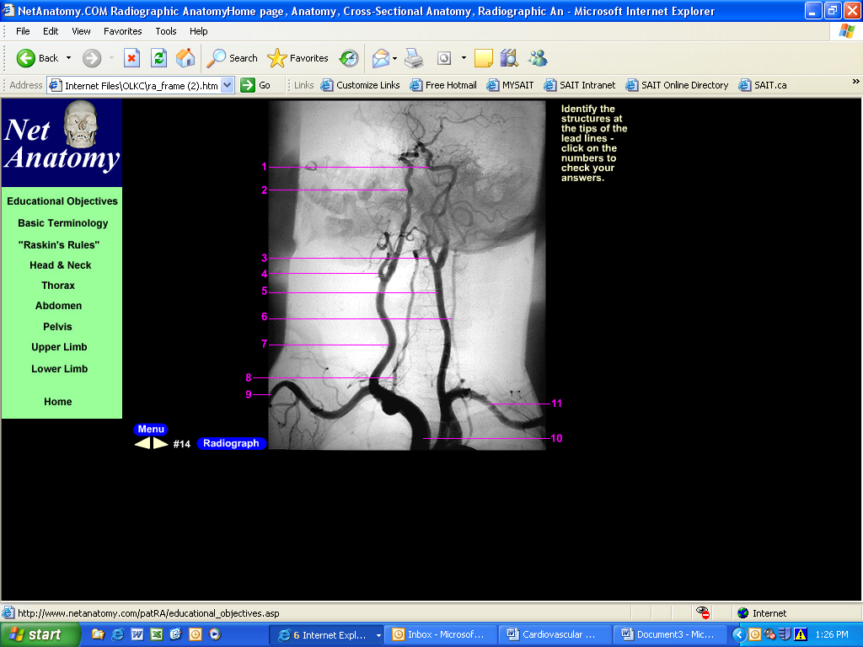
11) Label the arteries in image 2.
Image 2
1.
2.
3.
4
5
6.
7.
8.
9.
10.
11.

12) Label the arteries of the Circle of Willis below:

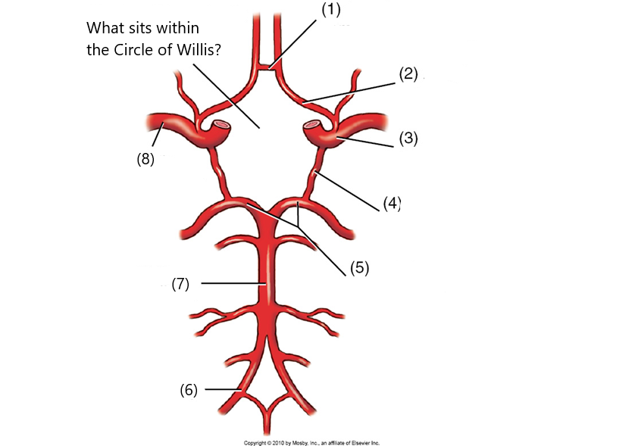
Which gland lies here?

1.
2.
3.
4.
5.
6
7.
8.

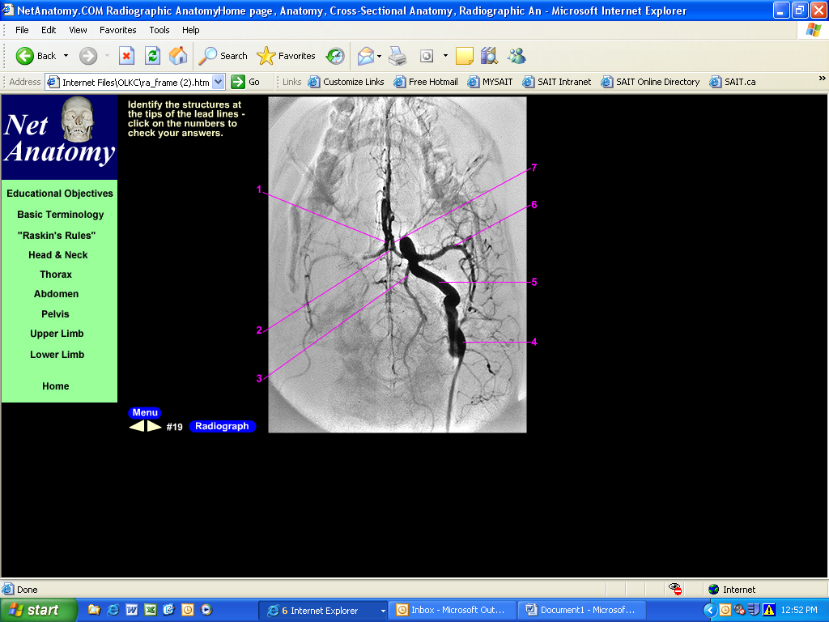
.
Note: This image is from Net Anatomy
13) Label the arteries in image 3.
Image 3

1.
2.
3.
4.
5.
6.
7.
Note this vessel is perpendicular to the Circle of Willis

Note: This image is from Net Anatomy
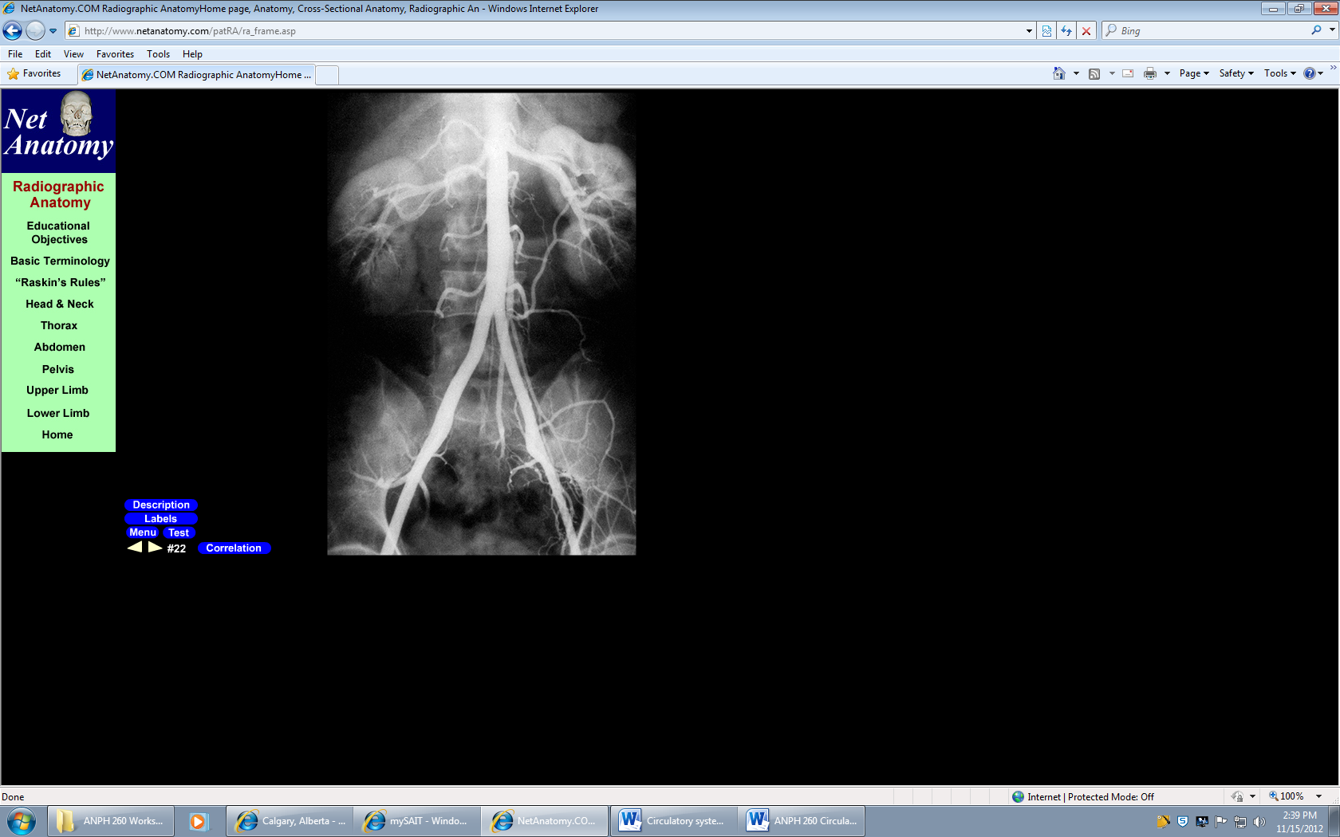
Image 4
14) Label the anatomy in image 4
1. Organ within yellow circle?

2. Artery?

3. Artery?

4. Artery?

5. Artery?

6. Artery?

Venous Circulation, Dural Sinuses and Portal System

To complete the following questions, please refer to pages 660,662,663,664, in Bontrager

15) Label the veins on image 5.
Image 5

A
A
B
C
D(superficial)
E
G
F (superficial)
H

B

C

D

E

F

G

H

16) Which of the veins in the image above are useful for venipuncture?

17) Which of the veins in the image above may be used to insert a central line for the
administration of drugs?

18) Which of the following is true regarding the IVC?

a) The portal vein dumps into the IVC
b) Blood pressure in the IVC is very low
c) It lies a little to the left of the spine
d) It branches into the right and left external and internal iliac veins at the level of L4

19) Which of the following is true regarding the SVC?

a) It only receives blood from the head and neck
b) Its proximal end is at the confluence of the right and left brachiocephalic veins
c) It dumps deoxygenated blood into the left atrium of the heart
d) It anastomoses with the IVC

20) The portal vein carries nutrient rich deoxygenated blood from the digestive organs to the
liver, where solute and nutrient levels are regulated, and foreign matter is removed T F

21) Which of the following will provide a palpable pulse?

a) IVC
b) Internal Jugular vein
c) Brachial vein
d) None of the above (veins do not provide a pulse)

22) Which of the following is true regarding the dural sinuses?

a) They are contained within the folds of the dura mater
b) They drain into the carotid veins
c) They lie in the subarachnoid space
d) They drain into the external jugular veins

23) On image 6, label the superior sagittal sinus, and the transverse sinus.

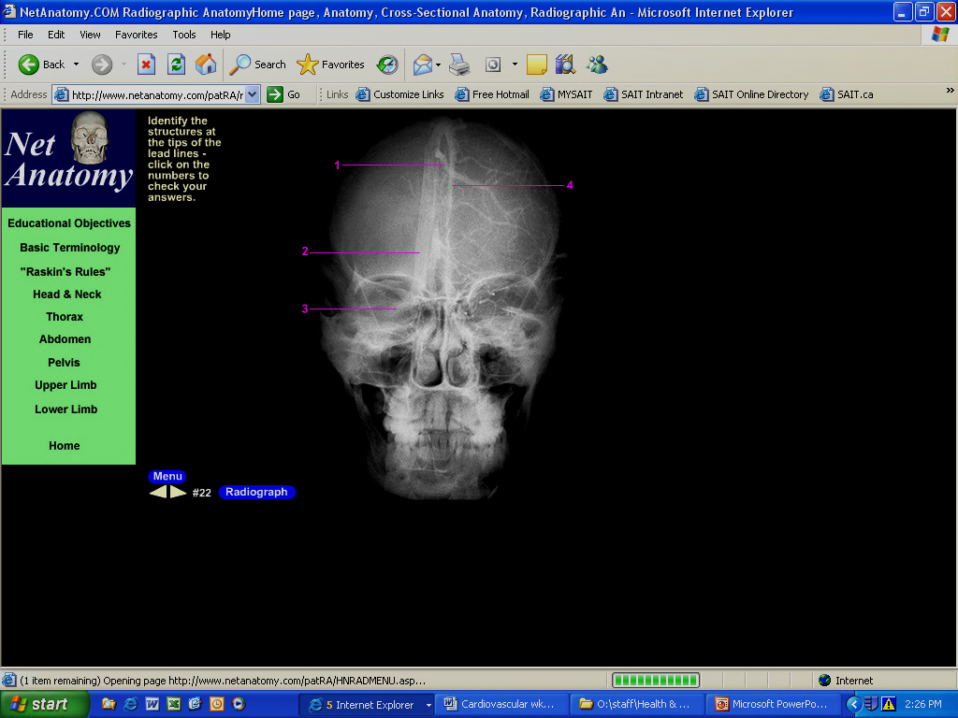
Image 6

Note: This image is from Net Anatomy

24) Which is more anterior, the SVC, or the thoracic aorta?

25) Which lies more to the right, the IVC or the aorta?

26) Describe how the cerebral sinuses are similar to veins.

27) Arteries have three layers to their walls but veins have only two. T F

28) The blood pressure in the portal vein is higher than the blood pressure in the IVC. T F

29) There are ______ pulmonary veins:

  - One
  - Two
  - Three
  - Four

