ANPH 252 – Anatomy and Pathology 2
Activity – Nephron and Kidney Labelling







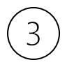


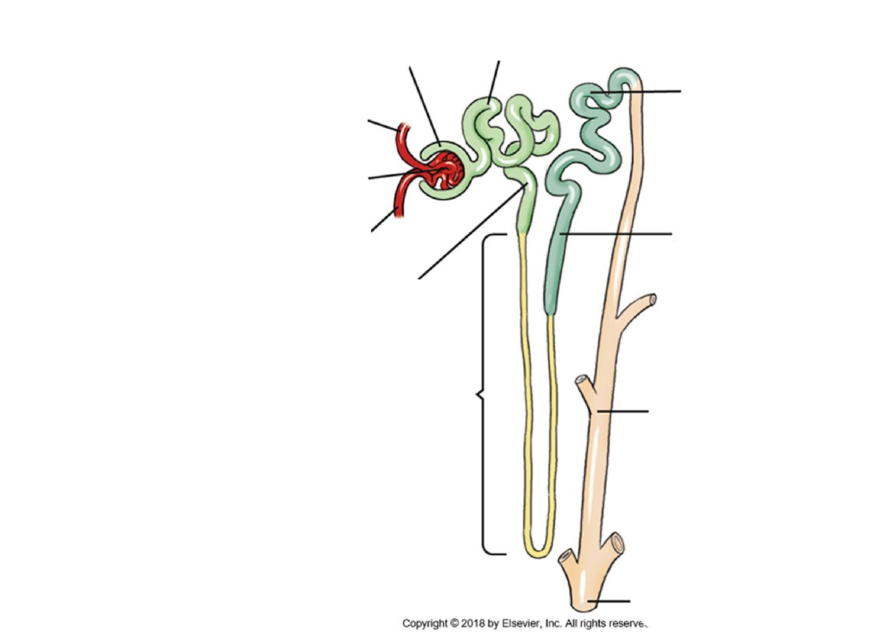
1. 6.
2. 7.
3. 8.
4. 9.
5. 10.











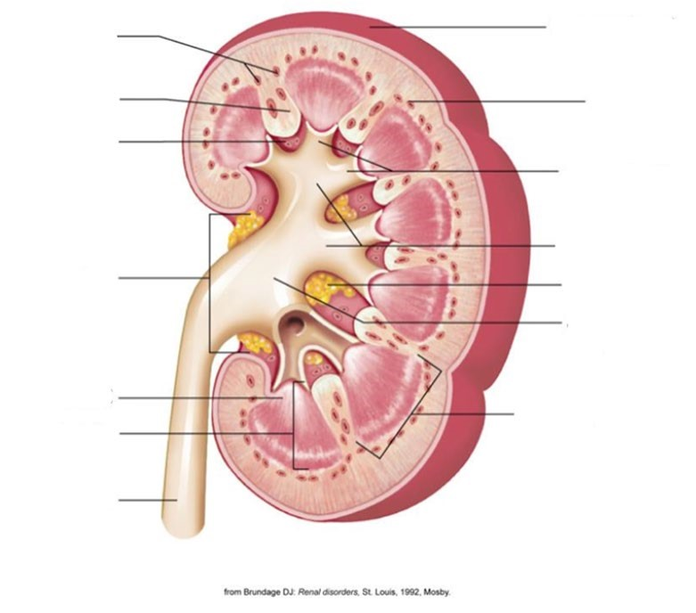
13
11
12
1. 11.
2. 12.
3. 13.
4.
5.
6.
7.
8.
9.
10.

