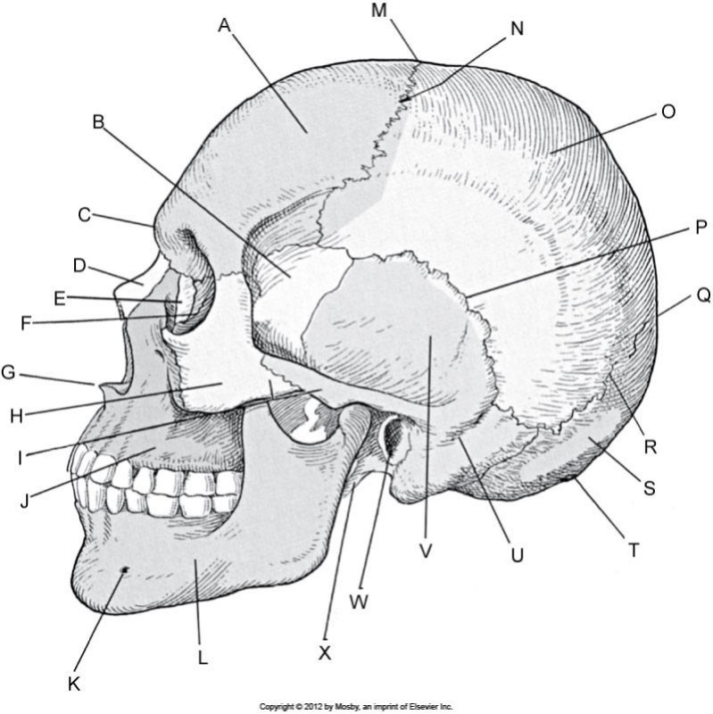Ethmoid
Frontal bone
Sphenoid
Glabella
Nasal bones
Lacrimal bone
Anterior
nasal spine
Zygoma
Zygomatic arch/
zygomatic
process of
temporal bone
Alveolar process
of maxilla
Mental foramen
Mandible
Styloid process
EAM
Temporal
bone (squamous
portion)
Mastoid portion of
temporal bone
inion
Occipital bone
Lambdoidal suture
Lambda
Squamous suture
Parietal bone
Coronal suture
Bregma
1

MRT Program
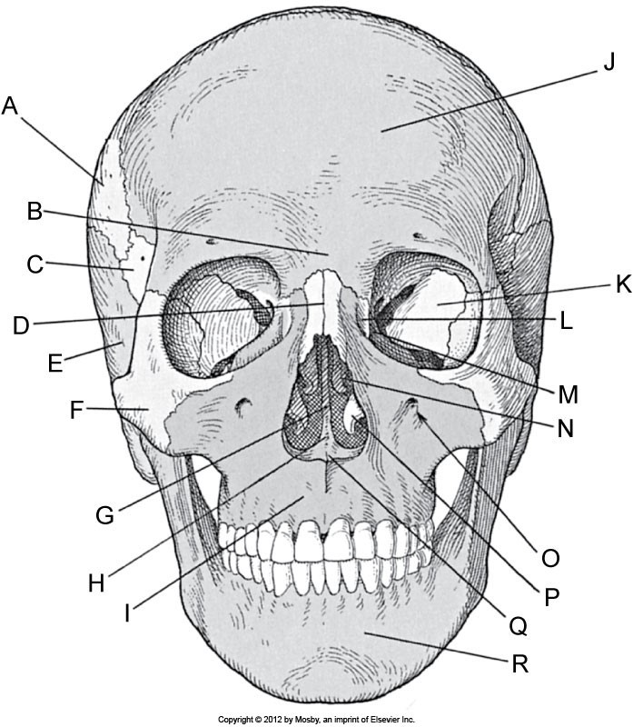
Glabella Sphenoid
Parietal bone
Nasal bone
Temporal bone
zygoma
Perpendicular plate of
Vomer
Alveolar process
of maxilla
Mentum
Anterior nasal spine
Inferior nasal concha
Infraorbital foramen
Middle nasal concha
Ethmoid
Lacrimal bone
Sphenoid
Frontal bone
ethmoid
2

MRT Program

