Worksheet: X-ray production Review - Answers

Purpose:
Objective 1.1: Explain the process of x-ray production in an X-ray tube.

Instructions:
Identify the assemblies, and path of electron travel; Label the parts of the X-ray tube.
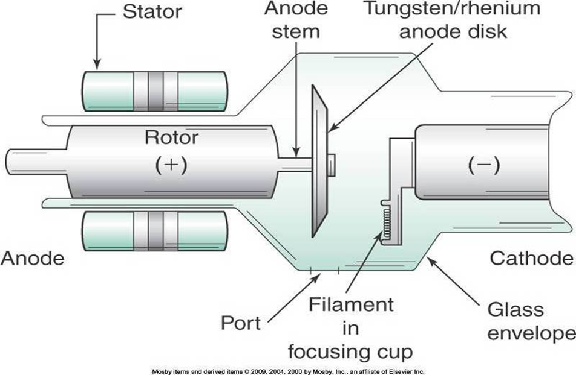
*Port = Window

Instructions:
Answer the multiple-choice questions.
- The negative side of the x-ray tube holds the:
  - Filament
  - Target
  - Rotor
  - Cathode

- What causes thermionic emission?
  - Rotation of the target
  - Current variation
  - Potential difference
  - Heating the filament (enables electrons to “boil” off the filament)

- What is a characteristic of a Target used in conventional CT scanners?
  - Lightweight
  - Fast cooling rate
  - Prolonged tube life
  - Fixed (conventional = old; in older tubes, the target did not rotate)

- Why does CT use a thicker Target, than GR x-ray tubes?
(Thicker targets enable ↑ heat capacity so we can take more exposures for a longer period, in CT)
  - Enables higher target rotation speeds
  - Decreases spatial resolution and heat dissipation
  - Increases the heat load on the anode target
  - Exposures are longer and produce more heat

- What is an important consideration in CT imaging?
  - Housing cooling times
(Longer exposure times ↑ heat production; should always consider how much time you have available to scan, to ensure you can image all required anatomy)
  - Anode cooling times
  - Maximum exposure times
  - Maximum patient dose

- Where are the useful photons emitted?
  - Filament
  - Target
  - Focusing cup
  - Focal spot (the area the electrons “strike” the target)

- What enables maximum emission of x-ray photons from the tube, with the least amount of absorption?
  - Filament
  - Window (aka. port – a thinner section of tube envelope, located below the target)
  - Focusing cup
  - Target

- When electrons bombard the target, how much of their kinetic energy converts to heat?
  - 1%
  - 25%
  - 50%
  - 99%

- What is a function of an x-ray tubes protective housing?
  - Prevents electric shock
  - Dissipates heat
  - Maintains tube current
  - Prevents arcing

