4.3 Describe how to access and use Safety Data Sheets (SDS) for the safe use, handling and disposal of a hazardous product.

The safety data Sheets (SDS) must be easily available to all workers in the workplace at all times. The SDS may be stored in paper form in a binder or electronically on a computer system.
Training on where to find the SDS, how to access and interpret them is required for all workers.
Prior to using the hazardous product, the worker should review the SDS, in its entirety, for important safe use, handing and disposal information.
The following are some examples of where to find some of the information needed for the safe use, handling and disposal of a hazardous product (e.g. liquid nitrogen).
Section 2 – Hazards identification quickly identifies the hazard by displaying the hazard pictogram and grouping it with the signal word and hazard statement as highlighted by arrows on Figure 6.
Precautionary statements also provide a quick reference in this section.
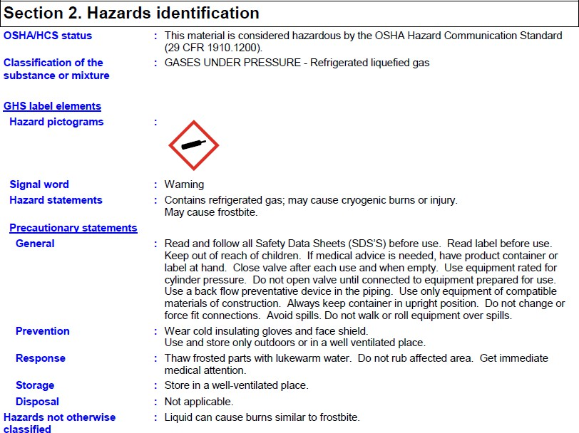

Figure 6: Safety Data Sheet (SDS) - Section 2 – Hazards Identification

Section 7 – Handling and Storage provides information on how to safety handle and store the hazardous product. The example in Figure 7 gives instructions for protective measures, occupational hygiene and conditions for safe storage. It refers the worker to Section 8 for information on appropriate personal protective equipment.
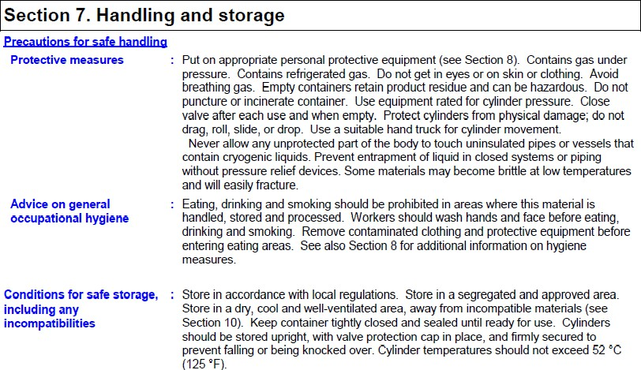

Figure 7: Safety Data Sheet (SDS) - Section 7 – Handling and Storage

Section 8: Exposure controls/personal protection informs the worker of what, if any, personal protective equipment needs to be worn to protect the worker from the hazard. In Figure 8 it is recommended that chemical resistant, impervious gloves be worn at all times and that the gloves must be insulated and suitable for low temperatures. Safe eyewear should also be worn if there is a possibility of exposure to liquid splashes, mist, gases or dust.

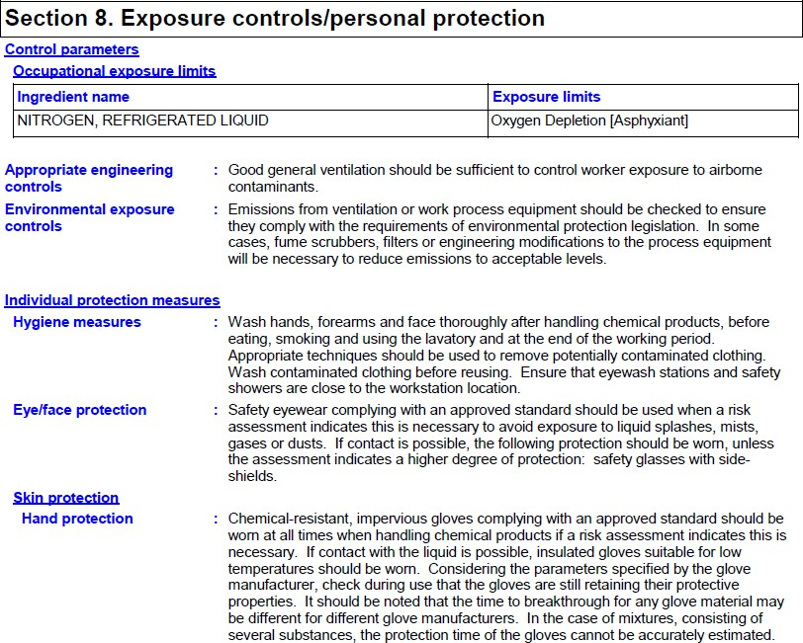
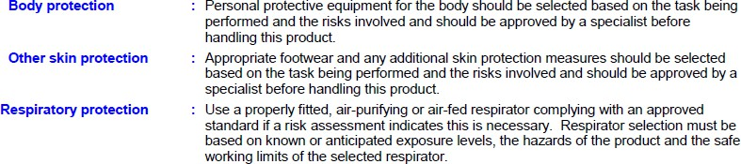

Figure 8: Safety Data Sheet (SDS) - Section 8 – Exposure Controls/Personal Protection

Section 13 – Disposal considerations provides the worker with information of how to safely dispose of waste, recyclable and non-recyclable products. Figure 9 show that waste should be disposed of safety, complying with the environmental protection and waste disposal legislation of the local authority.

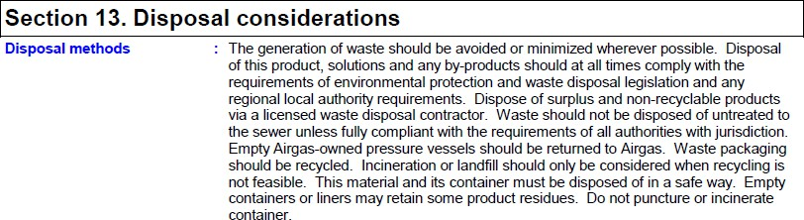

Figure 9: Safety Data Sheet (SDS) - Section 13 – Disposal considerations

