Image Critique Questions – ANSWER KEY

Module 5
1. Use the 5 evaluation criteria categories when critiquing the following image to determine if it is diagnostic:
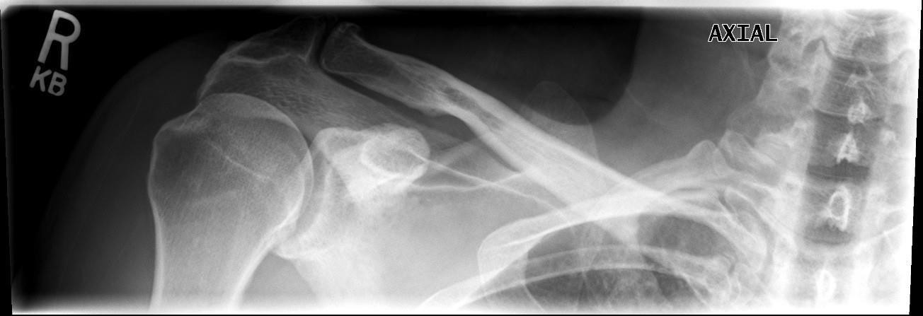
Axial Clavicle @ 75 kVp
Edenbrook Imaging Library Is this image diagnostic? Yes No *clipped anatomy
- Is all the required anatomy included in the radiograph?
Yes No
*If no, explain what is required
Entire clavicle – inferior portion of the medial end is clipped
- Does the anatomical appearance in the radiograph correlate to what is expected from an axial projection?
Yes No
*If no, explain how the appearance of this radiograph is different compared to the ideal radiograph

Superior angle of scapula superimposed over clavicle
- Shoulder is elevated, causing the clavicle to appear more vertical than normal

- Identify if the appropriate amount of radiation was used to form the image.
Acceptable, Overexposed, Underexposed
- Is motion present in the image?
Yes No
- Identify if the collimated light field was:
Acceptable, Too Small, Too Large (*side-to-side = too large, only required to include ½ of the sternum and ½-inch lateral from acromion; superior-inferior = accurate if patient positioning was corrected)
- Was the CR close to the middle of the required anatomy?
Yes No *side-to-side = okay but CR should be moved slightly more inferiorly to prevent clipping anatomy

- Does the marker placement follow ’s Marker Rules?
Yes No *no lead arrow was used to indicate it was an axial projection
- Are there artifacts in the image?
Yes No
*If yes, could they have been removed? *the electronic annotation should not be placed over anatomy

2. Use the 5 evaluation criteria categories when critiquing the following image to determine if it is diagnostic:

- Is all the required anatomy included in the radiograph?
Yes *excessive amounts No
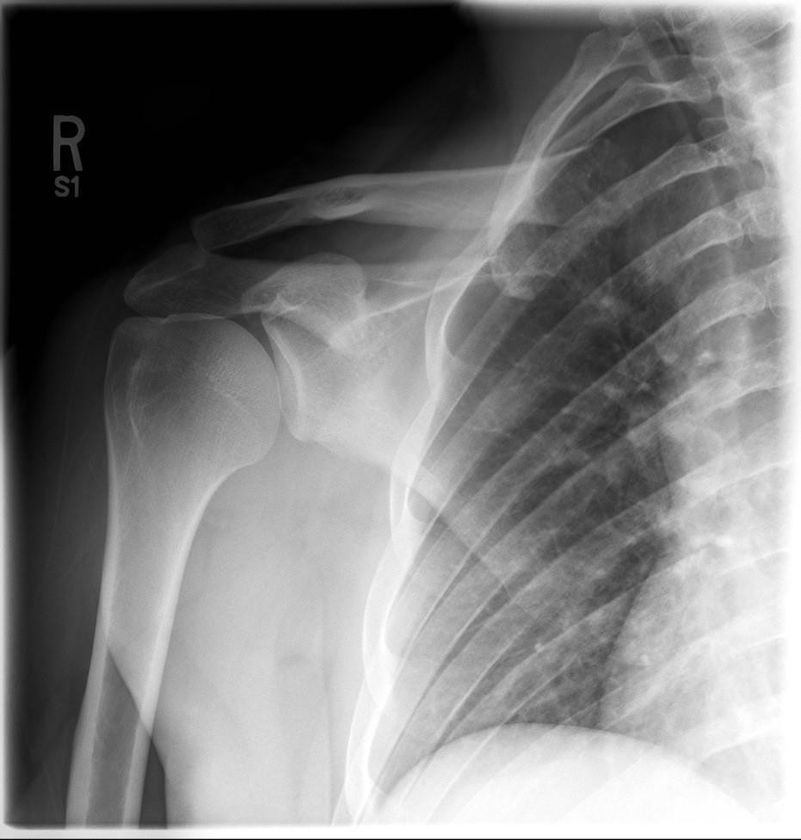
*If no, explain what is required

- Does the anatomical appearance in the radiograph correlate to what is expected from an AP oblique projection?

Glenoid @ 65 kVp

Yes No
*If no, explain how the appearance of this radiograph is different compared to the ideal radiograph

Rims of glenoid fossa are not perfectly superimposed
- Humerus should be placed in neutral rotation (greater tubercle is seen in profile laterally, suggesting the patient was instructed to maintain external rotation)

Edenbrook Imaging Library
- Identify if the appropriate amount of radiation was used to form the image. Acceptable, Overexposed, Underexposed
- Is motion present in the image?
Yes No
- Identify if the collimated light field was:
Acceptable, Too Small, Too Large *radiograph should only include area outlined in yellow
- Was the CR close to the middle of the required anatomy?
Yes No *CR needs to be moved more laterally and slightly more superiorly (over the shoulder joint)
- Does the marker placement follow ’s Marker Rules?
Yes No

- Are there artifacts in the image?
Yes No
*If yes, could they have been removed?
Is this image diagnostic? Yes No *underexposed

- Which routine projection of the shoulder is displayed?

AP Projection

- What positioning error(s) occurred?

Shoulder is elevated
- Rotation

Shoulder is rolled anteriorly (aka. Forward) i.e. poor posture = midcoronal plane tilted anteriorly

- If the image was repeated, how would you correct the positioning error(s)?

Depress/relax shoulder
- Patient is rotated/turned towards the affected shoulder; roll/rotate them until they are flat against the detector (rotate towards the unaffected side)

Ask patient to stand straight (or roll their shoulders back towards the IR)
66 kVp

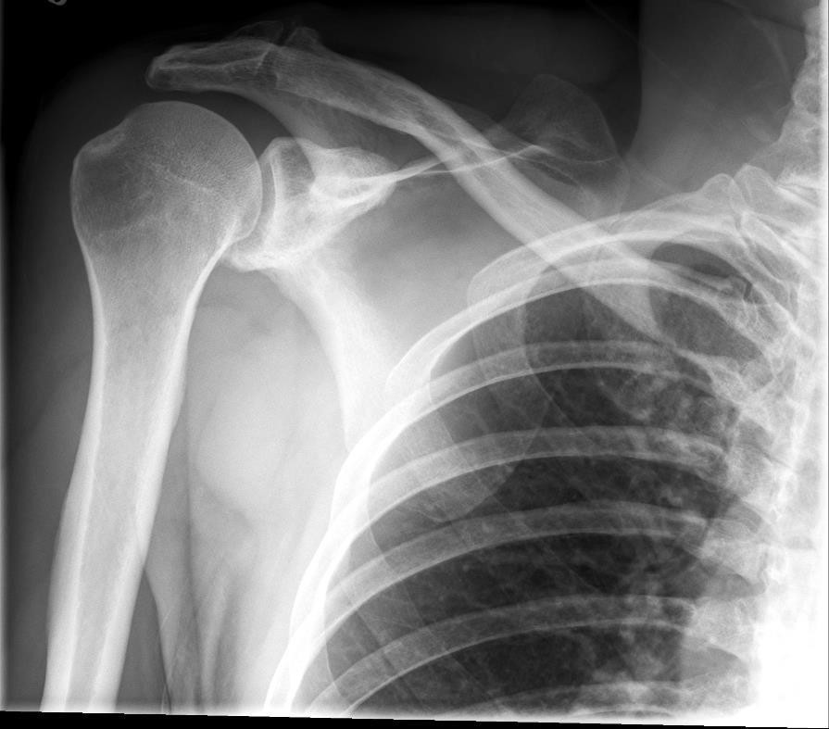
Edenbrook imaging library

- How did you identify the positioning error(s)?

Clavicle appears more vertical than normal
- Medial end of clavicle is farther away from the spine than normal

Superior angle of scapula is superior to the clavicle

- If the image had to be repeated, would you make any other adjustment(s)? Explain your rationale.

Increase the technique – image was underexposed
  - Add a lead marker to the IR prior to exposure, over the superior lateral corner as per marker rules

Abduct arm slightly and externally rotate the arm until the humeral epicondyles are parallel to the IR (currently appears more similar to a neutral rotation)
  - *Collimation and CR centering is most likely acceptable if patient was positioned appropriately

  - Use the image below to answer the next five questions:

- Which routine projection of the shoulder is displayed?

PA Oblique (Scap Y) projection

- What positioning error(s) occurred?

Shoulder is rolled anteriorly (aka. midcoronal plane is tilted anteriorly)
- Excessive arm abduction

- If the image was repeated, how would you correct the positioning error(s)?

Ask patient to stand straight (or roll their shoulders back towards the tube)
- Reduce arm abduction (ask patient to move elbow closer to their torso)

- How did you identify the positioning error(s)?

Superior angle of scapula is projected above/superior to the clavicle
- Body of humerus is not superimposing the scapular body

90 kVp

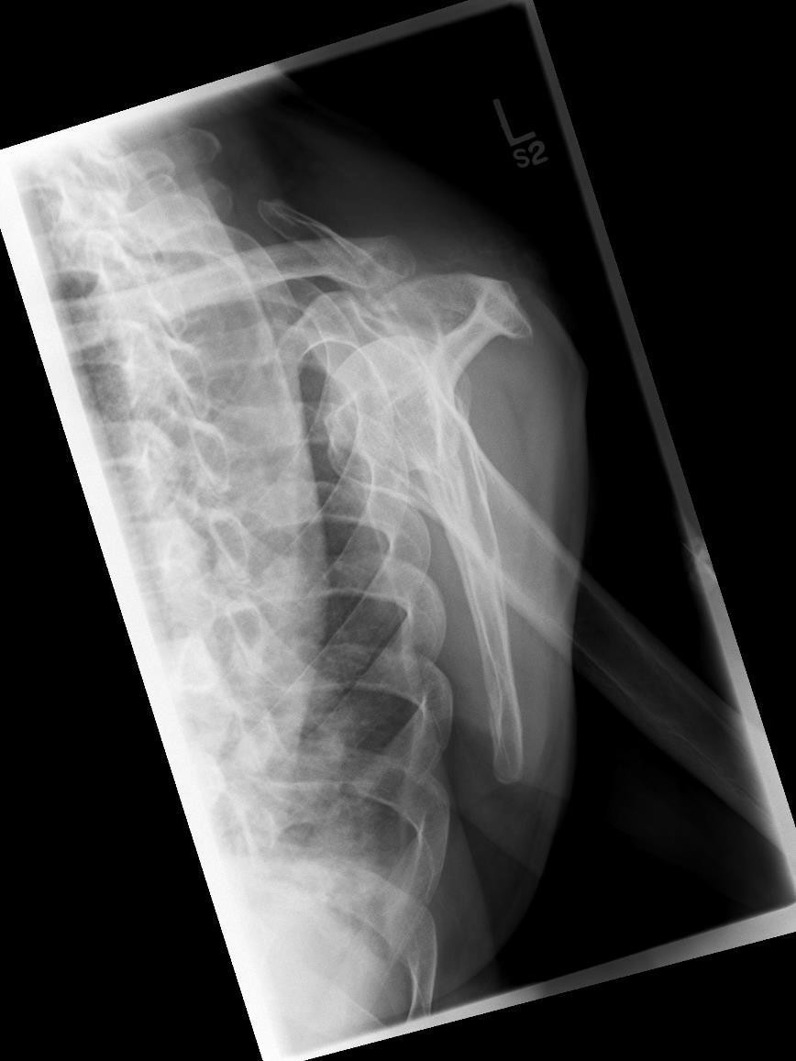
Edenbrook Imaging Library

- If the image had to be repeated, would you make any other adjustment(s)? Explain your rationale.

Decrease technique – image was overexposed
  - Center the CR over the medial border of the scapula (move centering more laterally) and increase the collimation side-to-side and superiorly-inferiorly as excessive amounts of anatomy have been included in the radiograph (collimation & CR centering should appear as outlined by the yellow box)

  - Use the 5 evaluation criteria categories when critiquing the following image to determine if it is diagnostic:

- Is all the required anatomy included in the radiograph?
Yes No
*If no, explain what is required Entire scapula – clipping inferior angle

- Does the anatomical appearance in the radiograph correlate to what is expected from a PA Oblique projection?
Scap Y @ 72kVp

Yes No
*If no, explain how the appearance of this radiograph is different compared to the ideal radiograph

Medial/Vertebral and lateral/axillary borders of the scapula are not superimposed

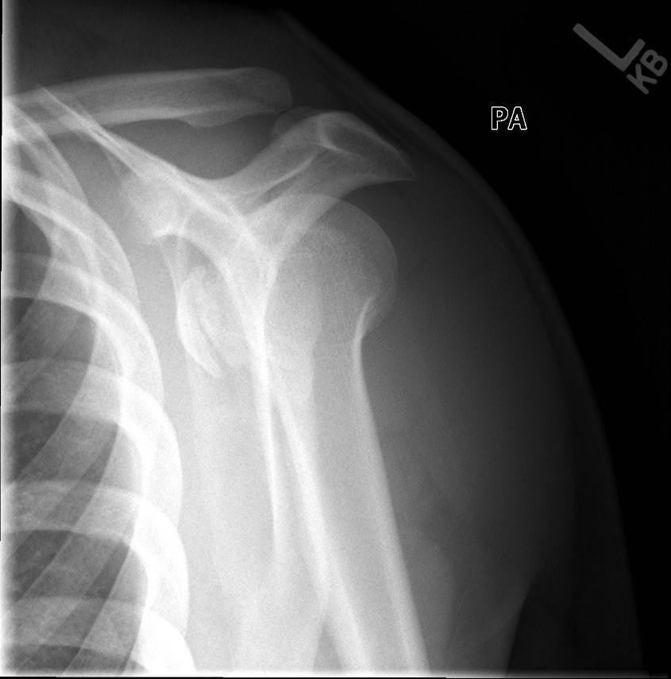
Edenbrook Imaging Library

- Identify if the appropriate amount of radiation was used to form the image.
Acceptable, Overexposed, Underexposed
  - Is motion present in the image?
Yes No
- Identify if the collimated light field was:
Acceptable, Too Small *side-to-side = okay; inferiorly-superiorly too small, Too Large
  - Was the CR close to the middle of the required anatomy?
Yes No *CR centering should be over the medial border of the scapula (when the patient is properly positioned) move CR more inferiorly and medially then decrease up and down collimation

- Does the marker placement follow ’s Marker Rules?
Yes No
  - Are there artifacts in the image?
Yes No
*If yes, could they have been removed?

Is this image diagnostic? Yes No *clipped anatomy

- Use the image below to answer the next five questions:
70 kVp
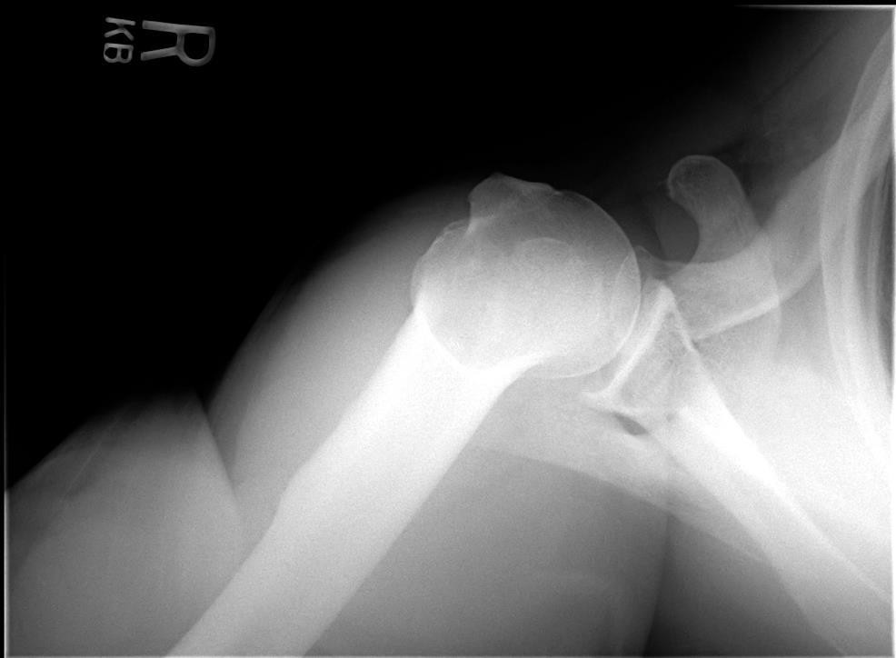
R
Edenbrook Imaging Library
- Which routine projection of the shoulder is displayed? Superoinferior axial projection

- What positioning error(s) occurred?

Anatomy misalignment

- If the image was repeated, how would you correct the positioning error(s)?

Move the patients elbow more anteriorly, until the elbow and shoulder are aligned (aka. parallel to length of cassette)

- How did you identify the positioning error(s)?

Body of humerus is not parallel to edge of IR

- If the image had to be repeated, would you make any other adjustment(s)? Explain your rationale.

Marker orientation is incorrect (aka. does not follow ’s Marker Rules) marker should be turned to appear as though it is “walking” on the humerus (marker orientation should display as demonstrated by the yellow “R”)

