Name:

CT Imaging of the Neck CT Imaging of the Chest

Part 1 – Anatomy
MRAD 281

- What are the 3 sections of the pharynx, superior to inferior?

- What are the 3 pieces of cartilage that make up the larynx?

- Which is anterior, the trachea or the esophagus?

- At what vertebral level does the trachea bifurcate?

- What is this bifurcation called, and what does it bifurcate into?

- What is the structure that joins the right and left lobe of the thyroid gland?

- Name the 3 pairs of salivary glands.

- Where are the parotid glands located?

- From left to right, name the arterial branches off the aortic arch.

- The artery branches into the right subclavian artery and the right common carotid artery.

- The carotid arteries sit to the jugular veins.

- The external carotid arteries sit (anterior/posterior) to the internal carotid arteries.

- Just above the level of bifurcation, the external carotid artery is (medial/lateral) to the internal carotid arteries.

- As it ascends the neck, at a higher level, the external carotid artery is (medial/lateral) to the internal carotid arteries.

- What arteries travel through the transverse foramina of the cervical vertebrae?

- What are typically the largest blood vessels in the neck?

- The internal jugular veins sit to the carotid arteries.

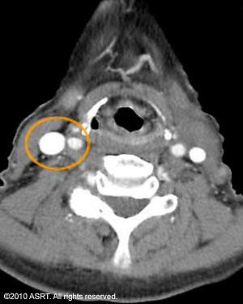
- What 2 vessels appear circled on the image?

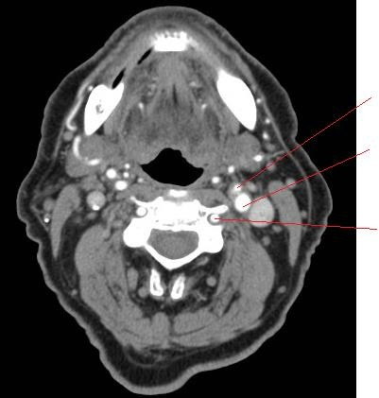
- Label the anatomical structures on the image below:

- Describe the differences between the right and left lungs.

- List the fissures and segments of each lung.

- What is the pleura? List and describe the 2 pleural layers.

- What is the hilum? List some of the structures that pass through the hilum.

- What structures are contained within the mediastinum?

- List and describe the 4 chambers of the heart.

- The aortic arch lies to the pulmonary arteries.

- The aortic arch corresponds to approximately which vertebral level?

- The thoracic aorta sits to the vertebral column.

- The pulmonary trunk arises from which chamber of the heart?

- The IVC enters which chamber of the heart?

- Name the 3 branches of the aortic arch.

- The brachiocephalic trunk divides into which two arteries?

- The right brachiocephalic veins are forms by the union of the:

- The left brachiocephalic vein sits to the branches of the aorta.

- The right and left brachiocephalic veins unite to form the .
- Label the image below:

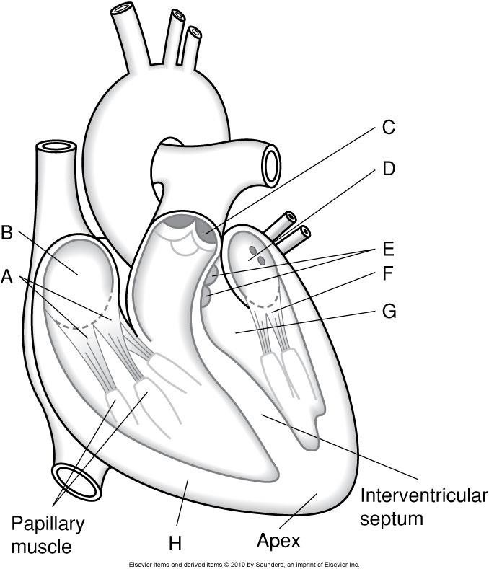

- Label the image below:

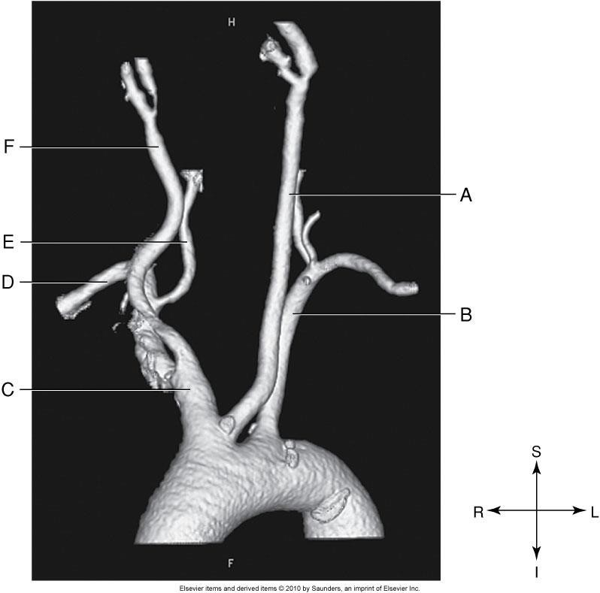

- Label the image. What vertebral level is this slice taken at? How can you tell?
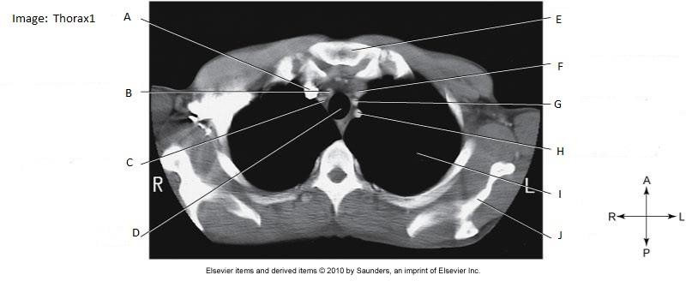

- Label the image. What vertebral level is this slice taken at? How can you tell?
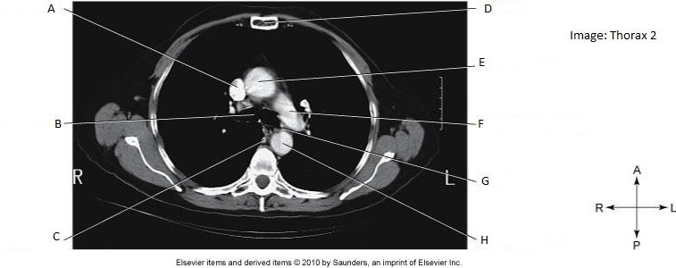

Part 2 – Imaging Procedures

  - What window width & window level are commonly used to display standard (soft-tissue) algorithm of the neck?

  - What is the advantage of using a soft algorithm for a CECT neck?

  - List at least 3 indications for a CECT neck.

  - List one indication for a NECT neck.

  - Describe the most common type of stroke

  - List 5 clinical indications for stroke / TIA that would prompt a CT neck/head scan.

  - What anatomy should be included on a CECT neck?

  - What is the approximate kVp / mA used for a CECT neck?

  - Describe the contrast protocol for a CECT neck.

  - What anatomy should be included on a CTA neck CoW & Carotids?

  - What is the approximate kVp / mA used for a CTA neck?

  - CTA CoW and Carotids usually include MIP reconstructions.
    - Describe MIP Maximum Intensity Projection.

    - What is the appropriate WW and WL?

  - What is the contrast protocol for CTA Cow & Carotids?

  - How does an emboli appear on CT?

  - List 2 challenges in scanning the patient’s chest, and how you as the technologist could manage this challenge.

  - What is an appropriate lung window width & window level?

  - List 3 indications for a NECT chest.

  - When is contrast indicated for a CT scan of the chest?

  - What anatomy should be included for a CECT chest?

  - For Chest CT, a pitch of greater than 1 may be used. What are the advantages and disadvantage of this setting?

  - What is the contrast protocol for CECT chest?

  - What filter/algorithm can be applied to NECT chest for lung nodule reformats?

  - What 3 scans are often done as part of a HRCT chest protocol?

  - Describe the difference between using a timing bolus and bolus tracking for a CTA chest for PE.

  - What anatomy should be included for a CTA chest for PE?

  - How does a technologist reduce respiratory motion artifact when scanning CTA chest for PE?

  - What is the purpose of following a bolus contrast injection with a saline flush when performing a CECT or CTA chest?

  - Describe the advantages and disadvantages of incremental vs. helical HRCT exams?

