- Match the following terms with their definitions:
A) hypertrophy | J | A condition that is caused by medical intervention
B) resection | F | Against the flow of nature
C) fistula | H | A mass of tissue that branches into a lumen
D) achalasia | A | An increase in the number of cells unrelated to a tumor
E ) nosocomial | B | Surgical repair of an organ
F) retrograde | I | Deficient blood supply
G) abscess | C | Abnormal passageway between two organs
H) polyp | D | A sphincter’s inability to relax
I) ischemia | G | A loculated collection of pus
J) iatrogenic | E | A hospital acquired disease
- State the disease classifications associated with each of the following pathologies:
Crohns - inflammatory
Esophageal atresia - congenital
Hypertrophic Pyloric Stenosis - congenital
Sliding hiatal hernia - degenerative
Peptic ulcer - inflammatory
Situs inversus - congenital
Adynamic ileus - traumatic
Vovulus – traumatic or degenerative
- Define “hernia” and explain why a hernia must be treated surgically. A loop of bowel that protrudes through a weakness in the bowel wall, due to an anatomic weakness. If the loop becomes “incarcerated” and cannot be pushed back, then it must be reduced surgically to prevent the bowel loop from being “strangulated” as a result of decreased blood supply. If a hernia is not treated appropriately it can cause a bowel obstruction.
- What does GERD stand for? Gastroesophageal Reflux Disease
- Which sphincter is compromised in patients with GERD? The LES - Lower esophageal (gastroesophageal) sphincter
- Explain why occasional acute episodes of GERD are not usually a cause for concern.
It is not uncommon to experience some reflux now and again due to lifestyle and/or natural aging processes
- What complications can occur as a result of chronic GERD? Inflammation of the esophagus, strictures, or ulcerative lesions
Refer to case study one to answer questions 8 thru 15

CASE STUDY ONE
Craig is fifty-two years old and a self-professed workaholic. He has been experiencing chronic heartburn for the last six months. As a travelling sales rep, he is on the road constantly, and wines and dines in fancy restaurants 5 days out of 7. He drinks copious amounts of coffee to keep himself awake while driving. Recently he has been waking up with generalized abdominal pain, which is usually relieved by NSAID’s and a midmorning breakfast.
Although his physician does not think Craig has a life threatening condition, he has scheduled him for an esophagram and an endoscopy (placing a scope down his throat to view his stomach) and has recommended that he stop taking NSAID’s for the time being.
- What is a NSAID? Non-steroidal anti-inflammatory drug
- Give an example of a common NSAID. Tylenol, Ibuprofen, Aspirin, Motrin
- What is the most likely cause of Craig’s heartburn? GERD secondary to a sliding hiatal hernia, which is the most common type of hiatal hernia (occurs in 50% of people over 50 years old) A rolling hiatal hernia is very rare.
- List some lifestyle changes that might relieve Craig’s heartburn:
- drink less coffee, and stay awake at the wheel by eating something less acidic such as sunflower seeds
- drink less wine and eat earlier in the evening
- eat less quantity of food in one sitting
- sleep with his head higher than his feet
- What two digestive pathologies may be causing Craig’s symptoms?
  - sliding hiatal hernia
  - peptic ulcer
  - gastritis
- Where will Craig’s GE junction most likely appear on the esophagram, when the table is tipped into a Trendelenburg position? Above the diaphragm
MRT Program – ©
- Why did the physician schedule an endoscopic exam? To determine if Craig has a peptic ulcer
- Why did the physician ask Craig to stop taking NSAID’s? They can irritate the stomach lining further

CASE STUDY TWO
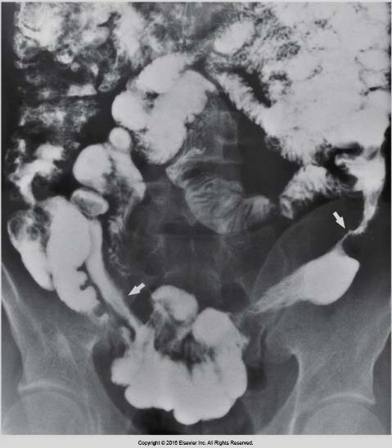
An ambulatory adult comes to the x-ray department for a small-bowel follow-through. They are on contact isolation. As you are taking their history, they tell you they have LUQ pain and bloody stool. They are thin as a rake. During the exam the doctor examines the terminal ileum very closely, and you notice a generalized cobblestone appearance to the bowel. Their AP abdomen x-ray is shown in image 2 below.
16. Which of the following is true regarding this situation?
- The “string sign” in image 2 indicates that the patient most likely has colon cancer False: the string sign is in the small bowel not the colon
  2 | Eisenberg 5-44
- The “string sign” in image 2 is a classic radiographic signof regional enteritis True: because the walls of the bowel

become inflamed and edematous, causing radiographic filling defects
- The technologist will need to wear a gown, gloves, andmask for the exam. False: the patient is on contact isolation and so you only need a gown and gloves

- The “string sign” in image 2 indicates a type of fistula False: The string sign represents a decreased lumen, not an abnormal connection between two organs.
- The patient has bloody stool because they have peritonitis False: the peritoneum is not continuous with bowel and if it was (i.e. the patient had a punctured bowel) then a barium study would have been contraindicated
- This patient is suffering from a chronic disease with acute episodes True
- This patient is most likely between the ages of 50 and 70 False. Crohn’s primarily affects young adults
- If this patient has a bowel resection done, they will still be at risk for a recurrence. True
- What is the most common cause of a large bowel blockage? colon/rectal cancer And a small bowel one? Adhesions secondary to surgery
- What is the most likely complication of diverticulosis? Inflammation
- Which of the following will most immediately cause a bowel blockage?
  - achalasia
  - intussusception
  - peptic ulcer
  - gastroenteritis
- All colonic polyps should be removed regardless of size, as they have the potential to become cancerous. a) True
b) False
- What is the primary radiographic sign of colon cancer? Apple core or napkin ring sign
- List two diseases that are a pre-disposition to colon cancer.
  - ulcerative colitis
  - familial polyposis
- If colon cancer is not diagnosed early in its development, it has the potential to spread via the lymphatic system to other organs such as the liver, or lungs.
  - True
  - False
- A volvulus most often occurs in the transverse colon
  - True
  - False. It occurs in the sigmoid which has a longer mesentery
- In the chart below, match the radiographic appearance/sign with the disease. More than one sign may apply to a given disease. Some diseases may have no radiographic signs listed.
Crohn’s | C,H, I,  G | A) rat tail
Achalasia | A,K | B) step ladder
Volvulus |  | C) cobblestone
Intussusception | D | D) coiled spring
Diverticulosis | I | E ) napkin ring
Diverticulitis | I | F) collar-buttoned
Ulcerative colitis | F,G | G) lead pipe
Colon cancer | E, L | H) skip lesions
MRT Program – ©
Small Bowel blockage | B | I) string sign
Hiatal hernia |  | J) boot sign
Coarctation of the aorta |  | K) beak sign
Tetrology of fallot | J | L) apple core
- Almost all patients who undergo bowel surgery will suffer from adynamic ileus a) True
b) False

