Common Musculoskeletal Injections
A wide variety of different musculoskeletal (MSK) structures can be injected using fluoroscopy. Below is a list of several general types of MSK injections.
Imaging of these injections is usually only done on one plane, either AP/PA or lateral.
- Peripheral Joint Injection - Corticosteroid
  - Most joints, large or small, can be injected with corticosteroid to reduce inflammation and pain.
  - Tends to wear off fairly quickly (approx. 3 months), but can be repeated indefinitely.
  - Simple, fast injection procedure that is well tolerated by most patients with few risks.
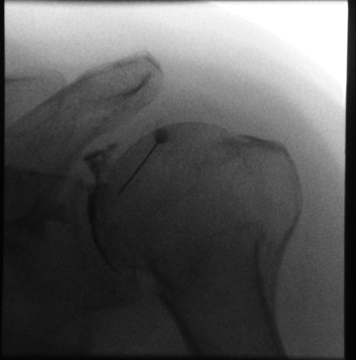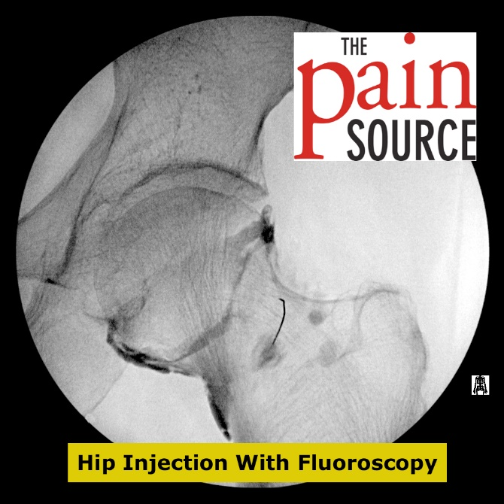
Image courtesy of Canada Diagnostic Centres http://thepainsource.com/hip-joint-injection-with-fluoroscopy-technique-and-tips/

- Peripheral joint Injection – Viscosupplement
- Hyaluronic acid compound is injected to a joint capsule to supplement synovial fluid that has diminished due to age or wear on the joint.
- Usually done in knee and hip joints, but can also be done in smaller joints like AC joint or IP joints.
- Not covered by Alberta Healthcare. Patient must pay for the medication syringe.
- Can slow the progression of osteoarthritis and delay joint replacement surgery.
- Injection procedure and risks are the same as a corticosteroid injection.
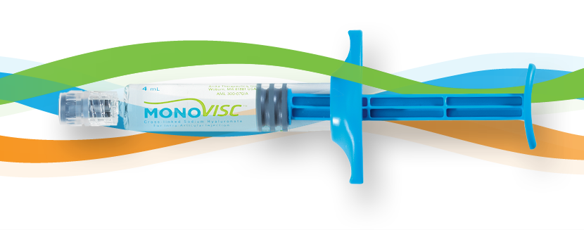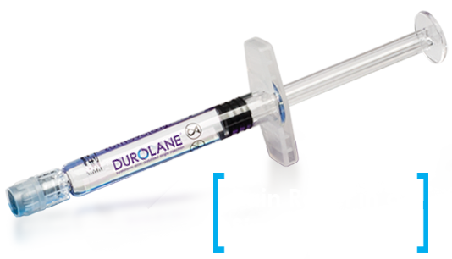
Monovisc.com Durolane.com
- Bursa Injection
- Corticosteroid is injected into the space between or on top of muscles.
- Bathes soft tissue structures (tendons, ligaments, or bursae) in anti-inflammatory medication.
- Used to reduce pain of overuse or repetitive strain injuries.
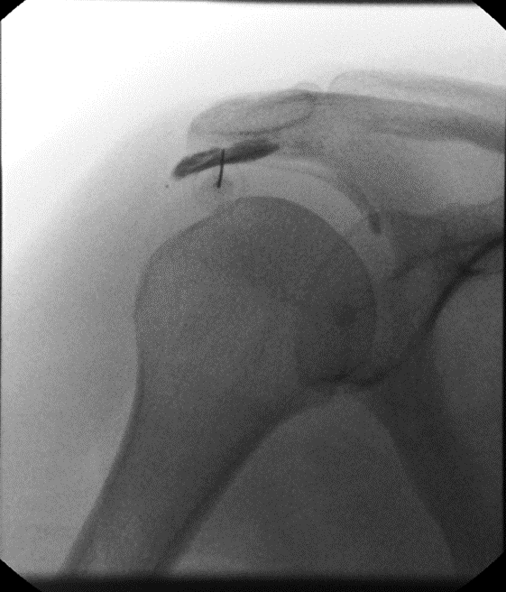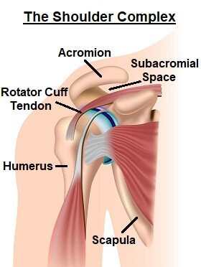
Subacromial bursa injection image courtesy of Canada Diagnostic Centres https://www.shoulder-pain-explained.com/shoulder-impingement-syndrome.html
- Tendon Sheath injection
- Corticosteroid is injected into the tendon sheath where it coats the tendon within, reducing inflammation.
- Can decrease swelling of the tendon sheath, allowing for greater movement of a joint i.e. “trigger finger” injections.
- Very common in the hand, ankle, and rotator cuff.
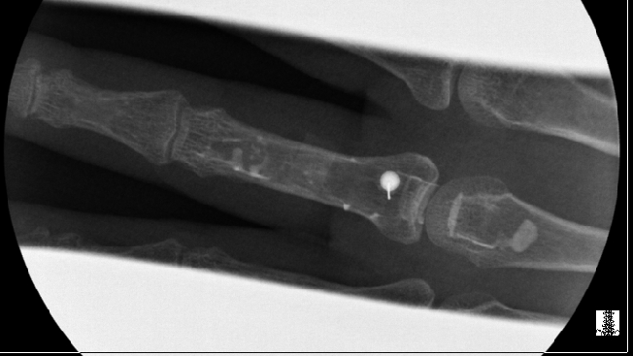
Trigger finger injection image courtesy of Canada Diagnostic Centres
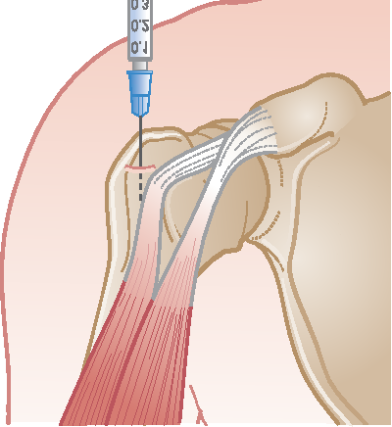
Linscott, Margaret. “Injuries to the Shoulder Girdle and Humerus.” (2013).
- Arthrograms
- Diagnostic exam done on a joint to visualize the soft tissue structures within that joint
- Often done on shoulder, hips, or knees; but can be done on just about any joint.
- A large bolus of fluid, usually a mixture of local anesthetic, radiographic contrast, and saline, is injected into the joint. Once the joint is expanded images are taken of the joint in various positions and on various planes.
- The patient then moves on to another modality such as ultrasound or MRI for further evaluation.
- The results of the exam will determine the treatment path.
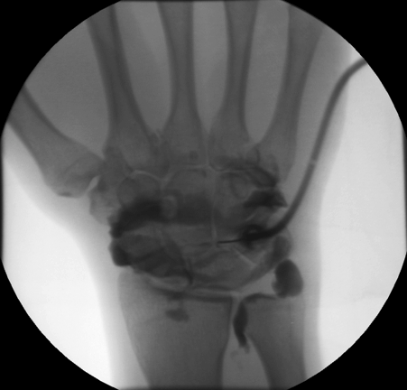
http://uwmsk.org/arthrography/wrist-arthro.png
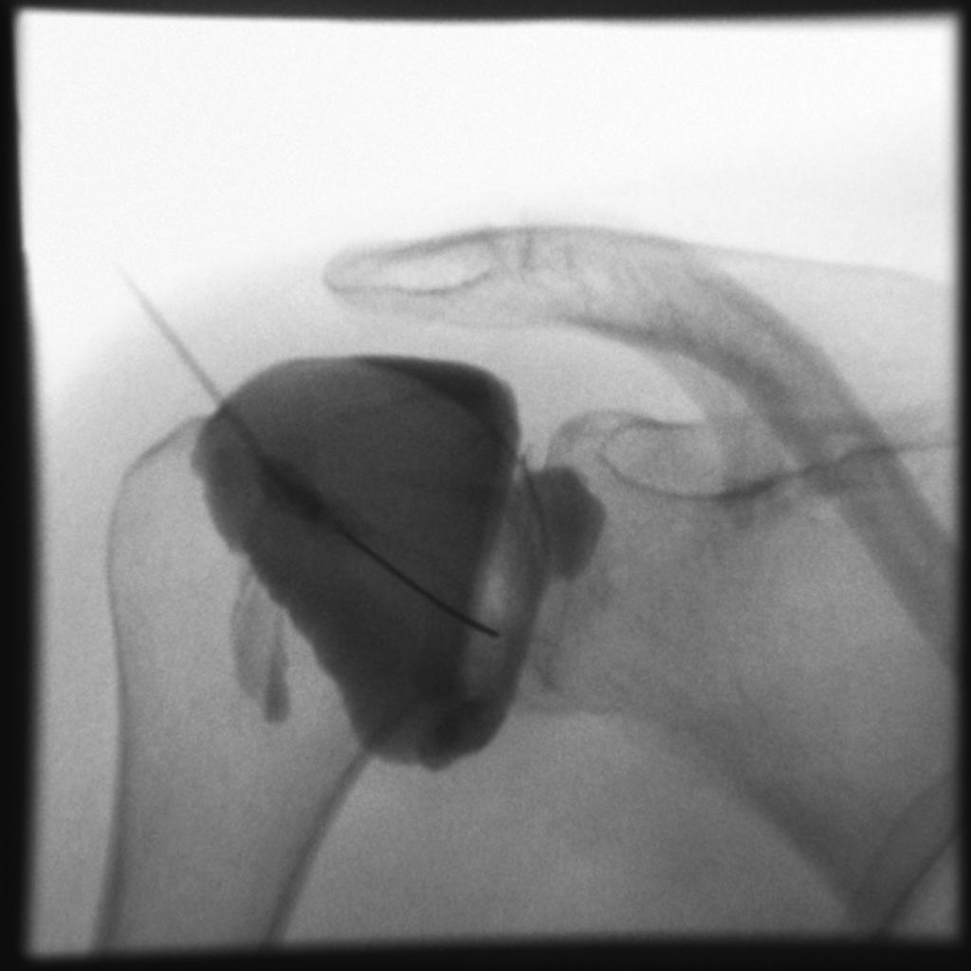
Case courtesy of A.Prof Frank Gaillard, Radiopaedia.org, rID: 7545

