A-tubercle (on anterior arch)
- articular pillar
- transverse foramen
- Vertebral arch
- transverse process
- Superior facet
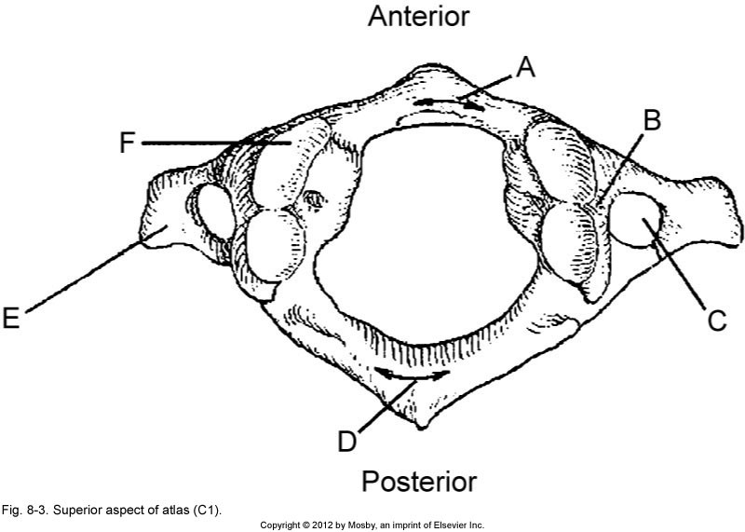

 | 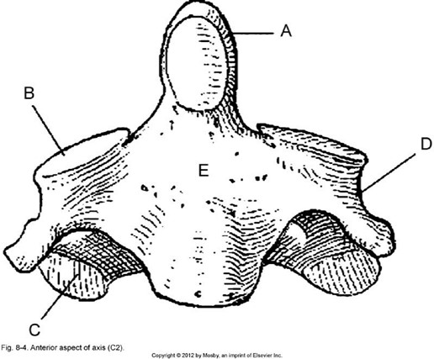
  - Odontoid or dens
  - Superior articular process
  - Inferior articular process
  - Transverse process ^{E-} body

- Odontoid or dens
- Superior articular process
- Spinous process
- Inferior articular process
- Transverse process
- Transverse foramen G- body

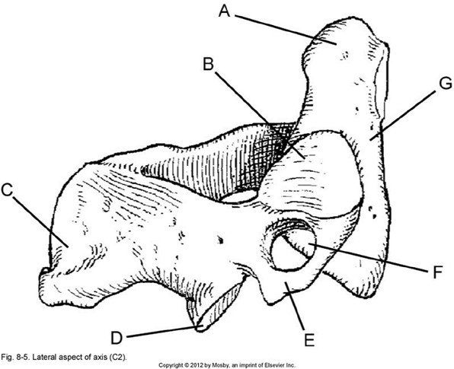
 | 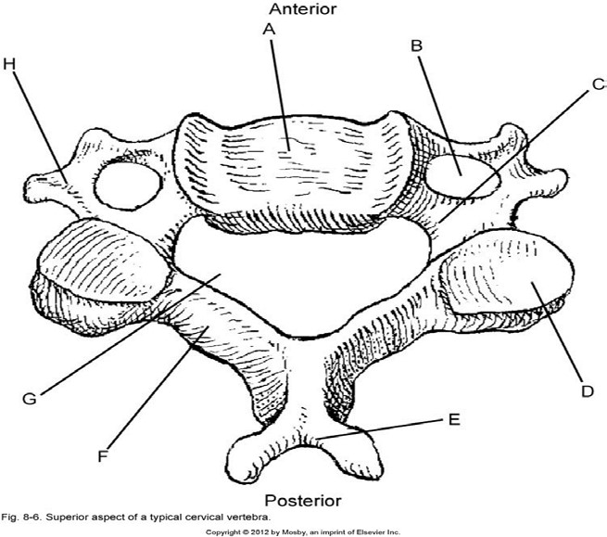
  - Body
  - Transverse foramen
  - Pedicle
  - Superior articulating process and facet
  - Spinous process
  (bifid)
  - Lamina
  - Vertebral foramen
  - Transverse process
- Superior articular process
- Lamina
- Spinous process
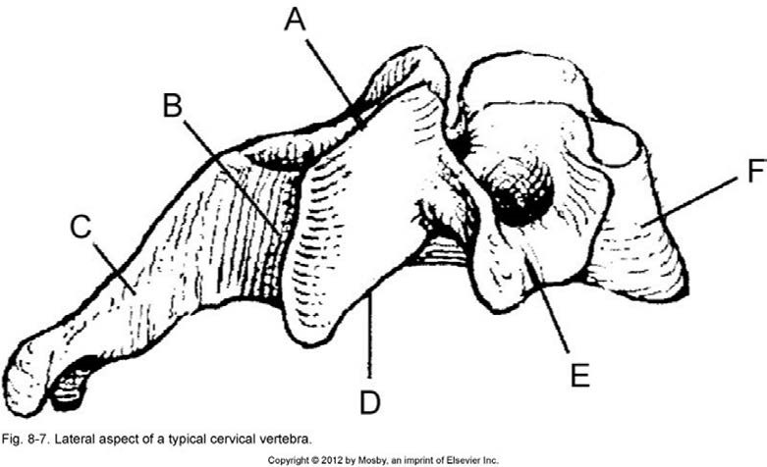
- Inferior articular process
- Transverse process
- body

