MRAD 256 – Worksheet - Cranium Image Critique – ANSWER KEY
- Positioning: Tilt or rotation, is the head positioned properly, are appropriate lines “lined up” properly: OML, IOML, AML etc
- Central ray angulation: what is the angle that should be used for the image/position/projection
- Collimation: is the collimation appropriate for the projection? Comment how it should be corrected
- Required anatomy: is all required anatomy imaged/. If not, what is missing? Is the anatomy demonstrated properly ie petrous ridges in lower 1/3 of orbit etc
- Acceptable?: Would you consider this image appropriate for a student logbook?
☺
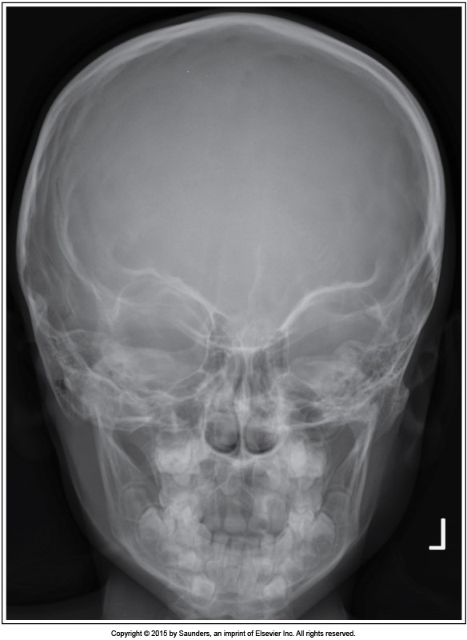
Positioning: tilt and rotation, both toward the left
Central ray angulation: 15 deg caudad
Collimation: Too large for skull, should only include to base of skull
Required anatomy: yes
Acceptable?: No
Caldwell for skull
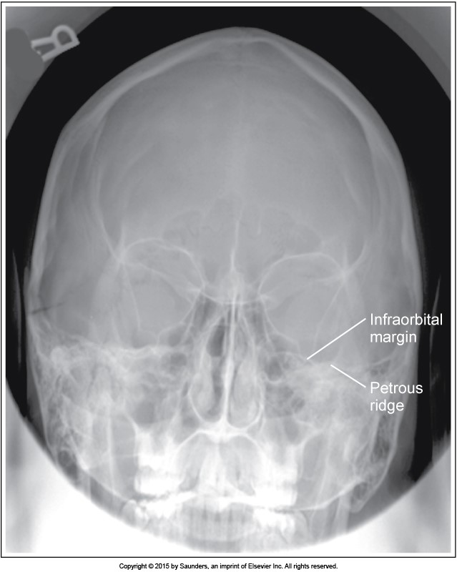
Positioning: insufficient chin tuck
Central ray angulation: if OML was perpendicular to the IR, the tube angle was > 15 °
Collimation: ok
Required anatomy: no, petrous ridges are seen below the orbits
Acceptable?: no
Caldwell for skull
Positioning: no chin tuck
Central ray angulation: Should be 15°, if OML was perpendicular to IR, then excessive caudal angulation was used
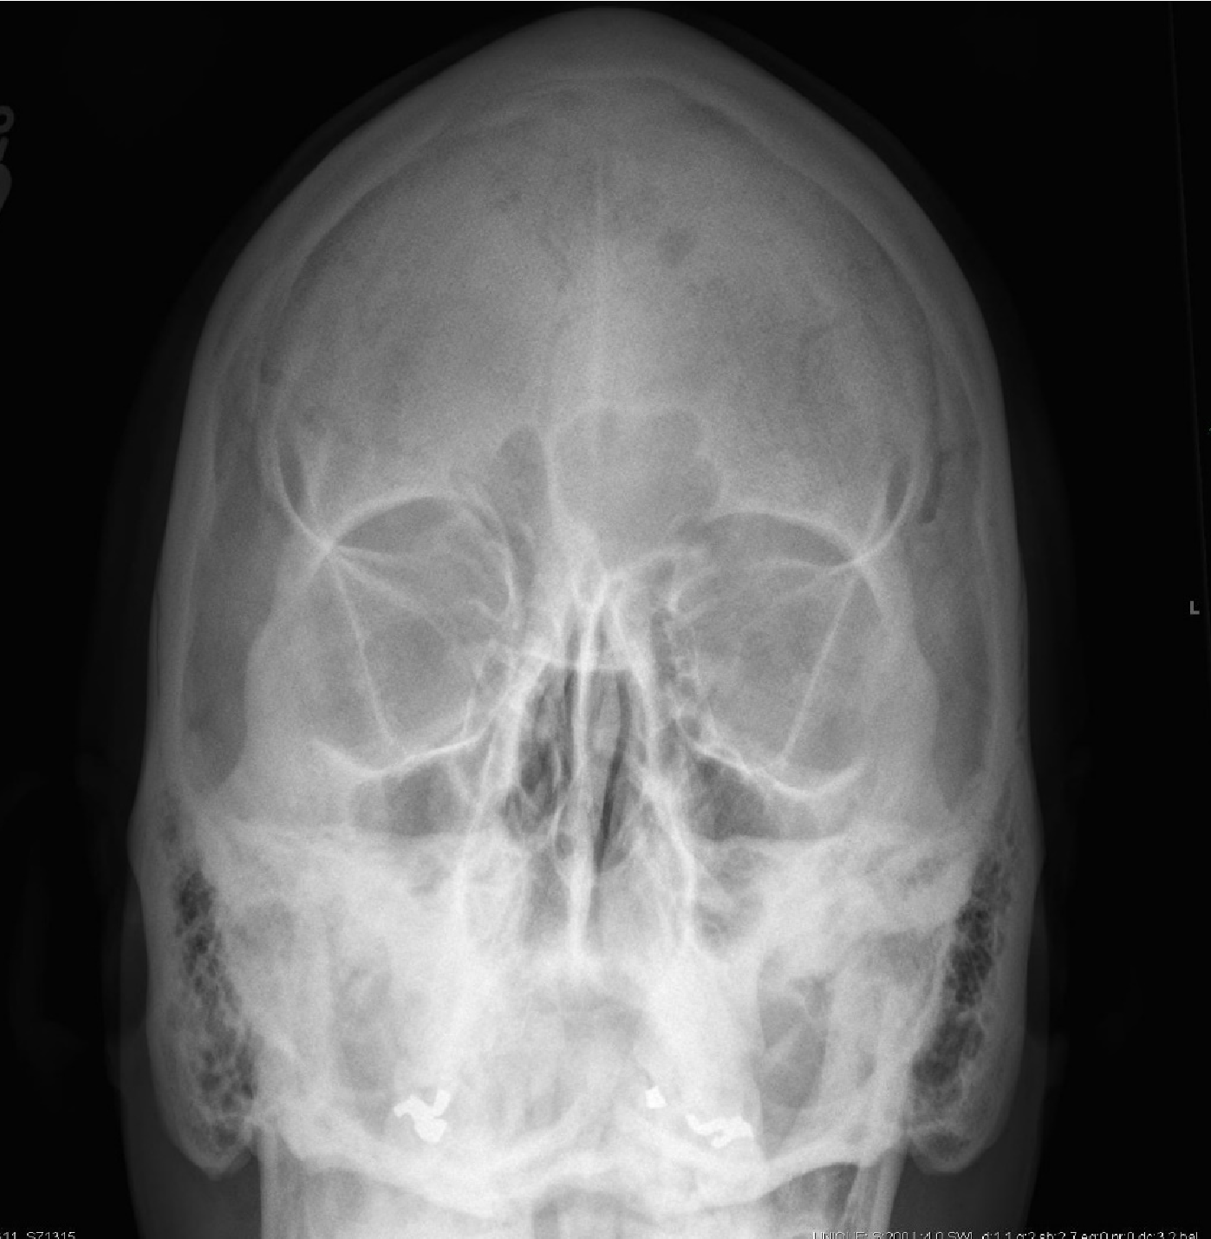
Collimation: need to collimate tighter side-toside
Required anatomy: no, petrous ridges seen in maxillary sinuses
Caldwell for skull
Case courtesy of Dr Matt A. Morgan, Radiopaedia.org, rID: 35611
Acceptable?: no
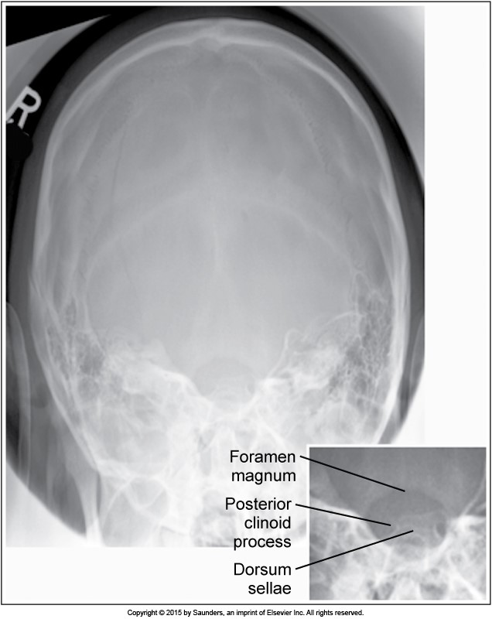
Positioning: rotation to the left, places dorsum sellae to the left side of the foramen
Central ray angulation: 30° caudad
Collimation: ok
Required anatomy: yes, dorsum sellae seen in foramen magnum
Townes for skull Acceptable?: no
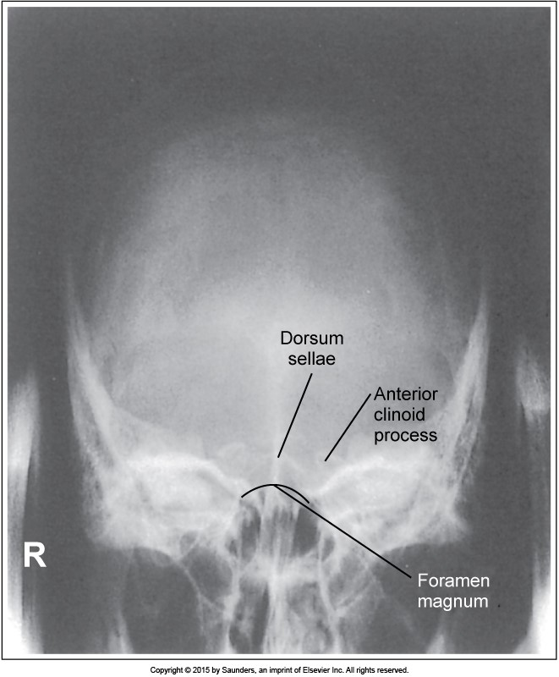
Positioning: not enough chin tuck, OML not perpendicular to IR
Central ray angulation: if OML was perpendicular to the IR, then the tube angle was < 30°
Collimation: ok
Required anatomy: no, dorsum sellae is not seen in foramen magnum, seen superior to it
Acceptable?: no Townes for skull
Positioning:tilted to the right, not enough chin elevation, petrous ridges seen in maxillary sinuses
Central ray angulation: none required
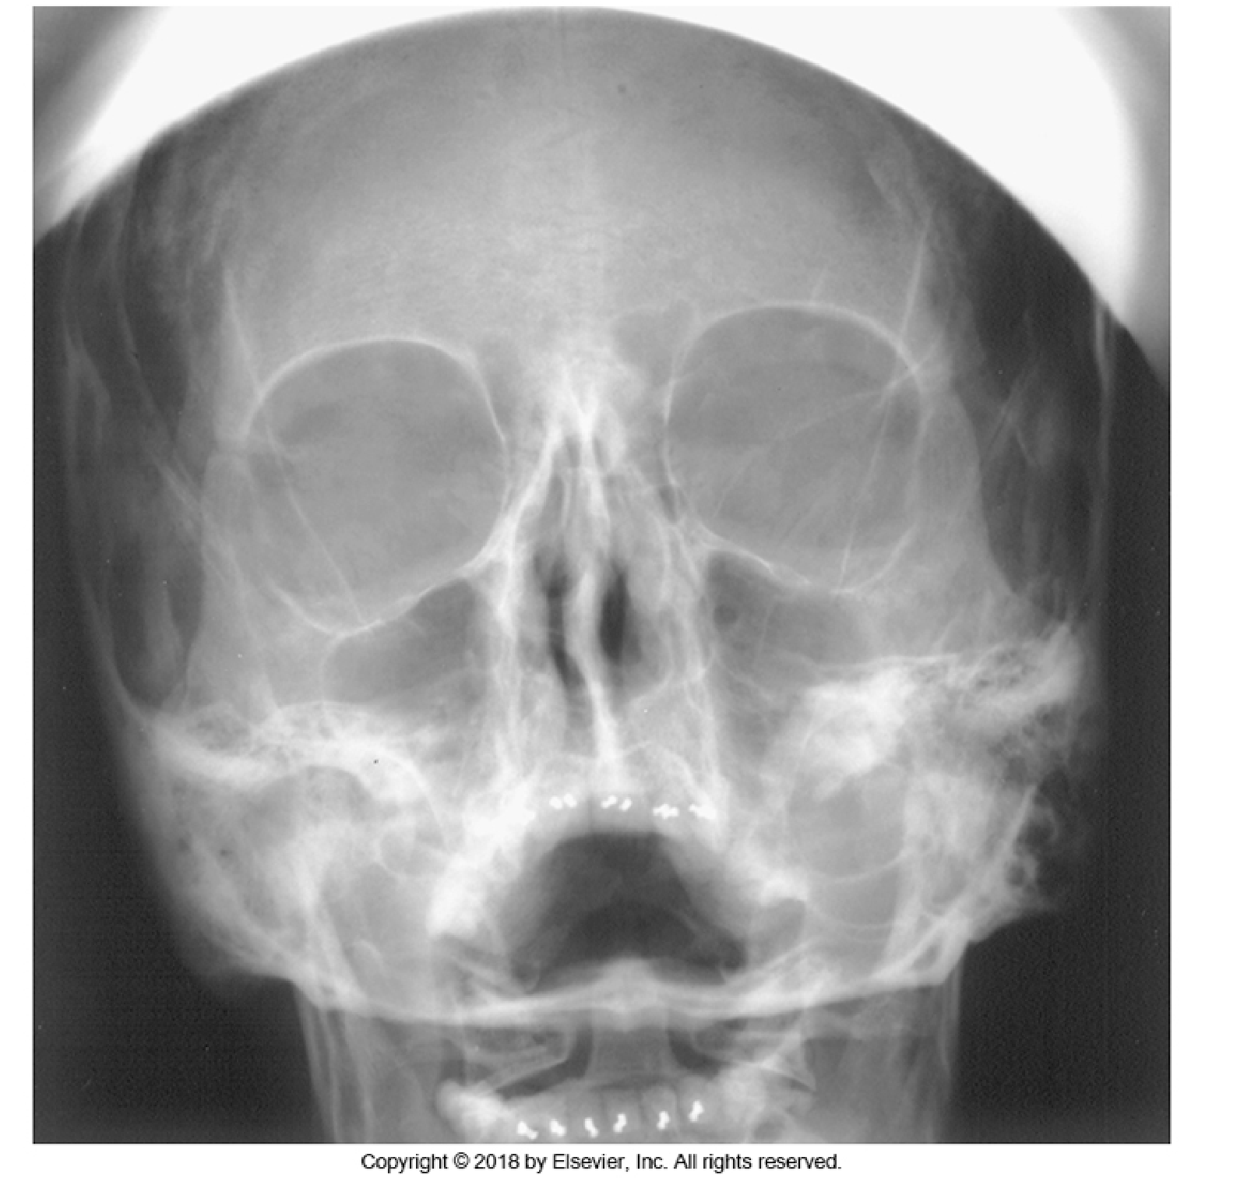
Collimation: includes too much of skull, sinuses require tighter collimation
Required anatomy: maxillary sinuses are not visualized due to superimposition of petrous ridges
Waters for sinuses
Acceptable?: no
Positioning: true lateral as evidenced by superimposed mandibular rami, superimposed orbital roofs. Slight separation of mandibular bodies is due to OID of the side further from the IR
IOML is not parallel to the floor, as occipital bone is very close to the c spine
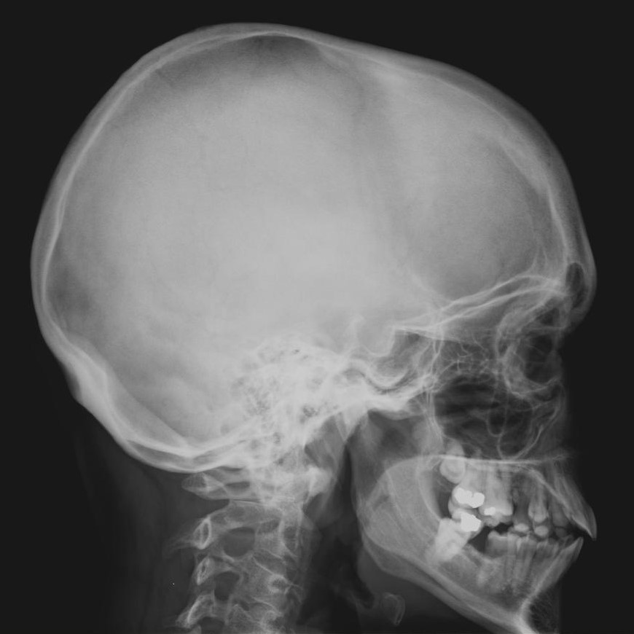
Central ray angulation: none required, horizontal ray
Collimation: includes too much inferior to the base of skull, full mandible not required
Required anatomy: yes
Lateral skull
Acceptable?: no, due to collimation size
Case courtesy of Dr Matt A. Morgan, Radiopaedia.org, rID: 37222
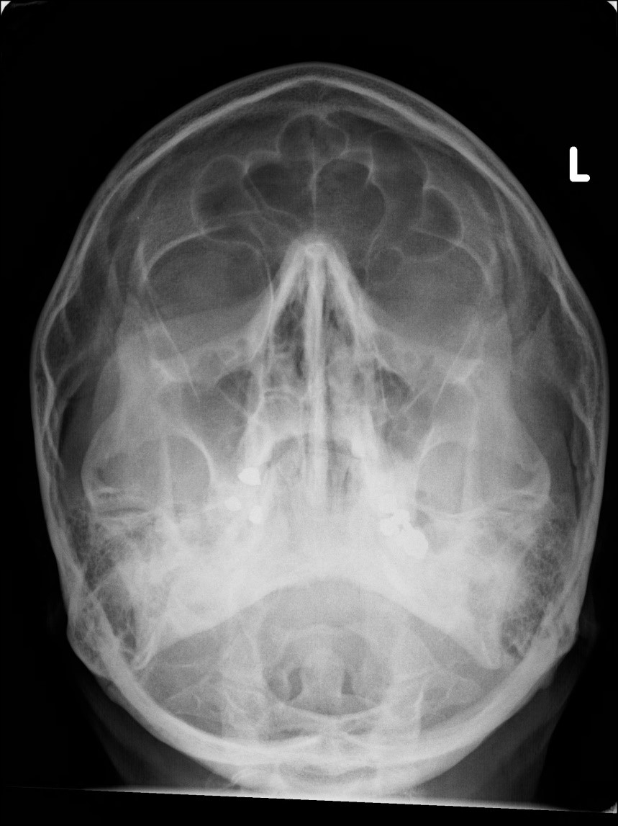
Positioning: No tilt or rotation, petrous ridges are seen below the maxillary sinuses
Central ray angulation: horizontal beam, no angle required
Collimation: Includes full skull, too much included. Should be collimated to include bottom of maxilla to the supraorbital groove
Required anatomy: all included
Waters for facial bones Acceptable?:no, due to collimation field size being too large
Case courtesy of Dr Jeremy Jones, Radiopaedia.org, rID: 46272
Positioning: tilted to the right and rotated to the left, not enough chin tuck
Central ray angulation: should be 15◦, if OML was perpendicular to the IR then the angle is >30 degrees
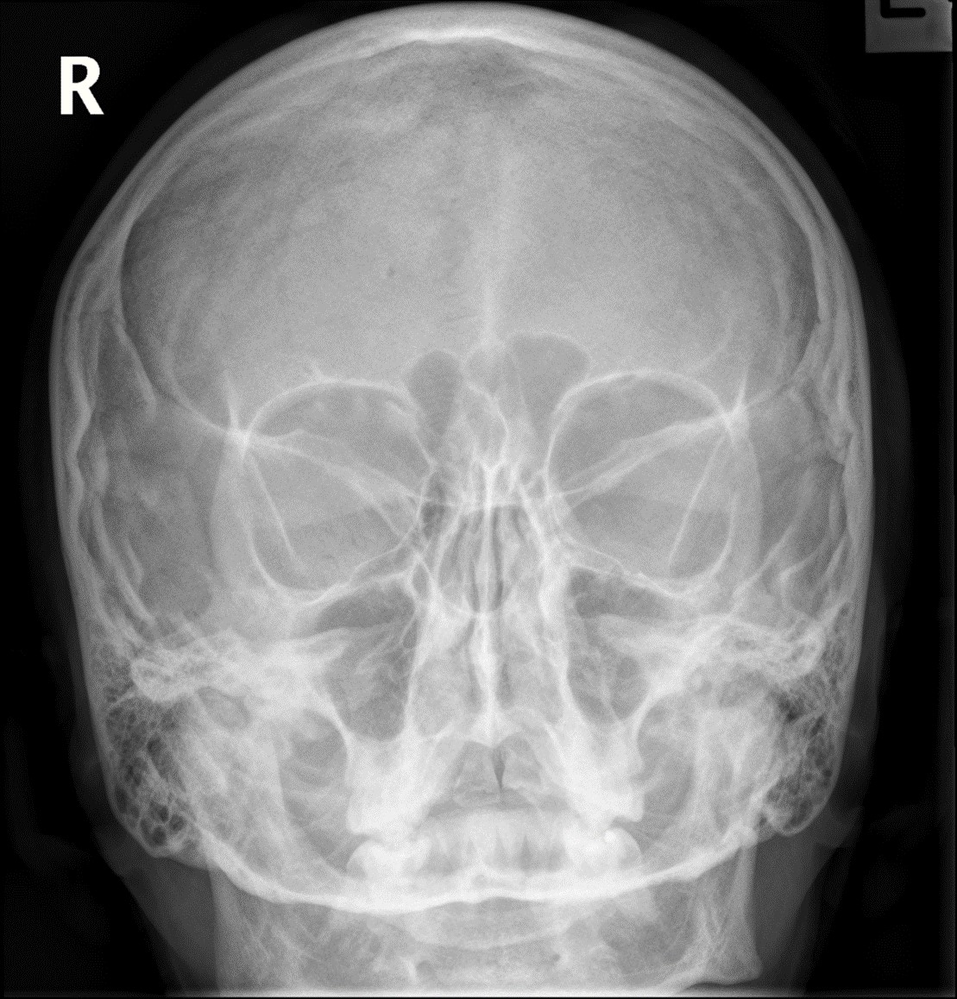
Collimation: includes too much below the maxilla, due to incorrect positioning/ angle Required anatomy: no
Caldwell for facial bones
Acceptable?: no
Case courtesy of Dr Bruno Di Muzio, Radiopaedia.org, rID: 48270
Positioning: IOML is parallel to floor, slight tilt evidenced by one EAM and TMJ slightly superior to the other
Central ray angulation: horizontal beam
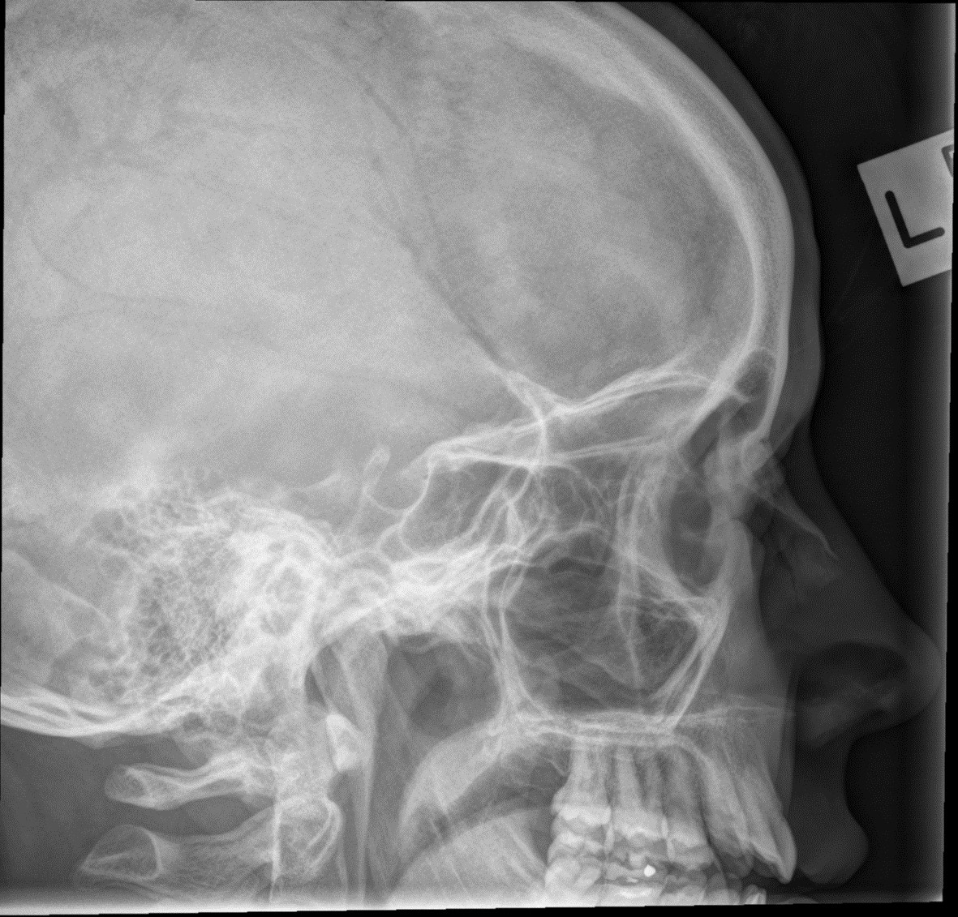
Collimation: includes too much posterior to the EAM
Required anatomy:yes
Lateral for facial bones
Case courtesy of Dr Bruno Di Muzio, Radiopaedia.org, Acceptable?:no
rID: 48270
Positioning: rotated to left, as evidenced by shorter distance from left orbital rim to skull table compared to the right, petrous ridges seen below maxillary sinuses indicating proper elevation of MML
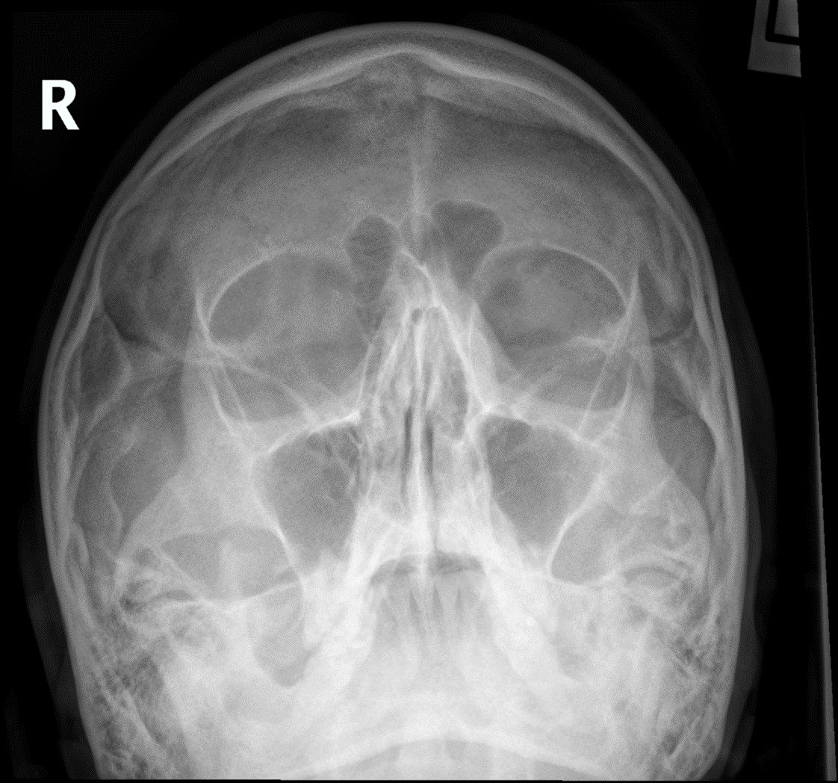
Central ray angulation: horizontal beam
Collimation: should be collimated only to include bottom of maxilla to supraorbital groove
Waters for facial bones
Required anatomy: yes
Case courtesy of Dr Bruno Di Muzio, Radiopaedia.org, rID: 48270
Acceptable?: no
Positioning: true lateral as evidenced by superimposed orbital roofs, clearly defined sella turcica, superimposed mandibular rami
Central ray angulation: horizontal
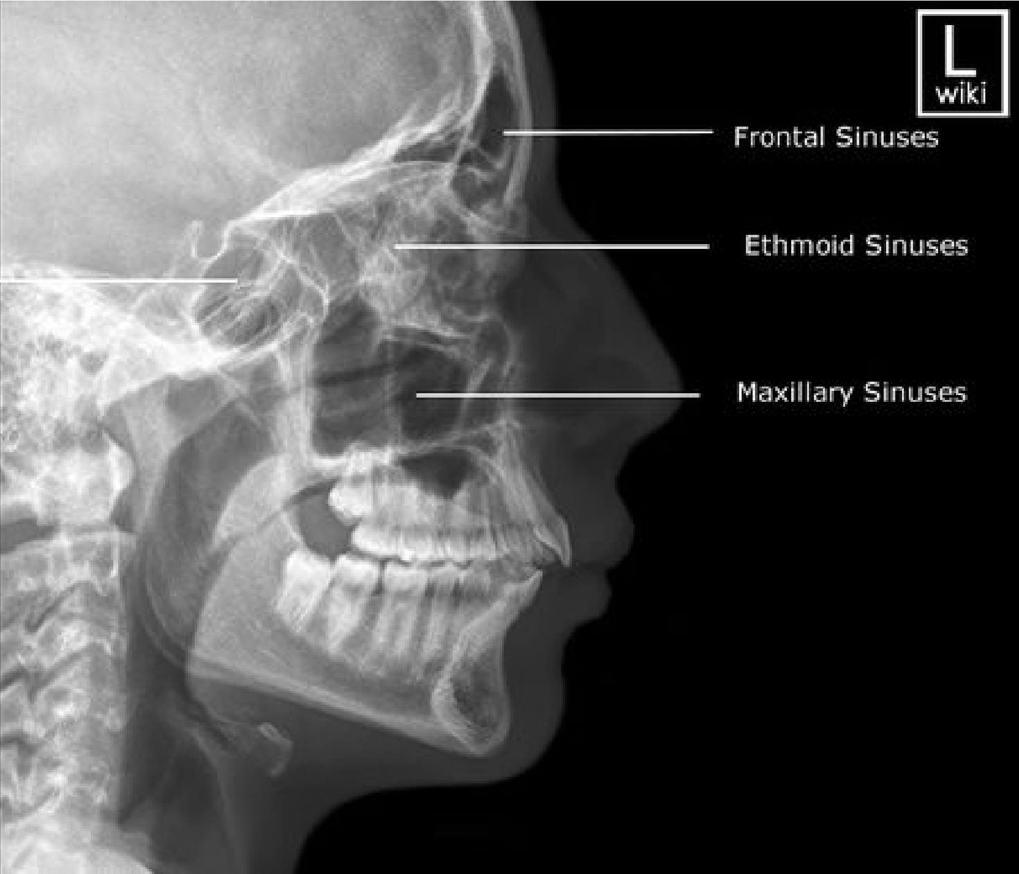
beam
Collimation: does not need to include all of mandible, assume the side to side collimation is correct (black screen added for labelling)
Required anatomy: all sinuses are included
Lateral sinuses
Acceptable?:no
Positioning: OML perpendicular to IR
Central ray angulation: horizontal
beam
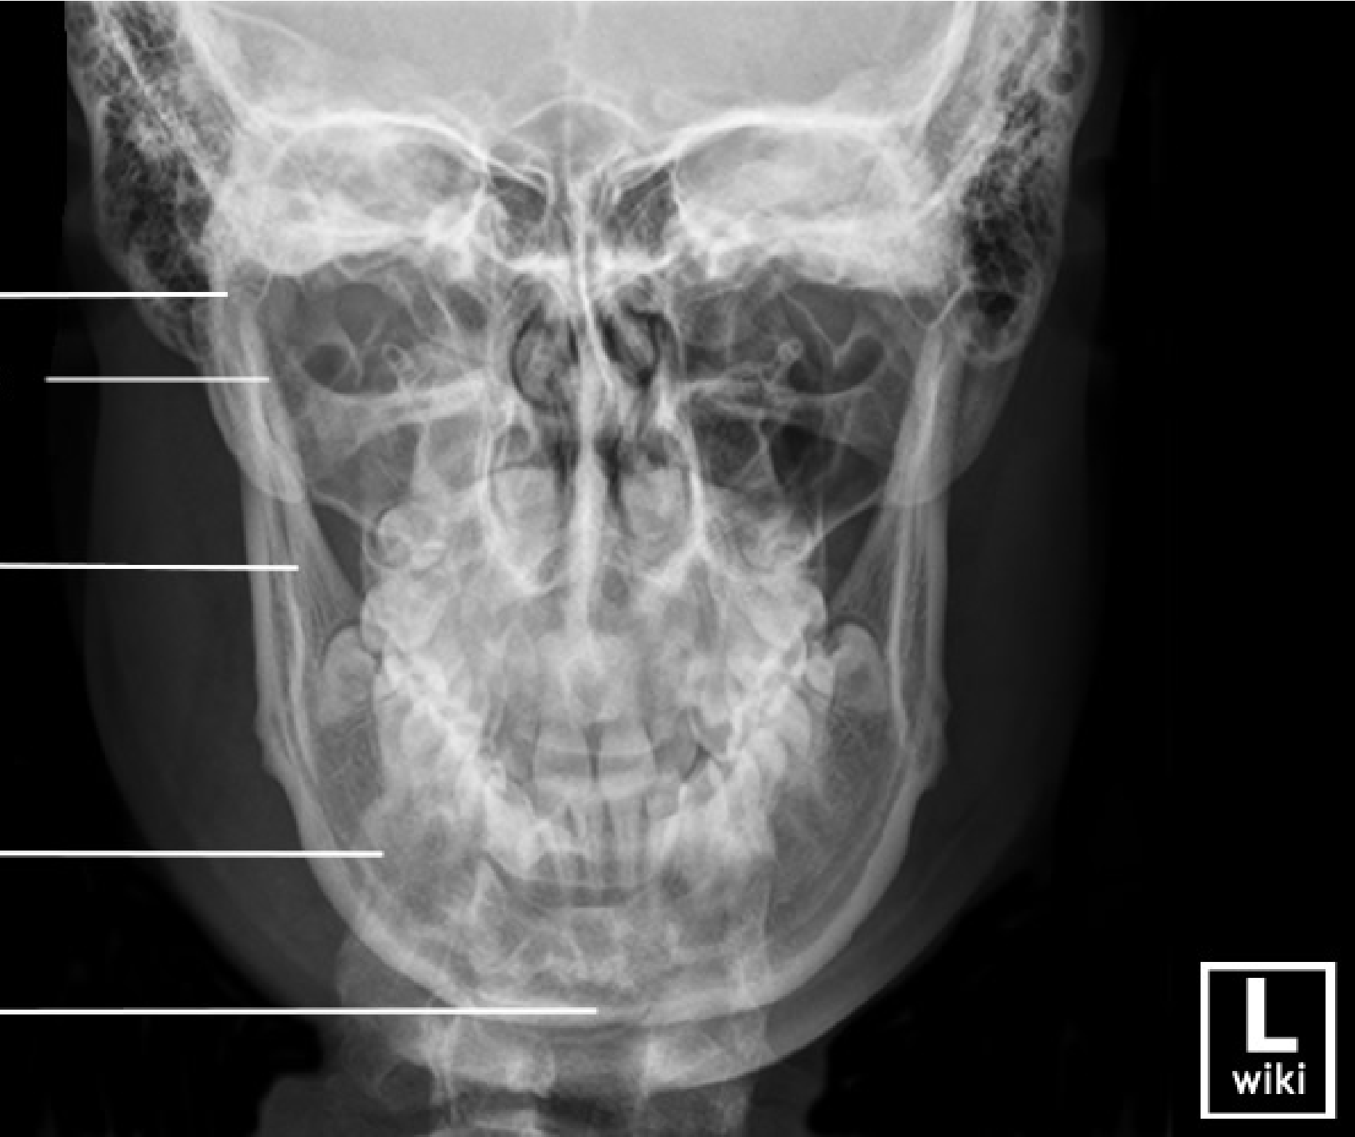
Collimation: good top to bottom, and assume black screen side to side was for labelling
Required anatomy: all included
PA mandible
Acceptable?: YES!
Positioning: Positioned to include all of down side mandible free of superimposition, chin extended to clear ramus from c spine
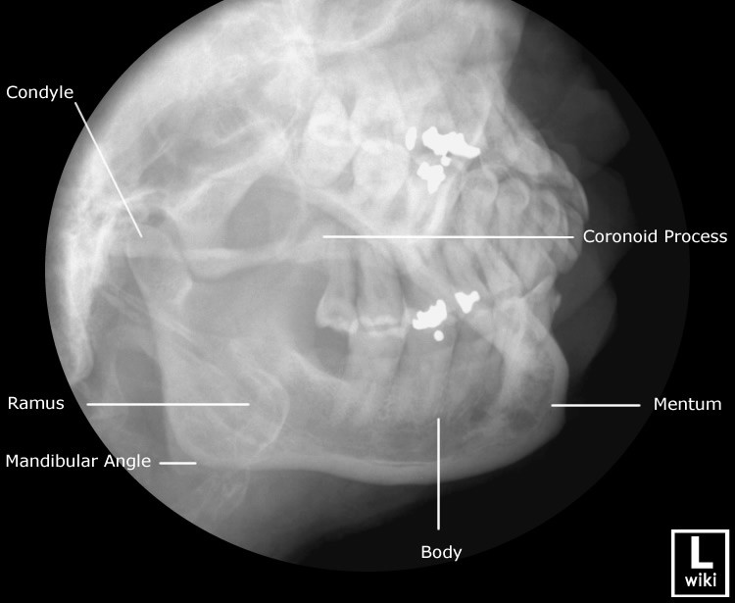
Central ray angulation: 0 deg tube with 25 deg head tilt, OR 0 deg head tilt with 25 deg cephalad tube angle OR 15 deg tube angle and 10 deg head tilt (or vice versa)
Collimation: good
Axiolateral oblique mandible Required anatomy: yes, condyle to
mentum is demonstrated free of
superimposition of other half of mandible
Acceptable?: yes

