MRAD 202 – Patient Care 2
Image – Chest X-ray with Central Venous Catheter (CVC)

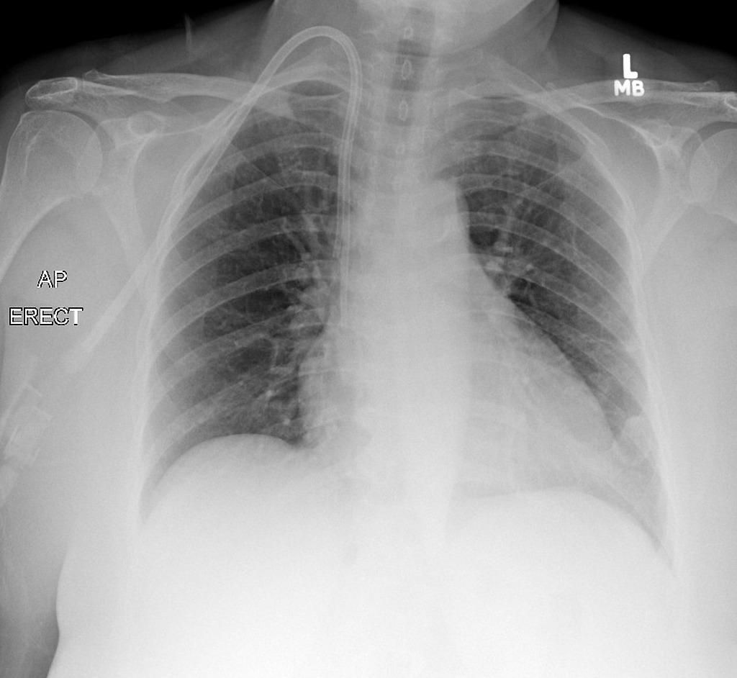
https://www.google.com/url?sa=i&rct=j&q=&esrc=s&source=images&cd=&ved=2ahUKEwiHw7_itaXhAhVKylQKHYvcCVAQjRx6BAgBEAU&url=https%3A%2F%2Fradiopaedia.org%2Fcases%2Fpermacath-on-chest-x-ray&psig=AOvVaw3CYatloapmgWNFjj-DASvk&ust=1553882561611870

