Activity: Test 15 Visual Inspection of Fluoroscopic Equipment Procedure

Purpose:
This activity will help you complete a procedure checklist for a visual inspection of a fluoroscopic X-ray room.

Instructions:
- Read the verification checklist for a fluoroscopic X-ray room in your department.
- Compare the textbook checklist for similarities and differences.

Equipment
- Fluoroscopic X-ray room

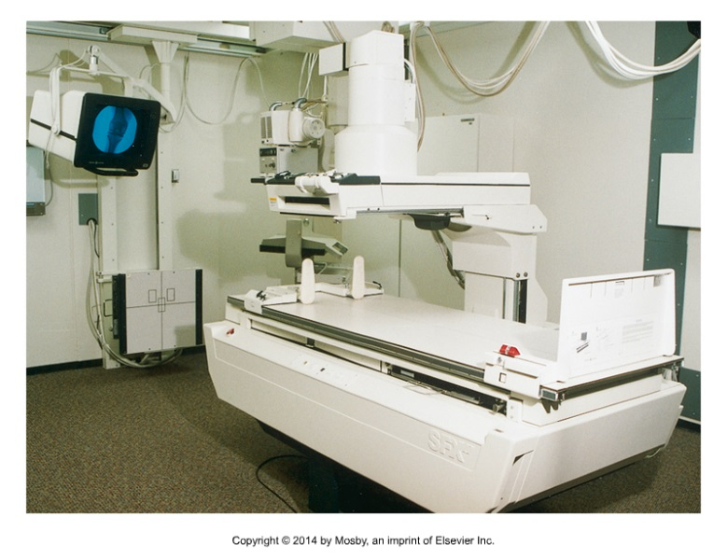 | 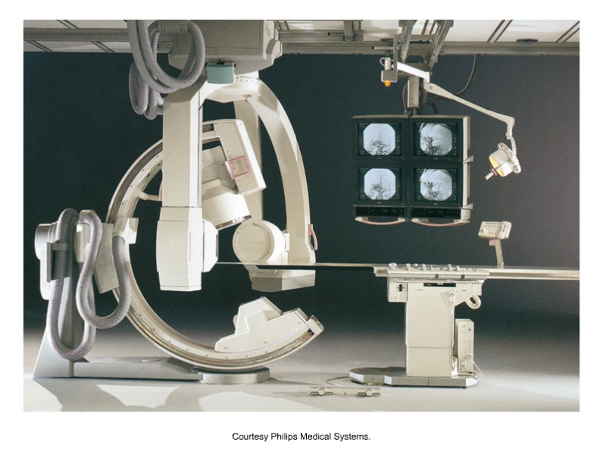

Edenbrook MRT Procedure Steps
Items to be checked:
- Fluoroscopic tower and table locks – manually operate all locks to verify function.

- Power assist – the tower should move smoothly over the tabletop when the power assist is activated.

- Protective curtain – verify that the protective curtain is present and contains at least 0.25 mm Pb equivalent (for units with the image intensifier above the tabletop only).

- Bucky slot cove r– verify that the Bucky slot cover swings into place when the Bucky assembly slides to the far top or bottom of the table.

- Exposure switch – verify that the exposure switch (both hand and foot switches) will activate under continuous pressure only and will deactivate when released. (Be sure to wear a lead apron.)

- Fluoroscopic timer – verify with a stopwatch that the 5-minute reset timer is functioning and is accurate.

- Lights/meter function – verify that all indicator lights and meters function as specified by the manufacturer.

- Compression device/spoon observation – the device should move in and out of place easily and be free of any splatters of contrast media.

- Park position interrupt – place the tower in the park position (not over the X-ray table) and then press the exposure switch. Fluoroscopic devices cannot be capable of activation when the intensifier or tower is not intercepting the beam.

- Primary protective barrier – verify that the unit is equipped with a primary protective barrier. Optional: verify that it reduces exposure to less than 2 mR/hr for every R/min measured at tabletop.

- Collimation shutters – open and close the collimation shutters to verify that they are functioning. Optional: verify that the collimators are accurate to within ±3% of the SID, using a fluoroscopic beam alignment tool.

- Monitor brightness – place a penetrometer on a homogenous phantom and view the image on the monitor to see if all steps are visible.

- Table angulation and motion – move the fluoroscopic examination table to both the upright position and back down (table should move freely). Also, use a protractor to verify that the angulation indicator is accurate to within ±2 degrees.

- Lead aprons and gloves – verify that lead aprons and gloves are present. Also, lay each one (separately) on the table and view under fluoroscopy for the presence of any cracks or holes (falls under lead apparel testing).

Sample Fluoroscopic X-ray Room Checklist

Fluoroscopic System Visual Inspection
Date: _____________

ITEM
Fluoroscopic tower
Table locks
Power assist
Protective curtain
Bucky slot cover
Exposure switch
Fluoroscopic timer
Lights/meter function
Compression device/spoon observation
Park position interrupt
Primary protective barrier
Collimation shutters
Monitor brightness/contrast
Table angulation and motion
Lead aprons/gloves
Place a P in the column if the item passes the visual inspection and an F if it fails.
Place NA in the column if the item is not applicable.

Critical Thinking Question
1. Why should a fluoroscopic system visual inspection occur every 6 months, while a general X-ray visual inspection occurs annually?

