Module 8

Image Critique Questions

- Use the 5 evaluation criteria categories when critiquing the following image to determine if it is diagnostic:

AP Pelvis @ 95 kVp
Is this image diagnostic? Yes No

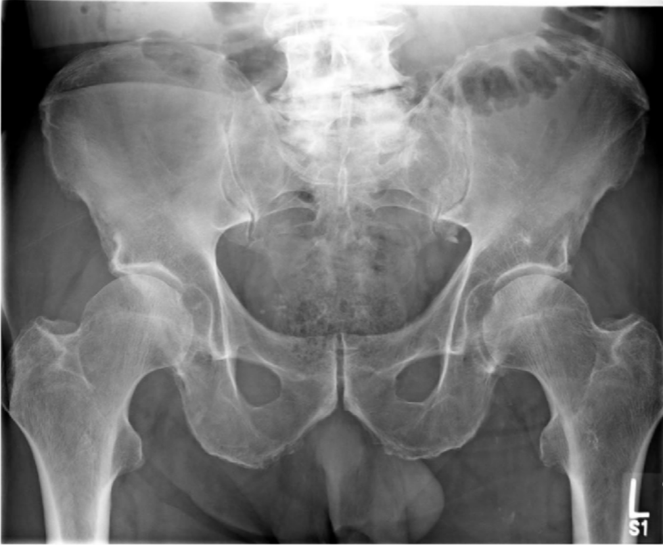
SAIT Imaging library
- Is all the required anatomy included in the radiograph? Yes No
*If no, explain what is required

- Does the anatomical appearance in the radiograph correlate to what is expected from an AP projection? Yes No
*If no, explain how the appearance of this radiograph is different compared to the ideal radiograph

- Identify if the appropriate amount of radiation was used to form the image. Acceptable, Overexposed, Underexpos
ed
No
  - Is motion present in the image? Yes
- Identify if the collimated light field was: Acceptable,Too Small, Too Large
  - Was the CR close to the middle of the required anatomy? Yes No
- Does the marker placement follow Edenbrook Marker Rules? Yes No
  - Are there artifacts in the image? Yes No
1 MRAD 204:RadiographicTechniqueI

*If yes, could they have been removed?

- Use the 5 evaluation criteria categories when critiquing the following image to determine if it is diagnostic:
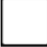
- Is all the required anatomy included in the radiograph? Yes No
*If no, explain what is required

- Does the anatomical appearance in the radiograph correlate to what is expected from a routine AP projection?
Yes No 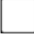
*If no, explain how the
appearance of this radiograph is different compared to the ideal radiograph
AP Hip @ 90 kVp


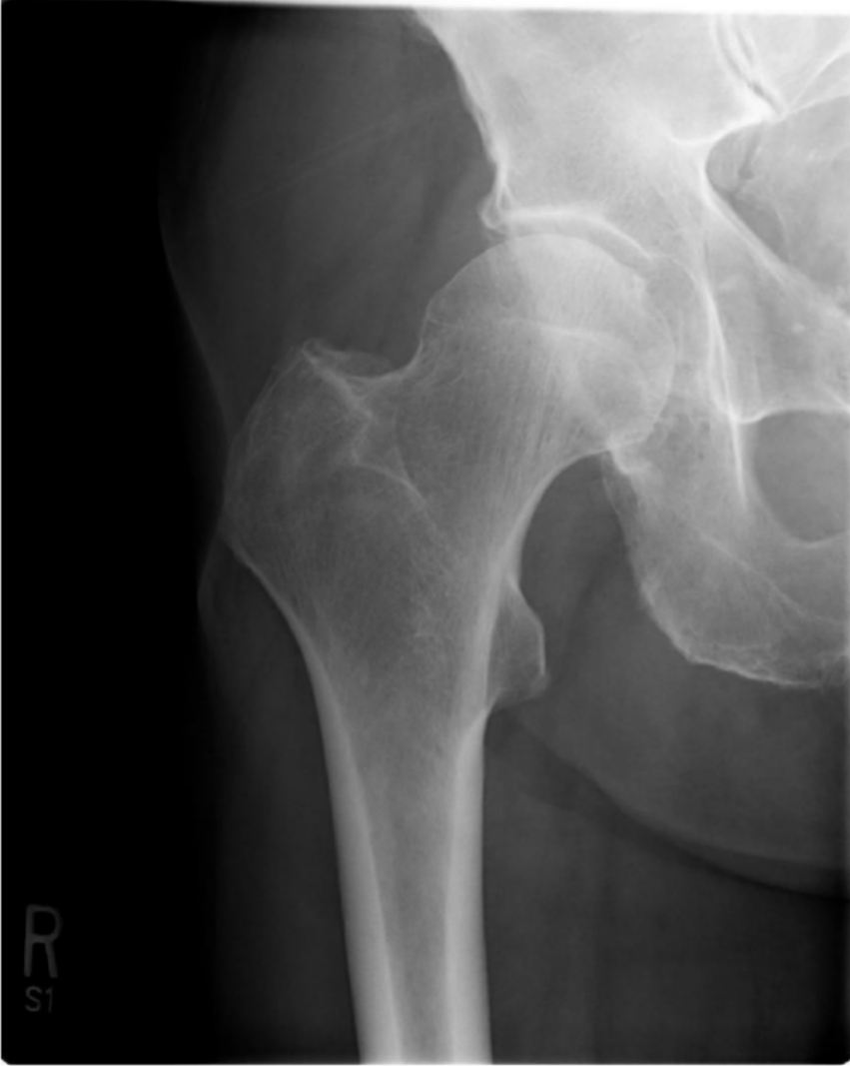
- Identify if the appropriate amount of radiation was used to form the image.
Acceptable, Overexposed,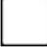 Underexposed
  - Is motion present in the image?
Yes No 
- Identify if the collimated light field was:
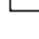 Acceptable, Too Small, Too Large

  - Was the CR close to the middle of the required anatomy?
Yes No
- Does the marker placement follow Edenbrook Marker Rules?

SAIT Imaging library

Is this image diagnostic? Yes No

Yes No
  - Are there artifacts in the image?


Yes No
*If yes, could they have been removed?

- Use the image below to answer the next five questions:
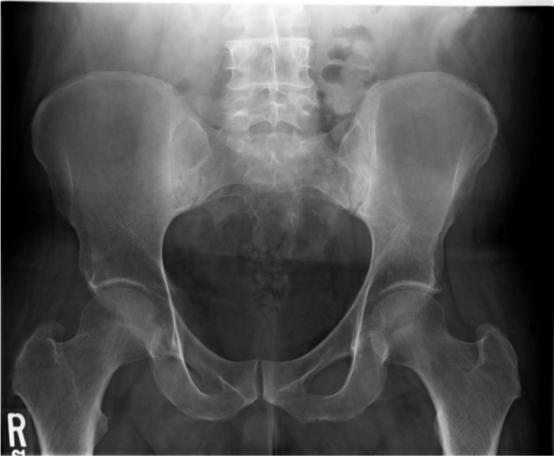
90 kVp
SAIT Imaging library
    - Which routine projection of the pelvis is displayed?
    - What positioning error(s) occurred?

    - If the image was repeated, how would you correct the positioning error(s)?

    - How did you identify the positioning error(s)?

    - If the image had to be repeated, would you make any other adjustment(s)? Explain your rationale.

- Use the image below to answer the next five questions:

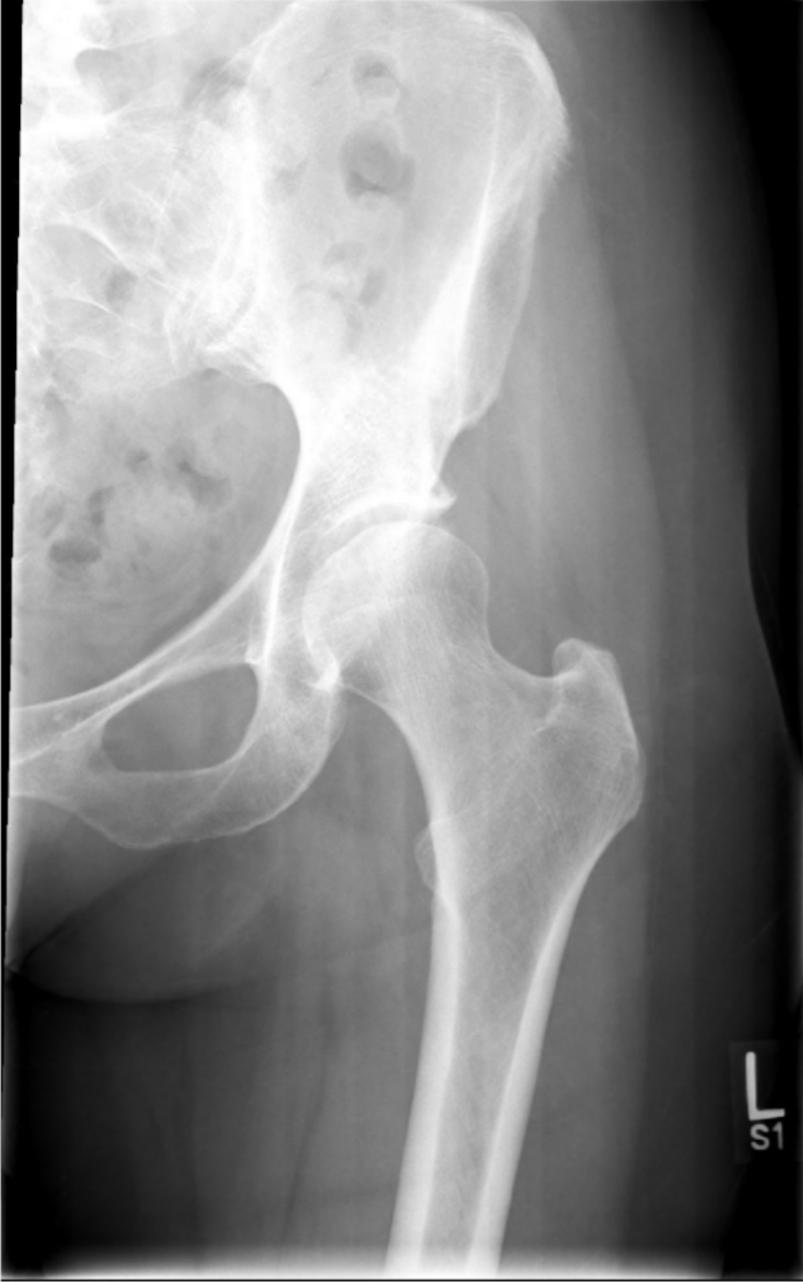
72 kVp

- Which routine projection of the hip is displayed?

- What positioning error(s) occurred?

- If the image was repeated, how would you correct the positioning error(s)?

- How did you identify the positioning error(s)?

SAIT Imaging library
- If the image had to be repeated, would you make any other adjustment(s)? Explain your rationale.

- Use the 5 evaluation criteria categories when critiquing the following image to determine if it is diagnostic:

Lateral Hip @ 80 kVp
Is this image diagnostic? Yes No

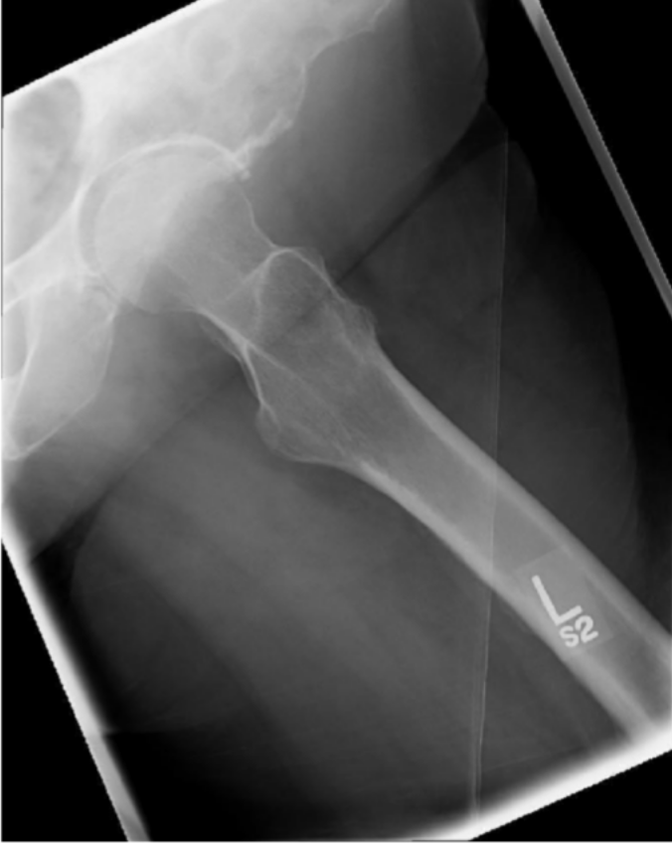
SAIT Imaging library

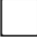
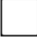
  - Is all the required anatomy included in the radiograph? Yes No
*If no, explain what is required

  - Does the anatomical appearance in the radiograph correlate to what is expected from a lateral projection? Yes No
*If no, explain how the appearance of this radiograph is different compared to the ideal radiograph
  - Identify if the appropriate amount of radiation was used to form the image. Acceptable, Overexposed, Underexposed 
    - Is motion present in the image? Yes No
  - Identify if the collimated light field was: Acceptable,Too Small, Too Large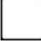
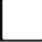
    - Was the CR close to the middle of the required anatomy? YesNo

  - Does the marker placement follow Edenbrook Marker Rules? Yes No
    - Are there artifacts in the image? YesNo
*If yes, could they have been removed?

