CT Imaging of the Head Review Activity
Part 1 – ANATOMY
- Match the definition or description with the correct term or structure.
_F Cerebral Aqueduct
_G Corpus Callosum

_H Dura Mater

_K Falx Cerebri

_E Middle Cerebral Artery
_B Perpendicular plate of ethmoid

I Pons
D Posterior Cerebral Artery
C Sigmoid Sinus

J Thalamus

A Vertebral artery
- Ascends in transverse foramen
- Part of the nasal septum
- Drains into the internal jugular vein
- Branch of the basilar artery
- Branch of the internal carotid artery
- Passes through the midbrain
- Part of the white matter of the brain
- Outermost layer of the meninges
- Middle region of the brainstem
- Part of the diencephalon
- Located between the cerebral hemispheres

- Label the image below:
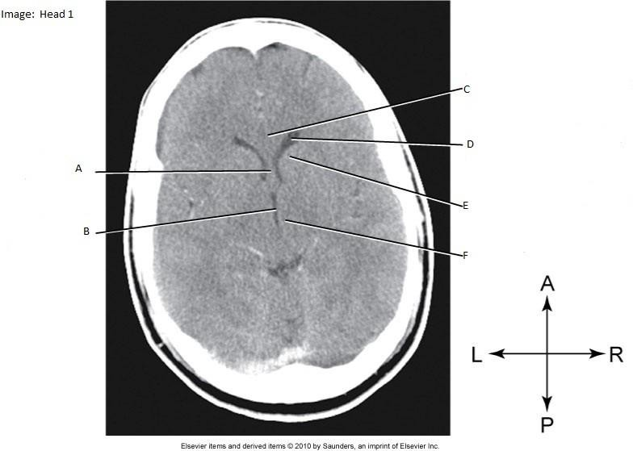

  - Septum pellucidum
  - 3rd ventricle
  - Corpus callosum
  - Anterior horn
  - Head of caudate nucleus
  - thalamus

- Label the image below:
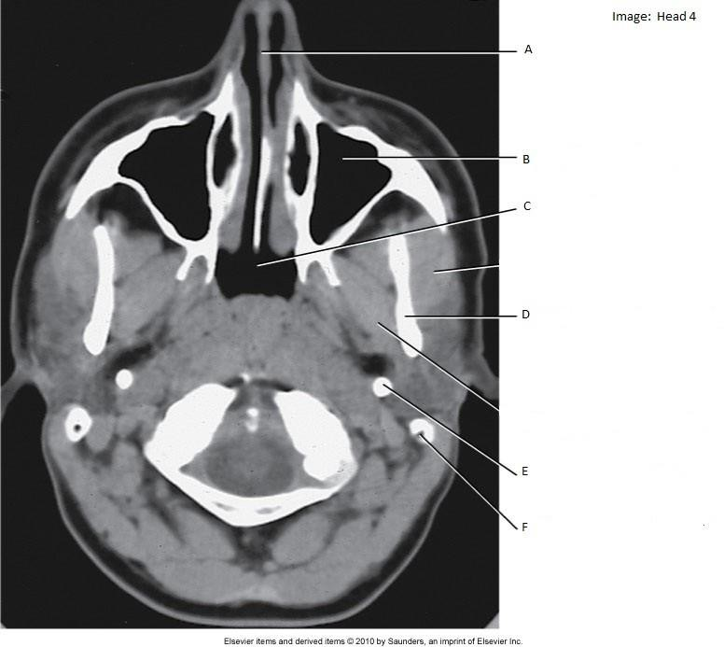

  - Nasal septum
  - Maxillary sinus
  - nasopharynx
  - Ramus of mandible
  - Internal carotid artery
  - Internal jugular vein

- Label the image below:
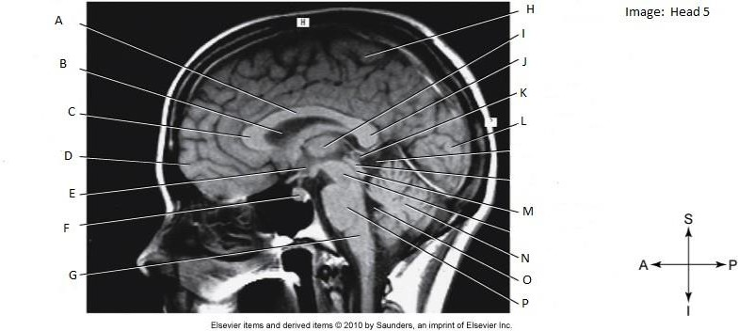
- body of corpus callosum
- lateral ventricle
- genu of corpus callosum
- frontal lobe
- hypothalamus
- pituitary gland
- medulla
- parietal lobe
- thalamus
- splenium of corpus callosum
- pineal gland
- occipital lobe
M cerebral aqueduct
- cerebellum
- 4th ventricle
- pons

- Label the image below:

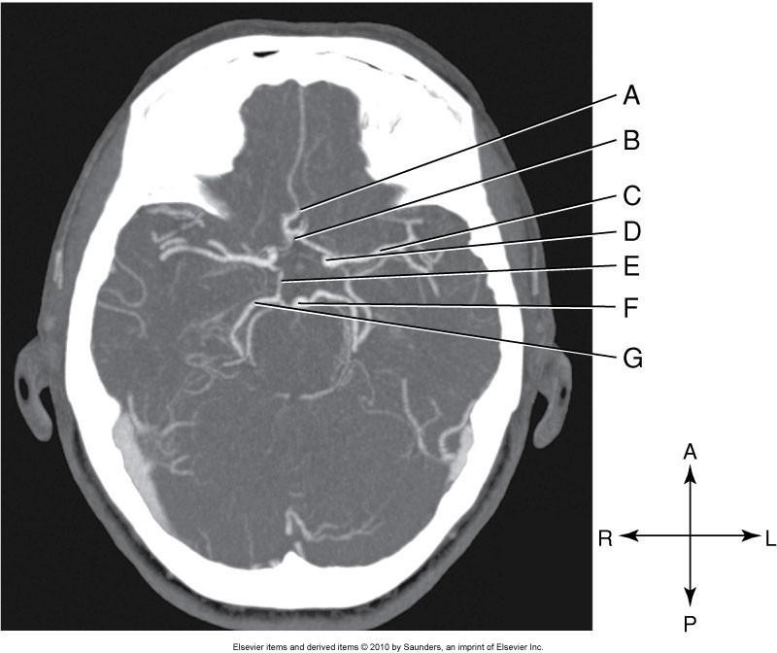
- anterior cerebral
- anterior communicating
- middle cerebral
- internal carotid
- posterior communicating
- basiliar
- posterior cerebral

- Label the image below:
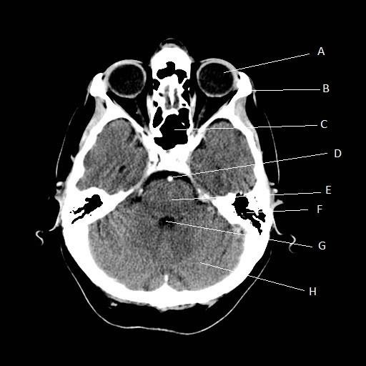
- Globe of the eye
- Zygoma
- Sphenoid sinus
- Basilar artery
- Pons
- Mastoid air cells
- 4th ventricle
- cerebellum

- Label the image below:
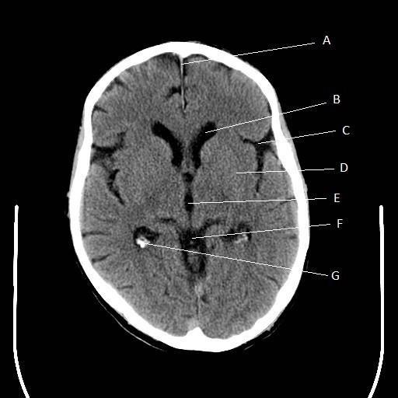

  - Falx Cerebri
  - Anterior horn
  - Central fissure
  - Parietal lobe
  - 3rd ventricle
  - Quadrigeminal cistern
  - Choroid plexus

- List the ventricles of the brain.
Lateral Ventricles (Anterior, Posterior and Inferior horns), 3rd ventricle and 4th ventricle.

- Which ventricle sits the most inferiorly? 4th ventricle

- What are the choroid plexus and how does it appear on CT images?
The structures within the ventricles which produce CSF. Appears often as calcification within the ventricles.

- List the meninges and their relationships? (ie – which layer is the outermost layer -> innermost layer)
Dura Mater (outermost), Arachnoid Mater (middle), Pia Mater (innermost)

- List the lobes of the cerebrum Frontal, Parietal, Temporal, Occipital

- What is the corpus callosum?
Band of white matter that connects the 2 hemispheres of the brain. Divided into the genu (anterior), body, and splenium (posterior)

- What are the superficial shallow grooves on the surface of the brain called? Sulci

- List the fissures of the brain and the sections each separates. Longitudinal – separates the right and left hemispheres of cerebrum Transverse – separates the cerebrum (occipital lobe) and cerebellum Central – Separates the frontal and parietal lobes
Lateral – separates the frontal, parietal and temporal lobes.

- What is the falx cerebri?
Where the dura mater dips into the longitudinal fissure, separating the right and left hemispheres of the cerebrum.

- The temporal lobes are seen on axial CT images at the level of what? Dorsum Sellae

- List the 3 sections of the brainstem and their relationship (Superior -> Inferior) Midbrain, Pons, Medulla

- What is the vermis?
Connects the two cerebellar hemispheres.

- What venous sinus is shaped like an S and is continuous with the internal jugular vein? Sigmoid Sinus

- What venous sinus occupies the entire space (anterior – posterior) along the superior aspect of the brain and moves ?
Superior Sagittal Sinus

- At the junction of the falx cerebri and the tentorium cerebelli, what two venous sinuses
/ veins join to become the straight sinus? Inferior Sagittal Sinus & Great Cerebral Vein

- What artery ascends into the brain through the transverse foramen? Vertebral Artery

- What structure allows passage of CSF between the 3rd and 4th ventricles? Cerebral Aqueduct
Part 2 – Imaging Procedures

- Describe the patient & anatomy position for a CT Head
Supine, head first, normal respiration, eyes open or closed. Line up the OML or SOML.
- How can the technologist position the patient to reduce radiation dose? SOML

- Determine which of the following statements describe helical scanning (H), conventional (C) scanning, or both (H, C)
  - Short acquisition time H
  - Improved detail C
  - Improved spatial resolution H
  - Allows gantry tilt C
  - Reduced radiation dose C
  - Capable of MPR H, C
  - Capable of 3D reconstructions H

- How can you reduce beam-hardening artifact in the posterior cranial fossa? Decrease slice thickness, increase kVp
- What is a reasonable Soft-Tissue window for viewing images of the head? WW 160 WL 40

- What is a reasonable bone window for viewing images of the head? WW 2500 WL 400
- Define, and describe the radiographic appearance of:
  - Epidural hematoma
  - Subdural hematoma
  - Subarachnoid hemorrhage
  - Intracerebral hemorrhage

- List 3 common indications for NECT head.
ICH, mass, lesion, MS, early infarction, stroke symptoms, dementia, hydrocephalus, trauma, headache
- List 3 common indications for CECT head.
Known mass or lesion, arteriovenous malformation, metastases, known aneurysm, seizure
- Why should a non-enhanced study be performed before injection of contrast? Identify an early bleed, rule out ICH. If contrast is injected, cannot differentiate between a brain bleed and contrast.

- What is the contrast protocol for CECT head? 100mls at 1.0 ml/sec, 5 min scan delay.
- What are some advantages of using CT Angiography over conventional catheter angiography?
Fast, available, less invasive, less risk of complication
- What is the contrast protocol for CTA head?
60 mls at 4.0 ml/sec. Use Bolus tracking with an ROI on the carotid artery at C4

- List 3 indications for CT sinuses.
Chronic sinusitis, inflammatory disease, polyps, pre-op (image-guided)
- List 3 indications for CT facial bones. Fracture, soft-tissue injury, foreign body

- List 2 indications for NECT orbits.

Foreign body, trauma

- List 3 indications for CECT orbits.
Intraorbital mass, inflammation, infection, vascular injury.
- What is the contrast protocol for CECT orbits?
Split bolus = 50 ml at 1 ml/sec, 2 minute delay, 50 ml at 1 ml/sec. Scan immediately following second bolus.

